**COVID-19 BOT**

An app for everyone to analyze their COVID-Situation

**COVID-19 BOT**

A Bot lying on Amazon Lex tried to determine whether you are Corona positive or negative based on your symptoms and travel history and people you are in contact with. It doesn’t say anything with surety cause only way to be sure is taking medical test, we can’t deny this fact.

But here we tried creating a scenario where our bot communicates with you and try to know about your symptoms and travel history et cetera based on the input you fed to it. Basically, it collects all this information and then analyses the situation but as we said earlier, we can’t be that sure and can’t rely on this information fully.

**Architecture**

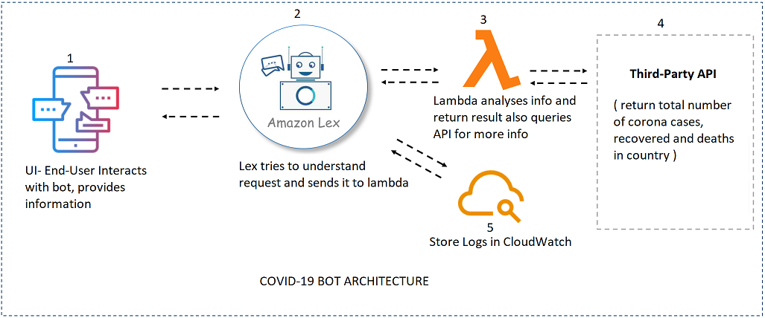

Basically, when a user chats with Bot, it craves for important information required from the user in an interactive way though the UI. That data is passed onto AMAZON LEX which understands the requests using the advanced deep learning functionalities of automatic speech recognition (ASR) for converting speech to text, and natural language understanding (NLU) to recognize the intent of the text. Based on its understanding, it calls the underlying lambda function for deep analyses of information available. Lambda does its analyses and returns the result. Another lambda parallelly called an API and retrieves the data about total number of corona positive cases, deaths and recovered, when asked to do so.

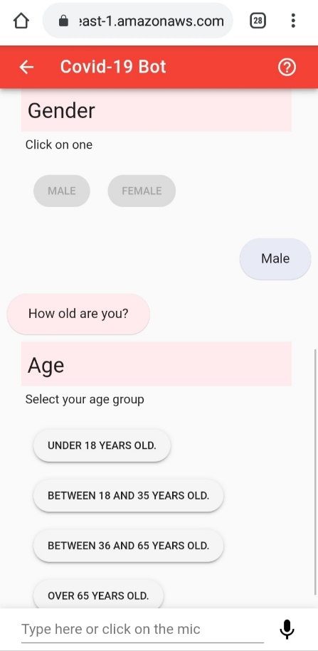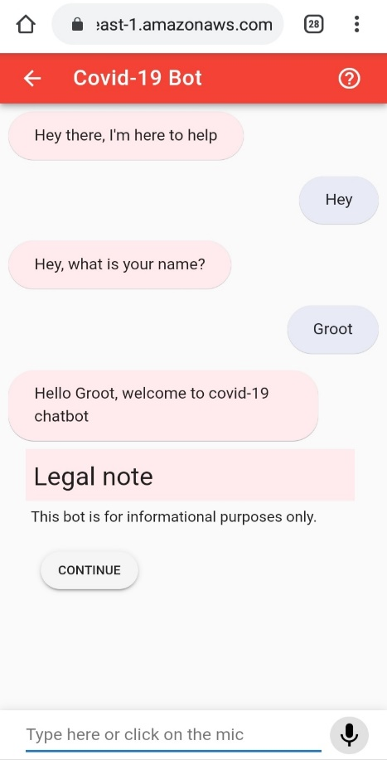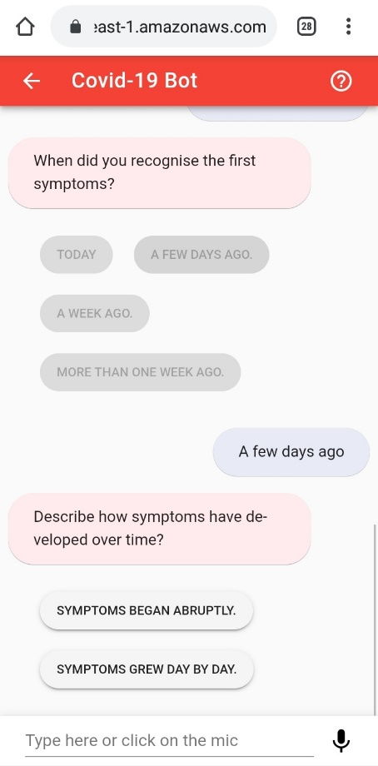

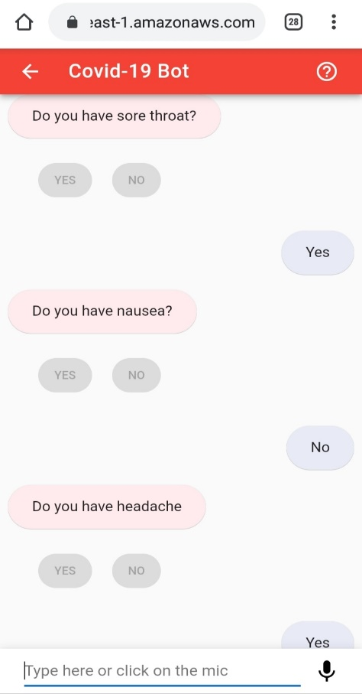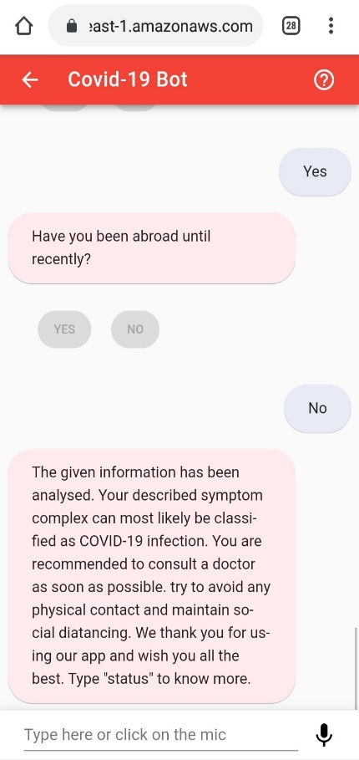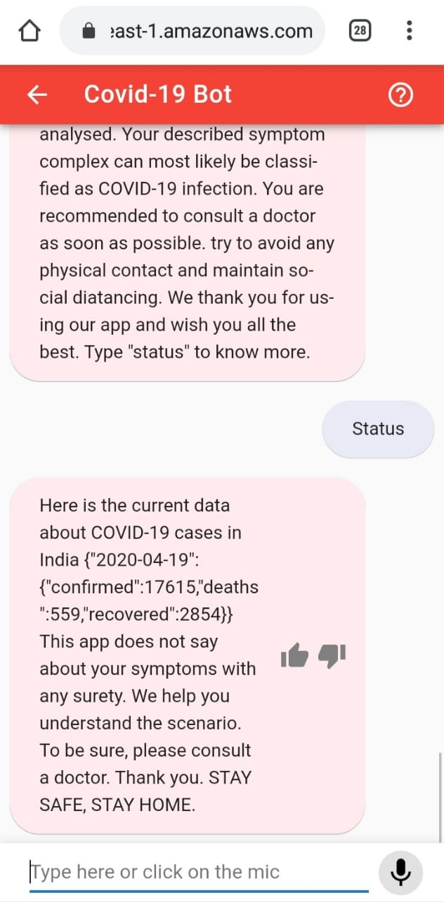

**Technology Stack**

AWS services are extensively used :

* Amazon Lex Bot

Amazon Lex is a service for building conversational interfaces into any application using voice and text. Amazon Lex provides the advanced deep learning functionalities of automatic speech recognition (ASR) for converting speech to text, and natural language understanding (NLU) to recognize the intent of the text, to enable you to build applications with highly engaging user experiences and lifelike conversational interactions.

* AWS Lambda Function (Node 12.x runtime)

AWS Lambda lets you run code without provisioning or managing servers. You pay only for the compute time you consume. With Lambda, you can run code for virtually any type of application or backend service, the one we are using in Node.js 12.x runtime as backend.

* CloudFormation: It deploys the following:
* S3 buckets to host the web application (UI)
* CodeBuild project to build the configuration and deploy to S3
* Optional Cognito Identity Pool for unauthenticated identities
* Optional Lambda function to delete S3 buckets
* CloudWatch Logs groups related to Lambda functions
* Associated IAM roles

**FUTURE SCOPE**

* The project can be extended to include voice input for people who don’t know English. Translation can also be used with it for non-native languages.
* Also, can suggest nearby hospital based on user’s location.
* Sentimental Analyses
* Et cetera

**DEPENDENCIES**

Our solution is very much reliant on the data provided by user for effective analyses. For more reliable and efficient output, provided data should be correct.

Required data includes:

Personal Info, like Name, Age group, Gender et cetera.

Symptoms like fever, headache, nausea, shortness of breath et cetera.

when symptoms first appeared, how evolved.

Any recent travel history.

*NOTE : Any discrepancy in data could lead to false positive.*