How to Setup to perform UWSN Experiments:
You have to go through all the mentioned steps which include installation, knowing about connections of Receiver and Transmitter, before you setup your system for experiments to obtain results.

Installation of GNU Radio:
You need to download the source from GNU Radio official website . Our code is compatible with gnuradio-3.3.0 version so I will recommend you to download this version. Since some of the libraries have been changed in the latest version, therefore, you have to slightly change the code to make it compatible with the latest version if you wish to use it. I will summarize here the procedure to install gnuradio-3.3.0.
Before installing Gnu radio you must install all the dependencies. You can install the dependencies according to your specific operating system since I am using Ubuntu 11.04 so I will install the below mentioned dependencies, for dependencies other than Ubuntu 11.04 the following link should be consulted.
sudo apt-get -y install git-core autoconf automake libtool g++ python-dev swig\
pkg-config libboost-all-dev libfftw3-dev libcppunit-dev libgsl0-dev \
libusb-dev sdcc libsdl1.2-dev python-wxgtk2.8 python-numpy\
python-cheetah python-lxml doxygen python-qt4 python-qwt5-qt4 libxi-dev\
libqt4-opengl-dev libqwt5-qt4-dev libfontconfig1-dev libxrender-dev

Now after installing all the dependencies you need to extract the previously downloaded gnuradio-3.3.0 to required destination. I extracted that in my home folder. Now you can configure and install GNU Radio by following commands
$ cd gnuradio-3.3.0
$ ./configure --prefix=/usr/
$ make
$ make install

- If it gives some access error use the make command followed with sudo to give it administrator permission.
Now add the custom installation directories to the environment settings, otherwise applications will not be able to find the headers, libraries, python scripts, etc.
Open your .bashrc file
$ sudo gedit .bashrc

then add the following line at the end of the file:
# PYTHON PATH
export PYTHONPATH=$PYTHONPATH:/usr/local/lib/python2.7/dist-packages

save the file and run the following commands.

$ sudo ldconfig

Once you are done with the installation, you can run one of the examples of the GNURadio to confirm whether it is running or not. The simplest example is the dial tone example in which you listen to a dial tone from the sound card.

$ cd /usr/share/gnuradio/examples/audio
$ ./dial_tone.py

Now you can run the transmit code by these commands. Considering my code is placed at Desktop/underwater folder.

$ cd Desktop/underwater
$ python fsk_transmit.py

The program will run and will ask you to enter the following:
- Data rate
- Centre frequency

If you run the receiver code by these commands
$ cd Desktop/underwater
$ python fsk_receive.py

you will get some error like this

Traceback (most recent call last):
File "fsk_receive.py", line 15, in <module>
from gnuradio import goodney
ImportError: cannot import name goodney

You are getting this error because goodney block is not installed in your system. You can install the block

How to build a block:
$ cd gr-goodney
$ ./configure --prefix=/usr/
$ make
$ make install

- If it gives some access error use the make command followed with sudo to give administrator permission.

After successful building of YourBlock you need to confirm that the files should be in /usr/lib/pythonx.x/dist-packages. If not, you need to manually move them to this directory.

Now if you run the receiver code by these commands

$ cd Desktop/underwater
$ python UPPER_receive.py

The program will run and will ask you to enter the following:

- Range
- Data Rate
- Centre Frequency
- Modification detail (Not Necessary to enter )
Once you are done with installation now it’s time to experiment by simply loopback.
For this connect a stereo cable in the speaker of Transmitter Laptop to microphone of Receiver Laptop.
Note: Change the gain in the transmitter code to be 0.002. You have to change gain of the block name attenuator in the code.
attenuator = gr.multiply_const_ff(0.002)

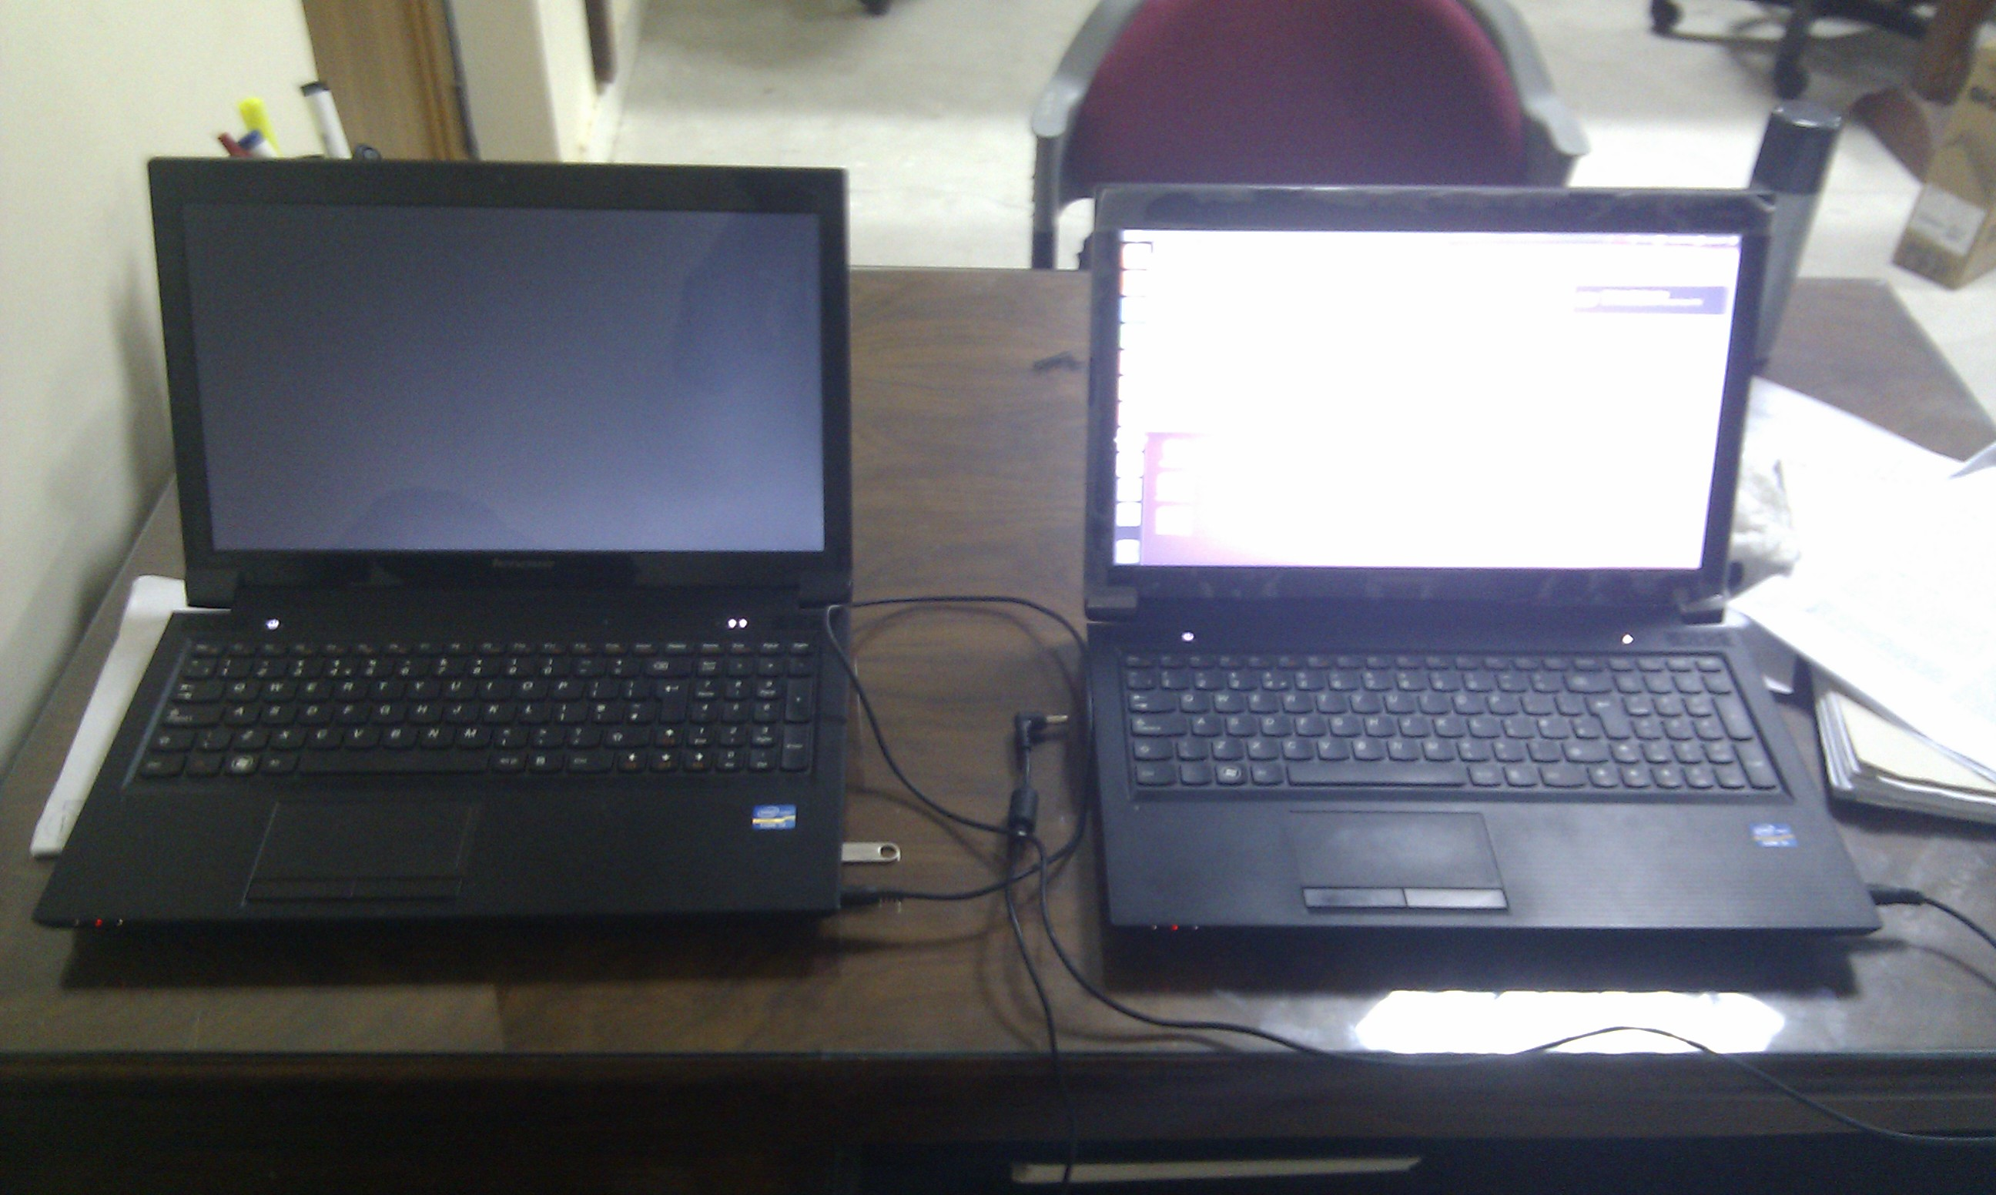
First run the Receiver code in the Receiver Laptop by these commands.
$ cd Desktop/underwater
$ python UPPER_receive.py

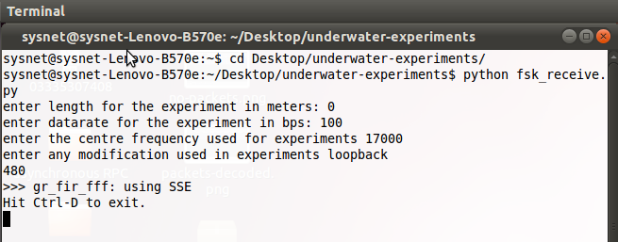

Now run the Transmitter code in the transmitter laptop by these commands.

$ cd Desktop/underwater
$ python UPPER_transmit.py

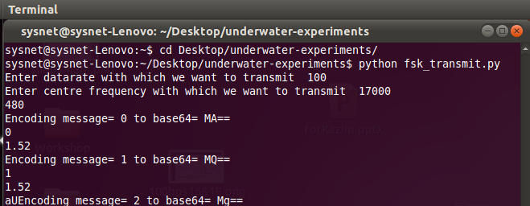

Transmitter Circuit:
The transmitter circuit consists of the following components
- Laptop
- Power Amplifier
- Transformer
- Transducer

  - Power Amplifier takes input from line out port of the laptop. It works on 12 V and
draws a current of 0.6 Amps.
  - Output Power Amplifier is connected to the primary side of the transformer.
  - The output of the transformer is connected to the transducer.

12 Volt Vcc to the Power Amplifier
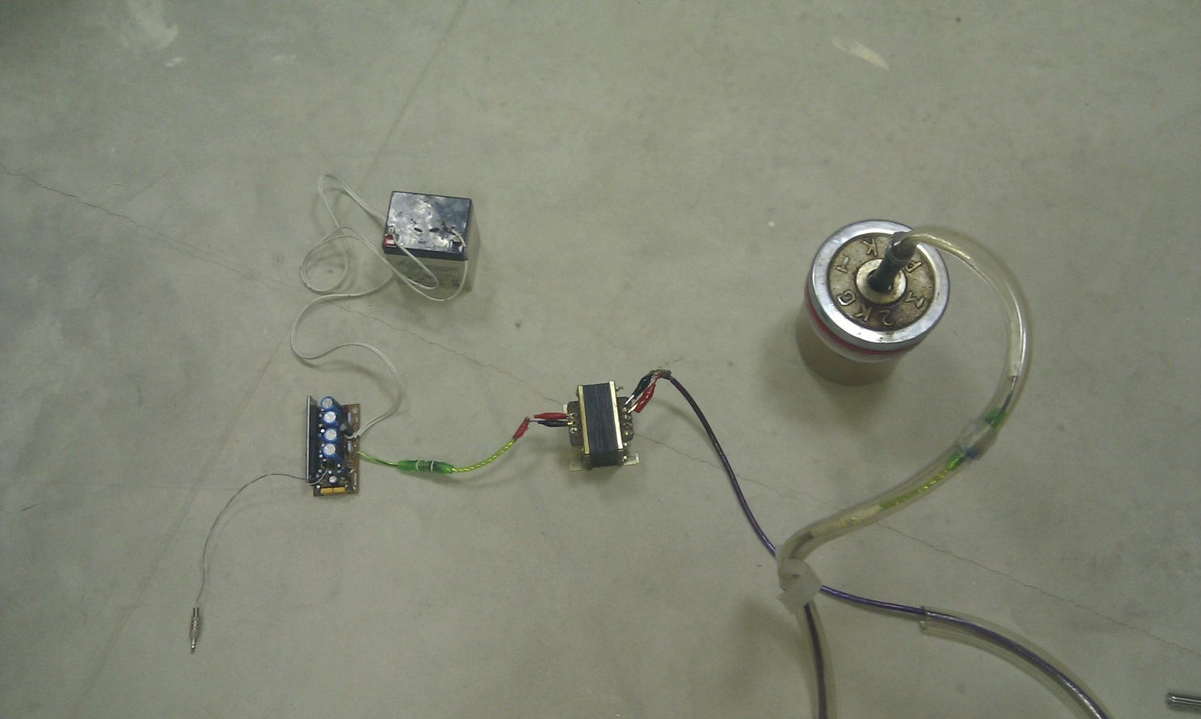

To laptop (Input of Power Amplifier ) Output of Power Amplifier to Primary side of Transformer

Receiver Circuit:
The receiver circuit consists of the following components:
- Transducer
- Preamplifier
- Low Pass Filter
- Automatic Gain Control (AGC)
- Laptop

In our design we have placed Preamplifier, Low pass filter and Automatic Gain Control on a single board. Input, output and Vcc are connected to the same board with a common ground.
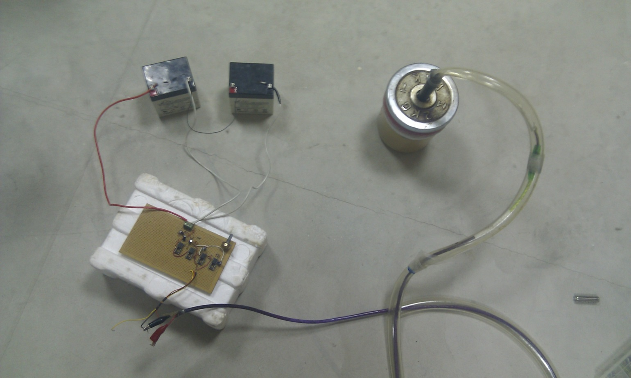
The receiver circuit works on +/- 12 volts. Two batteries of 12 volts are connected in series.

Output of transducer
Output of receiver circuit to Laptop

Output to Microphone jack Common Ground of Laptop

Setup for Experimentation:
Connect the Receiver circuitry as mentioned in above part and connect yellow pin with the cable’s +side which connect with the Microphone of the Receiver Laptop (Laptop running Receiver Code). Make the connections as mentioned in the transmitter part and connect the Power Amplifier to the Speaker of the Transmitter Laptop (Laptop running Transmitter Code).
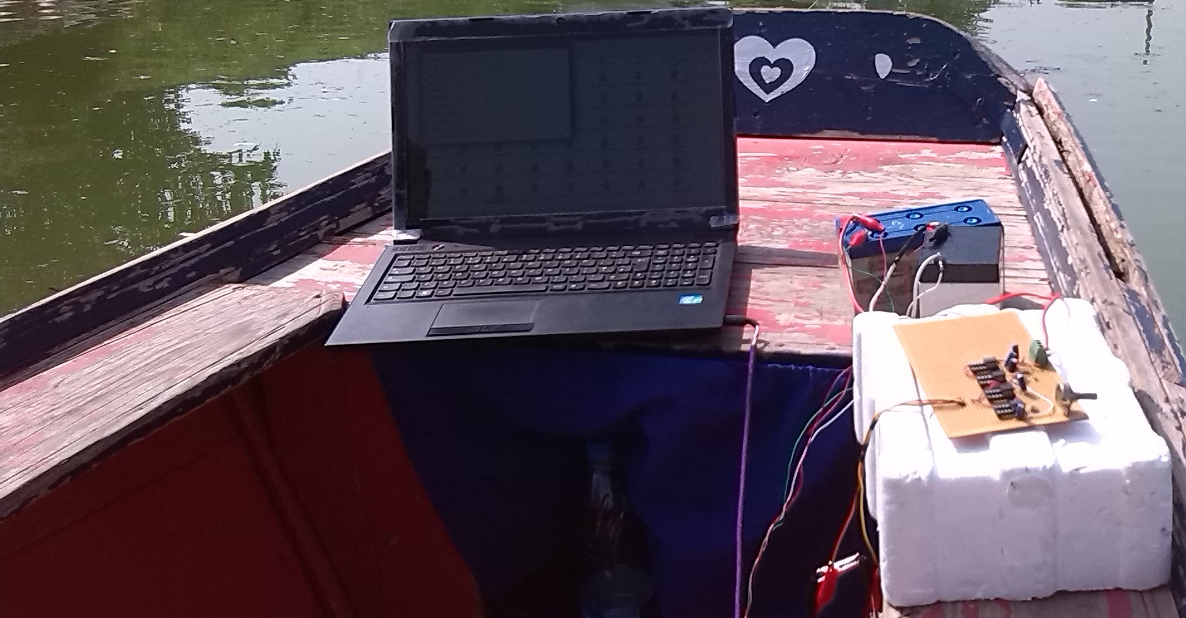 Receiver Side (Picture Taken while experimenting at Rawal Lake Islamabad).

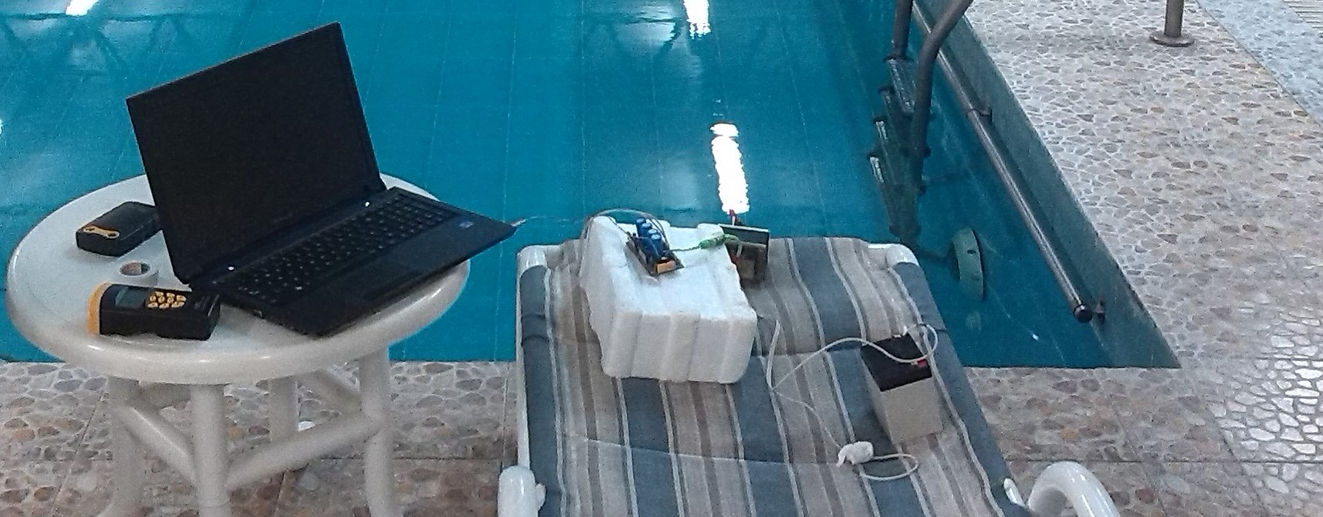
Transmitter Side (Picture Taken while experimenting at Nescom club Swimming Pool Islamabad).
Run the code in both the transmitter and receiver as mentioned above.
Note: Change the gain in the transmitter code to be 0.05. You have to change gain of the block name attenuator in the code.
attenuator = gr.multiply_const_ff(0.05)

