**Setup of Wireless Throttle with JMRI Withrottle Server**

Christoph Hauenstein – Dec24.2023.

The network credentials can be manually entered during the S**etup**, which can be accessed during the first 6 seconds after the throttle is turned on.

Buttons used for this setup procedure:

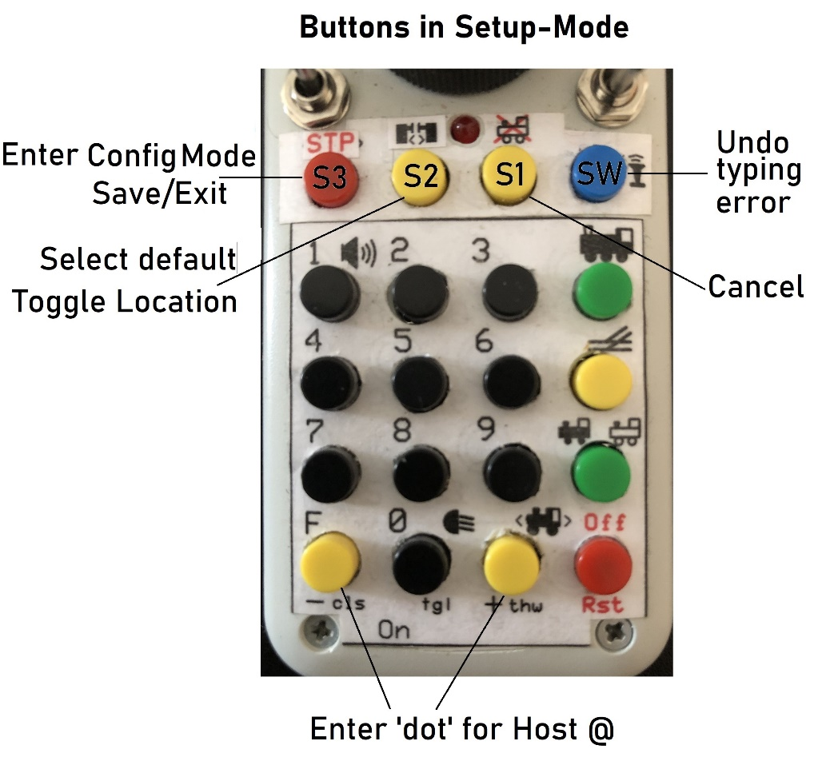

the first display that appears after power on shows the following:

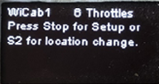

While this display appears: Within 6 seconds press the Stop button for network configuration and continue below, or

press the S2 button for switching locations which is described further down.

This option is also called at the end of the Throttle-Setup.

Meaning of location: the code provides a “default = hardcoded” network configuration. It can be used for instance for your **HOME** layout and can only be changed by altering the code as described at the end of this doc.

And there is the network configuration that can be entered as described below.

It is kept in storage beyond power off.

It can be used for instance when you go to your **CLUB**.

SETUP called by pressing Stop:

The following display appears where the number of throttles can be defined:

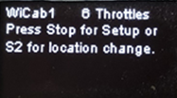

Accept current setting by pushing on knob or turn knob to change the number of throttles and then push knob.

The throttle now goes into the **network** configuration. It displays the current setting and searches for nearby networks:

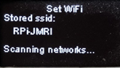

After a couple of seconds a list appears with the result of the search, looking something like:

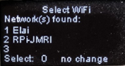

If the stored Network SSID is the one desired select 0 and push the knob. Or turn the knob for selecting one of the other networks:

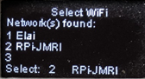

In this example the knob was turned to 2. To select push the knob.

Next the password can be entered (the following settings can be bypassed by pressing the S1 button):

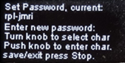

If there is no need to change the current setting just press Stop to continue to the next step.

To change the password turn the knob one notch, the first character will be displayed:

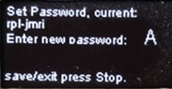

Turn the knob until the right character is displayed, then push on knob to save it.

Here the A was selected:

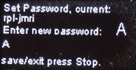

Turn knob for next character,

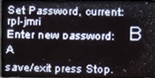

push knob to save and repeat until password is complete:

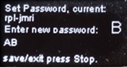

Press Stop to save and exit password setup when finished.

Mistyped a letter or two? press the Whistle (SW) button to undo the last letter. Each time the button is pressed the last appearing letter is removed.

The Network IP Address is entered next. Use the keypad to enter:

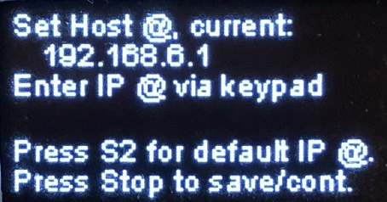

First digit(s) of the Host address has (had) been entered:

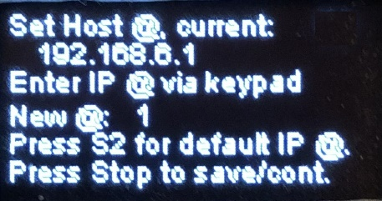

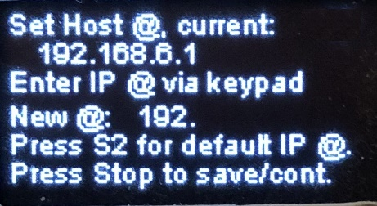

Next follows the Port number setting, in the same way as before by using the keypad:

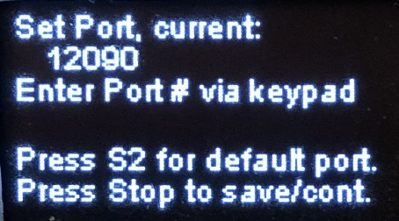

First digit of the port number has been entered:

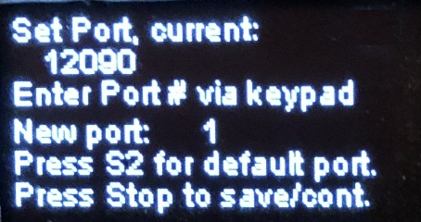

Once done you can select the Location (Club or Home) can be selected next:

**Set Location:**

(can be entered also directly at beginning of setup by pressing S2)

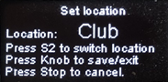

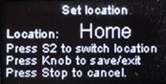

The following are the coded values for the default settings:

char* dftssid = "RPi-JMRI";

char* dftpass = "rpI-jmri";

char* dfthost = "192.168.6.1";

int dftport = 12090;

These values can be changed by altering them in the source code ‘sketch_WiFi_Multi_Throttle_v1-2_23xxxx’.

The lengths of password and Network SSID are limited to 25 characters.