**WiCab Operation** (Oct. 11. 2023)**:**

**Buttons & Switches:**

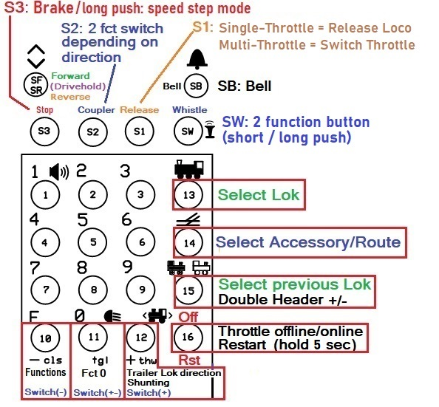

**Turn the throttle on.**

**To switch number of throttles:**

When **“Press Stop for Setup”** appears on the display press **Stop** (Brake – S3 button) within 5 seconds.

If you don’t press Stop within 5 seconds **startup** continuous normally.

If Stop was pressed the current throttle setting is displayed. Turn Speed Knob to select a new number of throttles - up to 6. Press down on the Knob. This will change the setting to the currently displayed number of throttles and continue with normal startup.

**To switch between throttles during normal work press the S1 button.**

**Normal Startup:**

The throttle code tries to connect to the Local Wireless Network. If the network is not active (responding) the code retries for 1 minute. If a connection is established within 1 minute the code tries to connect to the server. If the server is not active (responding) the code retries for 1 minute. If the connection to the server is not established or lost during operation the code tries to reconnect for 2 minutes.

**Loco Display:**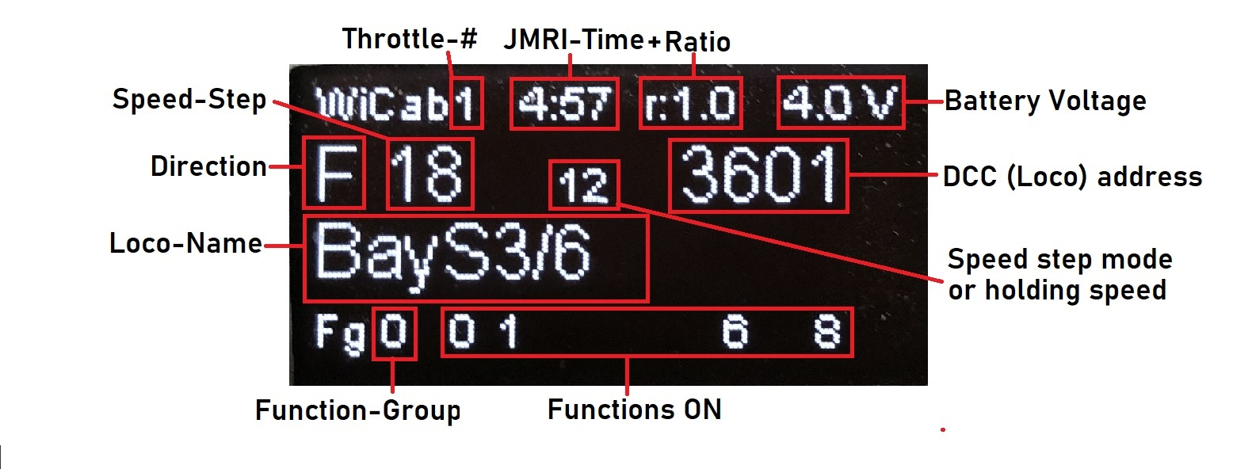

**Note:**  during the selection of a locomotive address by either going through the roster or going through the stack, the number of the roster/stack element is displayed in place of the drive-hold speed.

**Select a loco:**

After power on the last used address is displayed with a “?” which means it is not activated yet.

In Multi-Throttle-Mode each throttle will display its own last used loco address.

If you want to use that address press the  button (13), or push the **Speed Knob**. If not, select another address in 1 of 3 ways:

1. **Using the Roster:**

Step through the roster by rotating the speed knob until the loco you want is displayed, press thebutton,

or push the **Speed Knob**.

1. **Using the Stack:**

Press  button (15). By repeatedly pressing it steps through the throttle stack for the last 6 used addresses. Select one by pressing the  button (13), or push the **Speed Knob**.

1. **Using the Number Keypad:**

Enter a new address. Press the button (13), or push the **Speed Knob**.

To select a new address at any time press the  button (13) and proceed with one of the steps above.

**Release a Loco:**

the S1 button releases the current loco while using the device as single throttle.

Pressing button 13 in order to select a new loco also releases the current loco, in Single and Multi- throttle modes.

When the throttle is put offline by pressing the Off button (button 16) all locos that are currently active in all throttles are released.

**Recommendation: before turning off power press the Off button** in order to release all locos.

**Enter Double Header:**

Select the trailing loco first by following the steps above. Press  button (15). A plus sign appears in front of the address. Then press the  button (13) to select the Leading loco.

To change the direction of only the trailing loco press the button (12).

**Accessory decoder:**

Press the  button (14). Then either:

1. Use the Number Keypad to enter the accessory decoder address. Press the Button (14) again. Press the F button (10) for Close (-), Zero button (11) for Toggle (+-), or button (12) for Throw (+).
2. If Routes are defined in JMRI: turn the speed knob until you see the route you wish to set.

Press button 14 to end Accessory address mode.

**Function select display:**

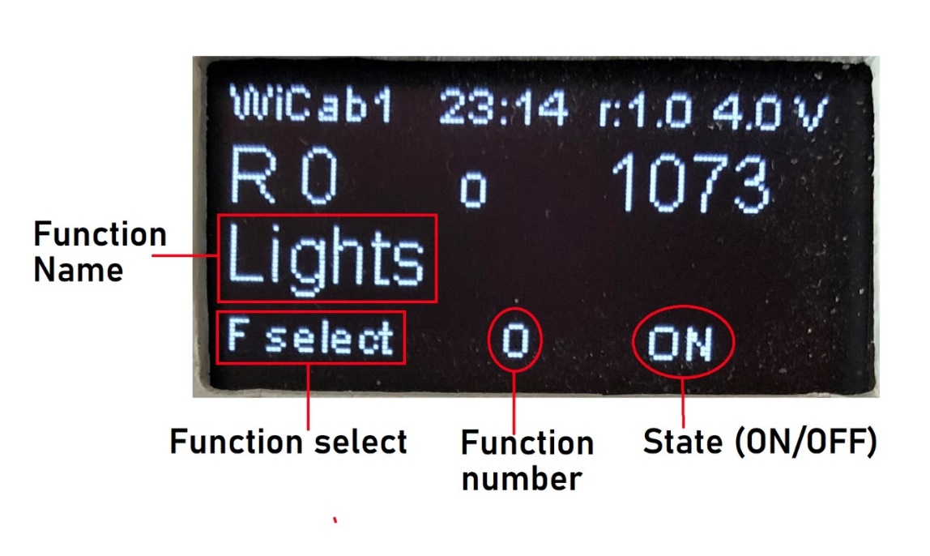

**Select Function by Name:**

Press the F-key repeatedly until **“F select”** is displayed. Rotate Speed Knob until the desired function is displayed. Push down the Speed Knob to change the function state, or press the F-key to cancel.

**Speed & Speed Step Mode:**

The throttle detects the speed step mode in the selected Loco automatically.

To change the speed step mode: at speed 0 press and hold the stop button until the mode changes.

Supported modes: 28 & 128. The **Brake-button** sets the speed to zero (decoders interpret this as Brake).

Changing the Direction while in motion also issues **Brake**.

**Drive-Hold:**

The center position of the direction switch selects this function if it is defined for a Loco in the **Roster.** When this function is activated the speed that is “on hold” is also displayed next to the speed setting display. Moving the direction switch away from the center position turns **“Drive Hold”** off.

**When you use this function make sure it is set as “Momentary” (Locked = unchecked) in the Roster.**

**Fade (Sound-Fading):**

is used for instance when the train goes into a tunnel or for the effect for distance. Which button is used for Fade depends on the definition in the JMRI-Roster for Sound. It can be either one of the two: F1 or F8. The Sound button controls **Sound** at speed 0, and the function **Fade** - if available - at speed greater than 0.

**Functions:**

In normal mode with address mode off the numbers keypad can be used to turn on/off DCC functions F0-F28.

"F" = "Functions" button: Press/release F button to toggle through function groups.

Functions 0 to 9 can be accessed in Fg0, F10-F19 in Fg1, F20-F28 in Fg2.

The current states of all functions (as well as the direction for a Loco) are retrieved from the server.

Function Names and Modes “momentary” or “continuous”, can be configured in JMRI by going to “Actions” – “Labels and Media” tabs.

Button (12) is also mapped to a function (“Shunting”). It too can be mapped to anything you want, or not mapped. It can be used while operating a loco like any other Function.