**Update to version 23.10.28 of Wireless Throttle with JMRI Withrottle Server**

Christoph Hauenstein - Nov.08.2023.

The network credentials are no longer hardcoded in the program.

They can be manually entered during the setup that can be called during the first 6 seconds after the throttle is turned on.

Buttons used for this setup procedure:

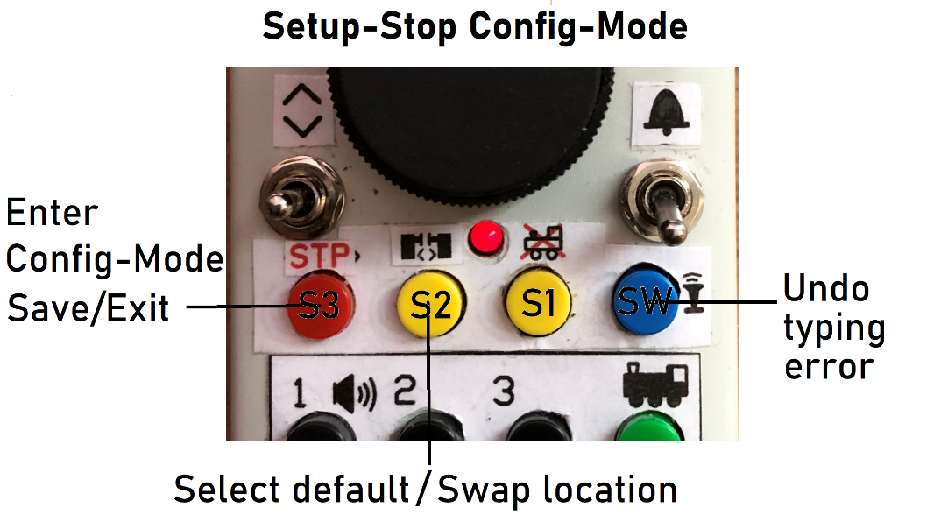

While the following display appears:

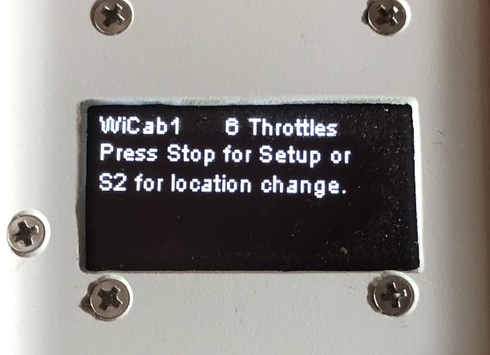

Within 5 seconds press the Stop button for network configuration and continue below, or

press the S2 button for switching locations which is described further down.

Meaning of location: the code provides a “default = hardcoded” network configuration. It can be used for instance for your home layout and can only be changed by altering the code as described at the end of this doc.

And there is the network configuration that can be entered as described below.

It is kept in storage beyond power off.

It can be used for instance when you go to your club.

Network configuration:

The following display appears:

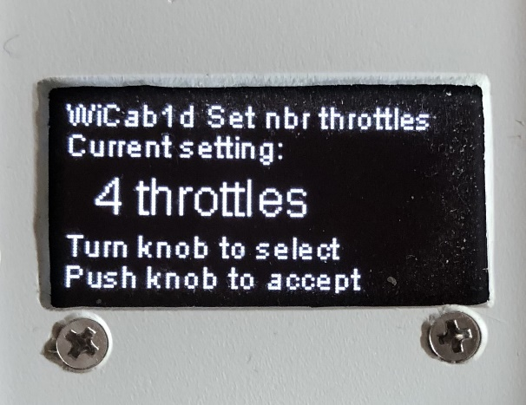

Select number of throttles you prefer, press down on knob. Next display:

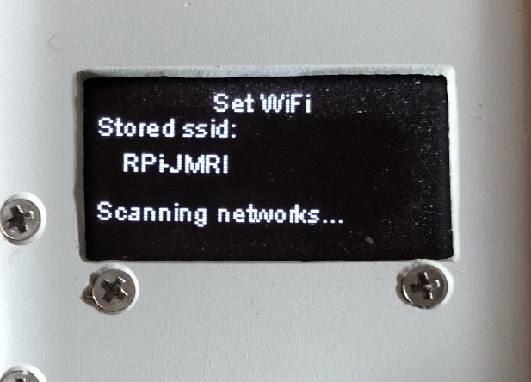

The throttle now searches for nearby networks:

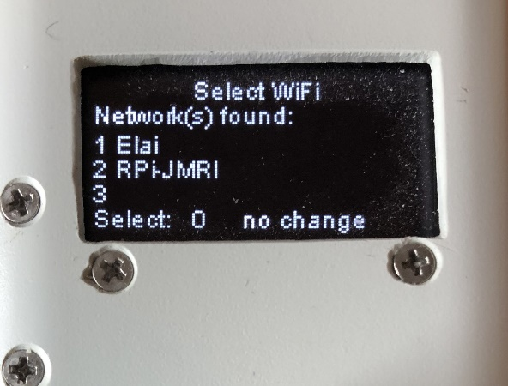

Select 0 to bypass this step with no change.

Turn the knob for your choice.

In the example below the knob was turned for choice 2:

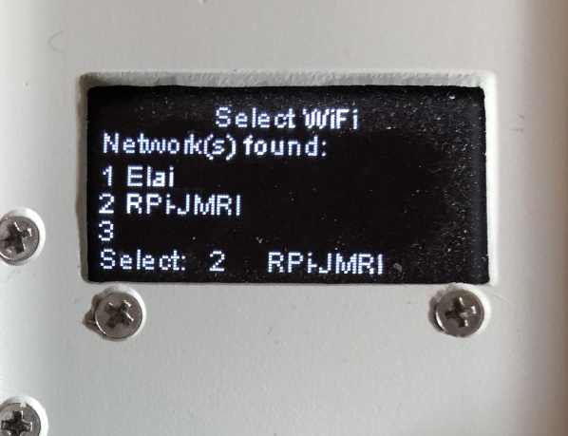

Push down on knob to save your selection.

The display for setting the network password appears:

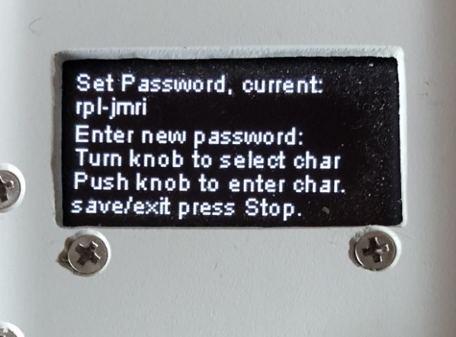

Turn the knob to enter the first letter, or press Stop to exit without change,

Or select the default (hardcoded) password by pressing the ‘coupler button’ = switch S2.

The knob was turned so the first choice letter appears:

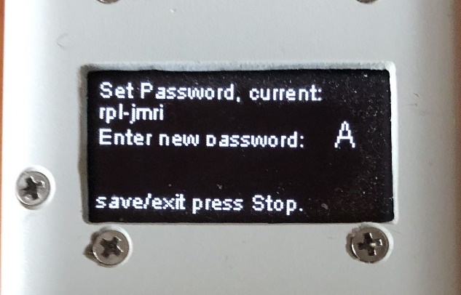

Turn the knob until the right letter/number/special character is displayed, then push down on the knob to save your selection: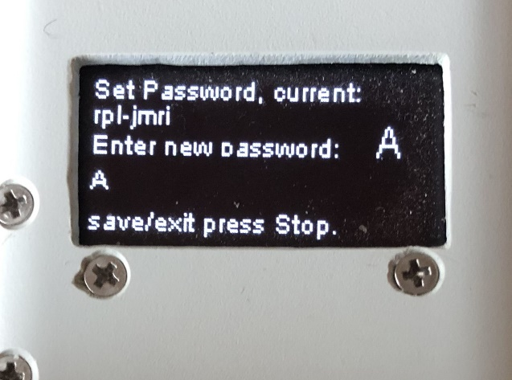

Your choice is added to the next line for displaying the full password.

Turn knob for next letter:

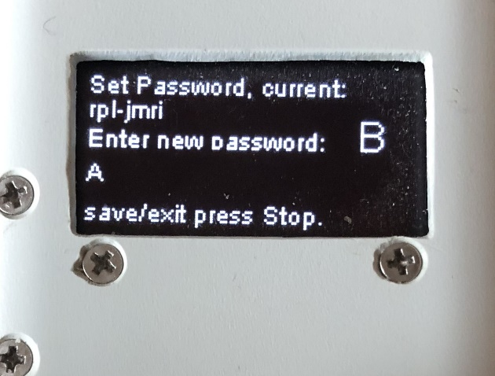

Push down on knob to save.

The letter was added to the password in progress:

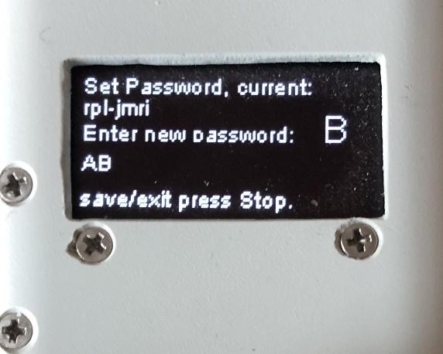

Press Stop to save and exit password setup when finished.

Mistyped a letter or two? Don’t worry: press the Whistle (SW) button to undo the last letter. Each time the button is pressed the last appearing letter is removed.

Next step, enter the Host IP Address:

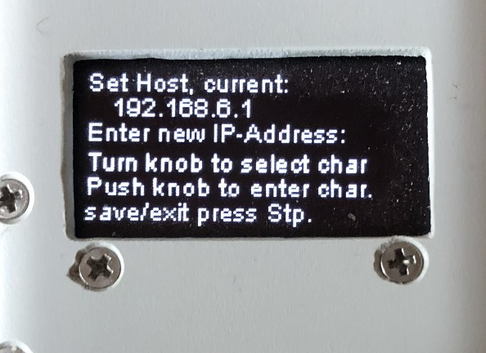

Turn the knob to enter the first number, or press Stop to exit without change,

Or press S2 (coupler button) to select the default (hardcoded) IP address.

See image after next.

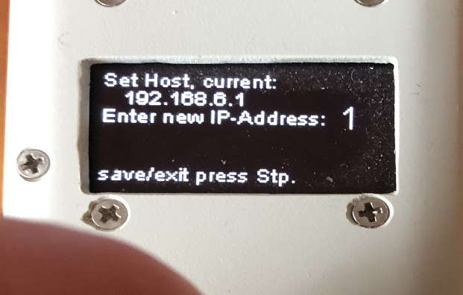

Knob was turned for first number.

The next steps follow the same pattern like entering the password:

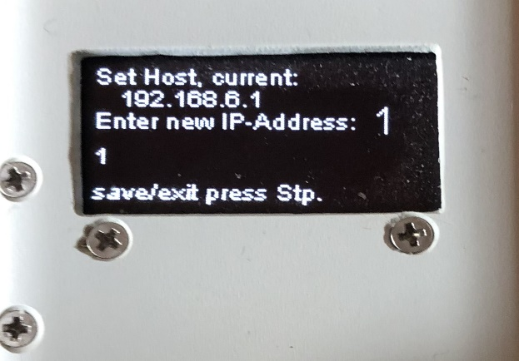

When finished, save and exit by pressing Stop. The throttle starts the normal startup procedure.

If you entered a wrong character during the process: same is before with the password.

Location change:

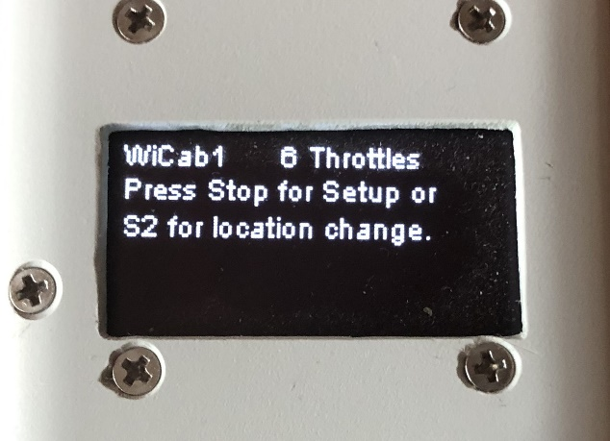

Press the S2 button with 6 seconds.

The current setting is displayed.

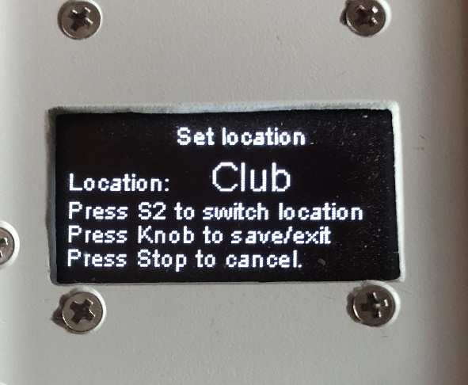

Press the S2 button to toggle locations:

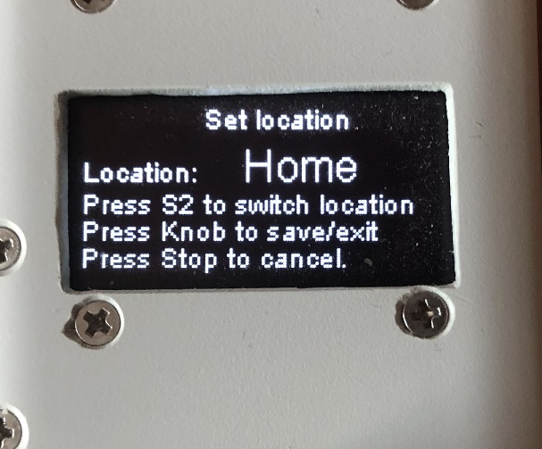

Push down on knob to save the new setting, or

Press Stop to cancel without saving.

The following are the coded values for the default setting:

char* dftssid = "RPi-JMRI";

char* dftpass = "rpI-jmri";

char* dfthost = "192.168.6.1";

In case you want different default values you can change them by altering those variables in the source code ‘sketch_WiFi_Multi_Throttle_v1_231028’.

The lengths of password and host address as well as the Network SSID are limited to 25 characters.