**WiCab Operation** (Feb. 07. 2024)**:**

**Buttons & Switches:**

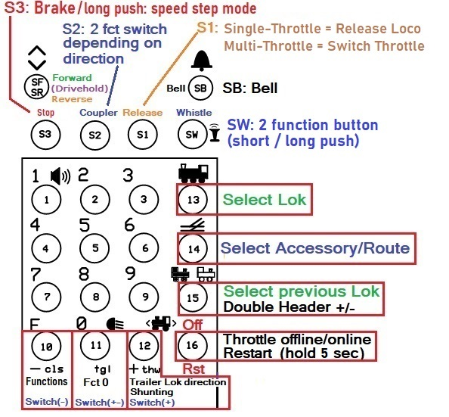

**Normal Startup:**

The throttle code tries to connect to the Local Wireless Network. If the network is not responding the code retries for 1 minute. If a connection is established within 1 minute the code tries to connect to the host server. If the server is not responding the code retries for 1 minute. If the connection to the server is not established, or lost during operation, the code tries to reconnect for 2 minutes. After that it gives up and stays offline.

**Loco Display:**

**Select a loco:**

After power on the last used address is displayed with a “?” which means it is not activated yet.

In Multi-Throttle-Mode each throttle will display its own last used loco address.

If you want to use it press the  button (13). If not, select another address in 1 of 3 ways:

1. **Using the Roster:**

Step through the roster by rotating the speed knob until the loco you want is displayed, press the button (13), or the Speed Knob.

1. **Using the Stack:**

Press  button (15). By repeatedly pressing it steps through the throttle stack for the last 6 used addresses. Select one by pressing the  button (13), or the Speed Knob.

1. **Using the Number Keypad:**

Enter a new address. Press the button (13) ), or the Speed Knob.

To select a new address at any time press the  button (13) and proceed with one of the steps above.

**Release a Loco:**

the S1 button releases the current loco while using the device as single throttle.

Pressing button 13 to select a new loco also releases the current loco, in Single and Multi- throttle modes.

When the throttle is put offline by pressing the Off button (button 16) all locos that are currently active in all throttles are released.

**Recommendation: before turning off power press the Off button** in order to release all locos.

**Enter Double Header:**

Select the trailing loco first by following the steps above. Press  button (15). A plus sign appears in front of the address. Then press the  button (13) to select the Leading loco.

To change the direction of only the trailing loco press the button (12).

**Accessory decoder (aka Stationary decoder):**

Press the  button (14). Then either:

1. Use the Number Keypad to enter an accessory decoder address, or turn the speed knob for displaying turnout names. Press the Button (14) again to select the displayed turnout. Press the F button (10) for Close (-), Zero button (11) for Toggle (+-), or button (12) for Throw (+). Press button 14 to end Accessory mode.
2. If Routes are defined in JMRI: after pressing button 14 the first time in step (a) press it again. Turn the speed knob until you see the route you wish to set.

Press button 14 to set the route and end Accessory address mode.

**Speed & Speed Step Mode:**

The throttle detects the speed step mode in the selected Loco automatically.

To change the speed step mode: at speed 0, press and hold the stop button until the mode changes.

Supported modes: 28 & 128 (=126 steps).

The **Brake-button** sets the speed to zero (decoders should interpret this as Brake).

Changing the Direction while in motion also issues **Brake**.

**Drive-Hold:**

If this function is defined for a Loco in the Roster, the center position of the direction switch selects that function. When this function is activated the speed that is “on hold” is also displayed next to the speed setting display. Moving the direction switch to the current direction of the Loco turns “Drive Hold” off.

**When you use this function make sure it is set as “Momentary” (Lock = unchecked) in the Roster.**

**Fade (Sound-Fading):**

Some decoders provide a function for “fading” = turn volume down to simulate tunnel or distance.

Normally Function 8 (US/AU) or Function 1 (EU) turns the sound on/off. If Fade is defined in the roster for a locomotive and the loco is driving - the Sound button accesses the function for Fade (if available) instead of F8/F1. When the loco is stopped and Fading is still on, the function 8/1 key will first turn fading off. Then another push will switch the sound again. Which of the two F-keys will control the Sound must be defined in the JMRI-Roster.

**Make sure this function - and Fade if available - are set as “Locked” in the Roster**

**Functions:**

In normal mode with address mode off the numbers keypad can be used to turn on/off functions F0-28.

"F" = "Functions" button: Press/release F button to toggle through function groups 0 to 2 and “select”.

Functions 0 to 9 can be accessed in Fg0, F10-F19 in Fg1, and F20-F28 in Fg2. In “select” the Knob is used to step through the function-names available for the selected loco. Push the speed knob to change the current state of the function.

Button (12) is also mapped to a function (“Shunting”). It too can be mapped to anything you want. It can be used while operating a loco like any other Function.

**Select Function by Name:**

Function Select display:

Press the F-key repeatedly until **“F select”** is displayed. Rotate Speed Knob until the desired function is displayed. Push down the Speed Knob to change the function state, or press the

F-key to cancel. **All** functions that are defined in the JMRI Roster for a loco can be selected in that way.

**Fg0 Button assignment: Fg1 Button assignment:**

**Functions assigned to extra buttons:**

The 4 buttons you see in the above image are mapped to following functions in **Function Group 0:**

Button name S3 = Brake, S2 = Coupler, S1 = switch Throttle, S0 = Whistle.

**The buttons can be mapped to anything you want in Fg 1 & 2**.

Mapping in the above example **for Fg1:**

S3 = **Top Light**, S2 = **Cab Light**, S1 = **Tail Light**. S0 = not mapped.