**WiCab Operation** (April. 09. 2024)**:**

**Buttons & Switches:**

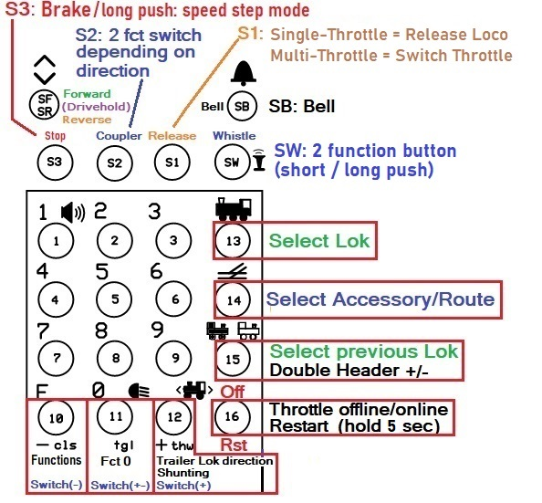

**Note:**

Functions for buttons Sw (=S0), S1, S2, S3 are shown for Function Group 0.

They can be mapped to other functions that are then called when Function Group 1 or 2 is active. For buttons that have no extra mapping for Fg1 or 2 the Fg0 assignments are used also in Fg1 or 2.

**Startup:**

The throttle comes configured as Single Throttle. It can be changed to a Multi-Throttle during start up:

**Turn the throttle on.**

**The first screen displays something like this:**

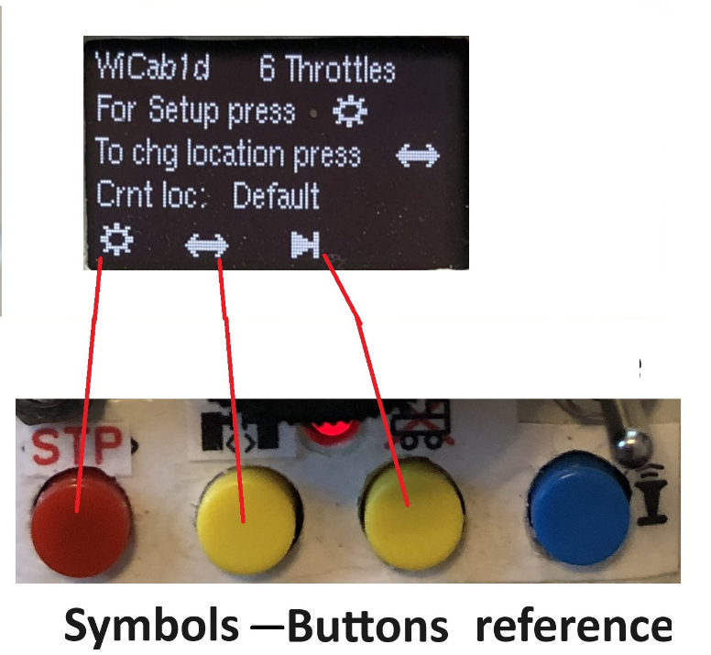

**Buttons for the configuration:**

To change the number of throttles setting and/or the Network configuration press **S3 **  within 10 seconds after power on.

Or press **S2 ** to only change the location.

If you don’t press **S3** or **S2** within 10 seconds **startup** continuous normally.

To jump to Normal Startup without waiting 10 sec press **Skip **

**After choosing Setup, “Switch number of throttles” is displayed:**

If S3  was pressed the current throttle setting is displayed. Turn Speed Knob to select a new number of throttles if you wish - up to 6. Press down on the Knob. This will change the setting to the currently displayed number of throttles. Or press **Skip **to continue without change.

**Normal Startup:**

The throttle code tries to connect to the Local Wireless Network. If the network is not responding the code retries for 1 minute. If a connection is established within 1 minute the code tries to connect to the host server. If the server is not responding the code retries for 1 minute. If the connection to the server is not established, or lost during operation, the code tries to reconnect for 2 minutes. After that it gives up and stays offline.

**Loco Display:**

**Select a loco:**

After power on the last used address is displayed with a “?” which means it is not yet activated.

In Multi-Throttle-Mode each throttle will display its own last used loco address.

If you want to use it press the  button (13). If not, select another address in 1 of 3 ways:

1. **Using the Roster:**

Step through the roster by rotating the speed knob until the loco you want is displayed, press the button (13), or the Speed Knob to select.

1. **Using the Stack:**

Press  button (15). By repeatedly pressing it steps through the throttle stack for the last 6 used addresses. Select one by pressing the  button (13), or the Speed Knob.

1. **Using the Number Keypad:**

Enter a new address. Press the button (13), or the Speed Knob.

To select a new address at any time, press the  button (13) and proceed with one of the steps above.

**Release a Loco:**

the S1 button releases the current loco while using the device as single throttle.

Pressing button 13 to select a new loco also releases the current loco, in Single and Multi- throttle modes.

When the throttle is put offline by pressing the Off button (button 16) all locos that are currently active in all throttles are released.

**Recommendation: before turning off power press the Off button** in order to release all locos.

**Enter Double Header:**

Select the trailing loco first by following the steps above. Press  button (15). A plus sign appears in front of the address. Then press the  button (13) to select the Leading loco.

To change the direction of only the trailing loco press the button (12).

**Accessory decoder (aka Stationary decoder):**

Press the  button (14). Then either:

1. Use the Number Keypad to enter an accessory decoder address or turn the speed knob for displaying turnout names. Press the Button (14) again to select the displayed turnout. Press the F button (10) for Close (-), Zero button (11) for Toggle (+-), or button (12) for Throw (+). Press button 14 to end Accessory mode.
2. If Routes are defined in JMRI: after pressing button 14 the first time in step (a) press it again. Turn the speed knob until you see the route you wish to set.

Press button 14 to set the route and end Accessory address mode.

**Speed & Speed Step Mode:**

The throttle detects the speed step mode in the selected Loco automatically.

To change the speed step mode: at speed 0, press and hold the stop button until the mode changes.

Supported modes: 28 & 128 (=126 steps).

The **Brake-button** sets the speed to zero (decoders should interpret this as Brake).

Changing the Direction while in motion also issues **Brake**.

**Drive-Hold:**

If this function is defined for a Loco in the Roster, the center position of the direction switch selects that function. When this function is activated the speed that is “on hold” is also displayed next to the speed setting display. Moving the direction switch away from the centre position turns “Drive Hold” off.

**When you use this function make sure it is set as “Momentary” (Lock = unchecked) in the Roster.**

**Fade (Sound-Fading):**

Some decoders provide a function for “fading” = turn volume down to simulate tunnel or distance.

Normally Function 8 (US/AU) or Function 1 (EU) turns the sound on/off. If Fade is defined in the roster for a locomotive and the loco is driving - the Sound button accesses the function for Fade instead of F8/F1. When the loco is stopped and Fading is still on, the function 8/1 key will first turn fading off. Then another push will switch the sound again. Which of the two F-keys will control the Sound must be defined in the JMRI-Roster.

**Make sure this function is set as “Locked” in the Roster**

**Functions:**

In normal mode with address mode off the number keypad can be used to turn on/off functions F0-28.

"F" = "Function-Group" button: Press/release F button to step through function groups 0 to 2 and “select”.

Functions 0 to 9 can be accessed in Fg0, F10-F19 in Fg1, and F20-F28 in Fg2. In “select” the Knob is used to step through the function-names available for the selected loco. Push the speed knob to change the current state of the function.

Button (12) is also mapped to a function (“Shunting”). It too can be mapped to anything you want. It can be used while operating a loco like any other Function.

**Select Function by Name:**

Function Select display:

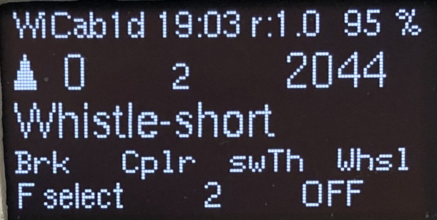

**Fg(3) Fct # State**

**Fct-Name**

Press the F-key repeatedly until **“F select”** is displayed. Rotate Speed Knob until the desired function is displayed. Push down the Speed Knob to change the function state, or press the

F-key to cancel. **All** functions that are defined in the JMRI Roster for a loco can be selected in that way.

**Fg0 Button assignment: Fg1 Button assignment:**

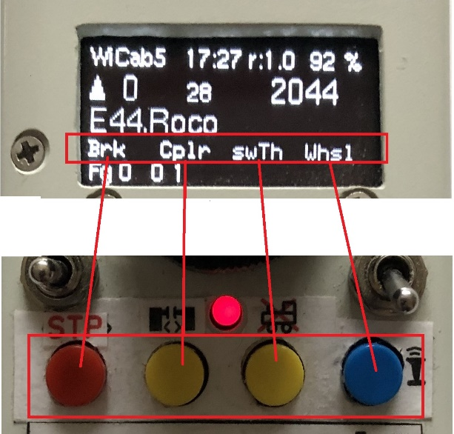 **Ein Bild, das Text, Messgerät enthält.
**

**Functions assigned to the 4 extra buttons:**

The 4 buttons you see in the above image are mapped to following functions in

**Function Group 0:**

Button name S3 = Brake, S2 = Coupler, S1 = switch Throttle, S0 = Whistle.

**Function Groups 1&2:**

**The buttons can be mapped to anything you want**.

**If a button is not mapped for Fg1 or 2 the Fg0 mapping takes place.**

In the sketch I provided I mapped **for Fg1:**

**S3 = no mapping, S2 =** **Cab Light**, **S1 =** **Tail Light**. **S0 =** **Top-Light**.

So **S3** will always issue **Brake** as this is the default.

I did not map anything in **Fg 2** (yet).

**Enter Network credentials:**

In the first display after power on select Setup.

After leaving ‘Set nbr throttles’ the next step is called

**Network configuration:**

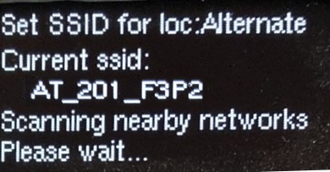

The current network SSID is shown if a network was previously configured.

The throttle searches for nearby networks. Wait until available networks are listed.

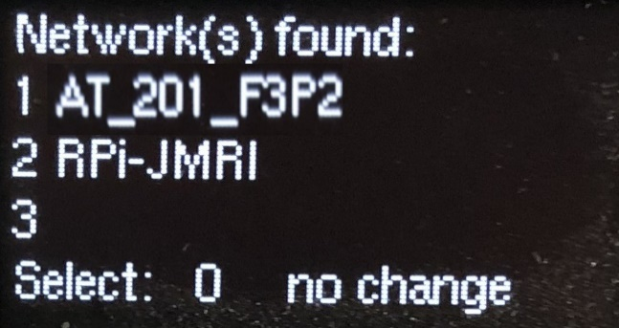

To select a network, turn the knob to the desired network. Up to 6. 4 to 6 are displayed when you turn the knob clockwise past 3. Press down on the knob to select.

Select 0 for no change.

In case the network you want is not listed, but you know it exists and you know the SSID (hidden network SSID is not broadcast):

Turn the knob to 7 and push down on the knob. This allows you to manually enter the network SSID.

A **Network SSID** can be entered character by character, by turning the knob and pushing it down selecting a character. See “Set Password” in the next step.

Once a Network is selected or entered the Network Password can be entered.

Next Set Password is displayed:

A **new Password** can be entered character by character, by turning the knob and pushing it down selecting a character when a right character is displayed.

The symbols on the bottom line show the functions of the 4 extra buttons S3-S0

during the configuration. Here they are: **enter, select default, skip, erase**.

Once done, save the whole password by pressing the  key.

Next the current Host IP address is displayed if one was previously configured.

A **new Host @** can be entered using the keypad number keys and either the **F** or the  button for the dots (the 2 buttons left and right of the zero-button).

Save the new Host @ by pressing the key.

Next the current Port Number is displayed if one was previously configured.

A **new Port nbr** can be entered using again the keypad number keys.

Save the new Port # by pressing the key.

The Network configuration is now finished.

Now you can select if you want to stay with the “Default” (hard coded, Home) setting, or go to the “Alternate” (Club) setting.

**Location:**

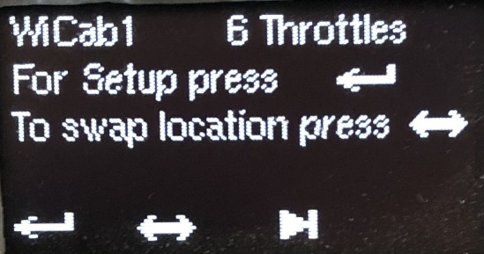

Now you can select if you want to stay with the “Default” (hard coded, Home) setting, or go to the “Alternate” (Club) setting.

This option can also be entered in the **first selection** screen, **S2**  instead of **S3** .

There is one more step following ‘Set location’:

**Default Sound Function:**

European countries’ sound files normally use the F1-key to turn sound on or off. Other countries’ sound files, like the US, usually use F8.

For loco’s registered in the JMRI-Roster the Sound Function Key is defined there, and it overwrites the default setting, for each loco individually.

The default setting is used for loco’s not in the Roster. For instance, for an address that is not in the Roster and entered manually via the keypad.

The following functions and their numbers are used in the default setting:

Whistle short = 2, whistle long = 3, bell = 5, coupler = 4, shunting = 6, sound = 1/8.

Everything is saved beyond power on!

All screens in the above configuration showing  can be skipped by pressing this button.

Note: in some of the screen shots you see a ‘d’ following the throttle name, like ‘WiCab1d’.

It means that the program was compiled with “#define LOG”.