1. **What is software? What is software engineering?**

* Software is a set of instruction to execute user commands to perform specific task.
* Software engineering is a design, Develop, programming, testing of computer software.

1. **Explain types of software.**

* **Software** has five types 1) System Software
* 2).Application software 3)Driver software. 4) Middleware Software. 5) Programming Software.

* **1).System software:**

System software is a type of computer program that is designed to run a computer’s hardware and application programs.

E.g. Notepad, Calculator, Clock etc..

**2).Application Software :**

Application software is a computer software package that performs a specific function for a user, or in some cases, for another application. E.g. Microsoft office, paint, etc..

**3).Driver software:** This software often considered to be types of system software. Driver software is operates and control devices that are plugged into a computer.

E.g. printer, USB, etc..

**4). Middleware software:** Middleware software is lies between operating system and application running on it. Middleware enable communication and data management for distributed application.

E.g. Web server.

**5). Programming software:** Computer programmers use programming software to write code. Programming software enables developer to write, test and debug the other program.

E.g. Editor, compiler, interpreter.

1. **What is software development Life-Cycle.**

* Software development life-cycle (SDLC) is a process used by the software industry to design, develop and test high quality software.
* **Life-Cycle**

* **Planning:**

Planning for the quality assurance requirements and identification of the risk associated with the project is also done in the planning stage.

In this phase developer gathering information and idea form client to develop program.

* **Analysis:**

Analysis in SDLC to understand business needs and processing needs. In this phase developer gathering all the specific information required for new program and determining first idea for prototype.

* **Design:**

Define solution system based on requirement and analysis decision. In this phase developer build structured design document based on planning and analysis for program. Like DFD flow chart etc..

* **IMPLEMENTATION**:

The software engineers start writing the code according to the client’s requirements. During this stage developer complete application as per client requirement.

* **Testing:**

This is the process of finding defects or bugs in the created software. In this phase tester taste the application and give a review to ensure that the application work according to customer requirement.

* **Maintenance:**

The software is deployed after it has been approved for release. In this phase developer give services to client for application.

1. **What is DFD? Create a DFD diagram on Flip kart.**

* DFD is introduce the Flow of data of system or progress of your product.
* DFD is graphical tool and useful for communicating with users and it’s also given inputs and output entry’s itself.
* **Diagram of Flip kart**

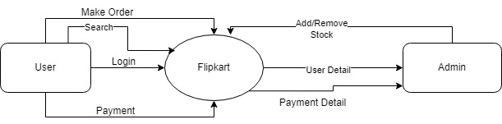

**Fig. DFD Level 0 Diagram For Flip kart0**

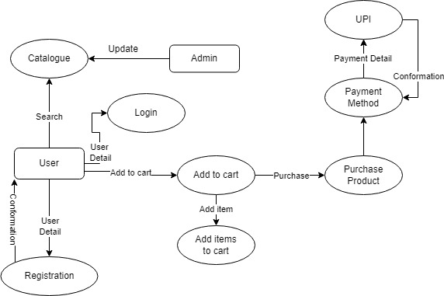

**Fig. DFD Level 1 Diagram For Flip kart**

1. **What is Flow chart? Create a flowchart to make addition of two number.**

* **Flowchart of Addition of two numbers:**

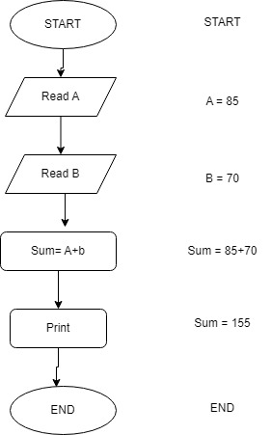

1. **What is Use case Diagram? Create a Use case on Bill Payment on Paytm**

* Use case is a diagram of how user perform task on website.
* Use case diagram help we can find out pre and post condition after the interaction with the actor.
* **Use case Diagram for Billing System**

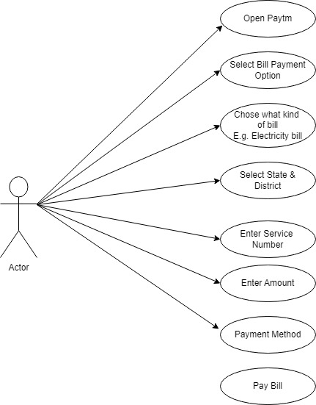

0