1. **What is Software? What is Software engineering?**

* **Software** is a set of instruction or command to perform certain task.
* E.g. MS office, Notepad, Calculator, etc.
* **Software engineering** is to design, Develop, Programming, Testing of Computer Software.

1. **Explain type of software?**

* Software has two types:

1. **System Software:** It is in-built software E.g. Calendar, Calculator, clock, Notepad
2. **Application Software:** Software Develop by Developer it’s called Application Software E.g. Whatsapp, Instagram, Facebook …
3. **What is software development life-cycle?**

* **Software Development Life Cycle (SDLC)** is a step by step approach for software development to achieve high quality product within the cost and time.
* **Life Cycle:**
* **Planning:**

ProjectPlanning is first phase of SDLC. In this stage developer gathering business ideas for product from client.

* **Analysis:**

Analysis is second stage of SDLC. In this stage developer analysis their planning for Software.

* **Design:**

In this stage developer design chart according to their planning. The original plan and vision are elaborated into software design document that include DFD Diagram, Flowchart, Use case diagram.

* **Implementation:**

Implementation is fourth stage of SDLC. In this stage developer developing software. Developer Write coding for their software.

* **Testing:**

In this stage tester test the Product to make sure it is functioning properly and does what it’s meant to do and giving a reviews.

* **Maintenance:**

In this stage developer give service of product to client. If client find bugs and error in software these bugs need to be fixed for better experience

1. **What is DFD? Create a DFD diagram on Flip kart**

* **Data Flow Diagram (DFD):** Flow of data of system is represent by DFD
* It is graphical tool useful for communicating with users, managers, other personnel.
* Useful for analyzing existing as well as propose system.
* **DFD diagram on Flip kart**

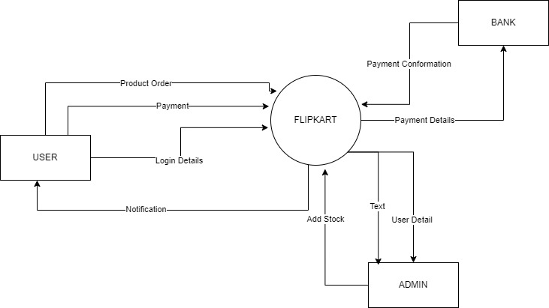

**Fig. Level 0 DFD Diagram for Flip kart**

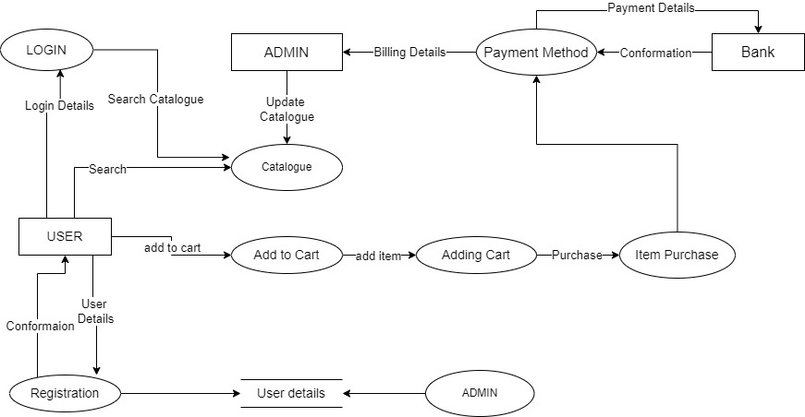

**Fig. Level 1 DFD Diagram for Flipchart**

1. **What is flowchart? Create a flowchart to make addition of two numbers**

* **Flowchart** is a diagram that represents an algorithm and process.
* It is a diagrammatic representation solution for given problem.
* **Flowchart for addition of two numbers:**

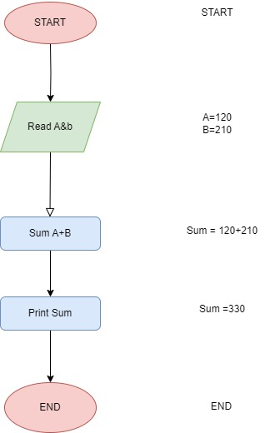

1. **What is Use case Diagram? Create a Use case on bill payment on Pay tm**

* In Use case Diagram developer shows how user perform task on website.
* **Use case on bill payment on Pay tm:**

