**Explanation Of Project**

**Project Details :**

It is a **Campus recruitment system** which has the following features:-

1. Different companies come to campus, having other profiles for recruitment.
2. Each company conducts a recruitment drive on a specific date, time, and venue.
3. Each company can conduct a drive for more than one job.
4. Each position has some related information like job title, qualification, and salary.
5. Students are shortlisted for each job based on some eligibility criteria like minimum Percentage of marks and a maximum number of failed subjects.
6. Different jobs can have a different number of rounds for the test.
7. All information about the drive, like company profile, jobs offered, etc. are shared with students.
8. Students are shortlisted based on some eligibility criteria decided by Institute who can participate in the drive.
9. Then all the eligible students are informed with the date and time of the test.
10. Record of all students who appeared and cleared all the rounds are maintained.

**Databases Part :**

1. Company Database:-

It contains data about each company.

It contains information like Name, address, turnover, and core business area.

2) Student Database:-

It contains data about students.

It contains information like Name, Roll no. , Percentage, no. of failed subjects, etc.

3) Drive Database:-

It contains data about the recruitment drive.

It contains information like Company name, and job title offered, date , time, venue, salary, etc..

**GUI Part :**

1. Student Form - To take student data from students which are used to send notifications to the student about the jobs in which he/she is eligible.
2. Company Form - To take company data from companies that include Name, address, turnover, and core business area.
3. Drive From – To take drive information from the company so that students can be informed about the job eligibility criteria, etc.
4. Track Score – To take the score of each round during the placement process and generate the final score.

**Cartesian decomposition:**

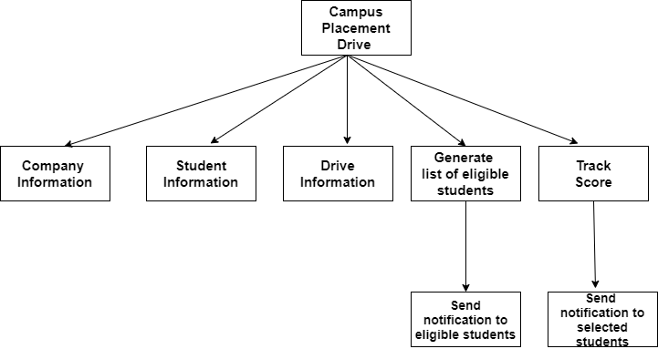

|  |  |
| --- | --- |
| **Node** | **Purpose** |
| Campus Placement Drive | This module is used to coordinate the submodules under it. |
| Company Information | This module is used to take company data from companies that include Name, address, turnover, and core business area. |
| Student Information | This module is used to take student data from students, which are used to send notifications to the student about the jobs in which he/she is eligible. |
| Drive Information | This module is used to take drive information from the company so that students can be informed about the job eligibility criteria, etc |
| Generate List of Eligible Students | This module is used to generate the list of eligible students to form the student’s data and drive data. |
| Send notifications to eligible Students | This module is used to send notifications to eligible Students with the drive information. |
| Track Score | This module is used to track the score of the student during the placement process through the form. |
| Send notifications to send Students | This module is used to send notifications to selected Students. |

**Modular Structure:**

