CUEE203: OBJECT-ORIENTED PROGRAMMING
PRACTICAL RECORD
Enrollment No. | 25CE015
Name | Dhairy Chauhan

Practical 1: Enums, Records and Switch Expressions
Description | 1. Vending machine (VendingMachine.java, main in this file)  (a) Define an enum Coin with constants ONE, TWO, FIVE, TEN.  (b) In main, set a snack price of 15 and a running total of 0; create a Scanner.  (c) Loop: read a coin name, use a switch expression to convert the Coin to its value (ONE→1, TWO→2, FIVE→5, TEN→10), add it to the total, and print the total so far.  (d) Stop the loop once the total reaches 15 or more.  (e) Print the change to return (total − 15).  Expected output: TEN then FIVE prints “Paid. Change: 0”; TEN then TEN prints “Paid. Change: 5”.
Code | import java.util.Scanner;  enum Coin  {  ONE,TWO,FIVE,TEN  }  class practical  {  public static void main(String[] args)  {  int price=20;  int total=0;  Scanner sc=new Scanner(System.in);  while(price>total)  {  System.out.print("enter coin:");  String input=sc.next().toUpperCase();  Coin coin=Coin.valueOf(input);  int value=switch(coin)  {  case ONE->1;  case TWO->2;  case FIVE->5;  case TEN->10;  };  total+=value;  }  System.out.println(total);  System.out.println(total-price);  }  }
Output | 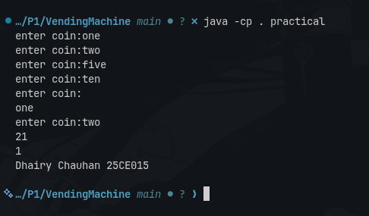  P-1.1.png

Program 1.2: Toll Booth System
Description | 2. Toll booth (TollBooth.java, main in this file)  (a) Define a record Vehicle(String number, String type).  (b) In main, keep a running toll total and three counters (bike, car, truck).  (c) Loop until the user types “done” for the number: build a Vehicle, use a switch expression on its type for the toll (bike→20, car→50, truck→150), add to the total, and increment that type’s counter.  (d) After the loop, print the total toll and the type with the highest count.  Expected output: two cars + one bike → “Total toll: 120”, “Most frequent: car”.
Code | import java.util.Scanner;  enum VehicleType {  BIKE,  CAR,  TRUCK  }  record Vehicle(int number, VehicleType type) {}  class Practical {  public static void main(String[] args) {  Scanner sc = new Scanner(System.in);  int toll = 0, b = 0, c = 0, t = 0;  System.out.print("Enter vehicle type : ");  String input = sc.next().toUpperCase();  while (!input.equals("DONE")) {  VehicleType type = VehicleType.valueOf(input);  System.out.print("Enter vehicle number: ");  int number = sc.nextInt();  Vehicle v = new Vehicle(number, type);  switch (v.type()) {  case BIKE -> {  toll += 20;  b++;  }  case CAR -> {  toll += 50;  c++;  }  case TRUCK -> {  toll += 150;  t++;  }  }  System.out.print("Enter vehicle type: ");  input = sc.next().toUpperCase();  }  System.out.println("Total Toll = " + toll);  System.out.print("Most frequent:");  if(b>c)  {  if(b>t)  {  System.out.print("BIKE");  }  else  {  System.out.print("CAR");  }  }  else{  if(c>t)  {  System.out.print("CAR");  }  else  {  System.out.print("TRUCK");  }  }  System.out.println("Dhairy Chauhan 25CE015");  sc.close();  }  }
Output | 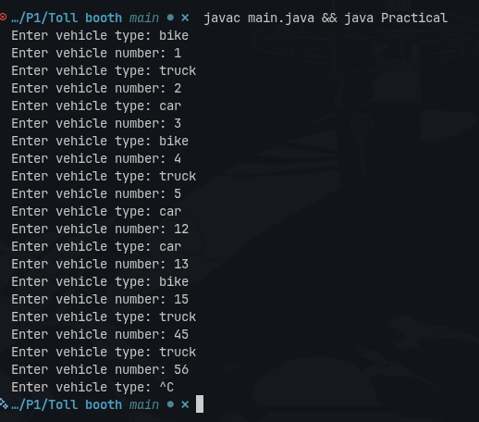  p-1.2.png

Program 1.3: Rock-Paper-Scissors, Lizard and Spock
Description | 3. (For Advanced Learners – home) Rock-Paper-Scissors-Lizard-Spock (RPSLS.java)  (a) Define an enum Move with ROCK, PAPER, SCISSORS, LIZARD, SPOCK.  (b) Write winner(Move a, Move b) returning 1 if a beats b, -1 if b beats a, 0 for a tie — use a switch expression listing what each move beats (Scissors cut Paper, Paper covers Rock, Rock crushes Lizard, Lizard poisons Spock, Spock smashes Scissors, and the five mirror cases).  (c) In main, play 5 rounds: pick a random computer Move, read the player’s Move, call winner(), print the round result and keep score.  (d) After 5 rounds, print the overall winner.  Expected output: each round prints both moves and the round winner; ends with a “You win 3–2” summary.
Code | import java.util.Scanner;  enum Move {  ROCK, PAPER, SCISSORS, LIZARD, SPOCK  }  record Winner(Move me, Move computer) {};  public class Main {  public static void main(String[] args) {  int k = 0;  int j = 0;  int Computer = 0;  int Me = 0;  Scanner sc = new Scanner(System.in);  System.out.println("Enter your move:");  String me = sc.next().toUpperCase();  System.out.println("Enter computer move:");  String computer = sc.next().toUpperCase();  Move me1 = Move.valueOf(me);  Move computer1 = Move.valueOf(computer);  Winner w = new Winner(me1, computer1);  while (k != 5) {  k++;  j = switch (w.me()) {  case ROCK ->  (w.computer() == Move.SCISSORS ||  w.computer() == Move.LIZARD) ? 1 : -1;  case PAPER ->  (w.computer() == Move.ROCK ||  w.computer() == Move.SPOCK) ? 1 : -1;  case SCISSORS ->  (w.computer() == Move.PAPER ||  w.computer() == Move.LIZARD) ? 1 : -1;  case LIZARD ->  (w.computer() == Move.PAPER ||  w.computer() == Move.SPOCK) ? 1 : -1;  case SPOCK ->  (w.computer() == Move.ROCK ||  w.computer() == Move.SCISSORS) ? 1 : -1;  };  if (j == (-1)) {  Computer++;  System.out.println("me move:" + Computer);  System.out.println("computer move:" + Me);  System.out.println("computer win");  }  if (j == 1) {  Me++;  System.out.println("me move:" + Computer);  System.out.println("computer move:" + Me);  System.out.println("me win");  }  if (Me == Computer) {  System.out.println(" Tie ");  }  System.out.println("Enter your move:");  me = sc.next().toUpperCase();  System.out.println("Enter computer move:");  computer = sc.next().toUpperCase();  me1 = Move.valueOf(me);  computer1 = Move.valueOf(computer);  w = new Winner(me1, computer1);  if (Computer > Me) {  System.out.println("computer win " + Computer + " - " + Me);  }  if (Me > Computer) {  System.out.println("you win " + Me + " - " + Computer);  }  }  System.out.println("Dhairy Chauhan 25CE015");  sc.close();  }  }
Output | 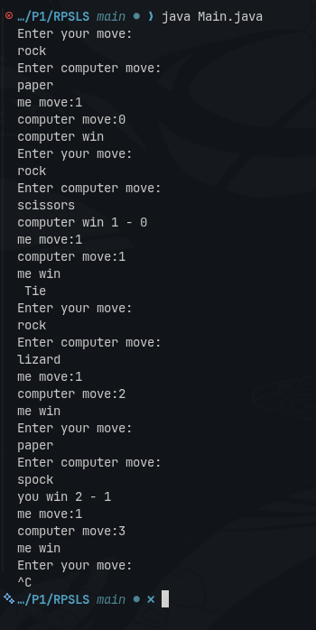  P-1.3.png

Practical 2: Constructors, Constructor Chaining and Static Members
Description | 1. Smart thermostat (Thermostat.java, main in this file)  (a) Create class Thermostat with private String location, private int temperature, private static final int MIN=16 and MAX=30, and private static int activeCount=0.  (b) Constructor(location, startTemp): store location; set temperature to startTemp if it is within MIN..MAX else 22; increment activeCount.  (c) Constructor(location): chain with this(location, 22).  (d) raise(): if temperature < MAX add 1, else print “Already at maximum (30)”.  (e) lower(): if temperature > MIN subtract 1, else print “Already at minimum (16)”.  (f) Add getTemperature() (no setter) and static getActiveCount().  (g) In main: create two thermostats, call raise() 10 times then lower() 20 times in loops (printing the temperature each time), then print getActiveCount().  Expected output: temperature rises to 30 then “Already at maximum”, falls to 16 then “Already at minimum”, count 2.
Code | import java.util.Scanner;  class Thermostat {  private String location;  private int temperature;  private static final int MIN = 16;  private static final int MAX = 30;  private static int activeCount = 0;  Thermostat(String location, int startTemp) {  this.location = location;  if (startTemp >= MIN && startTemp <= MAX) {  this.temperature = startTemp;  } else {  this.temperature = 22;  }  activeCount++;  }  Thermostat(String location) {  this(location, 22);  }  void raise() {  if (temperature < MAX) {  temperature++;  } else {  System.out.println("Already at max with 30");  }  }  void lower() {  if (temperature > MIN) {  temperature--;  } else {  System.out.println("Already at min with 16");  }  }  int getTemperature() {  return temperature;  }  static int getActiveCount() {  return activeCount;  }  }  public class Main {  public static void main(String args[]) {  Scanner sc = new Scanner(System.in);  Thermostat t1 = new Thermostat(null, 0);  for (int i = 0; i <= 10; i++) {  t1.raise();  System.out.println("temperature: " + t1.getTemperature());  System.out.println("");  if (t1.getTemperature() == 30) {  break;  }  }  for (int i = 0; i <= 20; i++) {  t1.lower();  System.out.println("temperature: " + t1.getTemperature());  System.out.println("");  if (t1.getTemperature() == 16) {  break;  }  }  System.out.println("All the active counts: " + Thermostat.getActiveCount());  System.out.priintln("Dhairy Chauhan 25CE015");  sc.close();  }  }
Output | 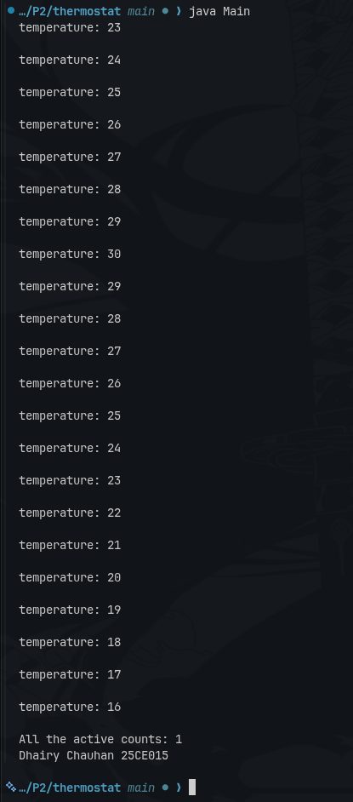  p-2.1.png

Program 2.2: Cinema Show Seat Booking
Description | 2. Cinema show (CinemaShow.java, main in this file)  (a) Create class CinemaShow with private String title, private int seatsAvailable, private final int capacity, and private static int totalBooked=0.  (b) Constructor(title, capacity): set both and seatsAvailable = capacity. Constructor(title): chain with this(title, 100).  (c) book(int n): if n ≤ seatsAvailable, reduce seatsAvailable by n, add n to totalBooked, return true; else return false unchanged.  (d) cancel(int n): increase seatsAvailable by n but never above capacity.  (e) Add getSeatsAvailable() and static getTotalBooked().  (f) In main: run a sequence of book and cancel calls, printing the result and seats after each, then print getTotalBooked().  Expected output: booking more than available prints false and leaves seats unchanged; totalBooked equals the successful bookings.
Code | class CinemaShow {  String title;  private int SeatsAvailable;  private final int capacity;  private static int totalBooked = 0;  CinemaShow(String title, int capacity) {  this.capacity = capacity;  this.title = title;  this.SeatsAvailable = capacity;  }  CinemaShow(String title) {  this(title, 100);  }  int book(int n) {  if (n <= 0) {  return 0;  }  if (n <= SeatsAvailable) {  SeatsAvailable = SeatsAvailable - n;  totalBooked = totalBooked + n;  return 1;  } else {  return 0;  }  }  int cancel(int n) {  if (n <= 0) {  return SeatsAvailable;  }  if (n <= capacity - SeatsAvailable) {  SeatsAvailable = SeatsAvailable + n;  totalBooked = totalBooked - n;  return SeatsAvailable;  } else {  return SeatsAvailable;  }  }  int gsa() {  return SeatsAvailable;  }  static int gtb() {  return totalBooked;  }  }  public class Main {  public static void main(String[] args) {  CinemaShow cs = new CinemaShow("spiderman : brand new day", 100);  cs.book(76);  System.out.println("seats:" + cs.title + " " + cs.gsa());  System.out.println("total seat: " + CinemaShow.gtb());  cs.cancel(25);  System.out.println("total seats available" + cs.title + ""+cs.gsa());  System.out.println("Dhairy Chauhan 25CE015");  }  }
Output | 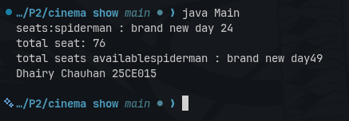  p-2.2.png

Program 2.3: Parking Lot
Description | 3. (For Advanced Learners – home) Parking lot (ParkingLot.java)  (a) Create class ParkingLot with private int twoWheelers and fourWheelers, private final int twoCap and fourCap, and private static long revenue=0.  (b) park(String type): for “two”, if twoWheelers < twoCap increment and add 20 to revenue; for “four”, if fourWheelers < fourCap increment and add 40; otherwise print “Full” and reject.  (c) leave(String type): decrement the matching count but never below 0.  (d) In main: simulate a sequence of park/leave events, printing each outcome, then print final occupancy and revenue.  Expected output: parking into a full section is refused; revenue = 20×(two parked) + 40×(four parked).
Code | parkinglot.java  import java.util.Scanner;  class parkinglot  {  private int twowheelers = 0;  private int fourwheelers = 0;  private final int twocap = 30;  private final int fourcap = 30;  private static int revenue = 0;  void park(String type)  {  if(type.equals("two"))  {  if(twowheelers < twocap)  {  twowheelers++;  }  else  {  System.out.println("Full");  }  }  if(type.equals("four"))  {  if(fourwheelers < fourcap)  {  fourwheelers++;  }  else  {  System.out.println("Full");  }  }  }  void leave(String type)  {  // If user enters "-", no vehicle leaves  if(type.equals("-"))  {  return;  }  if(type.equals("two"))  {  if(twowheelers > 0)  {  twowheelers--;  }  else  {  System.out.println("No two wheeler available");  }  }  if(type.equals("four"))  {  if(fourwheelers > 0)  {  fourwheelers--;  }  else  {  System.out.println("No four wheeler available");  }  }  }  void returnvalue()  {  System.out.println(20 * twowheelers + 40 * fourwheelers);  }  public static void main(String[] args)  {  parkinglot p = new parkinglot();  Scanner sc = new Scanner(System.in);  for(int i = 0; i < 5; i++)  {  System.out.print("enter type for parking: ");  String input = sc.next();  p.park(input);  }  for(int i = 0; i < 5; i++)  {  System.out.print("enter type for leave: ");  String input = sc.next();  p.leave(input);  }  p.returnvalue();  System.out.print("25CE047 - JAIMIN KHAMBHALIYA");  }  }
Output | 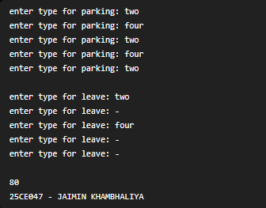  p-2.3.png

Practical 3: Object Equality: equals, hashCode and toString
Description | 1. Distinct points (Point.java + Driver.java with main)  (a) Create class Point with private int x, y and a constructor.  (b) Override toString() to return “(x, y)”.  (c) Override equals(Object) to be true when both x and y match, and hashCode() to agree (e.g. Objects.hash(x, y)).  (d) In Driver.main: build a Point[] with some repeated coordinates.  (e) Count distinct points: for each point, use equals() to check whether it already appeared earlier; count those that did not.  (f) Print “Distinct: N”.  Expected output: 5 points with 2 repeats → “Distinct: 3”.
Code | Point.java  import java.util.Objects;  class Point  {  private int x;  private int y;  Point(int x, int y)  {  this.x = x;  this.y = y;  }  public String toString()  {  return "(" + x + ", " + y + ")";  }  public boolean equals(Object obj)  {  if (this == obj)  return true;  if (!(obj instanceof Point))  return false;  Point p = (Point) obj;  return x == p.x && y == p.y;  }  public int hashCode()  {  return Objects.hash(x, y);  }  }  Driver.java  public class Driver  {  public static void main(String[] args)  {  Point[] points =  {  new Point(1, 2),  new Point(3, 4),  new Point(1, 2),  new Point(5, 6),  new Point(3, 4)  };  int distinct = 0;  for (int i = 0; i < points.length; i++)  {  boolean found = false;  for (int j = 0; j < i; j++)  {  if (points[i].equals(points[j]))  {  found = true;  break;  }  }  if (!found)  {  distinct++;  }  }  System.out.println("Distinct: " + distinct);  System.out.println("Dhairy Chauhan 25CE015");  }  }
Output | 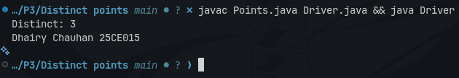  p-3.1.png

Program 3.2: Duplicate Card Detection
Description | 2. Duplicate card check (Card.java + Driver.java)  (a) Create class Card with private String rank, suit and a constructor.  (b) Override toString() to return rank + “ of ” + suit (e.g. “Queen of Hearts”).  (c) Override equals()/hashCode() by rank + suit.  (d) In Driver.main: add cards to a Card[] one at a time; before adding each, use equals() to check it against the earlier cards.  (e) Print “Duplicate found: <card>” the first time a repeat appears.  Expected output: a second “Ace of Spades” → “Duplicate found: Ace of Spades”.
Code | Card.java  import java.util.Objects;  class Card  {  private String rank;  private String suit;  Card(String rank, String suit)  {  this.rank = rank;  this.suit = suit;  }  public String toString()  {  return rank + " of " + suit;  }  public boolean equals(Object obj)  {  if (this == obj)  return true;  if (!(obj instanceof Card))  return false;  Card c = (Card) obj;  return rank.equals(c.rank) && suit.equals(c.suit);  }  public int hashCode()  {  return Objects.hash(rank, suit);  }  }  Driver.java  public class Driver  {  public static void main(String[] args)  {  Card[] cards = new Card[5];  cards[0] = new Card("Ace", "Spades");  cards[1] = new Card("King", "Hearts");  cards[2] = new Card("Queen", "Clubs");  cards[3] = new Card("Ace", "Spades");  for (int i = 0; i < cards.length; i++)  {  for (int j = 0; j < i; j++)  {  if (cards[i].equals(cards[j]))  {  System.out.println("Duplicate found: " + cards[i]);  System.out.println("25CE047 - JAIMIN KHAMBHALIYA");  return;  }  }  }  System.out.println("No duplicate found");  System.out.println("Dhairy Chauhan 25CE015");  }  }
Output | 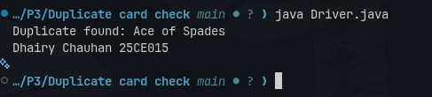  p-3.2.png

Program 3.3: Equality of Fractions
Description | 3. (For Advanced Learners – home) Fractions (Fraction.java + Driver.java)  (a) Create class Fraction with private int num, den.  (b) In the constructor, reduce to lowest terms: compute g = gcd(num, den) and divide both by g.  (c) Override toString() to return num + “/” + den.  (d) Override equals()/hashCode() using the reduced num and den.  (e) In Driver.main: create several equivalent fractions (1/2, 2/4, 3/6) and confirm they are all equal and print the same.  Expected output: new Fraction(2,4) prints “1/2” and equals new Fraction(1,2).
Code | Fraction.java  import java.util.Objects;  class Fraction  {  private int num;  private int den;  Fraction(int num, int den)  {  int g = gcd(num, den);  this.num = num / g;  this.den = den / g;  }  private int gcd(int a, int b)  {  a = Math.abs(a);  b = Math.abs(b);  while (b != 0)  {  int temp = b;  b = a % b;  a = temp;  }  return a;  }  public String toString()  {  return num + "/" + den;  }  public boolean equals(Object obj)  {  if (this == obj)  return true;  if (!(obj instanceof Fraction))  return false;  Fraction f = (Fraction) obj;  return num == f.num && den == f.den;  }  public int hashCode()  {  return Objects.hash(num, den);  }  }  Driver.java  public class Driver  {  public static void main(String[] args)  {  Fraction f1 = new Fraction(1, 2);  Fraction f2 = new Fraction(2, 4);  Fraction f3 = new Fraction(3, 6);  System.out.println("Fraction 1: " + f1);  System.out.println("Fraction 2: " + f2);  System.out.println("Fraction 3: " + f3);  System.out.println("f1 equals f2: " + f1.equals(f2));  System.out.println("f2 equals f3: " + f2.equals(f3));  System.out.println("f1 equals f3: " + f1.equals(f3));  System.out.println("Dhairy Chauhan 25CE015");  }  }
Output | 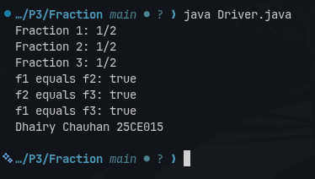  p-3.3.png

Practical 4: Strings and Regular Expressions
Description | 1. Password strength (PasswordChecker.java + Driver.java)  (a) In PasswordChecker, check four rules — length ≥ 8, contains an uppercase letter, contains a digit, contains a special character — using regex (e.g. “.*[A-Z].*”) or String methods.  (b) Write strength(String pw) that counts how many rules pass and returns “Weak” (0–1), “Medium” (2–3) or “Strong” (4).  (c) In Driver.main: test several passwords; for each, print which rules passed and the final label.  Expected output: “abc” → Weak; “Abcd1234!” → Strong.
Code | pass.java  import java.util.Scanner;  class pass {  static int strength(String pw) {  int l = pw.length();  int count = 0;  if (l >= 8) {  count++;  }  if (pw.matches(".*[A-Z].*")) {  count++;  }  if (pw.matches(".*[0-9].*")) {  count++;  }  if (pw.matches(".*[^a-zA-Z0-9].*")) {  count++;  }  System.out.println(count);  if (count == 1){  System.out.println("Weak");  }  else if ( count == 2 || count == 3){  System.out.println("Medium");  }  else if(count == 4){  System.out.println("Strong");  }  else{  System.out.println("Retry");  }  return count;  }  }  public class main {  public static void main(String args[]) {  Scanner sc = new Scanner(System.in);  System.out.println("Enter your password: ");  String password = sc.next();  pass.strength(password);  System.out.println("Dhairy Chauhan 25CE015");  sc.close();  }  }
Output | 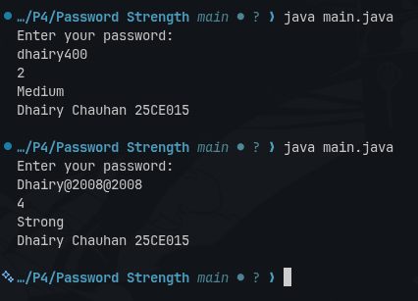  p-4.1.png

Program 4.2: Log Message Filter
Description | 2. Chat-log filter (ChatFilter.java + Driver.java)  (a) In Driver.main, define a String[] of log lines like “10:05 alice Hello there” (include one malformed line with fewer than 3 parts).  (b) Read a keyword from the user.  (c) For each line, split into time/user/message with split(“ ”, 3); skip lines that do not have 3 parts.  (d) If the message contains the keyword (case-insensitive), increment a counter and append “time user: message” to a StringBuilder.  (e) Print “Matches: N” and the built report.  Expected output: keyword “hello” over 3 lines (1 malformed) → “Matches: 1” and the matching line.
Code | chartfilter.java  public class chartfilter  {  public static String filter(String[] logs,String value)  {  StringBuilder report = new StringBuilder();  int count=0;  String lowervalue= value.toLowerCase();  for(String line : logs)  {  String parts[] = line.split(" ",3);  if(parts.length<3)  {  continue;  }  String time = parts[0];  String name = parts[1];  String message = parts[2];  if(message.toLowerCase().contains(lowervalue))  {  count++;  report.append(time)  .append(" ")  .append(name)  .append(":")  .append(message)  .append("\n");  }  }  return ("matches : " + count +"\n"+ report);  }  }  driver.java  import java.util.Scanner;  class driver  {  public static void main(String[] args)  {  String log[]={  "10:20 jaimin how are you?",  "2:00 hello abc",  "abcdefgh",  "5:20 hello world"  };  Scanner sc=new Scanner(System.in);  System.out.print("enter key :");  String key=sc.next();  String result = chartfilter.filter(log,key);  System.out.println(result);  System.out.print("Dhairy Chauhan 25CE015");  }  }
Output | 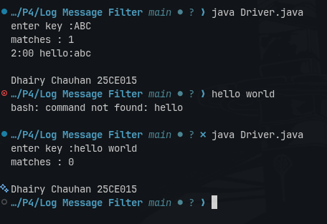  P-4.2.png

Program 4.3: Template Placeholder Filler
Description | 3. (For Advanced Learners – home) Template filler (TemplateFiller.java + Driver.java)  (a) In Driver.main, define a template like “Dear {name}, order {id} ships {date}.” and two parallel arrays: names {“name”, “id”} and values {“Riya”, “A07”} (note {date} is not supplied).  (b) Compile a Pattern for \{(\w+)\} and get a Matcher on the template.  (c) Walk the matches with a StringBuilder: for each {placeholder}, look up its value in the names array and replace with the value, or with “[?]” if not found.  (d) Print the filled template.  Expected output: the unsupplied {date} becomes [?].
Code | TemplateFiller.java  import java.util.regex.*;  class TemplateFiller  {  public static String fillTemplate(String template, String[] names, String[] values)  {  Pattern p = Pattern.compile("\\{(\\w+)\\}");  Matcher m = p.matcher(template);  StringBuffer result = new StringBuffer();  while (m.find())  {  String placeholder = m.group(1);  String value = "[?]";  for (int i = 0; i < names.length; i++)  {  if (names[i].equals(placeholder))  {  value = values[i];  break;  }  }  m.appendReplacement(result, value);  }  m.appendTail(result);  return result.toString();  }  }  Driver.java  class Driver  {  public static void main(String[] args)  {  String template = "Dear {name}, order {id} ships {date}.";  String[] names = {"name", "id"};  String[] values = {"Riya", "A07"};  String result = TemplateFiller.fillTemplate(template, names, values);  System.out.println(result);  System.out.println("25CE047 - JAIMIN KHAMBHAIYA");  }  }
Output | 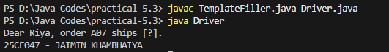  P-4.3.png

Practical 5: Abstract Classes
Description | 1. Shape areas: an abstract Shape with abstract area(); subclasses Circle, Rectangle, Triangle. Put a mix in a Shape[] and loop once to print each area and the running total, tracking the largest — one loop handling every shape through polymorphism.
Code | shape.java  abstract class Shape  {  abstract double area();  }  class Circle extends Shape {  double r;  Circle(double r) {  this.r = r;  }  double area() {  return 3.14 * r * r;  }  }  class Rectangle extends Shape {  double l, w;  Rectangle(double l, double w) {  this.l = l;  this.w = w;  }  double area()  {  return l * w;  }  }  class Triangle extends Shape {  double b, h;  Triangle(double b, double h)  {  this.b = b;  this.h = h;  }  double area()  {  return 0.5 * b * h;  }  }  class Main {  public static void main(String[] args)  {  Shape[] shapes =  {  new Circle(5),  new Rectangle(10, 4),  new Triangle(6, 8)  };  double total = 0;  double largest = 0;  for (Shape s : shapes)  {  double a = s.area();  System.out.println("Area = " + a);  total += a;  if (a > largest)  largest = a;  }  System.out.println("Total = " + total);  System.out.println("Largest = " + largest);  System.out.println("25CE071 - ANSH PATEL");  }  }
Output | 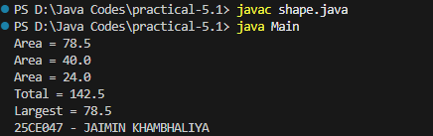  P-5.1.png

Program 5.2: Employee Payroll
Description | 2. Payroll: an abstract Employee with abstract monthlySalary(); FullTime (fixed), PartTime (hours × rate) and Intern (stipend), each calling super for the shared name/id. Loop a mixed array to print each salary and the total; use instanceof to add a note only for interns.
Code | payroll.java  abstract class Employee  {  abstract double monthlysalary();  }  class FullTime extends Employee  {  double monthlysalary()  {  return 50000;  }  }  class PartTime extends Employee  {  int h, r;  PartTime(int h, int r)  {  this.h = h;  this.r = r;  }  double monthlysalary()  {  return h * r;  }  }  class Intern extends Employee  {  int s;  Intern(int s)  {  this.s = s;  }  double monthlysalary()  {  return s;  }  }  class Main  {  public static void main(String[] args)  {  Employee[] employee =  {  new FullTime(),  new PartTime(2, 5),  new Intern(10000)  };  double total = 0;  double max = 0;  for(Employee e : employee)  {  double a = e.monthlysalary();  System.out.println("Salary: " + a);  total += a;  if(a > max)  {  max = a;  }  }  System.out.println("Total = " + total);  System.out.println("Max = " + max);  System.out.println("25CE047 - JAIMIN KHAMBHALIYA");  }  }
Output | 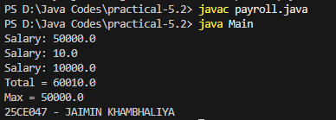  p-5.2.png

Program 5.3: Library Late Fee Calculation
Description | 3. (For Advanced Learners – home) Model a few media types that each compute a late fee differently and total the fees for a returned batch. Design the hierarchy and rules yourself.
Code | Driver.java  abstract class Media  {  String title;  int lateDays;  Media(String title, int lateDays)  {  this.title = title;  this.lateDays = lateDays;  }  abstract double calculateLateFee();  }  class Book extends Media  {  Book(String title, int lateDays)  {  super(title, lateDays);  }  double calculateLateFee()  {  return lateDays * 2;  }  }  class DVD extends Media  {  DVD(String title, int lateDays)  {  super(title, lateDays);  }  double calculateLateFee()  {  return lateDays * 5;  }  }  class Magazine extends Media  {  Magazine(String title, int lateDays)  {  super(title, lateDays);  }  double calculateLateFee()  {  return lateDays * 1;  }  }  public class Driver  {  public static void main(String[] args)  {  Media[] media = {  new Book("Java Book", 3),  new DVD("Avengers DVD", 2),  new Magazine("Tech Magazine", 4)  };  double total = 0;  for (Media m : media)  {  double fee = m.calculateLateFee();  System.out.println(m.title + " = Rs." + fee);  total = total + fee;  }  System.out.println("Total Late Fee = Rs." + total);  System.out.println("25CE047 - JAIMIN KHAMBHALIYA");  }  }
Output | 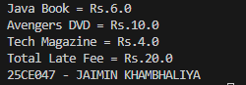  P-5.3.png

Practical 6: Interfaces, Lambda Expressions and Functional Interfaces
Description | 1. Remote control: an interface Switchable with on()/off() and a default toggle(); Fan and Light implement it. Loop over a Switchable[] toggling each. Then add a functional interface that decides, given a device and an hour, whether it may switch on, and supply it once as an anonymous class and once as a lambda.
Code | Driver.java  interface Switchable  {  void on();  void off();  default void toggle()  {  on();  }  }  class Fan implements Switchable  {  private boolean status = false;  public void on()  {  status = true;  System.out.println("Fan is ON");  }  public void off()  {  status = false;  System.out.println("Fan is OFF");  }  }  class Light implements Switchable  {  private boolean status = false;  public void on()  {  status = true;  System.out.println("Light is ON");  }  public void off()  {  status = false;  System.out.println("Light is OFF");  }  }  interface SwitchRule  {  boolean maySwitchOn(Switchable device, int hour);  }  public class Driver  {  public static void main(String[] args)  {  Switchable[] devices =  {  new Fan(),  new Light()  };  System.out.println("Toggling Devices:");  for (Switchable device : devices)  {  device.toggle();  }  SwitchRule rule1 = new SwitchRule()  {  public boolean maySwitchOn(Switchable device, int hour)  {  return hour >= 6 && hour <= 22;  }  };  SwitchRule rule2 = (device, hour) ->  {  return hour >= 8 && hour <= 20;  };  System.out.println("\nAnonymous Class:");  System.out.println("At 10:00: " +  rule1.maySwitchOn(devices[0], 10));  System.out.println("At 23:00: " +  rule1.maySwitchOn(devices[0], 23));  System.out.println("\nLambda:");  System.out.println("At 10:00: " +  rule2.maySwitchOn(devices[1], 10));  System.out.println("At 23:00: " +  rule2.maySwitchOn(devices[1], 23));  System.out.println("\n25CE047 - JAIMIN KHAMBHALIYA");  }  }
Output | 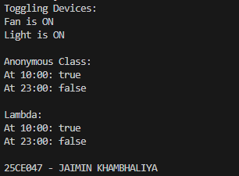  p-6.1.png

Program 6.2: Notification System
Description | 2. Notification senders: a functional interface Notifier with send(String); make email and SMS senders as lambdas, hold them in an array, and broadcast one message through all. Add a marker interface Urgent and send twice for senders marked urgent.
Code | Driver.java  interface Notifier  {  void send(String message);  }  interface Urgent  {  }  class EmailSender implements Notifier, Urgent  {  public void send(String message)  {  System.out.println("Email: " + message);  }  }  class SMSSender implements Notifier  {  public void send(String message)  {  System.out.println("SMS: " + message);  }  }  public class Driver  {  public static void main(String[] args)  {  Notifier email = (message) ->  {  System.out.println("Email: " + message);  };  Notifier sms = (message) ->  {  System.out.println("SMS: " + message);  };  Notifier[] senders =  {  email,  sms  };  String message = "Important notification";  System.out.println("Broadcast:");  for (Notifier sender : senders)  {  sender.send(message);  }  EmailSender urgentEmail = new EmailSender();  System.out.println("\nUrgent Notification:");  urgentEmail.send(message);  urgentEmail.send(message);  System.out.println("\n25CE047 - JAIMIN KHAMBHALIYA");  }  }
Output | 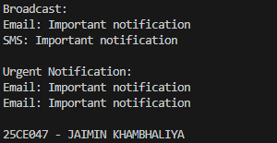  p-6.2.png

Program 6.3: Discount Rules
Description | 3. (For Advanced Learners – home) Build a small discount engine where each rule is a lambda the user picks at runtime and applies to a list of prices; organise it into packages and ship it as a runnable JAR.
Code | DiscountRule.java  package discount;  @FunctionalInterface  public interface DiscountRule  {  double apply(double price);  }  DiscountApp.java  package discount;  import java.util.Scanner;  public class DiscountApp  {  public static void main(String[] args)  {  Scanner sc = new Scanner(System.in);  double[] prices =  {  1000,  2000,  3000,  4000  };  System.out.println("Choose Discount Rule:");  System.out.println("1. 10% Discount");  System.out.println("2. 20% Discount");  System.out.println("3. No Discount");  System.out.print("Enter choice: ");  int choice = sc.nextInt();  DiscountRule rule;  if (choice == 1)  {  rule = price -> price - (price * 0.10);  }  else if (choice == 2)  {  rule = price -> price - (price * 0.20);  }  else  {  rule = price -> price;  }  System.out.println("\nPrices after discount:");  for (double price : prices)  {  System.out.println(price + " -> " + rule.apply(price));  }  System.out.println("\n25CE047 - JAIMIN KHAMBHALIYA");  sc.close();  }  }
Output | 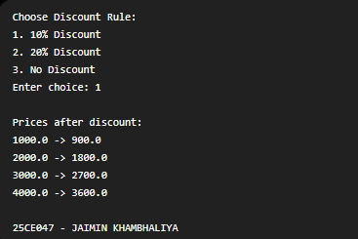  p-6.3.png

