Aim: Initiate the semester-long StudentHub portal by identifying the problem
scope, user roles, key modules, navigation flow, and minimum 10 pages.
Create a sitemap, low-fidelity wireframe, project folder structure,
README file, and GitHub repository.

Tools/Technology to be Used: VS Code, Draw.io/Figma, Git, GitHubvscode

Theory Logic: The StudentHub portal is planned by first identifying the requirements, users, and main features. A sitemap is created to show the navigation between pages. Low-fidelity wireframes are then prepared to show the basic layout and structure of each page before development. Git and GitHub are used to organize and manage the project. This helps create a clear and structured foundation before implementation.

Output: Wireframes
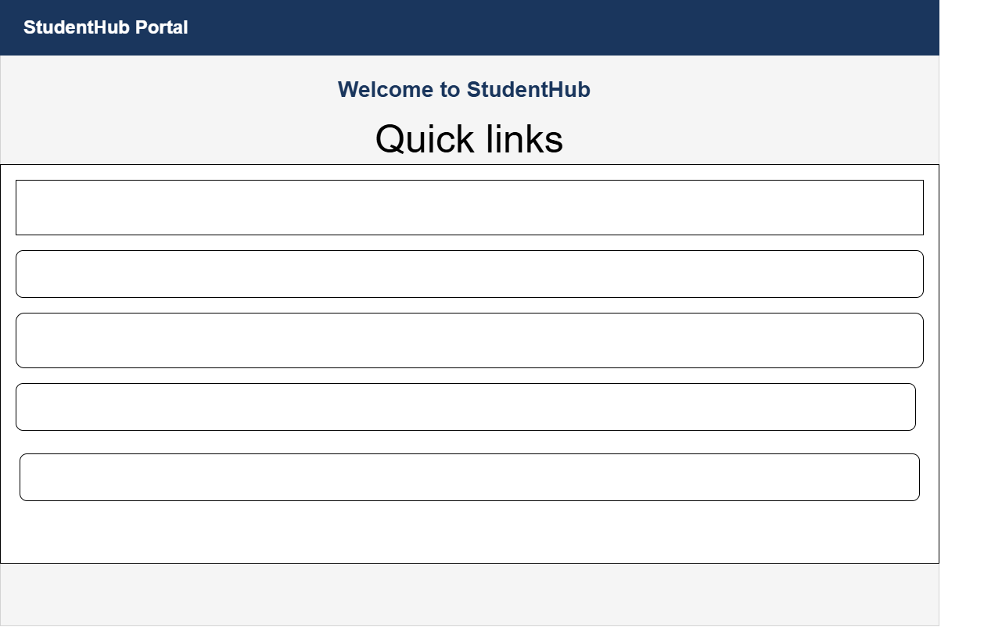
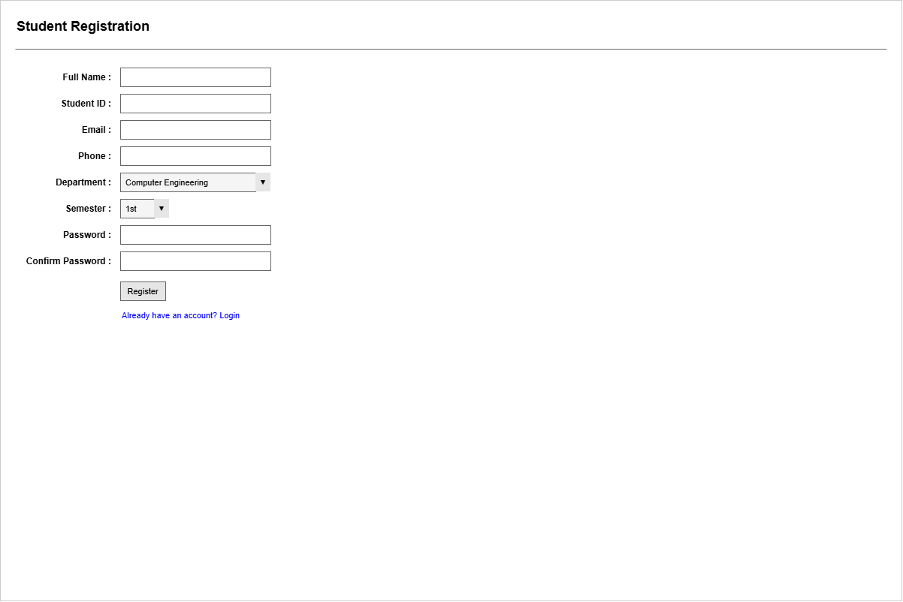
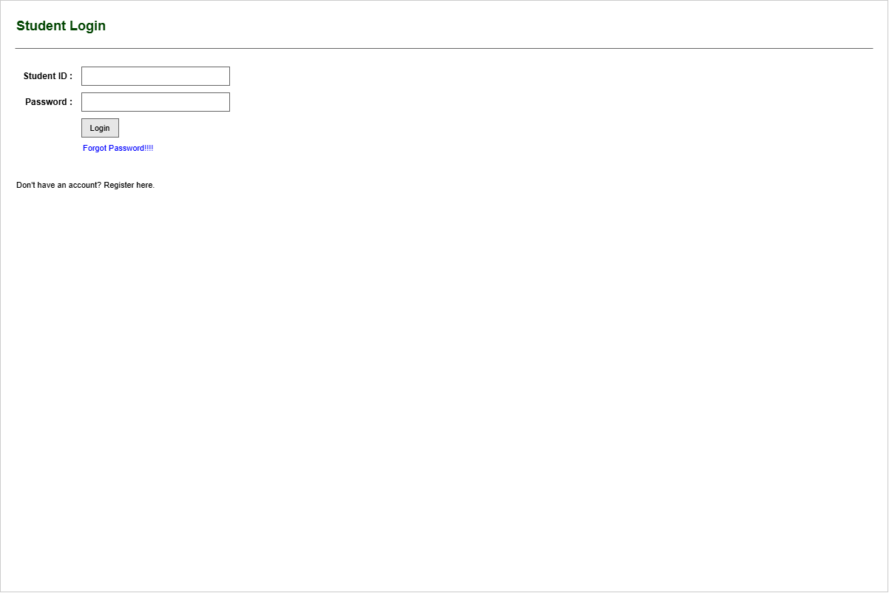
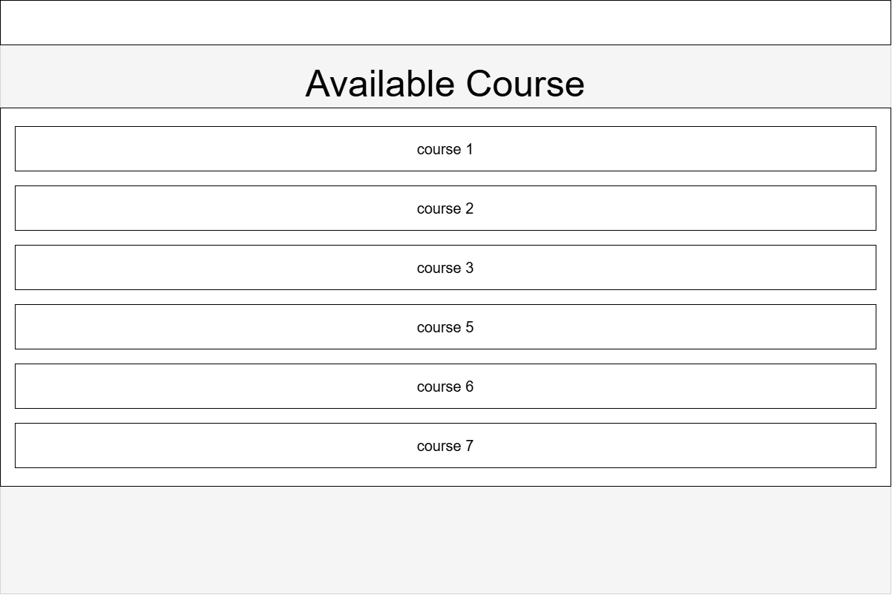
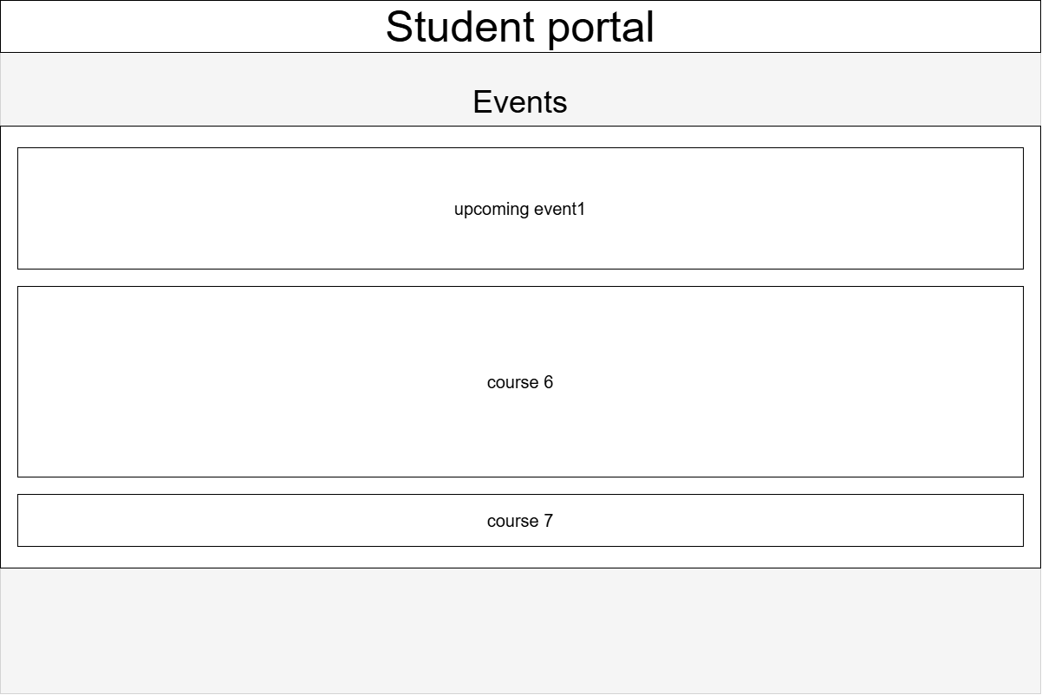
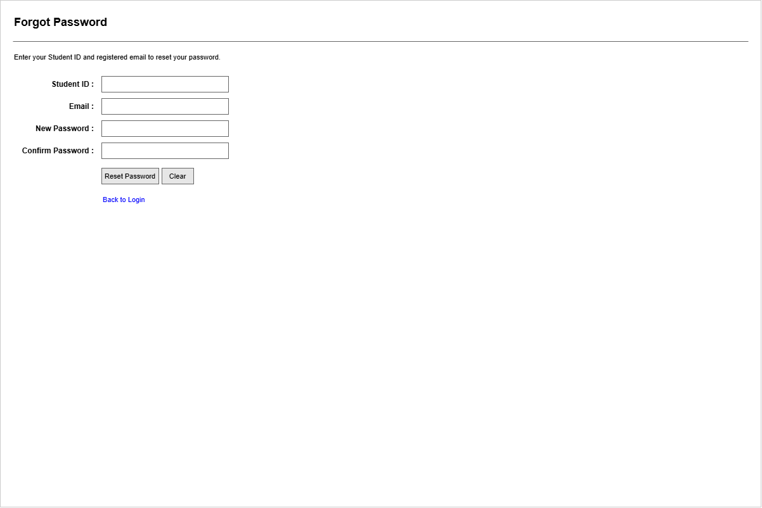
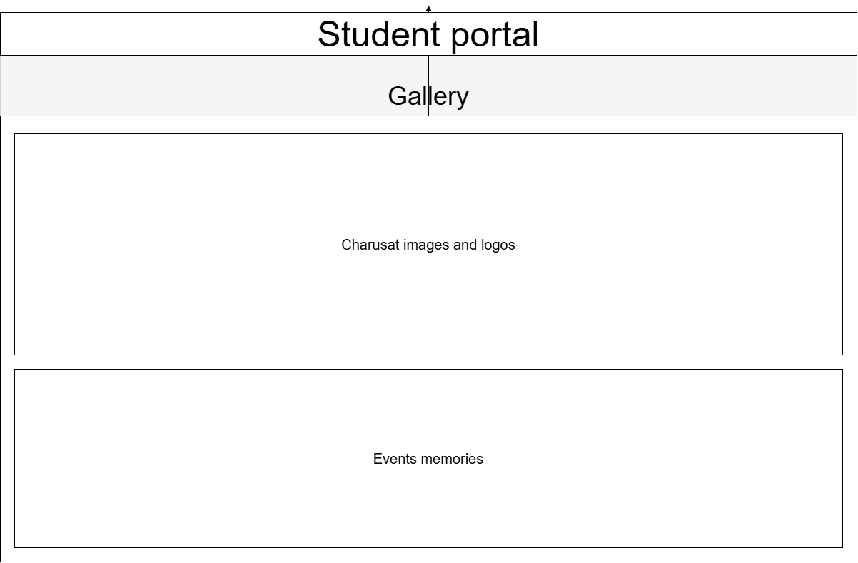
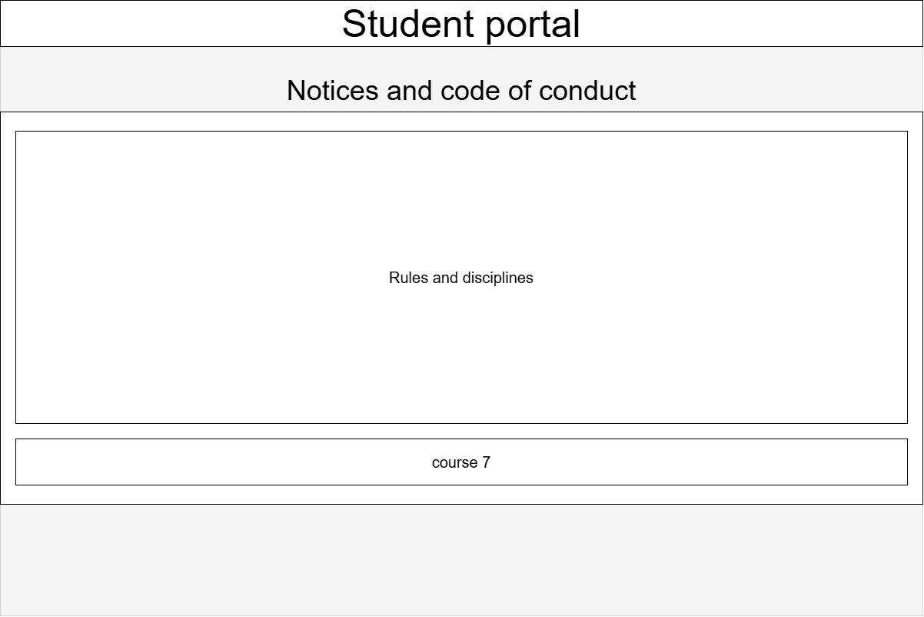
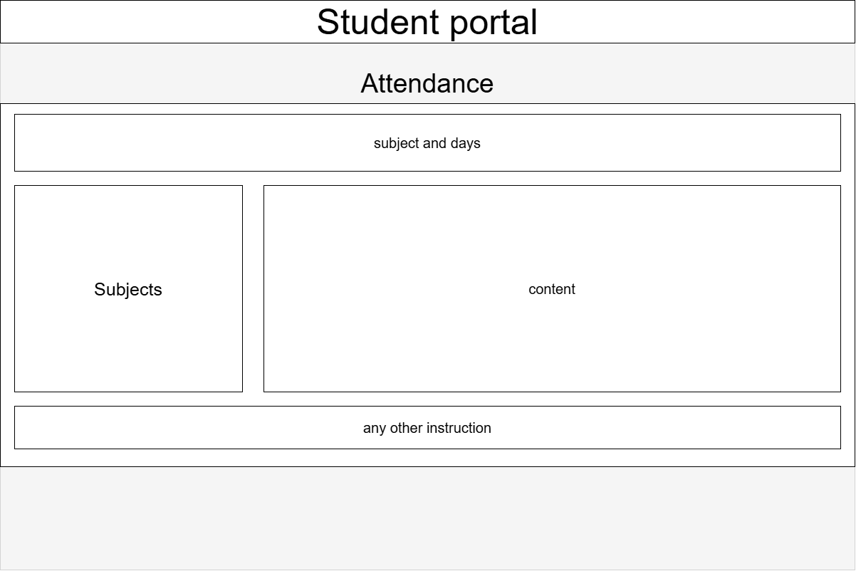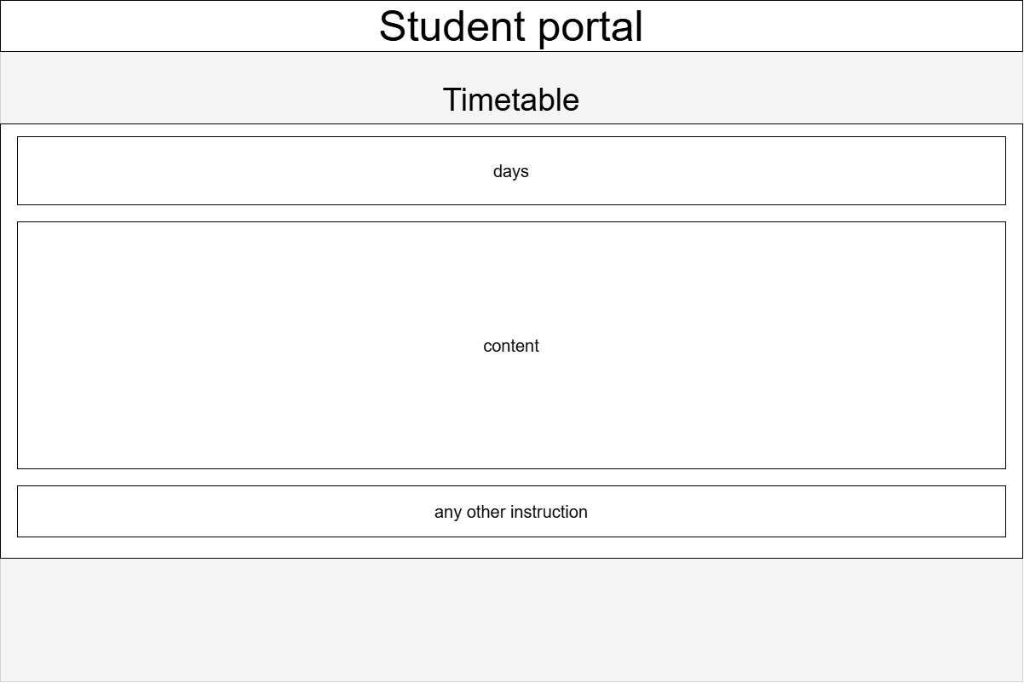

Question-Answer: 1. What is URL and parts of URL?
A URL (Uniform Resource Locator) is the address used to locate a resource on the Internet.
Main parts of a URL are:
- Protocol: https:// — defines how the browser communicates with the server.
- Domain: example.com — identifies the website.
- Path: /about — identifies a specific page or resource.
- Query: ?id=10 — sends additional information to the server.
- Fragment: #section1 — points to a specific section of a page.
Example: https://example.com/about?id=10#section1
2. How does HTML file process in a web browser?
When a user opens an HTML file, the browser reads the HTML code and creates a DOM (Document Object Model). It then processes CSS for styling and JavaScript for functionality. Finally, the browser renders the page on the screen for the user.
Flow:
HTML → DOM → CSS/JavaScript Processing → Rendering → Web Page
3. How will page navigation flow be managed among all HTML pages?
Page navigation is managed using HTML hyperlinks (<a> tags). Each link contains the path or URL of another HTML page. When the user clicks the link, the browser loads the requested page.
Example:
<a href="about.html">About</a>
This allows users to move between pages such as Home, About, Courses, Events, and Contact.
4. How will GitHub commits be maintained after each practical?
After completing each practical, the changes are saved using Git and uploaded to GitHub. A commit is created with a clear message describing the work completed.
Basic flow:
git add . → git commit -m "Practical 1 completed" → git push
This maintains a proper history of the project and helps track changes made after each practical.

Conclusion: I will be able to analyze requirements and prepare a structured
project foundation before implementation.

