Aim: Develop static HTML5 skeletons for at least 10 StudentHub pages such as
Home, About, Register, Login, Dashboard, Events, Profile, Contact,
Admin, FAQ, and Feedback. Use semantic tags and accessibility-friendly
structure.

Tools/Technology to be Used: VS Code, HTML5, browser accessibility inspection tools

Theory Logic: The main concept of this practical is to create the basic structure of the StudentHub portal using HTML5. Semantic HTML tags are used to organize content clearly, while hyperlinks connect different pages and provide easy navigation. Forms are used for user input such as registration, login, and password reset. Tables and lists are used to display information such as attendance, results, timetable, events, gallery, and notices. This practical focuses on creating clean, linked, and accessibility-friendly HTML page structures before adding advanced styling or functionality.

Code:
<!DOCTYPE html>
<html>
<head>
<title>StudentHub - Home</title>
<link rel="stylesheet" href="home.css">
</head>
<body>

<div class="header">
<h1>StudentHub Portal</h1>
</div>

<div class="main">
<div class="sidebar">
<h3>Quick Links</h3>
<a href="login.html">Login</a>
<a href="Register.html">Register</a>
<a href="forgot.html">Forgot Password</a>
<a href="about.html">About Us</a>
</div>

<div class="content">
<h2>Welcome to StudentHub</h2>
<p>This portal helps students access academic information, notices, attendance, results, and events.</p>

<div class="grid">
<a href="Courses.html"><div class="card"><h3>Courses</h3><p>View all courses</p></div></a>
<a href="Attendance.html"><div class="card"><h3>Attendance</h3><p>Check your attendance</p></div></a>
<a href="Results.html"><div class="card"><h3>Results</h3><p>See your results</p></div></a>
<a href="simpletimetable.html"><div class="card"><h3>Timetable</h3><p>Class schedule</p></div></a>
<a href="Notice.html"><div class="card"><h3>Notice</h3><p>Latest notices</p></div></a>
<a href="Events.html"><div class="card"><h3>Events</h3><p>Upcoming events</p></div></a>
<a href="Gallery.html"><div class="card"><h3>Gallery</h3><p>Photos and videos</p></div></a>
<a href="Profile.html"><div class="card"><h3>Profile</h3><p>Your profile</p></div></a>
</div>
</div>
</div>

<div class="footer">
<p>StudentHub Portal</p>
<p><a href="Contact.html">Contact Us</a> | <a href="about.html">About</a></p>
</div>

</body>
</html>
------------------------------------------------------------------------------------------------------HOME PAGE CODE
<!DOCTYPE html>
<html>
<head>
<title>StudentHub - Register</title>
</head>
<body>
<div>
<h1><u>Student Registration</u></h1>
<hr>
<form id="registerForm">
<table>
<tr>
<td><b>Full Name :</b></td>
<td><input type="text" id="fullName" size="30" required></td>
</tr>
<tr>
<td><b>Student ID :</b></td>
<td><input type="text" id="studentId" size="30" required></td>
</tr>
<tr>
<td><b>Email :</b></td>
<td><input type="email" id="email" size="30" required></td>
</tr>
<tr>
<td><b>Phone :</b></td>
<td><input type="text" id="phone" size="30" required></td>
</tr>
<tr>
<td><b>Department :</b></td>
<td>
<select id="department">
<option>Computer Engineering</option>
<option>Information Technology</option>
<option>Mechanical Engineering</option>
<option>Civil Engineering</option>
<option>Electrical Engineering</option>
</select>
</td>
</tr>
<tr>
<td><b>Semester :</b></td>
<td>
<select id="semester">
<option>1st</option>
<option>2nd</option>
<option>3rd</option>
<option>4th</option>
<option>5th</option>
<option>6th</option>
<option>7th</option>
<option>8th</option>
</select>
</td>
</tr>
<tr>
<td><b>Password :</b></td>
<td><input type="password" id="password" size="30" required></td>
</tr>
<tr>
<td><b>Confirm Password :</b></td>
<td><input type="password" id="confirm" size="30" required></td>
</tr>
<tr>
<td></td>
<td><input type="submit" value="Register"></td>
</tr>
<tr>
<td></td>
<td><a href="login.html">Already have an account? Login</a></td>
</tr>
</table>
</form>
</div>

<script src="auth.js"></script>
</body>
</html>

--------------------------------------------------------------------------------------------------REGISTER PAGE CODE
<!DOCTYPE html>
<html>
<head>
<title>StudentHub - Login</title>
</head>
<body>

<div style = " color: rgb(17, 97, 50)">
<h1><u>Student Login</u></h1>
<hr>
<form id="loginForm">
<table>
<tr>
<td><b>Student ID:</b></td>
<td><input type="text" id="studentId" size="25" ></td>
</tr>
<tr>
<td><b>Password :</b></td>
<td><input type="password" id="password" size="25" ></td>
</tr>
<tr>
<td></td>
<td><input type="submit" value="Login"></td>
</tr>
<tr>
<td></td>
<td><a href="forgot.html">Forgot Password!!!!</a></td>
</tr>
</table>
</form>
<br>
<p>Don't have an account? <a href="Register.html">Register here</a>.</p>
</div>
<script src="auth.js"></script>
</body>
</html>
-------------------------------------------------------------------------------------------------------LOGIN PAGE CODE

<!DOCTYPE html>
<html>
<head>
<title>StudentHub - Forgot Password</title>
</head>
<body>

<h1>Forgot Password</h1>
<hr>
<p>Enter your Student ID and registered email to reset your password.</p>
<br>
<form>
<b>Student ID :</b>
<br>
<input type="text" size="25" required>
<br><br>
<b>Email :</b>
<br>
<input type="email" size="25" required>
<br><br>
<b>New Password :</b>
<br>
<input type="password" size="25" required>
<br><br>
<b>Confirm Password :</b>
<br>
<input type="password" size="25" required>
<br><br>
<input type="submit" value="Reset Password"> <input type="reset" value="Clear">
<br><br>
<a href="login.html">Back to Login</a>
</form>

</body>
</html>

----------------------------------------------------------------------------------------------------FORGOT PAGE CODE
<!DOCTYPE html>
<html>
<head>
<title>StudentHub - Attendance</title>
</head>
<body>

<div class="container">
<h1><u>Attendance Record</u></h1>
<hr>
<table border="1">
<tr>
<th>Subject</th>
<th>Total</th>
<th>Present</th>
<th>Percentage</th>
</tr>
<tr><td>C Programming</td><td>40</td><td>38</td><td>95%</td></tr>
<tr><td>Java</td><td>35</td><td>32</td><td>91%</td></tr>
<tr><td>DSA</td><td>30</td><td>28</td><td>93%</td></tr>
<tr><td>CN</td><td>25</td><td>24</td><td>96%</td></tr>
</table>
<br>
<p><b>Overall Attendance : 94%</b></p>
</div>

</body>
</html>

-----------------------------------------------------------------------------------------------ATTENDACE PAGE CODE
<!DOCTYPE html>
<html>
<head>
<title>StudentHub - Results</title>
</head>
<body>

<div class="nav">
<a href="home.html">Home</a>
<a href="about.html">About</a>
<a href="Profile.html">Profile</a>
<a href="Courses.html">Courses</a>
<a href="simpletimetable.html">Timetable</a>
<a href="Attendance.html">Attendance</a>
<a href="Results.html">Results</a>
<a href="Notice.html">Notice</a>
<a href="Events.html">Events</a>
<a href="Gallery.html">Gallery</a>
<a href="Contact.html">Contact</a>
<a href="login.html">Login</a>
<a href="Register.html">Register</a>
<a href="forgot.html">Forgot Password</a>
</div>

<div class="container">
<h1><u>Semester Result</u></h1>
<hr>
<table border="1">
<tr>
<th>Subject</th>
<th>Grade</th>
</tr>
<tr><td>C Programming</td><td>A</td></tr>
<tr><td>Java</td><td>A+</td></tr>
<tr><td>DBMS</td><td>B+</td></tr>
<tr><td>Web Development</td><td>A</td></tr>
<tr><td>Mathematics</td><td>A</td></tr>
</table>
<br>
<p><b>CGPA : 7.73</b></p>
<p><b>Result Status : PASS</b></p>
</div>

</body>
</html>
-----------------------------------------------------------------------------------------------------RESULT PAGE CODE
<!DOCTYPE html>
<html lang="en">
<head>
<meta charset="UTF-8">
<meta name="viewport" content="width=device-width, initial-scale=1.0">
<title>Weekly Timetable</title>
<link rel="stylesheet" href="simpletimetable.css">
</head>
<body>
<h1>Weekly timetable</h1>
<div>
<table border="1">
<tr>
<th>Day</th>
<th>9:00 - 10:00</th>
<th>10:00 - 11:00</th>
<th>11:00 - 12:00</th>
<th>12:00 - 1:00<br><small>BREAK</small></th>
<th>1:00 - 2:00</th>
<th>2:00 - 3:00</th>
</tr>
<tr>
<td>Monday</td>
<td>DBMS</td>
<td>OS</td>
<td>WT</td>
<td rowspan="5"><b>BREAK</b></td>
<td>WDF</td>
<td>TOC</td>
</tr>
<tr>
<td>Tuesday</td>
<td>TOC</td>
<td>DSA</td>
<td>ML</td>
<td>WEB3</td>
<td>DBMS</td>
</tr>
<tr>
<td>Wednesday</td>
<td>OS</td>
<td>ML</td>
<td>WEB3</td>
<td>DSA</td>
<td>CN</td>
</tr>
<tr>
<td>Thursday</td>
<td>CN</td>
<td>DBMS</td>
<td>ML</td>
<td>AI</td>
<td>DSA</td>
</tr>
<tr>
<td>Friday</td>
<td>DSA</td>
<td>DBMS</td>
<td>WT</td>
<td>ML</td>
<td>DSA</td>
</tr>
</table>
</div>
</body>
</html>

------------------------------------------------------------------------------------------------TIMETABLE PAGE CODE
<!DOCTYPE html>
<html>
<head>
<title>StudentHub - Events</title>
</head>
<body>
div>

<div class="container">
<h1><u>Upcoming Events</u></h1>
<hr>

<h2>Coding Competition</h2>
<p><b>Date :</b> 12 August 2026</p>
<p><b>Venue :</b> Computer Lab</p>
<br>

<h2>Sports Day</h2>
<p><b>Date :</b> 20 August 2026</p>
<p><b>Venue :</b> College Ground</p>
</div>

</body>
</html>

-----------------------------------------------------------------------------------------------------EVENTS PAGE CODE
<!DOCTYPE html>
<html>
<head>
<title>StudentHub - Gallery</title>
</head>
<body>

<div class="container">
<h1><u>College Gallery</u></h1>
<hr>
<img src="https://encrypted-tbn0.gstatic.com/images?q=tbn:ANd9GcRnDemYwYY1Ai0jVZbRJd7rtrcuB5sIPK5F6Y3Em8g3cw&s=10">

<h2>Places in College</h2>
<ul>
<li>Campus</li>
<li>Computer Lab</li>
<li>Library</li>
<li>Sports Ground</li>
<li>Annual Function</li>
<li>Graduation Ceremony</li>
</ul>
</div>

</body>
</html>

---------------------------------------------------------------------------------------------------GALLERY PAGE CODE
<!DOCTYPE html>
<html>
<head>
<title>StudentHub - Notice</title>
</head>
<body>

<div class="container">
<h1><u>Latest Notices</u></h1>
<hr>
<ul>
<li>Semester Examination starts from 15 December 2026</li>
<li>College will remain closed on 25 December</li>
<li>Project submission deadline is 30 November</li>
<li>Industrial Visit registration is open.</li>
<li>Sports Week starts next Monday.</li>
</ul>
</div>

</body>
</html>
-----------------------------------------------------------------------------------------------------NOTICE PAGE CODE
Output: 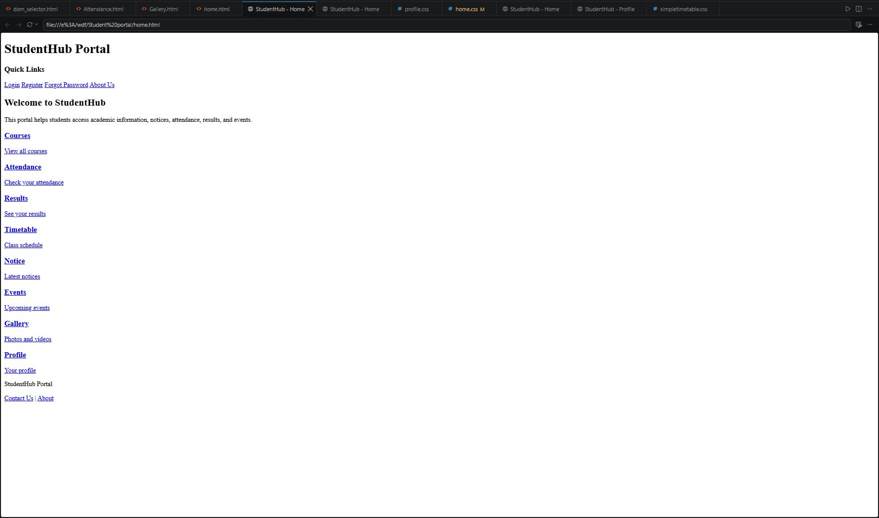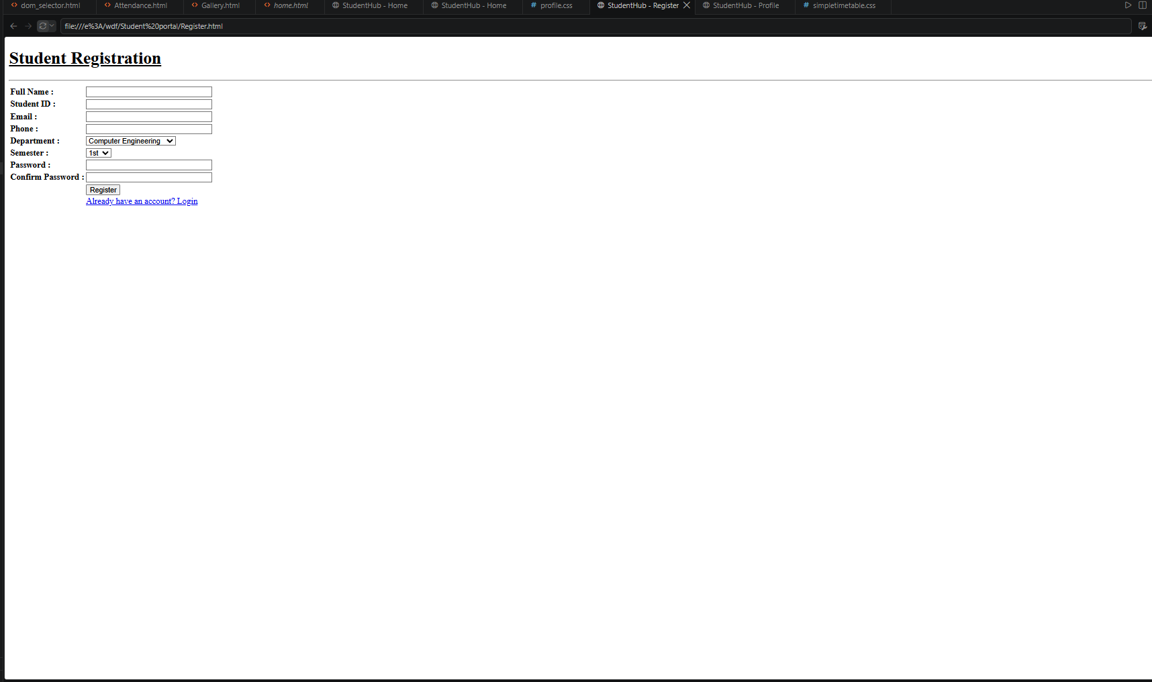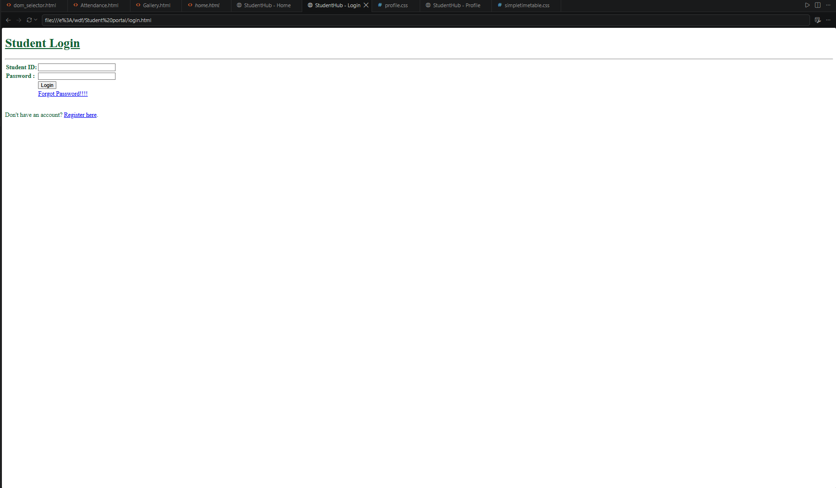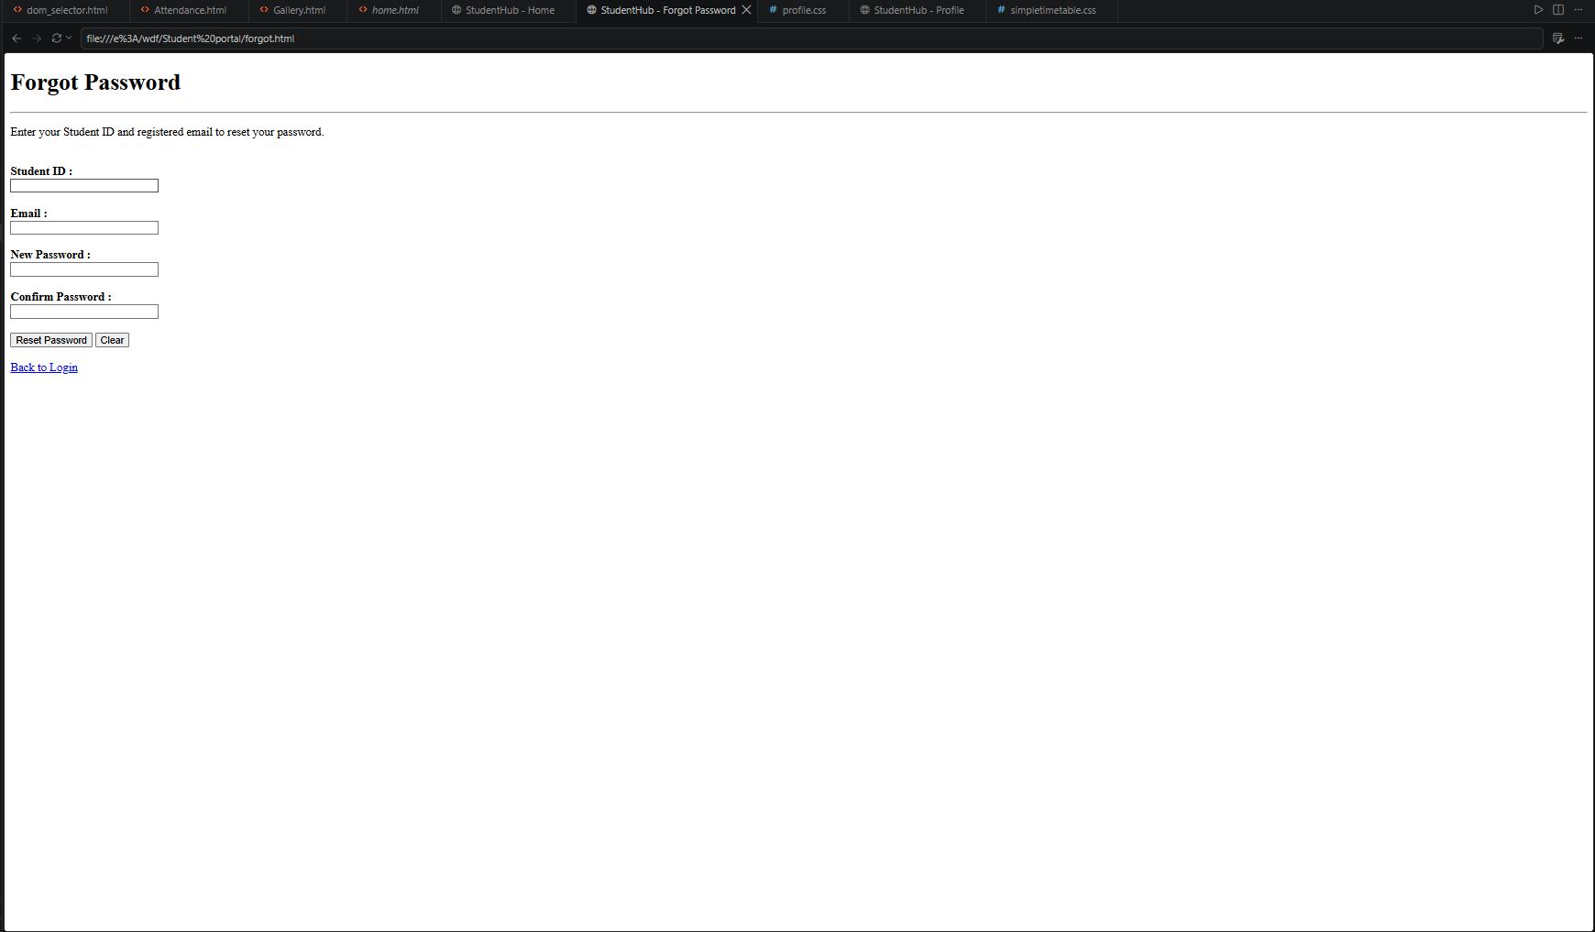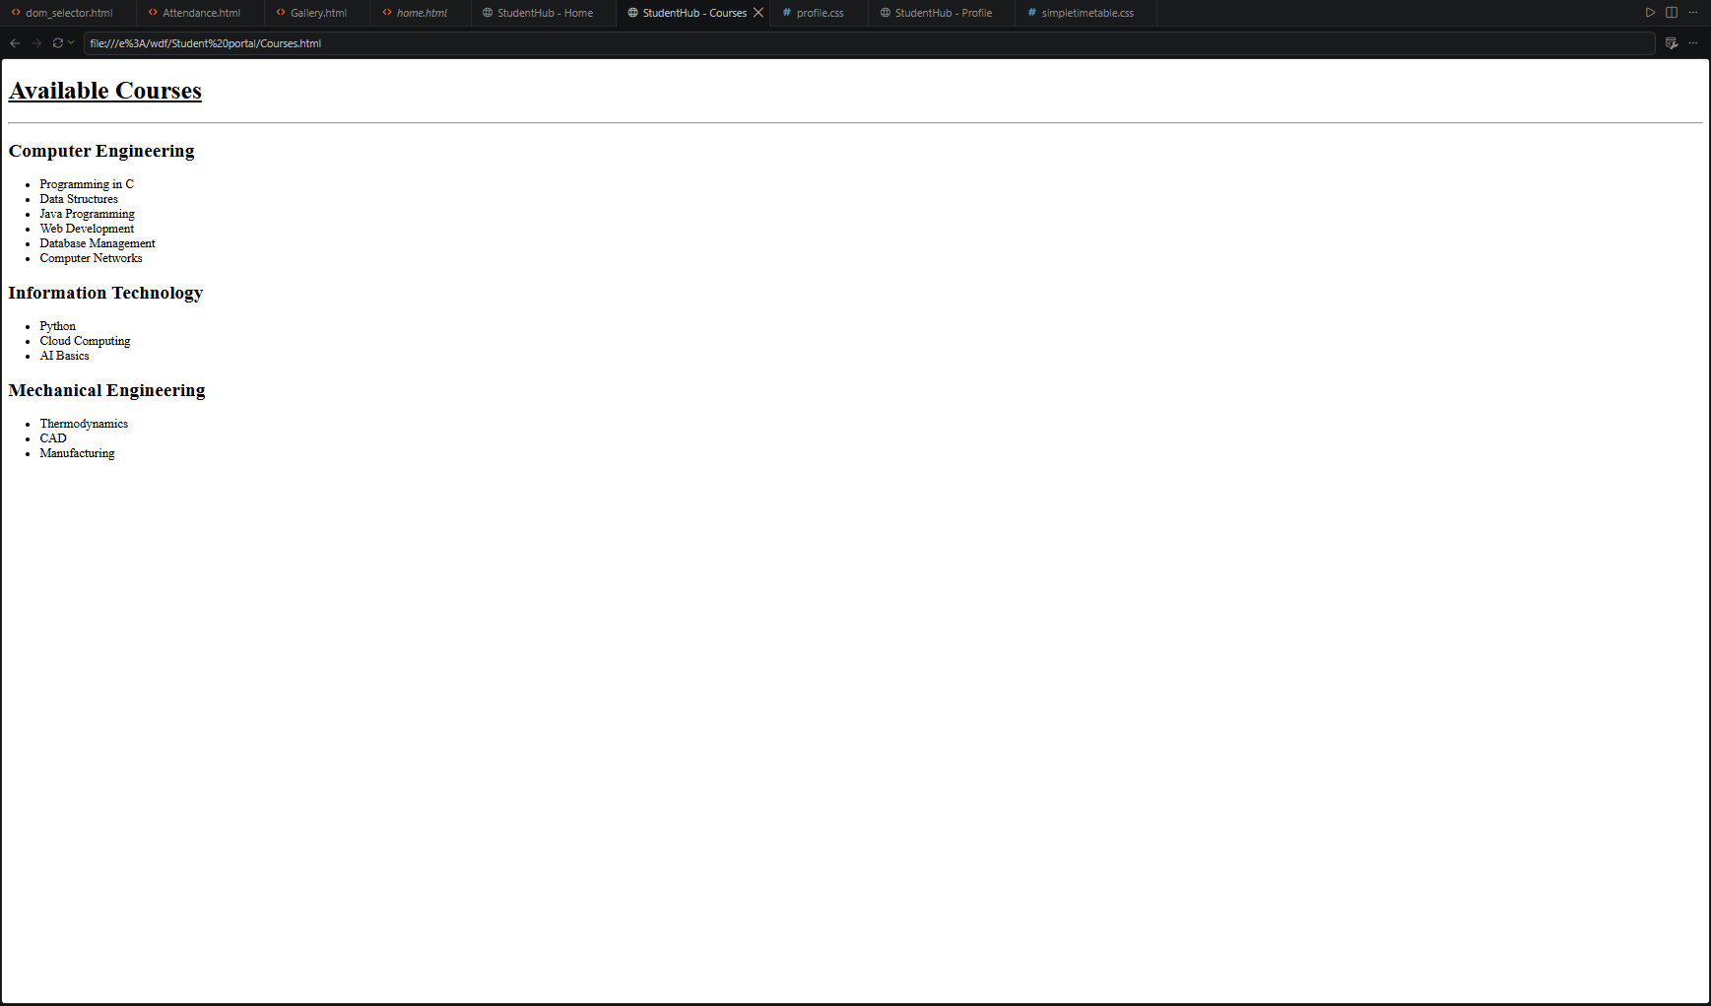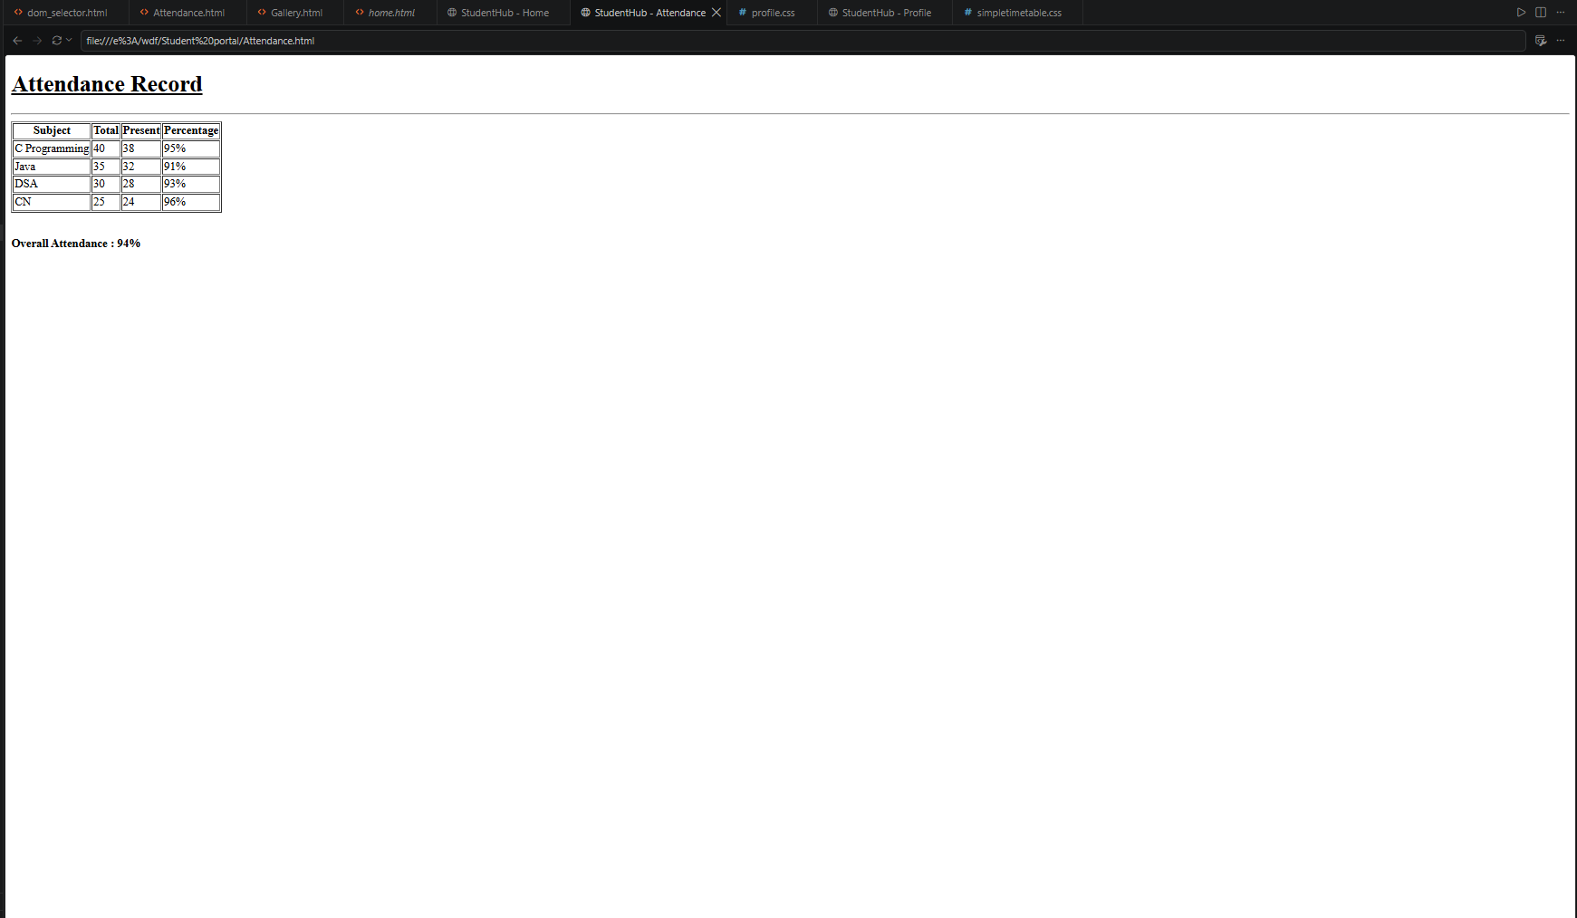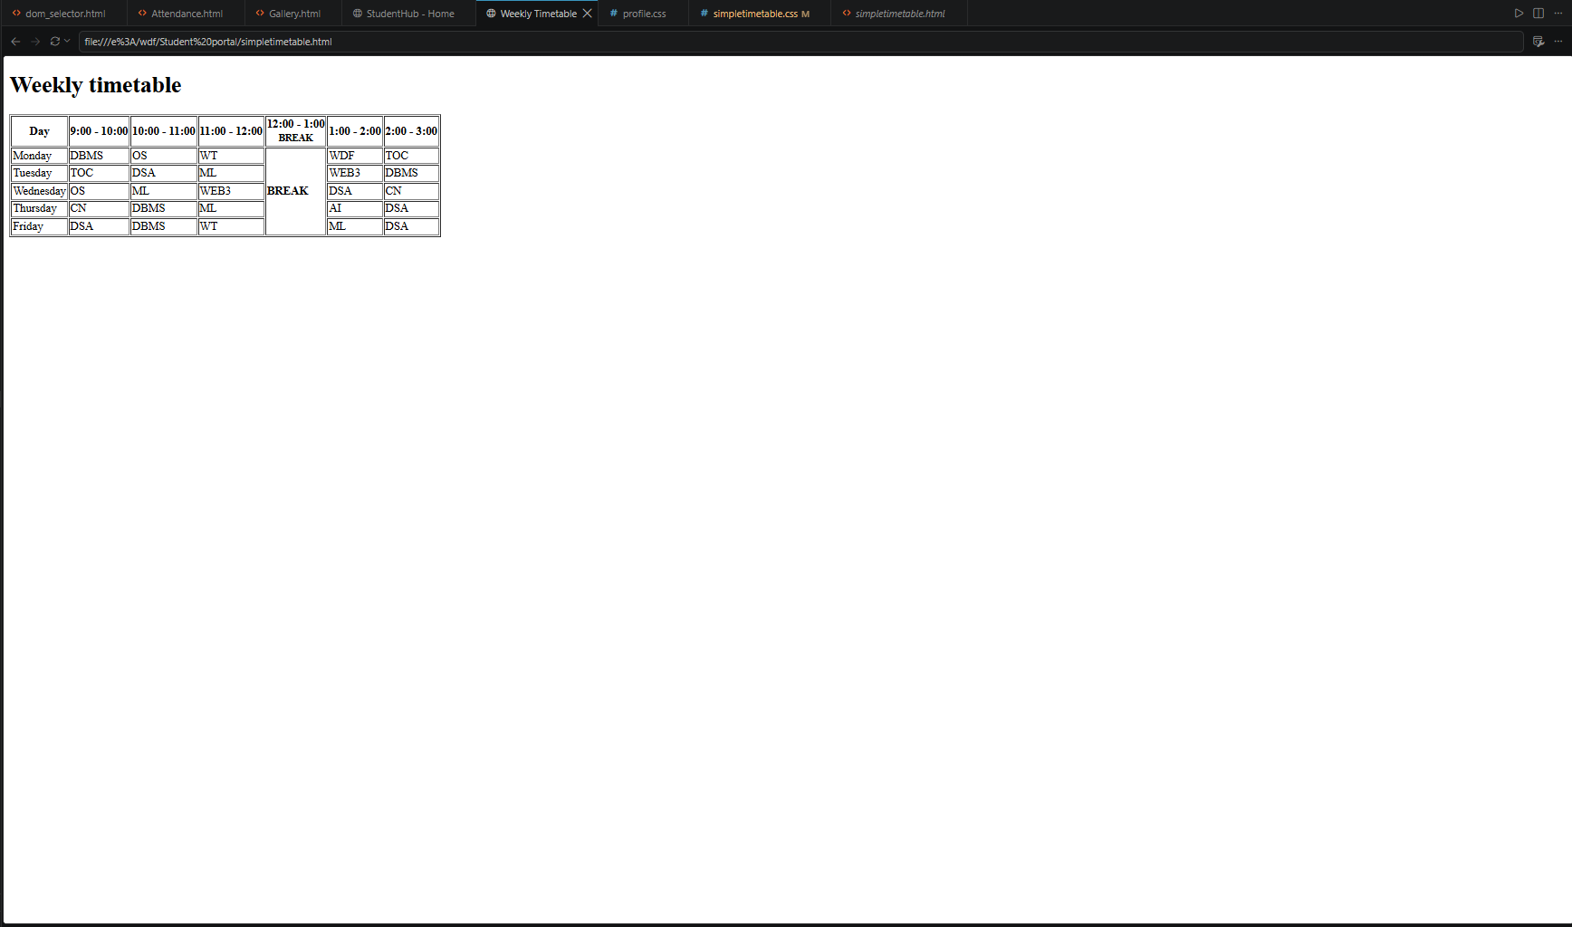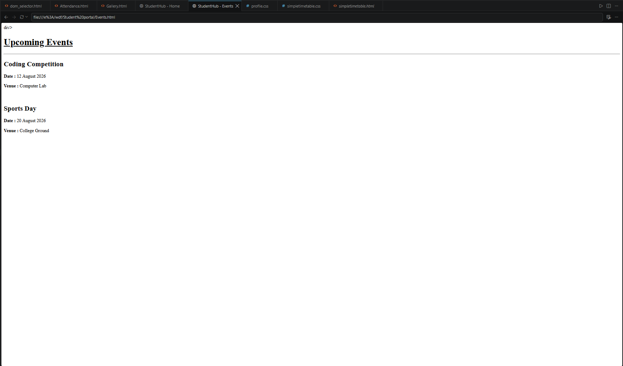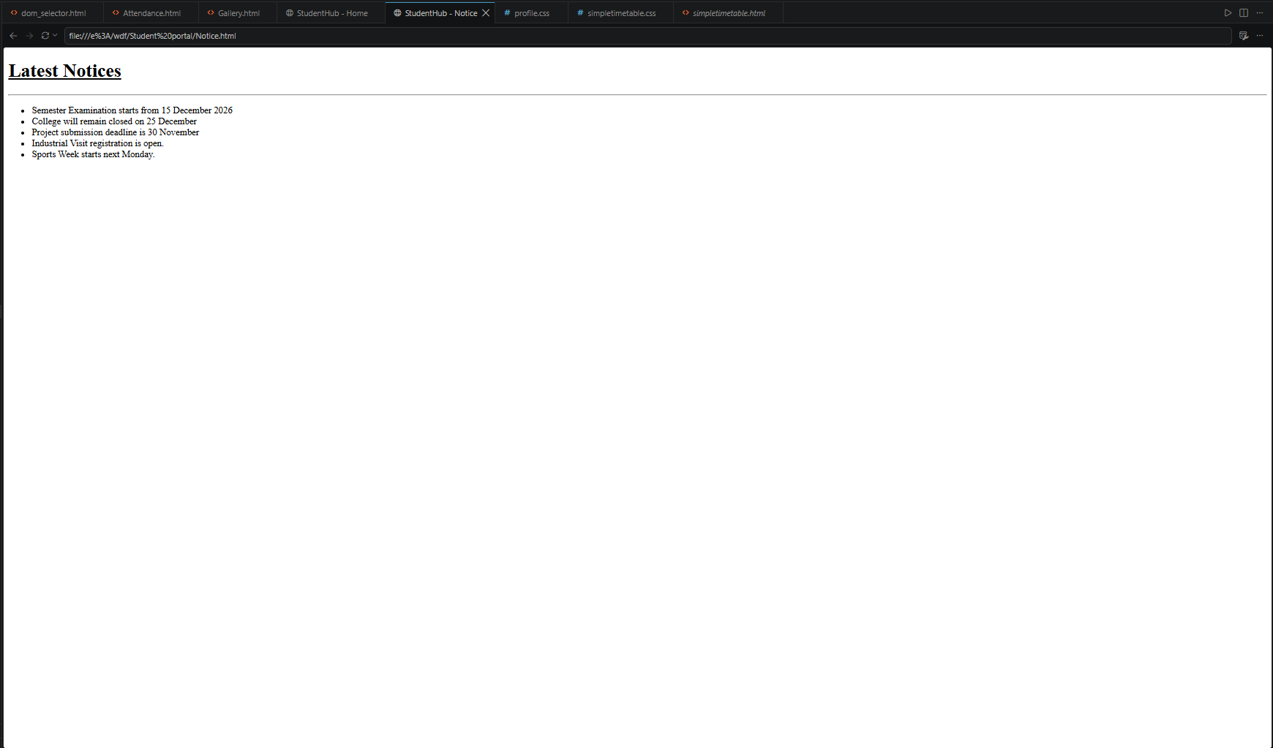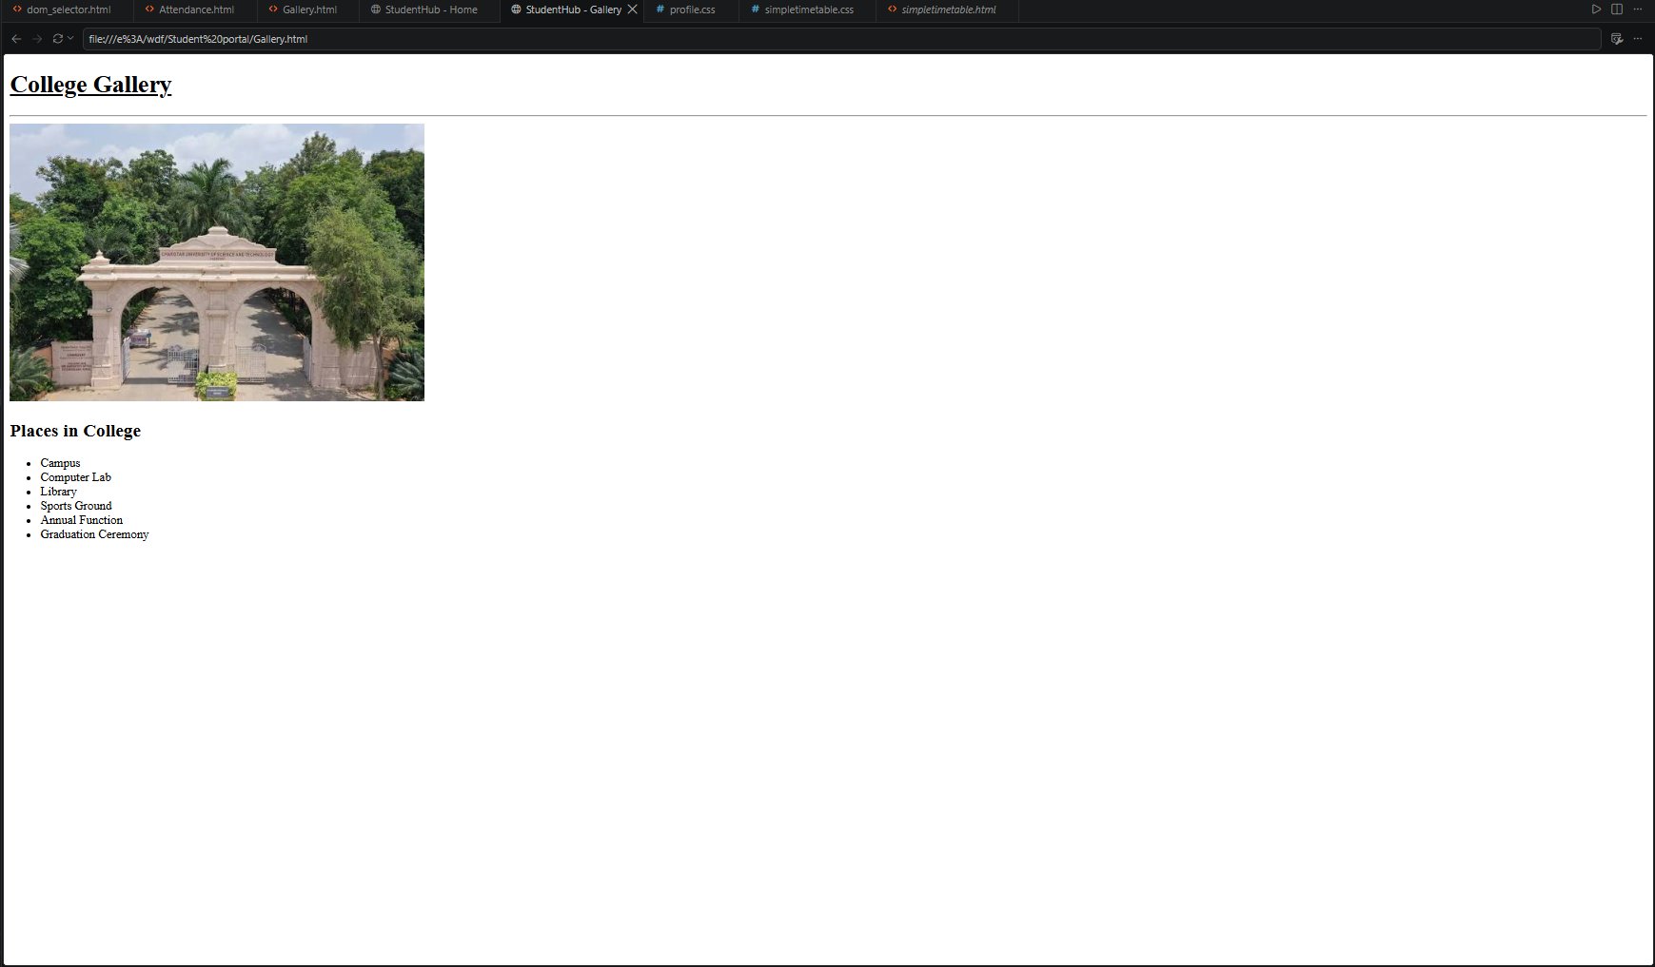

Question-Answer:
1. Are semantic tags such as header, nav, main, section, article, aside, and footer used properly?
Partially. The HTML uses structural elements such as headings, tables, forms, and links, but the provided pages mainly use <div> elements instead of consistently using semantic tags like <header>, <nav>, <main>, <section>, and <footer>.
2. Are form labels, headings, image alt text, and navigation links accessible?
Partially. Headings and navigation links are provided, and forms contain descriptive text for their fields. However, the form fields are not consistently connected to <label> elements, and the gallery image does not include an alt attribute.
3. Is the page structure consistent across all pages?
Yes, mostly. The pages follow a similar HTML structure with headings, content sections, and navigation links. However, some pages use different layouts and navigation structures, so further standardization would improve consistency.

Conclusion : I will create clean, linked, and accessibility-ready HTML page
structures.

