AI-Powered Credit Risk Intelligence Dashboard

Using Excel, Tableau & Generative AI
Submitted By:
Karan Singh Chauhan
Course:
BCA / MCA
Tools Used:
Microsoft Excel, Tableau, Generative AI

Project Objective
The objective of this project is to analyse customer credit risk and loan repayment behaviour using banking data. The project aims to identify high-risk customer profiles, understand financial patterns, analyse income and employment trends, and generate business recommendations using Artificial Intelligence (AI).
The project combines Excel, Tableau, and Generative AI to transform raw banking data into meaningful business intelligence for decision-making.

Dataset Information
The dataset used in this project is based on customer loan and credit behaviour from a banking environment. The dataset contains customer demographic, financial, employment, and loan-related information.
The raw dataset consists of:
- 307,511 rows
- 122 columns
For business analysis purposes, only the most relevant business variables were selected and transformed for analysis.

Data Preparation & Feature Engineering
During data preparation, anomalies were identified in employment duration data. Certain records contained unrealistic employment values (e.g., 1000+ years), which were identified as placeholder values for missing employment information. These were transformed into a business-friendly category (“No Employment”) to improve data quality and interpretation.

Data Cleaning & Transformation
To improve interpretability and business understanding, customer risk and income segmentation variables were created. Customers were categorized into High Risk and Low Risk groups based on repayment behaviour. Additionally, customers were segmented into income groups to enable financial profile analysis and risk comparison across economic categories.

Business Insight 1 — Customer Risk Distribution
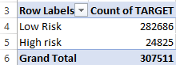
The customer portfolio analysis revealed that the majority of banking customers belonged to the Low-Risk category, while a relatively smaller portion represented High Risk customers.
Out of 307,511 customers, approximately:
- 282,686 customers (91.9%) were categorized as Low Risk
- 24,825 customers (8.1%) were categorized as High Risk
This indicates that the bank maintains a predominantly stable customer portfolio, while a smaller percentage of customers may require stricter credit monitoring and financial risk assessment.

Business Insight 2 — Financial Stability vs Default Risk
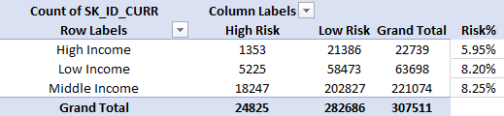
The analysis examined the relationship between customer income levels and loan repayment risk. A comparison of default risk percentages revealed meaningful differences across financial segments.
Customers in the Middle-Income category recorded the highest default risk (8.25%), closely followed by Low Income customers (8.20%). In contrast, High Income customers demonstrated significantly lower financial risk (5.95%), indicating stronger repayment stability.
This suggests that higher income levels may contribute to better financial resilience, while middle- and low-income borrowers may require stronger credit assessment and customized lending strategies.
The findings highlight the importance of income-based risk segmentation in banking decision-making.

Business Insight 3— Education & Repayment Reliability
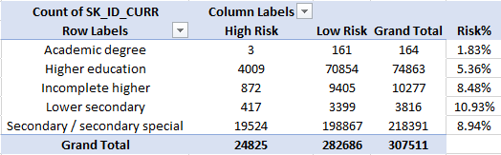
The analysis revealed a strong relationship between customer education level and loan repayment reliability. Customers with higher educational qualifications demonstrated significantly lower default risk, while lower educational categories showed comparatively higher financial vulnerability.

Customers with an Academic Degree recorded the lowest risk rate (1.83%), followed by customers with Higher Education (5.36%). In contrast, customers belonging to Lower Secondary education showed the highest default probability (10.93%), while Secondary / Secondary Special customers recorded a risk rate of 8.94%.
The findings suggest that education level may influence financial discipline, income stability, and repayment behavior, making it an important variable in customer credit risk assessment.
Banks may benefit from incorporating education-based customer profiling into lending strategies and financial risk evaluation models.
Business Insight 4 — Occupation-Based Credit Risk Analysis
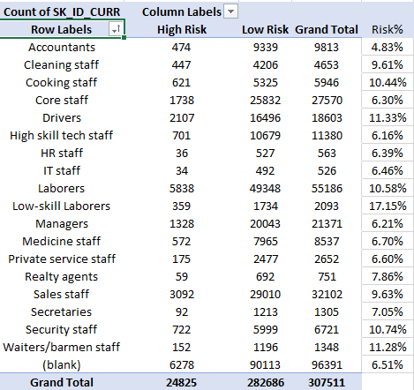
The analysis revealed significant differences in loan repayment risk across occupational categories, indicating that customer profession may strongly influence financial stability and repayment behaviour.
Customers working in low-skill occupations demonstrated the highest financial risk, with Low-Skill Laborers recording the highest default rate (17.15%), followed by Drivers (11.33%), Waiters/Barmen Staff (11.28%), and Security Staff (10.74%).
In contrast, customers employed in professional and managerial occupations showed comparatively lower financial risk. Accountants recorded the lowest default rate (4.83%), followed by High Skilled Tech Staff (6.16%) and Managers (6.21%).
The findings suggest that occupation type may serve as an important indicator of customer repayment reliability, enabling banks to improve credit assessment and develop more personalized lending strategies.

Business Insight 5 — Asset Ownership & Financial Stability
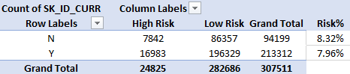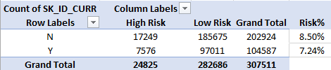
The analysis explored whether asset ownership influences customer financial stability and repayment behaviour. The findings revealed that customers owning financial assets demonstrated comparatively lower default risk.
Customers who owned property recorded a lower default probability (7.96%) compared to customers without property ownership (8.32%). Similarly, customers who owned a car showed a significantly lower risk rate (7.24%), while customers without a car recorded a higher default probability (8.50%).
These findings suggest that asset ownership may act as an indicator of financial security and repayment capability, making it a valuable factor in customer credit risk assessment.
The results indicate that banks may benefit from incorporating asset ownership indicators into loan approval and customer risk evaluation strategies.

Business Insight 6 — Employment Stability & Default Risk
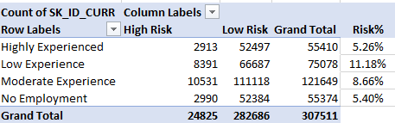
The analysis examined the relationship between employment stability and customer repayment behaviour. The findings revealed a strong relationship between work experience and financial risk.
Customers with Low Employment Experience recorded the highest default probability (11.18%), indicating greater financial instability and repayment vulnerability. In contrast, Highly Experienced customers demonstrated the lowest financial risk (5.26%), suggesting stronger repayment reliability and economic stability.
Interestingly, customers categorized under No Employment recorded a comparatively lower default rate (5.40%), which may indicate the presence of financially supported applicants such as homemakers, retirees, or dependent family members.
These findings suggest that employment stability plays an important role in customer creditworthiness, making it a valuable indicator in banking risk assessment and lending decisions.

Business Insight 7 — High-Risk Customer Persona Analysis
To better understand customer default behaviour, a persona-based analysis was conducted to identify the dominant characteristics of high-risk borrowers. Multiple demographic, financial, employment, and asset-based variables were analysed to develop a representative high-risk customer profile.

- Income Profile of High-Risk Customers
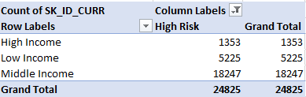
The analysis revealed that Middle Income customers formed the largest share of high-risk borrowers (18,247 customers), followed by Low Income customers (5,225 customers). This finding suggests that repayment risk is not limited to financially weaker groups and may also affect middle-income borrowers.

- Education Profile of High-Risk Customers
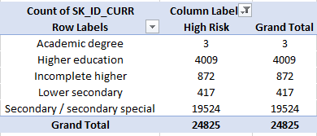
Customers with Secondary / Secondary Special education dominated the high-risk category (19,524 customers), indicating that educational background may influence financial stability and repayment discipline.

- Occupation Profile of High-Risk Customers
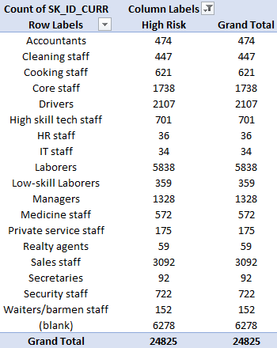

High-risk customers were primarily concentrated in labour-intensive occupations, particularly Laborers, Sales Staff, and Drivers, suggesting higher financial vulnerability within these professions.
- Property Ownership Profile

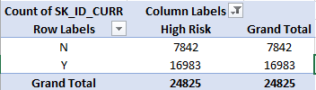
Surprisingly, a significant proportion of high-risk customers owned property, indicating that property ownership alone may not be sufficient to determine repayment reliability.

- Car Ownership Profile
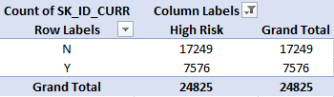
A larger proportion of risky borrowers did not own a car, suggesting a possible relationship between asset ownership and financial stability.
- Employment Profile of High-Risk Customers
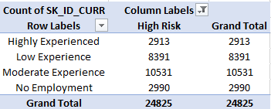
Most high-risk customers belonged to the Moderate Experience and Low Experience employment categories, indicating that employment stability may influence repayment behaviour.
Final Persona Summary
Based on the analysis, a typical high-risk borrower in the banking portfolio is likely to be a middle-income customer with secondary education, working in labour-intensive occupations, possessing limited asset ownership, and demonstrating moderate employment stability.

AI-Assisted Credit Risk Intelligence Framework
To extend the project beyond descriptive analytics, an AI-Assisted Credit Risk Intelligence Framework was developed using customer financial, employment, educational, and socio-economic indicators identified during banking risk analysis.
The framework combines multiple borrower characteristics to simulate an intelligent borrower risk evaluation process for banking decision-making.

Risk Indicators Table
Risk Factor | Higher Risk Pattern | Lower Risk Pattern
Income Level | Middle / Low Income | High Income
Education | Secondary / Lower Secondary | Higher Education
Occupation | Labourers, Drivers, Sales Staff | Manager, Accountants
Employment | Low Experience | Higher Experienced
Asset ownership | No Car / No Property | Own Car/Property

AI Prototype Implementation — Credit Risk Intelligence GPT
To operationalize project findings into a practical AI solution, a custom AI-Assisted Credit Risk Intelligence GPT was developed. The system evaluates borrower financial profiles using customer characteristics identified during data analysis, including income level, education, occupation, employment stability, and asset ownership.
The GPT prototype applies a project-specific weighted risk-scoring framework to classify borrowers into Low Risk, Moderate Risk, and High Risk categories while providing explainable reasoning and lending recommendations.
Unlike generic chatbot recommendations, the prototype was grounded in patterns derived from 307,511 customer records, enabling more structured and data-backed borrower evaluation.
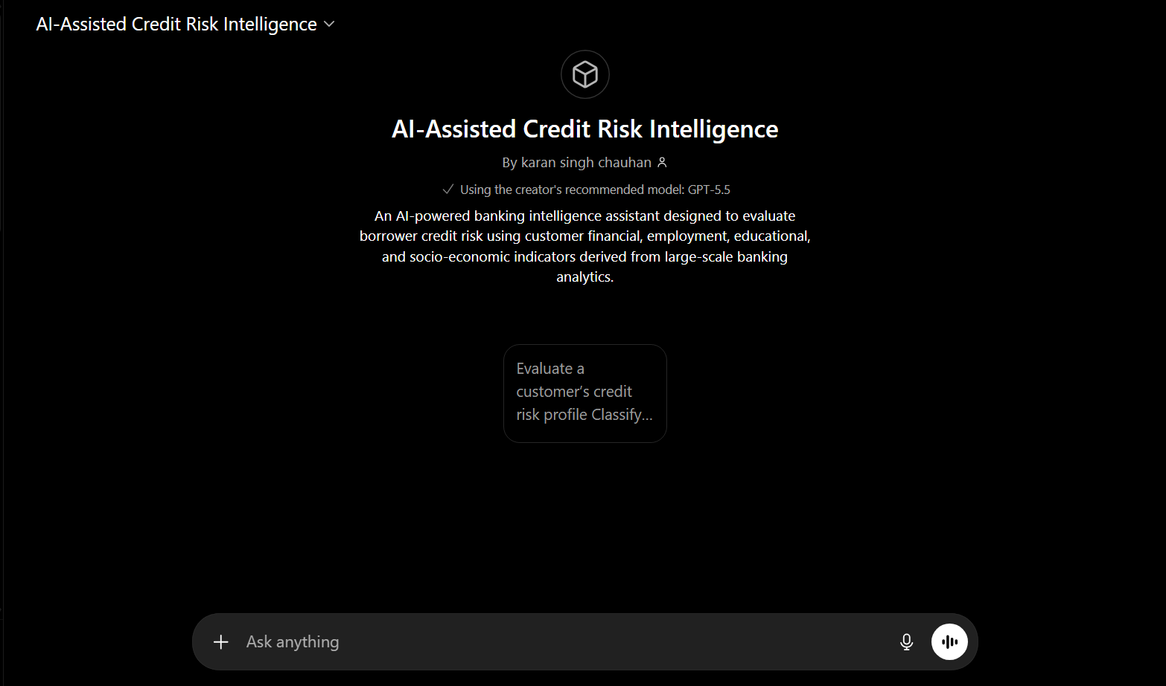
AI Credit Risk GPT Interface

Interface of the AI-Assisted Credit Risk Intelligence GPT developed to simulate borrower risk evaluation using project-specific banking indicators.
High-Risk Borrower Evaluation
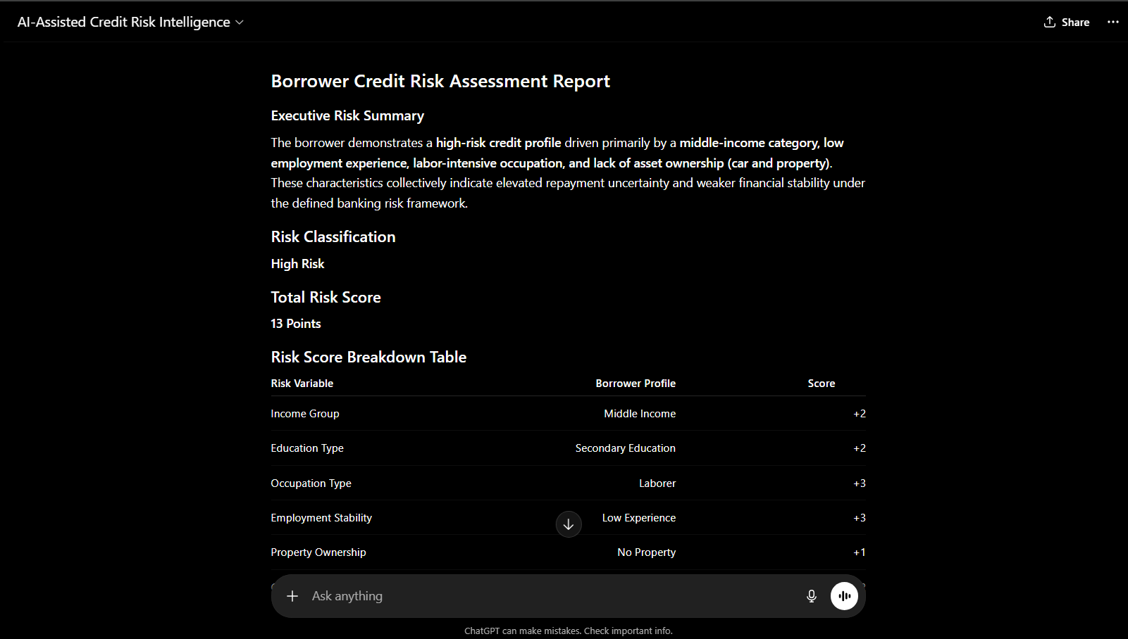
Example of borrower classification where the AI prototype identified a customer as High Risk based on multiple risk indicators, including occupation type, employment stability, and asset ownership profile.

Risk Score Breakdown
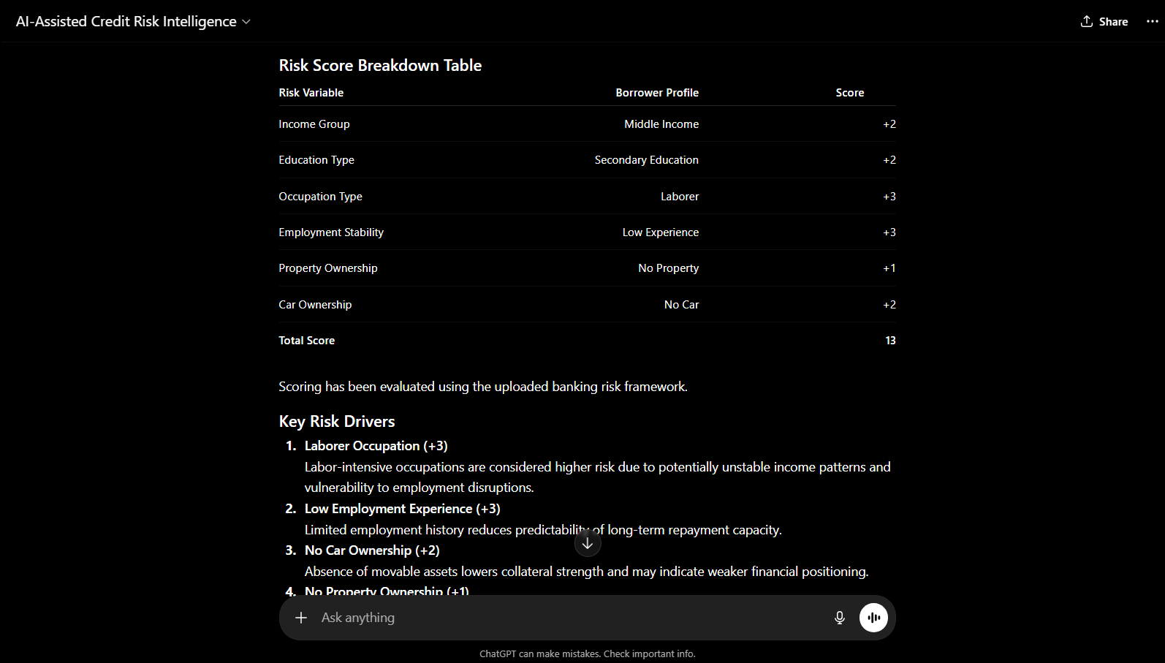
Explainable risk-scoring mechanism demonstrating how customer attributes contribute to total borrower risk classification within the AI framework.
Underwriting Recommendation Output
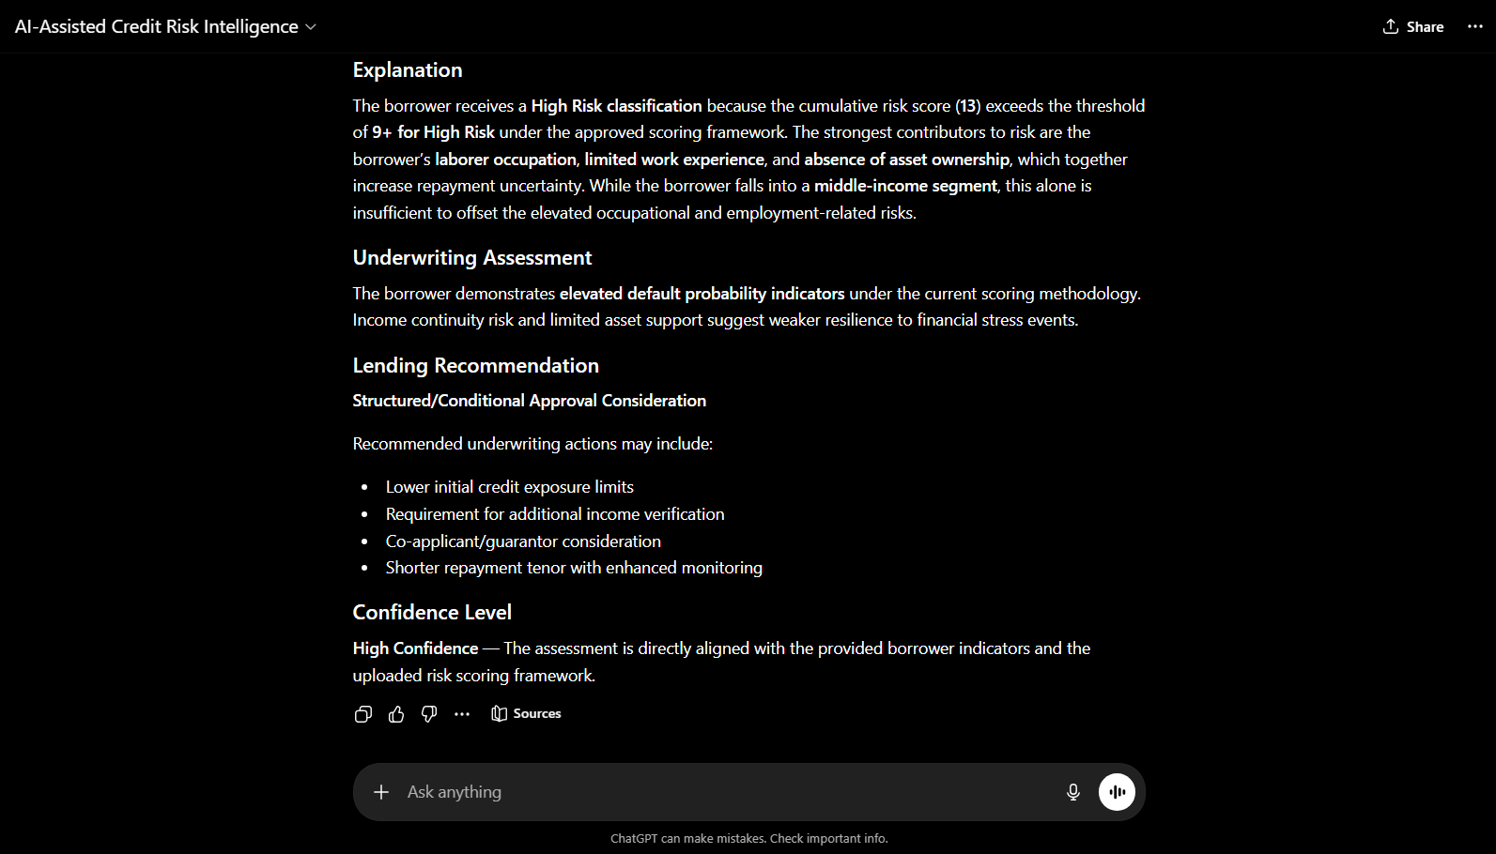
AI-generated underwriting assessment and lending recommendation based on customer financial and socio-economic indicators.

Tableau Dashboard Development
To enhance business intelligence and improve visual interpretation of customer credit risk behaviour, an interactive Tableau dashboard was developed using the transformed banking dataset. The dashboard was designed to provide a consolidated overview of customer risk distribution, financial behaviour, employment stability, and occupation-based credit risk patterns.
The objective of the dashboard was to transform raw analytical findings into an interactive decision-support system that enables quick borrower risk assessment and business-level interpretation.
The dashboard combines KPI indicators and risk visualization charts to support banking professionals in identifying high-risk borrower segments and improving lending decisions.

Dashboard KPIs
The dashboard includes six key performance indicators (KPIs) to summarize the overall customer portfolio and financial characteristics:
- Total Customers: 307,511
- High Risk Customers: 24,825
- High Risk Percentage: 8.1%
- Average Income: 168,798
- Average Credit Amount: 599,026
- Average Employment Years: 6.5 years
These KPIs provide an immediate overview of portfolio health and customer financial characteristics for business decision-making.

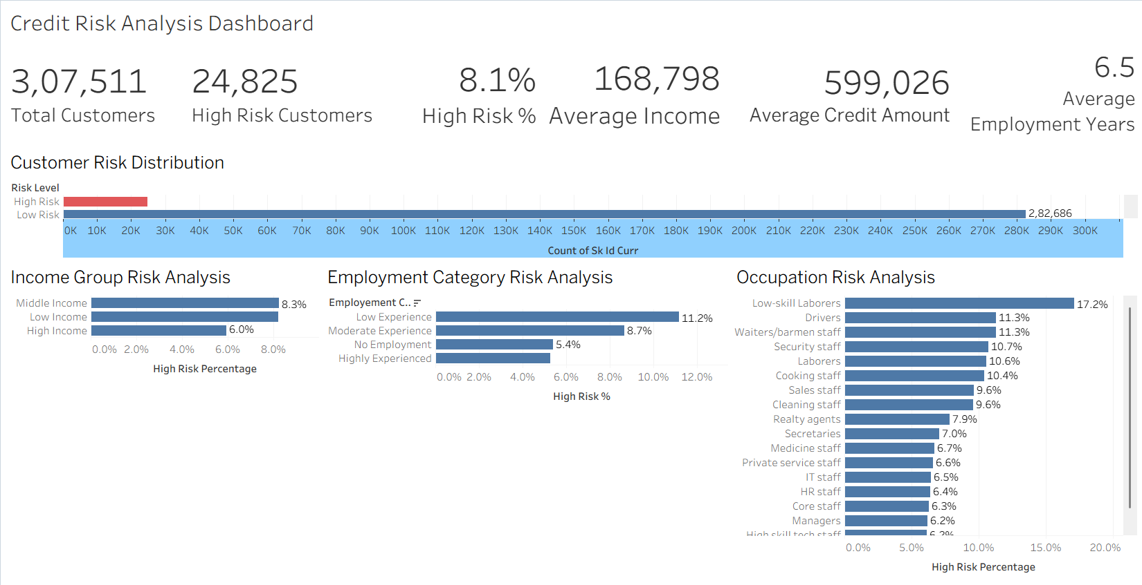
Dashboard Visualizations
The Tableau dashboard was developed using multiple analytical visualizations to represent borrower credit risk behaviour across different customer segments.
1. Customer Risk Distribution
This visualization presents the overall distribution of High-Risk and Low-Risk customers in the banking portfolio. The analysis revealed that the majority of customers belonged to the Low-Risk category, indicating a relatively stable borrower portfolio.
2. Income Group Risk Analysis
This chart compares repayment risk across customer income categories. Middle-income and low-income customers demonstrated higher risk percentages compared to high-income borrowers, suggesting financial resilience differences among income groups.
3. Employment Category Risk Analysis
The employment risk visualization revealed that customers with low employment experience demonstrated the highest financial vulnerability, while highly experienced customers showed comparatively lower repayment risk.

4. Occupation Risk Analysis
Occupation-based analysis showed that labour-intensive professions such as labourers, drivers, and service workers demonstrated comparatively higher default risk, while professional occupations exhibited lower financial vulnerability.
Business Value of Tableau Dashboard
The Tableau dashboard transformed static business analysis into an interactive and visually interpretable business intelligence system. Instead of manually reviewing spreadsheets and tables, decision-makers can quickly identify high-risk customer groups, monitor borrower patterns, and evaluate financial risk indicators through visual dashboards.
The dashboard improves analytical efficiency and supports faster, more informed lending decisions within banking environments.

Project Conclusion
Add this as your final section:
This project successfully analysed customer credit risk behaviour using banking data consisting of 307,511 customer records and 122 business variables. Through extensive data cleaning, feature engineering, and risk segmentation, meaningful relationships between financial stability, education, occupation, employment patterns, asset ownership, and borrower risk were identified.
The analysis revealed that customer default probability is influenced by multiple socio-economic and employment-related factors rather than a single indicator. Customers with lower employment stability, labour-intensive occupations, lower educational backgrounds, and weaker asset ownership profiles demonstrated comparatively higher repayment risk, while financially stable and professionally employed customers showed stronger repayment reliability.
To extend traditional analytics into practical decision-making, an AI-Assisted Credit Risk Intelligence Framework was developed using project-derived borrower characteristics. Furthermore, a functional AI-Assisted Credit Risk Intelligence GPT prototype was implemented to simulate borrower risk evaluation through structured scoring and explainable banking recommendations.
The project combines Microsoft Excel, Tableau, Generative AI, and business intelligence techniques to transform raw banking data into actionable financial insights and intelligent borrower evaluation strategies.
Overall, the project demonstrates how data analytics and AI can work together to improve banking decision-making, customer risk profiling, and credit assessment processes in modern financial institutions.

Future Scope
This makes the report feel more advanced.
Future improvements to the project may include the integration of machine learning-based credit risk prediction models, real-time borrower evaluation systems, and API-based banking intelligence tools to further improve lending decisions and financial risk forecasting.

