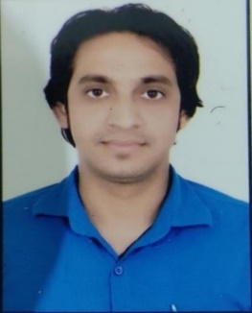 **Praveen Singh Chauhan**

8957187318, 9826449625

[Chauhanpraveensingh303@gmail.com](mailto:Chauhanpraveensingh303@gmail.com)

**Objective**

Eager to work in challenging positions where my problem-solving skills, with a strong desire to learn new prospects to help the organization in the achievement of its goal.

**Skills**

* **Database**: SQL, Mongo dB with Mongoose
* **Web Technologies**: Angular12, JavaScript, ReactJS, Typescript, Bootstrap, JSON, WordPress, HTML5, CSS as a MEAN / MERN full stack developer.
* **JavaScript Full Stack**: NodeJS, JavaScript (Angular) with Express.js

framework

* **Version Control System**: GIT
* **Development Tools**: Visual studio code, Visual Studio, MS SQL server

**Education**

* Completed BCA in year 2014 from SMU with 75%.
* Completed 12th standard in year 2009 with 59%.
* Completed 10th standard in year 2007 with 85%.

**Experience**

* 2 years of experience in Reliance as a technical support .
* 1 year of experience in Software IT Ltd.
* 1 year in Zomato as Customer care in Jindal Telecom, New Delhi.
* 2 years of experience as Lab Assistant in Rizvi Engineering college Allahabad.

**Projects:Angular**

1. Fashion Design E-commerce Web App
2. NEWS web API.
3. Employee Management App
4. Current Weather Condition App
5. Affiliated All-in-One Web Site
6. Online Fresh Fast-Food App.

**Personal Details:**

* **Date of Birth**: May 04, 1991
* **Marital Status**: Unmarried
* **Passport Details:** Yes
* **Languages Spoken**: English and Hindi
* **Hobbies:** singing, photography, cooking and reading

**Declaration:**

I hereby declare that all the above-mentioned information is true to the best of my knowledge and belief.

Place:

Date: ( Praveen Singh Chauhan)