SCREENSHOT GRAVEYARD SOLVER

Original design prompt
Design a polished, human-made feeling UI/UX for Screenshot Graveyard Solver, a web app that turns screenshots into organized tasks.
The core flow is simple: a user drops screenshots into a watched folder, the app reads them, extracts action items, and shows the results in a task dashboard. Each task can show its title, source screenshot, priority, due date, assignee, and extraction status.
Aim for the feel of a thoughtfully designed productivity tool: clear, calm, practical, and distinctive. Avoid the generic AI-product look: no glowing gradients, floating brains, excessive glassmorphism, decorative sparkles, oversized rounded cards, or dashboard clutter. Use a restrained palette, strong typography, deliberate spacing, and a few purposeful visual details. Make the hierarchy obvious at a glance.
Design these states:
Dashboard: tasks grouped by status or due date, with clear priority cues and useful filters.
Screenshot intake: show when new screenshots are detected and how many are waiting to be processed.
Task review: make extracted details easy to confirm or edit, and keep the source screenshot accessible for context.
Empty state: explain how to add screenshots and what will happen next.
Error state: clearly identify screenshots the app could not read and offer a simple retry path.
Keep the experience fast to scan and easy to use. Use realistic sample tasks from Slack messages, emails, and meeting notes. Make buttons, navigation, and task rows feel like a real product someone could use every day. Prioritize accessibility, readable contrast, keyboard navigation, and responsive layouts.
The finished design should feel specific to rescuing forgotten tasks from a screenshot backlog, not like a generic AI dashboard.

Source screenshot
Generated Slack conversation used as a task’s source image.
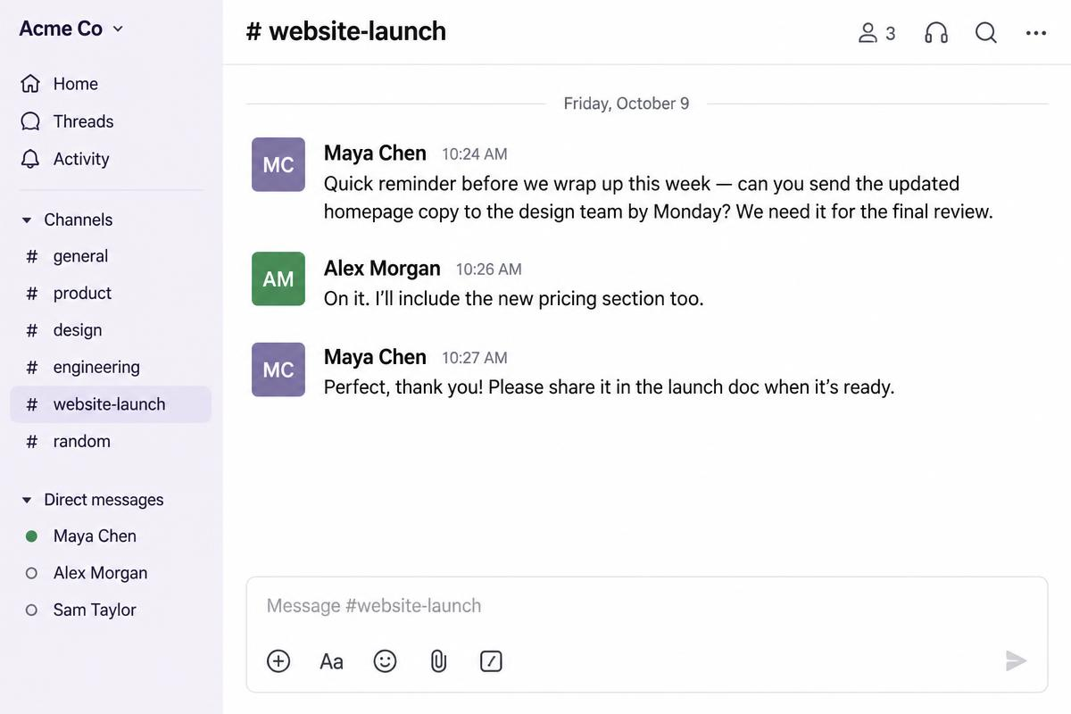

Task dashboard
Desktop dashboard with priority, due dates, assignees, extraction status, and the unreadable-screenshot notice.
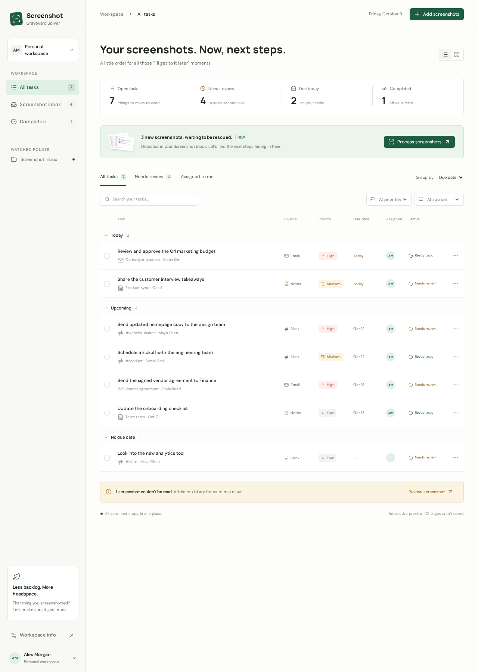

Task review
Editable task details alongside the source screenshot.
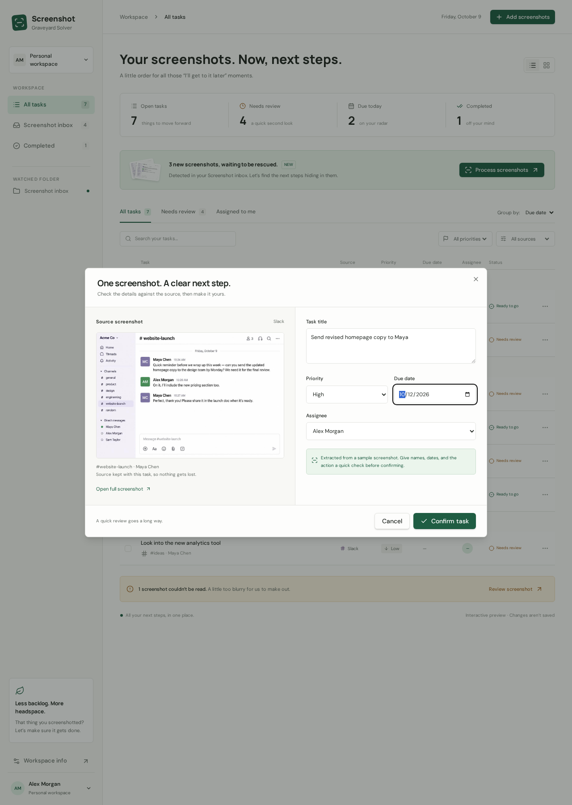

Empty search results
The dashboard when no tasks match the search.
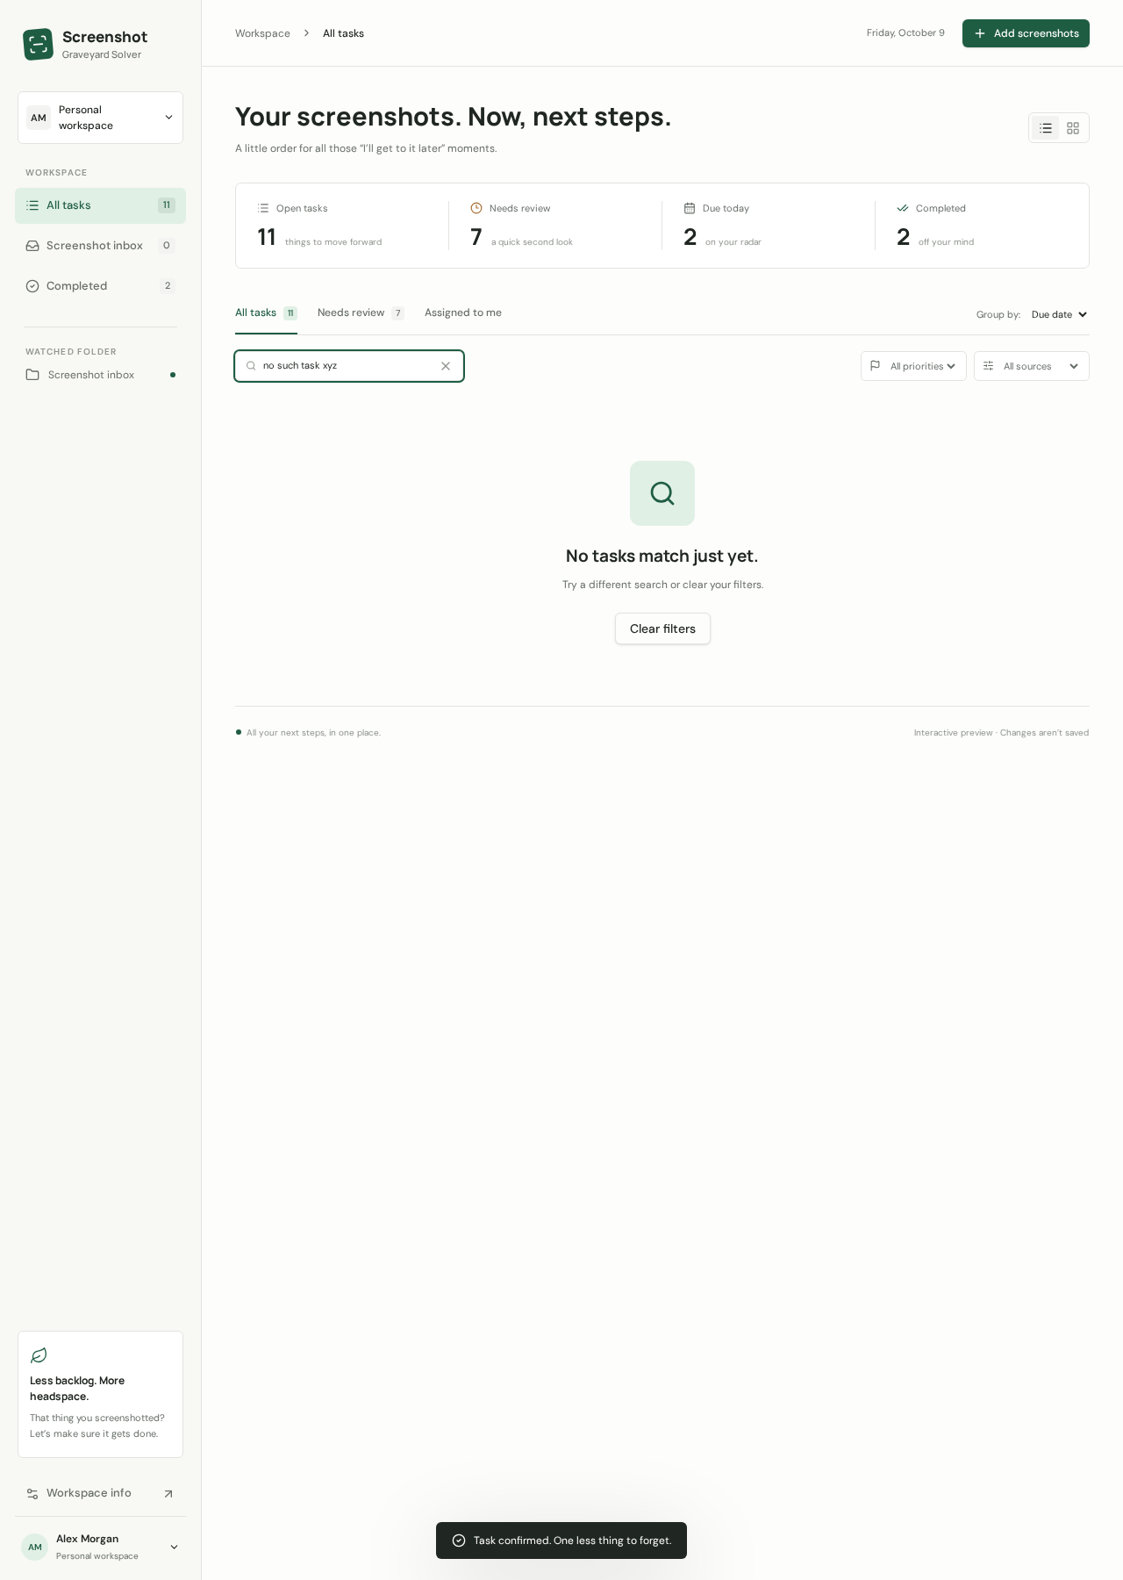

Mobile dashboard
Phone-sized layout with compact task rows and navigation.
