**DIGITAL ASSIGNMENT – 1**

**COURSE TITLE: BIG DATA ANALYTICS**

**COURSE CODE: ITA6008**

**SLOT: B1+B2+TB1+TB2**

**SEMESTER:SUMMER SPECIAL TERM,2021-22**

Consider the below two files and implement the word count Map Reduce program.

**File 1:**

Big data is a combination of structured, semistructured and unstructured data collected by organizations.

File 2:

Big data also encompasses a wide variety of data types, including the following: Structured data, such as transactions and financial records. Unstructured data, such as text, documents and multimedia files. Semistructured data, such as web server logs and streaming data from sensors.

**Github link -**

**CODE IN JAVA**

import java.io.IOException;

import java.util.StringTokenizer;

import org.apache.hadoop.conf.Configuration;

import org.apache.hadoop.fs.Path;

import org.apache.hadoop.io.IntWritable;

import org.apache.hadoop.io.Text;

import org.apache.hadoop.mapreduce.Job;

import org.apache.hadoop.mapreduce.Mapper;

import org.apache.hadoop.mapreduce.Reducer;

import

org.apache.hadoop.mapreduce.lib.input.FileInputFormat;

import

org.apache.hadoop.mapreduce.lib.output.FileOutputFormat;

public class WordCount {

public static class TokenizerMapper

extends Mapper<Object, Text, Text, IntWritable>{

private final static IntWritable one = new

IntWritable(1);

private Text word = new Text();

public void map(Object key, Text value, Context

context

) throws IOException,

InterruptedException {

StringTokenizer itr = new

StringTokenizer(value.toString());

while (itr.hasMoreTokens()) {

word.set(itr.nextToken());

context.write(word, one);

}

}

}

public static class IntSumReducer

extends Reducer<Text,IntWritable,Text,IntWritable>

{

private IntWritable result = new IntWritable();

public void reduce(Text key, Iterable<IntWritable>

values,

Context context

) throws IOException,

InterruptedException {

int sum = 0;

for (IntWritable val : values) {

sum += val.get();

}

result.set(sum);

context.write(key, result);

}

}

public static void main(String[] args) throws Exception

{

Configuration conf = new Configuration();

Job job = Job.getInstance(conf, "word count");

job.setJarByClass(WordCount.class);

job.setMapperClass(TokenizerMapper.class);

job.setCombinerClass(IntSumReducer.class);

job.setReducerClass(IntSumReducer.class);

job.setOutputKeyClass(Text.class);

job.setOutputValueClass(IntWritable.class);

FileInputFormat.addInputPath(job, new Path(args[0]));

FileOutputFormat.setOutputPath(job, new

Path(args[1]));

System.exit(job.waitForCompletion(true) ? 0 : 1);

}

}

OUTPUTS -

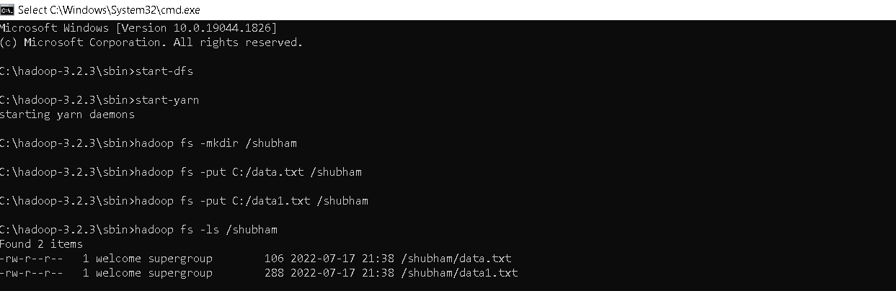

**File 1 Data -**



**File 2 Data -**

