**Practical Training Report**

on

**Core JAVA**

at

**Derwent Technologies (P) Ltd.**

**(Partner - MTA INDIA) Noida**

Submitted in partial fulfillment of the

requirements for the award of degree of

**BACHELOR OF TECHNOLOGY**

**in**

**COMPUTER SCIENCE & ENGINEERING**



**Department of Computer Science and Engineering**

**National Institute of Technology, Uttarakhand**

**20th May, 2016 – 30th June, 2016**

**Submitted to: Submitted by:**

Mr.Surendra Singh Sourabh Singh Chauhan

Asst. Professor BT14CSE022

Dept. of CSE

**DECLARATION**

I, **SOURABH SINGH CHAUHAN** hereby declare that the practical training report titled **“Core JAVA”** submitted herein has been carried out by me at**Derwent Technologies (P) Ltd. (Partner - MTA INDIA) Noida**. The work carried out by me is original and has not been submitted earlier as whole or a part for the award of any degree / diploma at this or any other Institution / University.

**Date: 24/08/2016 SOURABH SINGH CHAUHAN**

**Roll No. BT14CSE022**

**Department of CSE**

**NIT Uttarakhand**

**ACKNOWLEDGEMENT**

I consider myself very fortunate to get the opportunity to perform the summer training at**Derwent Technologies (P) Ltd.(Partner - MTA INDIA)Noida**. I got opportunity to get a practical exposure into actual environment and it provides me the golden opportunity to make my theoretical concept of recruitment and selection process in a more clear way.

I am very much thankful to **Mr. S.R Niyazi**and**Mr.AnilSoni**for providing me the opportunity to do the training at **Derwent Technologies (P) Ltd.(Partner - MTA INDIA)Noida**. Also, thankful to all the staff for their cooperation during my training for providing me necessary information without which this report would not have been completed.

Moreover, I also thank my teachers **Mr.Surendra Singh** and **Dr. Nitin Kumar** for providing me pre - requisite knowledge regarding the training before leaving the college in last semester.

**TABLE OF CONTENTS**

|  |  |
| --- | --- |
| **TOPIC** | **Page(s)** |
| **Chapter 1: Introduction** | 5-8 |
| * 1. Objectives of the industrial training program |
| **1.2**  The scope of the industrial training program |
| **1.3** Duration |
| **1.4** The importance of the industrial training program |
| **1.5** Benefits of training |
| **1.6** Objective |
| **Chapter 2 : The Training Organization** | 9-11 |
| **2.1** The training organization and training environment |
| **2.2** Business functions of the organization, staff strength, the  administrative system, organizational chart. |
| * 1. Computer systems and network infrastructure |
| **2.4** Other Details |
| **Chapter 3: Industrial Training** | 12-23 |
| **3.1** Objectives |
| **3.2** Analysis |
| **3.3** Technologies studied and techniques used |
| **3.4** Software and Tools Used |
| **3.5** Highlights of Training Exposure (area, scope) |
| **3.6** Snapshots |
| **Chapter 4: Conclusion** | 24 |
| **References/Bibliography** | 25 |

**Chapter 1: Introduction**

As part of graduation requirements, all the students undergoing B.Tech (mostly the third year and final year students), have to undergo an industrial training program for a minimum duration of four weeks.

This industrial training program is a zero-credit required course for undergraduates that gives them an opportunity to expose themselves in the real industrial world so as that they can learn to relate theoretical learning and real time practical implication in industrial environment.

The training refers to work experience that is relevant to professional development prior to graduation. No restriction is imposed on them whether they want to work in government agencies or private organizations.

This course helps us to understand the term BUREAUCRACY in a more practical manner and teaches us to deal with different kinds of situations which occur in a professional’s life.

Moreover, it also prepares the student for a new professional life both physically and mentally and also develops a sense of integrity which is an essential thing for an industry to work in an efficient manner.

**1.1 Objectives of the industrial training program**

Following are the objectives of industrial training program:

1. Undergraduates have an opportunity to expose themselves in working environment and make a student feel professional
2. For obtaining practicalworking experience in the field of study of students which helps them think efficiently and also in an industrial manner
3. Apply theories learnt in classroom in working environment
4. Solidifies students’ confidence after graduation
5. Improve communication and management skills
6. Cultivating them to work as a team
7. Develops a professional behavior

**1.2 The scope of the industrial training program**

* Observing the working mechanism of the industry
* Become familiar with the term bureaucracy
* Visual inspection and quality control on the final product
* Discussion and meeting with superior authorities
* Development of a new perspective of thinking

**1.3 Duration**

Generally, duration of an industrial summer training program is minimum 4 weeks.

The duration of my training was 20th May to 30th June,2016.

**1.4 The importance of the industrial training program**

“I hear and I forget. I see and I remember. I do and I understand”– Confucius

It has been widely reported that university graduates need to be better prepared for the workplace. So, what better way to do this than let students experience doing real work while they are still studying?

Industrial placement, where a student undertakes a period of training with an organization usually during a semester break, plays an important role in preparing the student for a professional career. From the hands-on training, the student learns about the skill sets required, demands of the industry and also work ethics. At the same time it gives the student an opportunity to put into practice what he or she has learned at university.

So, even before the student graduates he or she is trained to be job-ready, thus increasing the student’s employment prospects.

While the student will have much to gain from industrial placement, the same is also true for organisations which have such training programs in place. These programs can be of mutual benefit for employers because they may benefit from the quality of support, fresh ideas and energy that the student brings into the work environment.

Moreover, participating in internship programs allows the staffs of an organisation to develop leadership and mentoring skills, create exposure for the company, bring new perspectives and fresh ideas into the work environment. It is also a convenient pathway for the company to recruit human resource as some absorb trainees into their workforce after they graduate.

**1.5 Benefits of training**

* Increased job satisfaction and morale among employees
* Increased employee motivation
* Increased efficiencies in processes, resulting in financial gain
* Increased capacity to adopt new technologies and methods
* Increased innovation in strategies and products
* First-hand experience working as an engineering professional
* Apply your technical knowledge and engineering methods to a real-life situations
* Work with other engineering professionals
* Experience what it’s like to work in a professional organisation
* Increase your technical, interpersonal and communication skills, both oral and written
* Observe interactions of engineers with other professional groups
* Witness the functioning and organisation of business and companies

**1.6 Objective**

The objective of this report to write about what I have learnt during the industrial training and what tools, algorithms I have used through the entire industrial program.

**Chapter 2: The Training Organization**

C:\Users\Kushal\AppData\Local\Microsoft\Windows\INetCache\Content.Word\derwent-technologies-private-limited-logo-90x90.jpg



**Fig.2.1**: The Training Organization

**2.1 The training organization and training environment**

**Derwent Technologies (P) Ltd. (Partner - Microsoft Technology Associate,MTA-India)** is an education based company in sector – 62, Noida, Uttar Pradesh. It offers practical trainings (in both summers and winters) in various courses like ASP.NET with C#, PHP, MySQL, Core Java, Advanced Java, Android, Web Development, Networking, etc. Moreover, it also offers Industrial Training in these courses.

The company is partner with Microsoft Technical Associate which is also known as MTA. Microsoft Technology Associate (MTA) is an introductory Microsoft certification for individuals considering a career in technology. MTA certification addresses a wide spectrum of fundamental technical concepts, assesses and validates your core technical knowledge and enhances your technical credibility.

The company conducts MTA certification exam for the students for the respective courses in which they pursue their training.

The following are the exams for developer track for MTA certifications:

| **Title** | **Exam** | **Certification earned by passing any one exam** |
| --- | --- | --- |
| Software Development Fundamentals | 361 | MTA logo |
| Web Development Fundamentals | 363 |
| .NET Fundamentals | 372 |
| Gaming Development Fundamentals | 374 |
| HTML5 App Development Fundamentals | 375 |
| Software Testing Fundamentals | 379 |

There is a healthy and a competitive environment for all the students in the company as new modules are given to students to work upon every day. A lab is there for the same. Also there are assistant trainers in lab for guidance in any problem. Apart from MTA certification exam, an offline exam is also conducted in the company on the basis of which the grades of the student are decided.

**2.2 Business functions of the organization, staff strength, the administrative system, Organizational chart**

The organization has branches in many cities like Lucknow, Noida, Jhansi, Dehradun, Jaipur, Gwalior, etc. where each branch has faculties of all courses. The modules are given to students related to the topic which is covered on that day to work upon. In the whole duration of training, the student has to work on a project which is submitted at the last to the project head.

The staff at the organization is punctual and helpful. If any of the student ever faces a problem in any of the module, then the staff is always ready for the help. The staff strength at the center of my training i.e. Noida center is 10 – 15.

The center head is Mr. Anil Soni while the Core JAVA trainer is Mr.S.RNiyazi. He is Core JAVA and android expert and is a very good trainer. The whole administration at the center is in his hands and along with some staff, he handles it very well. The administrative head of each center has a direct communication with the head of the organization. Any requests from students are first sent and reviewed by the overall head and then passed on to the center heads for further processing.

The classes are held every working day for every course. After the classes there is a lab session for at least an hour so that every technique/concept can be applied practically to avoid confusions and speed up memorization.

**2.3 Computer systems and network infrastructure**

Computer System of this organization was really very good. There was a huge lab including good Wi-Fi system and windows10 was installed on every system with the required software. Computer lab was fully air conditioned. It was really very much pleasant to work under such lab.

**2.4 Other Details**

**Contact Details**

Derwent Technologies (P) Ltd. (Partner – Microsoft Technology Associate)

C-56/5 3rd Floor

Sector – 62, Mantec Tower

Near JSS Engineering College

Noida, Uttar Pradesh, India

Contact No.: +918858700955

Email: query@mtaindia.org, info@mtaindia.org

**Chapter 3: Industrial Training**

**3.1 Objectives**

One of the main objectives of industrial training is to obtain working experience in the industry which relates to their field of current study and using that knowledge or experience for study after finishingtraining and continuing study at university afterwards. Other ones include the understanding of bureaucracy, developing integrity/unity, communication skills, etc.

My training is entitled “Core JAVA” which is an Object-Oriented Technology. This technology was developed by Sun Microsystems and is based on OOPs concepts.

The objective of this training was to learn basics of this technology and understanding its practical applications in industry.

**3.2 Analysis**

During the training, I encountered many problems which were figured out just by thinking more. The modules given to the students were an integral part of the training as they helped the students to think from a developer’s perspective.

The major part of analysis phase was figuring out algorithms to problems/modules.

I analyzed every building block necessary to learn the basics of this technology and implemented it too during my project.

**3.3 Technologies studied and techniques used:**

Technologies/concepts which I studied during the industrial training are listed below:

Java is a high-level programming language originally developed by Sun Microsystems and released in 1995. Java runs on a variety of platforms, such as Windows, Mac OS, and the various versions of UNIX.

* **OOPS concept:**OOPS stands for Object Oriented Programming System. There are four main concepts of OOPS:
  + - **Encapsulation:Wrapping up of data into a single unit-**Encapsulation is the mechanism that binds together code and the data it manipulates, and keeps both safe from outside interference and misuse. Access to the code and data inside the wrapper is tightly controlled through a well-defined interface.
    - **Abstraction: Hiding Functionalities-**An essential element of object-oriented programming is abstraction. Humans manage complexity through abstraction. For example, people do not think of a car as a set of tens of thousands of individual parts.Canignorethedetailsofhowthe engine, transmissionandbrakingsystemswork. Instead they are free to utilize the object as a whole.
    - **Inheritance:Reusability of code of base class into derived class-**Inheritance is the process by which one object acquires the properties of another object. This is important because it supports the concept of hierarchical classification.Forexample, aGoldenRetrievers is part of theclassification dog, which in turn is part of the mammal class, which is under the larger class animal.
    - **Polymorphism:More than one functionality of a method-**Polymorphism (from the Greek, meaning “many forms”) is a feature that allows one interface to be used for a general class of actions. The specific action is determined by the exact nature of the situation.

For example in java we use polymorphism as **Method Overloading** and **Method Overriding.**

* + - **Java Buzzwords :**No discussion of the genesis of Java is complete without a look at the Java buzzwords. Although the fundamental forces that necessitated the invention of Java are portability and security, other factors also played an important role in molding the final form of the language. The key considerations were summed up by the Java team in the following list of buzzwords:
* **Object Oriented:** In Java, everything is an Object. Java can be easily extended since it is based on the Object model.
* **Platform independent:** Unlike many other programming languages including C and C++, when Java is compiled, it is not compiled into platform specific machine, rather into platform independent byte code. This byte code is distributed over the web and interpreted by virtual Machine (JVM) on whichever platform it is being run.
* **Simple:** Java is designed to be easy to learn. If you understand the basic concept of OOP Java would be easy to master.
* **Secure:** With Java's secure feature it enables to develop virus-free, tamper-free systems. Authentication techniques are based on public-key encryption.
* **Architectural-neutral:**Java compiler generates an architecture-neutral object file format which makes the compiled code to be executable on many processors, with the presence of Java runtime system.
* **Portable:** Being architectural-neutral and having no implementation dependent aspects of the specification makes Java portable. Compiler in Java is written in ANSI C with a clean portability boundary which is a POSIX subset.
* **Robust:** Java makes an effort to eliminate error prone situations by emphasizing mainly on compile time error checking and runtime checking.
* **Multithreaded:** With Java's multithreaded feature it is possible to write programs that can do many tasks simultaneously. This design feature allows developers to construct smoothly running interactive applications.
* **Interpreted:** Java byte code is translated on the fly to native machine instructions and is not stored anywhere. The development process is more rapid and analytical since the linking is an incremental and light weight process.
* **High Performance:** With the use of Just-In-Time compilers, Java enables high performance.
* **Distributed:** Java is designed for the distributed environment of the internet.
* **Dynamic:** Java is considered to be more dynamic than C or C++ since it is designed to adapt to an evolving environment. Java programs can carry extensive amount of run-time information that can be used to verify and resolve accesses to objects on run-time.

**Setting up the path for windows:**

Assuming you have installed Java in *c:\Program Files\java\jdk* directory:

* Right-click on 'My Computer' and select 'Properties'.
* Click on the 'Environment variables' button under the 'Advanced' tab.
* Now, alter the 'Path' variable so that it also contains the path to the Java executable. Example, if the path is currently set to 'C:\WINDOWS\SYSTEM32', then change your path to read 'C:\WINDOWS\SYSTEM32;c:\Program Files\java\jdk\bin'.

## Basic Syntax:

About Java programs, it is very important to keep in mind the following points.

* **Case Sensitivity -**Java is case sensitive, which means identifier **Hello**and **hello** would have different meaning in Java.
* **Class Names -**For all class names the first letter should be in Upper Case.   
    
  If several words are used to form a name of the class, each inner word's first letter shouldbe in Upper Case.  
    
  Example *class MyFirstJavaClass*
* **Method Names -**All method names should start with a Lower Case letter.   
    
  If several words are used to form the name of the method, then each inner word's first letter should be in Upper Case.  
    
  Example *public void myMethodName()*
* **Program File Name -**Name of the program file should exactly match the class name.   
    
  When saving the file, you should save it using the class name (Remember Java is case sensitive) and append '.java' to the end of the name (if the file name and the class name do not match your program will not compile).  
    
  Example: Assume 'MyFirstJavaProgram' is the class name. Then the file should be saved as *'MyFirstJavaProgram.java'*
* **public static void main(String args[]) -** Java program processing starts from the main() method which is a mandatory part of every Java program.

**Java Identifiers:**

All Java components require names. Names used for classes, variables and methods are called identifiers.

In Java, there are several points to remember about identifiers. They are as follows:

* All identifiers should begin with a letter (A to Z or a to z), currency character ($) or an underscore (_).
* After the first character identifiers can have any combination of characters.
* A key word cannot be used as an identifier.
* Most importantly identifiers are case sensitive.
* Examples of legal identifiers: age, $salary, _value, __1_value
* Examples of illegal identifiers: 123abc, -salary

**Java Modifiers:**

Like other languages, it is possible to modify classes, methods, etc., by using modifiers. There are two categories of modifiers:

* **Access Modifiers:**default, public , protected, private
* **Non-access Modifiers:**final, abstract, strictfp

**Java Variables:**

We would see following type of variables in Java:

* Local Variables
* Class Variables (Static Variables)
* Instance Variables (Non-static variables)

**Java Arrays:**

Arrays are objects that store multiple variables of the same type. However, an array itself is an object on the heap. We will look into how to declare, construct and initialize in the upcoming chapters.

**Java Enums:**

Enums were introduced in java 5.0. Enums restrict a variable to have one of only a few predefined values. The values in this enumerated list are called enums.

With the use of enums it is possible to reduce the number of bugs in your code.

For example, if we consider an application for a fresh juice shop, it would be possible to restrict the glass size to small, medium and large. This would make sure that it would not allow anyone to order any size other than the small, medium or large.

Let's look at how to save the file, compile and run the program. Please follow the steps given below:

* Open notepad and add the code as above.
* Save the file as: MyFirstJavaProgram.java.
* Open a command prompt window and go to the directory where you saved the class. Assume it's C:\.
* Type ' javac MyFirstJavaProgram.java' and press enter to compile your code. If there are no errors in your code, the command prompt will take you to the next line (Assumption: The path variable is set).
* Now, type ' java MyFirstJavaProgram ' to run your program.
* You will be able to see ' Hello World ' printed on the window.

# Files and I/O:

The java.io package contains nearly every class you might ever need to perform input and output (I/O) in Java. All these streams represent an input source and an output destination. The stream in the java.io package supports many data such as primitives, Object, localized characters, etc.

## Stream -

A stream can be defined as a sequence of data. there are two kinds of Streams

* **InPutStream:** The InputStream is used to read data from a source.
* **OutPutStream:** the OutputStream is used for writing data to a destination.

## Byte Streams -

Java byte streams are used to perform input and output of 8-bit bytes. Though there are many classes related to byte streams but the most frequently used classes are , **FileInputStream** and **FileOutputStream**.

## Character Streams -

Java **Byte** streams are used to perform input and output of 8-bit bytes, where as Java **Character** streams are used to perform input and output for 16-bit unicode. Though there are many classes related to character streams but the most frequently used classes are , **FileReader**and **FileWriter.**

## Reading and Writing Files –

## TheInputStream is used to read data from a source and the OutputStream is used for writing data to a destination.

## FileInputStream:

This stream is used for reading data from the files. Objects can be created using the keyword new and there are several types of constructors available.

Following constructor takes a file name as a string to create an input stream object to read the file:

InputStream f =newFileInputStream("C:/java/hello");

## FileOutputStream:

FileOutputStream is used to create a file and write data into it. The stream would create a file, if it doesn't already exist, before opening it for output.

Here are two constructors which can be used to create a FileOutputStream object.

Following constructor takes a file name as a string to create an input stream object to write the file:

OutputStream f =newFileOutputStream("C:/java/hello")

## Creating Directories:

There are two useful **File** utility methods, which can be used to create directories:

* The **mkdir( )** method creates a directory, returning true on success and false on failure. Failure indicates that the path specified in the File object already exists, or that the directory cannot be created because the entire path does not exist yet.
* The **mkdirs()** method creates both a directory and all the parents of the directory.

## Listing Directories:

You can use **list( )** method provided by **File** object to list down all the files and directories available in a directory

**3.4 Software and Tools Used**

**3.4.1 Tools Used in development**

For working on this platform we require following Software:

* Linux 7.1 or Windows xp/7/8/10 operating system.
* Java JDK 8
* Java Runtime Environment (JRE)
* Microsoft Notepad or any other text editor

**3.4.2 Programming Language Used in development of Project**

* Core JAVA

**3.5 Highlights of Training Exposure (area, scope)**

The main reason engineering students need to do Industrial Training (IT) is so they are well prepared for a graduate job in their chosen field. It is a chance for you to put what you have learned at university to work in the kind of real-life situations you will come up against when you start your career. Industrial training gives you great experience during your Bachelor of Engineering degree.

My area of summer training was to learn Core JAVA technology. During this training I learnt basics and different aspects of this language that are used in industry and development.

**3.6 Snapshots**

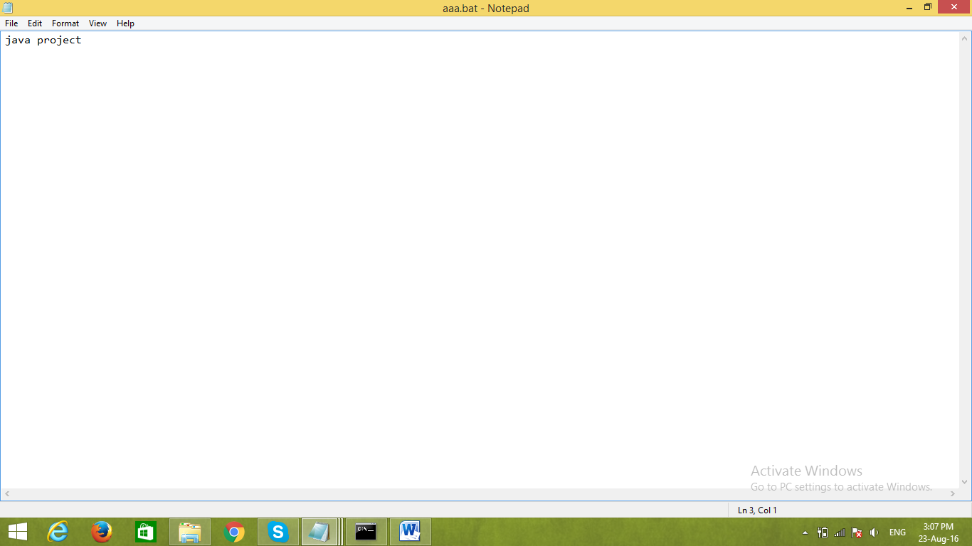

**Content of the batch file**

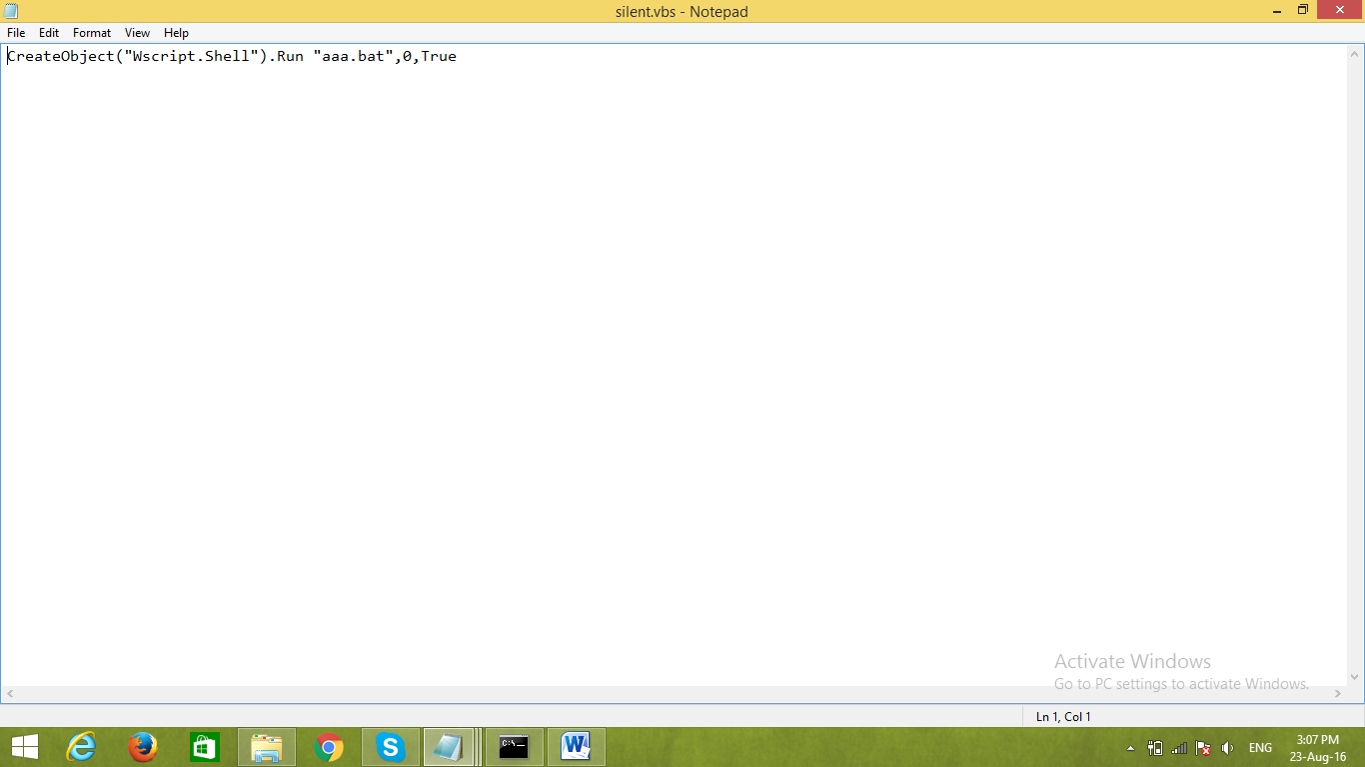

**Content of the .vbs file**

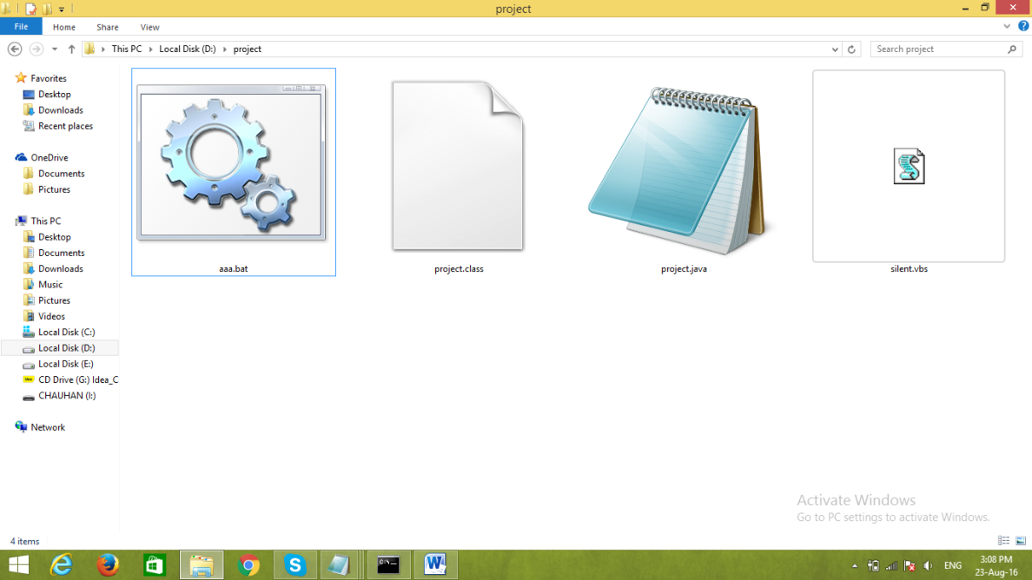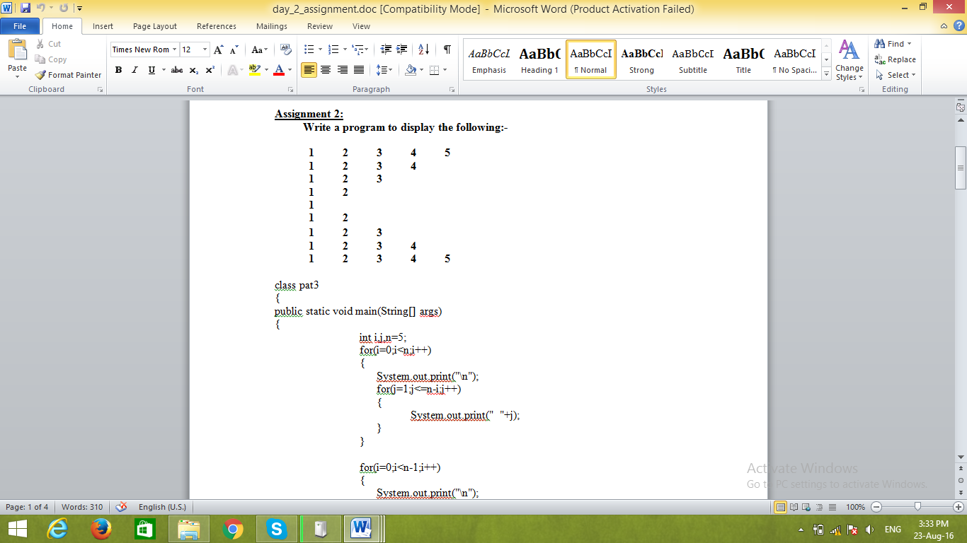

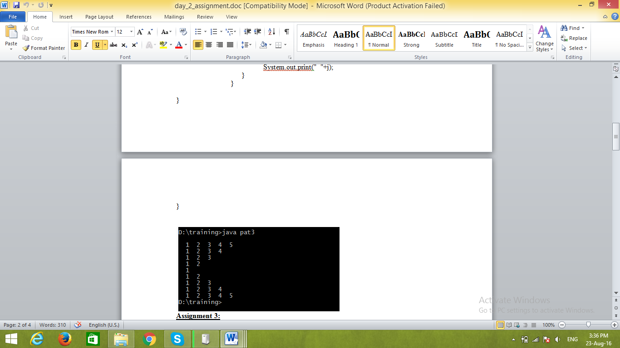

**Chapter 4: Conclusion**

The purpose of the Industrial Training is to provide exposure for the students on practical engineering fields. Through this exposure, students will have better understanding of engineering practice in general and sense of frequent and possible problems. This training is part of the learning process. So, the exposure that uplifts the knowledge and experience of a student needs to be properly documented in the form of a report. Through this report, the experience gain can be delivered to their peers. A properly prepared report can facilitate the presentation of the practical experience in an orderly, precise and interesting manner.

Through this training I learnt many things related to the practical applications of Core JAVA developed many modules too. The experience was quite nice and I can feel a sense of professional developing inside me.

**Bibliography**

**For downloading jdk-**

http://www.oracle.com/technetwork/java/javase/downloads/jdk8-downloads-2133151.html

**For downloading jre-**

http://www.oracle.com/technetwork/java/javase/downloads/jre8-downloads-2133155.html