EXPERIMENT 1 : STARTING WITH C

Activity 1: Write a C program to print “Hello World”.

ALGORITHM:
STEP 1: Start
STEP 2: Print Hello World
STEP 3 : Stop

FLOWCHART : START

Print Hello World

END

PSEUDOCODE :
START

print "Hello World"

END

CODE :
#include<stdio.h>

int main(){

printf("Hello World");

return 0;
}

OUTPUT :
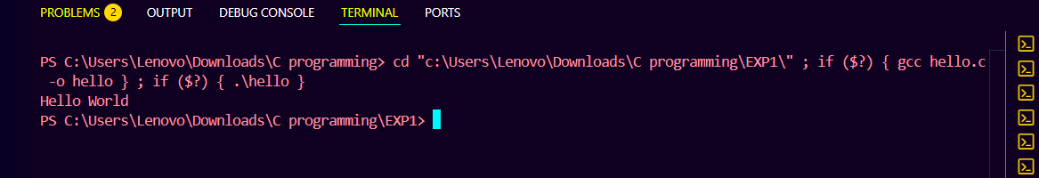

Activity 2: Write C program to print the address in multiple lines (new line).
ALGORITHM:
STEP 1: Start
STEP 2: print 108
STEP 3: print Golden Estate
STEP 4: print Baltana
STEP 5: print Zirakpur
STEP 6: print Punjab
STEP 7: Stop

FLOWCHART :
START

print 108
print Golden Estate

print Baltana

print Zirakpur

print Punjab

END

PSEUDOCODE :

START
print "108"
print "Golden Estate"
print "Baltana"
print "Zirakpur"
print "Punjab"
END
CODE :
#include <stdio.h>

int main() {
printf("108\n");
printf("Golden Estate\n");
printf("Baltana\n");
printf("Zirakpur\n");
printf("Punjab\n");
return 0;
}

OUTPUT:
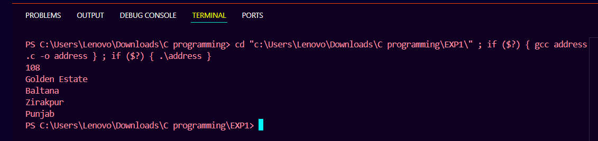

Activity 3: Write a program that prompts the user to enter his name name and age.
ALGORITHM :
Step 1: Start
Step 2: Declare variables name and age
Step 3: print Enter your name:
Step 4: read name
Step 5: print Enter your age:
Step 6: read age
Step 7: Stop

FLOWCHART : START
Read age
print Enter your age
Read name
print Enter your name
Declare name & age

END

PSEUDOCODE :
START

declare name as string
declare age as integer

print "Enter your name: "
input name

print "Enter your age: "
input age

END

CODE :
#include <stdio.h>

int main() {
char name[50];
int age;

printf("Enter your name: ");
scanf("%s", name);

printf("Enter your age: ");
scanf("%d", &age);

return 0;
}

OUTPUT :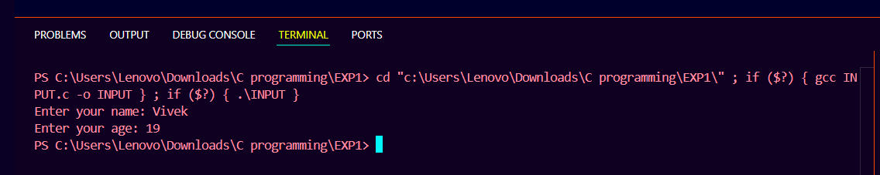

Activity 4: Write a C program to add two numbers take the numbers form user.
ALGORITHM :
Step 1: Start
Step 2: Declare variables num1, num2
Step 3: print "Enter first number:"
Step 4: input num1
Step 5: print "Enter second number:"
Step 6: input num2
Step 7: sum = num1 + num2
Step 8: print sum
Step 9: Stop
FLOWCHART : START
Declare num1 & num2

print Enter first number

Read num1
print Enter second number

Read num2

Sum = num1 + num2

END
print sum

PSEUDOCODE :
START

declare num1, num2, sum AS integer

print "Enter first number: "
input num1

print "Enter second number: "
input num2

sum ← num1 + num2

print "Sum = ", sum

END

CODE :
#include <stdio.h>

int main() {
int num1, num2, sum;

printf("Enter first number: ");
scanf("%d", &num1);

printf("Enter second number: ");
scanf("%d", &num2);

sum = num1 + num2;

printf("Sum = %d\n", sum);

return 0;
}

OUTPUT : 