EXPERIMENT 2 : OPERATORS

Activity 1: WAP a C program to calculate the area and perimeter of a rectangle based on its length and width.

ALGORITHM
STEP1: Start
STEP2: Declare variables length, width, area, perimeter
STEP3: Read length, width
STEP4: area = length * width
STEP5: perimeter = 2 * (length + width)
STEP6: Print area, perimeter
STEP7: End

FLOWCHART :
START

Declare variables length, width, area, perimeter

Read length, width

area = length * width
perimeter = 2 * (length + width)

Print area, perimeter

END

PSEUDOCODE :
START

declare length, width, area, perimeter AS integer

print "Enter the length of the rectangle: "
input length

print "Enter the width of the rectangle: "
input width

area ← length * width
perimeter ← 2 * (length + width)

print "Area of Rectangle = ", area
print "Perimeter of Rectangle = ", perimeter

END

CODE :
#include <stdio.h>

int main() {
int length, width, area, perimeter;

printf("Enter the length of the rectangle: ");
scanf("%d", &length);
printf("Enter the width of the rectangle: ");
scanf("%d", &width);

area = length * width;
perimeter = 2 * (length + width);

printf("Area of Rectangle = %d\n", area);
printf("Perimeter of Rectangle = %d\n", perimeter);

return 0;
}

OUTPUT:
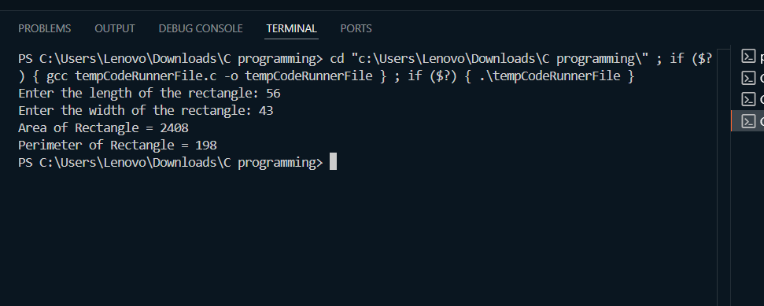

Activity 2: WAP a C program to convert the temperature from Celsius to Fahrenheit using the formula : F = (C * 9/5) + 32 .

ALGORITHM :
STEP1: Start
STEP2: Declare variables celsius, fahrenheit
STEP3: Read celsius
STEP4: fahrenheit = (celsius * 9 / 5) + 32
STEP5: Print fahrenheit
STEP6: End

FLOWCHART :
START

Declare variables celsius, fahrenheit

Read celsius

Fahrenheit = ( celsius * 9 / 5 ) + 32

Print fahrenheit

END

PSEUDOCODE:
START

declare celsius, fahrenheit AS float

print "Enter temperature in Celsius: "
input celsius

fahrenheit ← (celsius * 9 / 5) + 32

print "Temperature in Fahrenheit = ", fahrenheit

END

CODE :
#include <stdio.h>

int main() {
float celsius, fahrenheit;

printf("Enter temperature in Celsius: ");
scanf("%f", &celsius);

fahrenheit = (celsius * 9 / 5) + 32;

printf("Temperature in Fahrenheit = %.2f\n", fahrenheit);

return 0;
}

OUTPUT :
