EXPERIMENT 3.1 : CONDITIONAL STATEMENTS

Activity 1: WAP to take the check if the given triangle is valid or not. If the
validity is established, do check if the triangle is isosceles , equilateral, right angle or scalene. Take sides of the triangle as input from the user.

Algorithm :
STEP1: Start
STEP2: Read three sides a, b, c
STEP2: if (a + b > c) && (a + c > b) && (b + c > a) go to STEP 4
else print "Triangle is not valid" and go to STEP 8
STEP4: If a==b && b==c then print Equilateral triangle and go to Step 8 else go to STEP 5
STEP5: Else if a==b || b==c || c==a then print Isosceles triangle and go to STEP 8 else go to STEP 6
STEP6: Else if (a*a ==b*b + c*c) || (b*b == a*a + c*c) || (c*c == a*a + b*b) print Right angled triangle and go to STEP 8 else go to STEP 7
STEP7: Else print "Scalene triangle"
STEP8: End
FLOWCHART :
START

Read a, b, c

(a + b > c) && (b + c > a) && (c + a > b) False True

Print invalid triangle a== b && b==c True False Print Equilateral Triangle
a == b || b ==c || c==a Print isosceles triangle
True
False
True
a² == b² + c² || b² == c² + a² || c² == a² + b² Print right angled triangle

False
Print Scalene triangle

END

PSEUDOCODE:

START

declare a, b, c AS float

print "Enter three sides of the triangle:"
input a, b, c

IF (a + b > c) AND (a + c > b) AND (b + c > a) THEN
print "Triangle is valid."

IF (a == b) AND (b == c) THEN
print "Equilateral Triangle"
ELSE IF (a == b) OR (b == c) OR (a == c) THEN
print "Isosceles Triangle"
ELSE IF (a*a == b*b + c*c) OR (b*b == a*a + c*c) OR (c*c == a*a + b*b) THEN
print "Right-angled Triangle"
ELSE
print "Scalene Triangle"
END IF

ELSE
print "Triangle is not valid."
END IF

END

CODE :

#include <stdio.h>

int main() {
float a, b, c;

printf("Enter three sides of the triangle: ");
scanf("%f %f %f", &a, &b, &c);

if ((a + b > c) && (a + c > b) && (b + c > a)) {
printf("Triangle is valid.\n");

if (a == b && b == c) {
printf("Equilateral Triangle\n");
}

else if (a == b || b == c || a == c) {
printf("Isosceles Triangle\n");
}

else if ((a*a == b*b + c*c) || (b*b == a*a + c*c) || (c*c == a*a + b*b)){
printf("Right-angled Triangle\n");
}

else {
printf("Scalene Triangle\n");
}
}
else {
printf("Triangle is not valid.\n");
}

return 0;
}

OUTPUT:
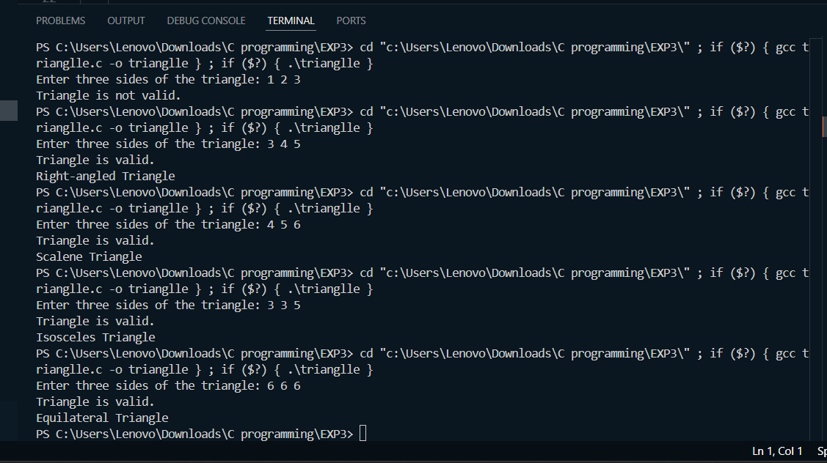

Activity 2: WAP to compute the BMI index of the person and print the BMI values as per the following ranges. You can use the following formula to compute $BMI =\frac{weight (kgs)}{height\left(m\right)*height(m)}$
Body State | BMI
Starvation | < 15
Anorexic | 15.1 to 17.5
Underweight | 17.6 to 18.5
Ideal | 18.6 to 24.9
Overweight | 25 to 25.9
Obese | 30 to 39.9

ALGORITHM :

STEP1: Start
STEP2: Declare variables weight, height, bmi
STEP3: Read weight and height
STEP4: Calculate bmi = weight / (height * height)
STEP5: If bmi < 15 then print "Starvation" and go to STEP11 else go to STEP6
STEP6: Else if bmi >= 15.1 && bmi <= 17.5 print "Anorexic" and goto STEP11 else go to STEP7
STEP7: Else if bmi >= 17.6 && bmi <= 18.5 print "Underweight" and go to STEP11 else go to STEP8
STEP8: Else if bmi >= 18.6 && bmi <= 24.9 print "Ideal" and go to STEP11 else go to STEP9
STEP9: Else if bmi >= 25 && bmi <= 25.9 print "Overweight" and go to STEP11 else go to STEP10
STEP10: Else if bmi >= 30 && bmi <= 39.9 "Obese" and go to STEP11 else print Invalid BMI value
STEP11: End

FLOWCHART:
START

Declare variables weight, height, bmi

Read weight, height

bmi = weight/(height*height)
False
True
if bmi < 15 Print Starvation
True
if 15.1<= bmi <= 17.5 Print Anorexic
False
True
if 17.6<= bmi <= 18.5 Print Underweight
False
True
if 18.6 <= bmi <= 24.9 Print Ideal weight
False
True
if 25 <= bmi <= 25.9 Print Overweight
False
True
if 30 <= bmi <= 39.9 Print Obese
False
Print Invalid BMI value END
PSEUDOCODE:

START

declare weight, height, bmi AS float

print "Enter weight (in kg):"
input weight

print "Enter height (in meters):"
input height

SET bmi = weight / (height * height)

IF bmi < 15 THEN
print "Starvation"
ELSE IF bmi >= 15.1 AND bmi <= 17.5 THEN
print "Anorexic"
ELSE IF bmi >= 17.6 AND bmi <= 18.5 THEN
print "Underweight"
ELSE IF bmi >= 18.6 AND bmi <= 24.9 THEN
print "Ideal weight"
ELSE IF bmi >= 25 AND bmi <= 29.9 THEN
print "Overweight"
ELSE IF bmi >= 30 AND bmi <= 39.9 THEN
print "Obese"
ELSE
print "Invalid BMI value"
END IF

END

CODE :

#include <stdio.h>

int main() {

float weight, height, bmi;

printf("Enter weight (in kg): ");
scanf("%f", &weight);
printf("Enter height (in meters): ");
scanf("%f", &height);

bmi = weight / (height * height);

if (bmi < 15) {
printf("Starvation\n");
} else if (bmi >= 15.1 && bmi <= 17.5) {
printf("Anorexic\n");
} else if (bmi >= 17.6 && bmi <= 18.5) {
printf("Underweight\n");
} else if (bmi >= 18.6 && bmi <= 24.9) {
printf("Ideal weight\n");
} else if (bmi >= 25 && bmi <= 29.9) {
printf("Overweight\n");
} else if (bmi >= 30 && bmi <= 39.9) {
printf("Obese\n");
} else {
printf("Invalid BMI value\n");
}

return 0;
}

OUTPUT :
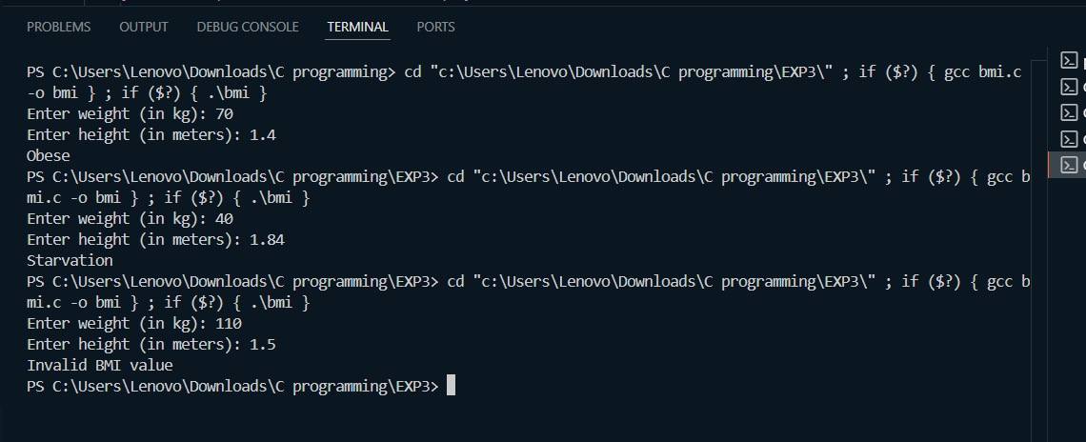

Activity 3: WAP to check if three (x₁, y₁), (x₂, y₂), (x₃, y₃) points are collinear or not.

Algorithm :
STEP 1: Start
STEP 2: Declare variables x1, y1, x2, y2, x3, y3,area
STEP 3: Read (x1, y1), (x2, y2), (x3, y3)
STEP 4: Calculate the area of triangle formed by the points area=0.5∗(x1)∗(y2−y3)+(x2)∗(y3−y1)+(x3)∗(y1−y2))
STEP 5: if Area == 0 then print "Points are Collinear" and go to STEP7
STEP 6: else Print "Points are Not Collinear"
STEP 7: End

Flowchart :
START

Declare variables x1,y1,x2,y2,x3,y3,area

Read x1, y1, x2, y2, x3, y3

area=0.5∗(x1)∗(y2−y3)+(x2)∗(y3−y1)+(x3)∗(y1−y2))
False
True
if area == 0

print Points are collinear print Points are non collinear

END

PSEUDOCODE:

START

DECLARE x1, y1, x2, y2, x3, y3 AS integer
DECLARE area AS float

print "Enter coordinates of first point (x1 y1):"
input x1, y1

print "Enter coordinates of second point (x2 y2):"
input x2, y2

print "Enter coordinates of third point (x3 y3):"
input x3, y3

SET area = 0.5 * (x1*(y2 - y3) + x2*(y3 - y1) + x3*(y1 - y2))

IF area == 0 THEN
print "The points are Collinear."
ELSE
print "The points are Not Collinear."
END IF

END

CODE :
#include <stdio.h>

int main() {

int x1, y1, x2, y2, x3, y3;
float area;

printf("Enter coordinates of first point (x1 y1): ");
scanf("%d %d", &x1, &y1);
printf("Enter coordinates of second point (x2 y2): ");
scanf("%d %d", &x2, &y2);
printf("Enter coordinates of third point (x3 y3): ");
scanf("%d %d", &x3, &y3);

area = 0.5 * (x1*(y2 - y3) + x2*(y3 - y1) + x3*(y1 - y2));
if (area == 0){
printf("The points are Collinear.\n");
}
else{
printf("The points are Not Collinear.\n");
}
return 0;
}

OUTPUT :
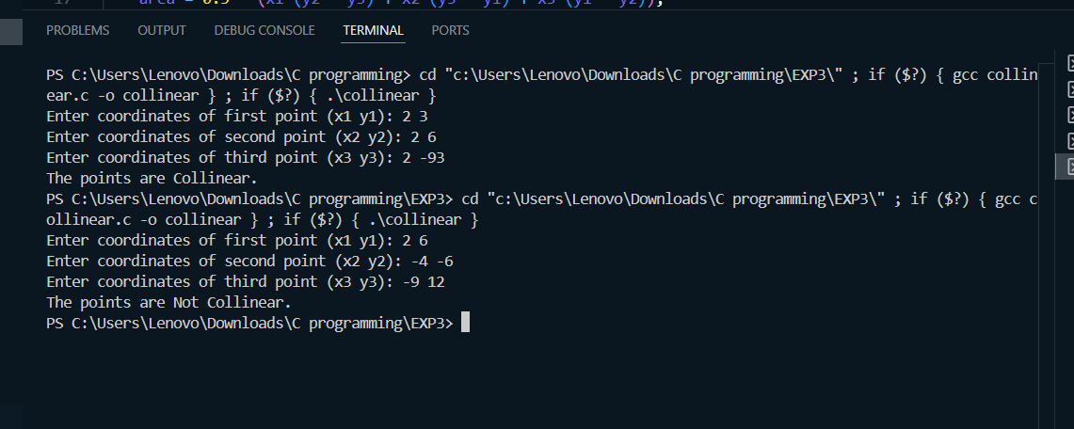

Activity 4: According to the Gregorian calendar, it was Monday on the date 01/01/01. If any year is input through the keyboard write a program to find out what is the day on 1st January of this year.
ALGORITHM:
STEP 1: Start
STEP 2: Read year
STEP 3: Initialize total_days = 0
STEP 4: For i from 1 to year - 1 :
if (i % 4 == 0 && i % 100 != 0) || (i % 400 == 0) Leap year do total_days += 366
else Normal year do total_days += 365
STEP 5: Calculate day = total_days % 7
STEP 6: if day == 0 then print “Monday” and go to STEP 14 else go to STEP 7
STEP 7: elseif day == 1 then print “Tuesday” and go to STEP 14 else go to STEP 8
STEP 8: elseif day == 2 then print “Wednesday” and go to STEP 14 else go to STEP 9
STEP 9: elseif day == 3 then print “Thursday” and go to STEP 14 else go to STEP 10
STEP 10: elseif day == 4 then print “Friday” and go to STEP 14 else go to STEP 11
STEP 11: elseif day == 5 then print “Saturday” and go to STEP 14 else go to STEP 12
STEP 12: elseif day == 6 then print “Sunday” and go to STEP 14 else go to STEP 13
STEP 13: else print “Invalid day”
STEP 14: End
FLOWCHART : START

Read year

Initialize total_days = 0
exit
For i = 1 to year-1

if (i % 4 == 0 && i % 100 != 0) || (i % 400 == 0)
False
True

total_days =+ 366 total_days =+ 365

day = total_days % 7
False
True
True
elseif day == 1 print Tuesday
if day == 0 print Monday
False
True
elseif day == 2 print Wednesday
False
True
elseif day == 3 print Thursday

False
True
elseif day == 4 print Friday
False
elseif day == 6 print Sunday
elseif day == 5 print Saturday
True
False

True
False

print Invalid day

END

PSEUDOCODE:
START

declare year, i, total_days, day AS integer
SET total_days = 0

print "Enter the year:"
input year

FOR i = 1 TO year - 1 DO
IF ((i % 4 == 0 AND i % 100 != 0) OR (i % 400 == 0)) THEN
total_days = total_days + 366
ELSE
total_days = total_days + 365
END IF
END FOR

SET day = total_days % 7

IF day == 0 THEN
print "Monday"
ELSE IF day == 1 THEN
print "Tuesday"
ELSE IF day == 2 THEN
print "Wednesday"
ELSE IF day == 3 THEN
print "Thursday"
ELSE IF day == 4 THEN
print "Friday"
ELSE IF day == 5 THEN
print "Saturday"
ELSE IF day == 6 THEN
print "Sunday"
ELSE
print "Error"
END IF

END

CODE :
#include <stdio.h>

int main() {
int year, i, total_days = 0, day;
printf("Enter the year: ");
scanf("%d", &year);

for(i = 1; i < year; i++) {
if((i % 4 == 0 && i % 100 != 0) || (i % 400 == 0)) {
total_days += 366; // Leap year
} else {
total_days += 365; // Normal year
}
}
day = total_days % 7;
if(day == 0){
printf("Monday");
}
else if(day == 1){
printf("Tuesday");
}
else if(day == 2){
printf("Wednesday");
}
else if(day == 3){
printf("Thursday");
}
else if(day == 4){
printf("Friday");
}
else if(day == 5){
printf("Saturday");
}
else if(day == 6){
printf("Sunday");
}
else {
printf("Error");
}
return 0;
}
OUTPUT: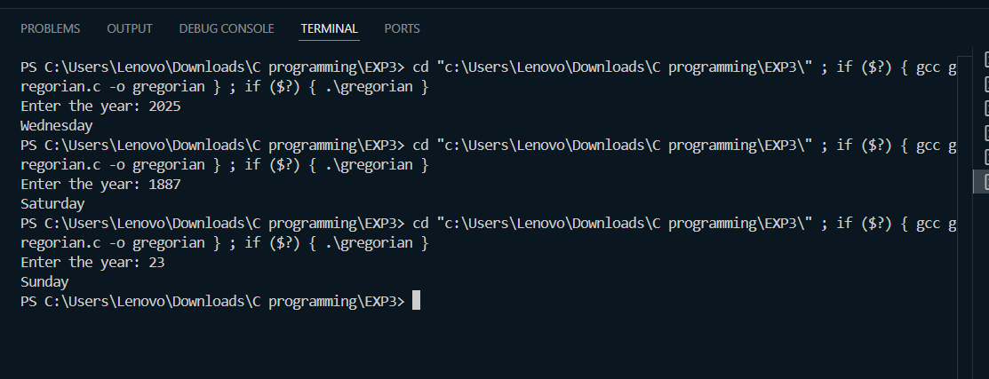

Activity 5: WAP using ternary operator, the user should input the length and breadth of a rectangle, one has to find out which rectangle has the highest perimeter. The minimum number of rectangles be three.

ALGORITHM:

STEP 1: Start
STEP 2: Read l1, b1, l2, b2, l3, b3
STEP 3: Calculate : p1 = 2 * (l1 + b1) p2 = 2 * (l2 + b2) p3 = 2 * ( l3 + b3)
STEP 4: Using Ternary Operator : max_perimeter = (p1 > p2) ? ((p1 > p3) ? p1 : p3) : ((p2 > p3) ? p2 :p3) STEP 5: Display max_perimeter
STEP 6 : End

FLOWCHART: START

Read (l1, b1), (l2, b2), (l3, b3)

p1 = 2 * ( l1 + b1)

p2 = 2 * ( l2 + b2)

p3 = 2 * ( l3 + b3)
NO
YES
is p1 > p2 && p1 > p3 ?
NO

YES
max_perimeter = p1 is p2 > p3 ?

max_perimeter = p2
max_perimeter = p3

Rectangle 1 has max perimeter Rectangle 2 has max perimeter

Rectangle 3 has max perimeter

END

PSEUDOCODE:
START

declare l1, b1, l2, b2, l3, b3 AS float
declare p1, p2, p3 AS float

print "Enter length and breadth of rectangle 1: "
input l1, b1

print "Enter length and breadth of rectangle 2: "
input l2, b2

print "Enter length and breadth of rectangle 3: "
input l3, b3

p1 = 2 * (l1 + b1)
p2 = 2 * (l2 + b2)
p3 = 2 * (l3 + b3)

IF p1 > p2 AND p1 > p3 THEN
print "Rectangle 1 has maximum perimeter = ", p1
ELSE IF p2 > p3 THEN
print "Rectangle 2 has maximum perimeter = ", p2
ELSE
print "Rectangle 3 has maximum perimeter = ", p3
END IF

END

CODE:
#include <stdio.h>

int main() {
float l1, b1, l2, b2, l3, b3;
float p1, p2, p3;

printf("Enter length and breadth of rectangle 1: ");
scanf("%f %f", &l1, &b1);
printf("Enter length and breadth of rectangle 2: ");
scanf("%f %f", &l2, &b2);
printf("Enter length and breadth of rectangle 3: ");
scanf("%f %f", &l3, &b3);

p1 = 2 * (l1 + b1);
p2 = 2 * (l2 + b2);
p3 = 2 * (l3 + b3);

(p1 > p2 && p1 > p3) ? printf("Rectangle 1 has max perimeter = %.2f\n", p1) : (p2 > p3 ?
printf("Rectangle 2 has max perimeter = %.2f\n", p2) :
printf("Rectangle 3 has max perimeter = %.2f\n", p3));

return 0;
}

OUTPUT:
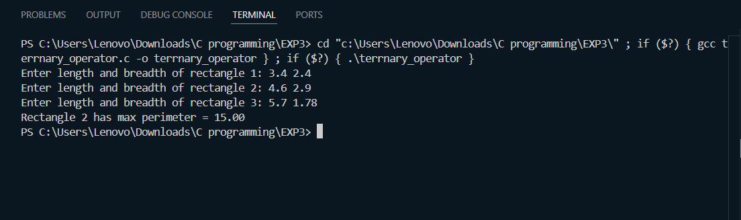

EXPERIMENT 3.2 : LOOPS

ACTIVITY 1: WAP to enter numbers till the user wants. At the end it should display the count of positives, negatives and zeroes entered.

ALGORITHM :
STEP 1: Start
STEP 2: Initialize pos = 0, neg = 0, zero = 0
STEP 3: Read num
STEP 4: if num > 0 then pos = pos + 1 and go to STEP 6 else go to STEP 5
STEP 5: if num < 0 then neg = neg + 1 and go to STEP 6 else zero = zero + 1 and go to STEP 6
STEP 6: Read choice
STEP 7: if choice == 1 then go to STEP 3 else go to STEP 8
STEP 8: Print pos, neg, zero
STEP 9: End

FLOWCHART : START

Initialize pos = 0, neg = 0, zero = 0

Read num

pos = pos + 1 if num > 0
zero = zero +1
neg = neg + 1
if num < 0

Read choice

if choice == 1

print pos, neg, zero

EXIT

PSEUDOCODE :
START

num, pos, neg, zero, choice as integer
SET pos = 0, neg = 0, zero = 0

REPEAT
print "Enter a number:"
input num

IF num > 0 THEN
pos = pos + 1
ELSE IF num < 0 THEN
neg = neg + 1
ELSE
zero = zero + 1
END IF

print "Do you want to continue? (1 = Yes, 0 = No):"
input choice

UNTIL choice != 1

print "Count of positive numbers =", pos
print "Count of negative numbers =", neg
print "Count of zeroes =", zero

END

CODE :
#include <stdio.h>

int main() {
int num, pos = 0, neg = 0, zero = 0;
int choice;

do {
printf("Enter a number: ");
scanf("%d", &num);

if (num > 0)
pos = pos + 1;
else if (num < 0)
neg = neg + 1;
else
zero = zero + 1;

printf("Do you want to continue? (1 = Yes, 0 = No): ");
scanf("%d", &choice);

} while (choice == 1);

printf("\nCount of positive numbers: %d", pos);
printf("\nCount of negative numbers: %d", neg);
printf("\nCount of zeroes: %d\n", zero);

return 0;
}

OUTPUT :
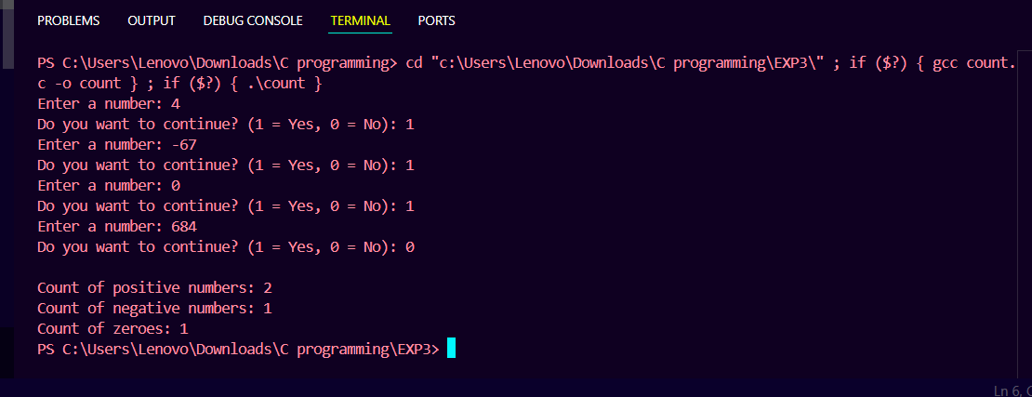

ACTIVITY 2: WAP to print the multiplication table of the number entered by the user. It should be in the correct formatting. (Num * 1 = Num)
ALGORITHM :
STEP 1: Start
STEP 2: Read num
STEP 3: Initialize i = 1
STEP 4: Repeat STEP 5 to STEP 7 while i <= 10
STEP 5: result = num * i
STEP 6: print num * i = result
STEP 7: i = i + 1
STEP 8: End
FLOWCHART : START

Read num

Initialize i = 1
i = i + 1
true
Print num * i = result
result = num * i
is i <= 10

false
EXIT

PSEUDOCODE:
START

declare num, i, result as integer

print "Enter a number:"
input num

print "Multiplication Table of", num, ":"

FOR i = 1 TO 10 DO
result = num * i
print num, "*", i, "=", result
END FOR

END

CODE :
#include <stdio.h>

int main() {
int num, i, result;

printf("Enter a number: ");
scanf("%d", &num);

printf("\nMultiplication Table of %d:\n", num);

for(i = 1; i <= 10; i++) {
result = num * i;
printf("%d * %d = %d\n", num, i, result);
}

return 0;
}

OUTPUT :
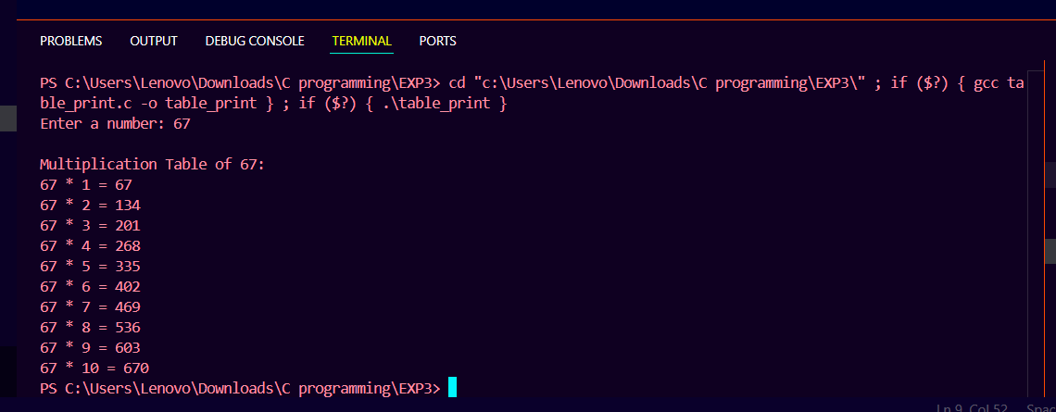

ACTIVITY 3: WAP to generate the following set of output :

- 1
2 3
4 5 6

ALGORITHM :

STEP 1: Start
STEP 2: Initialize i = 1, num = 1
STEP 3: Repeat STEP4 to STEP9 while i <= 3
STEP 4: Set space = 3
STEP 5: Repeat while space > i
Print " "
space = space - 1
STEP 6: Set j = 1
STEP 7: Repeat while j <= i
Print num
num = num + 1
j = j + 1
STEP 8: Print "\n"
STEP 9: i = i + 1
STEP 10: Stop

FLOWCHART: START

Initialize i = 1, num = 1

Yes No
is i <= 3 END

Set space = 3

No
is space > i Set j = 1
Yes
No
Print “ “ is j <= i ? print “\n”

Yes
i = i + 1
space = space - 1
Print num

num = num + 1

j = j + 1

PSEUDOCODE :
START

DECLARE i, j, space, num AS integer
SET num = 1

FOR i = 1 TO 3 DO
FOR space = 3 TO i + 1 DO
print " "
END FOR

FOR j = 1 TO i DO
print num
num = num + 1
END FOR

print newline
END FOR

END

CODE :
#include <stdio.h>

int main() {
int i, j, space, num = 1;

for (i = 1; i <= 3; i++) {
for (space = 3; space > i; space--) {
printf(" ");
}

for (j = 1; j <= i; j++) {
printf("%2d ", num);
num++;
}

printf("\n");
}

return 0;
}

OUTPUT:
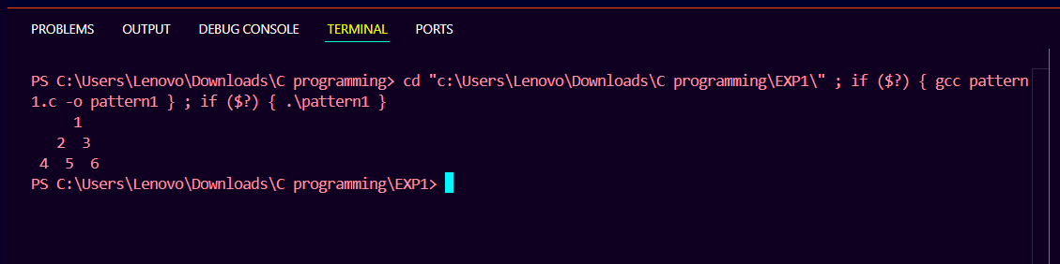

- 1
- 1
- 2 1
- 3 3 1
ALGORITHM :
STEP 1: Start
STEP 2: Initialize n = 4, i = 0
STEP 3: Repeat STEP4 to STEP15 while i < n else go to STEP16
STEP 4: Set space = 1
STEP 5: Repeat STEP6 to STEP7 while space <= n – i else go to STEP8
STEP 6: Print a space " "
STEP 7: space = space + 1
STEP 8: Set coef = 1
STEP 9: Set j = 0
STEP 10: Repeat STEP11 to STEP13 while j <= I else go to STEP14
STEP 11: Print coef
STEP 12: coef = coef * (i - j) / (j + 1)
STEP 13: j = j + 1
STEP 14: Print “ \n”
STEP 15: i = i + 1
STEP 16: Stop

FLOWCHART :
START

Initialize n = 4, i = 0

Yes No
is i <= n ? END

Set space = 1

No
is space <= n-1 coef = 1
Yes
Set j = 0
Print “ “

No
space = space + 1 is j <= i ? print “ \n “
Yes
i = i + 1
Print coef
j = j + 1
coef = coef * ( i – j ) / ( j + 1)

PSEUDOCODE :
START
SET n = 4
SET i = 0

WHILE i < n DO
SET space = 1
WHILE space <= n - i DO
PRINT " "
space = space + 1
END WHILE

SET coef = 1
SET j = 0
WHILE j <= i DO
PRINT coef
coef = coef * (i - j) / (j + 1)
j = j + 1
END WHILE

PRINT new line
i = i + 1
END WHILE
END

CODE :
#include <stdio.h>

int main() {
int n = 4;
int i, j, space, coef;

for (i = 0; i < n; i++) {

for (space = 1; space <= n - i; space++) {
printf(" ");
}

coef = 1;
for (j = 0; j <= i; j++) {
printf("%d ", coef);
coef = coef * (i - j) / (j + 1);
}

printf("\n");
}

return 0;
}

OUTPUT :
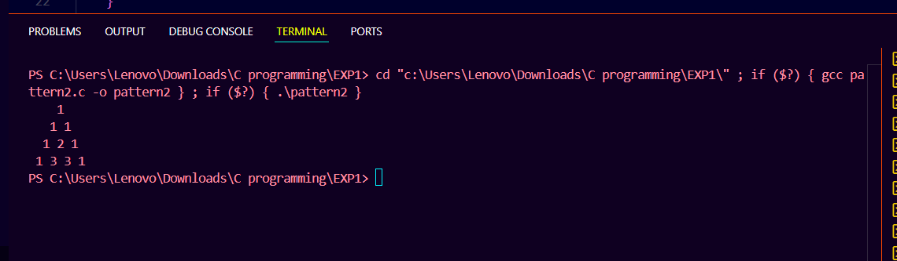

Activity 4 : The population of a town is 100000. The population has increased steadily at the rate of 10% per year for the last 10 years. Write a program to determine the population at the end of each year in the last decade.

ALGORITHM :
STEP 1: Start
STEP 2: Initialize population = 100000
STEP 3: Display “Population of the town over the last 10 years:”
STEP 4: Set year = 10
STEP 5: if year >= 1 go to STEP6 else go to STEP9
STEP 6: Compute population = population / 1.10
STEP 7: Display year, population
STEP 8: year = year - 1 and go to STEP5
STEP 9: Stop

FLOWCHART : START

year = year - 1
Display year, population
Population = population / 1.10 is year >= 1 ? END
Set year = 10
Print “Population of the town over the las decade"
Set population = 100000

Yes
No

PSEUDOCODE :
START

population = 100000
print "Population of the town over the last decade:"

FOR year = 10 TO 1 STEP -1 DO
population = population / 1.10
print "Year", year, "ago:", population
END FOR

END

CODE :
#include <stdio.h>

int main() {
float population = 100000;

printf("Population of the town over the last 10 years:\n");

for (int year = 10; year >= 1; year--) {
population = population / 1.10; // reverse 10% growth
printf("Year %d ago: %.0f\n", year, population);
}

return 0;
}
OUTPUT :
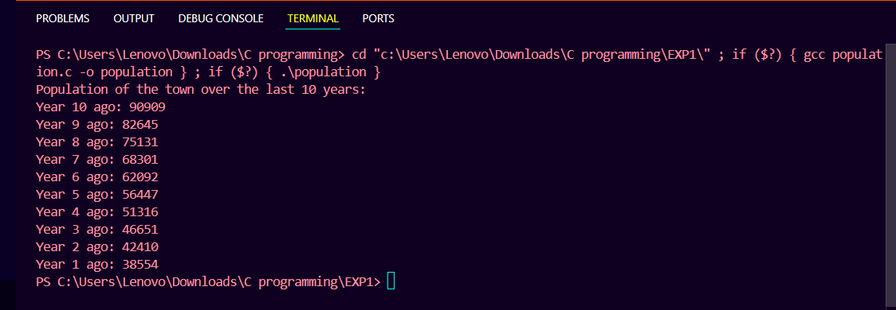
Activity 5: Ramanujan Number is the smallest number that can be expressed as the sum of two cubes in two different ways. WAP to print all such numbers up to a reasonable limit.
for a number L = 20. (that is limit)
Example of Ramanujan number: 1729

ALGORITHM :
STEP 1:

