EXPERIMENT 4 : VARIABLES AND SCOPE OF VARIABLES

Activity 1: Declare a global variable outside all functions and use it inside various functions to understand its accessibility.

ALGORITHM
STEP 1: Start the program.
STEP 2: Declare and initialize a global variable num = 5
STEP 3: Define the function show()
STEP 4: In show(), print the current value of num.
STEP 5: Define the function change()
STEP 6: In change(), assign num = 10 and print new value of num
STEP 7: In main(), print the initial value of num
STEP 8: Call the function show()
STEP 9: Call the function change()
STEP 10: Print value of num in main()
STEP 11: End

FLOWCHART :

START

Define & Initialize num = 5
Define function show()

Define function change()
Assign num =10 in show()

Print initial value of num in main ()

Call functions show() & change ()

Print old and new value of num inside main ()

END

PSEUDOCODE :
START

DECLARE global variable num = 5

FUNCTION show
print "Inside show(): num = ", num
END FUNCTION

FUNCTION change
SET num = 10
PRINT "Inside change(): num = ", num
END FUNCTION

MAIN FUNCTION
print "In main(): num = ", num
show()
change()
print "Back in main(): num = ", num
END MAIN

END

CODE :
#include <stdio.h>

// Global variable (accessible in all functions)
int num = 5;

void show() {
// Using the global variable directly
printf("Inside show(): num = %d\n", num);
}

void change() {
// Modifying the global variable
num = 10;
printf("Inside change(): num = %d\n", num);
}

int main() {
printf("In main(): num = %d\n", num);
show();
change();
printf("Back in main(): num = %d\n", num);
return 0;
}

OUTPUT:
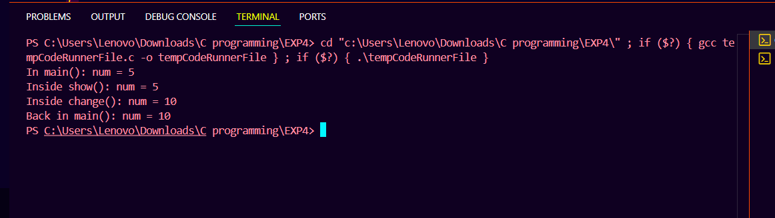

Activity 2: Declare a local variable inside a function and try to access it outside the function. Compare this with accessing the global variable from within the function.

ALGORITHM :
STEP 1: Start
STEP 2: Declare and initialize a global variable globalvar
STEP 3: Define the function localexample()
STEP 4: Declare a local variable localvar inside localexample() and initialize it.
STEP 5: Inside localexample(), print localvar and globalvar.
STEP 6: In main(), print the value of globalvar.
STEP 7: Call the function localexample().
STEP 9: End

FLOWCHART :
START

Define & Initialize globalvar = 50
Define function localexample()

Declare variable localvar in localexample()
Print globalvar inside main()

Call function localexample()

END

PSEUDOCODE:
START

Declare global variable globalvar = 50

FUNCTION localexample
DECLARE local variable localvar = 10
print "Inside localExample(): localvar = ", localvar
print "Inside localExample(): globalvar = ", globalvar
END FUNCTION

MAIN FUNCTION
print "In main(): globalvar = ", globalvar
localExample()

END MAIN

END

CODE :
#include <stdio.h>

// Global variable
int globalvar = 50;

void localExample() {
// Local variable
int localvar = 10;
printf("Inside localExample(): localVar = %d\n", localvar);
printf("Inside localExample(): globalVar = %d\n", globalvar);
}

int main() {
printf("In main(): globalVar = %d\n", globalvar);
printf("In main(): globalVar = %d\n", localvar);

return 0;
}

OUTPUT :
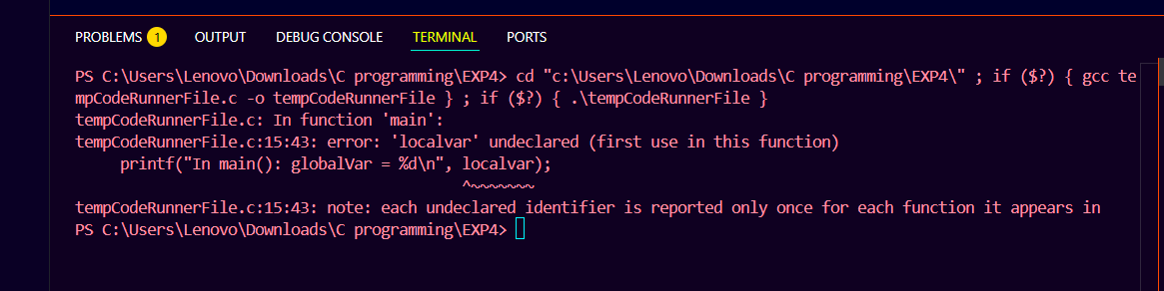
Encountered with an error for accessing the localvar inside the main() function

Activity 3: Declare variables within different code blocks and (enclosed by curly braces) and test their accessibility within and outside those blocks.
ALGORITHM :
STEP 1: Start
STEP 2: Declare and initialize variable x in the main()
STEP 3: Print the value of x in the main block
STEP 4: Enter inner block 1
STEP 5: Declare and initialize variable y in inner block 1
STEP 6: Print the values of x and y inside inner block 1
STEP 7: Enter inner block 2 inside inner block 1
STEP 8: Declare and initialize variable z in inner block 2
STEP 9: Print the values of x, y, and z inside inner block 2
STEP 10: Exit inner block 2
STEP 11: Exit inner block 1
STEP 12: End

FLOWCHART :
START

Define & Initialize x = 10
Print x

Declare and initialize y = 20 in inner block 1
Print x & y

Declare and initialize z = 30 in inner block 2

Print x, y & z
END

PSEUDOCODE :
START

DECLARE variable x in main block
print "In main block: x = ", x

ENTER inner block 1
DECLARE variable y
print "Inside inner block 1: x = ", x, ", y = ", y

ENTER inner block 2
DECLARE variable z
print "Inside inner block 2: x = ", x, ", y = ", y, ", z = ", z
EXIT inner block 2

EXIT inner block 1

END

CODE :

int main() {
int x = 10; // Variable in main block
printf("In main block: x = %d\n", x);

{
int y = 20; // Variable in inner block 1
printf("Inside inner block 1: x = %d, y = %d\n", x, y);

{
int z = 30; // Variable in inner block 2
printf("Inside inner block 2: x = %d, y = %d, z = %d\n", x, y, z);
}

}

return 0;
}

OUTPUT :
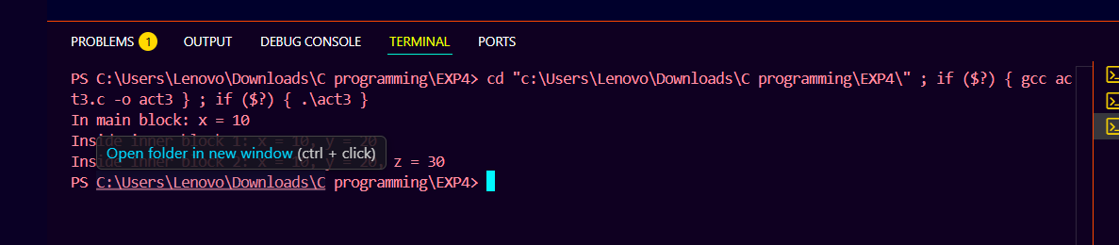

printf("In main block: x = %d, y = %d, z = %d\n", x, y, z);

y and z are not accessible outside inner blocks

This would cause a compilation error
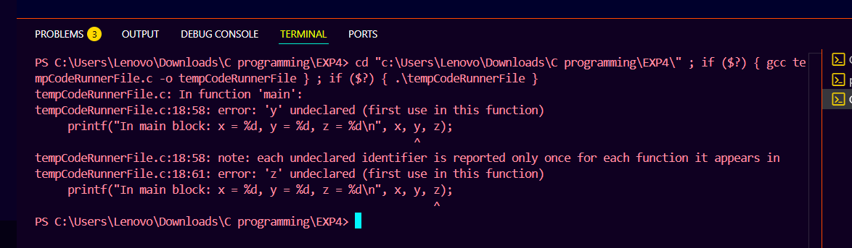

Activity 4: Declare a static local variable inside a function. Observe how its value persists across function calls.

ALGORITHM :
STEP 1: Start
STEP 2: Define the function counter() with static local variable count=0
STEP 3: Increment count by 1
STEP 4: Print the value of count
STEP 5: In main(), call counter() for the first time
STEP 6: Call counter() for the second time
STEP 7: Call counter() for the third time
STEP 8: End

FLOWCHART : START

Define function counter() with static variable count = 0
count = count + 1

Call count ()

Call count ()

Call count ()

END

PSEUDOCODE :
START

FUNCTION counter
DECLARE static local variable count = 0
Count = count + 1
print "Counter value: ", count
END FUNCTION

MAIN FUNCTION
print "Calling counter() first time:"
Call counter()

print "Calling counter() second time:"
Call counter()

print "Calling counter() third time:"
Call counter()
END MAIN

END

CODE :
#include <stdio.h>

void counter() {
static int count = 0; // static local variable
count++;
printf("Counter value: %d\n", count);
}

int main() {
printf("Calling counter() first time:\n");
counter();

printf("Calling counter() second time:\n");
counter();

printf("Calling counter() third time:\n");
counter();
return 0;
}
OUTPUT :
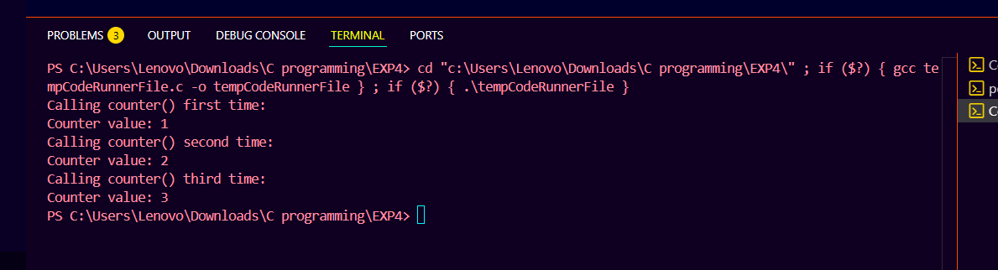
Static variable count retained its value between function calls, unlike normal local variables which are reinitialized each time.

