- Print square of number from 1 to 5

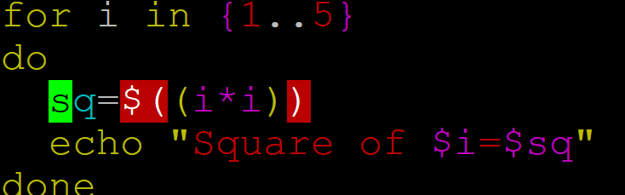

2) Keep asking user for a number until they enter 0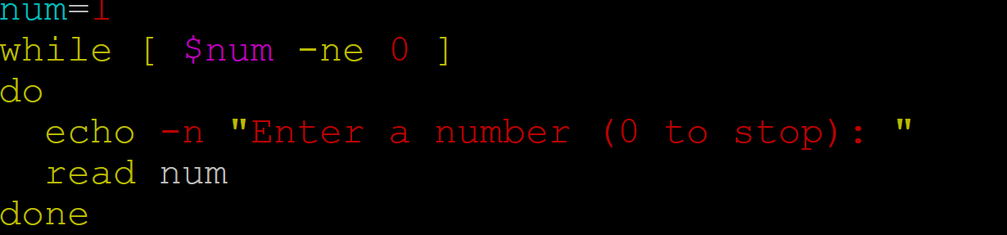

3) Write a shell script using positional parameters to add three numbers
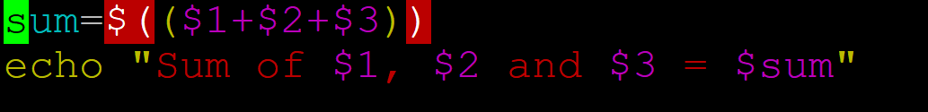

4) Print factorial of a number

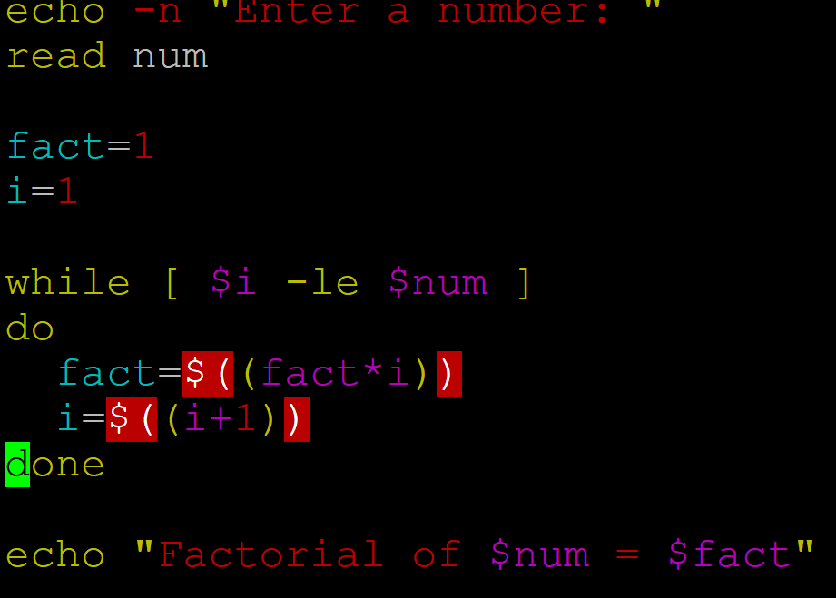

5) Print numbers from 1 to 10 but skip number 8
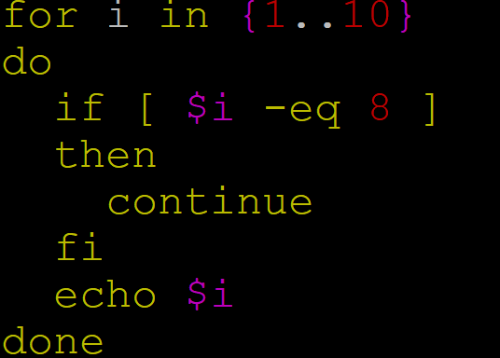

6) Print squares of numbers from 1 to 10
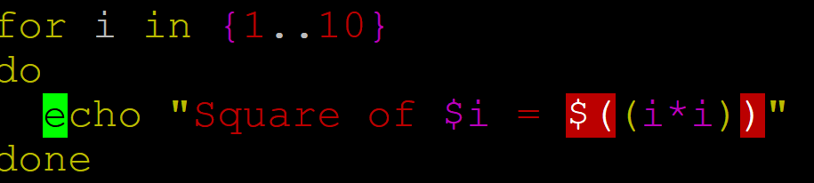

7) Print numbers from 5 to 1 using until loop

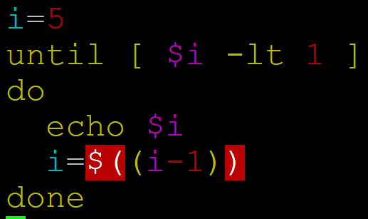

Check whether input Number is Palindrom Number or not.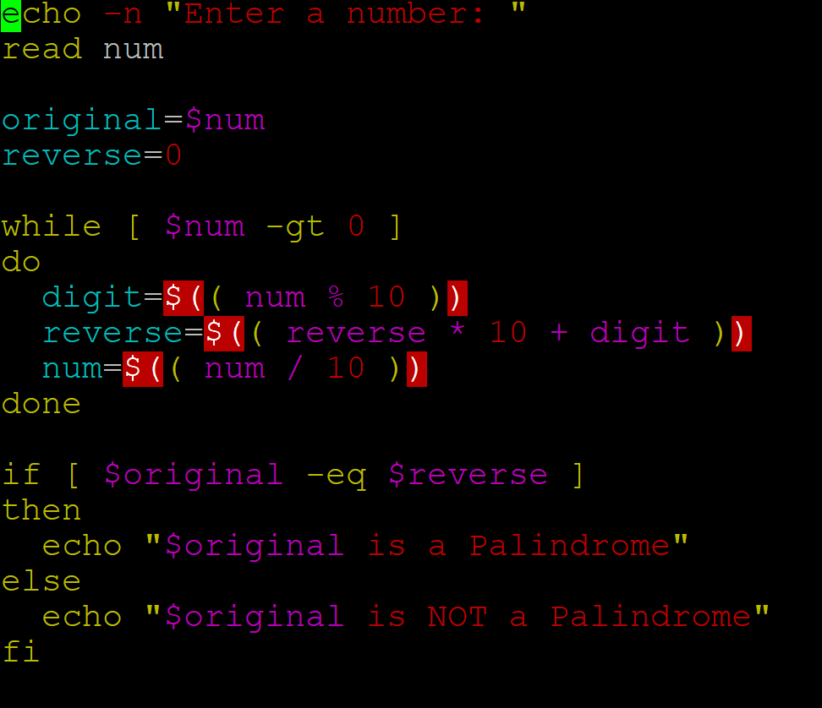

Check Enter number is Armstrong or not.

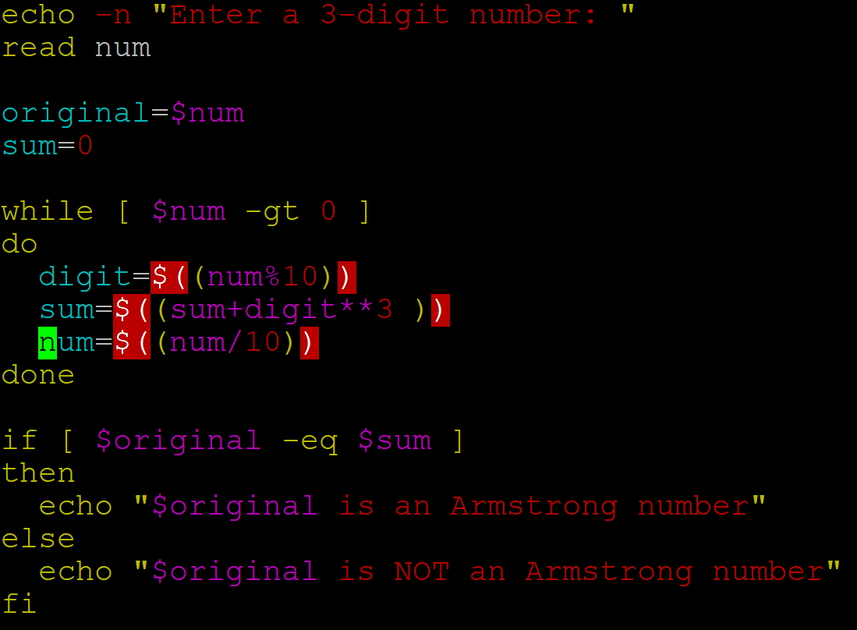

Write a shell script to check whether a given number is prime or not.
echo "Enter a number:"
read n

count=0

for ((i=1; i<=n; i++))
do
if [ $((n % i)) -eq 0 ]
then
count=$((count + 1))
fi
done

if [ $count -eq 2 ]
then
echo "$n is a Prime number"
else
echo "$n is Not a Prime number"
fi

