**COMPUTER NETWORKS**

**LAB 5**

**QUESTION1**

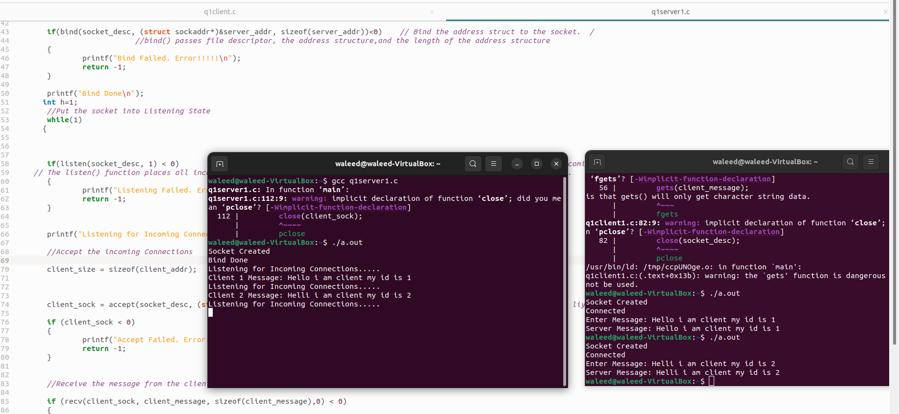

**Question 1 code:**

**Client side**

#include <stdio.h>  
#include <string.h>  
#include <sys/socket.h> //socket  
#include <arpa/inet.h> //inet_addr  
  
int main(void)  
{  
        int socket_desc;  
        struct sockaddr_in server_addr;  
        char server_message[2000], client_message[2000];  
         
        //Cleaning the Buffers  
         
        memset(server_message,'\0',sizeof(server_message));  
        memset(client_message,'\0',sizeof(client_message));  
         
        //Creating Socket  
         
        socket_desc = socket(AF_INET, SOCK_STREAM, 0);  
         
        if(socket_desc < 0)  
        {  
                printf("Could Not Create Socket. Error!!!!!\n");  
                return -1;  
        }  
         
        printf("Socket Created\n");  
         
        //Specifying the IP and Port of the server to connect  
         
        server_addr.sin_family = AF_INET;  
        server_addr.sin_port = htons(2000);  
        server_addr.sin_addr.s_addr = inet_addr("127.0.0.1");  
         
        //Now connecting to the server accept() using connect() from client side  
         
        if(connect(socket_desc, (struct sockaddr*)&server_addr, sizeof(server_addr)) < 0)  
        {  
                printf("Connection Failed. Error!!!!!");  
                return -1;  
        }  
         
        printf("Connected\n");  
         
        //Get Input from the User  
         
        printf("Enter Message: ");  
        gets(client_message);                                     //One is that gets() will only get character string data.  
                                                       // will get only one variable at a time.  
//  reads characters from stdin and loads them into str  
        //Send the message to Server  
         
        if(send(socket_desc, client_message, strlen(client_message),0) < 0)  
        {  
                printf("Send Failed. Error!!!!\n");  
                return -1;  
        }  
         
        //Receive the message back from the server  
         
        if(recv(socket_desc, server_message, sizeof(server_message),0) < 0)  
        {  
                printf("Receive Failed. Error!!!!!\n");  
                return -1;  
        }  
         
        printf("Server Message: %s\n",server_message);  
         
        memset(server_message,'\0',sizeof(server_message));  
        memset(client_message,'\0',sizeof(client_message));

        //Closing the Socket

close(client_sock);  
        close(socket_desc);  
        return 0;        
}

        close(socket_desc);  
         
        return 0;  
}

**Server Side**

#include <stdio.h>  
#include <string.h>  
#include <sys/socket.h> //socket  
#include <arpa/inet.h> //inet_addr  
  
int main(void)  
{  
         
        int socket_desc, client_sock, client_size;  
        struct sockaddr_in server_addr, client_addr;         //SERVER ADDR will have all the server address  
        char server_message[2000], client_message[2000];                 // Sending values from the server and receive from the server we need this  
  
        //Cleaning the Buffers  
         
        memset(server_message,'\0',sizeof(server_message));  
        memset(client_message,'\0',sizeof(client_message));     // Set all bits of the padding field//  
         
        //Creating Socket  
         
        socket_desc = socket(AF_INET, SOCK_STREAM, 0);  
         
        if(socket_desc < 0)  
        {  
                printf("Could Not Create Socket. Error!!!!!\n");  
                return -1;  
        }  
         
        printf("Socket Created\n");  
         
        //Binding IP and Port to socket  
         
        server_addr.sin_family = AF_INET;               /* Address family = Internet */  
        server_addr.sin_port = htons(2000);               // Set port number, using htons function to use proper byte order */  
        server_addr.sin_addr.s_addr = inet_addr("127.0.0.1");    /* Set IP address to localhost */  
  
  
  
// BINDING FUNCTION  
         
        if(bind(socket_desc, (struct sockaddr*)&server_addr, sizeof(server_addr))<0)    // Bind the address struct to the socket.  /  
                            //bind() passes file descriptor, the address structure,and the length of the address structure  
        {  
                printf("Bind Failed. Error!!!!!\n");  
                return -1;  
        }          
         
        printf("Bind Done\n");  
       int h=1;  
        //Put the socket into Listening State  
        while(1)  
       {  
         
         
         
        if(listen(socket_desc, 1) < 0)                               //This listen() call tells the socket to listen to the incoming connections.  
     // The listen() function places all incoming connection into a "backlog queue" until accept() call accepts the connection.  
        {  
                printf("Listening Failed. Error!!!!!\n");  
                return -1;  
        }  
         
       
        printf("Listening for Incoming Connections.....\n");  
         
        //Accept the incoming Connections  
         
        client_size = sizeof(client_addr);  
  
  
  
        client_sock = accept(socket_desc, (struct sockaddr*)&client_addr, &client_size);          // heree particular client k liye new socket create kr rhaa ha  
         
        if (client_sock < 0)  
        {  
                printf("Accept Failed. Error!!!!!!\n");  
                return -1;  
        }  
         
  
        //Receive the message from the client  
         
        if (recv(client_sock, client_message, sizeof(client_message),0) < 0)  
        {  
                printf("Receive Failed. Error!!!!!\n");  
                return -1;  
        }  
         
        printf("Client %d ", h);  
        printf("Message: %s\n",client_message);  
        h++;  
        //Send the message back to client  
         
        strcpy(server_message, client_message);  
         
        if (send(client_sock, server_message, strlen(client_message),0)<0)  
        {  
                printf("Send Failed. Error!!!!!\n");  
                return -1;  
        }  
         
        memset(server_message,'\0',sizeof(server_message));  
        memset(client_message,'\0',sizeof(client_message));  
         
        }  
         
           
        //Closing the Socket  
         
        close(client_sock);  
        close(socket_desc);  
        return 0;        
}

        close(socket_desc);  
         
        return 0;  
}

**QUESTION 2**

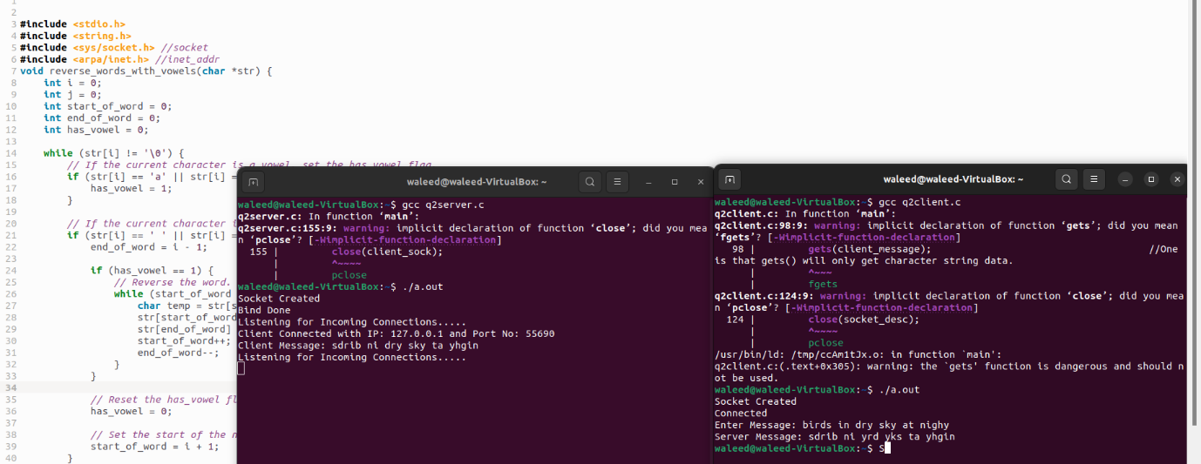

**Server code:**

/*

        TCP_Server. This Program will will create the Server side for TCP_Socket Programming.

        It will receive the data from the client and then send the same data back to client.

*/

#include <stdio.h>

#include <string.h>

#include <sys/socket.h> //socket

#include <arpa/inet.h> //inet_addr

void reverse_words_with_vowels(char *str) {

    int i = 0;

    int j = 0;

    int start_of_word = 0;

    int end_of_word = 0;

    int has_vowel = 0;

    while (str[i] != '\0') {

        // If the current character is a vowel, set the has_vowel flag.

        if (str[i] == 'a' || str[i] == 'e' || str[i] == 'i' || str[i] == 'o' || str[i] == 'u') {

            has_vowel = 1;

        }

        // If the current character is a space or the end of the string, reverse the word if it has at least one vowel.

        if (str[i] == ' ' || str[i] == '\0') {

            end_of_word = i - 1;

            if (has_vowel == 1) {

                // Reverse the word.

                while (start_of_word < end_of_word) {

                    char temp = str[start_of_word];

                    str[start_of_word] = str[end_of_word];

                    str[end_of_word] = temp;

                    start_of_word++;

                    end_of_word--;

                }

            }

            // Reset the has_vowel flag.

            has_vowel = 0;

            // Set the start of the next word.

            start_of_word = i + 1;

        }

        i++;

    }

if (has_vowel == 0 && start_of_word < i) {

end_of_word = i - 1;

while (start_of_word < end_of_word) {

char temp = str[start_of_word];

str[start_of_word] = str[end_of_word];

str[end_of_word] = temp;

start_of_word++;

end_of_word--;

}

}

}

int main(void)

{

        int socket_desc, client_sock, client_size;

        struct sockaddr_in server_addr, client_addr;         //SERVER ADDR will have all the server address

        char server_message[2000], client_message[2000];                 // Sending values from the server and receive from the server we need this

        //Cleaning the Buffers

        memset(server_message,'\0',sizeof(server_message));

        memset(client_message,'\0',sizeof(client_message));     // Set all bits of the padding field//

        //Creating Socket

        socket_desc = socket(AF_INET, SOCK_STREAM, 0);

        if(socket_desc < 0)

        {

                printf("Could Not Create Socket. Error!!!!!\n");

                return -1;

        }

        printf("Socket Created\n");

        //Binding IP and Port to socket

        server_addr.sin_family = AF_INET;               /* Address family = Internet */

        server_addr.sin_port = htons(2000);               // Set port number, using htons function to use proper byte order */

        server_addr.sin_addr.s_addr = inet_addr("127.0.0.1");    /* Set IP address to localhost */

        // BINDING FUNCTION

        if(bind(socket_desc, (struct sockaddr*)&server_addr, sizeof(server_addr))<0)    // Bind the address struct to the socket.  /

                                    //bind() passes file descriptor, the address structure,and the length of the address structure

        {

                printf("Bind Failed. Error!!!!!\n");

                return -1;

        }

        printf("Bind Done\n");

        //Put the socket into Listening State

        while (1){

        if(listen(socket_desc, 1) < 0)                               //This listen() call tells the socket to listen to the incoming connections.

     // The listen() function places all incoming connection into a "backlog queue" until accept() call accepts the connection.

        {

                printf("Listening Failed. Error!!!!!\n");

                return -1;

        }

        printf("Listening for Incoming Connections.....\n");

        //Accept the incoming Connections

        client_size = sizeof(client_addr);

        client_sock = accept(socket_desc, (struct sockaddr*)&client_addr, &client_size);          // heree particular client k liye new socket create kr rhaa ha

        if (client_sock < 0)

        {

                printf("Accept Failed. Error!!!!!!\n");

                return -1;

        }

        printf("Client Connected with IP: %s and Port No: %i\n",inet_ntoa(client_addr.sin_addr),ntohs(client_addr.sin_port));

               //inet_ntoa() function converts the Internet host address in, given in network byte order, to a string in IPv4 dotted-decimal notation

        //Receive the message from the client

        if (recv(client_sock, client_message, sizeof(client_message),0) < 0)

        {

                printf("Receive Failed. Error!!!!!\n");

                return -1;

        }

        reverse_words_with_vowels(client_message);

        printf("Client Message: %s\n",client_message);

        //Send the message back to client

        strcpy(server_message, client_message);

        if (send(client_sock, server_message, strlen(client_message),0)<0)

        {

                printf("Send Failed. Error!!!!!\n");

                return -1;

        }

        memset(server_message,'\0',sizeof(server_message));

        memset(client_message,'\0',sizeof(client_message));

        }

        //Closing the Socket

        close(client_sock);

        close(socket_desc);

        return 0;

}

**Client code:**

/*

        TCP_Client. This Program will implement the Client Side for TCP_Socket Programming.

        It will get some data from user and will send to the server and as a reply from the

        server, it will get its data back.

*/

#include <stdio.h>

#include <string.h>

#include <sys/socket.h> //socket

#include <arpa/inet.h> //inet_addr

void reverse_words_without_vowels(char *str) {

    int i = 0;

    int j = 0;

    int start_of_word = 0;

    int end_of_word = 0;

    int has_vowel = 0;

    while (str[i] != '\0') {

        // If the current character is a vowel, set the has_vowel flag.

        if (str[i] == 'a' || str[i] == 'e' || str[i] == 'i' || str[i] == 'o' || str[i] == 'u') {

            has_vowel = 1;

        }

        // If the current character is a space or the end of the string, reverse the word if it has no vowel characters.

        if (str[i] == ' ' || str[i] == '\0') {

            end_of_word = i - 1;

            if (has_vowel == 0) {

                // Reverse the word.

                while (start_of_word < end_of_word) {

                    char temp = str[start_of_word];

                    str[start_of_word] = str[end_of_word];

                    str[end_of_word] = temp;

                    start_of_word++;

                    end_of_word--;

                }

            }

            // Reset the has_vowel flag.

            has_vowel = 0;

            // Set the start of the next word.

            start_of_word = i + 1;

        }

        i++;

    }

if (has_vowel == 0 && start_of_word < i) {

end_of_word = i - 1;

while (start_of_word < end_of_word) {

char temp = str[start_of_word];

str[start_of_word] = str[end_of_word];

str[end_of_word] = temp;

start_of_word++;

end_of_word--;

}

}

}

int main(void)

{

        int socket_desc;

        struct sockaddr_in server_addr;

        char server_message[2000], client_message[2000];

        //Cleaning the Buffers

        memset(server_message,'\0',sizeof(server_message));

        memset(client_message,'\0',sizeof(client_message));

        //Creating Socket

        socket_desc = socket(AF_INET, SOCK_STREAM, 0);

        if(socket_desc < 0)

        {

                printf("Could Not Create Socket. Error!!!!!\n");

                return -1;

        }

        printf("Socket Created\n");

        //Specifying the IP and Port of the server to connect

        server_addr.sin_family = AF_INET;

        server_addr.sin_port = htons(2000);

        server_addr.sin_addr.s_addr = inet_addr("127.0.0.1");

        //Now connecting to the server accept() using connect() from client side

        if(connect(socket_desc, (struct sockaddr*)&server_addr, sizeof(server_addr)) < 0)

        {

                printf("Connection Failed. Error!!!!!");

                return -1;

        }

        printf("Connected\n");

        //Get Input from the User

        printf("Enter Message: ");

        gets(client_message);                                     //One is that gets() will only get character string data.

                                                       //       will get only one variable at a time.

                                                                //  reads characters from stdin and loads them into str

        //Send the message to Server

        if(send(socket_desc, client_message, strlen(client_message),0) < 0)

        {

                printf("Send Failed. Error!!!!\n");

                return -1;

        }

        //Receive the message back from the server

        if(recv(socket_desc, server_message, sizeof(server_message),0) < 0)

        {

                printf("Receive Failed. Error!!!!!\n");

                return -1;

        }

        reverse_words_without_vowels(server_message);

        printf("Server Message: %s\n",server_message);

        memset(server_message,'\0',sizeof(server_message));

        memset(client_message,'\0',sizeof(client_message));

        //Closing the Socket

        close(socket_desc);

        return 0;

}