**Ch.Waleed Ishtiaq**

**Lab 09**

**Lab Statement 1: Analyzing TCP Packets using Wireshark (10)**

**Question 1:**

**Answer:**

IP address = 192.168.1.102

Port Number = 1161

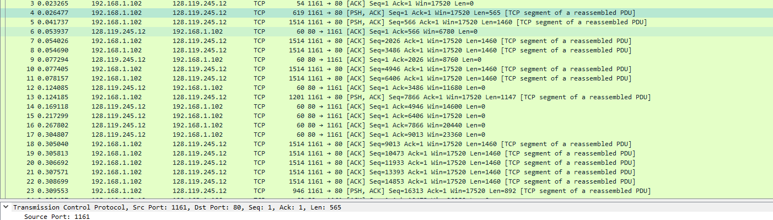

**Question 2:**

**Answer:**

IP address = 128.119.245.12

Port = 80

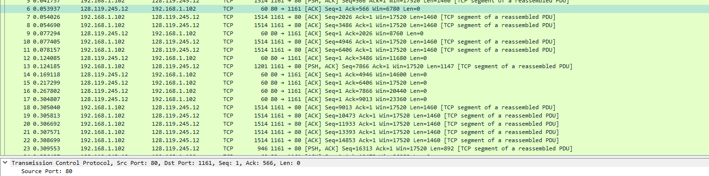

**Question 3:**

**Answer:**

Sequence Number = 0;

Flags in the segment tells us that this is an SYN segment.

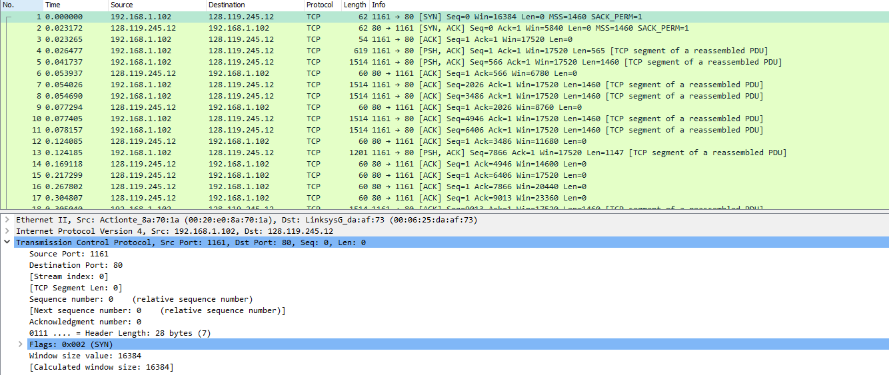

**Question 4:**

**Answer**: Sequence Number = 0, Ack number = 1,

Flags in the segment tells us that this is an SYNACK segment.

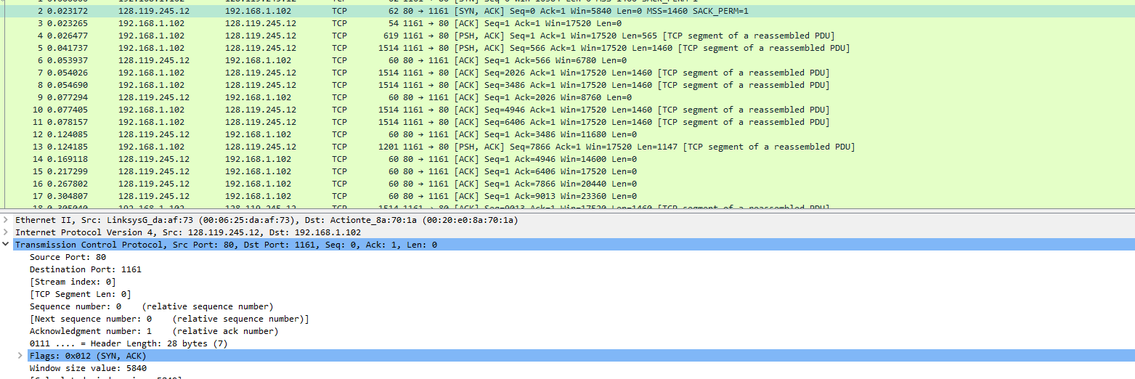

**Question 5:**

**Answer**: Because server is replying to frame 5, so the addition of sequence number of frame 5 and its length is ACK number of packet 9.

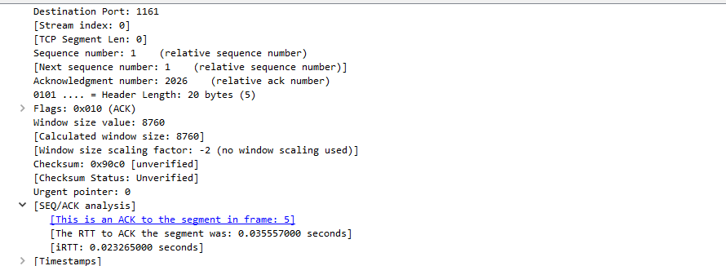

**Question 6:**

**Answer**: Because server is replying to frame 11, so the addition of sequence number of frame 11 and its length is ACK number of packet 16.

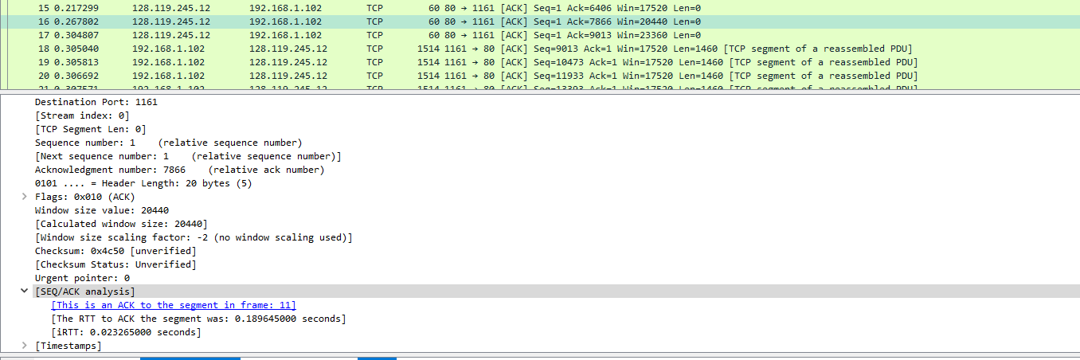

**Question 7:**

**Answer:** To make it easy to read and compare.

**Lab Statement 2: Analyzing UDP Packets using Wireshark (5)**

**Question 1 (Statement-2):**

**Answer:** Four fields

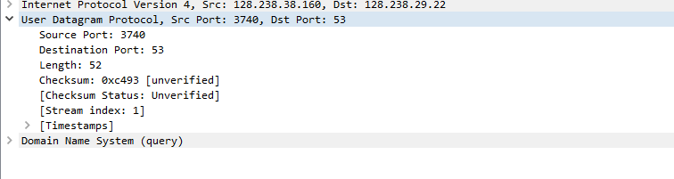

**Question 2 (Statement-2):**

**Answer**: 8 Bytes

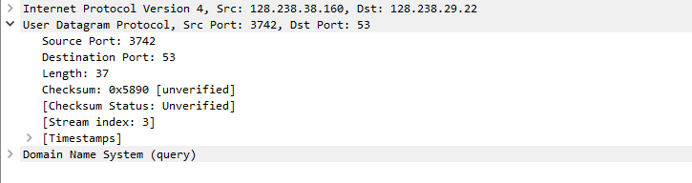

**Question 3:**

**Answer**: The value in the Length field is the length of whole packet including header and data, as UDP payload is 44 bytes and header length is 8 bytes… So length should be equal to 52 bytes which is mentioned in the UDP packet’s header.

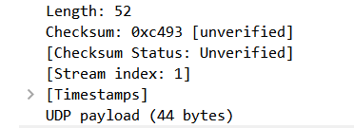

**Question 4:**

**Answer:** Port Number = 53.



**Lab Statement 3: Multithreaded ECHO server using TCP**

**(10)**

**Screen Shot:**

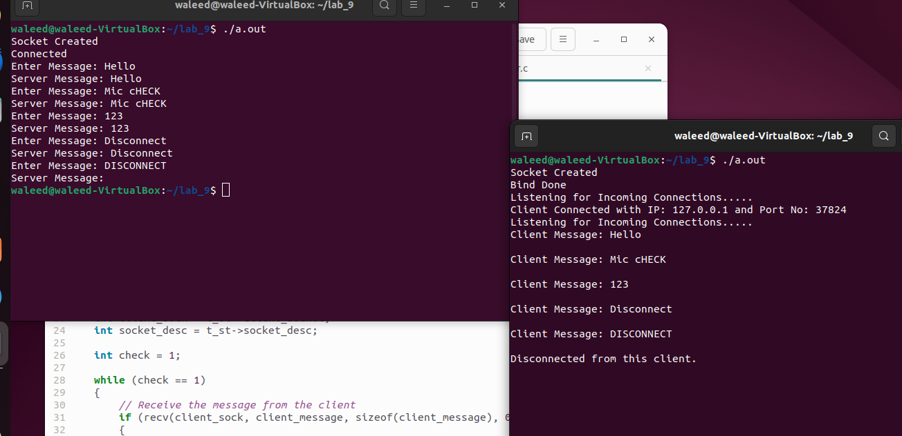

**Server:**

/*

TCP_Server. This Program will will create the Server side for TCP_Socket Programming.

It will receive the data from the client and then send the same data back to client.

*/

#include <stdio.h>

#include <pthread.h>

#include <string.h>

#include <stdlib.h>

#include <sys/socket.h>

#include <arpa/inet.h>

#define MAX_THREADS 3

struct Rec_data

{

int client_socket;

int socket_desc;

};

void *print_thread_info(void *rec_data)

{

char client_message[2000], server_message[2000];

memset(client_message, '\0', sizeof(client_message));

struct Rec_data *t_st = (struct Rec_data *)rec_data;

int client_sock = t_st->client_socket;

int socket_desc = t_st->socket_desc;

int check = 1;

while (check == 1)

{

// Receive the message from the client

if (recv(client_sock, client_message, sizeof(client_message), 0) < 0)

{

printf("Receive Failed. Error!!!!!\n");

break; // exit the loop if receive fails

}

printf("Client Message: %s\n\n", client_message);

if (strcmp(client_message, "DISCONNECT") != 0)

{

// Send the message back to the client

strcpy(server_message, client_message);

if (send(client_sock, server_message, strlen(client_message), 0) < 0)

{

printf("Send Failed. Error!!!!!\n");

break; // exit the loop if send fails

}

memset(server_message, '\0', sizeof(server_message));

memset(client_message, '\0', sizeof(client_message));

}

else

{

check = 0;

}

}

printf("Disconnected from this client.\n\n");

close(client_sock);

close(socket_desc);

free(rec_data); // Free allocated memory for Rec_data structure

pthread_exit(NULL);

}

int main(void)

{

int socket_desc, client_sock, client_size;

struct sockaddr_in server_addr, client_addr;

char server_message[2000], client_message[2000];

memset(server_message, '\0', sizeof(server_message));

memset(client_message, '\0', sizeof(client_message));

socket_desc = socket(AF_INET, SOCK_STREAM, 0);

if (socket_desc < 0)

{

printf("Could Not Create Socket. Error!!!!!\n");

return -1;

}

printf("Socket Created\n");

server_addr.sin_family = AF_INET;

server_addr.sin_port = htons(2000);

server_addr.sin_addr.s_addr = inet_addr("127.0.0.1");

if (bind(socket_desc, (struct sockaddr *)&server_addr, sizeof(server_addr)) < 0)

{

printf("Bind Failed. Error!!!!!\n");

return -1;

}

printf("Bind Done\n");

pthread_t threads[MAX_THREADS];

int t_in = 0;

while (1)

{

if (listen(socket_desc, 1) < 0)

{

printf("Listening Failed. Error!!!!!\n");

return -1;

}

printf("Listening for Incoming Connections.....\n");

client_size = sizeof(client_addr);

client_sock = accept(socket_desc, (struct sockaddr *)&client_addr, &client_size);

if (client_sock < 0)

{

printf("Accept Failed. Error!!!!!!\n");

return -1;

}

printf("Client Connected with IP: %s and Port No: %i\n", inet_ntoa(client_addr.sin_addr), ntohs(client_addr.sin_port));

if (t_in < MAX_THREADS)

{

struct Rec_data *data = (struct Rec_data *)malloc(sizeof(struct Rec_data));

data->client_socket = client_sock;

data->socket_desc = socket_desc;

pthread_create(&threads[t_in], NULL, print_thread_info, data);

pthread_detach(threads[t_in]); // Detach the thread to avoid memory leaks

++t_in;

}

else

{

if (send(client_sock, "Server Full.", strlen("Server Full."), 0) < 0)

{

printf("Send Failed. Error!!!!!\n");

}

close(client_sock);

close(socket_desc);

break;

}

}

// Closing the Socket

close(socket_desc);

return 0;

}

**Client:**

#include <stdio.h>

#include <string.h>

#include <sys/socket.h>

#include <arpa/inet.h>

#define MAX_MESSAGE_SIZE 2000

int main(void)

{

int socket_desc;

struct sockaddr_in server_addr;

char server_message[MAX_MESSAGE_SIZE], client_message[MAX_MESSAGE_SIZE];

memset(server_message, '\0', sizeof(server_message));

memset(client_message, '\0', sizeof(client_message));

// Creating Socket

socket_desc = socket(AF_INET, SOCK_STREAM, 0);

if (socket_desc < 0)

{

printf("Could Not Create Socket. Error!!!!!\n");

return -1;

}

printf("Socket Created\n");

server_addr.sin_family = AF_INET;

server_addr.sin_port = htons(2000);

server_addr.sin_addr.s_addr = inet_addr("127.0.0.1");

if (connect(socket_desc, (struct sockaddr *)&server_addr, sizeof(server_addr)) < 0)

{

printf("Connection Failed. Error!!!!!\n");

return -1;

}

printf("Connected\n");

int check = 1;

while (check == 1)

{

printf("Enter Message: ");

fgets(client_message, sizeof(client_message), stdin);

// Remove newline character from the input

client_message[strcspn(client_message, "\n")] = '\0';

if (strcmp(client_message, "DISCONNECT") == 0)

{

check = 0;

}

if (send(socket_desc, client_message, strlen(client_message), 0) < 0)

{

printf("Send Failed. Error!!!!\n");

return -1;

}

// Receive the message back from the server

if (recv(socket_desc, server_message, sizeof(server_message), 0) < 0)

{

printf("Receive Failed. Error!!!!!\n");

return -1;

}

printf("Server Message: %s\n", server_message);

memset(server_message, '\0', sizeof(server_message));

memset(client_message, '\0', sizeof(client_message));

}

// Closing the Socket

close(socket_desc);

return 0;

}