**Question1:**

**Create a TCL script to define a network topology of your choice with at least three nodes, connected using links**

set ns [new Simulator]  
  
set nf [open out.nam w]  
$ns namtrace-all $nf  
  
proc finish {} {  
global ns nf  
$ns flush-trace  
close $nf  
exec nam out.nam &  
exit 0  
}  
  
set n0 [$ns node]  
set n1 [$ns node]  
set n2 [$ns node]  
  
$n0 color orange  
  
$n0 shape hexagon  
  
$n1 color grey  
  
$n1 shape box  
  
$n2 color red  
  
  
$ns duplex-link $n0 $n2 2Mb 10ms DropTail  
$ns duplex-link $n1 $n2 2Mb 10ms DropTail  
  
$n0 color orange  
$n1 color orange  
$n2 color orange  
  
$ns queue-limit $n0 $n2 10  
$ns queue-limit $n1 $n2 10  
  
set tcp0 [new Agent/TCP]  
$tcp0 set fid 2  
$ns attach-agent $n1 $tcp0  
set sink0 [new Agent/TCPSink]  
$ns attach-agent $n0 $sink0  
$ns connect $tcp0 $sink0  
  
set ftp0 [new Application/FTP]  
$ftp0 attach-agent $tcp0  
$ns at 0.3 "$ftp0 start"  
$ns at 2.0 "$ftp0 stop"  
  
$ns at 8.0 "finish"  
$ns run

**ScreenShot**

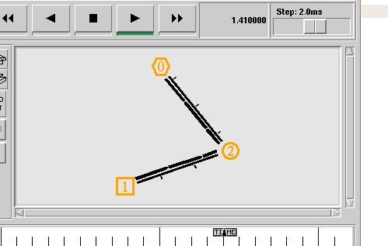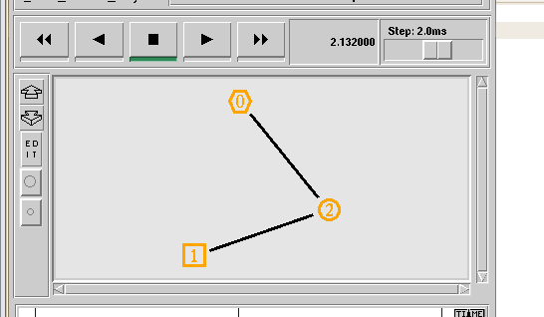

**Question2:**

**Create a circular network topology with four routers (R1, R2, R3, and  
R4) connected in a loop. Assign IP addresses to each router interface.  
Implement static routing to ensure communication between all routers.**

