Course: High Performance Computing Lab

Practical No 1

PRN:21510022

Name:Gunjan Chauke

Batch:B2

Title: Introduction to OpenMP

Problem Statement 1 – Demonstrate Installation and Running of OpenMP code in C

cmd: gcc -fopenmp -o hello helloworld.c

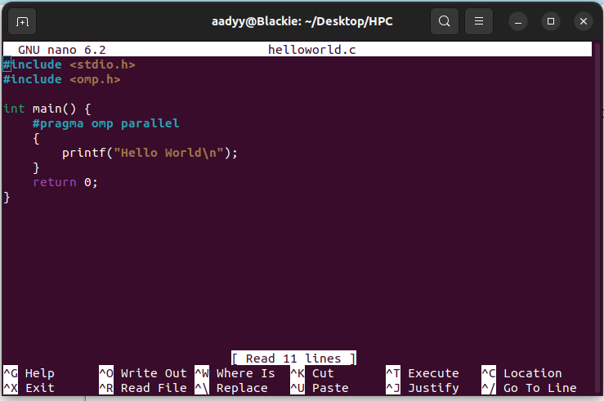

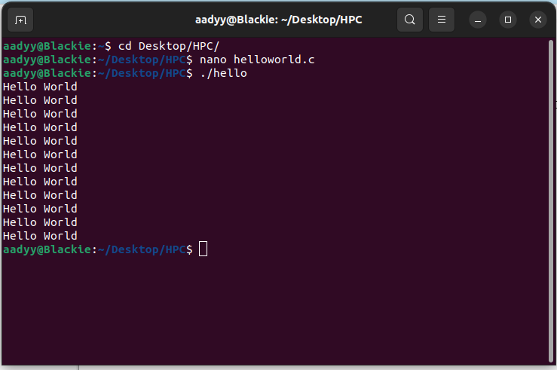

Statement 2 – Print ‘Hello, World’ in Sequential and Parallel in OpenMP

We first ask the user for number of threads – OpenMP allows to set the threads at runtime. Then, we print the Hello, World in sequential – number of times of threads count and then run the code in parallel in each thread.

Code snapshot:

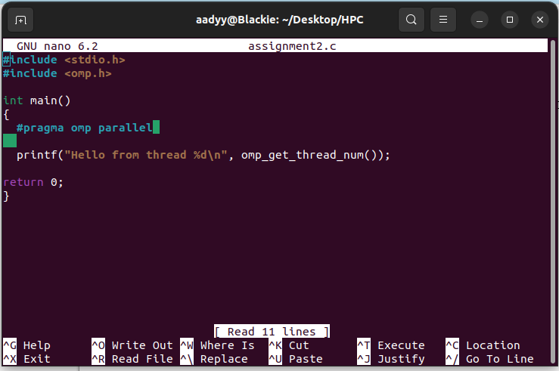

Output snapshot:

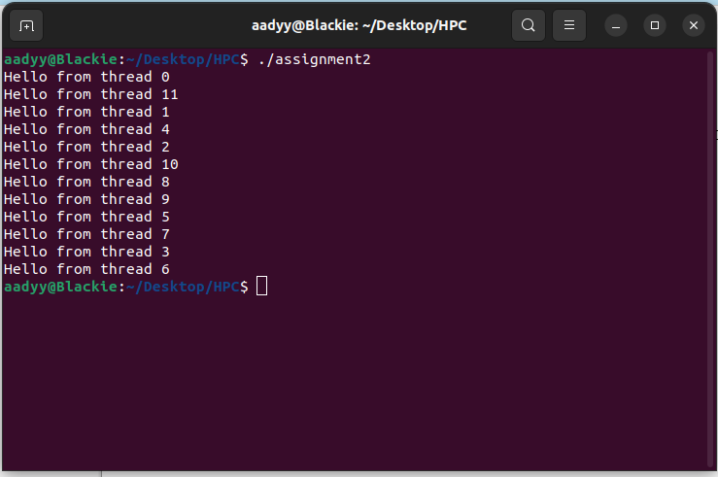

GitHub Link: make a public repository upload code of an assignment and paste its link here.

Problem statement 3: Calculate theoretical FLOPS of your system on which you are running the above codes.

Elaborate the parameters and show calculation.

o calculate the theoretical FLOPS of a CPU, you need to consider several factors:

1. Number of Cores: The total number of physical cores in the CPU.
2. Clock Speed: The operating frequency of the CPU, usually given in GHz (Gigahertz).
3. FLOP per Cycle: The number of floating-point operations that can be performed per clock cycle per core.

FLOPS=Number of Cores×Clock Speed (in Hz)×FLOP per Cycle