**Class:** Final Year (Computer Science and Engineering)

**Year:** 2024-25 **Semester:** 1

**Course:** High Performance Computing Lab

**Practical No. 2**

**PRN : 21510022**

**Name: Gunjan Chauke.**

**Title of practical: Study and implementation of basic OpenMP clauses**

Implement following Programs using OpenMP with C:

1. Vector Scalar Addition
2. Calculation of value of Pi

Analyse the performance of your programs for different number of threads and Data size.

**Problem Statement 1: Vector Scalar Addition**

**Screenshots:**

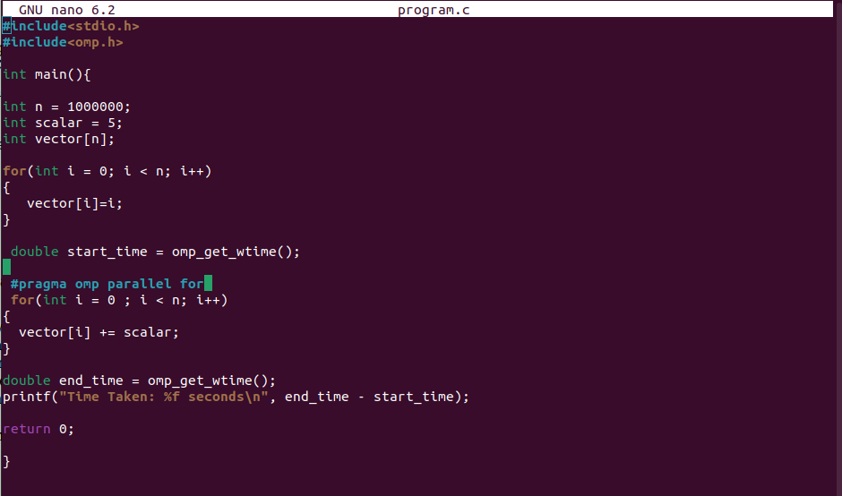

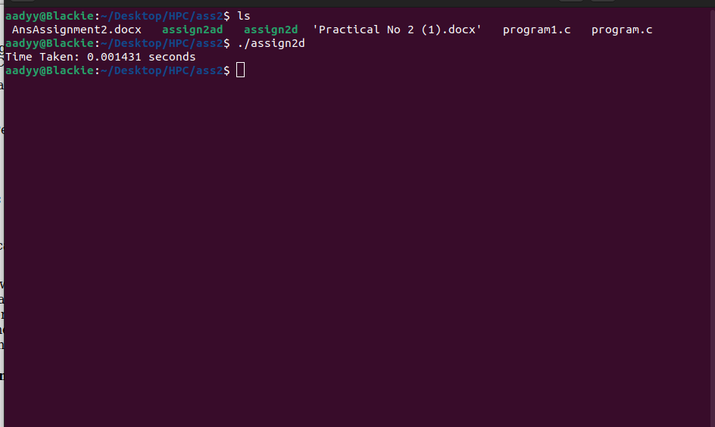

**Information:**

The vector-scaler program demonstrates parallel processing using OpenMP to add a scalar value to each element of a large array (vector). The program initializes an array of size 1 million with consecutive integers, then uses OpenMP to parallelize the addition of a scalar (e.g., 5) to each element. By leveraging multiple threads, the operation is completed faster compared to a serial execution. The program also measures and prints the time taken to perform this operation, highlighting the efficiency of parallel processing.

**Analysis:**

Parallel Speedup, Scalability, Overhead and Correctness

**Problem Statement 2:**

**Screenshots:**

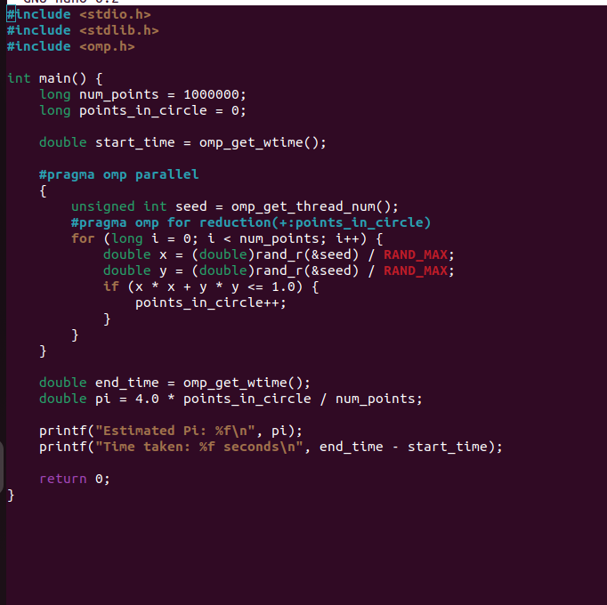

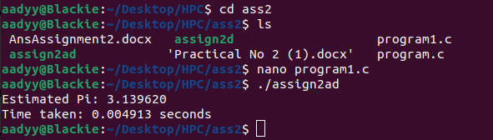

**Information:**

The program estimates π using the Monte Carlo method with parallelization via OpenMP. It generates random points in a square, calculates how many fall within a unit circle, and uses this to approximate π. Each thread runs independently with its own seed for random number generation.

**Analysis:**

Parallel Efficiency, Thread Safety , Accuracy And Scalability

**Github Link:**