**Kathford International College of Engineering and Management**

**Balkumari, Lalitpur, Nepal**

**PROJECT TITLE:-**

**“MED APPOINT: “WAY OF EASY HEALTH CARE”**

**A**



**Mid Defense Report**

**On**

**[MED APPOINT:”WAY OF EASY HEALTH CARE”]**

**Submitted To:**

Department of Information Technology

Kathford International College of Engineering and Management

**Submitted By:**

Sushil Chaulagain( 6-2-22-1762-2020)

Udghosh Mainali (6-2-456-75-2022)

**Submission Date:**

2081/08/07

# ABSTRACT

"Way of Easy Health Care: A Med Appoint Project" aims to revolutionize healthcare by offering a smooth online platform for scheduling medical appointments. In a world where time is precious, our project attempt to bridge the gap between patients and healthcare providers through an intuitive and user-friendly interface eliminating the hassle of traditional appointment booking. By using technology, it aims to empower individuals to effortlessly book appointments with qualified doctors, promoting timely interventions and fostering a healthier society.

***Keywords***: ***Online medical appointments, healthcare technology, patient-doctor connection***

I

Table of Contents

ABSTRACT 2

1. INTRODUCTION 1

2. PROBLEM STATEMENT 2

3. OBJECTIVE 2

4. METHODOLOGY 3

4.1 REQUIREMENT IDENTIFICATION: 3

4.1.1 Study of existing system 3

4.1.2 Requirement Collection 4

4.2 FEASIBILITY STUDY 4

4.3 USE CASE DIAGRAM 6

4.4 FLOWCHART 7

GANTT CHART 8

EXPECTED OUTCOME 8

REFERENCES 9

II

# CHAPTER-1: INTRODUCTION

* 1. INTRODUCTION

Med Appoint is a health care website that has been developed to modernize the appointment booking process and make healthcare accessible to all. A Med Appoint Project" emerges as a solution to one of the most persistent challenges in healthcare.

Through this website, users can book their appointment to a respective doctor. It’ll be easier for users to make appointment for them without worrying about standing in a queue. There will also be availability of doctors ensuring that every patient can easily connect with the right doctor at the right time whether you need to see a specialist or just need a check-up, our platform makes it easy for you to find the right doctor and schedule your appointment at a time that works for you.

# PROBLEM STATEMENT

In the current healthcare landscape, booking medical appointments often presents challenges for patients. Moreover, the traditional methods of appointment booking, such as phone calls or in-person visits, may not align with the preferences or lifestyles of modern-day individuals who seek convenience and efficiency. These challenges highlight the need for a solution that streamlines the appointment scheduling process, making it easier and more accessible for patients to connect with healthcare providers. Addressing these pain points is crucial not only for enhancing patient satisfaction but also for improving overall healthcare outcomes by ensuring timely access to medical care. Med Appoint will aim to empower patients to schedule appointment themselves in a very short period of time.

# OBJECTIVE

The project aims to achieve the following objectives:

* To enable communication between patients and healthcare providers.
* To provide integrated messaging features for query clarification and appointment reminders.

# METHODOLOGY

This project will follow agile methodology for rapid development

## REQUIREMENT IDENTIFICATION:

### Study of existing system

The Appointment Registration Portal at Hamro Doctor stands out as a dedicated platform for booking doctor appointment. The features is user-friendly design, with clear options for both new and existing users essential sections like home, about us, and login contribute to a seamless user experience, reflecting a commitment to best practices in website navigation.

Mero Doctor on the other hand offers features such as specialist video consultant, health packages, and doctor finding. In addition to that they have provided features like test booking and report can be shown online as well. The Doctor on call Nepal appoint system serves as a central platform for

Appointment activities within the hospitals in Nepal. The login form on the portal emphasizes security, guiding patients to use their phone number as the username and Date of Birth (BS) in YYYY-MM-DD format as the initial password. The inclusion of a &quot;Forgot Password&quot; option enhances user convenience, demonstrating a commitment to user-friendly and secure appointment management.

### Requirement Collection

In this project, gathering requirements is crucial. The system should prioritize user friendly design to accommodate users accessing it from various devices, including smartphones, tablets, and computers.

We need to identify and categorize user segments (user, admin and doctor). Define user needs, including access to old records, fee status, and the report. The project should implement an intuitive interface with clear navigation and options for accessing and managing patient information. It must also integrate secure login and data management features to ensure a smooth and protected user experience

## FEASIBILITY STUDY

* Technical Feasibility:

Infrastructure: Evaluate the availability of necessary hardware and software resources for development, deployment, and maintenance.

Technology: Assess the feasibility of implementing desired features using selected technologies, considering scalability, compatibility, and security.

Integration: Determine the feasibility of integrating with existing systems like electronic health records (EHR) or third-party services for seamless data exchange.

* Operational Feasibility:

User Adoption: Analyze the readiness of users, doctors, and administrators to adopt and utilize the system, including training requirements and potential resistance to change.

Workflow Integration: Assess the impact of the system on current workflows within healthcare facilities, ensuring smooth integration and minimal disruption to operations.

Support and Maintenance: Evaluate the availability of resources and expertise needed for ongoing support, maintenance, and updates to ensure continued functionality postimplementation.

* Economic Feasibility:

Cost-Benefit Analysis: Conduct a comprehensive analysis of development costs, infrastructure expenses, and potential revenue streams to determine financial viability.

Return on Investment (ROI): Assess the expected returns from the project, including increased efficiency, revenue generation, and cost savings, compared to initial investments.

Sustainability: Evaluate the long-term sustainability of the project, considering recurring costs, revenue stability, and potential for growth and expansion.

Risk Management: Identify potential economic risks and uncertainties, such as budget overruns or revenue shortfalls, and develop strategies to mitigate these risks effectively.

## USE CASE DIAGRAM

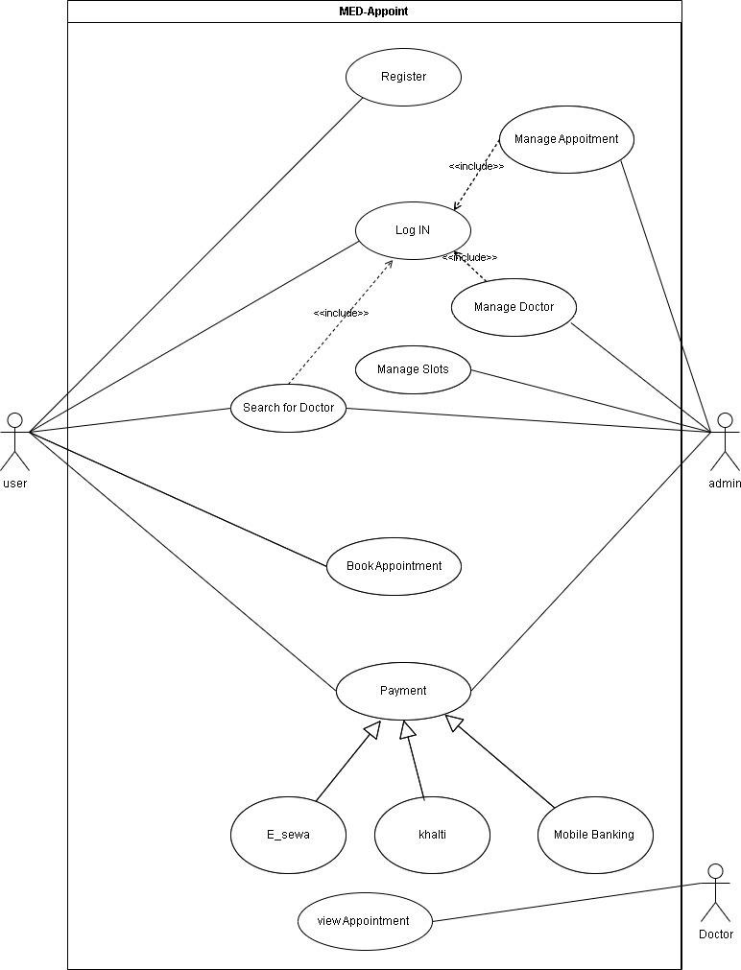

Fig: Use Case Diagram of doctor appointment website

## FLOWCHART

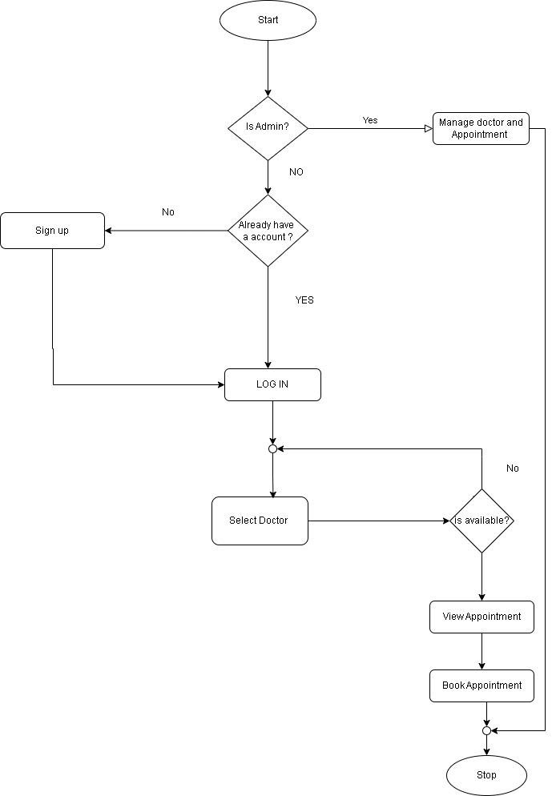

# GANTT CHART

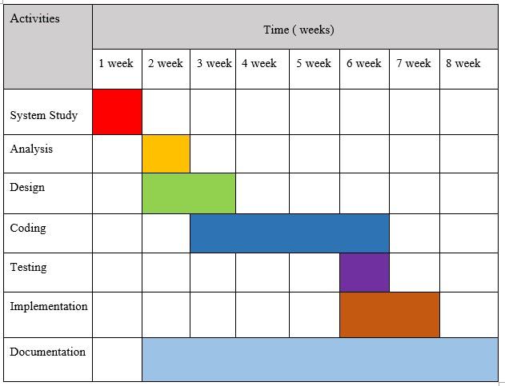

# EXPECTED OUTCOME

A doctor appointment system offers numerous benefits by increasing accessibility to healthcare services, allowing users to easily book appointments and reduce barriers to medical care. It improves efficiency in appointment management, enabling healthcare providers to optimize schedules and reduce wait times. Enhanced patient satisfaction is achieved through smoother booking processes, timely reminders, and better communication. The system also reduces no-show appointments with reminders and notifications, improving clinic efficiency. Additionally, it fosters better doctor-patient relationships through feedback and rating systems, allowing patients to make informed decisions and doctors to enhance their services. By providing data-driven insights, the system helps healthcare providers understand appointment trends, patient preferences, and service utilization for better resource allocation. It ensures compliance with healthcare regulations by adhering to privacy and security standards, and it is scalable and adaptable, accommodating growth and evolving healthcare needs with the flexibility to integrate new features and technologies.

# REFERENCES

1. P. N. Bhil, "Appointment system," p. https://ijcrt.org/papers/IJCRT1812133.pdf.
2. John Lekan, Akinode, "ijera," [Online]. Available: https://www.ijera.com/papers/vol12no4/Ser-3/l1204034852.pdf.
3. S. Eslami, "National Library of Medicine," [Online]. Available: https://www.ncbi.nlm.nih.gov/pmc/articles/PMC6078003/.