**Progress Test 1**

mkdir src/components

Tạo file src/components/[LoginForm.js](http://loginform.js)

import React, { useState } from 'react';

import { Form, Button, Container, Row, Col, Modal, Alert } from 'react-bootstrap';

import PropTypes from 'prop-types';

import axios from 'axios';

const LoginForm = ({ setUser }) => {

const [username, setUsername] = useState('');

const [password, setPassword] = useState('');

const [showModal, setShowModal] = useState(false);

const [showAlert, setShowAlert] = useState(false);

const [welcomeMessage, setWelcomeMessage] = useState('');

const handleLogin = async (e) => {

e.preventDefault();

try {

const response = await axios.get('http://localhost:3001/UserAccounts');

const users = response.data;

const user = users.find(u => u.username === username && u.password === password);

if (user) {

setWelcomeMessage(`Welcome, ${username} login Successful!`);

setShowModal(true);

setUser(user);

} else {

setShowAlert(true);

setTimeout(() => setShowAlert(false), 3000);

}

} catch (error) {

console.error('Login error:', error);

setShowAlert(true);

setTimeout(() => setShowAlert(false), 3000);

}

};

return (

<Container className="mt-5">

<Row className="justify-content-center">

<Col md={6}>

<h2 className="text-center mb-4">Login</h2>

{showAlert && (

<Alert variant="danger">

Invalid username or password!

</Alert>

)}

<Form onSubmit={handleLogin}>

<Form.Group className="mb-3">

<Form.Label>Username</Form.Label>

<Form.Control

type="text"

placeholder="Enter username"

value={username}

onChange={(e) => setUsername(e.target.value)}

required

/>

</Form.Group>

<Form.Group className="mb-3">

<Form.Label>Password</Form.Label>

<Form.Control

type="password"

placeholder="Enter password"

value={password}

onChange={(e) => setPassword(e.target.value)}

required

/>

</Form.Group>

<Button variant="primary" type="submit" className="w-100">

Login

</Button>

</Form>

<Modal show={showModal} onHide={() => setShowModal(false)}>

<Modal.Header closeButton>

<Modal.Title>Login Successful</Modal.Title>

</Modal.Header>

<Modal.Body>

{welcomeMessage}

</Modal.Body>

<Modal.Footer>

<Button variant="primary" onClick={() => setShowModal(false)}>

OK

</Button>

</Modal.Footer>

</Modal>

</Col>

</Row>

</Container>

);

};

LoginForm.propTypes = {

setUser: PropTypes.func.isRequired

};

export default LoginForm;

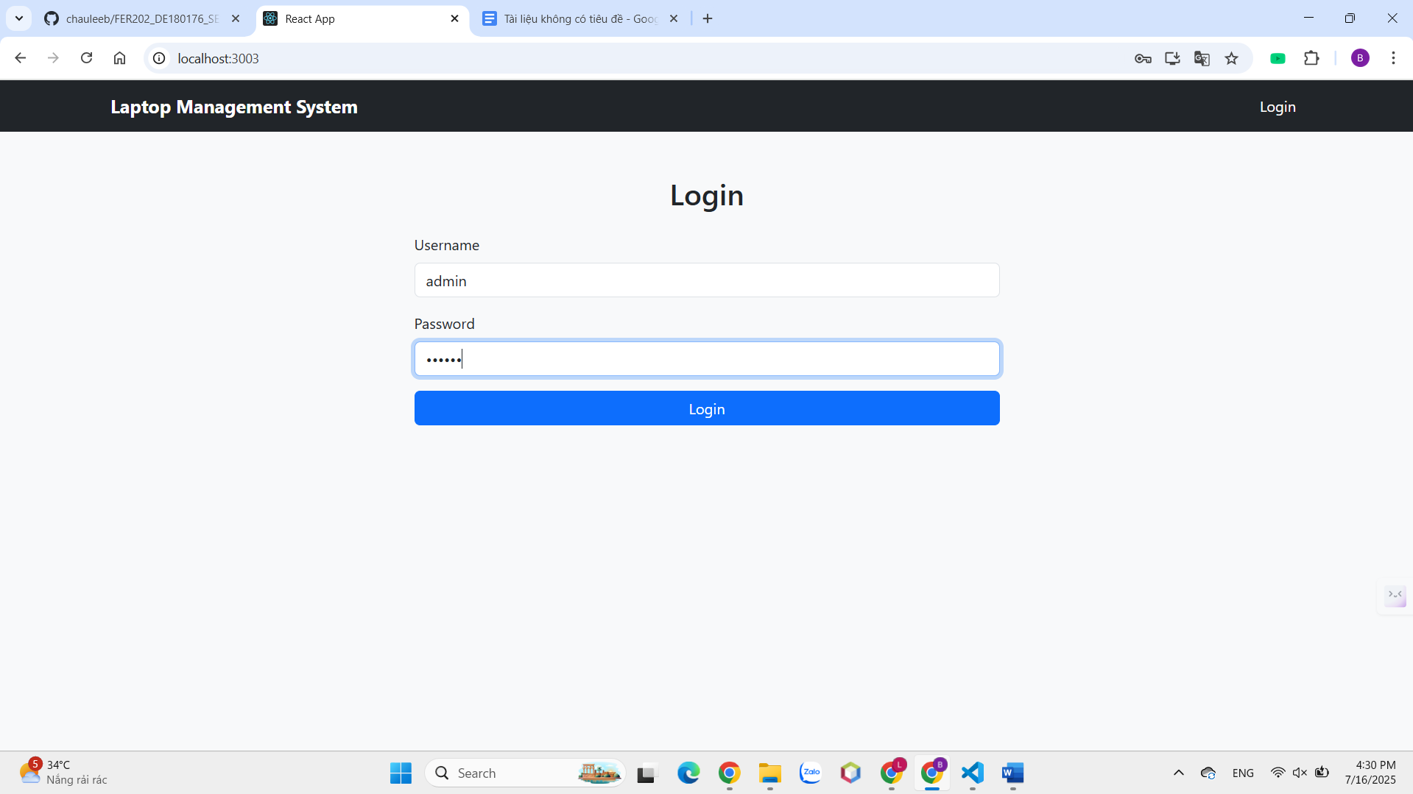

src/components/[LaptopManagement.js](http://laptopmanagement.js)

import React, { useState, useEffect } from 'react';

import { Container, Row, Col, Card, Button, Form, InputGroup, Alert } from 'react-bootstrap';

import { useNavigate } from 'react-router-dom';

import { Search } from 'react-bootstrap-icons';

import axios from 'axios';

const LaptopList = () => {

const [laptops, setLaptops] = useState([]);

const [filteredLaptops, setFilteredLaptops] = useState([]);

const [searchTerm, setSearchTerm] = useState('');

const navigate = useNavigate();

useEffect(() => {

fetchLaptops();

}, []);

const fetchLaptops = async () => {

try {

const response = await axios.get('http://localhost:3001/Laptops');

setLaptops(response.data);

setFilteredLaptops(response.data);

} catch (error) {

console.error('Error fetching laptops:', error);

}

};

const handleSearch = () => {

const filtered = laptops.filter(laptop =>

laptop.brand.toLowerCase().includes(searchTerm.toLowerCase()) ||

laptop.model.toLowerCase().includes(searchTerm.toLowerCase())

);

setFilteredLaptops(filtered);

};

const handleViewDetails = (id) => {

navigate(`/laptops/${id}`);

};

return (

<Container fluid className="mt-5">

<h2 className="text-center mb-4 fw-bold text-primary">Explore Our Laptops</h2>

<Row className="mb-4 justify-content-center">

<Col md={8} lg={6}>

<InputGroup className="shadow-sm">

<InputGroup.Text className="bg-light border-0">

<Search size={20} />

</InputGroup.Text>

<Form.Control

type="text"

placeholder="Search by brand or model..."

value={searchTerm}

onChange={(e) => setSearchTerm(e.target.value)}

className="border-0"

/>

<Button variant="primary" onClick={handleSearch} className="px-4">

Search

</Button>

</InputGroup>

</Col>

</Row>

<Row className="justify-content-center">

<Col lg={10} xl={10}>

<Row xs={1} sm={2} md={3} lg={4} className="g-4">

{filteredLaptops.map(laptop => (

<Col key={laptop.id}>

<Card className="h-100 laptop-card shadow-sm border-0">

<Card.Img

variant="top"

src={laptop.image}

style={{

height: '200px',

objectFit: 'cover',

borderTopLeftRadius: '10px',

borderTopRightRadius: '10px'

}}

alt={`${laptop.brand} ${laptop.model}`}

/>

<Card.Body className="d-flex flex-column p-3">

<Card.Title className="text-center mb-3 fw-bold">

{laptop.brand} {laptop.model}

</Card.Title>

<Card.Text className="text-muted text-center">

<strong>Year:</strong> {laptop.year}<br />

<strong>Price:</strong> {laptop.price}

</Card.Text>

<Button

variant="primary"

onClick={() => handleViewDetails(laptop.id)}

className="mt-auto btn-sm fw-bold"

>

View Details

</Button>

</Card.Body>

</Card>

</Col>

))}

</Row>

</Col>

</Row>

{filteredLaptops.length === 0 && (

<Row className="mt-4">

<Col className="text-center">

<Alert variant="warning" className="d-flex align-items-center justify-content-center">

<span className="me-2">⚠️</span> No laptops found matching your search.

</Alert>

</Col>

</Row>

)}

</Container>

);

};

export default LaptopList;

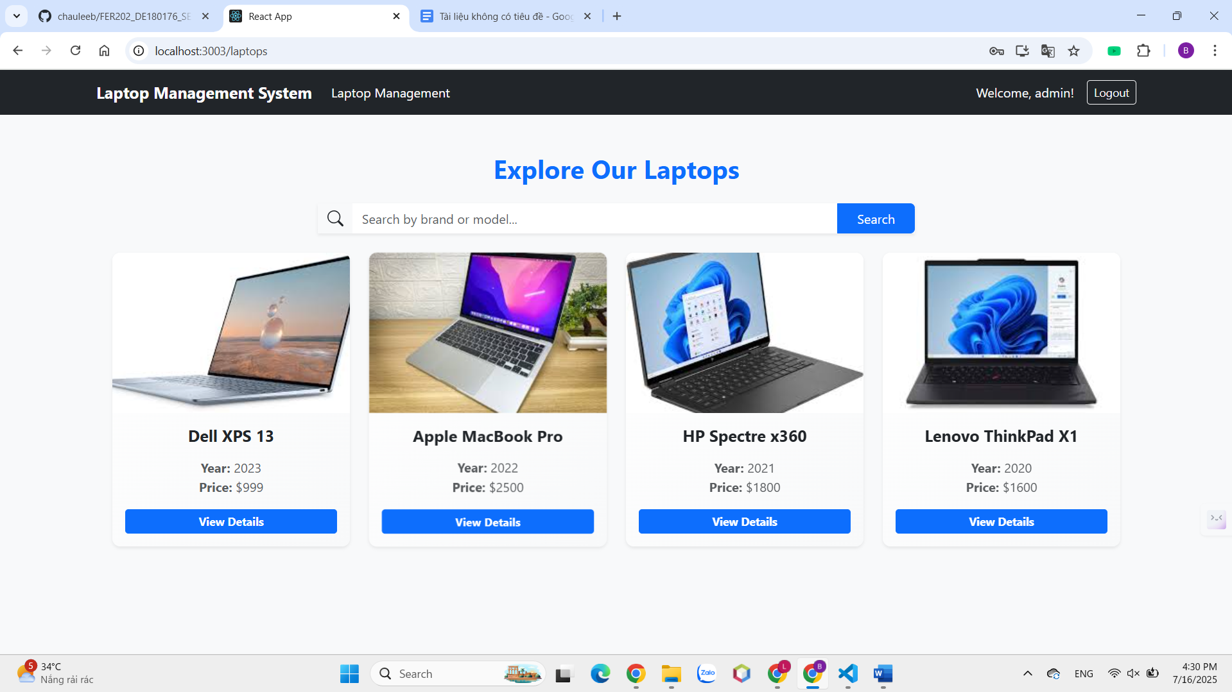

Tạo file src/components/[LaptopDetail.js](http://laptopdetail.js)

import React, { useState, useEffect } from 'react';

import { useParams, useNavigate } from 'react-router-dom';

import { Container, Row, Col, Card, Button, Alert } from 'react-bootstrap';

import { ArrowLeftCircle } from 'react-bootstrap-icons';

import axios from 'axios';

const LaptopDetail = () => {

const { id } = useParams();

const navigate = useNavigate();

const [laptop, setLaptop] = useState(null);

const [loading, setLoading] = useState(true);

const [error, setError] = useState(false);

useEffect(() => {

const fetchLaptopDetail = async () => {

try {

const response = await axios.get(`http://localhost:3001/Laptops/${id}`);

setLaptop(response.data);

setLoading(false);

} catch (error) {

console.error('Error fetching laptop detail:', error);

setError(true);

setLoading(false);

}

};

fetchLaptopDetail();

}, [id]);

if (loading) {

return (

<Container className="mt-5 text-center">

<div className="spinner-border text-primary" role="status">

<span className="visually-hidden">Loading...</span>

</div>

<p className="mt-2">Loading...</p>

</Container>

);

}

if (error || !laptop) {

return (

<Container className="mt-5">

<Alert variant="danger" className="text-center shadow-sm">

<Alert.Heading className="d-flex align-items-center justify-content-center">

<span className="me-2">⚠️</span> 404 Not Found

</Alert.Heading>

<p>The laptop with ID {id} was not found.</p>

<hr />

<Button

variant="outline-primary"

onClick={() => navigate('/laptops')}

className="mt-3 fw-bold"

>

<ArrowLeftCircle className="me-2" /> Back to Laptop List

</Button>

</Alert>

</Container>

);

}

return (

<Container className="mt-5">

<Row className="justify-content-center">

<Col md={10} lg={8}>

<Card className="shadow-sm border-0">

<Row className="g-0">

<Col md={6}>

<Card.Img

src={laptop.image}

style={{

height: '100%',

objectFit: 'cover',

borderTopLeftRadius: '10px',

borderBottomLeftRadius: '10px'

}}

alt={`${laptop.brand} ${laptop.model}`}

/>

</Col>

<Col md={6}>

<Card.Body className="p-4">

<Card.Title className="fw-bold text-primary mb-3">

{laptop.brand} {laptop.model}

</Card.Title>

<Card.Text>

<strong>Brand:</strong> {laptop.brand}<br />

<strong>Model:</strong> {laptop.model}<br />

<strong>Year:</strong> {laptop.year}<br />

<strong>Price:</strong> {laptop.price}<br />

<strong>Description:</strong> High-quality laptop with excellent performance and modern features.

</Card.Text>

<div className="d-flex gap-3">

<Button

variant="outline-primary"

onClick={() => navigate('/laptops')}

className="fw-bold"

>

<ArrowLeftCircle className="me-2" /> Back to List

</Button>

<Button

variant="primary"

onClick={() => navigate('/')}

className="fw-bold"

>

Home

</Button>

</div>

</Card.Body>

</Col>

</Row>

</Card>

</Col>

</Row>

</Container>

);

};

export default LaptopDetail;

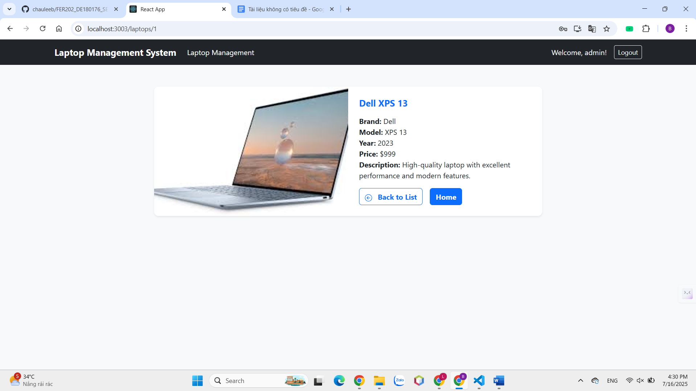

Tạo [App.js](http://app.js)

import React, { useState } from 'react';

import { BrowserRouter as Router, Routes, Route, Navigate, NavLink } from 'react-router-dom';

import { Navbar, Nav, Container, Button } from 'react-bootstrap';

import LoginForm from './components/LoginForm';

import LaptopList from './components/LaptopManagement';

import LaptopDetail from './components/LaptopDetail';

import 'bootstrap/dist/css/bootstrap.min.css';

import './App.css';

function App() {

const [user, setUser] = useState(null);

const handleLogout = () => {

setUser(null);

};

return (

<Router>

<div className="App">

{/* Navigation Bar */}

<Navbar bg="dark" variant="dark" expand="lg">

<Container>

<Navbar.Brand>Laptop Management System</Navbar.Brand>

<Navbar.Toggle aria-controls="basic-navbar-nav" />

<Navbar.Collapse id="basic-navbar-nav">

<Nav className="me-auto">

{user && (

<Nav.Link as={NavLink} to="/laptops">

Laptop Management

</Nav.Link>

)}

</Nav>

<Nav>

{user ? (

<div className="d-flex align-items-center">

<span className="text-light me-3">Welcome, {user.username}!</span>

<Button variant="outline-light" size="sm" onClick={handleLogout}>

Logout

</Button>

</div>

) : (

<Nav.Link as={NavLink} to="/">

Login

</Nav.Link>

)}

</Nav>

</Navbar.Collapse>

</Container>

</Navbar>

{/* Main Content */}

<Routes>

<Route

path="/"

element={

user ? <Navigate to="/laptops" /> : <LoginForm setUser={setUser} />

}

/>

<Route

path="/laptops"

element={

user ? <LaptopList /> : <Navigate to="/" />

}

/>

<Route

path="/laptops/:id"

element={

user ? <LaptopDetail /> : <Navigate to="/" />

}

/>

<Route

path="*"

element={

<Container className="mt-5">

<div className="text-center">

<h2>404 - Page Not Found</h2>

<p>The page you are looking for does not exist.</p>

<Button variant="primary" onClick={() => window.location.href = '/'}>

Go Home

</Button>

</div>

</Container>

}

/>

</Routes>

</div>

</Router>

);

}

export default App;

Cập nhật src/App.css

.App {

min-height: 100vh;

background-color: #f8f9fa;

}

.card {

transition: transform 0.2s, box-shadow 0.2s;

border-radius: 10px;

box-shadow: 0 2px 8px rgba(0,0,0,0.1);

}

.card:hover {

transform: translateY(-5px);

box-shadow: 0 4px 16px rgba(0,0,0,0.2);

}

.laptop-card {

background: linear-gradient(135deg, #ffffff 0%, #f8f9fa 100%);

transition: transform 0.3s, box-shadow 0.3s;

}

.laptop-card:hover {

transform: scale(1.05);

box-shadow: 0 6px 20px rgba(0,0,0,0.15);

}

.navbar-brand {

font-weight: bold;

}

/* Responsive layout for laptop cards */

@media (max-width: 1200px) {

.card {

min-height: 320px;

}

}

@media (max-width: 992px) {

.card {

min-height: 350px;

}

}

@media (max-width: 768px) {

.container-fluid {

padding: 0 15px;

}

.card {

margin-bottom: 1rem;

min-height: 300px;

}

}

@media (max-width: 576px) {

.card {

min-height: 280px;

}

}

Cập nhật [index.js](http://index.js)

import React from 'react';

import ReactDOM from 'react-dom/client';

import App from './App';

import 'bootstrap/dist/css/bootstrap.min.css';

const root = ReactDOM.createRoot(document.getElementById('root'));

root.render(

<React.StrictMode>

<App />

</React.StrictMode>

);

Search   
