**Preface**:

This folder contains the videos for demonstrating the simulation results in the paper “Automatically Guardrail Design of Subway Stations through Multi-objective Evolutionary Algorithms” summited to the 2020 IEEE International Conference on Systems, Man, and Cybernetics (SMC 2020).

As described in the paper, the motion of all agents in the videos is guided by the social force model, which is an approximation of the real crowd movement realized by the computer.

Two scenarios are described in the paper. One is Scenario1 which is designed artificially for some exploratory experiments. In the videos of Scenario1, agents coming from one gate are much more than other gates, so as to observe the patterns of the solutions.

The other is Scenario2 which is a real-world subway station. So, there are two sub-folders (i.e., “Scenario1” and “Scenario2”) contained in the “VIDEOS” folder.

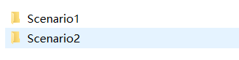

**Scenario1:**

In folder “Scenario1”, two sub-folders named “Exp1” and “Exp2” are created respectively for the experiment Exp1 and Exp2 conducted in our paper.

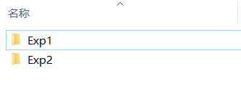

**Folder Exp1:** In folder Exp1, two videos are provided. The video named “No Guardrails.mp4” is prepared for the situation where no guardrails are placed in Exp1. While the video “1st-ParetoSolutions.mp4” contained in sub-folder “With Guardrails” corresponds to the Pareto solution found by G-MODE in Exp1.

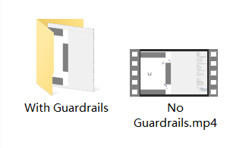

**Folder Exp2:** In folder Exp2, the video “No Guardrails (i.e., S0).mp4” presents the simulation results (i.e., S0 mentioned in the paper for Exp2) when no guardrails are placed in Exp2. While the six videos listed in sub-folder “With Guardrails” correspond to the six Pareto solutions (i.e., from S1 to S6, used in the paper for Exp2) found by G-MODE in Exp2.

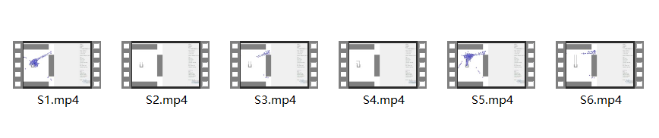

**Scenario2:**

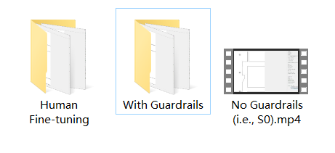

In folder “Scenario2”, the video named “No Guardrails (i.e., S0).mp4” is prepared for the situation where no guardrails are placed in Scenario2.

In sub-folder “With Guardrails”, seven videos are provided which correspond to seven Pareto solutions (i.e., S1, S4, S7, S10, S13, S16, and S19, listed in the paper for Scenario2) found by G-MODE for Scenario2. Totally, nineteen Pareto solutions are found by G-MODE which have been listed in the paper. And for brevity, we picked one out of every three solutions to record the video.

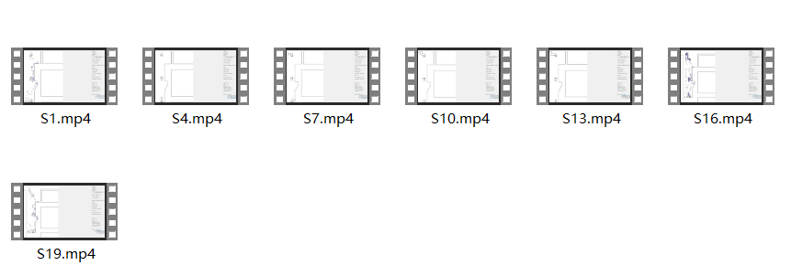

In sub-folder “Human Fine-tuning”, two videos are recorded. One (i.e., S12.mp4) is for the Pareto solution S12 draw in the paper. Another video “Modified S12.mp4” corresponds to the modified S12 after the human fine-tuning step.

