Readme

Contents

Deploying 1

Financial Summary 3

Financial Statements 4

Notes to Financial Statements 5

Independent Auditor’s Report 6

Contact Information 7

Company Information 7

# Deploying

## Materials needed

- JDK 8u112: <http://www.oracle.com/technetwork/java/javase/downloads/jdk8-downloads-2133151.html>

- Maven 3.3.9: https://maven.apache.org/download.cgi

- MongoDB community 3.41: https://www.mongodb.com/download-center#community

Please download and install them.

## Setup steps

1. Database

- Download “data.zip” from “ftp://ftp2.tma.com.vn/nnmchau/Database/”

- Extract it in to home dir (C:\) like this:

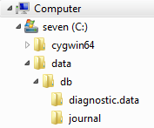

1. Network

* To change/enable/disable proxy option, modify values of *resourcebundle.proxy.ip, resourcebundle.proxy.port* in “src/main/resources/messages.properties” file.

Note*: Comment out one of them to disable proxy.

* By default, application work on port: 1373. To change it, modify “src/main/java/conf/application.conf”.

1. Add certification to JDK.

* Window Command: keytool -import -alias greenhopper -keystore "<Jdk path>\jre\lib\security\cacerts" -file "<Source> \greenhopper_certification.crt"

Example: keytool -import -alias greenhopper -keystore "C:\Program\ Files\Java\jdk1.8.0_45\jre\lib\security\cacerts" -file "C:\Users\pdkhoa\Desktop\Interview\mergeSource\interview\greenhopper_certification.crt"

* Enter password: changeit

## Starting server

1. Run “mongod.exe” from “C:\Program Files\MongoDB\Server\3.2\bin\”.
2. At the root dir of project, run cmd with command “mvn package ninja:run”

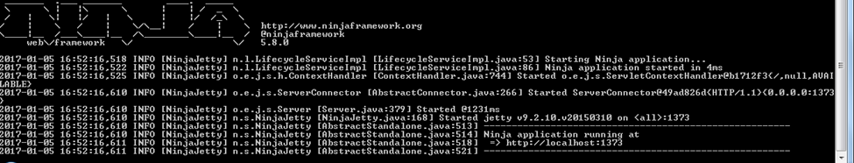

# Instruction

## Statement of Financial Position

* Liabilities
* Statement of Financial Position
* Ownership Equity

## Statement of Comprehensive Income (Profits and Losses)

* Income
* Expenses
* Profits

## Statement of Changes in Equity

Well, it wouldn’t be an annual report without a lot of numbers, right? This section is the place for all those financial tables.

To get started with a table that looks just like the sample here, on the Insert tab, click Tables, then choose Quick Tables.

|  |  |  |  |
| --- | --- | --- | --- |
| Description | Revenue | Expenses | Earnings |
|  |  |  |  |
|  |  |  |  |
|  |  |  |  |
|  |  |  |  |
|  |  |  |  |

## Statement of Cash Flows

* Operating
* Investing
* Financing

# Notes to Financial Statements

## Accounts

When you have a document that shows a lot of numbers, it’s a good idea to have a little text that explains the numbers. You can do that here.

## Debt

Of course, we would all prefer to just have profits. But if you’ve got any debt, this is the place to make notes about it.

## Going Concern

Okay, you get the idea. If you’ve got notes to add about your financials, add them here.

## Contingent Liabilities

Keep in mind that some of these headings might not apply to your business (and you might have others to add). This one, for example, is about potential liabilities that could arise if something happens in the future, such as a pending legal decision.

## Takeaways

What would you like your readers to understand? Add notes on key takeaways here.

# Independent Auditor’s Report

* 1. Unqualified Opinion
  2. Qualified Opinion Report
  3. Adverse Opinion Report
  4. Disclaimer of Opinion Report
  5. Auditor’s Report on Internal Controls of Public Companies
  6. Going Concern

# Contact Information

To replace a photo with your own, right-click it and then choose Change Picture.

|  |  |  |  |
| --- | --- | --- | --- |
| Sample person image | **Name**  Title  **Tel** [Telephone]  **Fax** [Fax]  [Email Address] | Sample person image | **Name**  Title  **Tel** [Telephone]  **Fax** [Fax]  [Email Address] |
|  |  |  |  |
| Sample person image | **Name**  Title  **Tel** [Telephone]  **Fax** [Fax]  [Email Address] |  |  |

# Company Information

**[Company]**

[Street Address, City, ST ZIP Code]

**Tel** [Telephone]

**Fax** [Fax]

[Website]

