User Guide

[Instruction 1](#_Toc473038811)

[Application 1](#_Toc473038812)

[Dashboard 2](#_Toc473038813)

[Gadget 4](#_Toc473038814)

[Database diagram 8](#_Toc473038815)

[Back-end diagram 9](#_Toc473038816)

[Front-end diagram 10](#_Toc473038817)

[Caching 11](#_Toc473038818)

[Greenhopper gadget caching: 11](#_Toc473038819)

[Test Execution Report Querying Rules 12](#_Toc473038820)

[Logging 13](#_Toc473038821)

# Instruction

## Application

* We strongly recommend using Google Chrome browser.
* Login UI

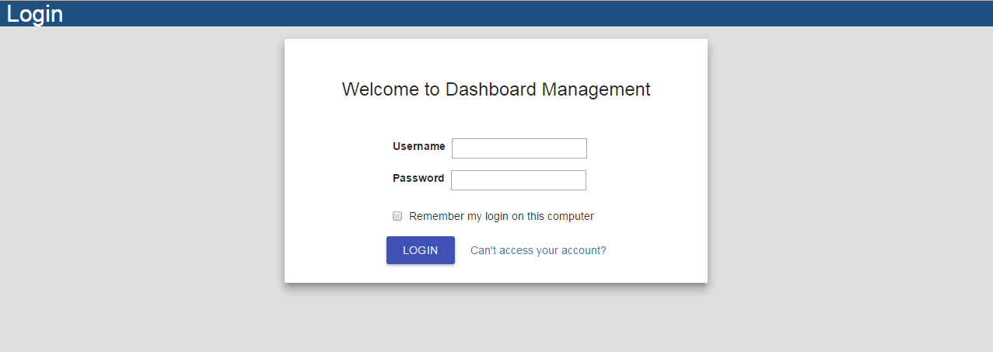

* Toolbar
* Admin user



User’s name

Create new dashboard

User’s profile page

Configuration page

Logout

## Dashboard

* Create Dashboard

Click create new dashboard on tool bar.

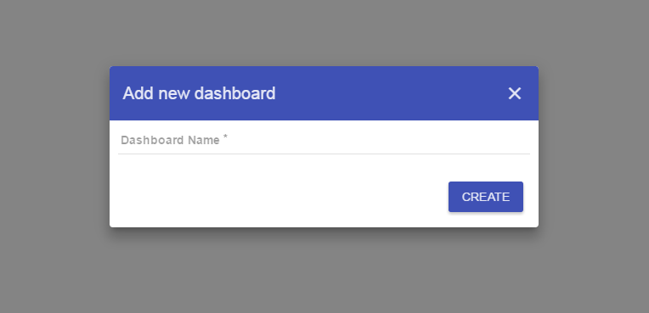

Enter dashboard’s name here

And then click here to create new dashboard

* Dashboard main UI

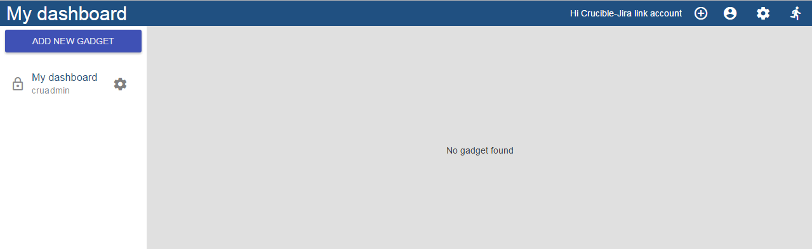

Dashboard list

Dashboard’s gadget list

Dashboard list item

Add new gadget button

* Dashboard list item

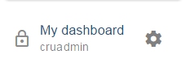

Dashboard privacy

Dashboard owner

Dashboard option

Dashboard name

|  |  |
| --- | --- |
| Icon | Privacy status |
| C:\Users\nnmchau\AppData\Local\Temp\7zEC96B4444\ic_lock_outline_black_24dp_2x.png | private |
| C:\Users\nnmchau\AppData\Local\Temp\7zE4DEF8F75\ic_public_black_24dp_2x.png | public |
| C:\Users\nnmchau\AppData\Local\Temp\7zE066694F7\ic_people_outline_black_24dp_2x.png | Share to specific group or project |

* Dashboard option UI

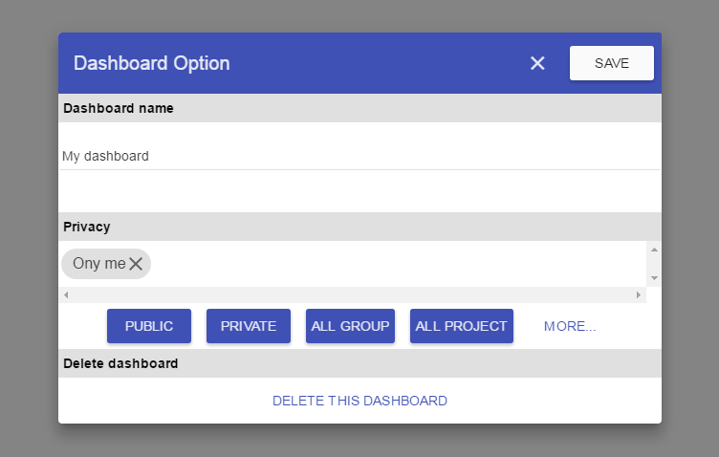

Save option

Edit dasboard name

Privacy status

Quick action to change privacy

Show groups and projects

Delete dashboard

Close dialog

## Gadget

1. Icons and their meaning

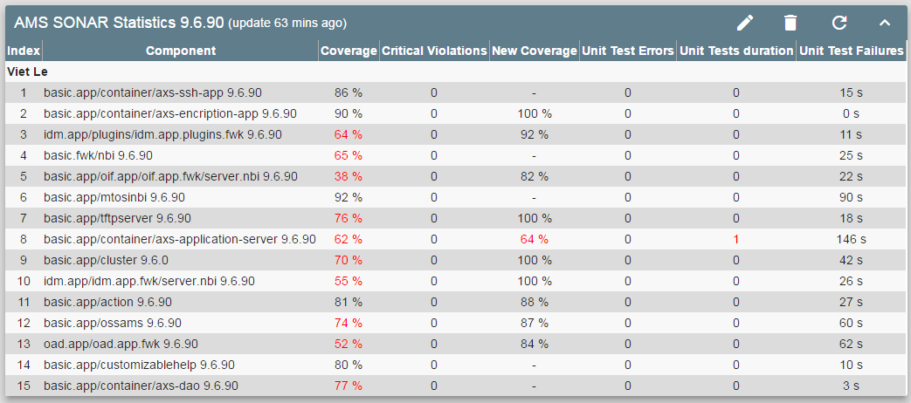

Edit gadged

Delete gadged

Update data

Collapse and expand view

Type of gadget

The last time get data

1. Greenhopper gadgets
   1. Greenhopper gadget setting:

New Epic Test Execution Report:

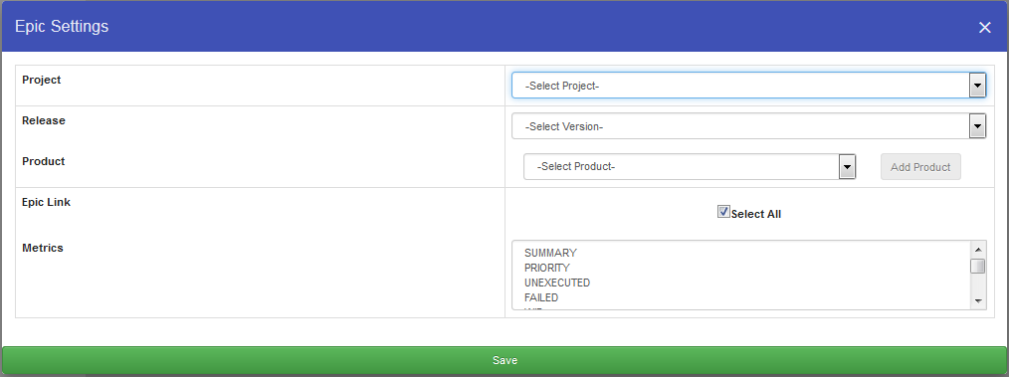

After filling in **project, release**, and **product** field, if epic link is not “**Select All**". Database will query for a list of epic issue keys.

**\*Note**: it might take some time to fetch project list the first time but it will be faster once that data is cached.

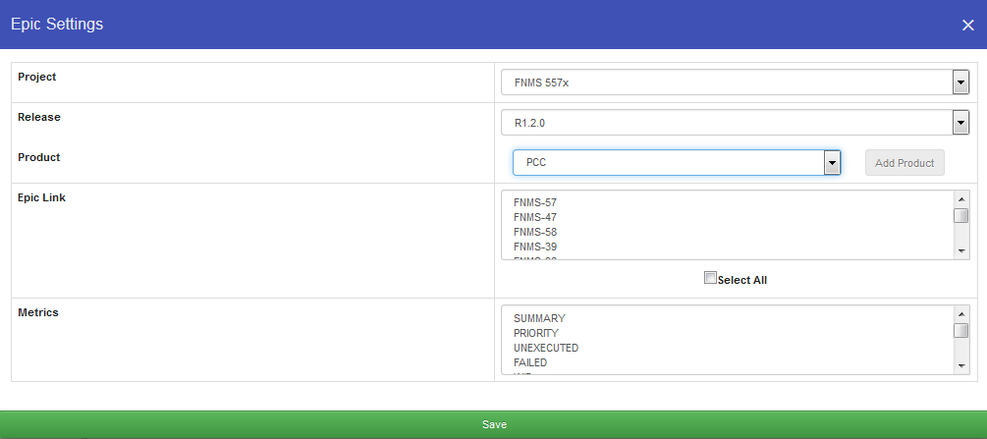

Select **epic link** and **test metrics** you want for your table then **save/update** gadget.

* 1. New User Story Test Execution Gadget instance:

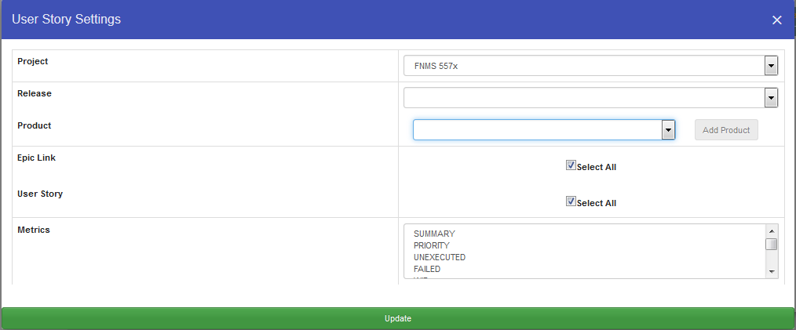

After filling in **project**, **release**, **product** field. If epic link field is not “**Select All**". Database will query for a list of epic issue keys. By default **epic links** and **user** story are selected all.

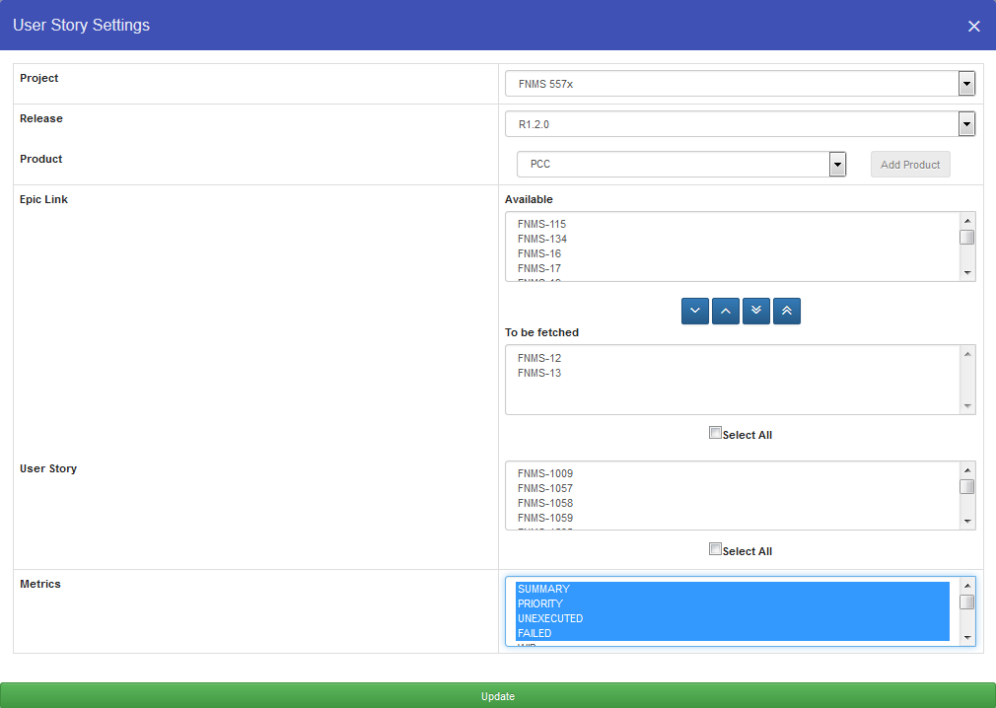

After obtaining **available epic links** list, select **available epic keys and add it to be fetched box,** these **to be fetched epic links** will be used to fetch **User Story** list.

Select **user story issue keys** and **test metrics** you want for the table then **save/update**.

* 1. New Assignee and Cycle Gadget instance:
* **Assignee** and **Test Cycle gadget** have the same dialog interface with the only difference is table details once it’s drawn. **In Assignee Gadget**, all **assignees** belong to a **Test Cycle** will be shown. Fill in the **project, release, product, metrics** you want for the table then update.

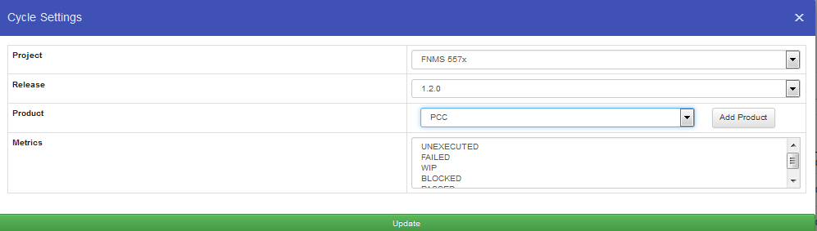

* 1. Authorize Greenhopper Product-Release:
* You can commission new Product and Release for other users to choose from in configuration page. Everyone can access this page.

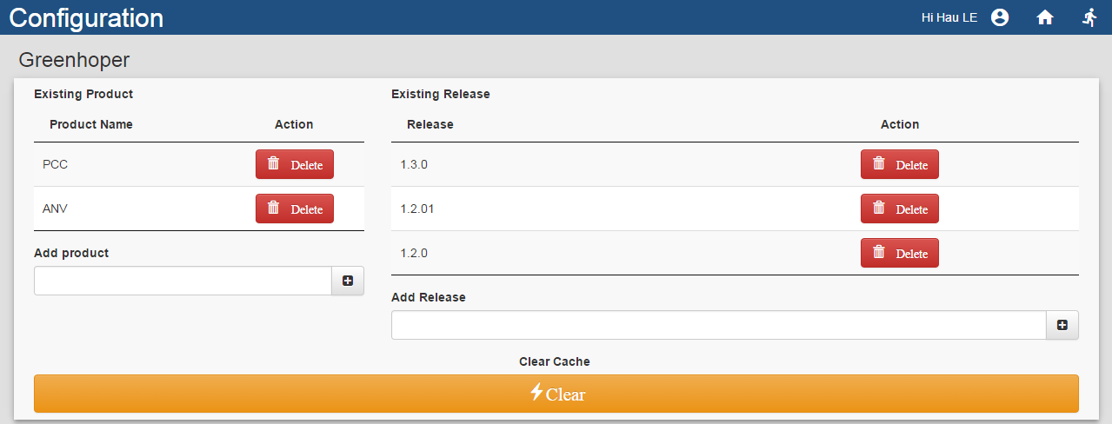

1. AMS SONAR Statistics
2. AMS Overdue Reviews Report

# Database diagram

C:\Users\dthehung\Downloads\Untitled Diagram (2).png

# Back-end diagramC:\Users\dthehung\Documents\My Received Files\Gadget.png

# Front-end diagram

**C:\Users\dthehung\Downloads\Untitled Diagram (1).png**

# Caching

## Greenhopper gadget caching:

* Data caching duration, login timeout and maximum concurrent threads allowed to fetch data from greenhopper is defined in *internal.conf.properties.*
* On Configuration page, there is a big wide orange button that will clear all greenhopper related cache on push.



* Overview:

#Greenhopper connection timeout. No timeout if value is 0

resourcebundle.project.timeout=60000

#Maximum records return by greenhopper query.

resourcebundle.search.maxrecords=10000

#Maximum number of concurrent threads

internal.conf.concurrent\_thread=20

#Interval(hour) to clear the entire cache on server

internal.conf.clearcache.time=24

#Interval(minute) to check time-to-live threshold for each greenhopper gadget

internal.conf.cleardatacache.time=1

#Time to live(minute).The time to live for each cached greenhopper gadget

internal.conf.gadgetdata.timetolive=10

# Test Execution Report Querying Rules

* For Epic issue, fetch Test issue for the first children. If the original epic issue has multiple epic child issues, user story issues, test issues and each of these issues has multiple child then fetch only Test issues belong to the original epic and its user story.
* Only fetch Test issue with “is a test by” issue link for Story issue
* On the other hand, fetch all Test issues inside Epic issue, including Test with “is a test by” link
* Only fetch the newest test execution in Test issue.
* “PLANNED” test metric is gotten from customfield\_14809 in return json query.
* “UNPLANNED” test metric is the sum of “PASSED” + “FAILED” + “UNEXECUTED” + “BLOCKED” + “WIP”.

# Logging

* There are 2 log files containing debugging information at project root folder.
* debug.log
* mylog.log