**PROJECT REPORT**

**On**

# TRAVEL-EASE

Submitted in partial fulfilment of the requirement for the

Course BEE (22CS026) of

**COMPUTER SCIENCE AND ENGINEERING**

## B.E. Batch-2022

**in**

**Jan -2025**



**Under the Guidance of :** - **Submitted By:** -

Rahul Singh Rajput Priya

Project Supervisor Roll No.: 2210992095

Prerna Sharma

Roll No.: 2210992086

**DEPARTMENT OF COMPUTER SCIENCE AND ENGINEERING**

## CHITKARA UNIVERSITY

**PUNJAB**

### CERTIFICATE

This is to be certified that the project entitled “Travel-Ease” has been submitted for the Bachelor of Computer Science Engineering at Chitkara University, Punjab during the academic semester July 2024 – December 2024 is a bona fide piece of project work carried out by “Priya (2210992095), Prerna Sharma (2210992086)” towards the partial fulfilment for the award of the course Integrated Project (CS 203) under the guidance of “Rahul Singh Rajput” and supervision.

**Signature:**

Rahul Singh Rajput

Project Supervisor (BE-CSE)

### CANDIDATE’S DECLARATION

We Priya (2210992095), Prerna Sharma (2210992086), B.E.-2022 of the Chitkara University, Punjab hereby declare that the Integrated Project Report entitled “Travel-Ease” is an original work and data provided in the study is authentic to the best of our knowledge. This report has not been submitted to any other Institute for the award of any other course.

**Signature: Signature:**

Priya Prerna Sharma

2210992095 2210992086

Place:

Date:

### ACKNOWLEDGEMENT

It is our pleasure to be indebted to various people, who directly or indirectly contributed in the development of this work and who influenced my thinking, behaviour and acts during the course of study.

We express our sincere gratitude to all for providing me an opportunity to undergo Integrated Project as the part of the curriculum.

We are thankful to “Rahul Sir” for his support, cooperation, and motivation provided to us during the training for constant inspiration, presence and blessings.

Lastly, we would like to thank the almighty and our parents for their moral support and friends with whom we shared our day-to day experience and received lots of suggestions that improve our quality of work.

**Priya Prerna Sharma**

2210992095 2210992086

**Table of Contents**

|  |  |  |
| --- | --- | --- |
| **S. L. No.** | **Topics** | **Page No.** |
| 1 | Abstract | 6 |
| 2 | Introduction | 6 |
| 2.1 | Background | 6 |
| 2.2 | Problem Statement | 7 |
| 3 | Software and Hardware Requirement Specification | 7 |
| 3.1 | Methods | 7 |
| 3.2 | Programming/Working Environment | 8 |
| 3.3 | Requirements to Run the Application | 8 |
| 4 | Database Analysing, Design and Implementation | 8 |
| 5 | Program’s Structure Analysing and GUI Constructing | 9 -12 |
| 6 | Conclusion | 13 |
| 7 | Future scope | 13 |
| 8 | Bibliography/References | 14 |

### 1. Abstract

A cutting-edge online platform for travelers, built using a full-stack web application, offering a seamless and engaging user experience. The frontend, developed using React.js, incorporates React Router for smooth navigation and React Query for efficient data management and real-time synchronization of travel information. The backend is powered by Express.js, handling essential functions such as user authentication, travel data management, and API requests. Security is a key focus, with JWT-based authentication ensuring that user sessions are protected.

### 2. Introduction

This project is a full-stack, Tour and Travel web application designed to offer a seamless and engaging user experience. Built with React.js on the frontend and Express.js on the backend, the application emphasizes scalability, performance, and security. The frontend leverages React Router for intuitive navigation, while React Query ensures efficient data management and real-time synchronization. Users can securely log in or sign up, create and manage posts, interact with others, and receive real-time notifications. The backend integrates Cloudinary for handling media uploads, and MongoDB is used for robust data storage. The application also features JWT-based authentication, ensuring that user data is secure and accessible only to authorized individuals. With a responsive and user-friendly UI, this project combines functionality with an elegant design to create a social media platform that users will enjoy.

#### 2.1 Background

In today's digital age, the way people plan and book their trips has undergone a significant transformation. With the rise of online travel agencies, travel blogs, and social media, travelers have access to a vast amount of information and resources to help them plan their trips. However, with so many options available, it can be overwhelming to navigate and find the right information. This background reflects a response to the evolving digital landscape, where security, scalability, and user satisfaction are paramount.

#### 2.2 Problem Statement

### The tour and travel industry has experienced significant growth in recent years, with more people traveling than ever before. However, the process of planning and booking a trip can be overwhelming, with numerous options available and a lack of personalized recommendations. Travelers face several challenges when planning their trips, including:

### Information Overload: With so many travel websites, blogs, and social media platforms, it can be difficult to find reliable and trustworthy information.

### Lack of Personalization: Many travel websites offer generic itineraries and recommendations that don't cater to individual preferences and interests.

### Security Concerns: Online transactions and personal data security are major concerns for travelers.

### Time-Consuming: Planning a trip can be a time-consuming process, requiring hours of research and planning.

### Limited Accessibility: Travel planning can be inaccessible to people with disabilities or those who are not tech-savvy.

### 3. Software and Hardware Requirement Specification

#### 3.1 Methods

The project employs a combination of modern technologies and secure practices to deliver a robust TourEase platform. The frontend, built with React.js, utilizes React Router for smooth navigation and React Query for real-time data synchronization. The backend, powered by Express.js, handles user requests, authentication, and media uploads via Cloudinary. MongoDB is used for efficient data storage, while JWT-based authentication secures user sessions. Real-time notifications enhance user engagement, and performance optimization techniques ensure a seamless experience across devices. Security measures such as HTTPS and data validation are implemented to protect user data.

#### 3.2 Programming/Working Environment

The development environment for Doc4Docs includes:

* **Programming languages:** HTML5, CSS3, JavaScript (React.js)
* **Frameworks:** React.js
* **Programming languages:** JavaScript (Node.js)
* **Frameworks:** Express.js (Postman)
* ***Database:*** MongoDB for data storage

#### 3.3 Requirements to Run the Application

* ***Hardware Requirements:*** 
  + Multi-core processor(Intel i5)
  + Minimum 8GB to 16GB recommended for smoother development
  + Stable Internet connection for cloud services(e.g., Cloudinary)

* ***Software Requirements:*** 
  + Node.js and npm installed

o MongoDB database server

o Web browser (latest version)

### 4. Database Analysing, Design and Implementation

### Database Analysis:

### The tour and travel website requires a database to store information about destinations, travel packages, bookings, and user data. The database should be designed to support the following entities:

### Destinations:

### Destination ID (primary key)

### Destination name

### Description

### Location

### Images

### Bookings:

### Booking ID (primary key)

### User ID (foreign key)

### Package ID (foreign key)

### Booking date

### Travel dates

### Status

### Database Design:

### Based on the entities identified in the analysis, the database design will consist of the following tables:

### Destinations Table:

### id (primary key, auto-increment)

### name

### description

### location

### images

### Database Implementation:

### The database will be implemented using MongoDB, a NoSQL database management system. The MongoDB schema will be designed to support the entities and relationships identified in the analysis and design phases.

### 5. Program’s Structure Analysing and GUI Constructing

The application is structured into several modules:

* ***User Authentication:*** JWT is used for securing user sessions, where tokens are stored on the client-side and sent with every authenticated request.
* ***State Management & Data Synchronization:*** React Query manages API calls and resl-time data synchronization, ensuring that the UI reflects the latest data across components.
* ***Interactive Elements:*** The UI ensures that key actions, like posting or interacting with content, are easily accessible and visually prominent.

**Snapshots:**



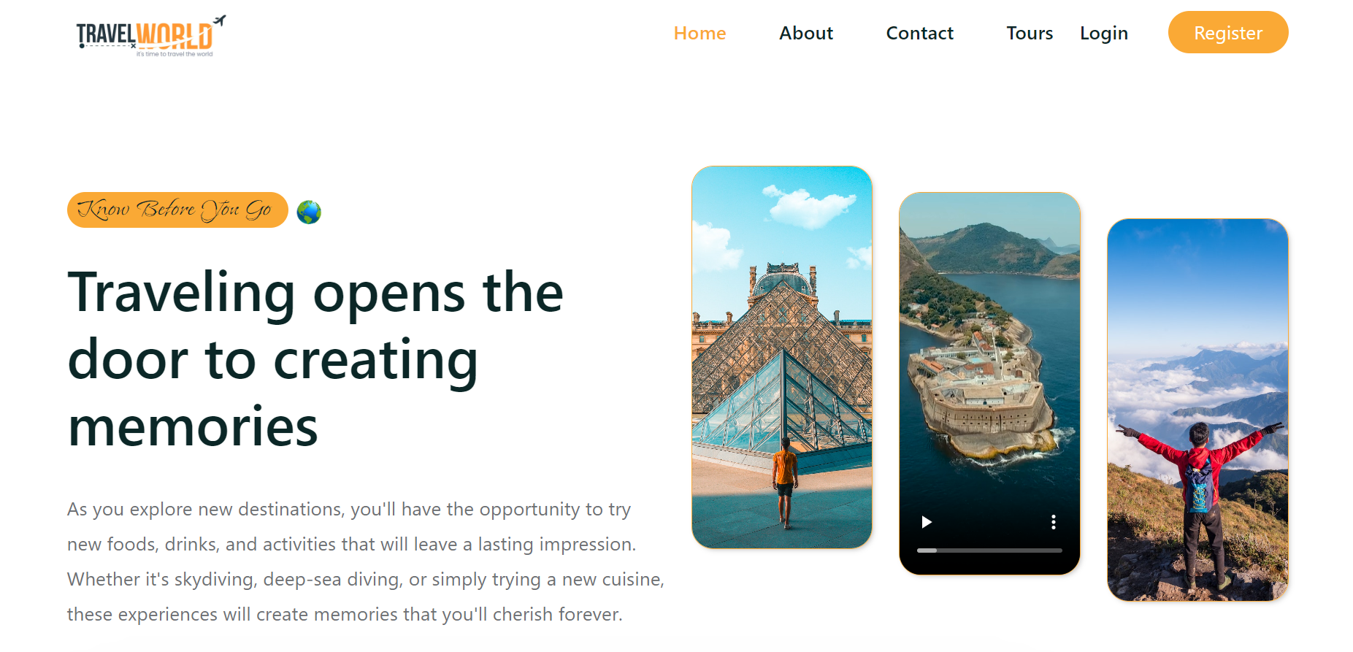



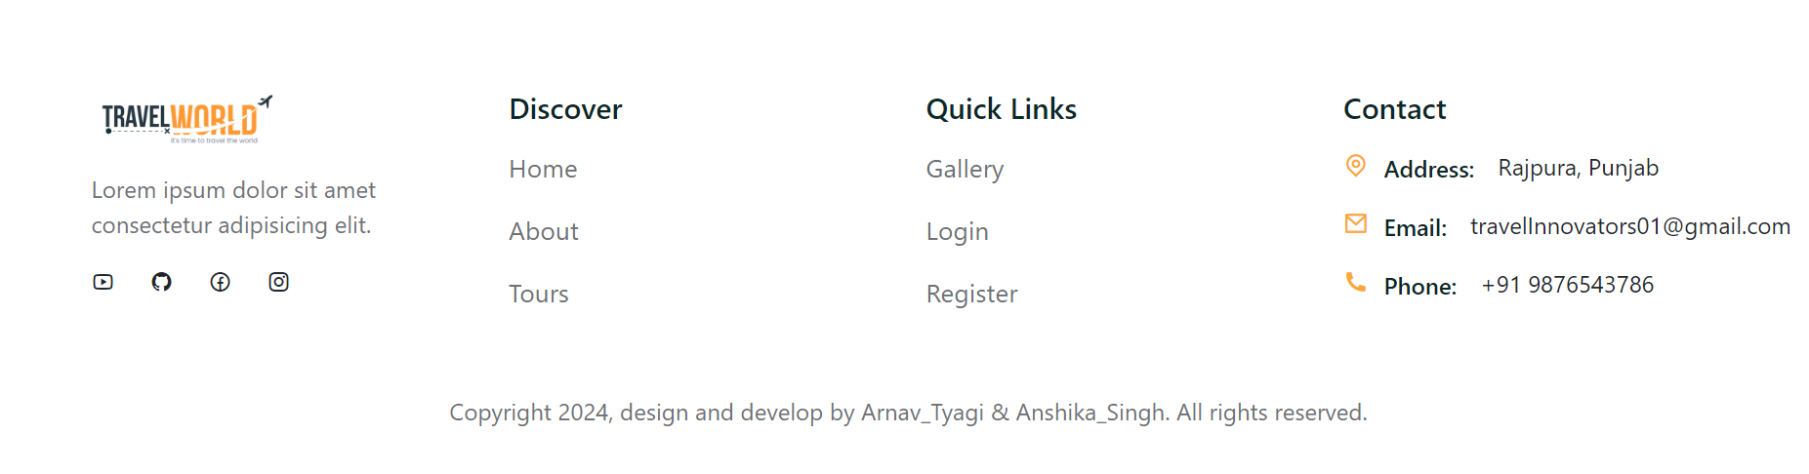

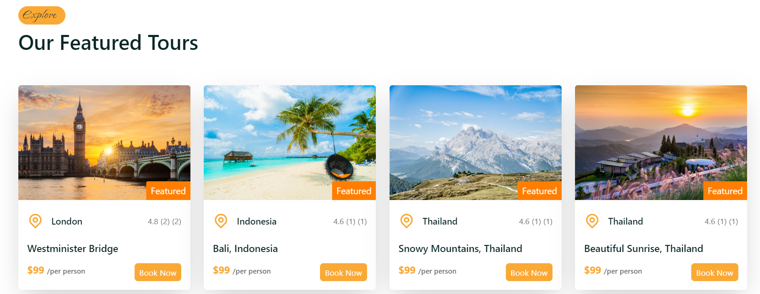

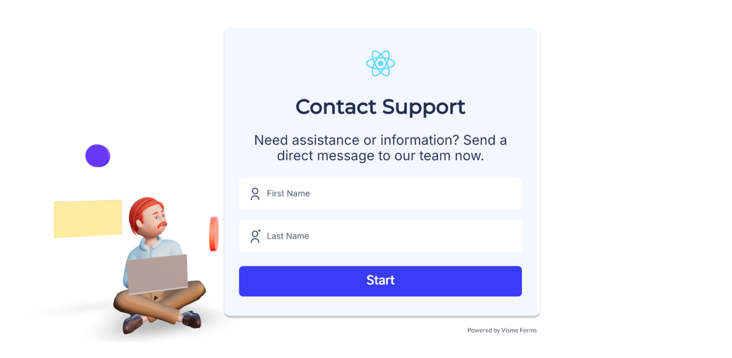

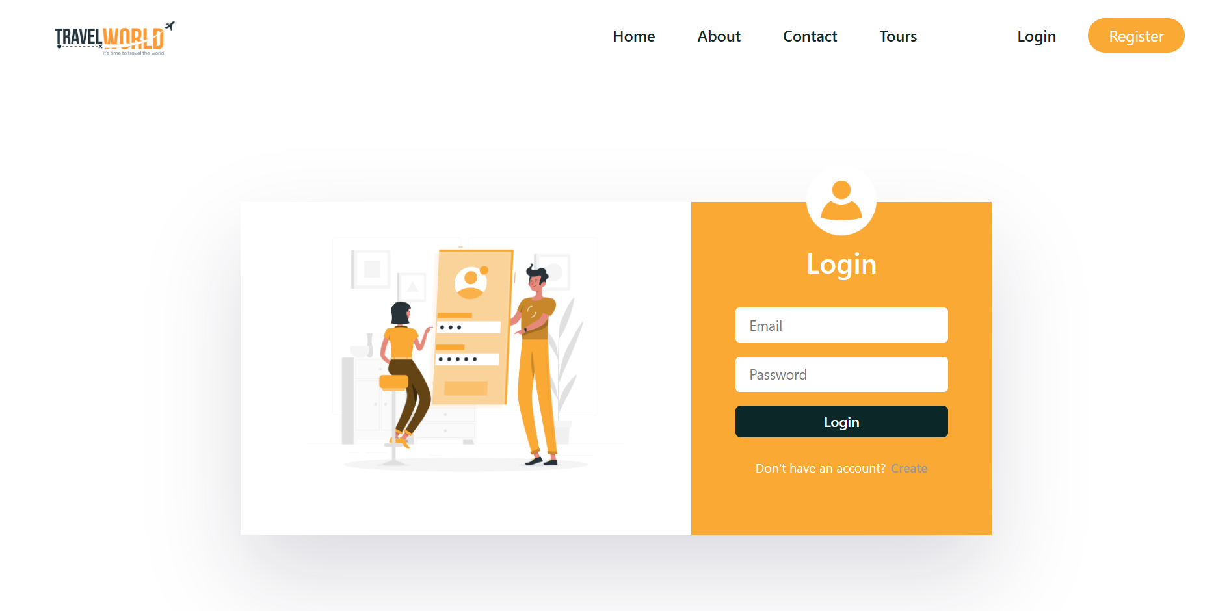

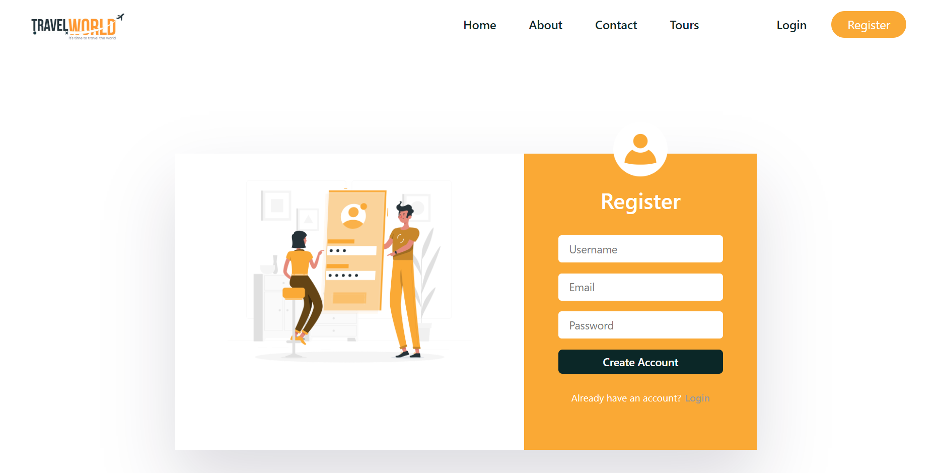

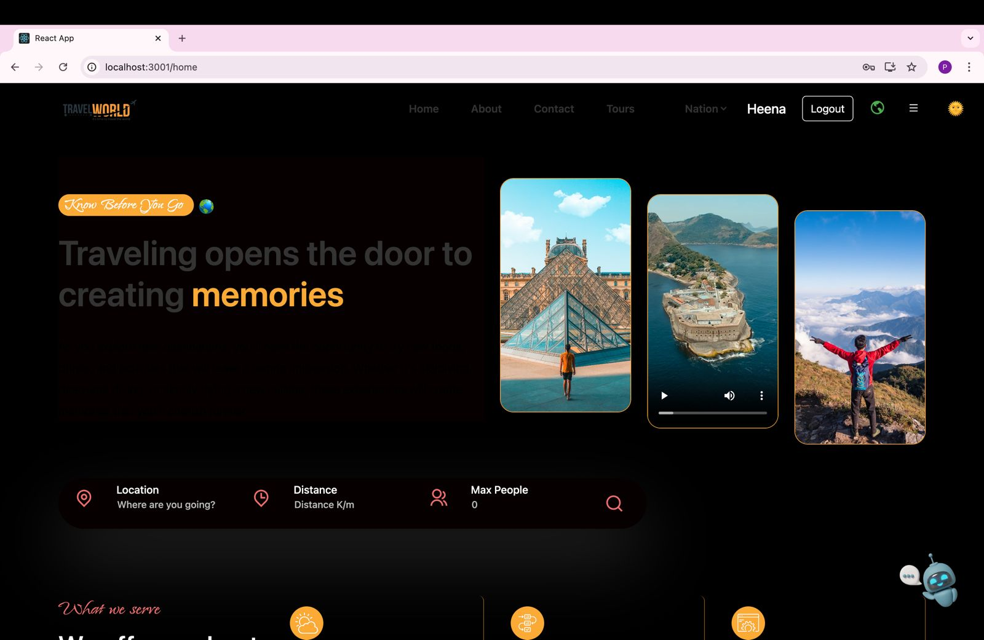

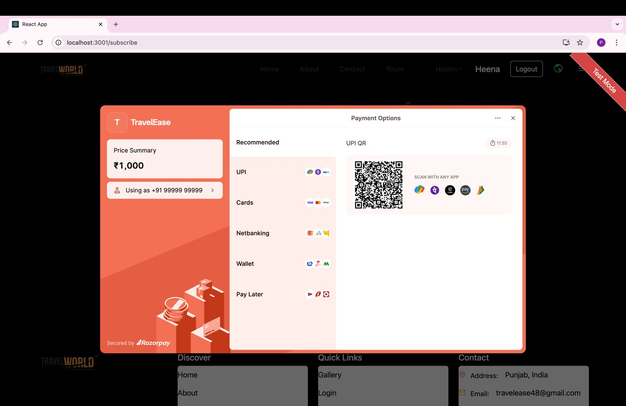

### 

### 

### 6. Conclusion

In conclusion, the tour and travel website is a comprehensive online platform designed to provide a seamless and engaging experience for travelers to plan and book their trips. The website offers a wide range of features, including destination guides, travel itineraries, booking and reservation systems, and social sharing capabilities.

**Key Takeaways:**

* **Personalized Experience:** The website provides a personalized travel experience, offering users customized travel recommendations and itineraries.
* **Seamless Navigation:** The website features a user-friendly interface and intuitive design, ensuring a smooth and enjoyable experience for users.
* **Reliable and Secure:** The website is built with security and reliability in mind, ensuring that user data and transactions are protected.

### 7. Future Scope

* **Artificial Intelligence:** Integrating AI and machine learning algorithms to provide more personalized travel recommendations and improve user experience.
* **Virtual and Augmented Reality:** Incorporating VR and AR technologies to offer immersive travel experiences and enhance user engagement.

In the travel industry, VR is being used to capture tourism destinations in a unique and immersive way, allowing users to explore a destination before visiting. This is achieved using specialist cameras, rigs, and software. The finished content can then be viewed on either a VR headset or a regular computer or mobile device.

 AR can be used to provide interactive maps and personalized recommendations to travelers. AR can be used to provide remote assistants and translation apps to travelers.

* **Mobile-First Design:** Optimizing the website for mobile devices, ensuring a seamless user experience across various platforms

### 8. References

* <https://www.npmjs.com/>
* <https://www.w3schools.com/REACT/DEFAULT.ASP>
* <https://www.mongodb.com/>
* <https://unsplash.com/>
* <https://youtube.com/>
* <https://github.com/>
* <https://www.makemytrip.com/>