

Safety Plan Lane Assistance

**Document Version: [Version]**

**Template Version 1.0, Released on 2017-06-21**



# Document history

|  |  |  |  |
| --- | --- | --- | --- |
| Date | Version | Editor | Description |
| 24-05-2018 | V1 | Trishla Chaurasia | Initial documentation of Safety plan Lane Assistance |
|  |  |  |  |
|  |  |  |  |
|  |  |  |  |
|  |  |  |  |

# Table of Contents

Document history

Table of Contents

Introduction

Purpose of the Safety Plan

Scope of the Project

Deliverables of the Project

Item Definition

Goals and Measures

Goals

Measures

Safety Culture

Safety Lifecycle Tailoring

Roles

Development Interface Agreement

Confirmation Measures

# Introduction

## Purpose of the Safety Plan

The safety plan discusses the safety plan for lane assistance. The main objective of this safety plan is to detect risk and reduce it to the acceptable level

## Scope of the Project

For the lane assistance project, the following safety lifecycle phases are in scope:

Concept phase

Product Development at the System Level

Product Development at the Software Level

The following phases are out of scope:

Product Development at the Hardware Level

Production and Operation

## Deliverables of the Project

The deliverables of the project are:

Safety Plan

Hazard Analysis and Risk Assessment

Functional Safety Concept

Technical Safety Concept

Software Safety Requirements and Architecture

# Item Definition

The item in question here is the Lane Assistance system. It alerts the driver that the vehicle has accidentally departed the lane and attempts to steer the vehicle back towards the center of the lane.

The Lane Assistance System will have two functions:

1.Lane departure warning: The lane departure warning function shall apply an oscillating steering torque to provide the driver a haptic feedback.

2.Lane keeping assistance: the lane keeping assistance function shall apply the steering torque when active in order to stay in ego lane**.**

The subsystems responsible for each subsystem are:

Camera Subsystems, Electronic Power Steering Subsystem, Car Display Subsystem

Following diagram represents boundaries of item

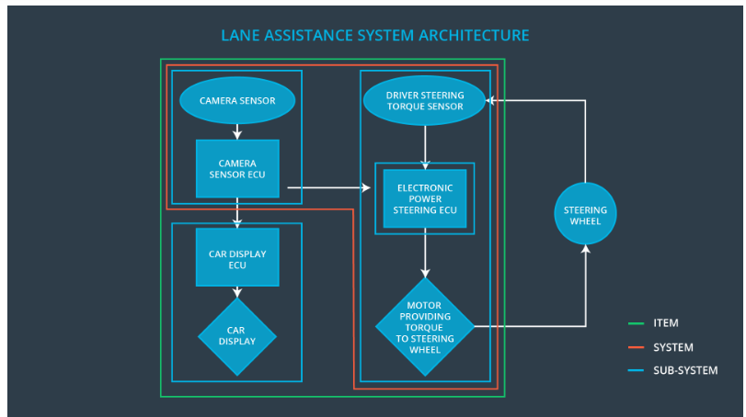

Since steering wheel is not part of the item, so it’s not part of the project

Goals and Measures

## Goals

This project goals are: - Identifying risk and hazardous situations in the Line Assistance system components. – Evaluating the risks of the hazardous situations. – Lowering the risk of the malfunctions to a reasonable level

Measures

|  |  |  |
| --- | --- | --- |
| Measures and Activities | Responsibility | Timeline |
| Follow safety processes | All Team Members | Constantly |
| Create and sustain a safety culture | All Team Members | Constantly |
| Coordinate and document the planned safety activities | All Team Members | Constantly |
| Allocate resources with adequate functional safety competency | Project Manager | Within 2 weeks of start of project |
| Tailor the safety lifecycle | Safety Manager | Within 4 weeks of start of project |
| Plan the safety activities of the safety lifecycle | Safety Manager | Within 4 weeks of start of project |
| Perform regular functional safety audits | Safety Auditor | Once every 2 months |
| Perform functional safety pre-assessment prior to audit by external functional safety assessor | Safety Manager | 3 months prior to main assessment |
| Perform functional safety assessment | Safety Assessor | Conclusion of functional safety activities |

# Safety Culture

Here are some characteristics of a good safety culture:

**High priority**: safety has the highest priority among competing constraints like cost and productivity

**Accountability**: processes ensure accountability such that design decisions are traceable back to the people and teams who made the decisions

**Rewards**: the organization motivates and supports the achievement of functional safety

**Penalties**: the organization penalizes shortcuts that jeopardize safety or quality

**Independence**: teams who design and develop a product should be independent from the teams who audit the work

**Well defined processes**: company design and management processes should be clearly defined

**Resources**: projects have necessary resources including people with appropriate skills

**Diversity**: intellectual diversity is sought after, valued and integrated into processes

**Communication**: communication channels encourage disclosure of problems

# Safety Lifecycle Tailoring

When it comes to dealing with entirely new implementation, the entire safety lifecycle including all the phases mentioned in chapter “Scope of the Project “ have to be followed and documented. For the lane assistance project, the following safety lifecycle phases are in scope:

Concept phase

Product Development at the System Level

Product Development at the Software Level

The following phases are out of scope:

Product Development at the Hardware Level

Production and Operation

# Roles

|  |  |
| --- | --- |
| Role | Org |
| Functional Safety Manager- Item Level | OEM |
| Functional Safety Engineer- Item Level | OEM |
| Project Manager - Item Level | OEM |
| Functional Safety Manager- Component Level | Tier-1 |
| Functional Safety Engineer- Component Level | Tier-1 |
| Functional Safety Auditor | OEM or external |
| Functional Safety Assessor | OEM or external |

# Development Interface Agreement

A DIA (development interface agreement) defines the roles and responsibilities between companies involved in developing a product. All involved parties need to agree on the contents of the DIA before the project begins.

The DIA also specifies what evidence and work products each party will provide to prove that work was done according to the agreement.

The OEM provides a functioning lane assistance system. Tier-1 is going to analyze and modify various sub-systems according to functional safety requirements.

The ultimate goal is to ensure that all parties are developing safe vehicles in compliance with ISO 26262.

Here are major sections of a DIA:

1.Appointment of customer and supplier safety managers

2.Joint tailoring of the safety lifecycle

3.Activities and processes to be performed by the customer; activities and processes to be performed by the supplier

4.Information and work products to be exchanged

5.Parties or persons responsible for each activity in design and production

6.Any supporting processes or tools to ensure compatibility between customer and supplier technologies

# Confirmation Measures

Confirmation measures serve two purposes:

1.that a functional safety project conforms to ISO 26262, and

2.that the project really does make the vehicle safer.

The people who carry out confirmation measures need to be independent from the people who actually developed the project. Confirmation review Ensures that the project complies with ISO 26262. As the product is designed and developed, an independent person would review the work to make sure ISO 26262 is being followed. A Functional safety audit make sure the actual implementation of the project conforms to the safety plan. A Functional safety assessment confirms that the plan, design and developed product actually achieve functional safety.