

Technical Safety Concept Lane Assistance

**Document Version: [Version]**

**Template Version 1.0, Released on 2017-06-21**



# Document history

|  |  |  |  |
| --- | --- | --- | --- |
| Date | Version | Editor | Description |
| 23-05-2018 | V1 | Trishla Chaurasia | Initial version of Technical safety concept documentation |
|  |  |  |  |
|  |  |  |  |
|  |  |  |  |
|  |  |  |  |

# 

# Table of Contents

Document history

Table of Contents

Purpose of the Technical Safety Concept

Inputs to the Technical Safety Concept

Functional Safety Requirements

Refined System Architecture from Functional Safety Concept

Functional overview of architecture elements

Technical Safety Concept

Technical Safety Requirements

Refinement of the System Architecture

Allocation of Technical Safety Requirements to Architecture Elements

Warning and Degradation Concept

# Purpose of the Technical Safety Concept

Technical Safety concept is somewhat similar to functional safety concept. While Functional safety gives an overview of the system, Technical safety goes deeper and provides technical details of the system. Technical safety requirements are derived from functional safety requirements

# Inputs to the Technical Safety Concept

## Functional Safety Requirements

|  |  |  |  |  |
| --- | --- | --- | --- | --- |
| **ID** | **Functional Safety Requirement** | **ASIL** | **Fault Tolerant Time Interval** | **Safe State** |
| Functional  Safety  Requirement  01-01 | The lane keeping item shall ensure that the  lane departure oscillating torque amplitude  is below Max_Torque_Amplitude | C | 50 ms | Turn off LDW |
| Functional  Safety  Requirement  01-02 | The lane keeping item shall ensure that the lane departure oscillating torque frequency is below Max_Torque_Frequency | C | 50 ms | Turn off LDW |
| Functional  Safety  Requirement  02-01 | The electronic power steering ECU shall  ensure that the lane keeping assistance  torque is applied for only Max_Duration. | B | 500 ms | Turn off LKA |

## Refined System Architecture from Functional Safety Concept

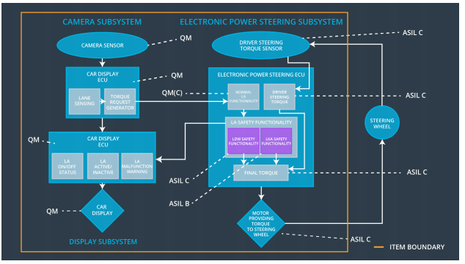

### 

### Functional overview of architecture elements

|  |  |
| --- | --- |
| **Element** | **Description** |
| Camera Sensor | Provides images to Camera Sensor ECU |
| Camera Sensor ECU - Lane Sensing | Estimates lane line from the image provided by Camera Sensor |
| Camera Sensor ECU - Torque request generator | Sends the additional torque request for the LDW and LKA functions |
| Car Display | Displays warnings |
| Car Display ECU - Lane Assistance On/Off Status | Controls the on/off status on the display |
| Car Display ECU - Lane Assistant Active/Inactive | Controls the active/inactive status on the display |
| Car Display ECU - Lane Assistance malfunction warning | Controls the malfunction warning on the display |
| Driver Steering Torque Sensor | Measure the torque applied to the steering wheel by the driver. |
| Electronic Power Steering (EPS) ECU - Driver Steering Torque | It processes inputs received from camera sensor ECU Driver Steering Torque Sensor, and then calculates suitable Lane Assistance functionality which results in final torque, which is then transferred to Steering wheel motor |
| EPS ECU - Normal Lane Assistance Functionality | It receives Camera Sensor ECU torque request and processes it |
| EPS ECU - Lane Departure Warning Safety Functionality | It receives request from the camera subsystem  to activate/deactivate the lane departure warning  system and then conveys this request to the steering wheel through the motor |
| EPS ECU - Lane Keeping Assistant Safety Functionality | It receives request from the camera subsystem to activate/deactivate the lane assistance system and conveys this request to the steering wheel through the motor |
| EPS ECU - Final Torque | Calculates final torque that needs to be applied to the steering wheel. It considers the inputs from LDW Safety, LKA Safety, data transmission etc. |
| Motor | Applies the final torque to the steering wheel |

# Technical Safety Concept

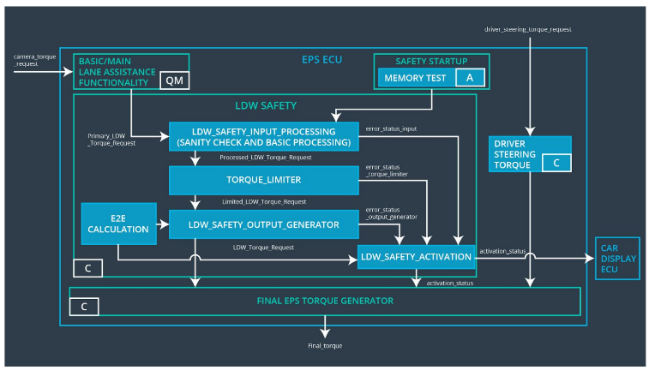

## Technical Safety Requirements

**Lane Departure Warning (LDW) Requirements:**

Functional Safety Requirement 01-01 with its associated system elements

(derived in the functional safety concept)

|  |  |  |  |  |
| --- | --- | --- | --- | --- |
| **ID** | **Functional Safety Requirement** | **Electronic Power Steering ECU** | **Camera ECU** | **Car Display ECU** |
| Functional  Safety  Requirement  01-01 | The lane keeping item shall ensure that the lane departure oscillating torque amplitude is below Max_Torque_Amplitude | X |  |  |

Technical Safety Requirements related to Functional Safety Requirement 01-01 are:

|  |  |  |  |  |  |
| --- | --- | --- | --- | --- | --- |
| **ID** | **Technical Safety Requirement** | **ASIL** | **Fault Tolerant Time Interval** | **Architecture Allocation** | **Safe State** |
| Technical  Safety  Requirement  01 | The LDW safety component shall ensure that the amplitude of the 'LDW_Torque_Request' sent to the 'Final electronic power steering Torque' component is below 'Max_Torque_Amplitude. | C | 50 ms | LDW safety | Set LDW Torque to zero |
| Technical  Safety  Requirement  02 | As soon as the LDW function deactivates the LDW feature, the 'LDW Safety' software block shall send a signal to the car display ECU to turn on a warning light. | C | 50 ms | LDW Safety | Set LDW Torque to zero |
| Technical  Safety  Requirement  03 | As soon as a failure is detected by the LDW function, it shall deactivate the LDW feature and the 'LDW_Torque_Request' shall be set to zero. | C | 50 ms | LDW Safety block | Set LDW Torque to zero |
| Technical  Safety  Requirement  04 | The validity and integrity of the data transmission for 'LDW_Torque_Request' signal shall be ensured. | C | 50 ms | Data Transmission Integrity Check | N/A |
| Technical  Safety  Requirement  05 | Memory test shall be conducted at start up of the EPS ECU to check for any faults in memory. | A | Ignition cycle | Memory test | Set LDW Torque to zero |

Functional Safety Requirement 01-2 with its associated system elements

(derived in the functional safety concept)

|  |  |  |  |  |
| --- | --- | --- | --- | --- |
| **ID** | **Functional Safety Requirement** | **Electronic Power Steering ECU** | **Camera ECU** | **Car Display ECU** |
| Functional  Safety  Requirement  01-02 | The lane keeping item shall ensure that the lane departure oscillating torque frequency is below Max_Torque_Frequency | X |  |  |

Technical Safety Requirements related to Functional Safety Requirement 01-02 are:

|  |  |  |  |  |  |
| --- | --- | --- | --- | --- | --- |
| **ID** | **Technical Safety Requirement** | **ASIL** | **Fault Tolerant Time Interval** | **Architecture Allocation** | **Safe State** |
| Technical  Safety  Requirement  01 | The LDW safety component shall ensure that the frequency of the 'LDW_Torque_Request' sent to the 'Final electronic power steering Torque' component is below 'Max_Torque_Frequency. | C | 50 ms | LDW safety | Set LDW Torque to zero |
| Technical  Safety  Requirement  02 | As soon as the LDW function deactivates the LDW feature, the 'LDW Safety' software block shall send a signal to the car display ECU to turn on a warning light. | C | 50 ms | LDW safety | Set LDW Torque to zero |
| Technical  Safety  Requirement  03 | As soon as a failure is detected by the LDW function, it shall deactivate the LDW feature and the 'LDW_Torque_Request' shall be set to zero. | C | 50 ms | LDW safety | Set LDW Torque to zero |
| Technical  Safety  Requirement  04 | The validity and integrity of the data transmission for 'LDW_Torque_Request' signal shall be ensured. | C | 50 ms | Data Transmission Integrity Check | N/A |
| Technical  Safety  Requirement  05 | Memory test shall be conducted at startup of the EPS ECU to check for any faults in memory | A | Ignition cycle | Memory test | Set LDW Torque to zero |

**Lane Departure Warning (LDW) Verification and Validation Acceptance Criteria:**

**Lane Keeping Assistance (LKA) Requirements:**

Functional Safety Requirement 02-1 with its associated system elements

(derived in the functional safety concept)

|  |  |  |  |  |
| --- | --- | --- | --- | --- |
| **ID** | **Functional Safety Requirement** | **Electronic Power Steering ECU** | **Camera ECU** | **Car Display ECU** |
| Functional  Safety  Requirement  02-01 | The lane keeping item shall ensure that the lane keeping assistance torque is applied for only Max_Duration | X |  |  |

Technical Safety Requirements related to Functional Safety Requirement 02-01 are:

|  |  |  |  |  |  |
| --- | --- | --- | --- | --- | --- |
| **ID** | **Technical Safety Requirement** | **ASIL** | **Fault Tolerant Time Interval** | **Allocation to Architecture** | **Safe State** |
| Technical  Safety  Requirement  01 | The LKA safety component shall ensure that the active duration time is below max duration | B | 500 ms | LKA safety | Set LKA Torque to zero |
| Technical  Safety  Requirement  02 | As soon as a failure is detected by the LKA function, it shall deactivate the LKA feature and the “LKA_Torque_Request” shall be set to zero. | B | 500 ms | LKA safety | Set LKA Torque to zero |
| Technical  Safety  Requirement  03 | As soon as the LKA function deactivates the LKA feature, the 'LKA Safety' software block shall send a signal to the car display ECU to turn on a warning light. | B | 500 ms | LKA safety | Set LKA Torque to zero |
| Technical  Safety  Requirement  04 | The validity and integrity of the data transmission for 'LKA_Torque_Request' signal shall be ensured. | B | 500 ms | Data Transmission Integrity Check | N/A |
| Technical  Safety  Requirement  05 | Memory test shall be conducted at start up of the EPS ECU to check for any faults in memory | A | 500 ms | Memory Test | Set LKA Torque to zero |

**Lane Keeping Assistance (LKA) Verification and Validation Acceptance Criteria:**

## Refinement of the System Architecture

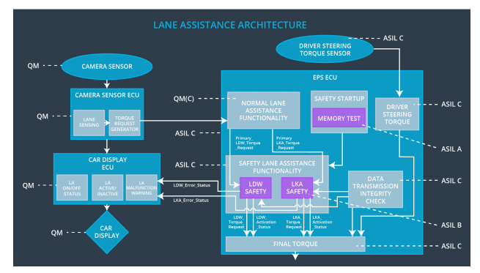

## Allocation of Technical Safety Requirements to Architecture Elements

For this item, all technical safety requirements are allocated to Electronic Power Steering ECU

## Warning and Degradation Concept

|  |  |  |  |  |
| --- | --- | --- | --- | --- |
| **ID** | **Degradation Mode** | **Trigger for Degradation Mode** | **Safe State invoked?** | **Driver Warning** |
| WDC-01 | Turn Off the function | Is maximum torque exceeded | Yes | Display warning |
| WDC-02 | Turn Off the function | Is maximum torque exceeded | Yes | Display Warning |