STEP 1: CREATING THE GIT HUB REPOSITORY WITH THE NAME OF MY ENROLLNMENT NO.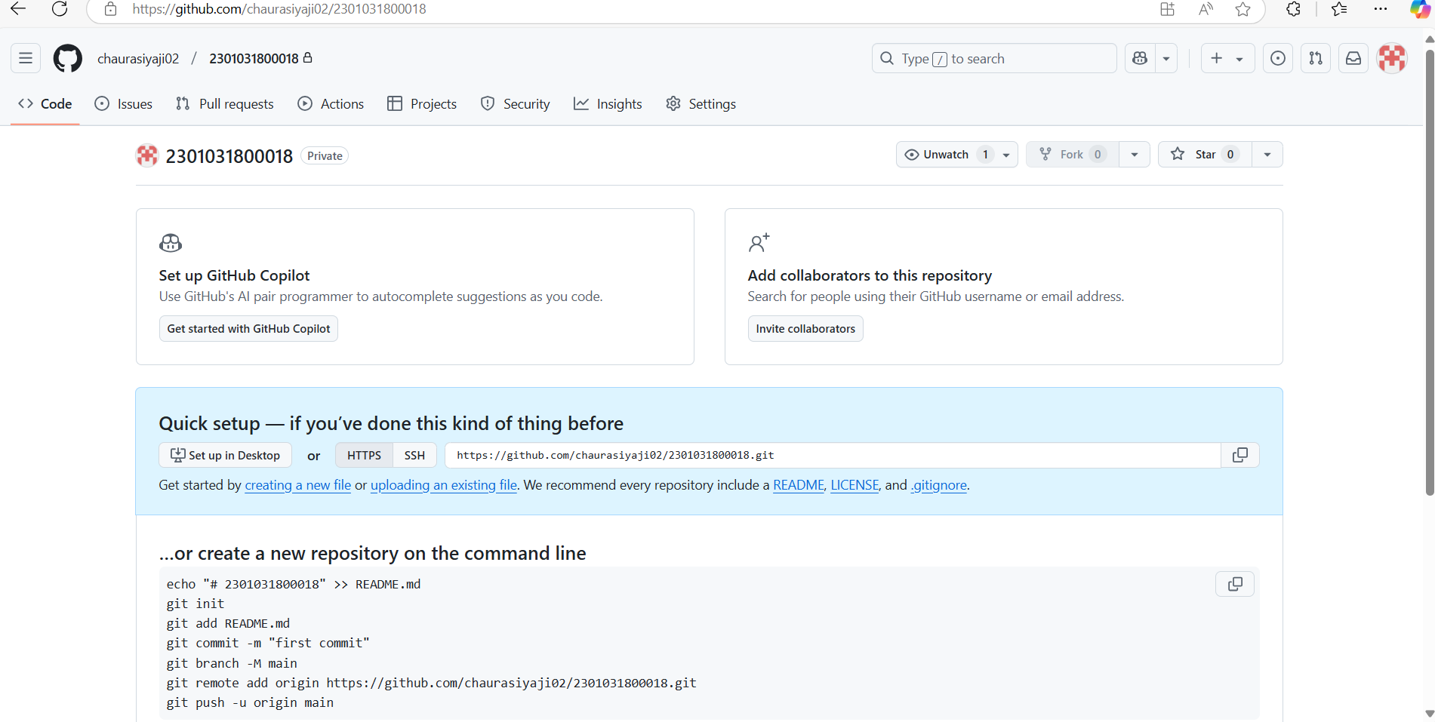

**STEP 2 : MAKING THE FIRST FOLDER NAME ASSIGNMENT_1**

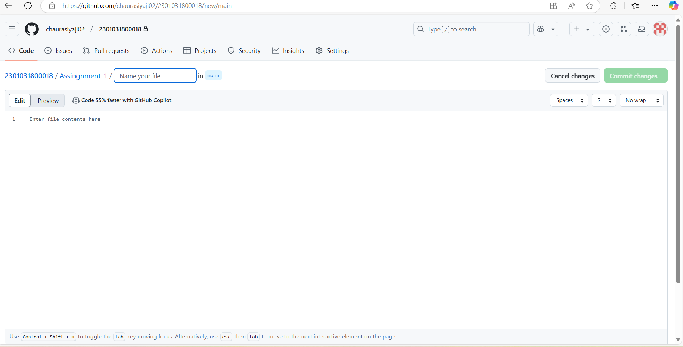

**STEP 3: AFTER CREATING THE ASSIGNMENT_ NOW CREATED THE NEW FOLDER NAMED ASSIGNMENT_2**

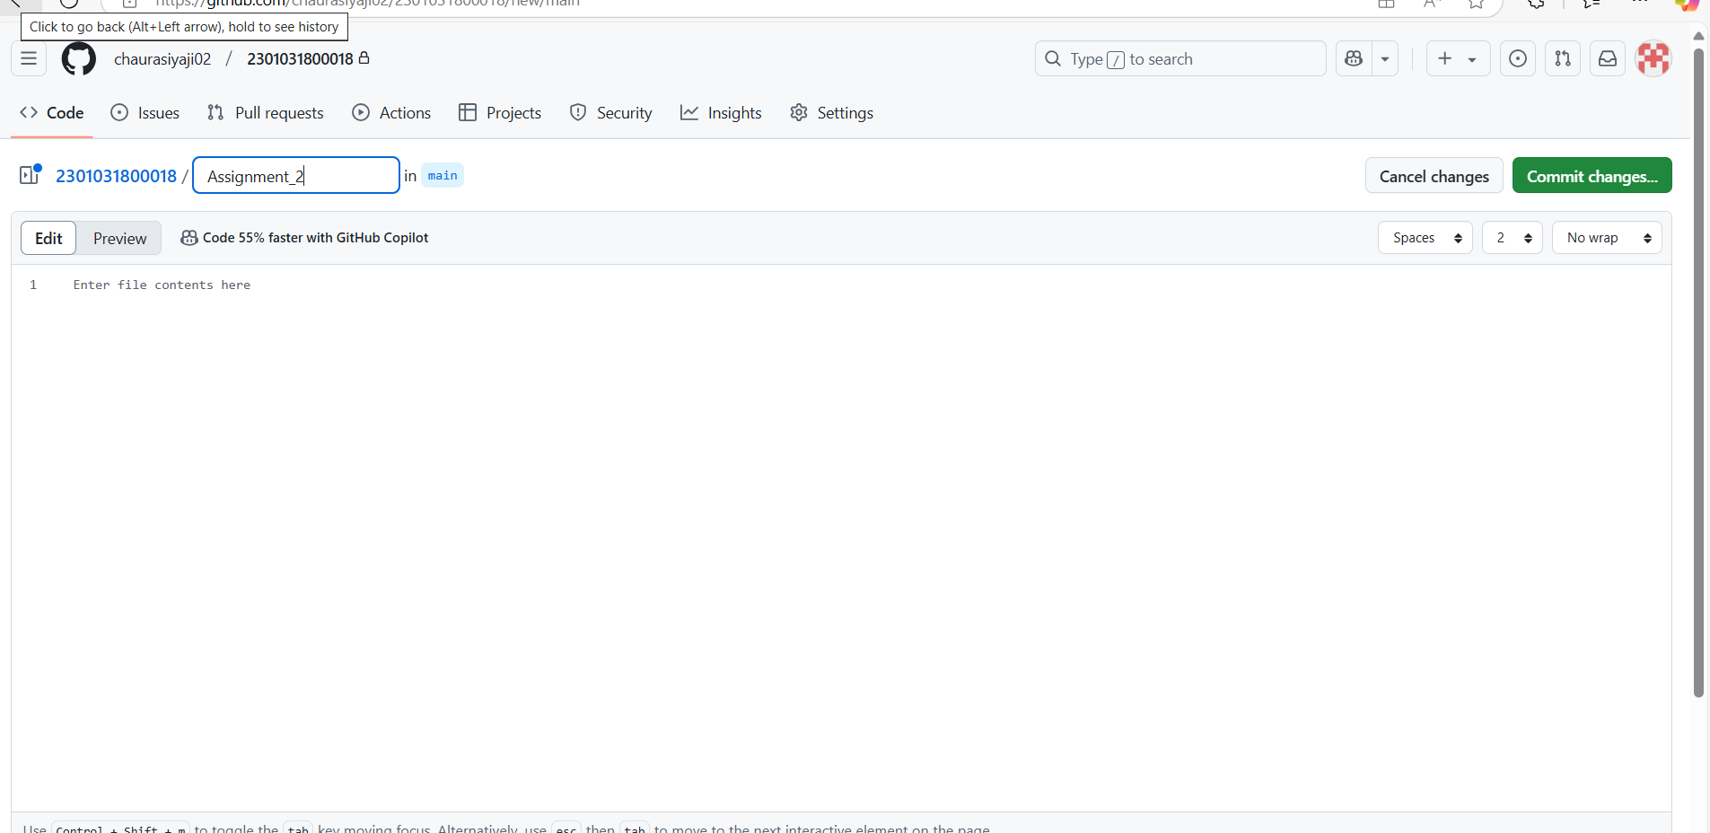

**STEP 4: NOW UPLOAD FILE IN ASSIGNMENT_2 FOLDER**

