Powershell – Create New App.

Login with Admin ID: Set Execution from Restricted to UnRestricted.

Install-Module –name Azure

Install-Module –name AzureRm

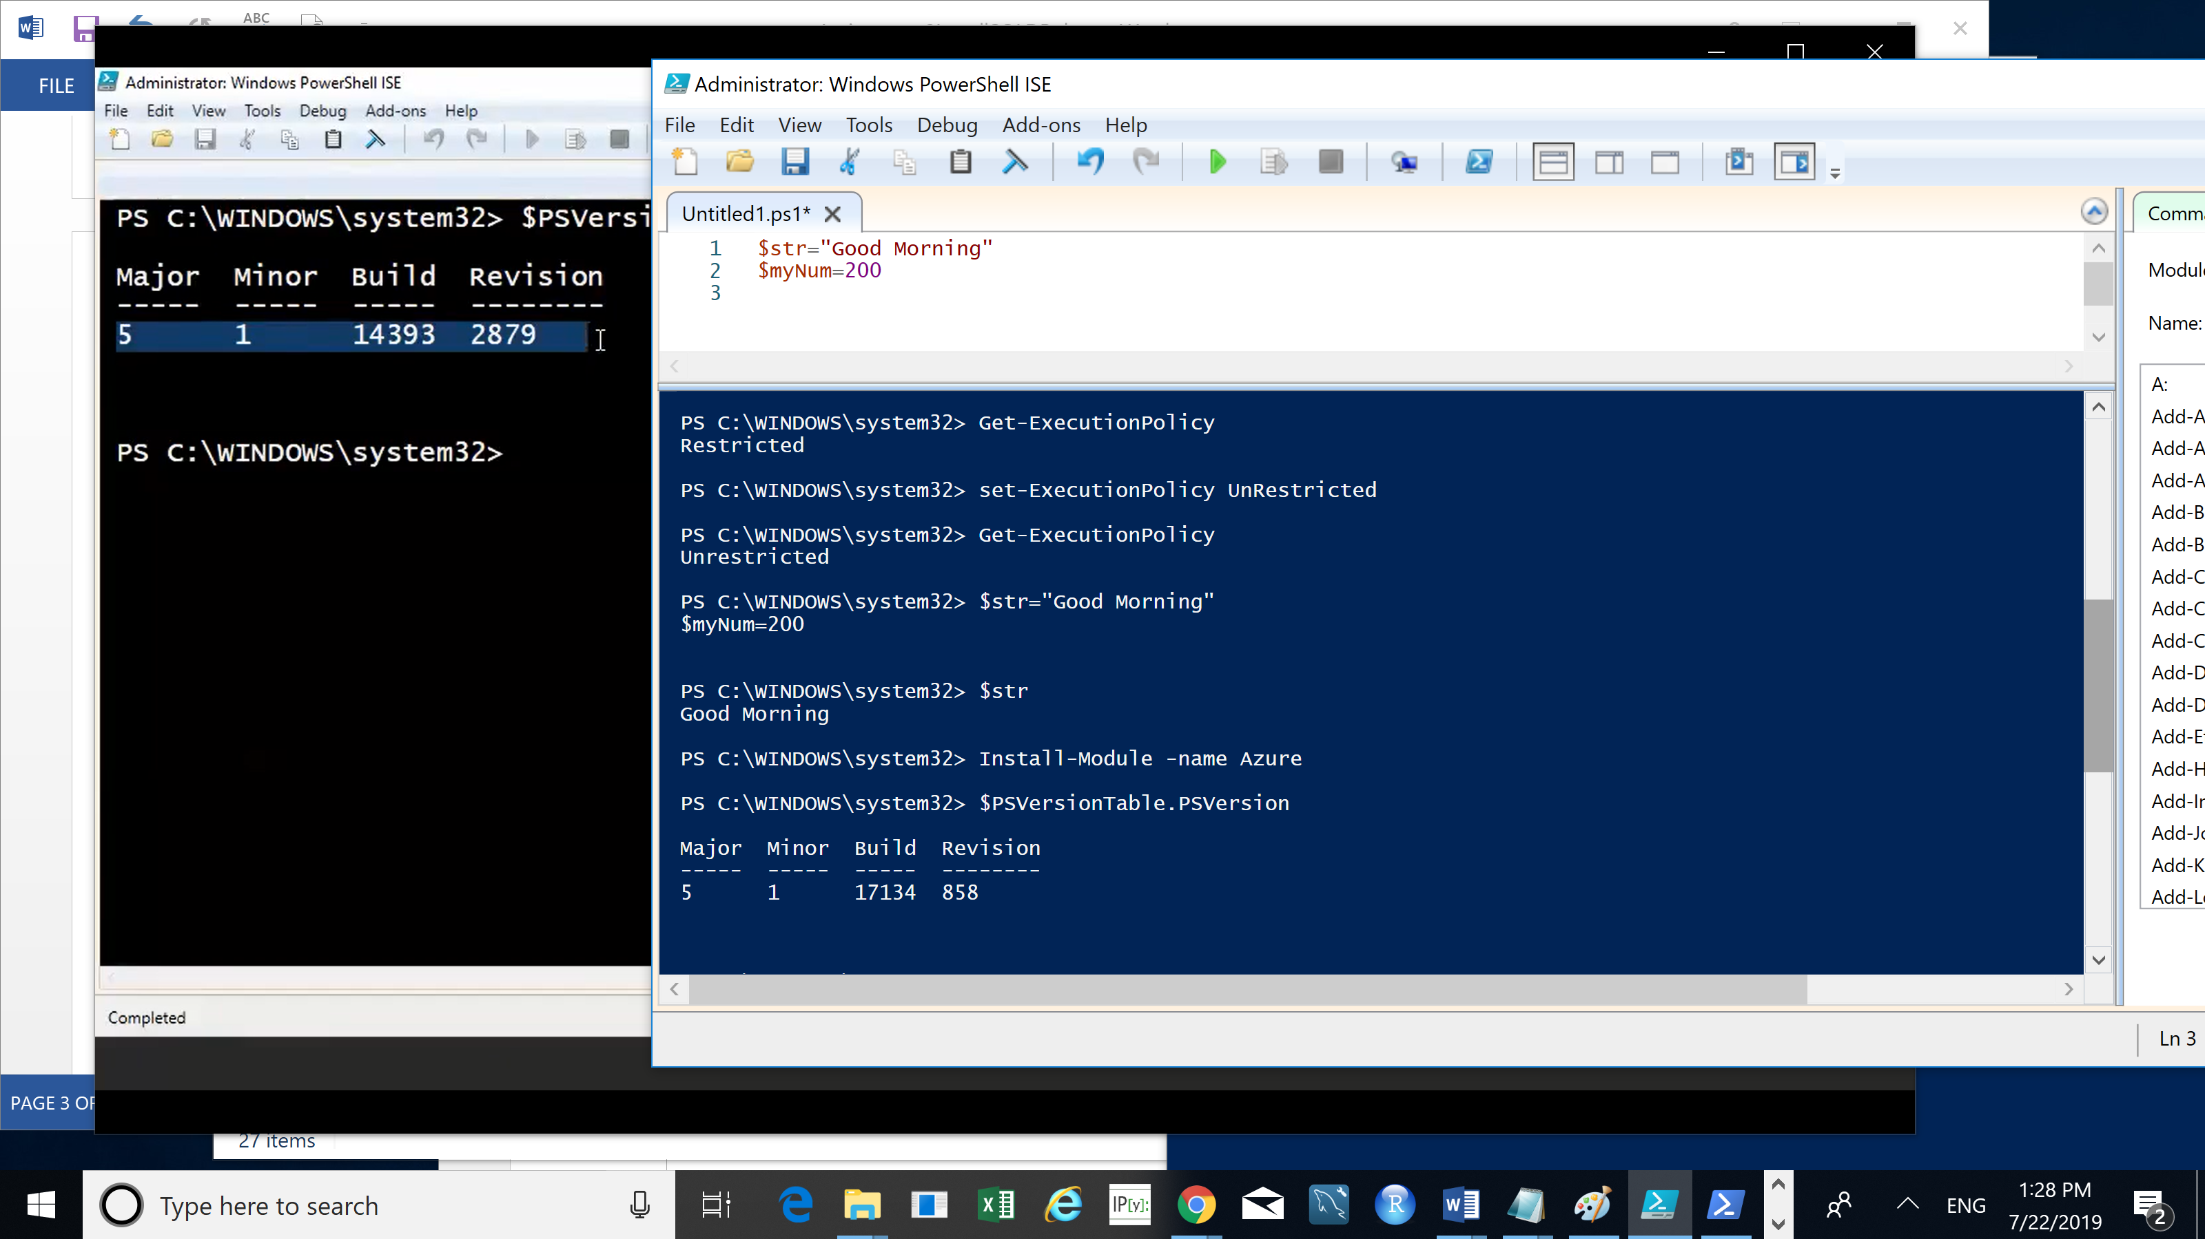

Login-AzureRmAccount

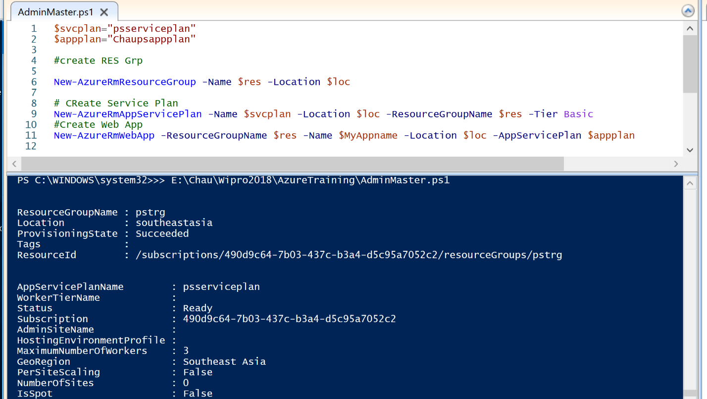

Results: After running the powershell script.

