R Homework 3 (Written)
Problem 1:

a) The mean & standard deviation of X is:

Mean: -0.00657 SD: 0.981

b) The P(X|-MeanX| >= k * sd) is:

The Probability for k = 1, is 0.309
The Probability for k = 2, is 0.049
The Probability for k = 3, is 0.003

c) Does it hold for Chebyshev's Inequality?

For k=1, my function returns TRUE
For k=2, my function returns TRUE
For k=3, my function returns TRUE

Problem 2:

a) The probability is 0.529

b) P(X==7) = 0.146

c) P = 0.4

d) When n=10 , Mean: 0.536 Variance: 0.158
When n=100, Mean: 0.529 Variance: 0.050
When n=1000, Mean: 0.528 Variance: 0.0158
When n=10000, Mean: 0.529 Variance: .00499

As n grows larger, the mean for the P is relatively close to ~0.59,
The Variance of the mean gets smaller and smaller. When n grows, the estimate is getting more and more percise.

Problem 3:

a)

Data: | Dataset 1 | Dataset 2 | Dataset 3
N=100 | Mean: 0.280  StandardDev: 0.0432  Median: 0.27  StandardDev: 0.044  (Median) | Mean: 1.192  StandardDev: 0.102  Median: 1.20  StandardDev: 0.089  (Median) | Mean: 1543.852  StdDev: 153.0615  Median: 1527.851  StdDev: 171.533  (Median)
N=1000 | Mean: 0.278  StandardDev: 0.0441  Median: 0.28  StandardDev: 0.044  (Median) | Mean: 1.192  StandardDev: 0.103  Median: 1.19  StandardDev: 0.103  (Median) | Mean: 1538.771  StdDev: 145.1281  Median: 1535.996  StdDev: 153.040  (Median)
N=10000 | Mean: 0.280  StandardDev: 0.0446  Median: 0.28  StandardDev: 0.044  (Median) | Mean: 1.189  StandardDev: 0.105  Median: 1.19  StandardDev: 0.103  (Median) | Mean: 1540.889  StdDev: 148.331  Median: 1537.89  StdDev: 149.36  (Median)

b)
The first graph is most likely a Bernoulli distribution. It contains n amount of trials of either success or fails. Contains only (1 (TRUE) or 0 (FALSE)).

The second graph is likely to be an multinomial distribution. The outcomes can only be either 0,1,2,3. It may consist of n binomial trials with k>2 outcomes.

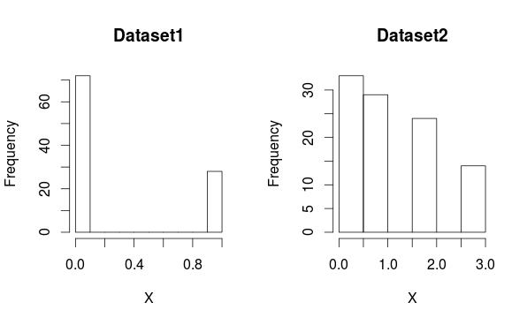
(Histograms attached below)

Problem 4:

N= | 1000 | 10000 | 100000
Points in Circle: | 791 | 7796 | 78563
Estimated Pi: | 3.164 | 3.118 | 3.1425

