R Program 1 Write Up

(a) Find the mean, median, and variance of body weight for all cats. Specify the units of each summary statistic.

The mean for all cats' bodyweight is ~2.724 kg (rounded).
The median for all cats' bodyweight is ~2.7 kg.
The variance for all cats' bodyweight is ~0.235 kg (rounded).

(b) Find the mean and standard deviation for female and male cats' body weight separately.

The mean for all female cats' bodyweight is 2.360 kg (rounded).
The standard deviation for all female cats' bodyweight is 0.2734 kg (rounded).

The mean for all male cats' bodyweight is 2.9 kg.
The standard deviation for all male cats' bodyweight is 0.467 kg.

- Draw a separate histogram (with appropriate titles and axis labels) for female and male cats' body weight. Does the range and center of the data appear to be the same?

The range and center for female and male cats are different. Male cats have a larger range, mean and center.

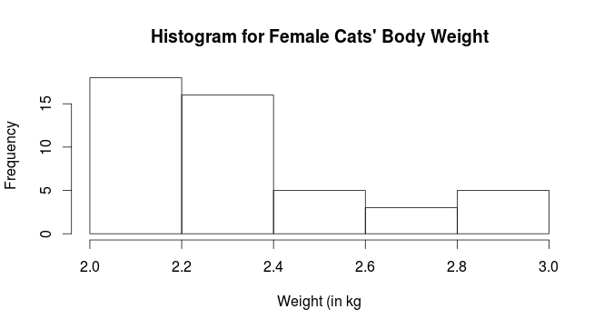
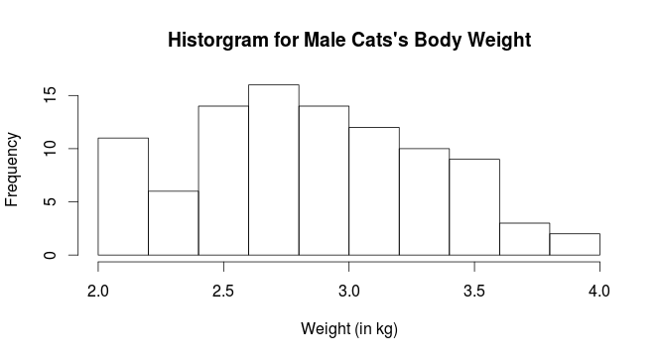

- Using the which function, along with the length function, and the proportion of male cats whose body weight is at least 2.5 kg, and do the same for female cats

The proportion of male cats with a bodyweight of at least 2.5 kg is 0.82 male cats.

The proportion of female cats with a bodyweight of at least 2.5 kg is 0.28 (rounded).

