# Milestone 2, UI Sketches

Chau Vu, Jan Rodriguez, Gabriel Frattallone

When a client accesses to the GuiChat, a window will pop up and asks for a username

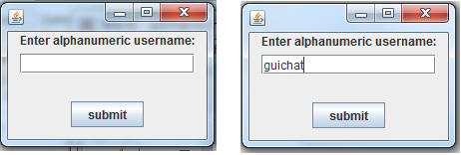

After hitting Enter or Submit button, a window will appear, showing all active users and ID of public chat rooms, if any.

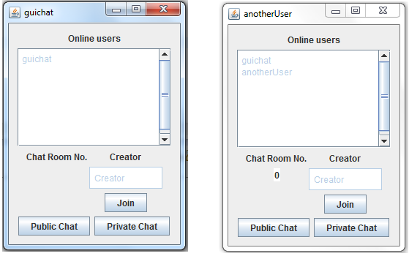

When user selects a Chat Room, in the figure, Room 0, the name of its creator will show up in the TextField under the Creator label.

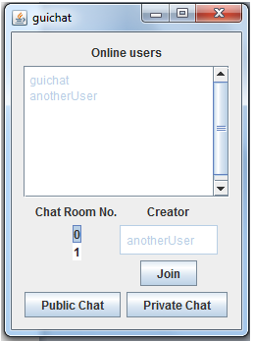

When user is selecting a chat room, and hits Join button, s/he will be able to join that chat room, i.e. a Conversation window will pop up with all of its current users. There are two ways to create a new conversation is to hit Public Chat or Private Chat button. If Public Chat button is hit, the chat room ID will show up in Chat Room No. list. In either ways, a conversation window will show up.

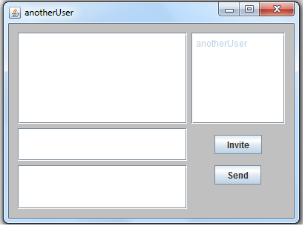

From this conversation window, users can send message or invite multiple users by typing in the corresponding text fields and hit Enter or hit Send/Invite

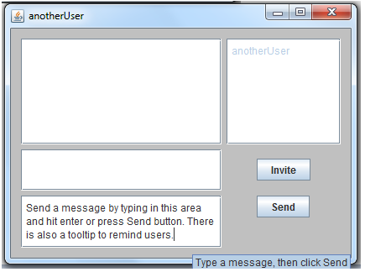

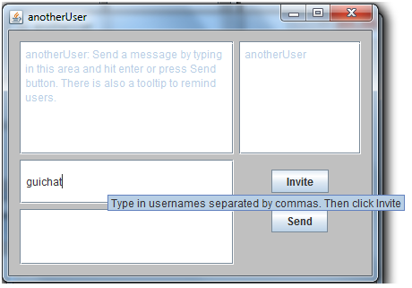

The text area next to messages is used to display users that are currently in the chat.

*Possible Improvement for the final deadline*: add more labels for the Conversation GUI so users know which area is which.