Part A - Question 1
TP (True Positive) = 140 FN (False Negative) = 10
FP (False Positive) = 30 TN (True Negative) = 20
Total Patients = 140 + 30 + 10 + 20 = 200
- Accuracy
There are 80% of accuracy that the models give correct predictions

- Misclassification Rate or Error rate
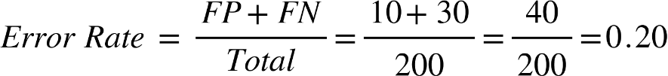
There is about 20% of the time, the model is wrong

- Precision or Positive Precision Value (PPV)
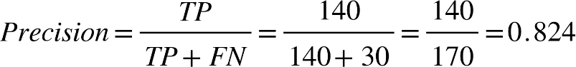
There is 82.4% of precision the model predicts someone has the disease

- Recall or Sensitivity/True Positive Recall (TPR)
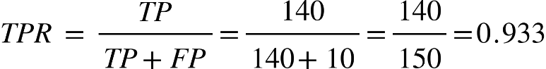
The model detects 93.3% of disease cases

- Interpretation
The model is 80% accurate in prediction, only 20% of error rate and a 82.4% of precision achieved. The model detects 93.3% of disease cases and only 6.7% of disease go undetected.
Part A - Question 2
TP (True Positive) = 180 FN (False Negative) = 20
FP (False Positive) = 30 TN (True Negative) = 70
Total Patients = 180+20+30+70 = 300
- Accuracy
There are 83.3% of accuracy that the models give correct predictions

- Misclassification Rate or Error rate
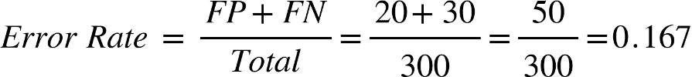
There is about 16.7% of the time, the models predict is wrong

- Precision or Positive Precision Value (PPV)
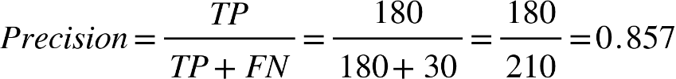
The model achieved 85.7% of precision rating the emails are spam

- Recall or Sensitivity/True Positive Recall (TPR)
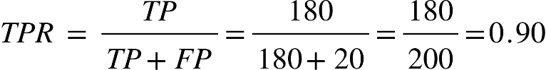
The model detects 90% of the emails are spam

- Interpretation
The model is 83.3% accurate in prediction whether the emails are spam or not spam, only 16.7% of error rate and a 85.7% of precision achieved. The model detects 90% of emails are spam and only 10% of them are not spam.
Part A - Question 3
TP (True Positive) = 80 FN (False Negative) = 10
FP (False Positive) = 20 TN (True Negative) = 90
Total Patients = 80+10+20+90 = 200
- Accuracy
There are 85% of accuracy that the models give correct predictions

- Misclassification Rate or Error rate
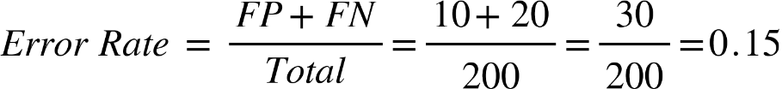
There is about 15% of the time, the models predict is wrong

- Precision or Positive Precision Value (PPV)
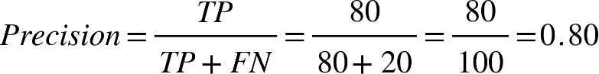
The model achieved 80% of precision having higher customer churn

- Recall or Sensitivity/True Positive Recall (TPR)
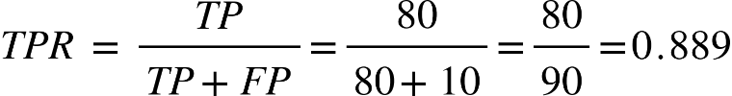
The model detects 88.9% of the customer churn.

- Interpretation
The model is 85% accurate in prediction whether the customers churn or loyal, only 15% of error rate and an 80% of precision achieved. The model detects 88.9% of customer churn and only 11.1% of customers under loyal.
Part B
 | Item | Description
1 | Overfitting | Overfitting happens when a model learns not only the patterns but also the noise and details in the training data which do not generalize to new data.
2 | Underfitting | Underfitting occurs when a model is too simple to capture the underlying pattern of the data.
3 | Hold-out Validation | A simple method to evaluate model performance by splitting the dataset into two parts, which are training set (to train the model) and testing set (to evaluate the model).
4 | K-fold Cross Validation | The dataset is split into K equal parts(folds). The model is trained on K-1 folds and tester on the remaining fold. This process is repeated K times and the results are averaged.
5 | Training set | The portion of data used to teach the model. It includes input features and the correct output (label/target) so the model can learn patterns.
6 | Testing set | A separate portion of data used after training to evaluate how well the model performs on unseen data.
7 | Target variable/Label | In supervised learning, the model learns to map inputs to this target. In classification, it is a category and in regression, it is a numerical value.
8 | Classification | A supervised learning task where the goal is to predict a categorical label. (exp. Whether email is spam or not spam)
9 | Regression | A supervised learning task where the goal is to predict a continuous numerical value. (exp. Predicting the price of a car based on its features.
10 | Stratified sampling | A sampling method where the dataset is divided into subgroups based on a feature (exp. class label) and samples are taken proportionally from each group especially in imbalanced datasets

