**Level: Gravity Change**

Friday, April 15, 2016

Designer: Alvaro Chávez Mixco

Version 1.3

**Changelog**

Version 1.3 (Friday, April 15, 2016)

* Replaced the endless pit appearance of the pits of Deaths. They now simulated a heating coil metal. This was done to give the player a clear indication of how far up and down he can go.
* Improved the guiding of the player through lighting. This was done by reducing the lights on the entrance side of the rooms and increasing the light on the side of the exit. This is particularly noticeable in Areas 9, and 13, where a different red colored marked the direction that the player has to go. The objective of this was to correct the feedback provided during the playtest that states that the constant switch of gravity eventually confused the direction was going.
* Added a rough simulation of friction when the player has inversed gravity. The intention of this is to make it easier for the player to control, and to remove the “sliding” that was present in the playtest,

+ Changed the design of the Area 2 hall. By removing the door hole, and replacing it with a whole the size of the hall, it’s less likely that the player will get stuck when blasting the door at the beginning of the game.

* To balance the difficulty of the game better, 1 Machinegun Robot from Area 8; and 2 Machinegun Robot from Area 13 were removed.
* Added a PC in Area 7 that displays the doors in Area 15 that lead to the boss. This will serve as a way to telegraph to the player where he will go at the end of the level.

Version 1.2 (Friday, March 04, 2016

* Modified the size of the Turrets in all the level, now they have a diameter of 1.25 meters instead of 1. Moved them slightly throughout the level to compensate their now bigger size.
* In Area 9, modified the width of the platforms in the “floor” and on the “roof” to be 2 meter wide instead of 1. This is to make it easier for the player, especially since this is the area where they first have to accurately change gravity.
* In Area 13, increased the width of the platform containing the 3 Turrets to 2 meters to accommodate the increased size of the turrets.
* In Area 15, increased the size of the boss room to be 16 x 16 meters. This was done to give the player more space to fight the boss, and evade his attacks. The increase in size also caused the hall in this area to be longer so that it could fit the boss room.
* In Area 15, added a set of double doors before the boss room. The purpose of this was to give a greater break period for the player, while the doors are opening, and to create a more dramatic entry upon the boss area.
* Modified the pacing chart to better reflect the level pace.

Version 1.1 (Friday, February 5, 2016)

* In Area 14, removed the wall present in the middle platform of the main room. This is to give the player more movement space.
* In Area 9, made the last platform (going toward Area 10) at floor level 1 meter shorter to ensure the player has to jump to get through it, can don’t simply walk over it.
* Removed 1 Big Robot enemy from Area 14, and moved the other enemies closer together to increase the size of the pits. It also affected the position of one of the explosive barrels, that moved further north to be closer to the other Big Robot enemies in the area. This to ensure that the player can’t simply jump over them.
* Increased width of the initial part (before the first corner) of the entry hall in Area 11 by 0.5 meters, so that it follows the level standard of 2 meters wide halls.
* Increased the size of the stairs in Area 8 (stairs that connect to Area 9 in the second floor) so that they are less steep. To accommodate this the checkpoint of Area 8, and the door of Area 7 (connecting to Area 8) were moved further east.
* Moved the cover walls in area 8 further into the pit to give the player more space to move behind them. Also moved them further away from the door so that the player have a better view of the pit before advancing.
* Increased size of deadly pits in Area 8 to ensure players can’t jump over them
* Removed the table in the office of Area 7 in order to make the room feel bigger.
* Modified the shape of the hall in Area 7. Now it has a straight shape instead of an L-shape, since that made the hall to small. The extra space of the previous hall was used to expand the maintenance lab in Area 7.
* Added checkpoint at start of Area 6 to better balance the game.
* Area 3, modified stairs so that they better fit in pit. Changed their orientation and size.
* Removed the part coming out of the platform in Area 2, since the player jumping distance is considerably big.
* Increased the size of the deadly pit in Area 4, to make it clear to the players that they can’t jump through.
* Player will not have to pick up pistol. He will already start with it, or will be given to him through a cut scene.
* Expanded size of pit in area 4 to prevent player from jumping over it
* Made adjustments between 5 cm and 10 cm to items to account for the width that the walls have.

**Table of contents**

Changelog…………………………………………………………………………….2-3

Overview............................................................................................................5-6

Location & Environment...........................................................................5

Level Assets.............................................................................................6

Level Difficulty..........................................................................................6

Map Layout.......................................................................................................7-13

Map Description............................................................................................ .14-35

Pacing Chart..............................................................................................…..35-37

**Overview**

* The game will be a first person shooter focused on action, with the twist the player will have to think more vertically because of the ability to control gravity.
* The story of the game is that the player is a captured subject in a research facility to test a device that changes gravity.
* In the game, the player’s health will only regenerate through med kits; the triple shot and machinegun weapons replenish ammunition via pick up.
* The gravity device allows the player to switch the direction of the gravity from down to up and vice versa. The player will have a small cool down to prevent abuse of the skill by flying (constantly changing gravity directions)
* In the game, enemies can shoot the player regardless if he is on the floor or roof. Meanwhile turrets are only able to shoot the player while they are in the same “plane”.

**Level Location and Environment**

* Indoors, inside a test facility to test a gravity changing device. There are no outdoor areas in the game. However, there are “pits” that are so deep that mean instant death to the player.
* The test facility only has robots/ turrets in it, besides the player
* The test facility, because of its testing purposes for changing gravity, has obstacles and elements in its roof and on its floor. This also influences the fact that most of the facility has relatively high roofs.
* The level will take place in a sci-fi setting, similar in style to Portal 1 first half of the game. It will have, for the most part, white concrete walls and floors.

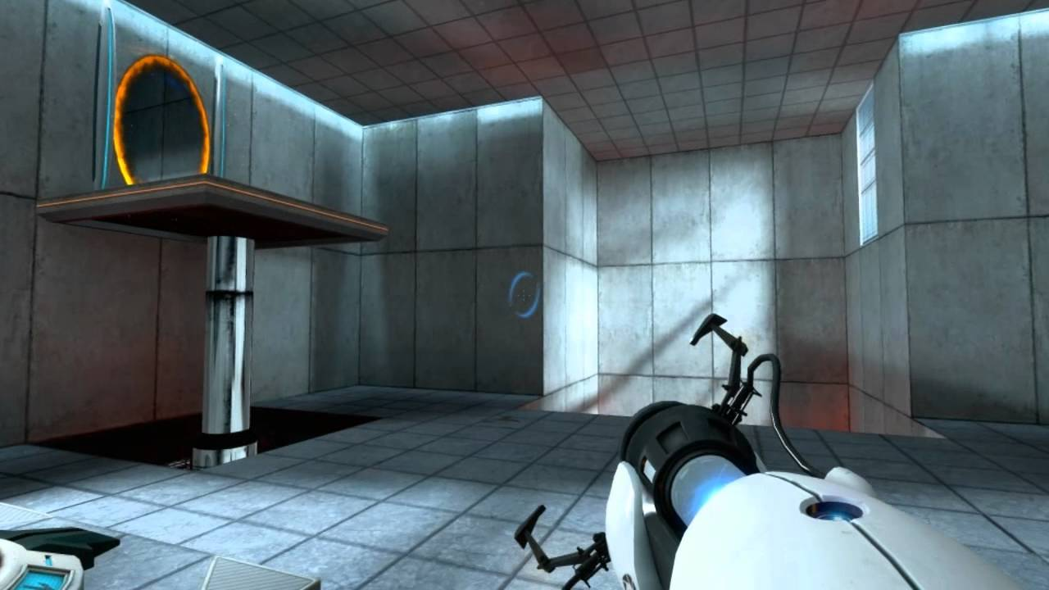

*Portal 1 screenshot, inspiration for aesthetics.*

**Level Assets**

**Pick ups**

* Med kit pickup
* Triple shot ammo
* Machinegun ammo
* Gravity device (pick up only at beginning of the game, to enable ability)

**Enemies & Hazards**

* Turret
* Pistol Robot
* Machinegun Robot
* Big Robot
* Boss

**Interactive**

* Explosive Barrels
* Stairs

**Props**

* Computer
* Desk
* Door
* Metal Crates
* Columns
* Bed

**Level Difficulty**

* The level is intended to last approximately 20 minutes.
* The level is intended to be the first level of the game, so it will teach all the gravity related mechanics to the player.
* The level is designed to be of moderate difficulty, made for people new to the game, but that have previous experience with First Person Shooters.
* Most of the rooms in the level are connected through halls. These halls serve as brief rest areas for the player.
* There is a boss battle at the end of the level.
* A difficult aspect in the game to consider is that when the player switches gravity it will also affect its enemies, which may be useful or harmful for him; since this will change the sight of the fight vertically possibly creating openings in defense.

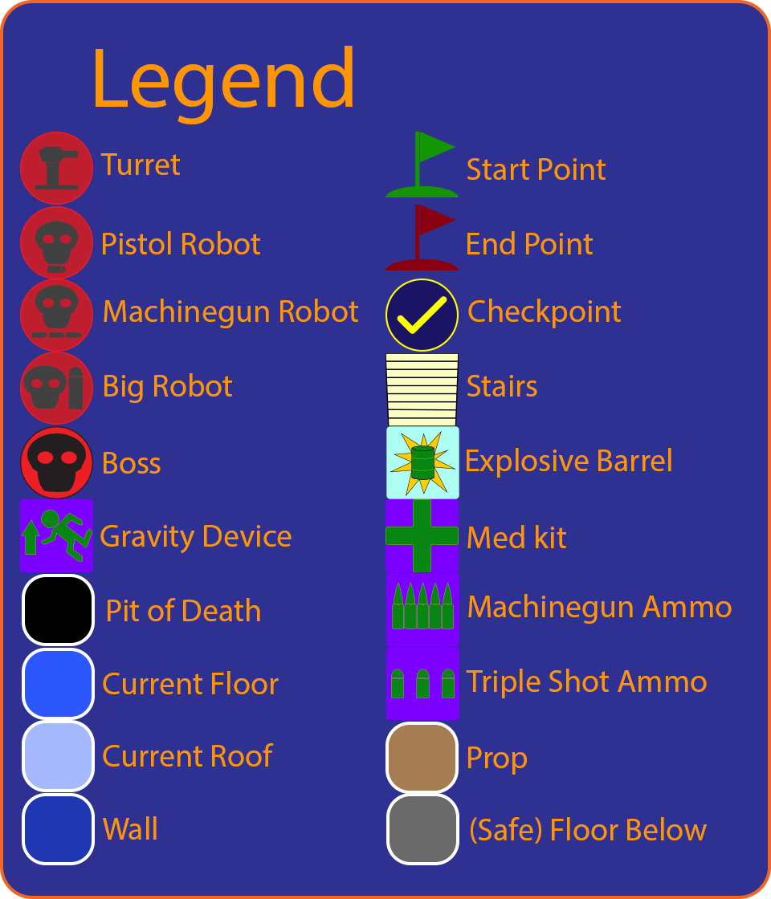

*Note: Some parts of the roof map are “missing” because the roof height in that areas is not significant enough to make a difference. Therefore they have the same structure as the floor.

**Map with Areas**

Floor

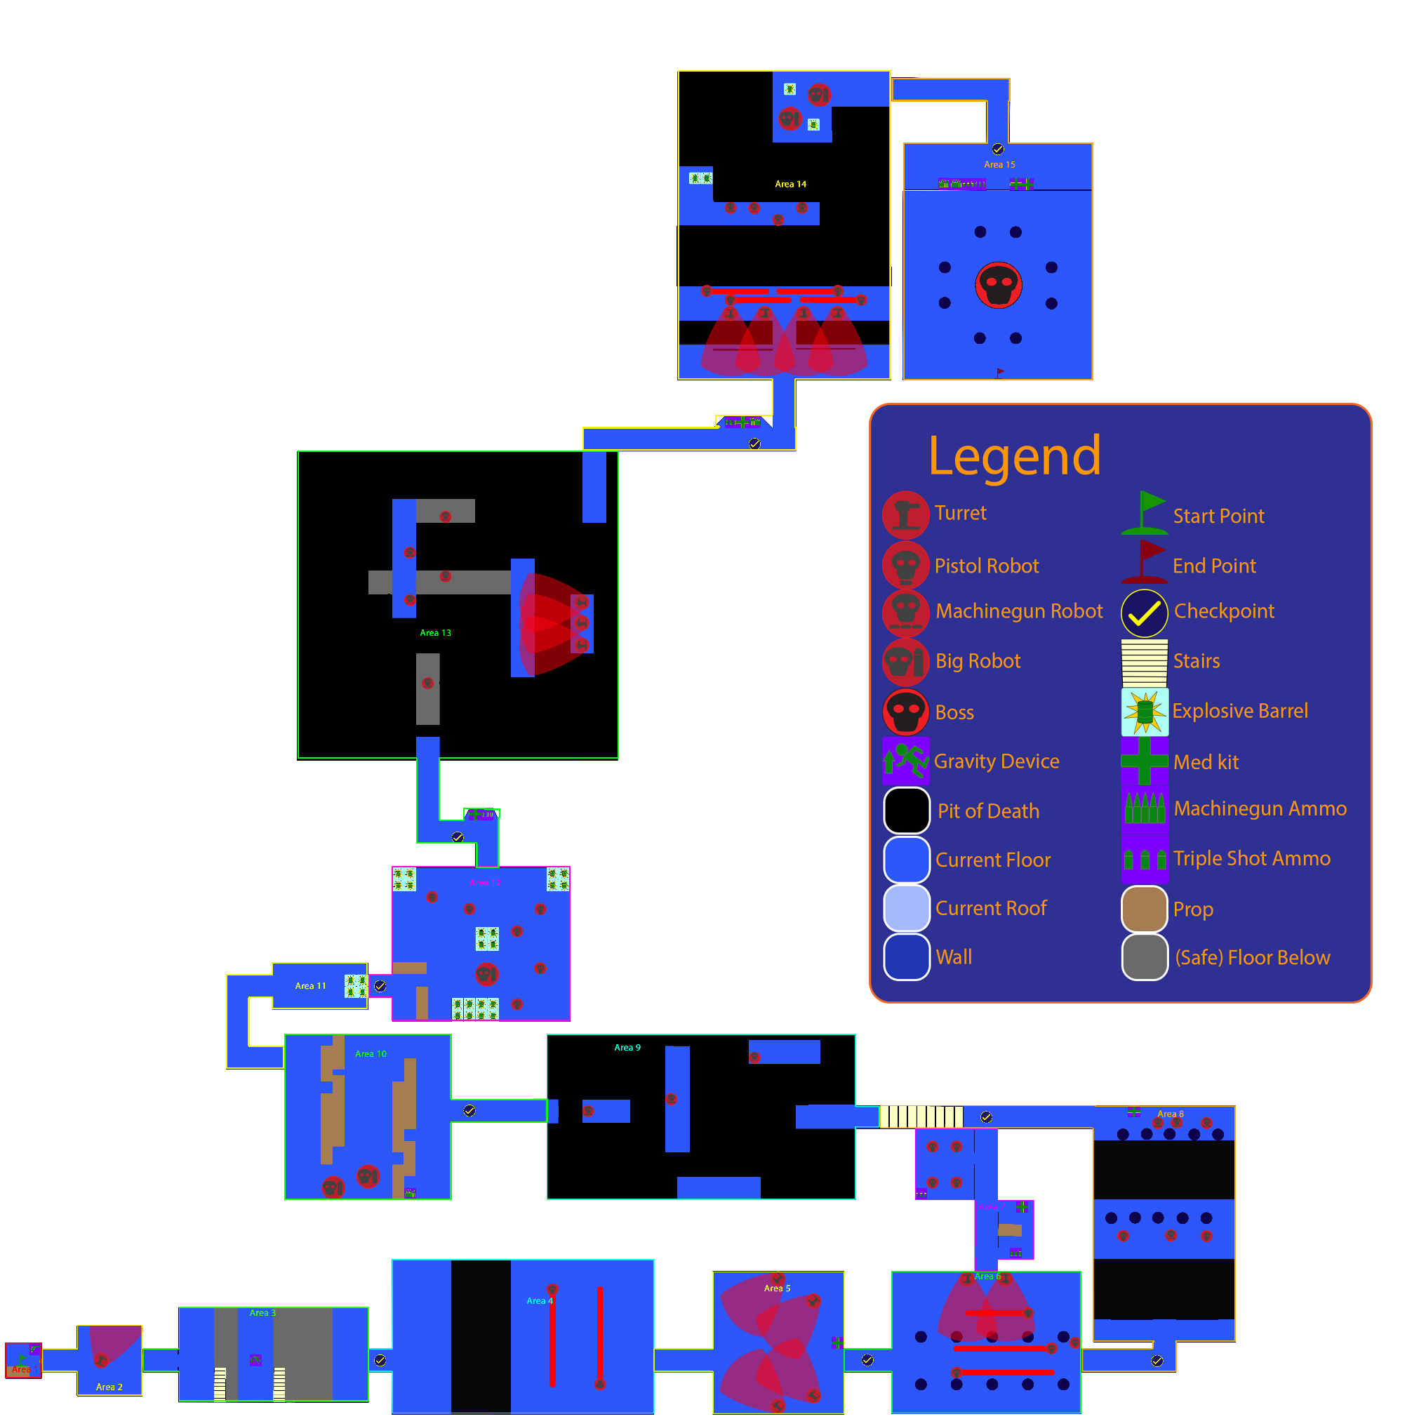

Roof

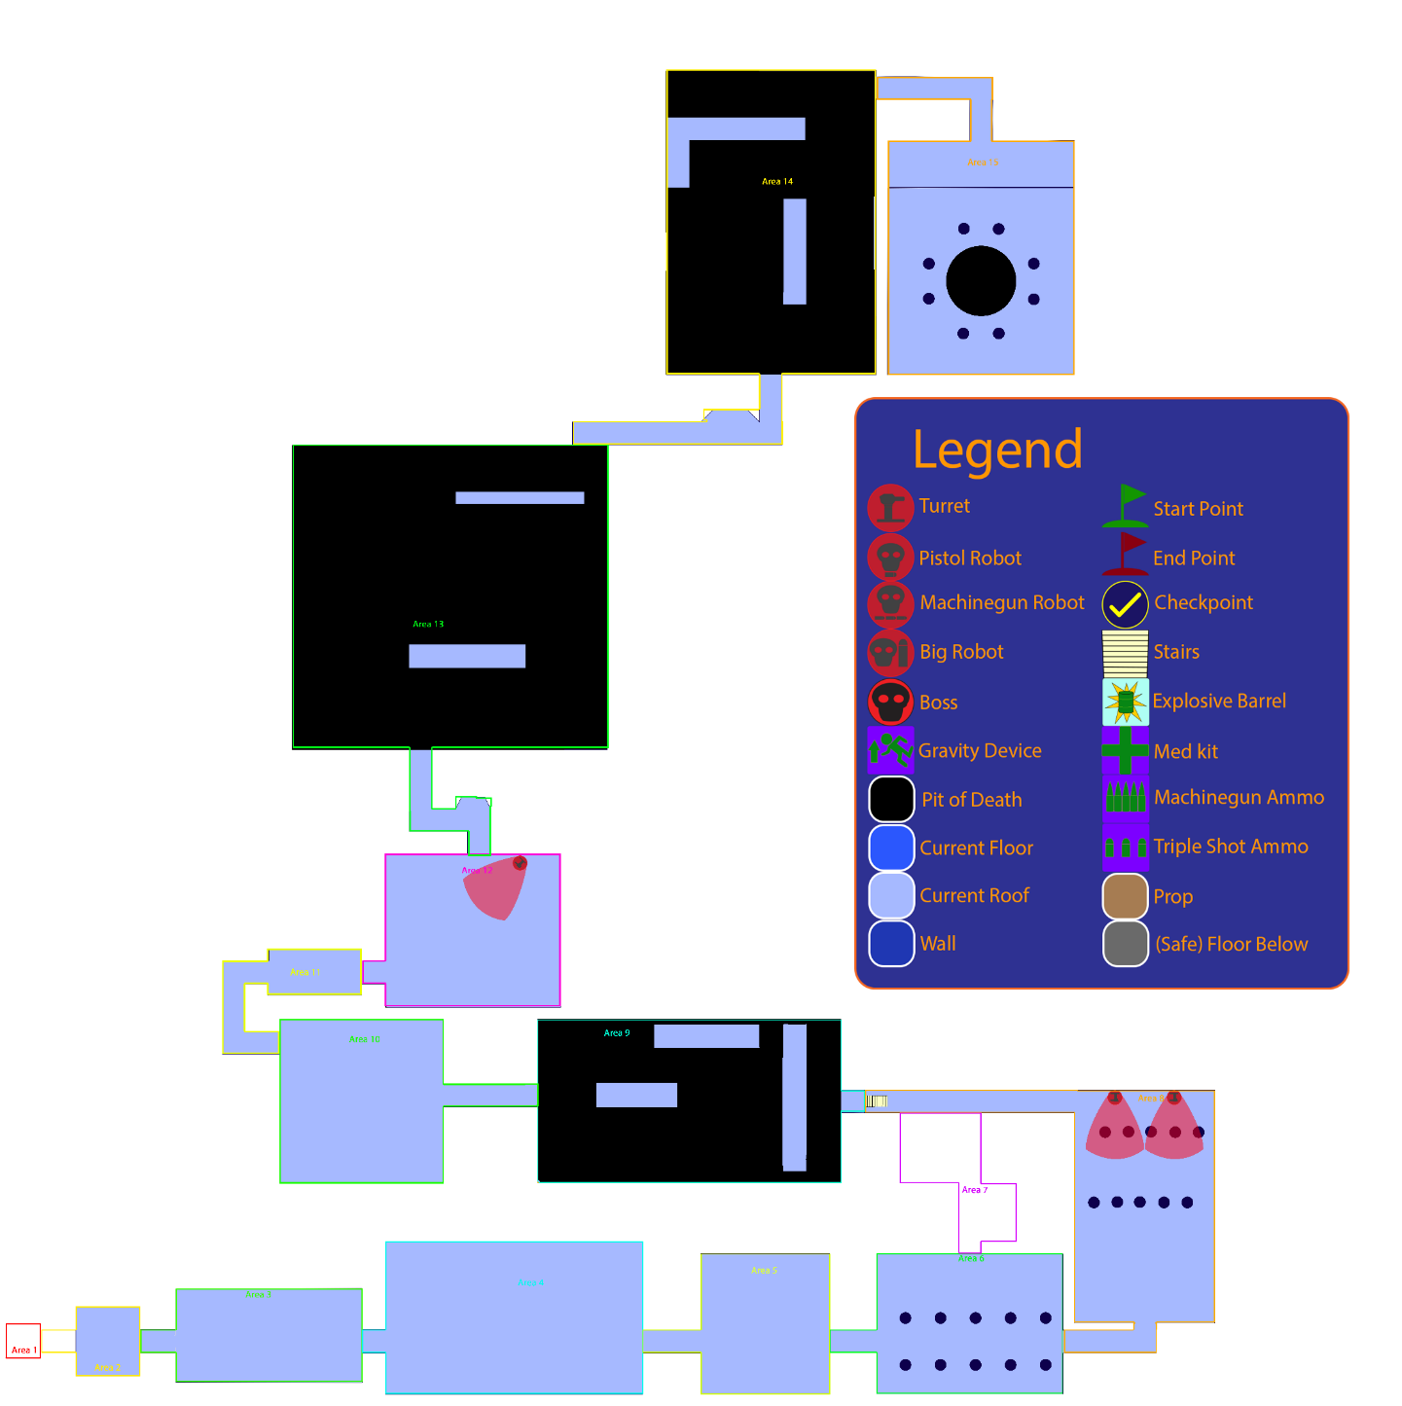

**Map with Grid (1 Square= 1 Meter)**

Floor

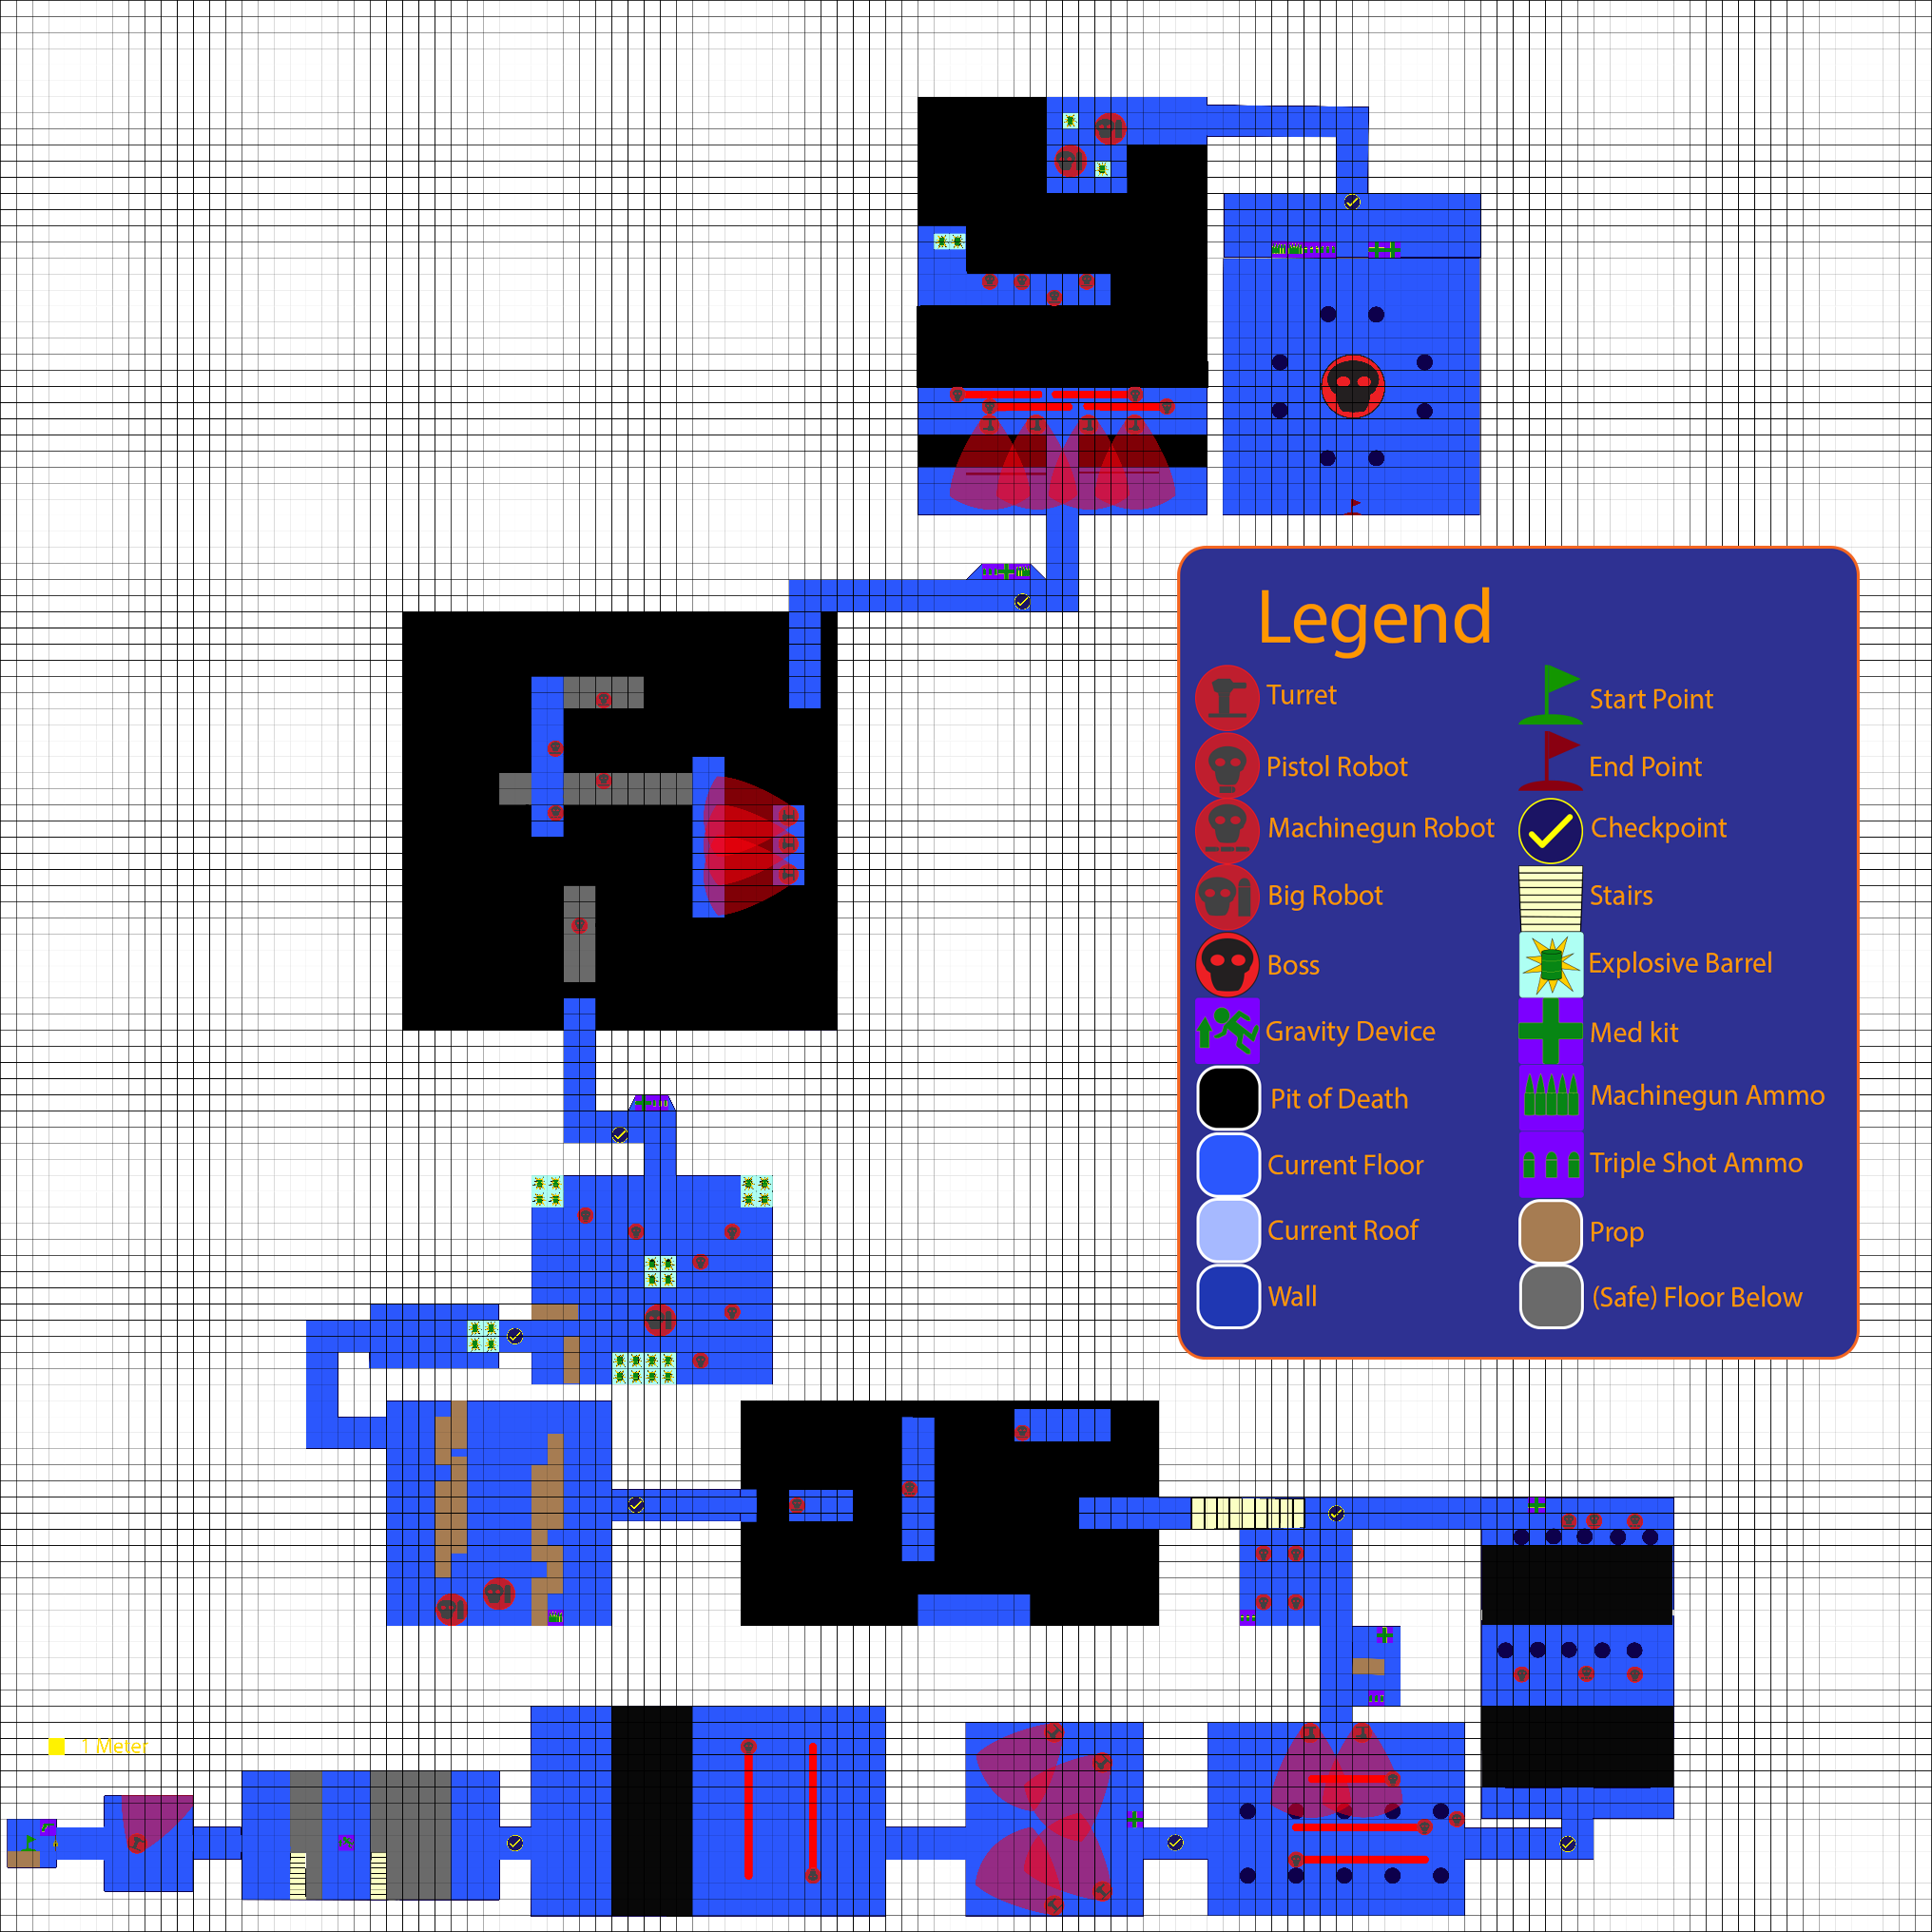

Roof

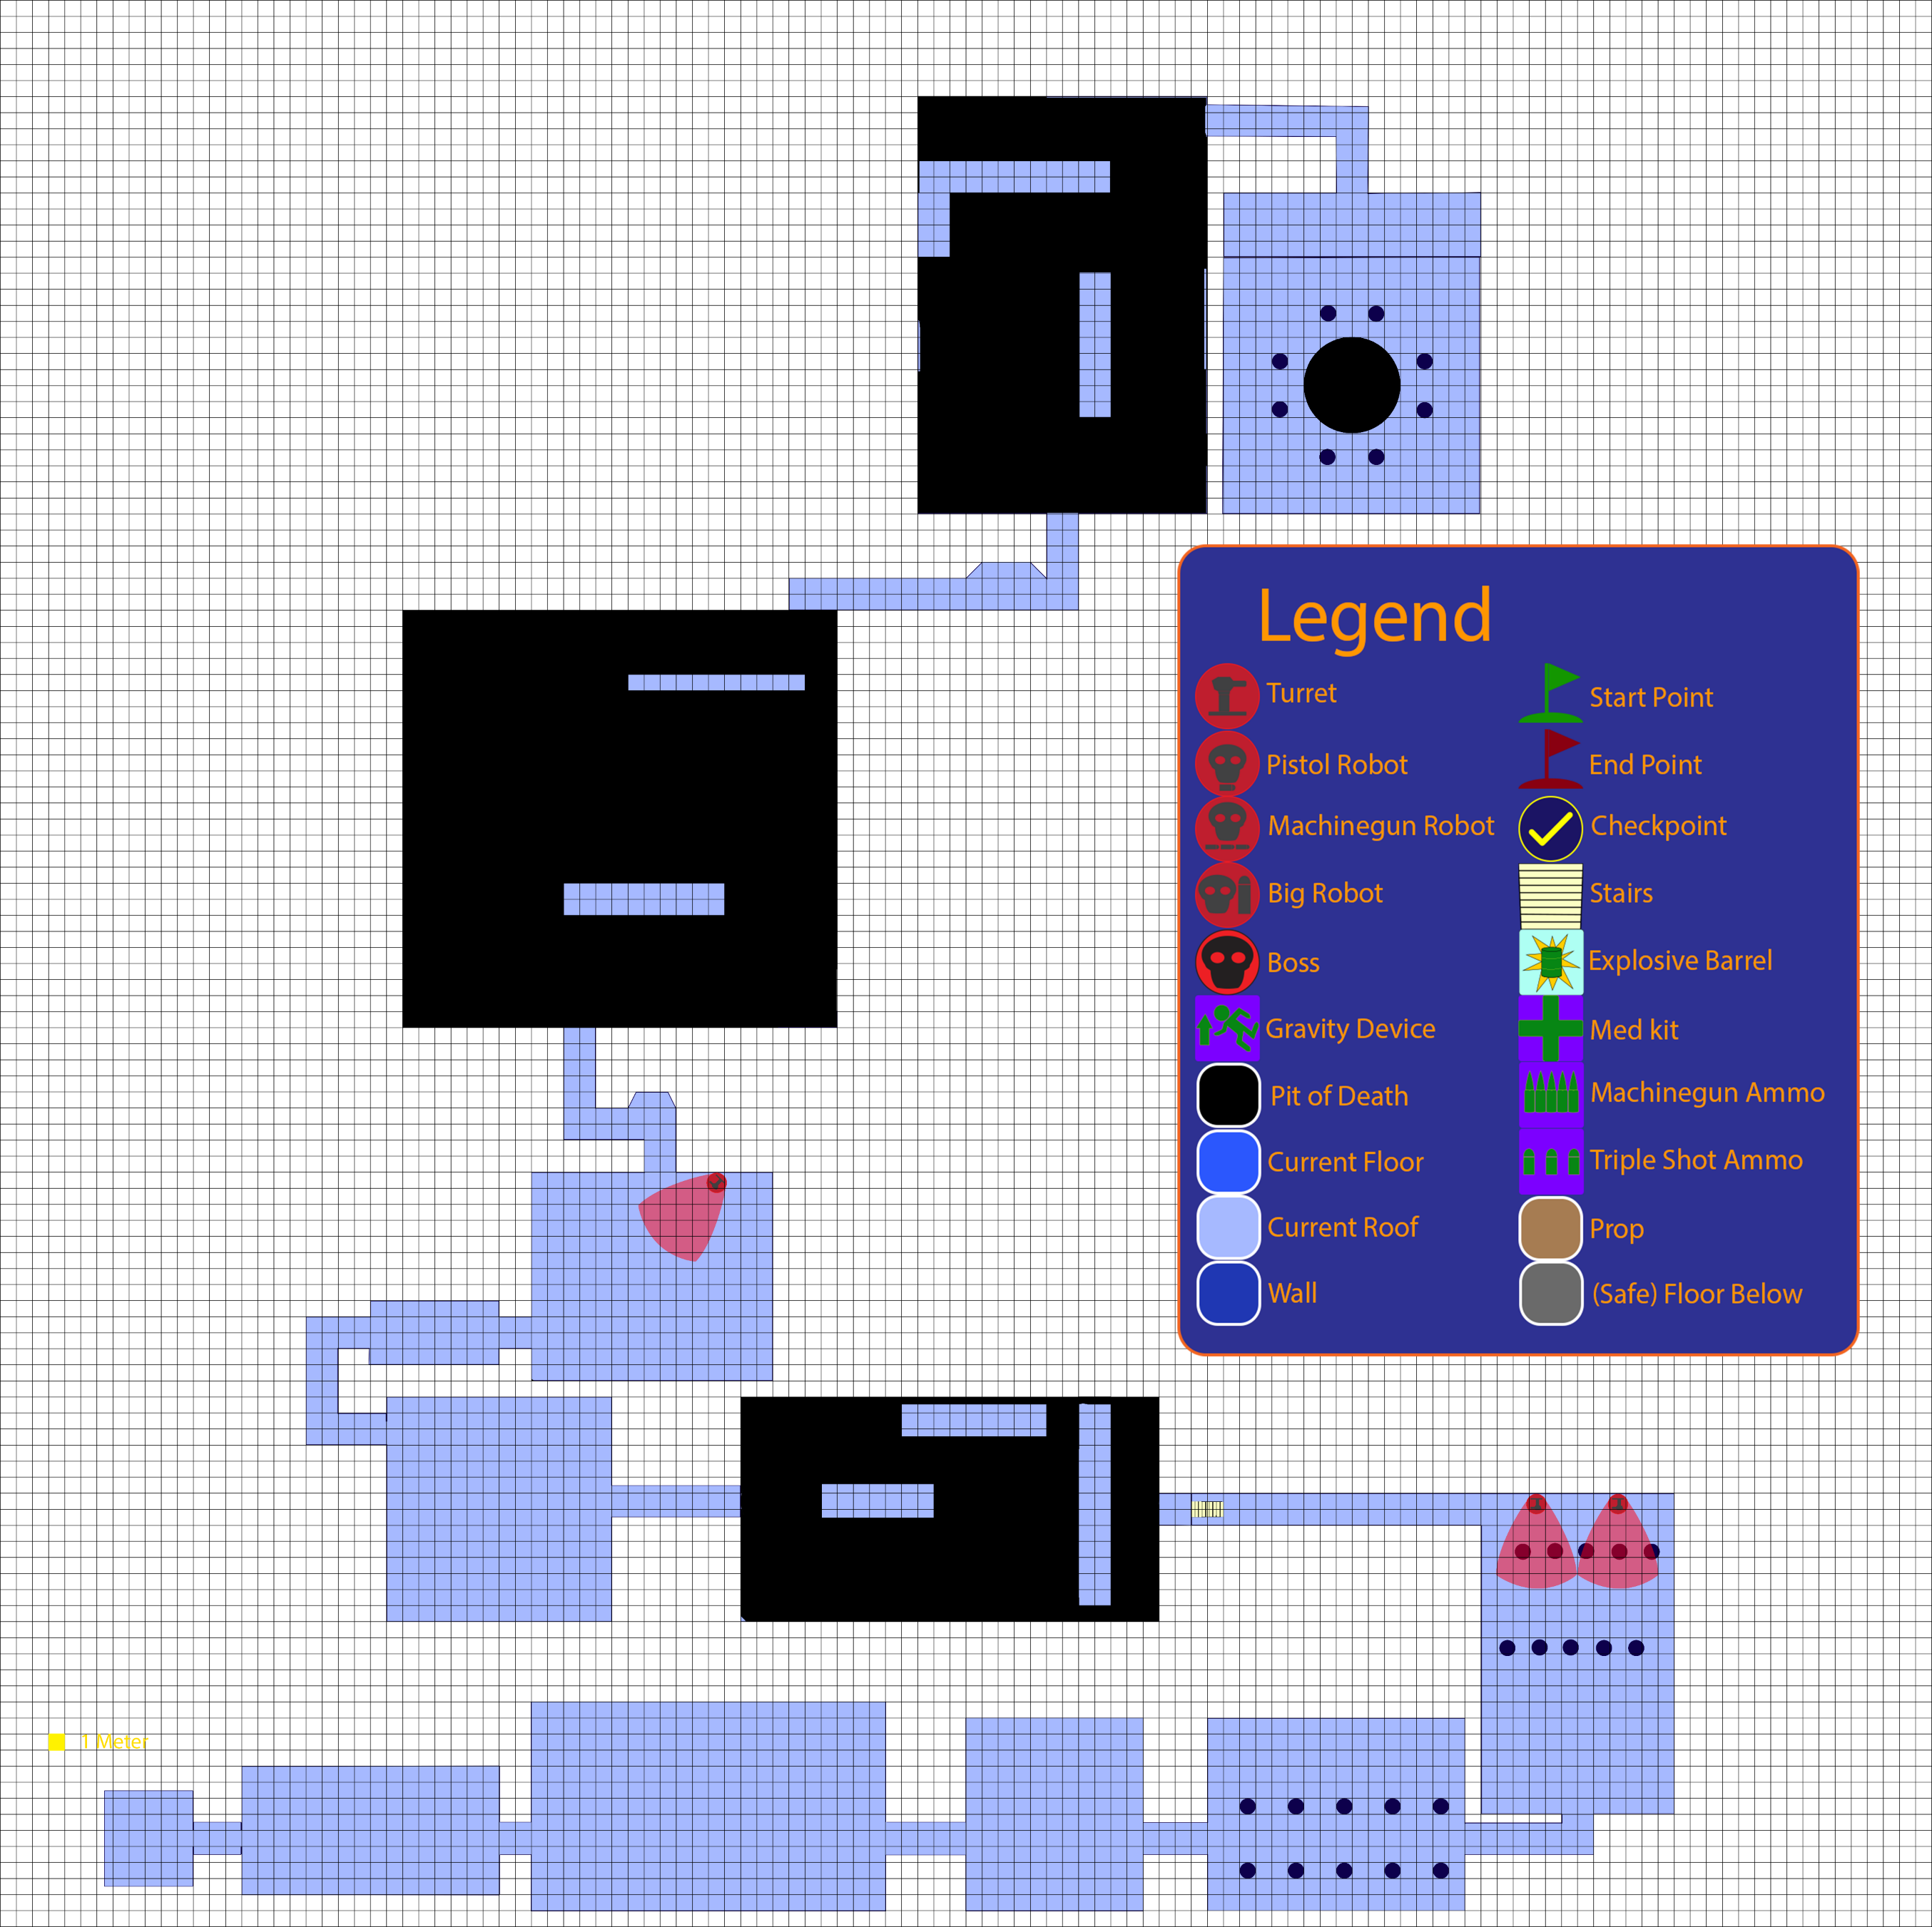

**Map clean (no areas)**

Floor

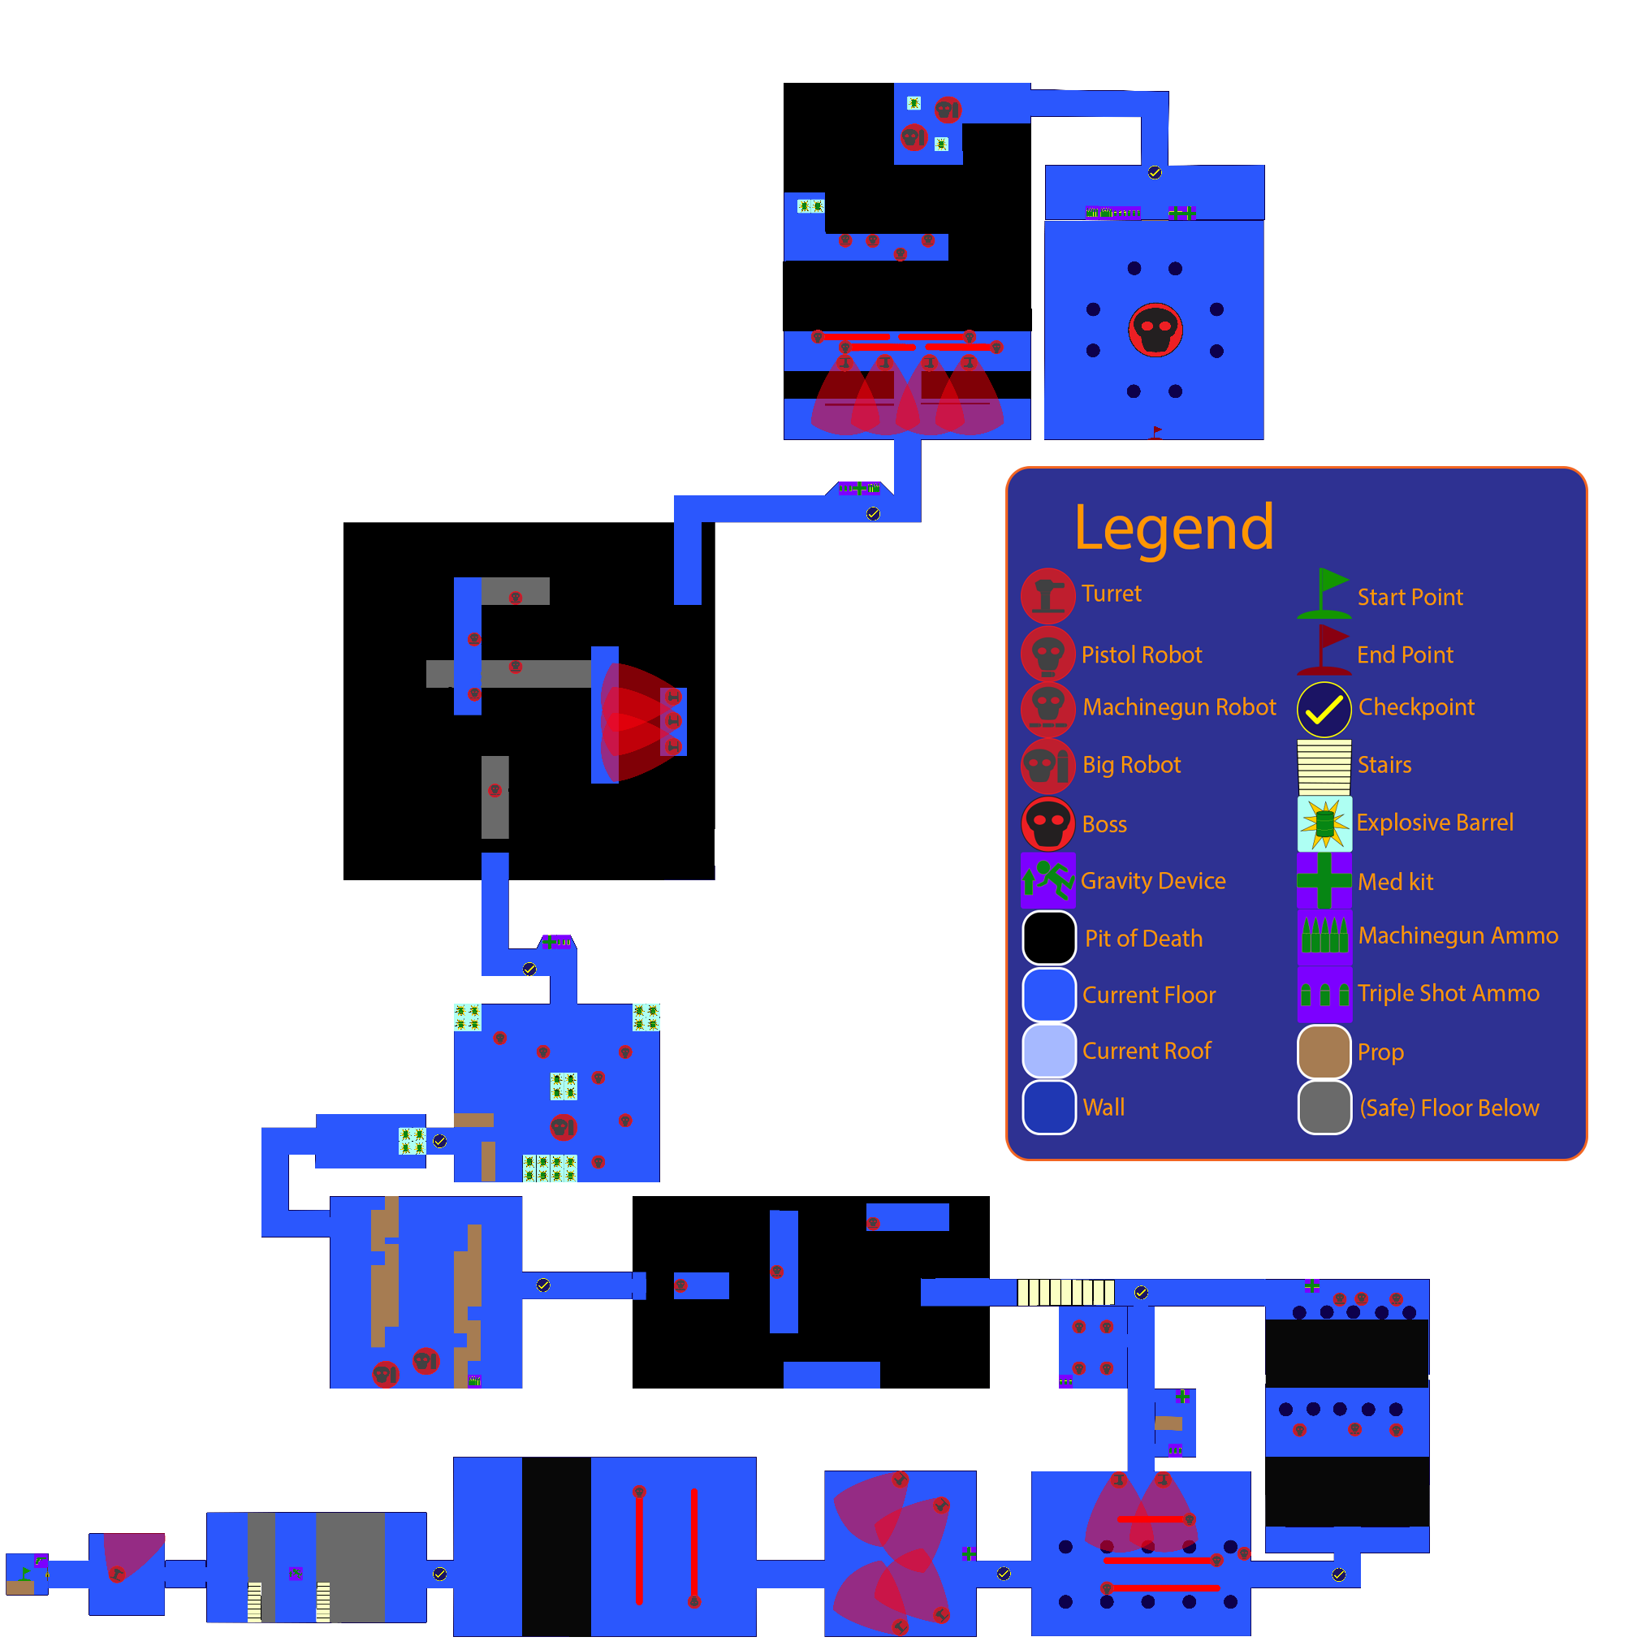

Roof

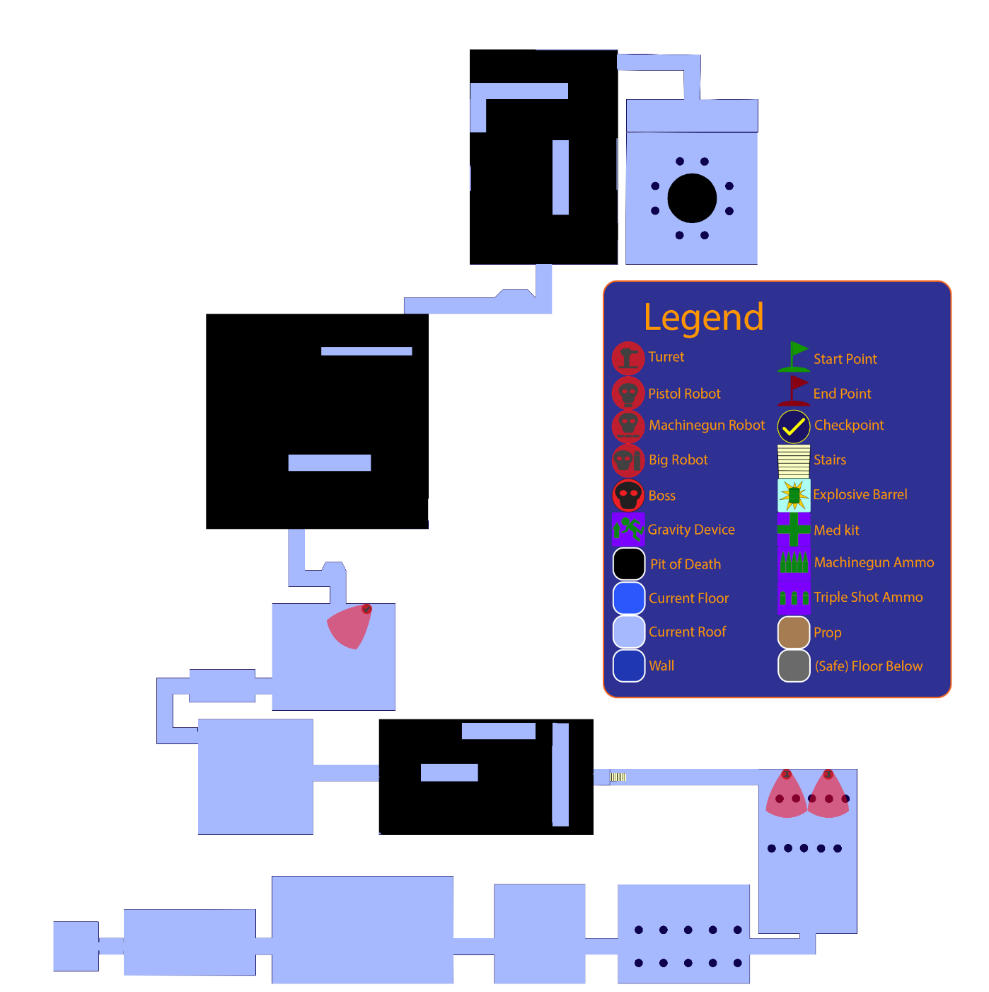

**Map Description**

**Floor 1**

**Area 1**

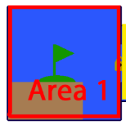

* GAME START
* The player starts in a small simple cell. The cell is dimly lit, with the main light of the room coming from under the locked exit door. After a second or two, a bright light will shine over a pistol that is in the corner of the room.
* The player will be facing a door. To advance the player will have to blast through the door by shooting his gun at it.
* In the cell, there are some aspects of environmental storytelling to indicate the player has spent a lot of time in the cell. Elements such as: scratches in the walls (similar to the one seen in movies to count the days), etc.
* Upon exiting through the door, the player will go through a small hall that will take him to Area 2.

**Area 2**

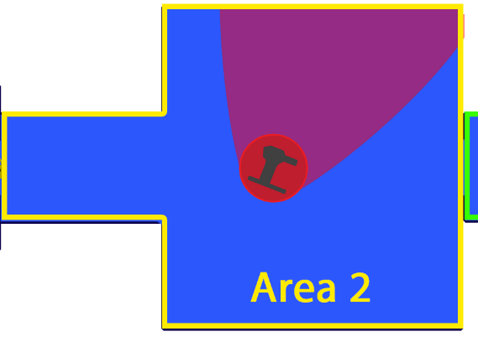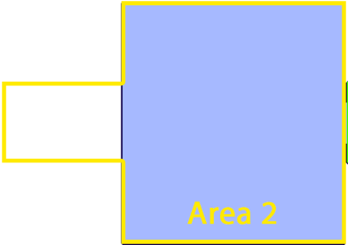

* 1 Turret
* This area serves to introduce the threat of turrets to the player, and to let him practice his shooting skills in a relatively safe environment (the player won’t get hit unless he walks into the line of sight of the turret).
* After leaving the hall, the player will notice just in front of him a turret. The turret will be facing the opposite way of the player’s door, so it won’t hurt the player unless he walks into his line of sight.
* To indicate that the turret is dangerous, there will be some blood splatters on the floor near the turret. Through this affordance, hopefully the player will realize that the turret is not friendly and must be destroyed.
* Directly in front of the player entrance to the area, there is another door. The door leads the player to the hall that leads to Area 3.

**Area 3**

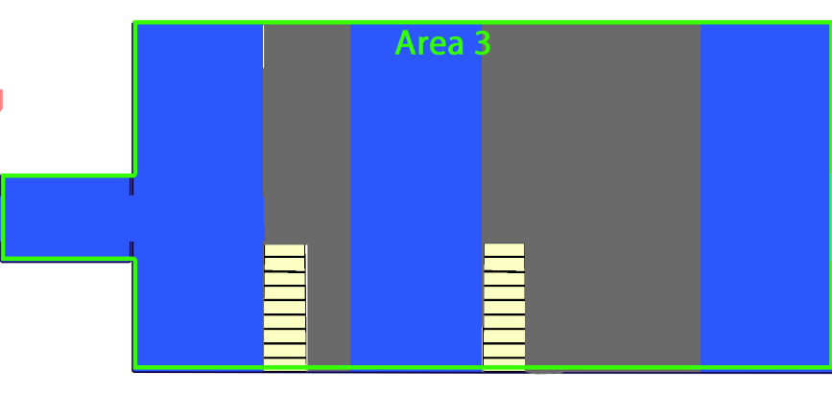

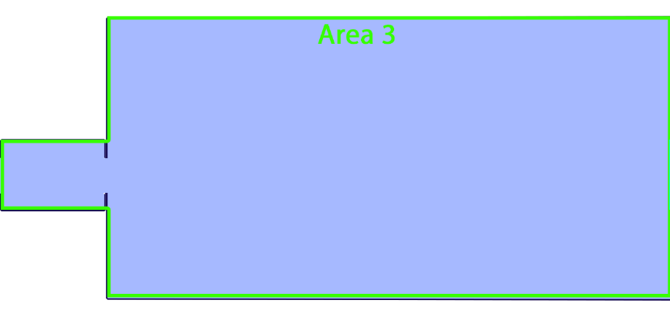

* 1 Gravity device
* This area is intended to introduce the player to the gravity changing mechanics in a safe environment.
* When the player enters the area, he will see a shiny display in the middle of the room. The display holds the Gravity Device. The display would have lights and shiny colors (in contrast to the white background), which would guide the player toward it.
* Between the player’s and the Gravity Device, there is a small non-lethal pit (unless there is a constant repetition). In the middle of the room, there is one part of the floor that is also directly in front of the Gravity Device that is a little bit closer to the platform where the Gravity Device is.
* This pit can be passed by the player through a normal jump, in the part of the floor coming out, that is closest to the other platform.
* This pit between the player’s starting position and the Gravity Device, has stairs in it so that the player can get back up in case he falls down.
* Ideally, once he jumps, the player would land directly in front of the Gravity Device so that he can grab it.
* Between the Gravity Device platform and the room exit, a door to a hall leading to Area 4, there is a significantly big pit.
* This pit serves as a skill gate for the player to learn how to use the Gravity Device, since to get across it the player has to reverse gravity and walk through the roof.
* The pit, even though wide, is still considered a safe environment, with not so much depth and even having stairs for the player to get back in case he falls down.

**Area 4**

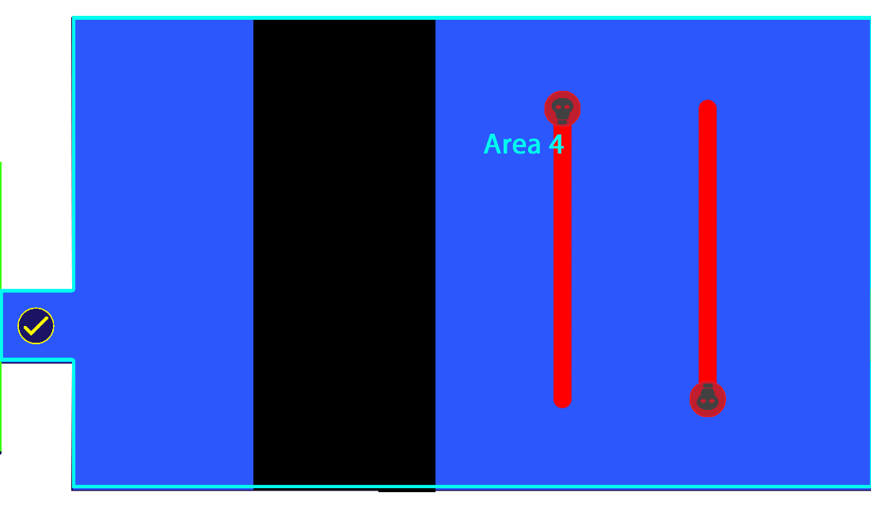

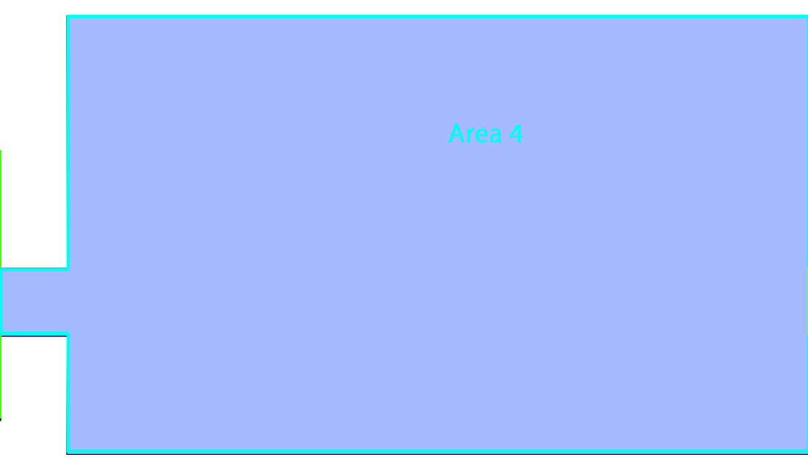

* **1 Checkpoint**
* 2 Pistol Robots
* This area serves to start introducing the player to real combat, it also helps to introduce the Pistol Robot.
* Upon exiting the hall from Area 3, the player will notice on the distance 2 Pistol Robots, but there will be a deadly pit between them.
* The pistol robots will be patrolling north and south from the other side of the pit.
* To cross through the pit, the player will have to use the gravity device to walk through the roof.
* Player trying to go through the roof all the way to the east door, going above the pistol robots, will notice that the robots can also shoot targets that are on the roof.
* Further east, after the robots, there is a door that leads to Area 5.

**Area 5**

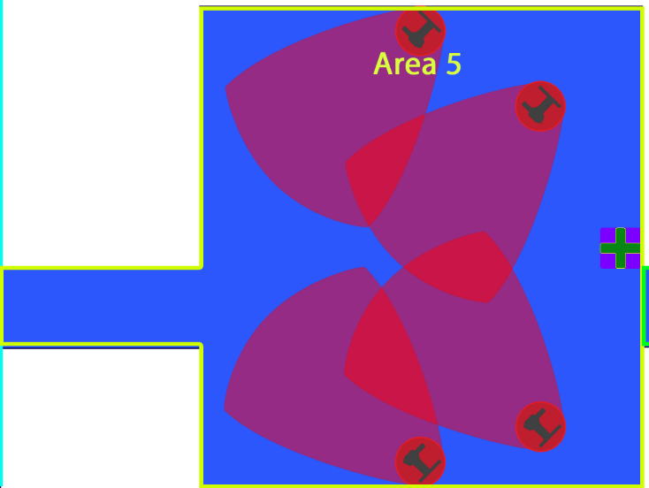

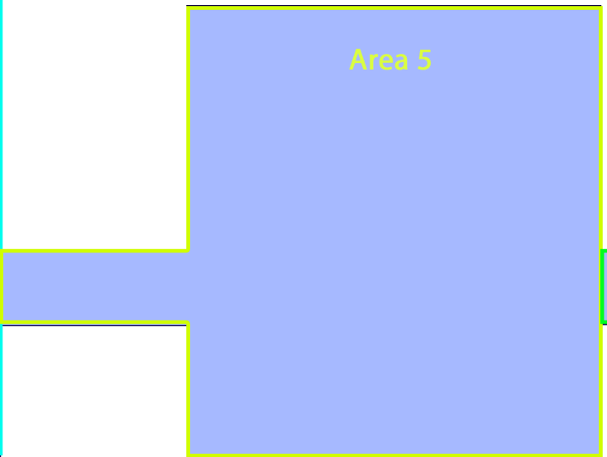

* 4 Turrets
* 1 Med kit
* The player will enter the room from the hall of Area 4, and see himself surround by 4 turrets.
* This area serves to highlight to the player that changing gravity can also be used to avoid enemies.
* The player is just barely out of the range of the turret, which gives him somewhat the opportunity to see how they want to tackle the fight. However, the turrets are clearly blocking the path on the floor to the door.
* Players may try to go through the roof by changing gravity, which would be a common reaction upon seeing the floor full of enemies. There they will learn that in contrast the enemies of area 4, turrets don’t shoot the player if he is in the other plane (roof/floor), this would allow the player to advance hassle free.
* Alternatively, the player can fight his way through the turrets on the floor.
* At the end of the room, just behind the turrets (also means it is out of their line of sight), next to the exit door, there is a med kit for the player to replenish any damage he may have received.
* The door connects to a hall leading to Area 6.

**Area 6**

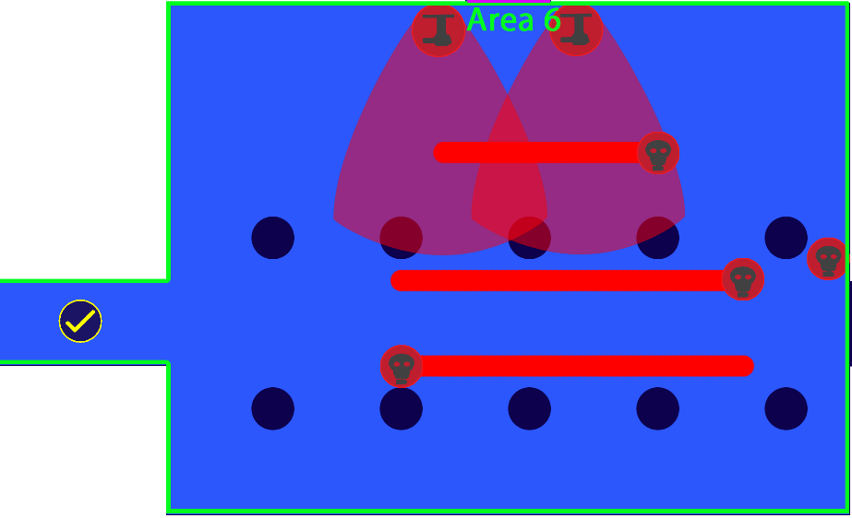

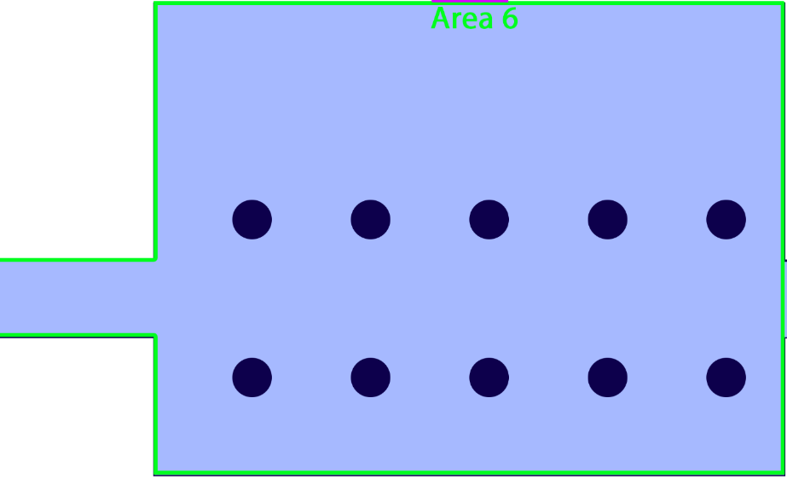

* **1 Checkpoint**
* 2 Turrets
* 4 Pistol Robots
* The hall leading to this area, again offers a small rest area, and a checkpoint for the player.
* Upon entering the area the player will notice a path of columns (on both of his sides) in front of him. Patrolling this path there are 2 Pistol Robots.
* In this area, the door East leads to Area 8, while the door North leads to Area 7. So there is a small branch in paths, for this section of the level.
* The door to the East is being guarded by 1 stationary Pistol Robot.
* The door to the North is being guarded by a patrolling Pistol Robot (patrolling north of the ones patrolling the column path), and 2 turrets that are placed next to the door.
* The stationary guards near the doors are set to prevent the player from simply running through the fight.
* Ideally the player will be lead to the East by the path of columns, which would also provide cover during the fight.
* Players would notice the North door because of the noise the turrets would make. That would catch his attention, and made him realize that there is something valuable in there, despite being better defended.

**Area 7**

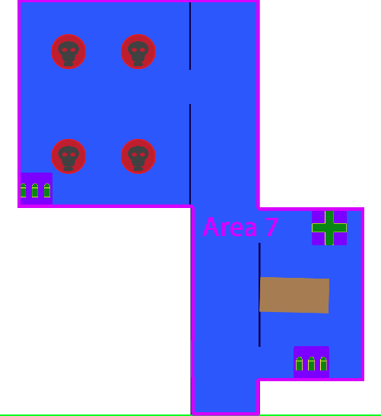

* 2 Triple Shot Ammo
* 4 Pistol Robots
* 1 Med Kit
* This area can be accessed from the South, coming from Area 6.
* On the East side of the Area there is a small research lab, it contains: a computer, and a desk. On the South East corner however, the player will find a Triple Show Ammo (and get access to the weapon if he didn’t have it before). This serves as a reward for exploration to the player, for taking the “hardest” route in Area 6. At the North East of the lab there is also a Med Kit for the player to replenish his health.
* Further North this area the player will find a maintenance lab South and another hall north, in Area 8.
* The maintenance lab has 4 Pistol Robots. This Pistol Robots are the weakest enemy and are in an enclosed environment, their purpose is for the player to test his new Triple Show weapon and feel powerful.
* At the back of this maintenance lab there is another set of Triple Shot Ammo so that the player doesn’t have any consequence for testing his new weapon.
* The computer in this area will display in its screen a picture (live rendering) of the doors that lead to the final door. This will serve as a way to telegraph to the player the obstacles he will have to face.
* The connection to the other hall, leads to Area 8. Specifically, the rest area between Area 8.

**Area 8**

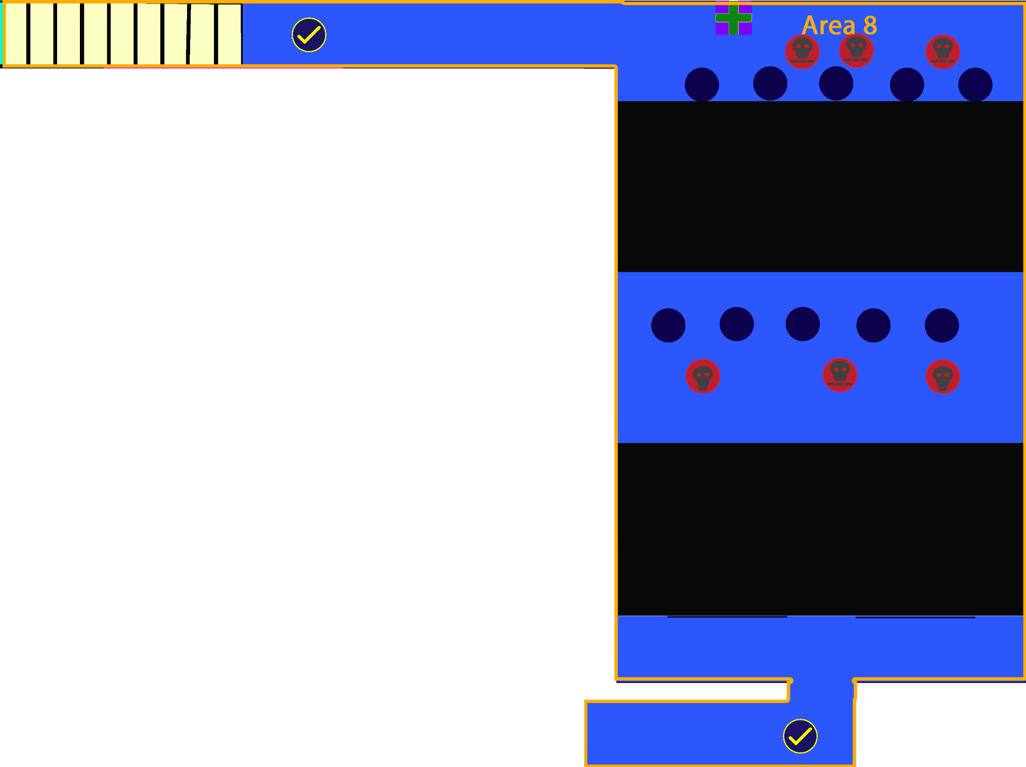

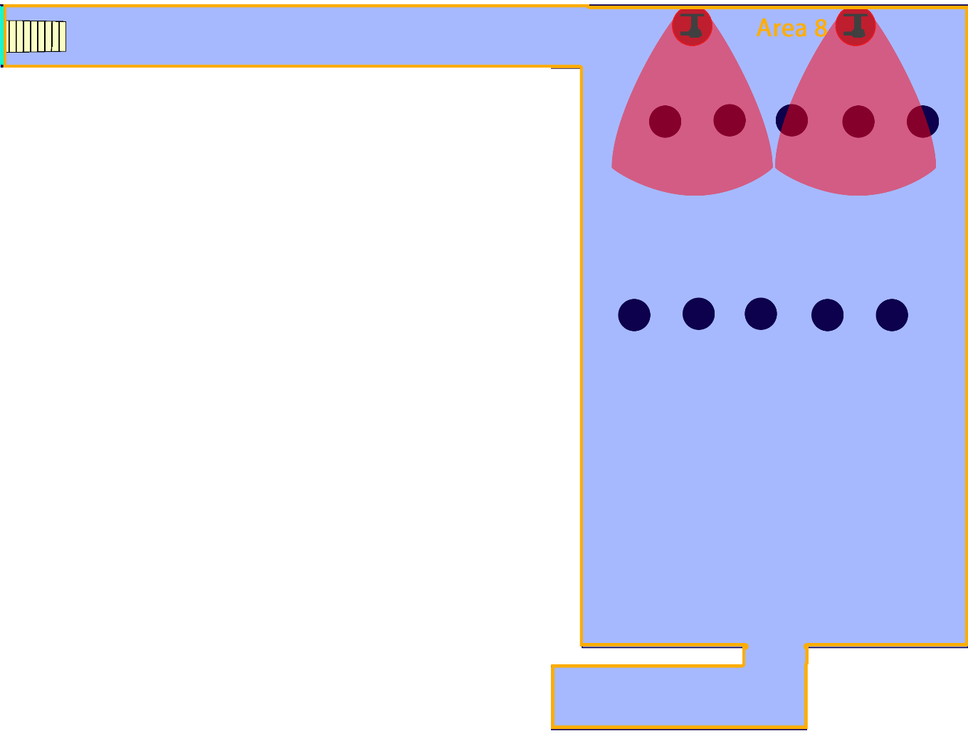

* **2 Checkpoint**
* 2 Pistol Robots
* 3 Machinegun Robots
* 1 Med Kit
* The bottom of this area can be accessed from Area 5.
* The North, rest/transition portion of this Area can be accessed from Area 7.
* This area consists of 3 main “platforms” each separated by a pit. The pits in this Area can only be crossed through changing the gravity.
* If the player enters from Area 6, he will pass through a checkpoint.
* Immediately after the player exits the “rest” hall he will see a wall on each of his sides, and in front of them a pit.
* Put to the next side of the pit, there are 2 Pistol Robots and 1 Machinegun Robot.
* The pit is there to ensure that the player has time to see and analyze the new threat presented by the Machinegun Robot.
* The walls before the pit are intended to serve as potential cover for the player.
* After the player progresses to the middle platform, he will observe a set of columns , that go all the way up to the roof, in front of him in the middle platform; and a another set of columns further ahead on the North platforms. These columns are again made in order to provide the player cover.
* On the North platform, the player will spot 4 Machinegun Robots on the floor, behind the columns.
* Also in the North Platform, but on the roof, there are 2 Turrets. These are set to counteract against the player when he is crossing the pit through the roof.
* In the top north wall of the room there is a Med Kit so that the player can replenish the health he lost.
* Through the back of this area there is a long hall. The hall connects through the South with Area 7.
* This hall also serves as a rest area, containing a checkpoint and also serving as a transition. Since this area has the stairs that connect to Area 9, on Floor 2.

**Floor 2**

**Area 9**

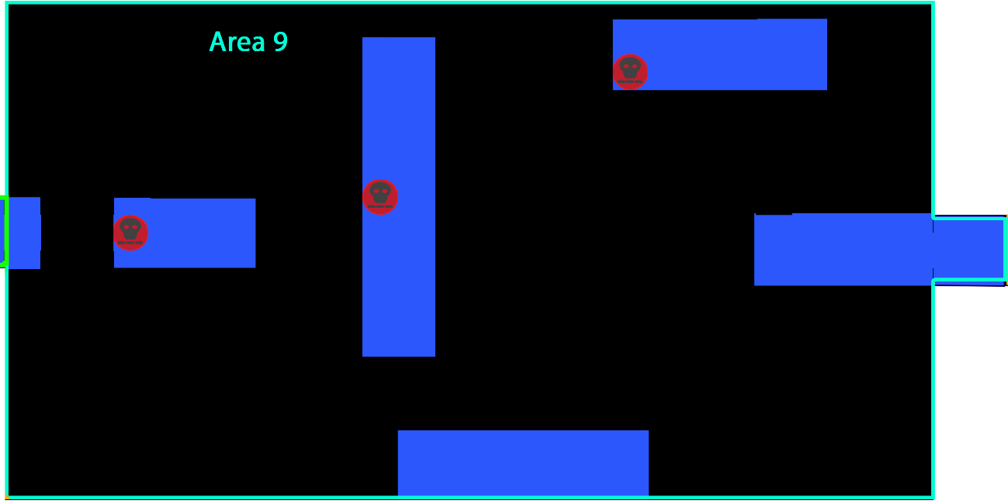

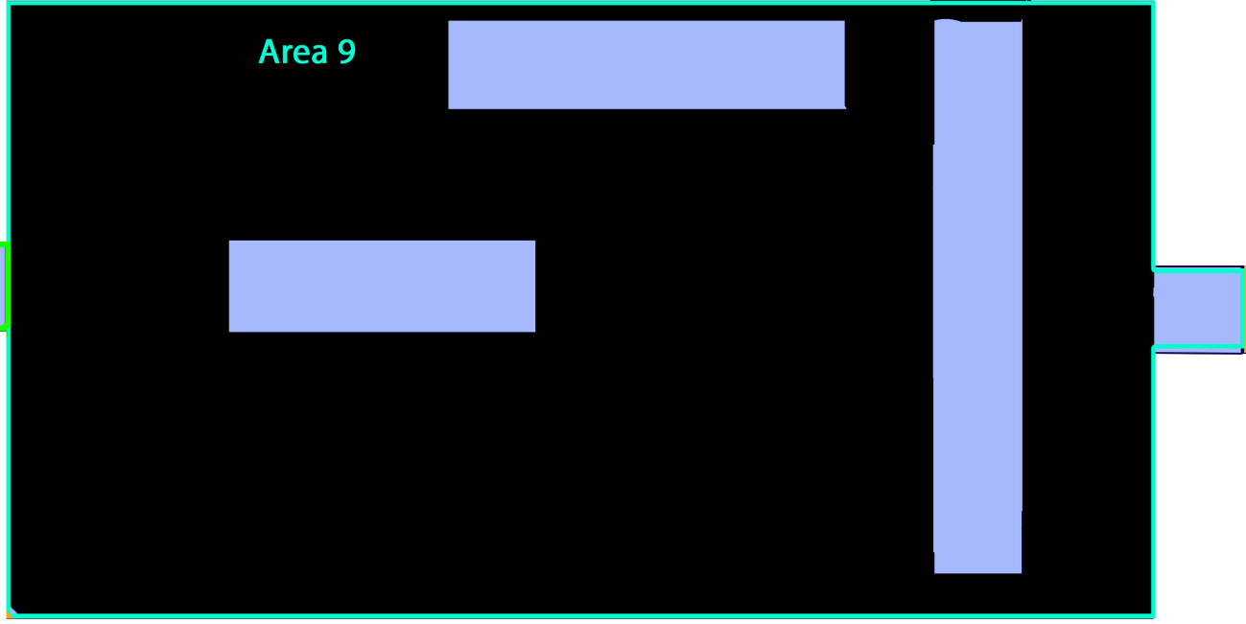

* 3 Machineguns Robots
* This area connects to Area 8 on Floor 1 through a set of stairs to the West.
* This area consists of a set of thin, small platforms that are not directly connected to each other, on both the roof and the floor.
* The way for the player to pass through this area is for him to travel through the platforms on the floor to drop on the ones on the roof (inversed gravity) and vice versa, from the roof to the floor (normal gravity). So connecting the platforms vertically, one on the roof with one on the floor.
* On the first platform in which the player appears, there are no enemies so that he has time to plan what he has to do and which path will take. After that there is a Machinegun Robot in each subsequent floor platform, there are no enemies on the roof platforms.
* In the last part of the area there is a small jump between the hall and the final platform. This jump is to be done with the normal jump capacities, since there is no platform above it to access it.
* The door that leads to Area 10, is lit by a bright red light. This light is intended to attract the player’s attention and guide him there. In comparison the light over in the entrance door to this area is dimly lit.
* The enemies on this part are intended to pressure the player into quick actions, while maneuvering in a relatively small space. So it will make the simple “puzzle” of traversing through the platforms more memorable.

**Area 10**

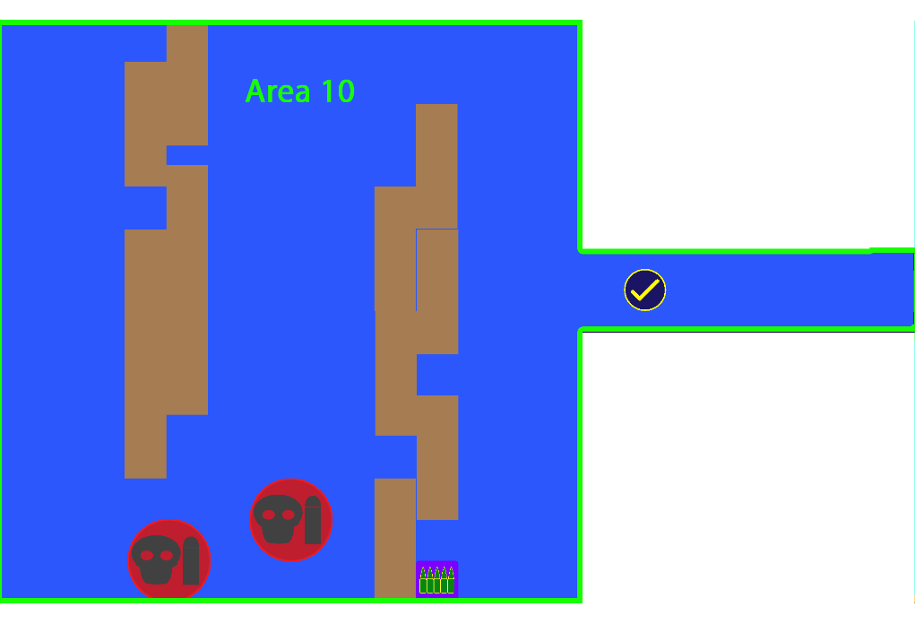

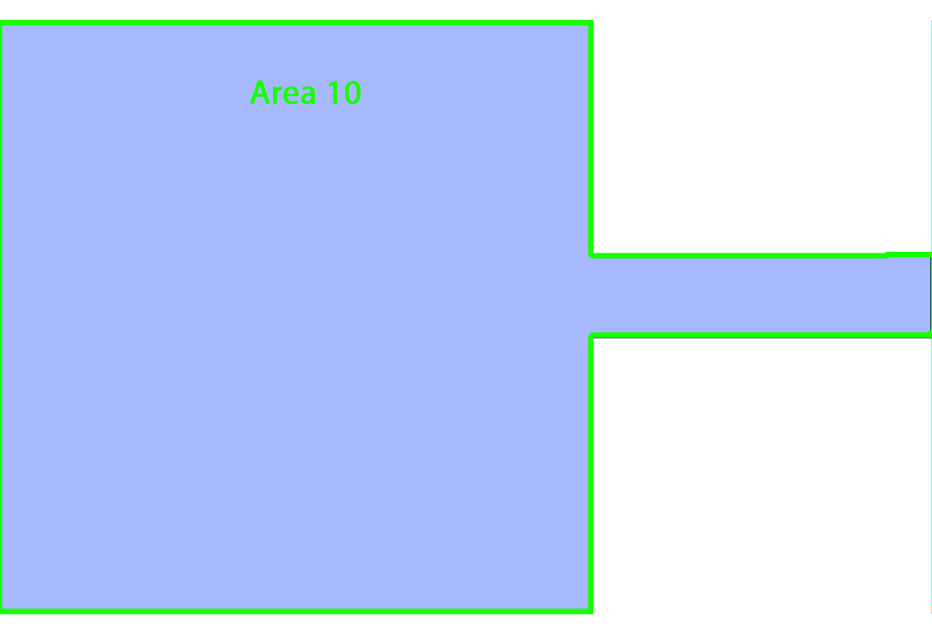

* **1 Checkpoint**
* 1 Machinegun Ammo
* 2 Big Robots
* This area has a hall that serves as a rest area at the beginning of it. The hall in this area contains a checkpoint for the player.
* This area is something similar to a storage room, filled with 2 walls of Metal Crates stacked upon each other. This crates are immovable and indestructible.
* The player can observe through the room numerous gravity devices spread through the room.
* Upon entrance to the storage, to the South there is a Machinegun Ammo. This reward is hinted.
* The metal crates in the storage force the player to pass through this area in a zig-zag pattern from North-South-North, if he goes through the floor. Alternatively, the player can inverse the gravity so that he can quickly go through the roof.

**Area 11**

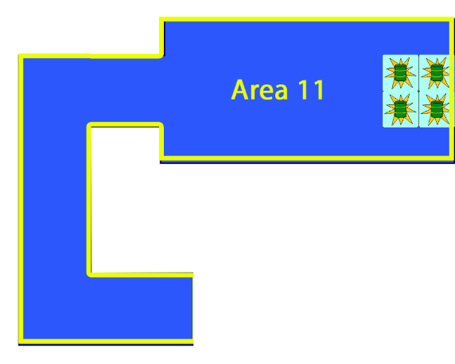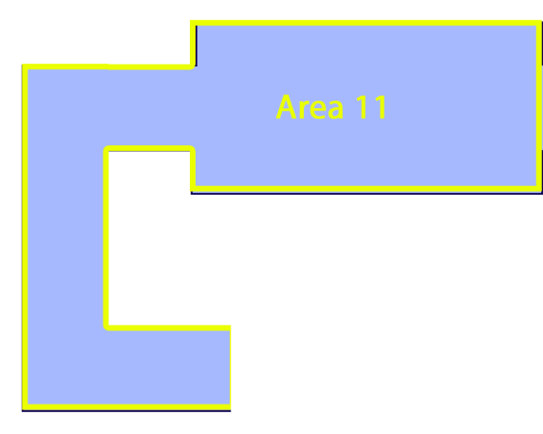

* 4 Explosive Barrels
* This area is intended to teach the player how the explosive barrels work.
* The area is basically a U- Shape hall that widens near the exit door. The exit door is being blocked by 4 Explosive barrels.
* The area immediately before the barrels is covered with explosion burn marks. This to hint the player the content the barrels have.
* To progress, the player will have to learn that shooting the barrels cause them to explode.

**Area 12**

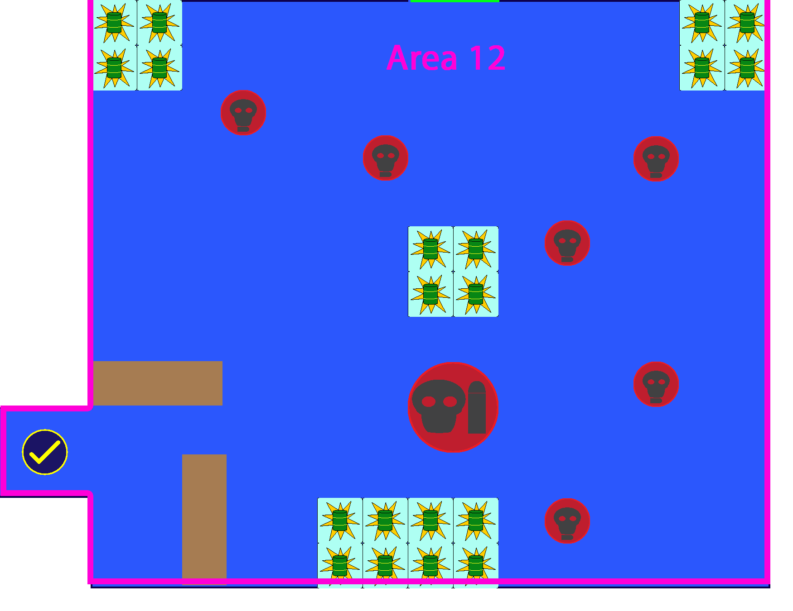

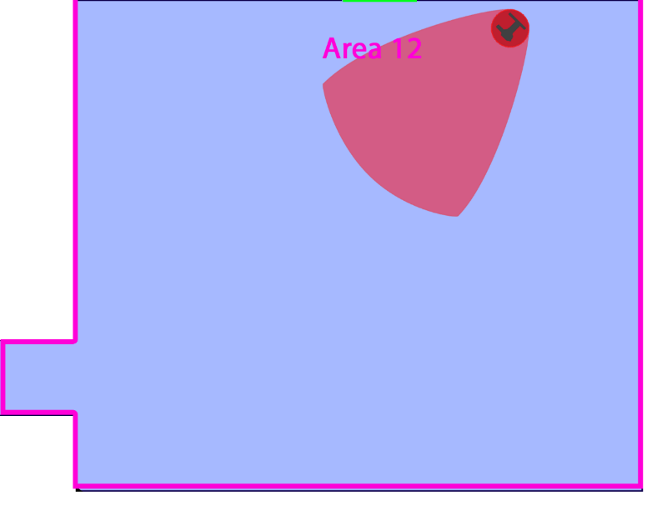

* **1 Checkpoint**
* 20 Explosive Barrels
* 1 Big Robot
* 6 Pistol Robot
* 1 Turret
* There is a checkpoint at the beginning of this area.
* This area is filled with robots all spread through the floor, and the turret set in the roof guarding the exit door. Placed there to prevent the player from merely running away, the player should still have some mobility on the roof without being affected by the turret.
* The explosive barrels are placed all around the room. The main idea of this area is for the player to text all the destructive might that the explosive barrels can offer. If the player shoots the barrels most of the enemies will perish or be seriously injured.
* Alternatively, the player can opt to choose the enemies normally. Near the player exit, from Area 11, there is a series of metal crates that can serve the player as an effective cover against the enemies.

**Area 13**

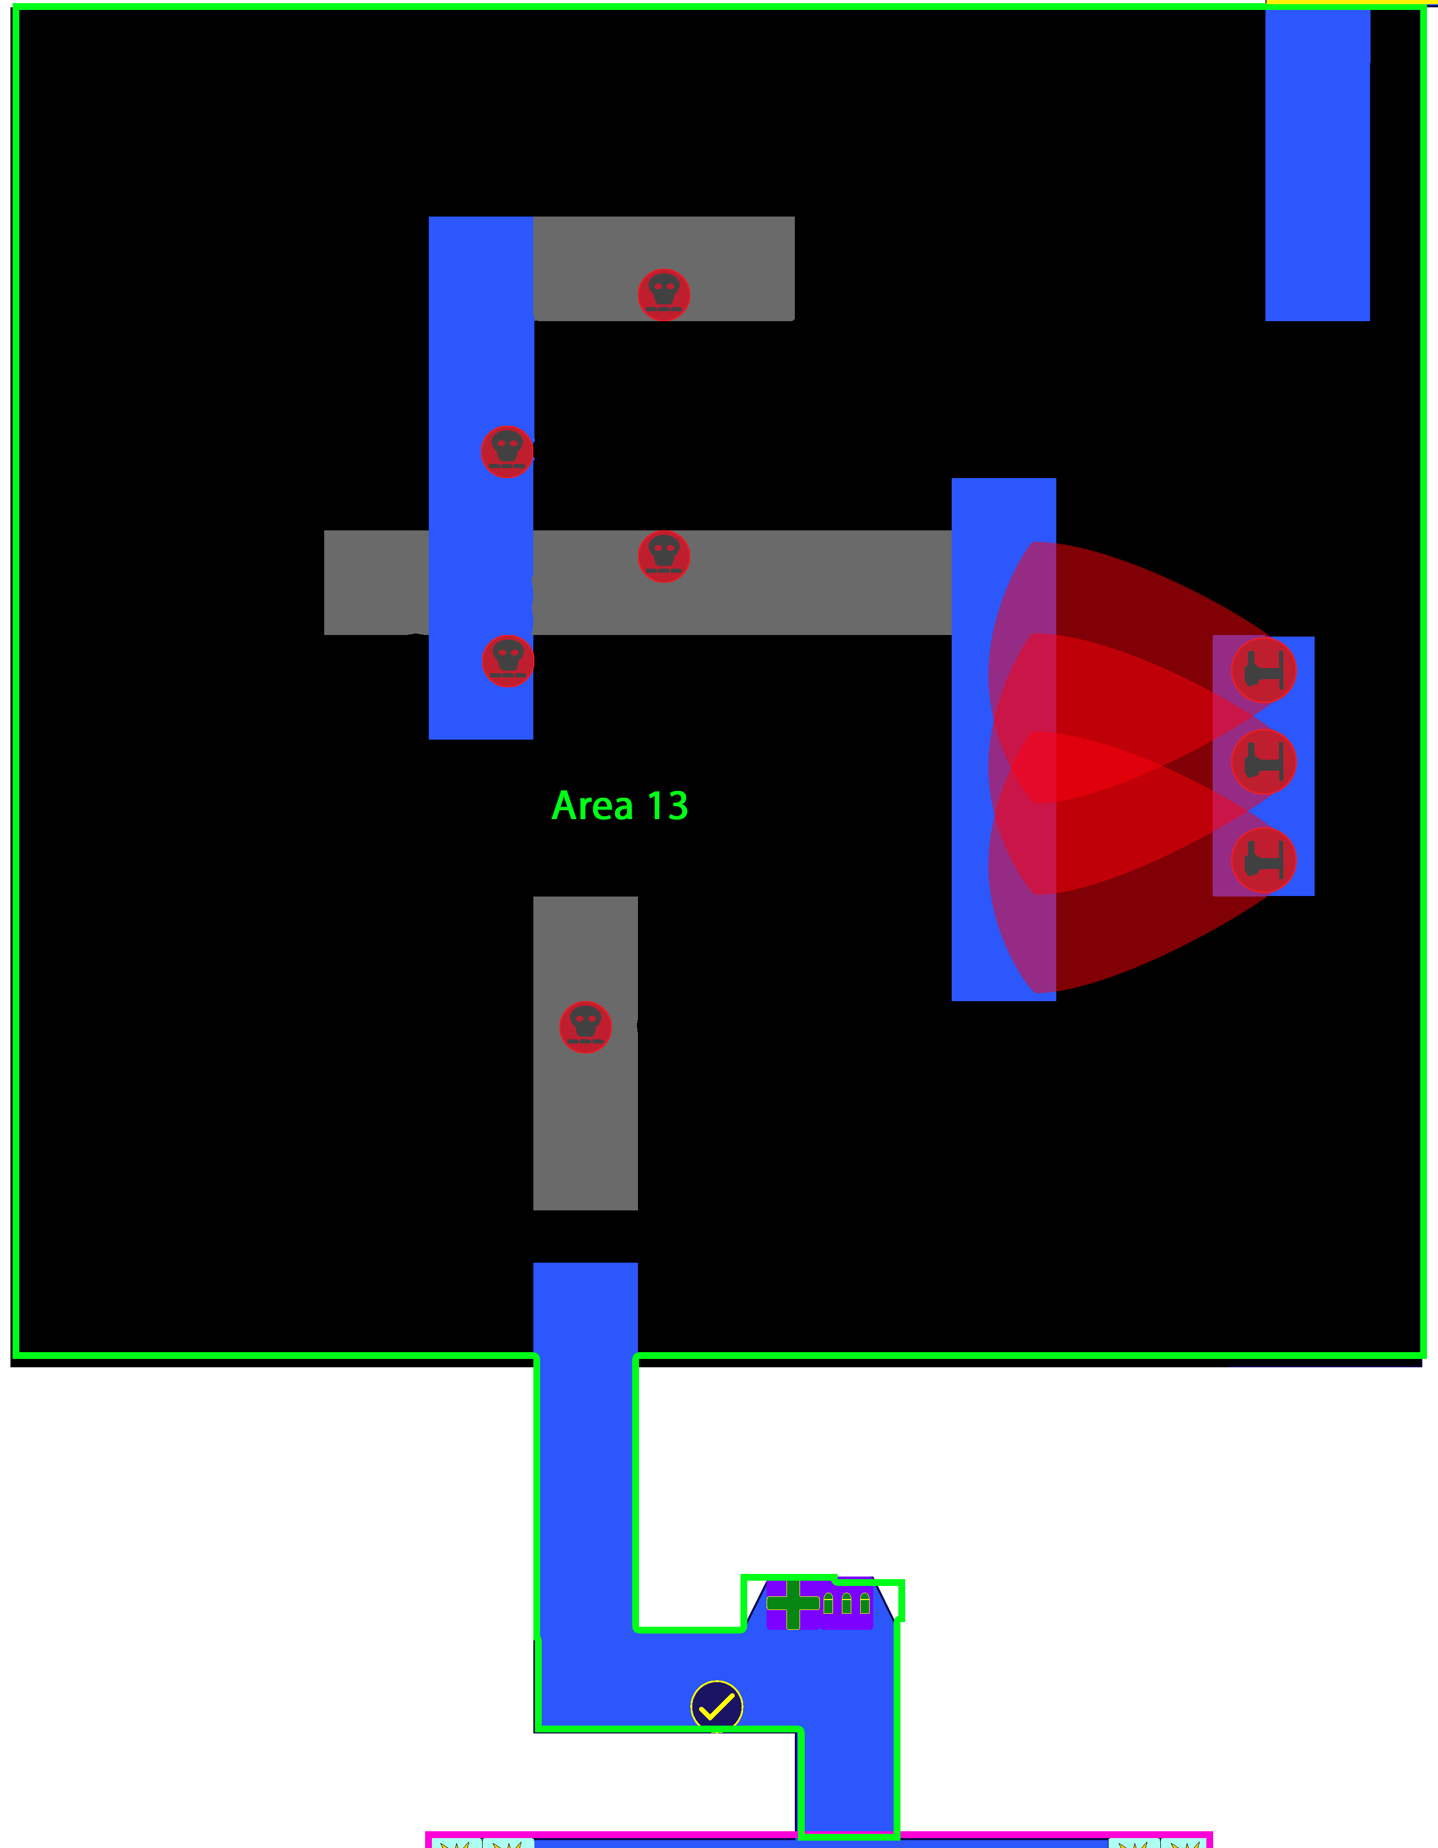

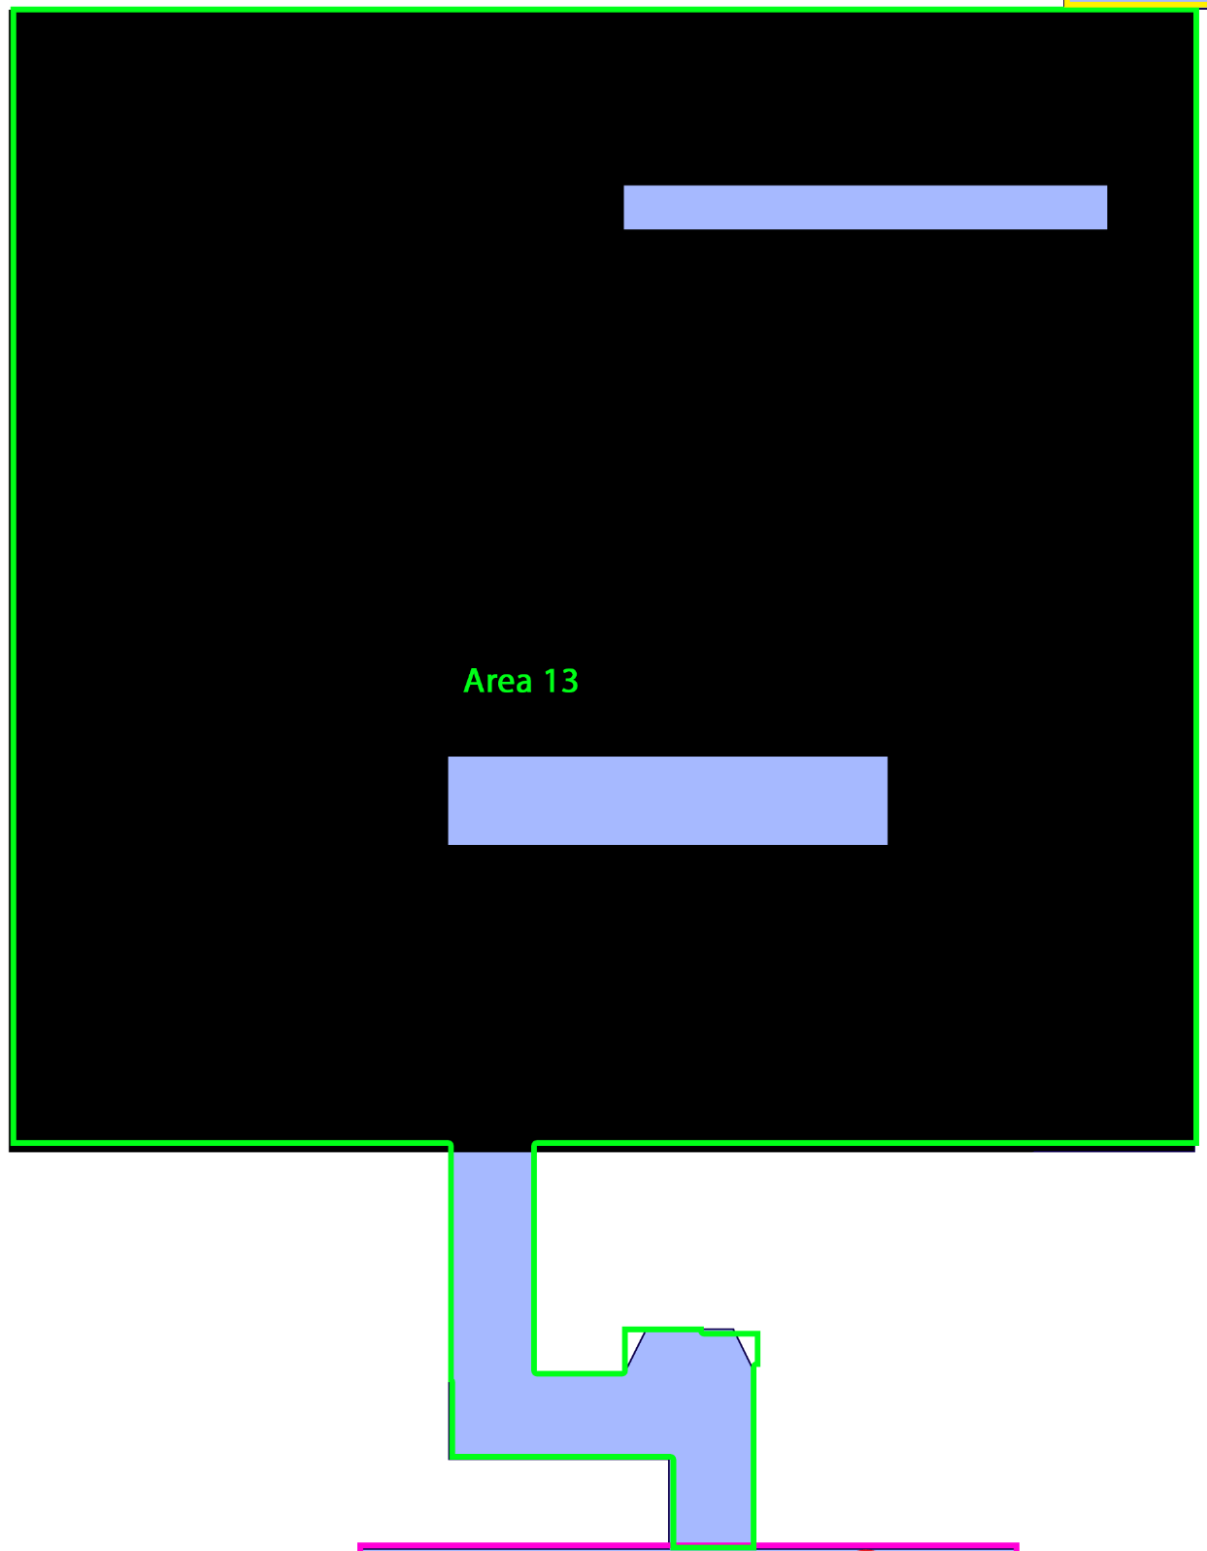

* **1 Checkpoint**
* 5 Machinegun Robot
* 3 Turrets
* 1 Med Kit
* 1 Machinegun Ammo
* There is a checkpoint at the beginning of this area.
* The rest hall at the beginning of this this area is purposely a corner in order to further slowdown the player so that he can rest. Also present in this area is a Med Kit and a Machinegun gun Ammo.
* This area is similar to Area 9, in the sense that the player has to travel through platforms in the roof and the floor. However, this area introduces another level of depth, with another set of platforms that are 1 floor below. So the player will have to deal with 4 levels of depth: the roof, the 2nd floor, the 1st floor and the 1st floor roof.
* As in Area 9, there is a bright red light guiding the player toward the door that leads him to Area 14. Again, the door which he used to enter this area is dimly lit.
* Machinegun robots are spread though the platforms in this area, again pressuring the player since he doesn’t have access to much cover in this area.
* There are also 3 turrets, in a single platform on 2nd floor. This turrets are intended to slow down the player, since they have within their range of fire a complete platform in the path toward the exit. So the player would be force to destroy the turrets before advancing.

**Area 14**

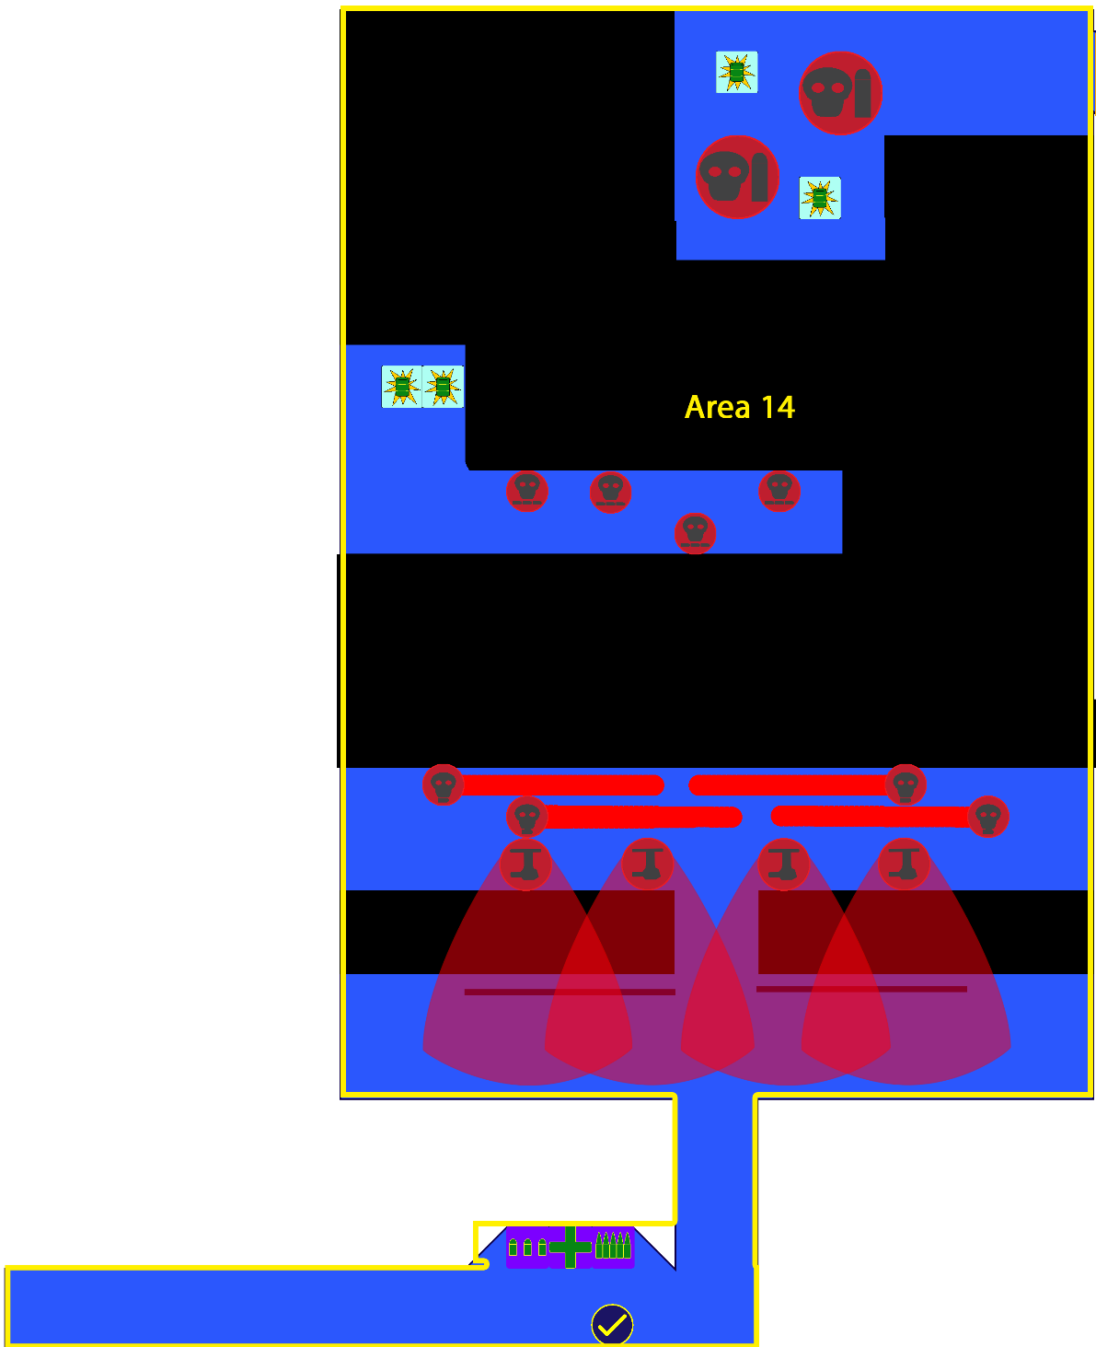

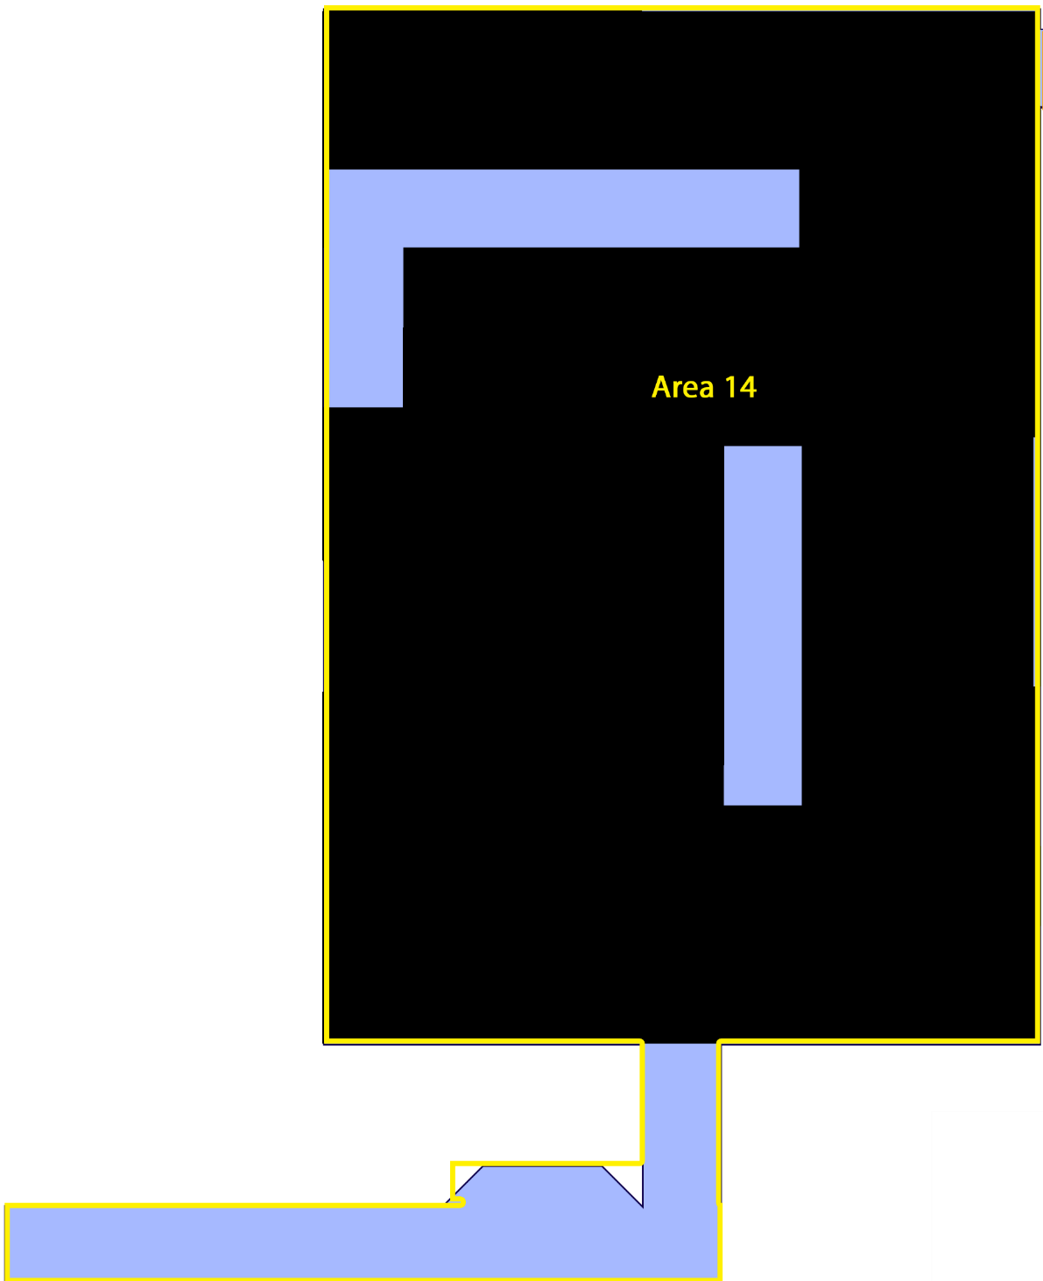

* **1 Checkpoint**
* 4 Machinegun Robot
* 4 Pistol Robots
* 2 Big Robots
* 4 Explosive Barrels
* 4 Turrets
* 1 Med Kit
* 1 Machinegun Ammo
* 1 Triple Shot Ammo
* There is a checkpoint at the beginning of this area. Along with resources and ammunition.
* This area starts with 2 walls for the player to take cover. Directly in front of the player there will be a line of 4 turrets point toward the player.
* The roof in this area is almost completely empty, a pit to death, except for some specific blocks required to progress.
* North of the turret there are 4 pistol robots patrolling the area, this are covering a path in the roof to lead to the middle platform.
* The middle platform contains 4 Machinegun Robots and a Wall corner used for cover (against the big robots in the north platform).
* In the middle platform the player has to go to the North West section in order to reach the roof part that will take him into the north platform.
* Still in the middle platform, there are 2 explosive barrels near this section of the roof. This is so that the player be extra careful about them, since the enemy can also shoot the barrels to explode them and damage the player.
* After going through the roof the player can reach the North platform, in this platform there are 2 Big Robots with 2 explosive barrels in the middle of them. The player can shoot the barrels to do a considerable damage to the robots so that he can later finish them off.

**Area 15**

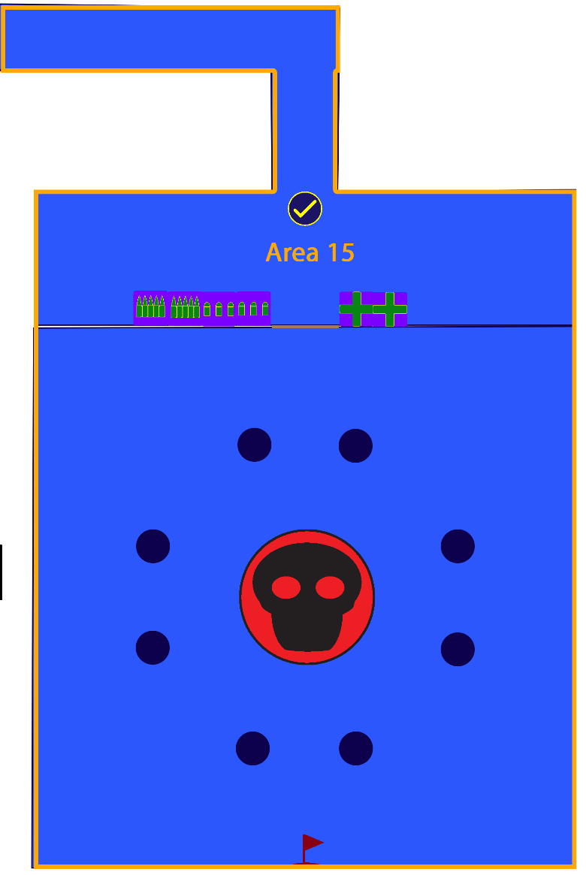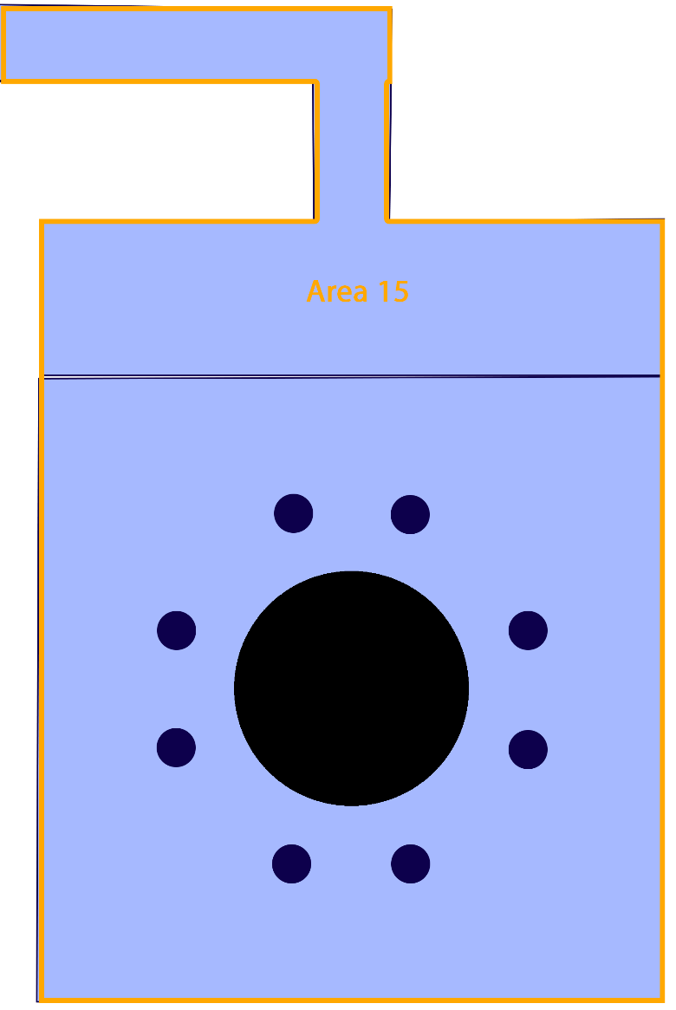

* **1 Checkpoint**
* **Level End**
* 1 Boss
* 1 Set of Double doors
* 2 Med Kit
* 2 Machinegun Ammo
* 2 Triple Shot Ammo
* There is a checkpoint at the beginning of this area
* The beginning of this area consist as a big hall that will serve as a big cool down for the player before he faces the boss
* Before reaching the boss, the player will reach an opening that contains enough Med Kits and ammunition so that the player is able to face the boss in top conditions.
* In this opening, as environmental storytelling, there will be blood splatters and Gravity Devices scattered around.
* Before entering the boss chamber, the player will have to open a set of double doors. These doors are placed to cause an even greater break between the rest period, and the difficult boss battle. The door also allows for a more dramatic entry to the boss chamber.
* The boss chamber consists of a circle of columns, with the boss being placed in the middle. The middle of the roof in the boss chamber is a death pit.
* The player is intended to use the columns, which go all the way to the roof, as cover while he circles around the boss.
* The boss is intended to start attacking the player, but because of his size he will be limited to the center area by the columns. However, if the player enters that area he will get attacked by the boss.
* During the boss fight, the boss will do an attack in which he will turn either a light on his head or in his jet (legs). The light indicates where the boss will attack next, the attack he does will instantly kill the player on contact. So the player has to observe the boss for when he turns on the light and change accordingly.
* Once the boss is death the level will be completed, a screen will appear informing the player about how long it took him to beat the levels and the number of deaths he had throughout it.

**Pacing Chart**

Pacing done in a scale from 1- 100. This is done following straightforward paths, only picking up the items required to accomplish a certain gameplay path. These charts don’t represent all the possible paths available.

It should be noted that after each room (area) there are halls , with varying lenghts, that serve as very small rest periods for the player. This rest periods are specially increased in the later areas of the level.

* Area 1: Player will advance normally through the area, with no apparent danger nearby.
* Area 2: Player will get nervous because of the turret, but nothing major since it won’t be directly attacking him.
* Area 3: The player will be for the first time outside of a safe zone and truly in a dangerous situation.
* Area 4: The player will merely be taught the basic movement mechanics.
* Area 5: The player will be surprised (even though he isn’t in much real danger) by being suddenly surrounded by turrets.
* Area 6: Player will have to encounter multiple enemies for the first time in a close environment.
* Area 8: Players will combine his gravity changing abilities with combat in a more serious situation for the first time. It will also be the first time he finds the
* Area 9: Player will have to practice already taught mechanics, but with a greater sense of challenge and danger.
* Area 10: Player may be slightly surprised by new enemy types, but shouldn’t present much of a challenge.
* Area 11: Player will learn, relatively safely a very basic mechanic.
* Area 12: Player once again will be surrounded by enemies
* Area 13: Player will have to put to test his gravity (platforming) changing abilities while being in combat.
* Area 14: In this area the player basically faces all the previous enemy types he has faced before.
* Area 15: The player faces the final boss of the level, presenting him with a challenge he hasn’t seen before and with a greater sense of danger.