# GAME OVERVIEW

## **Working game title**:

Atlacatl Trials

## **Platform**:

PC (Windows)

## **Target Audience:**

Teenagers to Young adult/ Diaspora from El Salvador (Salvadorans living in other countries) and from the region of Mesoamerica.

## Features/USPs:

* Unique setting of Mayan village, highlighting their way of life rather than Mayan ruins
* Educational value that will highlight key features of the civilization and promote the player to research further information

# ORIGINAL GAME DESIGN

## Game Concept:

In the 1520s the player will take control of Atlacatl, a reputed famous Pipil leader of the indigenous city of Cuzcatlán. In the game Atlacatl would have to undergo a series of trials that will serve to highlight the different virtues of the Mayan culture, as they prepare to face the incoming Spanish forces.

These trials will include solving puzzles related to the Mayan numbers and Mayan calendar, to proof his knowledge; collecting different items and exploring the village to highlight his culture; and culminate with him climbing to the top of the volcano while shooting targets with his bow and arrow to showcase his might.

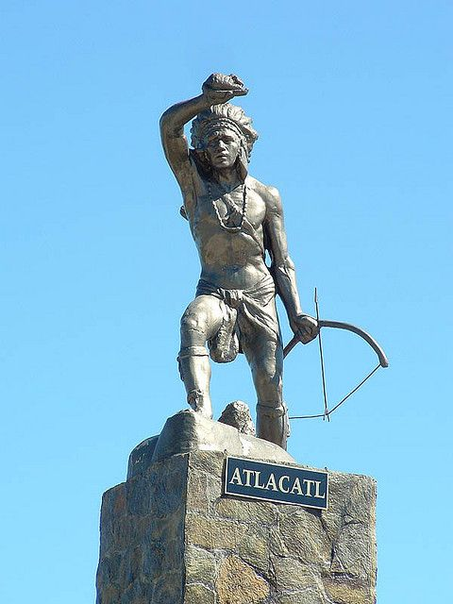

Statue depicting Atlacatl

The gameplay will be from a first-person perspective, giving the player the opportunity to fully immerse himself in the environment.

This game seeks to teach people about the Mayan culture in an engaging way, by placing them into a Mayan village. While a lot of information about the Mayans can be easily obtained by just playing the game, the game also offers the opportunity to interested players to read even more about Mayan culture (without being intrusive to players that just “want to play game”).

As the game is aimed to people that may not be that used to video games, the overall controls of the game will remain simple. Besides movement, most tasks in the game will be able to be completed with a single input.

The game will have different encyclopaedia or educational entries, where upon examining a certain object or place, detailed information about it and its importance would be displayed to the player.

The idea is inspired from the lack of game of games that display the Mayan’s way of life. While there are games that show Mayans ruins, and certain aspects of their mythology, few showcase how they lived their daily life.

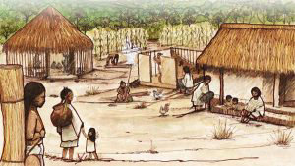

Depiction of Mayan village of Joya de Ceren

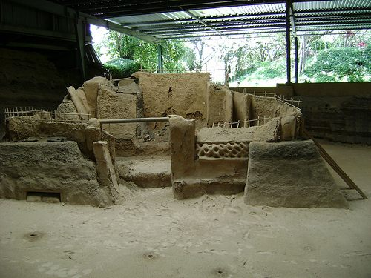

Ruins of Joya de Ceren in current times

## Setting and Environments:

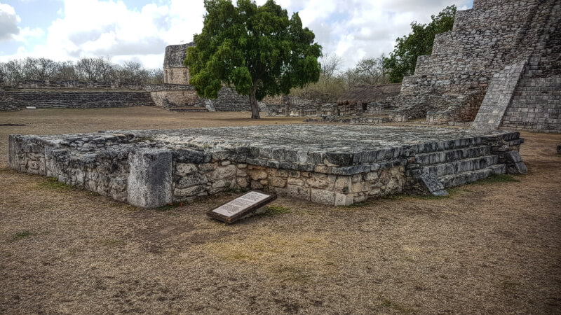

Ruins of Mayan altar

The game will take in a small Mayan village near the top of a volcano on the 1520s. The village consist of multiple small buildings, with a ceremonial altar on the middle of it. The village will be next to a flowing river, and at the bottom of a volcano, all of these surrounded by a thick jungle environment.

The structure of the village and the buildings in it would be heavily inspired in the [Joya de Ceren](http://www.fundar.org.sv/e_joyadeceren.html) archaeological site, which is also known as the “Pompeii of the Americas”. Each building would be small, but they have their own individual purpose. The village will not have any inhabitant, but common household items would be visible in it.

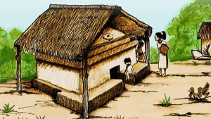

Mayan temascal, sauna bath

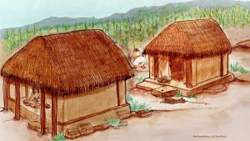

Drawing depicting Mayan houses

During the gameplay, the player will move from exploring a single house, to exploring the whole village, to finally exploring the area surrounding the village. This will involve the player climbing through a jungle path up to the top of a volcano.

Because the game aims to be educational about the Mayan culture, it must keep a certain degree of historical accuracy. This means that many structures may have unconventional appearance and mechanic, such being no doors or windows.

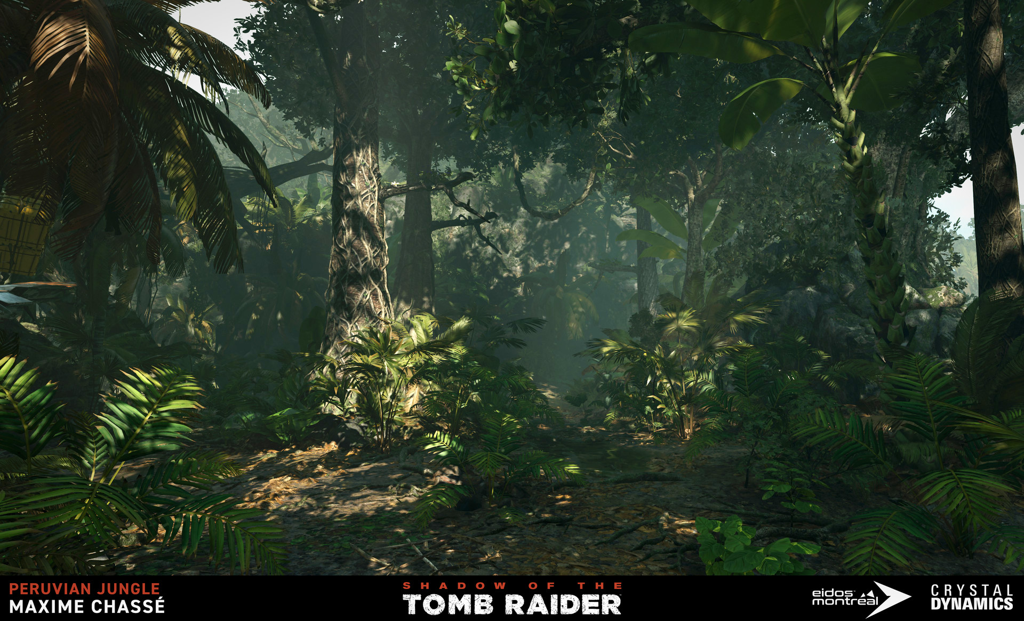

Jungle in Shadow of the Tomb Raider

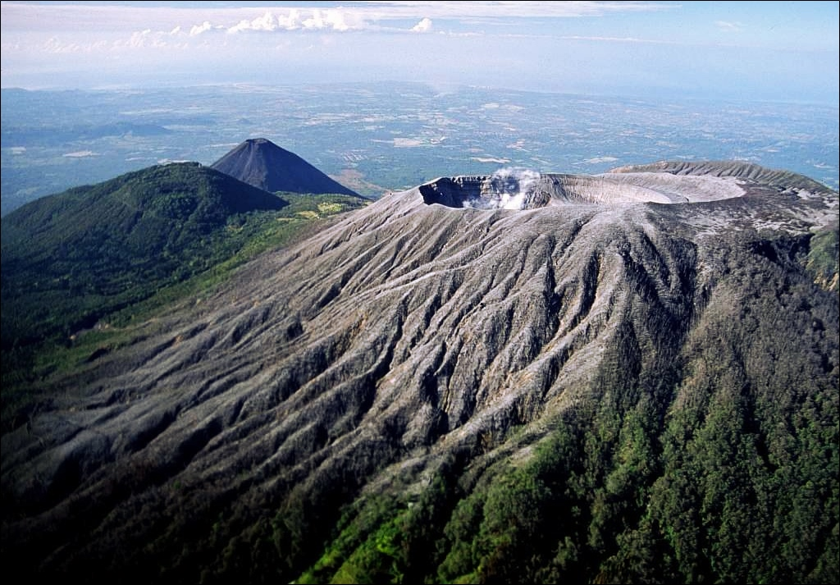

Santa Ana volcano, also known as Lamatepec

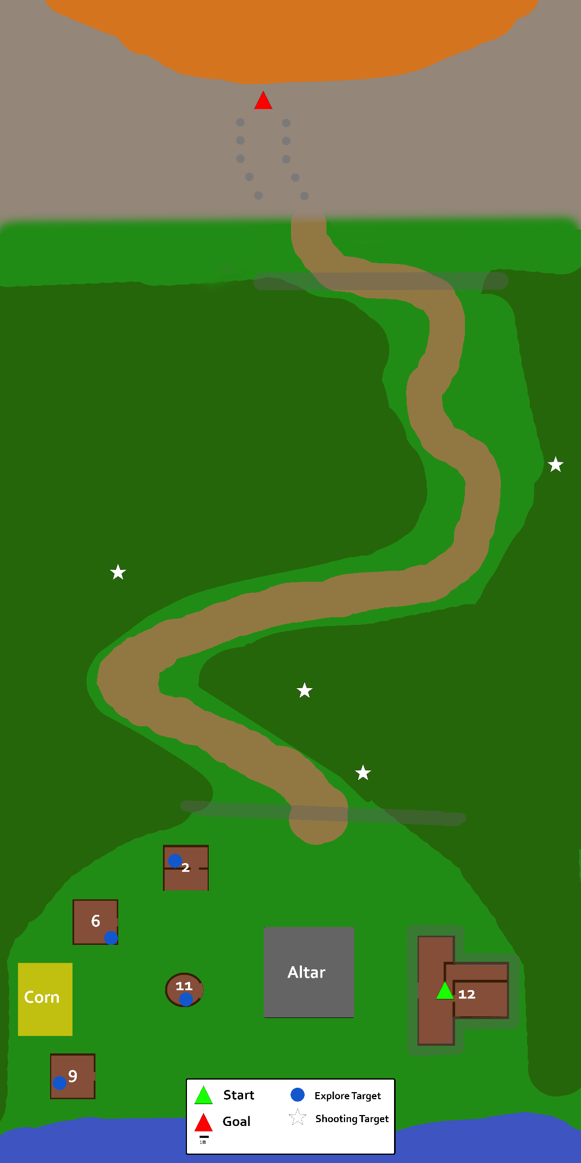

The structure numbers, in the layout, represent the structure in the archaeological site of [Joya de Ceren](http://www.fundar.org.sv/e_layout.html), from which they are loosely based on. These are:

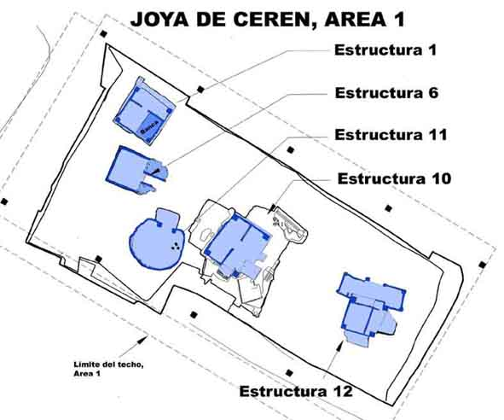

Reference to the internal structure of some of the buildings in Joya de Ceren, and the game.

* Structure 2: Typical Mayan household
* Structure 6: Storage
* Structure 9: Mayan sweat house, or temascal
* Structure 11: Kitchen
* Structure 12: Shaman workplace

## Key Gameplay features:

The main mechanics would be relatively simple, with a first-person point of view adventure game. The player will be tasked with finding different objects, and then pressing a button to collect the item or use it.

A more unique mechanic will be the bow and arrow, where the player will be able to charge his shots to control the strength with which the arrow is released. Though not unique, this familiar “action” like mechanic will serve as a hook for people that may consider normal “educational” games boring.

Though these mechanics will not be particularly special, the games main selling point will be its setting and its educational purpose. Since it would provide informative text, and visual reference of the different environment of the Mayan culture.

There would be 2 main puzzles, in the knowledge trial section of the game. The first one, used to show the Mayan Numbers, will have the player solve, in a 2D UI, a math equation using a mix of Mayan numbers, and traditional numbers. To solve this puzzle, the player will have to deduce the values that the different Mayans glyphs represent and choose the correct answer for the given equation.

The second puzzle, aimed to teach about the Mayan Calendar, will have the player spin a Mayan calendar wheel, showcasing the glyphs for the different Mayans date. Through these spins the player must math a specific symbol (date), indicated in game, at the correct position.

The exploration segment will have the player explore and interact with different items from the Mayan culture and daily life. When close to certain key objects or places, the player will be able to read more information about these.

The final segment will involve the more “action” mechanic shooting a bow and arrow; an activity well known to most people, and which was one of the main traits of Atlacatl. The force with which the arrow will be release will be dependent on how long the player has pulled his bow.

## Game Rules:

The player will be able to move around in first-person (move with keyboard and look with mouse). If the player is within range of an object he can use, a message prompt will be shown to tell him to press the respective key to use the item.

At different points in the game, the player will be able to read more information about certain key items/locations. This extra information will be shown in a translucent 2D overlay on top of the player screen. This will not pause the game; in case the player wants to see the object, he is reading about. This extra information prompt can be closed manually, or by walking away from the key object/location.

At most points in the game (excluding the Mayan Numbers puzzle and the end of level cinematic)., the player will be able to pause the game, opening a pause menu. This pause menu will allow the player to resume his current playthrough, see the controls, or quit the game completely.

The moveable area of the player will be restricted and will expand as he completes the different trials. At the start, the player will be able to move only inside a single house. Once the knowledge trial (puzzles) has been completed, he will unlock the village to explore, then when the exploration tasks are completed the jungle path will be unlocked, and finally when all the targets have been shot, the volcano top will be unlocked.

There will always be limitations, invisible walls, that prevent the player from going too far into the jungle, or into the volcano or river.

For the Mayan Numbers puzzle, the player will be shown a 2D screen pop up. While this is open the player will not be able to move, interact with objects, or open the pause menu. The player will only be able to click the buttons in the puzzle (3 possible answers for each question, and a quit puzzle button).

The Mayan Numbers puzzle has 2 questions. Both must be completed to consider the puzzle as done, and they must be solved in order. If a wrong answer is chosen for the puzzle, a sound and small effect will indicate to the player he is incorrect, but there will be not any penalty for it, and he can retry the question as many times as he likes. If the player quits the puzzle before completing both questions, he will have to restart the puzzle from the first question.

For the Mayan Calendar puzzle, the player will not open any type of special menu, but instead everything will be done in the normal 3D view. The player will be able to use the calendar wheel to spin it. The player must spin the wheel enough times until the glyph in the wheel, which must match the glyph indicated at the bottom of the calendar, matches the position of the arrow. The wheel must remain at the correct position for 1 second for it to register the puzzle as complete.

If the Mayan Numbers Puzzle or the Mayan Calendar Puzzle has been completed, that puzzle can not be redone, and its interactivity will be disabled.

The exploration tasks involve the player exploring the village, finding 3 different items, and picking them up (the single use button will collect them). Once an item has been collected, it will disappear from the level and cannot be picked up again. The exception to this is the additional task to use the sauna, which using the same input as for the other tasks, must be turned on. The sauna is considered an exploration task, alongside the item collection tasks, and these can be completed in any order.

Once all the exploration tasks have been done, the prayer must go to the altar and make an offering. This can only be done once all the previous exploration tasks have been completed. Once this offering has been done the player will be able to pick up the bow.

For shooting, the player will not be able to shoot until he obtains the bow and arrow. The player will be able to “charge” his shots to different intensity by holding the mouse button. Upon release, the arrow will be show with varying amount of force. The player can shoot at anything, but only hits to the obsidian skull targets will count as progress. Once the player hits all the targets, regardless of the order in which they are shot, he will be allowed to progress.

The end of game cinematic cannot be interrupted, with player input being disabled. 4 seconds after the end of game cinematic finishes, the level will be automatically restarted.

## Game Progress:

The game will be divided into 4 main areas, which the player must unlock after completing each of the 3 trials.

The first area will be the shaman house, where the player would have to solve 2 puzzles one involving Mayan numbers and the other one involving the Mayan calendar. All 2 steps of the Mayan number puzzle, and the single step of the Mayan calendar must be solved before being able to proceed.

After completing these puzzles, the knowledge trial, the player will be able to leave the shaman house and explore the Mayan village. In the village, the player would have to collect or use different objects that highlight the Mayan culture. Once he has completed all these tasks, he will be able to go to the altar, where after making an offering, he will be able to pick up the bow. This will complete the exploration trial and unlock the jungle path climb up the volcano.

For this final “might” trial, the player will have to climb the volcano traversing a jungle. There he would have to shoot 4 to highlight his mastery with the bow. The targets are placed alongside the climb up the volcano. Once all of them have been shot the volcano top area will be unlocked.

At the top of the volcano, the player will have to walk through 2 rows of censer, until he reaches the crater of the volcano. There he will interact with the statues at the top, completing the game.

This end of game will trigger an un-skippable cinematic that will pan the camera from the top of the volcano back to the Mayan village. There the game title will be displayed, and after a couple of seconds the game will be restarted.

At any point in the game, if the player gets close to certain items or locations, he will be able to read extra information about the Mayan culture.

## Game Flow:

The Mayan Numbers Puzzle, one of the puzzles in the first area, will be used to highlight the Mayan number system. In these challenges, the player will see a series of Mayan number glyphs in basic addition and subtraction operations, and the result of these operations in Mayan and regular numbers. However, the final equation in the screen will not have its answer shown, so the player must choose the correct answer that solves the Mayan number equation. These will serve to teach the player what each symbol means.

The puzzle has two different steps, or equations to solve. The first will start with values under 19, which due to the vigesimal nature of the Mayan numbering system mean there will be limited to one row only. However, the second equation to solve will have values over 20, which will mean that the 2 rows vigesimal system will have to be employed, increasing the level of challenge.

The second puzzle in the first area is the Mayan Calendar puzzle. This is a single step puzzle, where the matching symbol must be rotate to be at the bottom of the calendar wheel. The symbol that must be matched is clearly shown at the bottom of the calendar, and because there is only one input, one way to rotate the calendar wheel, completing the puzzle is not complex. However, to avoid people from just spamming the only input, the “solution” must stay in place for at least 1 second for it to registers; this to ensure that the answer was intentional and not an accident.

The exploration segment, where certain items must be collected, will be focused on highlighting the different buildings of the village. The player will be able to find one of the required items/tasks in each of the main buildings. From there, the player will just have to interact with it once to complete the task.

All tasks are placed logically, according to where you could find them in a Mayan village. Besides, limiting he player to only move within the village boundaries, will help guide him, preventing him from getting lost in a vast environment.

Once all items are collected, the player will have to go to the altar at the centre of the village, where they will make an offering and collect the bow. Again, this is done with simple clicks, no puzzle required.

For the final stage, the player will be able to shoot at static target his bow and arrows. The target positioning and distance from the player will grow steadily as he progresses through the jungle. However, there is no ammunition or time limit for the player to shoot all the targets.

At the end, the player will just walk to the edge of the volcano crater to finish the ritual and trigger the game animation.

## Game Controls:

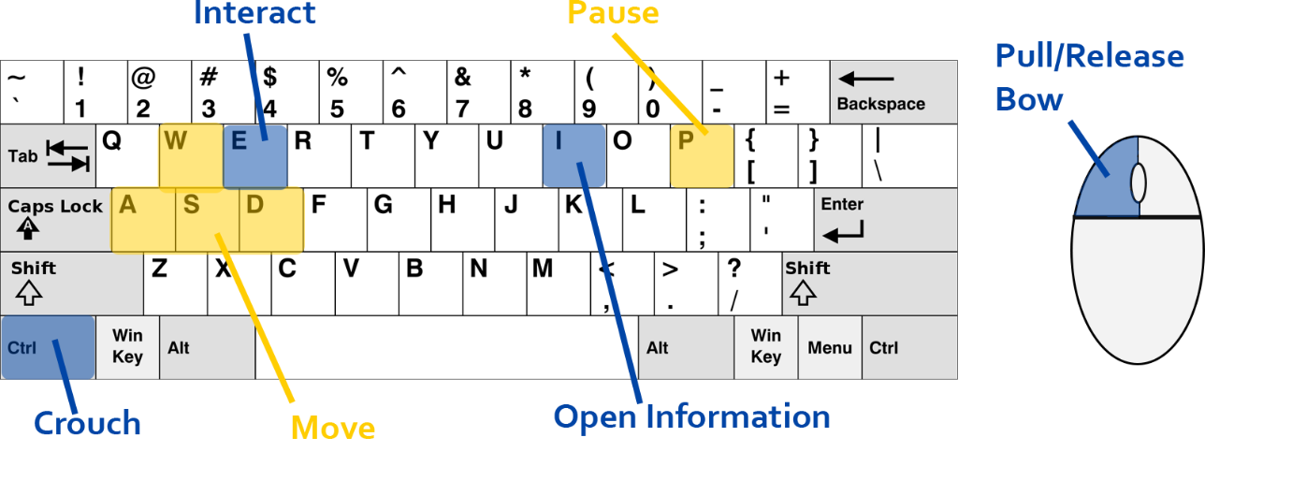

* WASD – Character Movement
* Ctrl – Toggle crouch on and off
* E – Interact (Includes using and collecting items)
* I – Toggles on/off the extra information about the nearby item/location
* P/Escape – Opens the pause menu
* Mouse – Look around
* Mouse Left Button – On press it starts pulling the bow, and on release fires arrow

The menus will be fully controllable with the mouse, with no form of keyboard support.

## Objects/Characters:

* Bow and arrow
  + Type: Major gameplay centrepiece
  + Use: Player will be able to control the bow and arrow in first person view to shoot
  + Description: Mayan bow and arrow. Since they did not have mastery of metalwork at this stage, the arrowheads were made of obsidian.

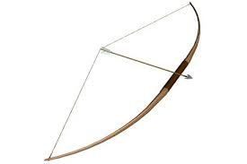

* Mayan Stone Tablet
  + Type: Puzzle centrepiece
  + Use: If the player interacts with this object, he will open the 2D UI screen for the Mayan Numbers puzzle.
  + Description: A stone table

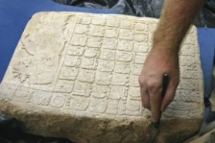

* Mayan calendar
  + Type: Puzzle centrepiece
  + Use: Player will be able to rotate the wheel of the Mayan calendar.
  + Description: A circular stone Mayan calendar, where each wheel has the symbol for different days of the calendar.

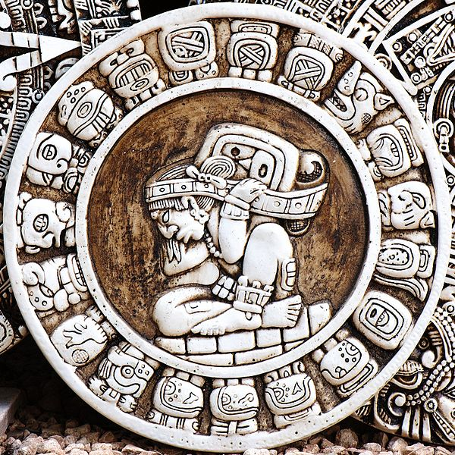

* Corn
  + Type: Puzzle collectible
  + Use: Player will have to collect item and place it on altar
  + Description: A piece of corn. This had great importance in Mayan culture, since the Popol Vuh (creation book of Mayan) stated that the men were made from it. It also was a cornerstone of their diet.

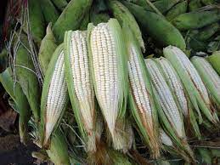

* Cocoa bean
  + Type: Puzzle collectible
  + Use: Player will have to collect item and place it on altar
  + Description: Cocoa beans, famous for being the foundation for chocolate. The Mayans brewed hot cocoa drinks, and even used it as a currency in a certain point.

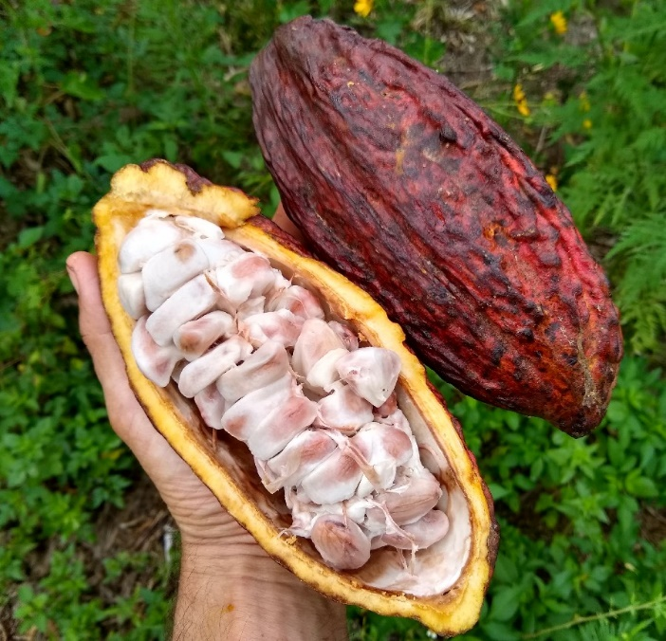

* Jade Knife
  + Type: Puzzle collectible
  + Use: Player will have to collect item and place it on altar
  + Description: Characterized by its aqua green colour, jade was extremely valuable for use in jewel and ornaments.

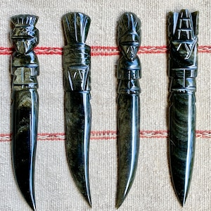

* Obsidian skull
  + Type: Gameplay target
  + Use: Using the bow and arrow, the player will have to shoot at the obsidian skulls, to complete a trial.
  + Description: Obsidian is a glass like volcanic rock of a black colour. It was commonly used to make different cutting tools due to the sharp edges that it could possess. The skull shape in this case, symbolizes the enemies that will have to be defeated.

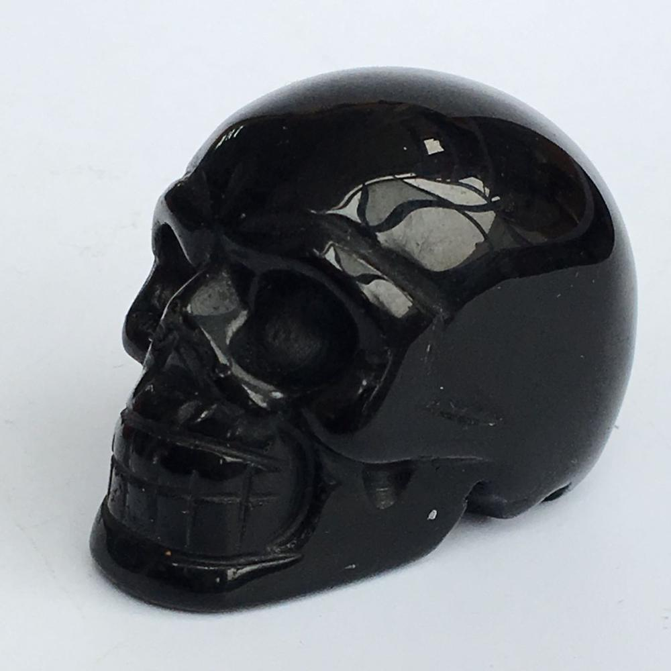

* Censer
  + Type: Dynamic object
  + Use: When the player gets close to it, it will automatically turn on.
  + Description: A censer made from clay. Multiple aromatic woods were used with it for rituals.

* Petate
  + Type: Prop

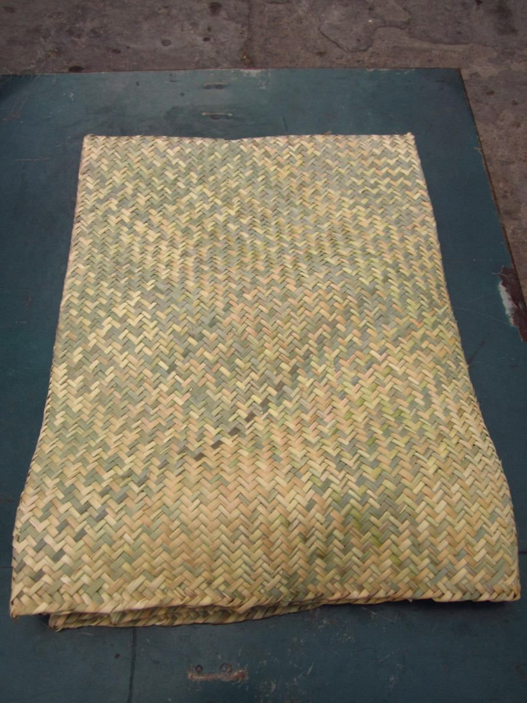

* Comal:
  + Type: Prop

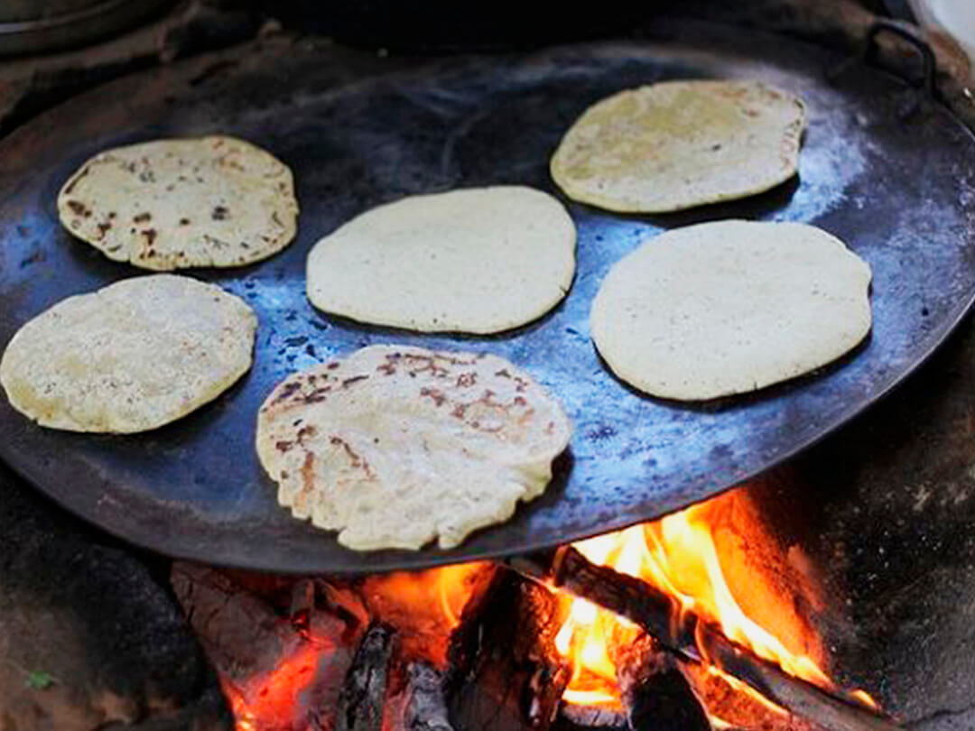

* Dog Toy
  + Type: Prop

* Atlacatl
  + Type: Main Character
  + Description: The unseen (in game) main character. A Mayan chieftain undergoing a series of trial to prove his worthiness. As a traditional Mayan people, he is of a relatively short height, but strong enough to easily handle the use of a bow.

## Game assets management:

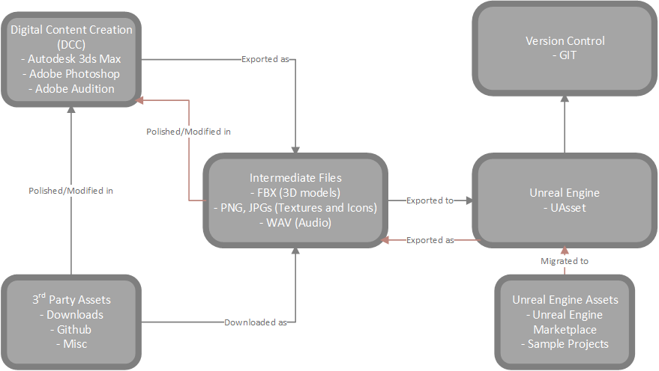

A small amount of assets may be created from scratch withing a Digital Content Creation tool. These assets would be exported as an intermediate file format, to finally be brought into Unreal Engine.

Most assets will be download as intermediate files from third-party vendors, which include projects freely distributed in [GitHub](https://github.com/), [TurboSquid](https://www.turbosquid.com/), and other asset marketplaces. This assets in their intermediate version may be either exported to Unreal Engine for direct use or brought back to a Digital Content Creation tool where they may be further polished or tweaked.

Some Unreal Engine Marketplace assets, and sample projects, are brought directly into Unreal Engine as their UAsset format. If these files needed to be tweaked, they would have to be exported from Unreal Engine to an intermediate format, and then finally brought to the digital content creation tool.

The whole Unreal Engine project, and its assets (in .uasset format), would finally be uploaded to a Git version control software.

The digital content creations tools that will be used to modify or create assets, per the asset type are:

* Adobe Photoshop – Textures
* Adobe Audition – Audio
* Autodesk 3ds Max – 3D Models

The external assets used in the project are:

* GameAssetFactory. (2020, July 12). Medieval Houses Modular Vol 2. Unreal Engine Marketplace. <https://www.unrealengine.com/marketplace/en-US/product/medieval-houses-modular-vol-01>
* Cihuahack. AJPana. (2018, October 27). Cihuahack 3D Models. GitHub. <https://github.com/AJPana/Cihuahack>
* KK Design. (2018, July 17). Modular Lost Ruins Kit. Unreal Engine Marketplace. <https://www.unrealengine.com/marketplace/en-US/product/modular-lost-ruins-kit>
* Gabro Media. (2019, October 11). Log Cabin. Unreal Engine Marketplace. <https://www.unrealengine.com/marketplace/en-US/product/log-cabin>
* NatureManufacture. (2017, December 7). Environment Set. Unreal Engine Marketplace. <https://www.unrealengine.com/marketplace/en-US/product/environment-set>
* Quixel Megascans. (2019, November 1). Megascans - Concrete Dirty Vol. 2. Unreal Engine Marketplace. <https://www.unrealengine.com/marketplace/en-US/product/d8a50f1769794b92b8c6a044705407f1>
* Quixel Megascans. (2019, November 1). Megascans – Definitive Fruits. Unreal Engine Marketplace. <https://www.unrealengine.com/marketplace/en-US/product/fa6a85e22fd24701b6d158ca08801598>
* Quixel Megascans. (2019, December 4). Megascans – Vegetables. Unreal Engine Marketplace. <https://www.unrealengine.com/marketplace/en-US/product/8ef1598076964207bd38e14cf950f706>
* Quixel Megascans. (2021, April 21). Megascans: Tropical. Unreal Engine Marketplace. <https://www.unrealengine.com/marketplace/en-US/product/eaf0eba657a5417aa843f0ad73e51db9>
* Quixel Megascans. (2019, November 1). Megascans – Pine Essentials. Unreal Engine Marketplace. <https://www.unrealengine.com/marketplace/en-US/product/38c306c3b45f48c499251e7a35065d7d>
* Quixel Megascans. (2021, June 15). Megascans: Rustic Pottery. Unreal Engine Marketplace. <https://www.unrealengine.com/marketplace/en-US/product/825cd6dd03534afc942cace2ae754095>
* RISD Nature Lab. (2021, February 9). Cocoa Pod. Sketchfab. <https://sketchfab.com/3d-models/cocoa-pod-8657b36b528147f499c26cec5b5e0907>
* Madison Pike. (2016, March 15). Texture, Decals & Visual Effects. Humble Bundle.
* Ultrachangon. (2017, March 16). Mayan Jaguar. Sketchfab. <https://sketchfab.com/3d-models/mayan-jaguar-96a0c8cb9f2c4eae8dedf4552d115f17>
* IdCcollective. (2016, June 2). Mayan Calendar. Sketchfab. <https://sketchfab.com/3d-models/mayan-calendar-b58714119c874f569df842cbfda11451>
* Gilles.schaeck. (2021, May 30). Maize Corn Plant. Sketchfab. <https://sketchfab.com/3d-models/maize-corn-plant-5fd3b104d8104519b061469c365d4974>
* Thunder. (2020, September 11). Animated Bow. Sketchfab. <https://sketchfab.com/3d-models/animated-bow-5340eb4804364b19b1666feef8d6d9dc>
* Jute Matting Zig Zag – PBR0242. Textures.com. <https://www.textures.com/download/PBR0300/134382>
* OBSIDIAN CRYSTAL - PBR0687. Textures.com. <https://www.textures.com/download/PBR0930/140603>
* FOODGRAINS0013. Textures.com. <https://www.textures.com/download/FoodGrains0013/104523>
* Soulzero. (2015, September 20). Corn. Turbosquid. <https://www.turbosquid.com/3d-models/free-corn-3d-model/962256>
* FXVarietyPack.
* Tridi Butik. (2021, January 26). Alfombra circular de ratán modelo 3d. Turbosquid. <https://www.turbosquid.com/es/3d-models/3d-rug-decor-1683187>
* Noxfcna. (2017, March 22). Yaxchilan – Lintel No 16. Sketchfab. <https://sketchfab.com/3d-models/yaxchilan-lintel-no-16-cc66c76b45e949a69870272ac39e0d79>
* JeongukChoi. (2018, June 27) M5 VFX Vol2. Fire and Flames. Unreal Engine Marketplace. <https://www.unrealengine.com/marketplace/en-US/product/m5-vfx-vol2-fire-and-flames>
* FX Cat. (2022, February 15). Realistic Starter VFX Pack Vol 2. Unreal Engine Market Place. <https://www.unrealengine.com/marketplace/en-US/product/realistic-starter-vfx-pack-vol>
* Emelyarules. (2021, February 20). Obsidian Knife Maya. Sketchfab. <https://sketchfab.com/3d-models/obsidian-knife-maya-90c2d687db2e406b9a0d4ccea1b502ed>
* 3dhdscan. (2017, August 18). Papaya Fruit. Sketchfab. <https://sketchfab.com/3d-models/papaya-fruit-337e1cf840e94d8cbd1edf134b4cccbf>
* Epic Games. (2020, June 24). Elemental Demo. UE Legacy Samples. <https://www.unrealengine.com/marketplace/en-US/product/elemental-demo>
* DopamineWarlock. (2022, March 13). Aztec Maquahuitl Stone Sword. Sketchfab. <https://sketchfab.com/3d-models/aztec-maquahuitl-stone-sword-f85c9b130cb94ca9be19214b1806ff16>
* Wikimedia. (2006, November 25). Maya numerals. Wikimedia. <https://commons.wikimedia.org/wiki/File:Maya.svg>
* Wikimedia. (2015, June 14). Haab Calendar. Wikimedia. <https://commons.wikimedia.org/wiki/Haab_calendar>
* Denelson83. (2006, January 12). KB United States. Wikimedia. <https://commons.wikimedia.org/wiki/File:KB_United_States.svg>
* printable_models. (2018, October 10). Altar V1. Free3D. <https://free3d.com/3d-model/altar-v1--220587.html>
* matthewHoldenSound. (2020, November 5). OWI_Bow Srting 2.wav. Free Sound. [https://freesound.org/people/matthewHoldenSound/sounds/542517/#](https://freesound.org/people/matthewHoldenSound/sounds/542517/)
* EminYILDIRIM. (2020, September 21). Bow Loading. Free Sound. <https://freesound.org/people/EminYILDIRIM/sounds/536067/>
* Mnemofonias0. (2022, January 8). Jungle of Palenque. Freesound. <https://freesound.org/people/Mnemofonias0/sounds/614187/>
* florianreichelt. (2021, March 17). Fire Crackles. Freesound. <https://freesound.org/people/florianreichelt/sounds/563766/>
* Godowan. (2014, April 29). Tunkul3. Freesound. <https://freesound.org/people/Godowan/sounds/235275/>
* Godowan. (2014, June 11). Tunkul. Freesound. <https://freesound.org/people/Godowan/sounds/240471/>
* Seidhepriest. (2012, December 2). Tlapanhuehuetl-4. Freesound. <https://freesound.org/people/Seidhepriest/sounds/170918/>
* FunWithSound. (2017, May 1). Breaking Glass 8. Freesound. <https://freesound.org/people/FunWithSound/sounds/390715/>
* braqoon. (2012, July 12). arrow_damage. Freesound. <https://freesound.org/people/braqoon/sounds/161098/>
* DSA98. (2017, May 16). 56-Ruedas De Carrito-consolidated. Freesound. <https://freesound.org/people/DSA98/sounds/393288/>
* davilca. (2012, June 24). loop-river-1. Freesound. <https://freesound.org/people/davilca/sounds/159492/>
* Audionautics. (2011, November 9). Lava loop. Freesound. <https://freesound.org/people/Audionautics/sounds/133901/>
* Awkner. (2012). Chichen Itza game – theme. Soundcloud. <https://soundcloud.com/awkner/chichen-itza-game-theme>

## Walk through:

At any point, when close to key items and locations the player can read extra information about the Mayan culture.

The player will start inside a house which he will not be able to leave until he solves the Mayan Number puzzle and the Mayan Calendar puzzle, which are in the adjacent rooms of the house.

After leaving the house, the player will be in the Mayan village, where he will have to gather a series of objects to offer as tribute in an altar. To collect the items, the player will have to walk around and explore the village, getting to know how it was structured. The objects will be simply picked, without having a puzzle requirement.

When all the items have been found and placed in the altar, the player will be able to pick up a bow. This will allow him to shoot arrows with varying degrees of force, dependent on the time spent charging the shot.

Then the player will have to climb up the volcano, going through a jungle path, using the bow to shoot a series of obsidian skulls. The player will have to shoot four of these static targets hidden in the jungle before being able to proceed.

Once the player reaches the top of the volcano, he will have to interact with the ritual state to complete the trials. Once this is done, an animation will be played, of the camera zooming out and going back to the village, completing the game.