SNOWFLAKE
Introduction (Youtube):
Why are all companies moving to snowflake?
To withstand their queries or database with AI.

Snowflakes accept two workloads.
1.Business intelligence.
2.AI/ML.
Here Data Engineer work is to load data.
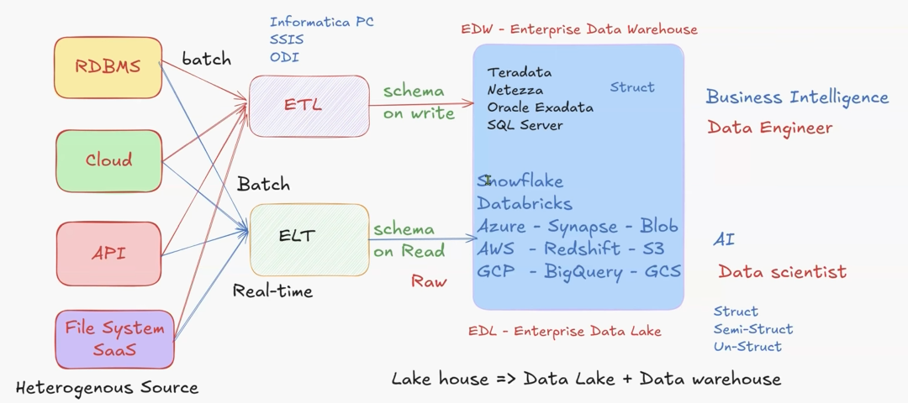
Not only above-mentioned sources. From many sources like Salesforce, SAP, front-end applications, we will get data.
Applications like Teradata, Netezza, Oracle Exadata, SQL Server maintain the structured data.
Applications like Snowflake, Databricks, Azure, AWS, GCP maintains the Struct, Semi-Struct, Un-Struct.
How these Applications store data? For Azure, In ADLS (Azure Data Lake Storage), the data was stored. For AWS, S3 is there. For GCP, GCS(Google Cloud Storage) is there.
After loading the data, in these applications only, transformation will happen.
Now-a-days, Migrations going on like, from Big query to Snowflake or Redshift to Snowflake.
Schema on write: While loading the data itself, it will write into the tables.
Schema on read: We build a schema as per our requirements.
For Ex: For BI team, if they want to create a report. They can create a schema. Similarly, for other domains also.
Previously, ETL could process only batch data but not live data. Now ELT, can process live data.
Architecture (Youtube):
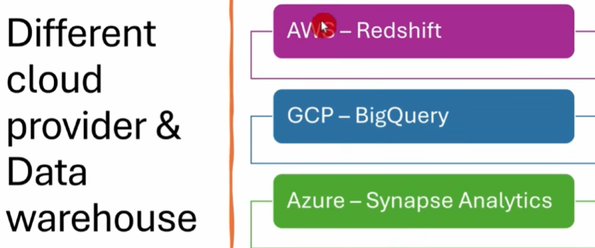

Datawarehouse:
The purpose of this is to consolidate and integrate different data sources and use them and optimize them for reporting and data analysis.
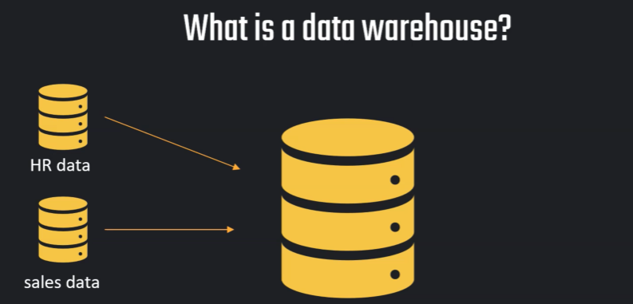
Analysing the data on this HR database might put unnecessary load and might interfere also with the operation that we are running here, maybe in the sales department or wherever this database is running.
Therefore, we don't want to touch this database, or we at least want to spend as little time as possible on this database. we don't want to use this database directly to analyse the data.
So therefore, we are doing ETL process.
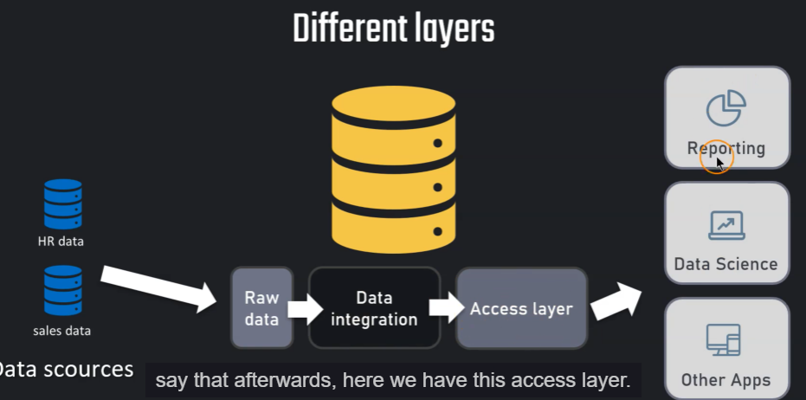
Raw Data is nothing but a Staging area.
Data Integration is Data Transformation.

Cloud Computing:
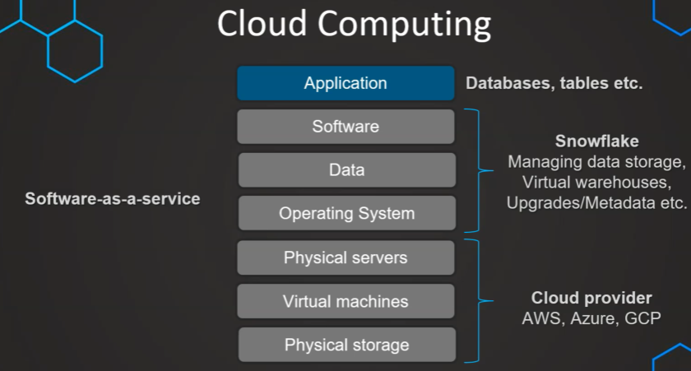
What is the need for cloud computing?
It was necessary to have a data centre, if this company or organization wants to or must work with data. But the problem is that this can cause a lot of overhead, because this means, the data centre is physically available in a building or a data centre room. So, we must maintain and manage the infrastructure. It can cause a lot of overhead like we are responsible for the security against physical and virtual breach, and the servers have to be cooled, which needs lot of electricity. We have the need for software and hardware upgrades.
Maybe we need to create virtual machines and manage all these servers and databases which needs lot of cost. If all of this could be outsourced and that the company can only focus on their application (Creating the databases and tables) itself. Overall, creating the Datawarehouse. Snowflake work model is SAAS type.

Snowflake Editions:
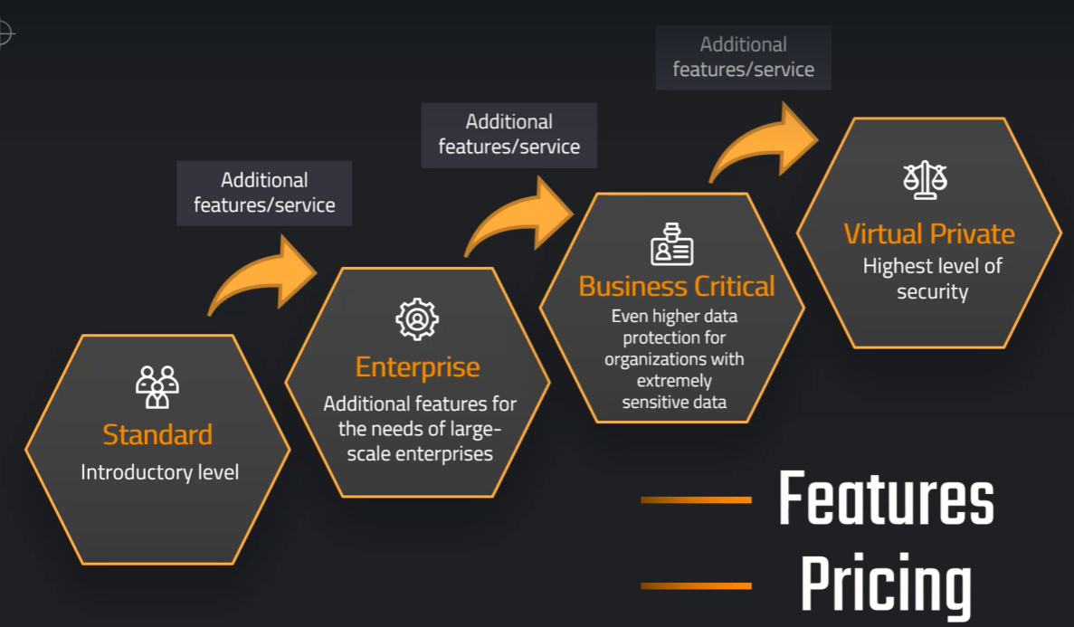
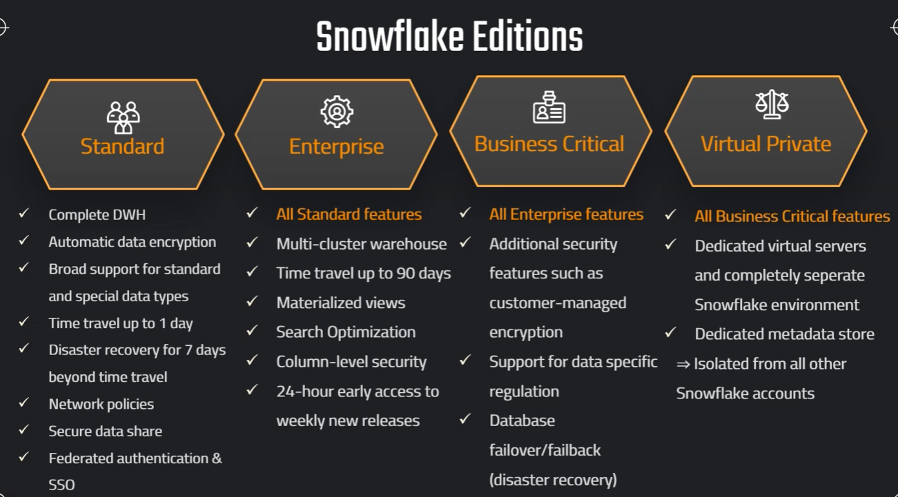

Snowflake Pricing:
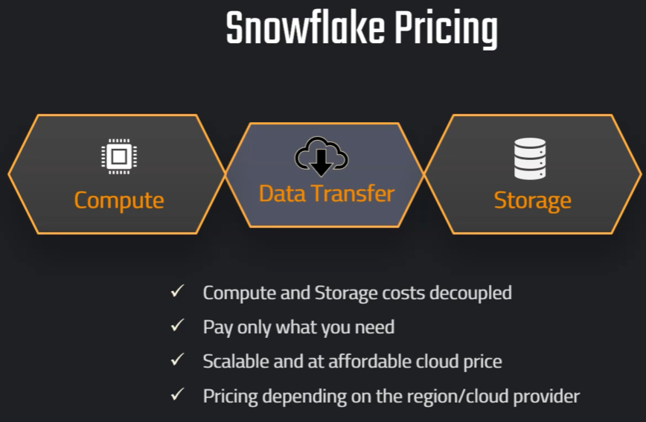
As per pricing, there are two types of blocks.1. Compute 2. Storage
When we need more storage, we can just increase storage, and we don't need to add and pay for additional compute. Snowflake charges for compute and storage with affordable price.
Compute: We are only paying for warehouses that are active. So, the warehouse provides the service with standard cost.
whenever we want to execute a query, we need some compute power, which is coming from the warehouses.
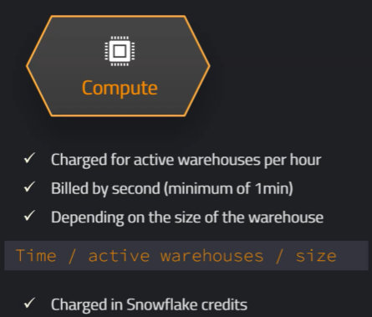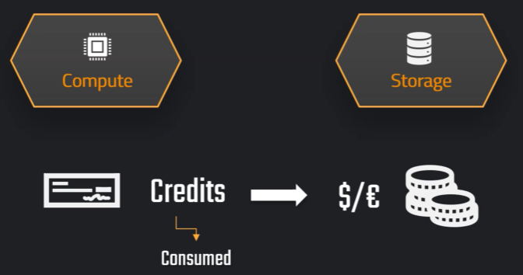
we are charged in the form of credits based on the consumption time and size(Small, X-Small, etc ..) of warehouse.
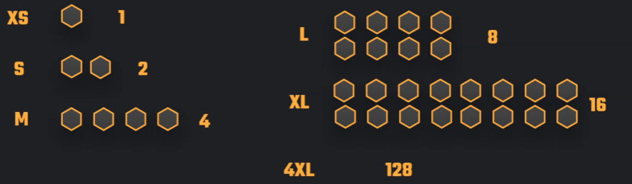
Hexagon are servers.
we have a price per credit depending on which region and which cloud provider our account is based on. So, they have different prices and different regions. For more details, we can go Snowflake Pricing Link.
Storage: Based on the region, the cost will be charged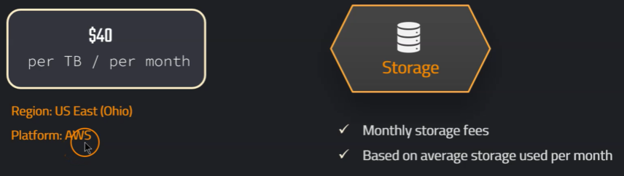
On-Demand Storage: Whatever we have used, we will pay for it.
Capacity Storage: With Assumption. For Ex: Every month we need only 100 GB to work. At a time, we will pay the amount for 100 GB (like Prepaid)
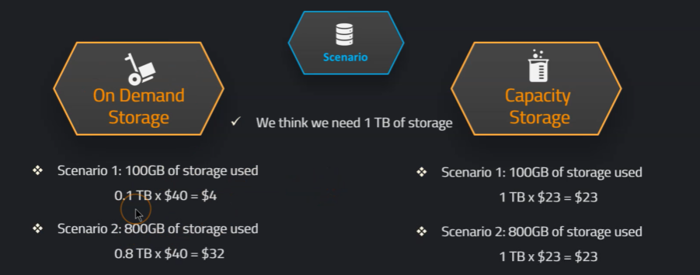
First, we can use On Demand Storage to know how much we are using. Then, we can opt for Capacity Storage. Because we already know how much we will use. For that GB we can pay previously. So that cost will be reduced.(It like Hathway Plan)
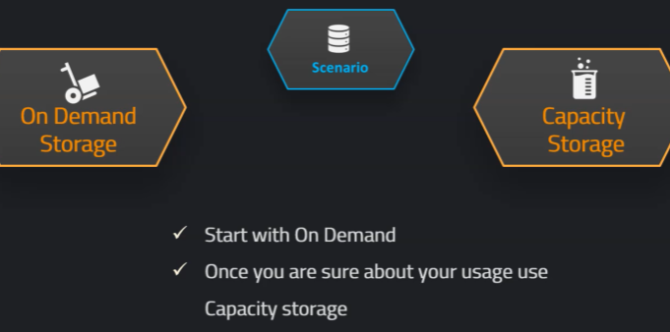
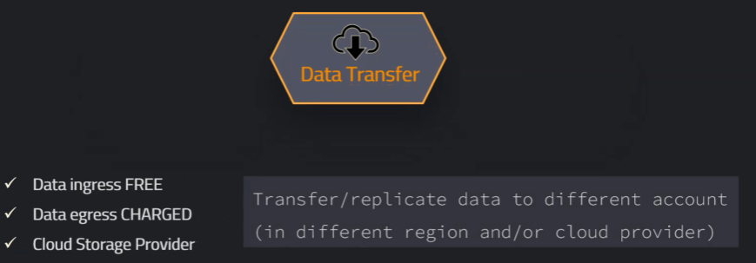

Monitor Usage:
How to monitor the cost? To do this, we need to have the role Account Admin selected, or another role that we have created apart from those default roles, that have sufficient privileges.
Go to Admin Cost Management
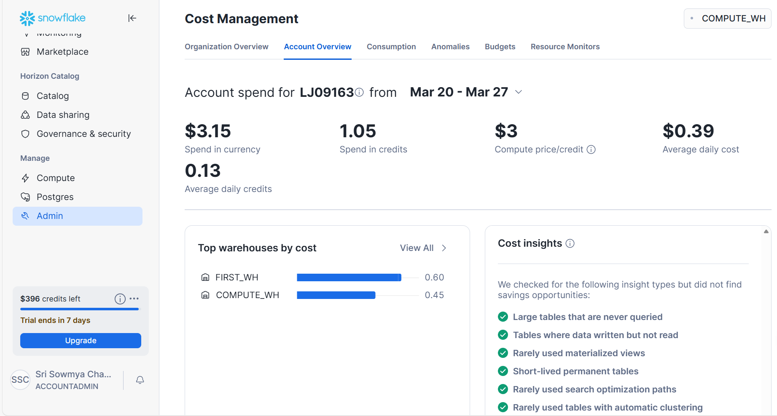
Here we can see, how much currency or credits snowflake was spent for Compute, Storage, Data Transfer for Particular Services (Compute, Storage, Data Transfer).We must keep one database to run Queries for getting all these details.
In Data Transfer, within our account, its not charged. Out of our account, its charged.

Resource Monitors:
The objects used to control and monitor credit usage of warehouses and account.
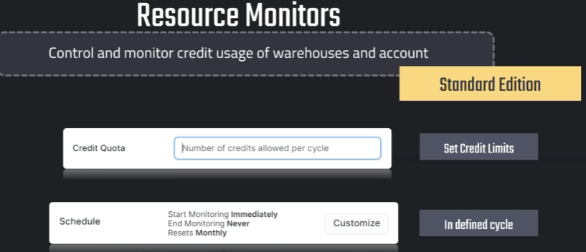
This is like a limit that we can set in a defined cycle. Not only in Standard Edition, but the resource monitors feature is available in all the editions.
Credit Quota: We can set some amount of credits per cycle.
Schedule: We can customize the credits for monthly as per the requirement.
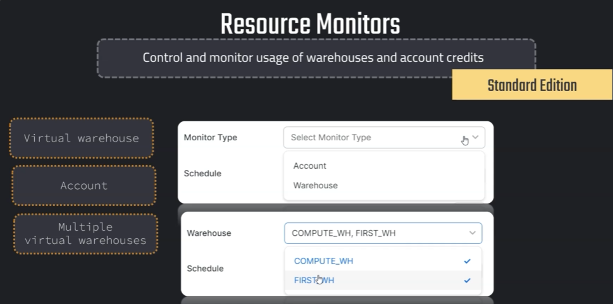
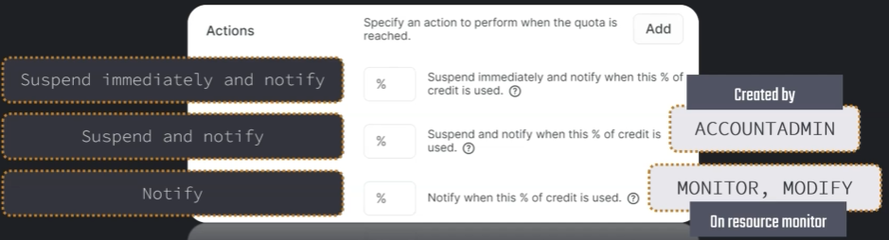
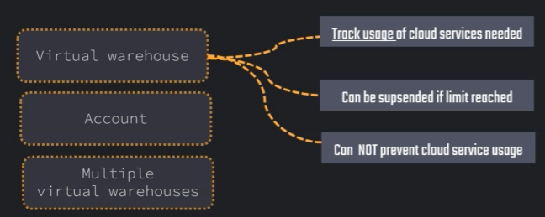

Setting Up Resource Monitors:
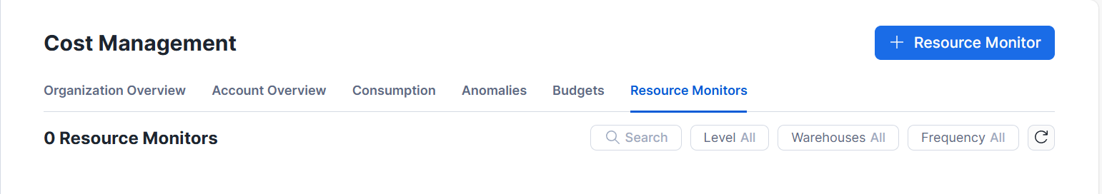
Go to + Resource Monitor 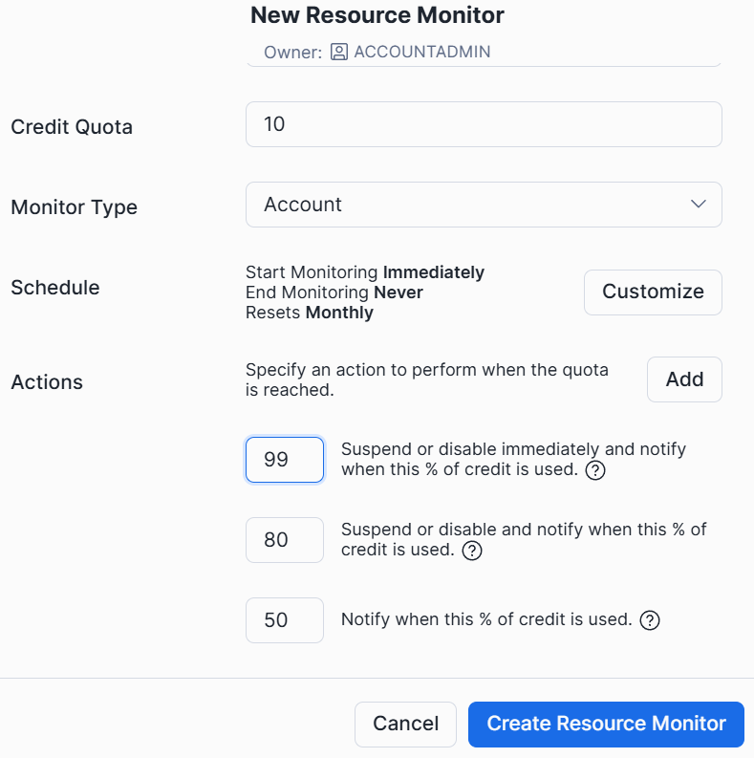
1.Notify when this % of credit is used:We get an Notification when 50 percentage of credits completed.Nothing will be shut down.
2.Suspend or Disable and notify when this % of credit is used: It will complete the current query and stops the execution of remaining Queries before the services suspended or warehouse shutdown and notified that 80% completed.
3.Suspend or Disable immediately and notify when % of credit is used: It stops the execution of current query and remaining Query and notified that 99 % completed.

Roles in Snowflake:
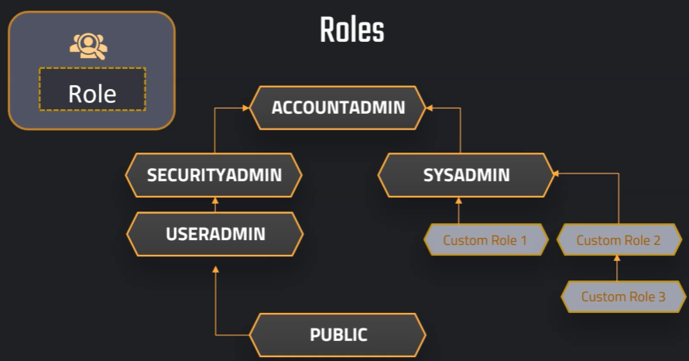
Using Grant, we can permission to the users.

Loading Data

Loading Methods:
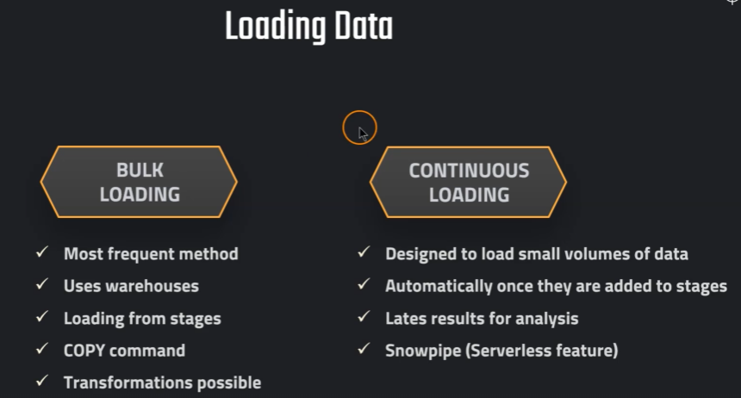
Bulk Loading: This uses the compute power of our warehouses.
For Continuous Loading, Snow pipe is used for data loading.

Understanding Stages:
Where the data can be loaded from.
Regarding the cost, we must consider that if the external stage is in a different region or a different platform that the one that is selected for our account.
For example, let's say we have an AWS account selected for the Snowflake account. So, we use the cloud provider AWS, and we have maybe the region US-East, and then we have now a stage that is associated or that is for a different region or a different cloud provider.
Then, this can occur additional data transfer cost, because we load data from or to another location.
So, here, this can occur of course, In data transfer costs either in the cloud provider or also in our account. So, depending on where we want to get the data out.
For example, if you use an Azure account and you want to load the data from there, then of course you don't pay any incoming data in Snowflake, but you always pay for the outgoing data.
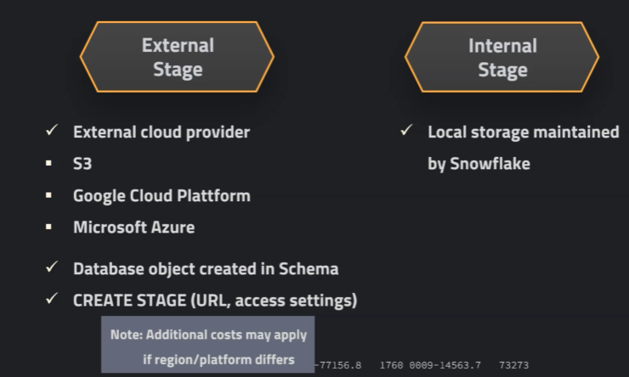
Internal Stage:

Creating Stage:
We can create the worksheets under the folder. For that, we need to create the folder also. First Folder is the name of the folder. Under that folder, SQL file was created.
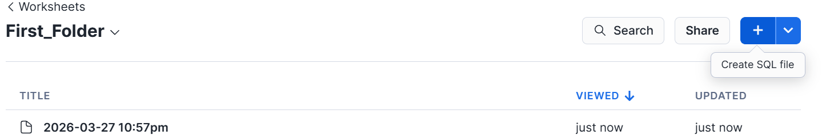
I can rename the file by going to that file.
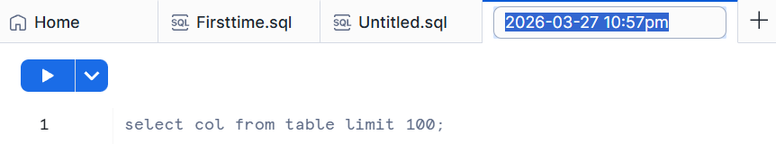
Code for Creating Stage:
// Database to manage stage objects, fileformats etc.
CREATE OR REPLACE DATABASE MANAGE_DB;
CREATE OR REPLACE SCHEMA external_stages;
// Creating external stage
CREATE OR REPLACE STAGE MANAGE_DB.external_stages.aws_stage url='s3://bucketsnowflakes3' credentials=(aws_key_id='ABCD_DUMMY_ID' aws_secret_key='1234abcd_key');
// Description of external stage
DESC STAGE MANAGE_DB.external_stages.aws_stage;
// Alter external stage
ALTER STAGE aws_stage
SET credentials=(aws_key_id='XYZ_DUMMY_ID' aws_secret_key='987xyz');
// Publicly accessible staging area
CREATE OR REPLACE STAGE MANAGE_DB.external_stages.aws_stage
url='s3://bucketsnowflakes3';
// List files in stage
LIST @aws_stage;

//Load data using copy command
COPY INTO OUR_FIRST_DB.PUBLIC.ORDERS FROM @aws_stage
file_format= (type = csv field_delimiter=',' skip_header=1)
pattern='.*Order.*';
Copy Command:
// Creating ORDERS table
CREATE OR REPLACE TABLE OUR_FIRST_DB.PUBLIC.ORDERS (
ORDER_ID VARCHAR(30),
AMOUNT INT,
PROFIT INT,
QUANTITY INT,
CATEGORY VARCHAR(30),
SUBCATEGORY VARCHAR(30));
SELECT * FROM OUR_FIRST_DB.PUBLIC.ORDERS;
// First copy command
COPY INTO OUR_FIRST_DB.PUBLIC.ORDERS
FROM @aws_stage
file_format = (type = csv field_delimiter=',' skip_header=1);
// Copy command with fully qualified stage object
COPY INTO OUR_FIRST_DB.PUBLIC.ORDERS
FROM @MANAGE_DB.external_stages.aws_stage
file_format= (type = csv field_delimiter=',' skip_header=1);
// List files contained in stage
LIST @MANAGE_DB.external_stages.aws_stage;
// Copy command with specified file(s)
COPY INTO OUR_FIRST_DB.PUBLIC.ORDERS
FROM @MANAGE_DB.external_stages.aws_stage
file_format= (type = csv field_delimiter=',' skip_header=1)
files = ('OrderDetails.csv');
// Copy command with pattern for file names
COPY INTO OUR_FIRST_DB.PUBLIC.ORDERS
FROM @MANAGE_DB.external_stages.aws_stage
file_format= (type = csv field_delimiter=',' skip_header=1)
pattern='.*Order.*';
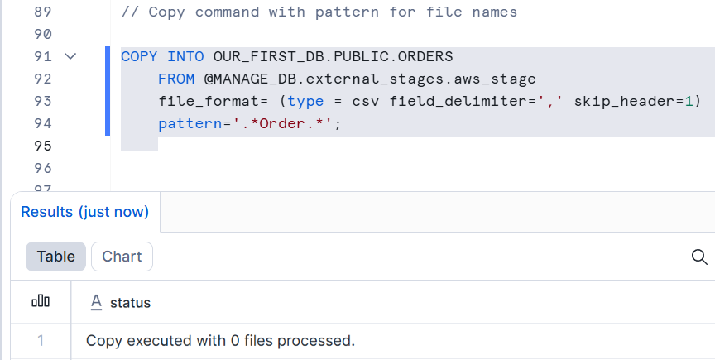
If the data was already there, it won’t insert or copy the data.
Transforming Data:
// Transforming using the SELECT statement
COPY INTO OUR_FIRST_DB.PUBLIC.ORDERS_EX
FROM (select s.$1, s.$2 from @MANAGE_DB.external_stages.aws_stage s)
file_format= (type = csv field_delimiter=',' skip_header=1)
files=('OrderDetails.csv');
// Example 1 - Table
CREATE OR REPLACE TABLE OUR_FIRST_DB.PUBLIC.ORDERS_EX (
ORDER_ID VARCHAR(30),
AMOUNT INT
);
SELECT * FROM OUR_FIRST_DB.PUBLIC.ORDERS_EX;

// Example 2 - Table
CREATE OR REPLACE TABLE OUR_FIRST_DB.PUBLIC.ORDERS_EX (
ORDER_ID VARCHAR(30),
AMOUNT INT,
PROFIT INT,
PROFITABLE_FLAG VARCHAR(30));
// Example 2 - Copy Command using a SQL function (subset of functions available)
COPY INTO OUR_FIRST_DB.PUBLIC.ORDERS_EX
FROM (select
s.$1,
s.$2,
s.$3,
CASE WHEN CAST(s.$3 as int) < 0 THEN 'not profitable' ELSE 'profitable' END
from @MANAGE_DB.external_stages.aws_stage s)
file_format= (type = csv field_delimiter=',' skip_header=1)
files=('OrderDetails.csv');
SELECT * FROM OUR_FIRST_DB.PUBLIC.ORDERS_EX;
// Example 3 - Table
CREATE OR REPLACE TABLE OUR_FIRST_DB.PUBLIC.ORDERS_EX (
ORDER_ID VARCHAR(30),
AMOUNT INT,
PROFIT INT,
CATEGORY_SUBSTRING VARCHAR(5) );
// Example 3 - Copy Command using a SQL function (subset of functions available)
COPY INTO OUR_FIRST_DB.PUBLIC.ORDERS_EX
FROM (select
s.$1,
s.$2,
s.$3,
substring(s.$5,1,5)
from @MANAGE_DB.external_stages.aws_stage s)
file_format= (type = csv field_delimiter=',' skip_header=1)
files=('OrderDetails.csv');
SELECT * FROM OUR_FIRST_DB.PUBLIC.ORDERS_EX;
Additional Transformations:
//Example 3 - Table
CREATE OR REPLACE TABLE OUR_FIRST_DB.PUBLIC.ORDERS_EX (
ORDER_ID VARCHAR(30),
AMOUNT INT,
PROFIT INT,
PROFITABLE_FLAG VARCHAR(30) );
//Example 4 - Using subset of columns
COPY INTO OUR_FIRST_DB.PUBLIC.ORDERS_EX (ORDER_ID,PROFIT)
FROM (select
s.$1,
s.$3
from @MANAGE_DB.external_stages.aws_stage s)
file_format= (type = csv field_delimiter=',' skip_header=1)
files=('OrderDetails.csv');
SELECT * FROM OUR_FIRST_DB.PUBLIC.ORDERS_EX;
//Example 5 - Table Auto increment
CREATE OR REPLACE TABLE OUR_FIRST_DB.PUBLIC.ORDERS_EX (
ORDER_ID number autoincrement start 1 increment 1,
AMOUNT INT,
PROFIT INT,PROFITABLE_FLAG VARCHAR(30));
//Example 5 - Auto increment ID
COPY INTO OUR_FIRST_DB.PUBLIC.ORDERS_EX (PROFIT,AMOUNT)
FROM (select
s.$2,
s.$3
from @MANAGE_DB.external_stages.aws_stage s)
file_format= (type = csv field_delimiter=',' skip_header=1)
files=('OrderDetails.csv');
SELECT * FROM OUR_FIRST_DB.PUBLIC.ORDERS_EX WHERE ORDER_ID > 15;
DROP TABLE OUR_FIRST_DB.PUBLIC.ORDERS_EX;

