Hierarchical Structure of Jira
Terminologies and Work-Item Hierarchy

1. Introduction
Jira is a work management and issue-tracking tool developed by Atlassian. It helps teams plan, assign, track and manage work throughout a project.
In Jira, work is not kept in one flat list. A large piece of work is broken down into smaller pieces, and each piece is recorded as an issue. Issues are placed at different levels, so that a bigger item can contain the smaller items that help complete it. This arrangement is called the hierarchical structure of Jira.
This document first explains the terms needed to understand the hierarchy, and then explains the hierarchy itself with a diagram and an example.

2. Terminologies
Project / Space: A project (also called a space in some Jira versions) is used to organise related work. It is the place where issues are created, assigned and tracked, and it has its own settings, permissions and workflows.
Example: A Banking Application project can hold issues for login, payments and account management.
Issue: An individual piece of work tracked in Jira. It can be a requirement, a task, a bug or another type of work. Recent Jira versions call it a work item; this document uses the word issue.
Example: "Fix login validation error" is an issue.
Issue Key: A unique identifier given to every issue. It is made of the project key and a number.
Example: BANK-101
Issue Type: The category of an issue. It decides what kind of work the issue represents. The common types are Epic, Story, Task, Bug and Sub-task.
Example: BANK-101 is of the type Bug.
Epic: A large body of work that can be divided into smaller, related issues. It is used to organise and track a major feature.
Example: User Authentication, which includes login, registration and password reset.
Story: A requirement written from the user's point of view, saying what the user wants and why.
Example: As a customer, I want to reset my password so that I can regain access to my account.
Task: A specific piece of work that needs to be completed. It can be assigned to a team member and tracked.
Example: Prepare test data for the login module.
Bug: A defect or unexpected behaviour in the application, usually found when the actual result differs from the expected result.
Example: The application allows login with an incorrect password.
Sub-task: A smaller unit of work created under a parent issue to divide the work into manageable activities. It can be assigned and tracked separately.
Example: Under the task "Test the Login Page": test valid credentials and test invalid credentials.
Parent and Child Issue: A parent issue is one that contains other issues, and the issues inside it are its children. This parent-child relationship is what creates the hierarchy.
Example: An Epic is the parent of the Stories and Tasks placed under it.

3. Hierarchical Structure of Jira

3.1 Overview
The standard Jira hierarchy has the following levels:
Project → Epic → Story / Task / Bug → Sub-task
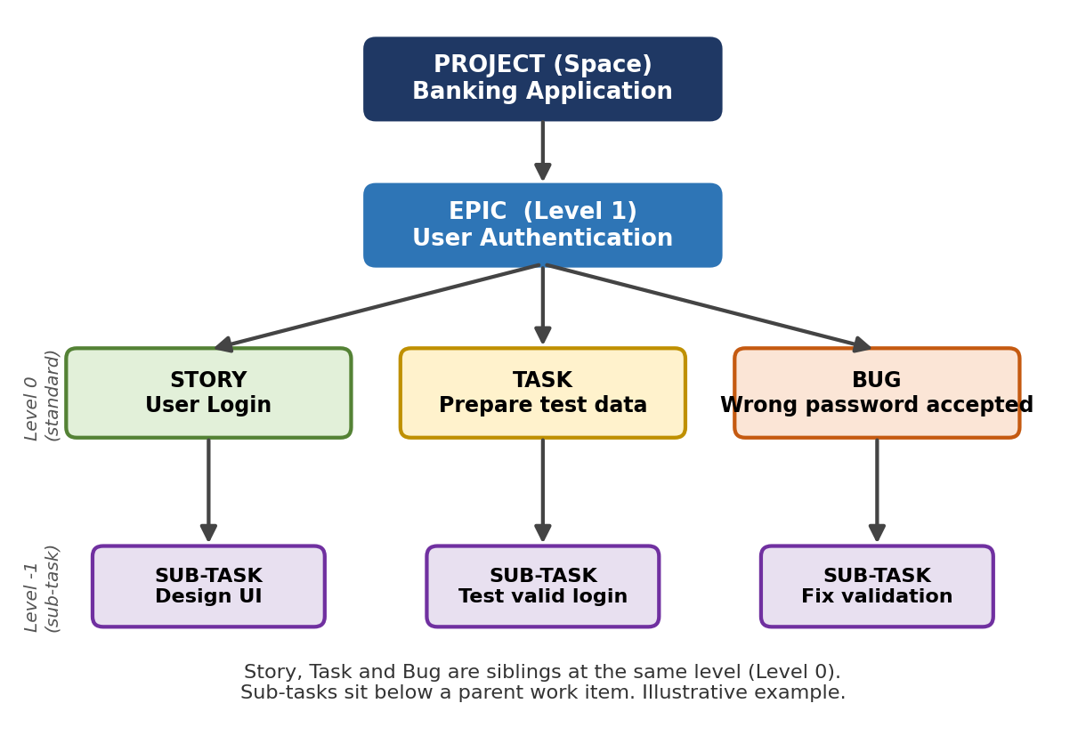
Figure 1: Standard Jira hierarchy
The Project is the container for all the work. An Epic sits inside the project. Story, Task and Bug are placed side by side under an Epic, because they are at the same level. Sub-tasks are placed below one of these items.

3.2 Levels of the Hierarchy
Level | Item | What it represents
Container | Project | The home of all related work
Level 1 | Epic | A large feature or goal made of many smaller items
Level 0 | Story, Task, Bug | A normal unit of work
Level -1 | Sub-task | A small step of a parent Story, Task or Bug

3.3 Each Level Explained
Project. It holds every Epic, Story, Task, Bug and Sub-task of a piece of software or a team. Every issue belongs to exactly one project. Example: the Banking Application project with the key BANK.
Epic. It groups related work that is too big to finish in one go. Stories, Tasks and Bugs are attached to it, so the progress of the whole feature can be seen in one place. Example: BANK-1, User Authentication.
Story, Task and Bug. These are the everyday units of work and sit at the same level under an Epic. A Story describes what the user needs, a Task is a piece of work to be done, and a Bug is a defect to be fixed. Example: BANK-2 (Story) User Login, BANK-3 (Task) Design the login page, BANK-6 (Bug) Wrong password is accepted.
Sub-task. It breaks a Story, Task or Bug into smaller steps that can be given to different people. A Sub-task always has a parent and cannot have Sub-tasks of its own. Example: under BANK-4 "Implement authentication" there can be the Sub-tasks "Code password validation" and "Write unit tests".

3.4 Important Points
- Story, Task and Bug are not in a parent-child chain with each other. They are normally at the same level, so a Task is not created under a Story. To show that two of them are related, use a Sub-task, keep both under the same Epic, or connect them with an issue link.
- Issue links are not hierarchy. Links such as "blocks" or "relates to" show a connection between issues, but they do not place one issue below another.
- Sub-tasks are the lowest level. A Sub-task cannot contain further Sub-tasks.
- Hierarchies can differ. Higher Jira plans allow extra levels above Epic, such as Initiative. The levels available depend on the Jira plan and project configuration.

3.5 Example
The example below uses a banking application. The issue keys are only for illustration and are not real Jira records.
Key | Issue type | Summary | Placed under
BANK | Project | Banking Application | -
BANK-1 | Epic | User Authentication | Project
BANK-2 | Story | As a user, I want to log in securely | BANK-1
BANK-3 | Task | Design the login page | BANK-1
BANK-4 | Task | Implement authentication | BANK-1
BANK-7 | Sub-task | Code password validation | BANK-4
BANK-8 | Sub-task | Write unit tests | BANK-4
BANK-6 | Bug | Application allows login with an incorrect password | BANK-1
BANK-9 | Sub-task | Fix password validation | BANK-6

Here BANK-2, BANK-3, BANK-4 and BANK-6 are at the same level under the Epic BANK-1, and the Sub-tasks sit below the Task and the Bug they belong to.

4. Conclusion
The Jira hierarchy organises work in layers: a Project contains Epics, an Epic contains Stories, Tasks and Bugs, and these can be divided into Sub-tasks. Knowing which level an item belongs to makes it easier to plan, assign and track work, and to see how small pieces of work add up to a complete feature.

