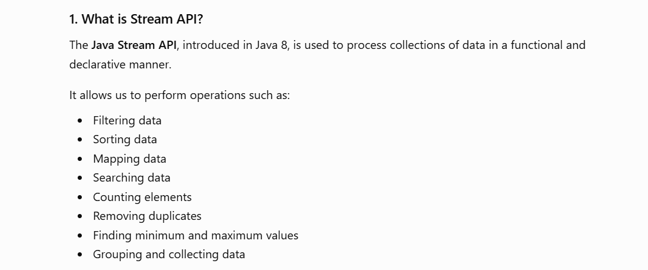
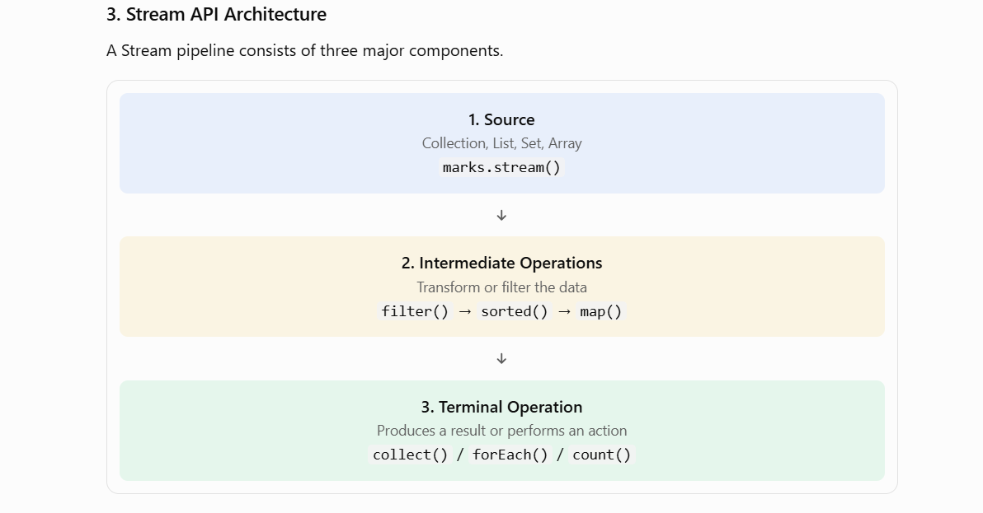

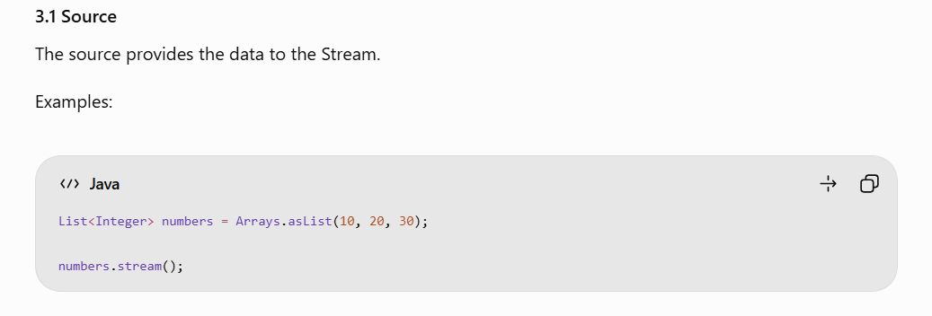
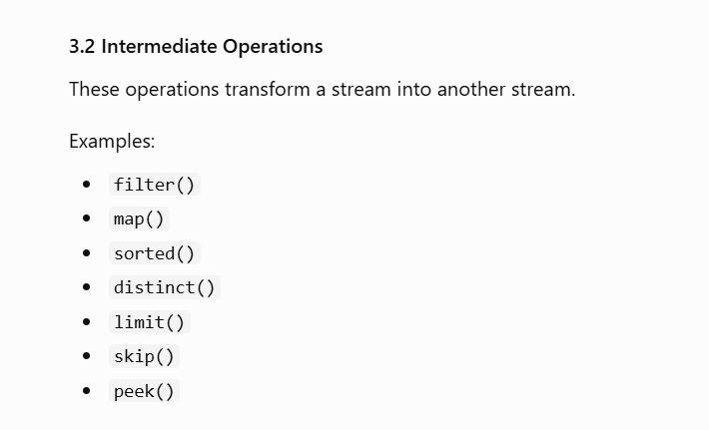
Intermediate Operations generate another stream.
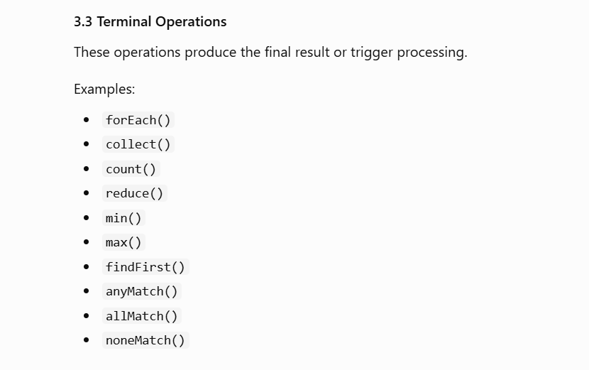

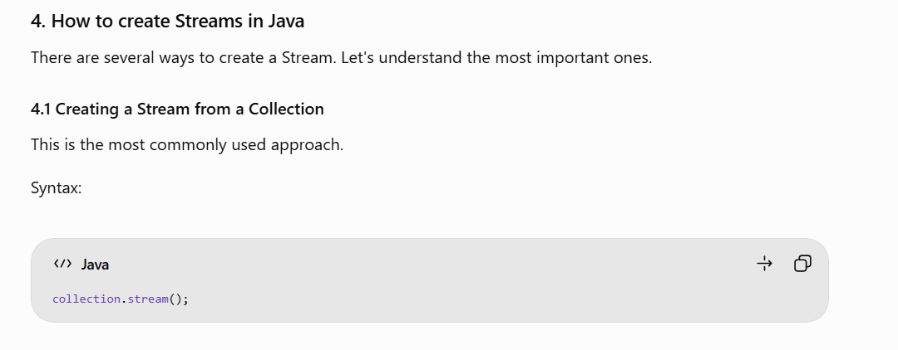
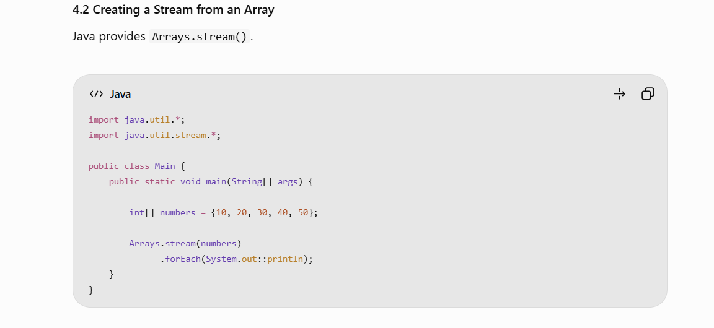
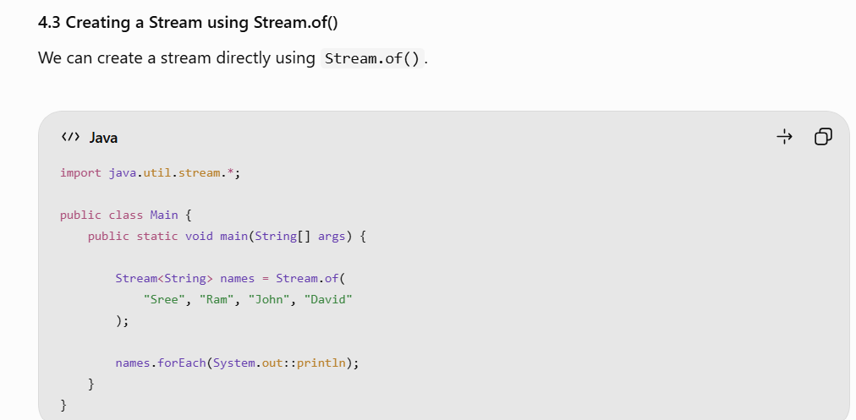
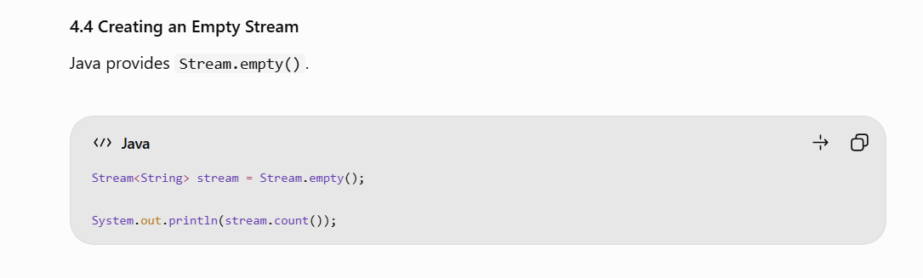
Output : - 0
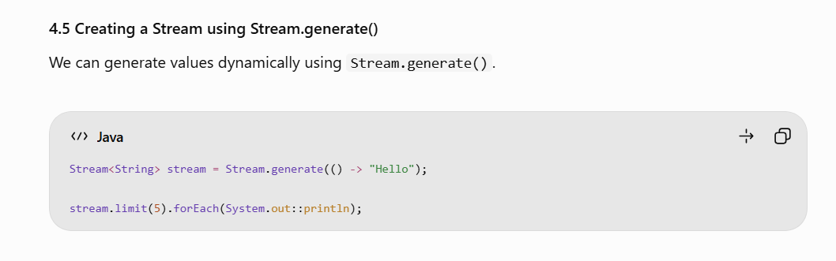
Output : - print hello (5 times )
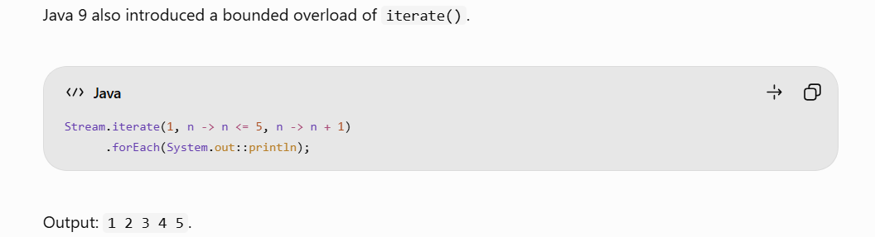

The terminal operation triggers execution.
The Intermediate Operations are lazy . they do not execute until a terminal operation is invoked.
A consumed stream cannot be reused.
Streams can be created from collections, arrays and generated values.
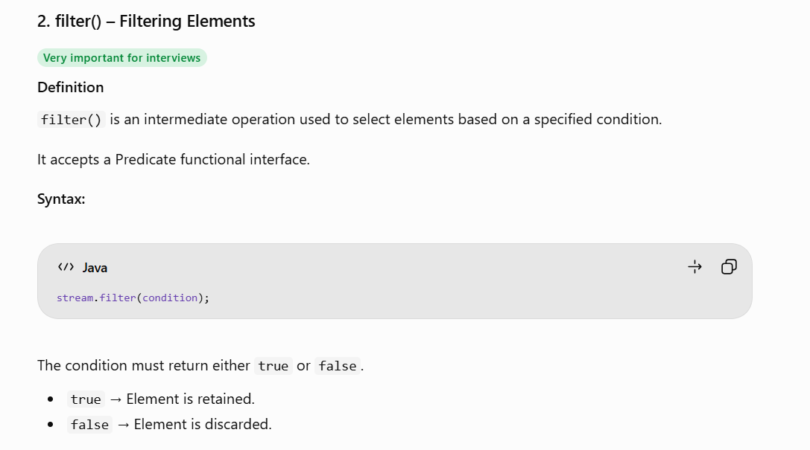
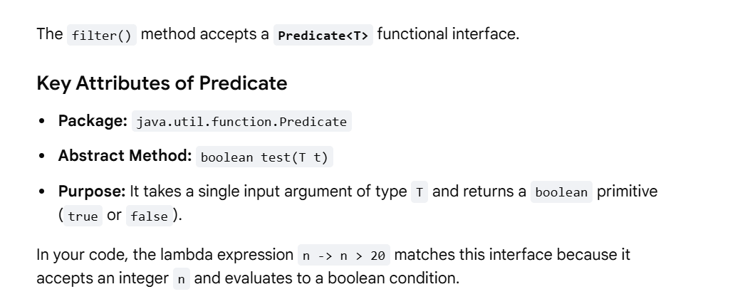

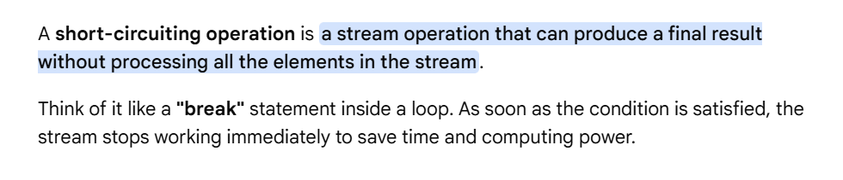
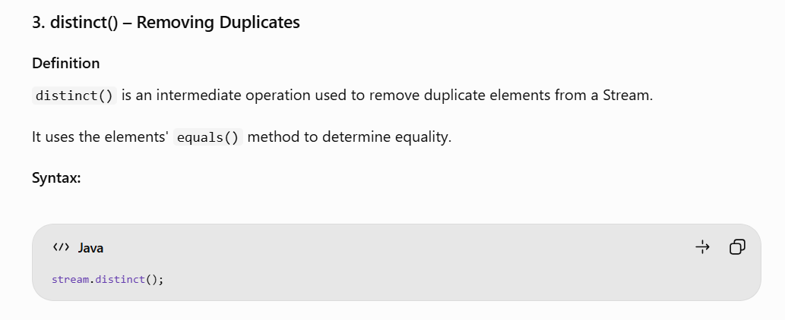

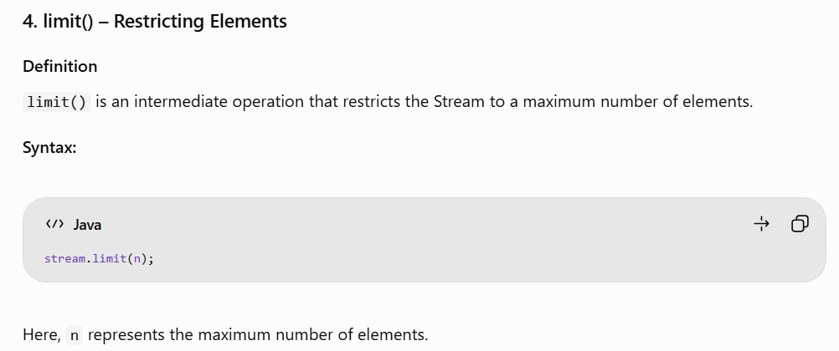

Limit() is the only intermediate short circuiting operation. And all the terminal operations come under short circuiting operations .

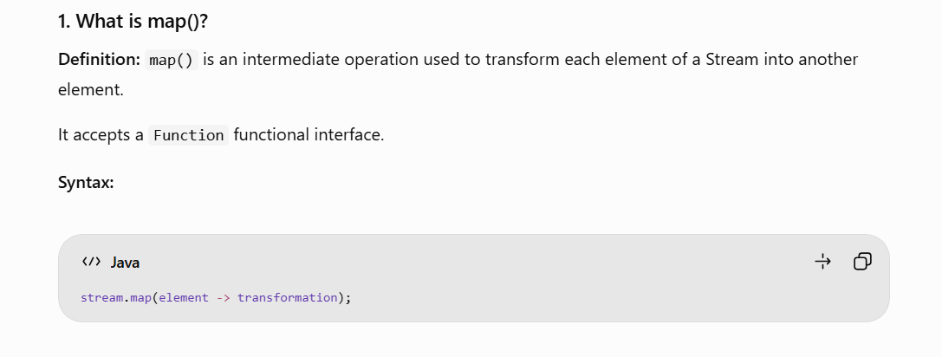
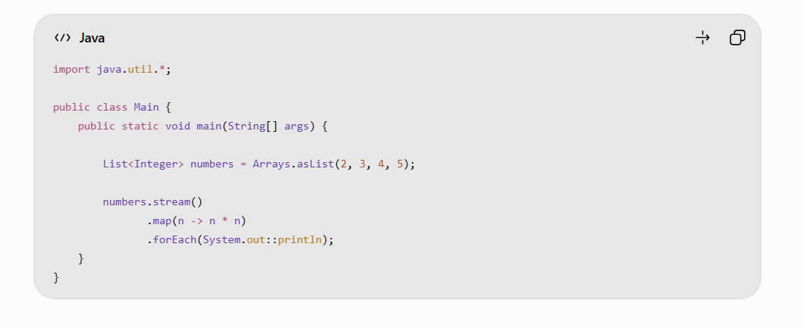
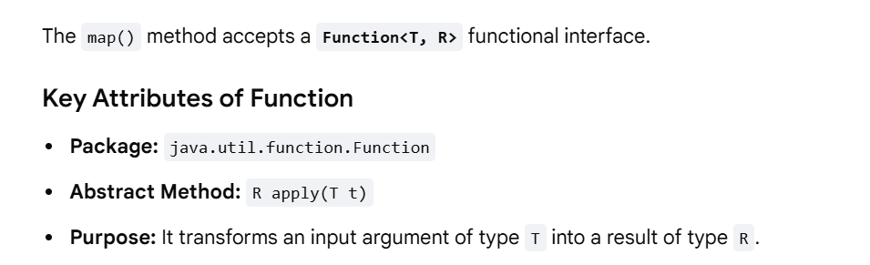
Understand the generic types:
- T = Input type.
- R = Return type.

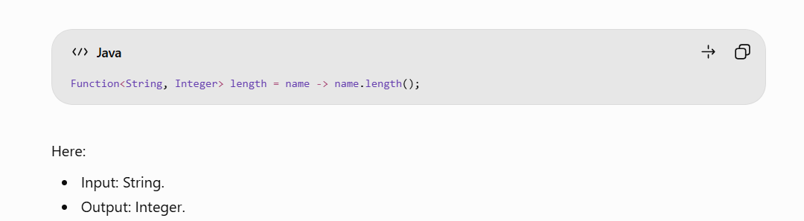
map() can change the element type.
map() is stateless, it is highly efficient and safe to use in parallel streams(Will Discuss later).
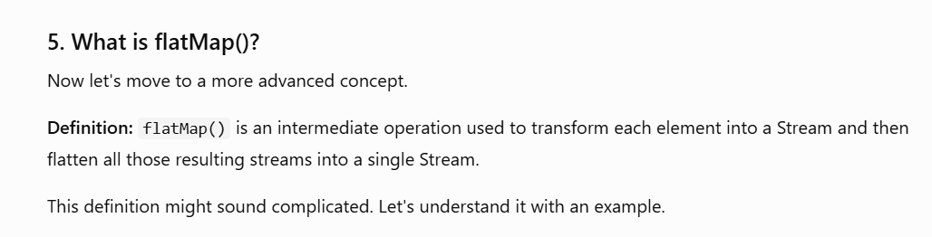
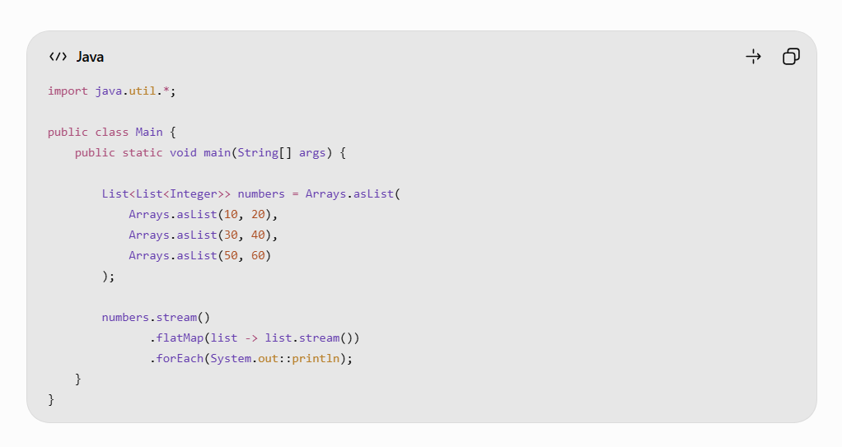
Output : 10 20 30 40 50 (in new Lines)

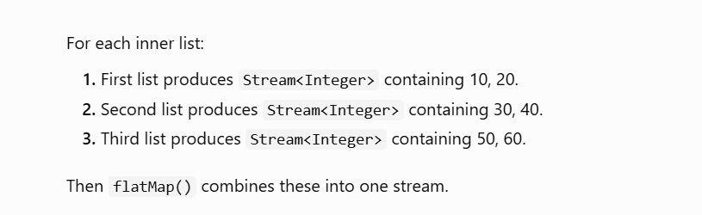
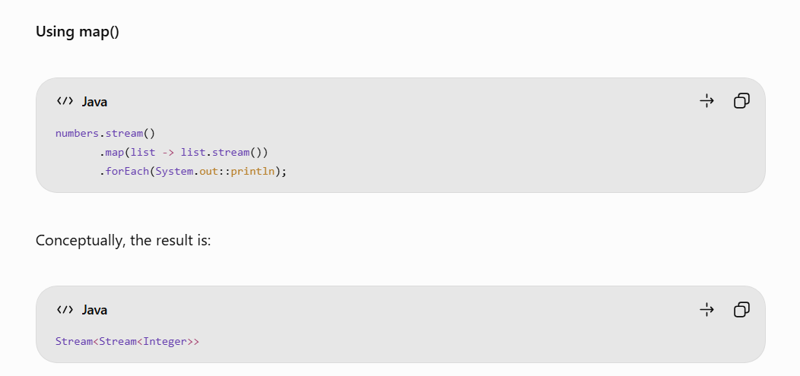
Using FlatMap() :-
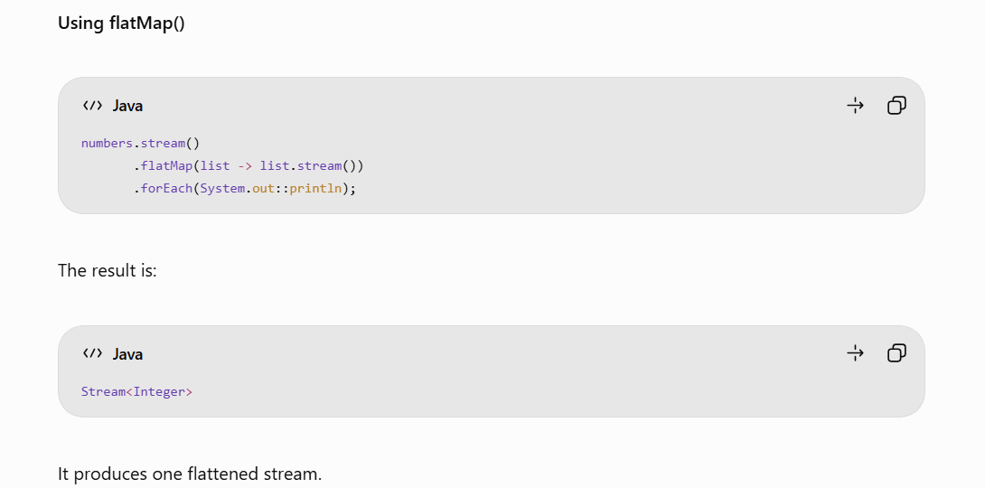
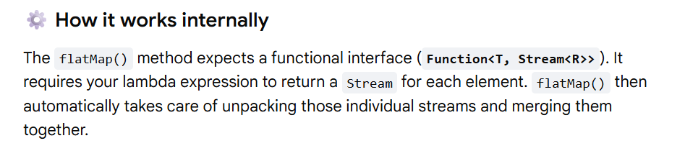
What is flattening?
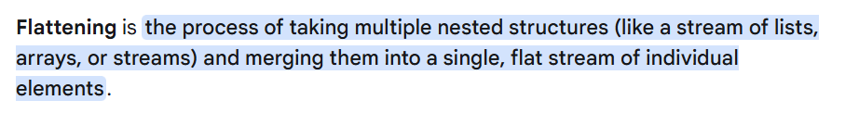
Can map() change the data type?
Yes we can change the data type as we use Function functional interface which can change the
data type -- Function<T, R> functional interface ,Abstract Method: R apply(T t) .
------------------------------------------------------------------------------------------------------------------------------
Sorted() – Intermediate Operation
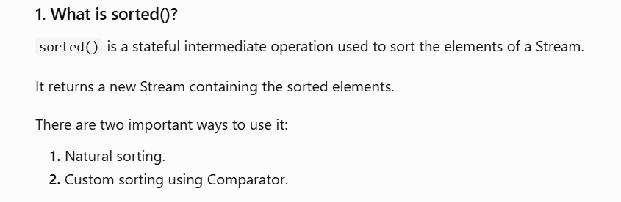
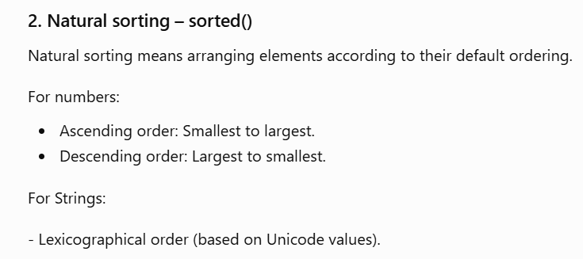
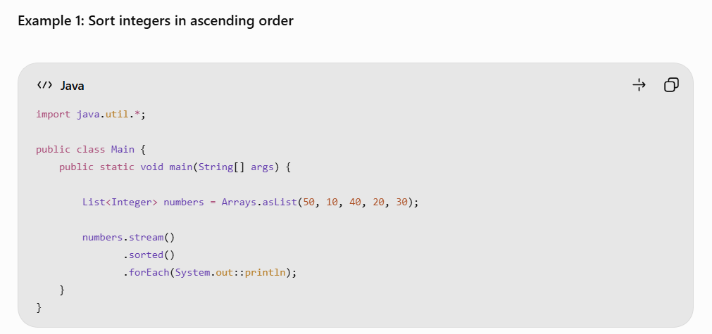
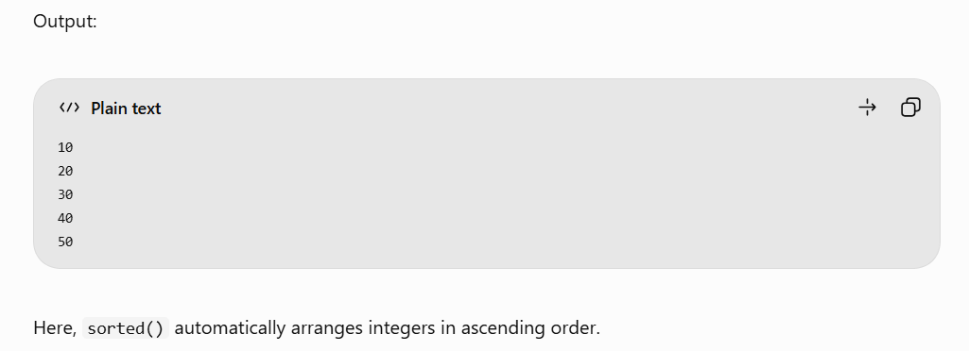
Descending order – Comparator.reverseOrder()

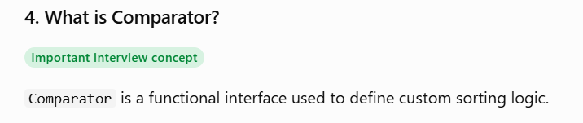
It belongs to: java.util.Comparator
Its important abstract method is: int compare(T o1, T o2);
It compares two objects and returns:
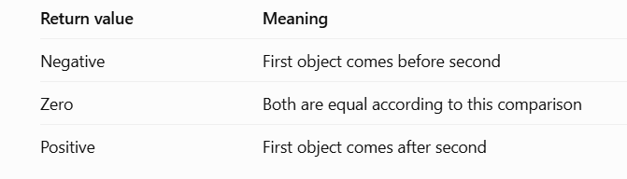
Comparator<Integer> comp = (a, b) -> b - a;
This defines descending numerical ordering for ordinary values, though Comparator.reverseOrder() is safer because subtraction can overflow

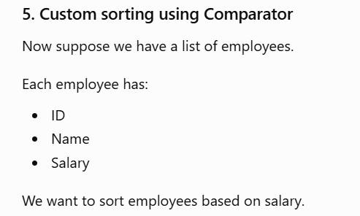
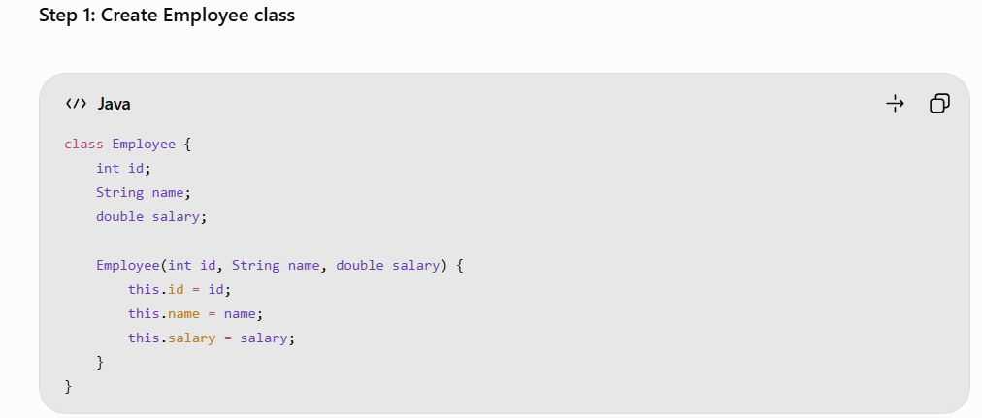
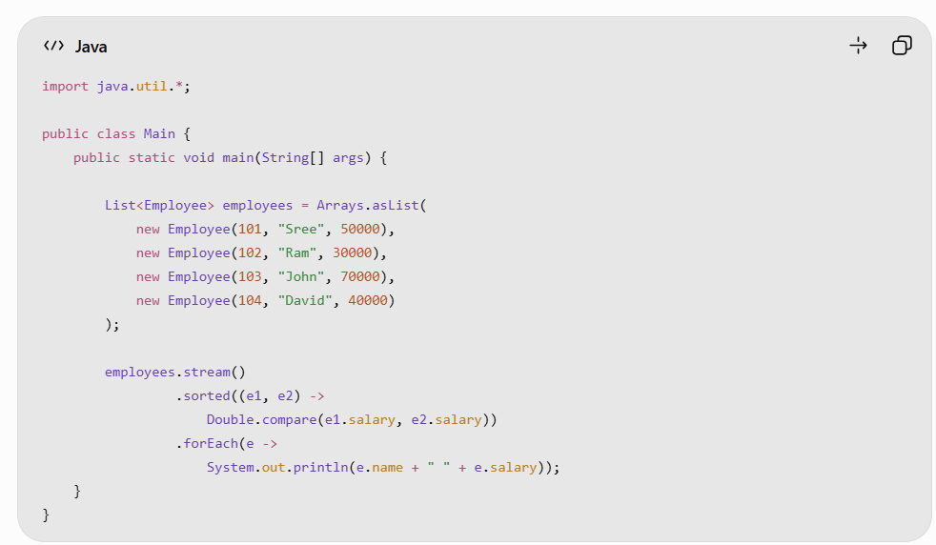

6. Comparator.comparing() :
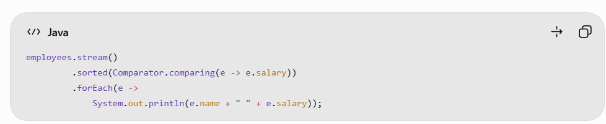
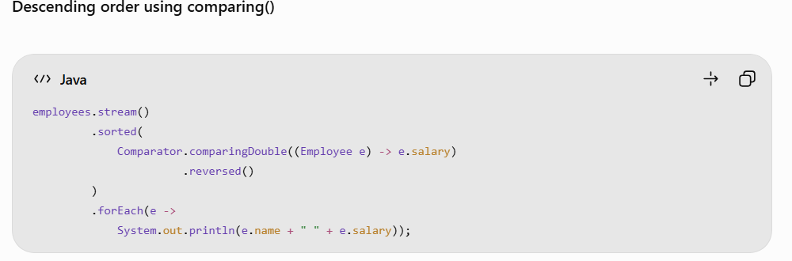

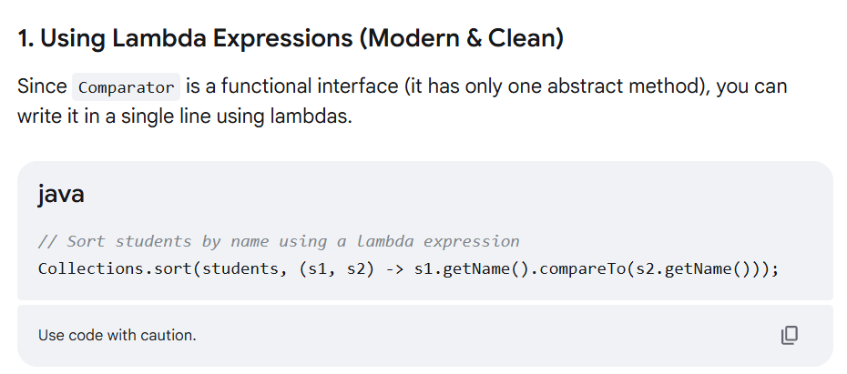
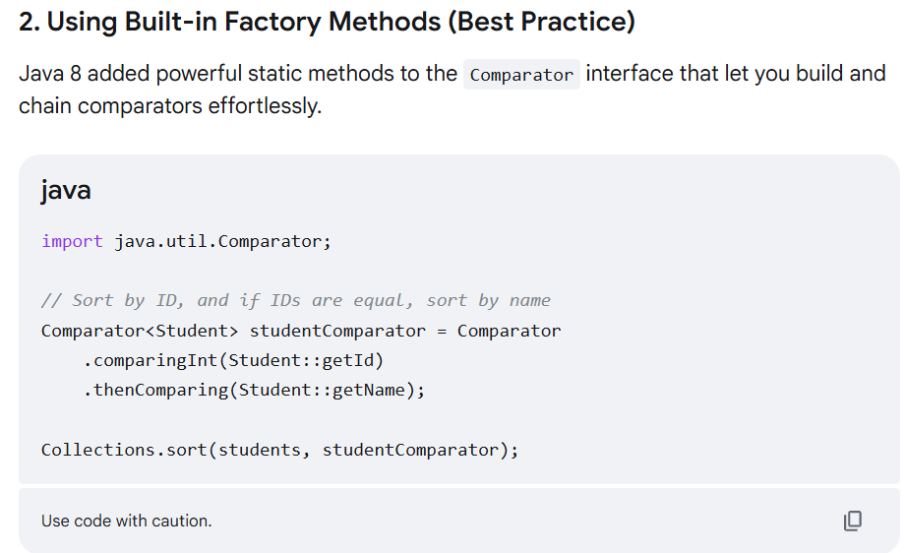

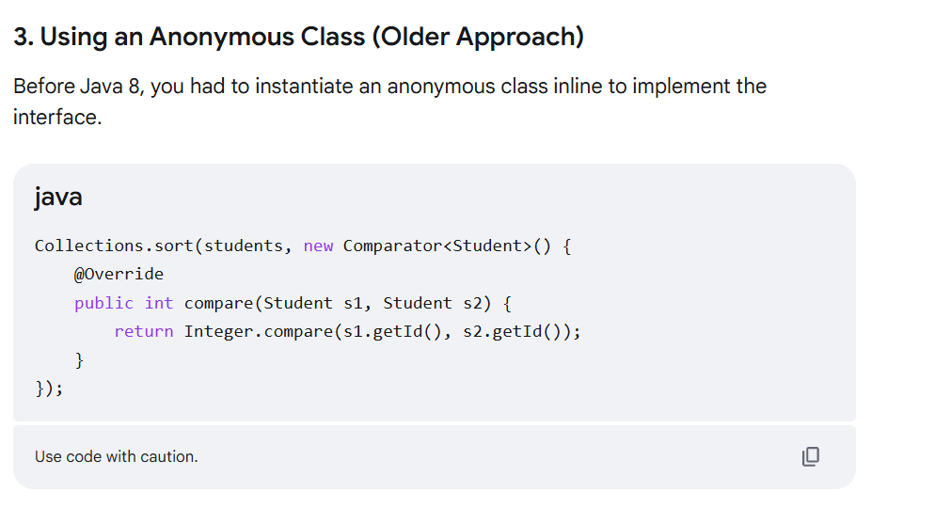

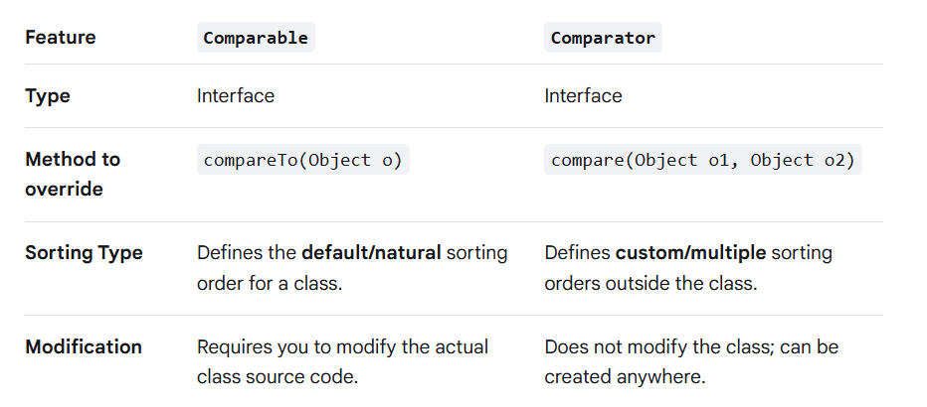

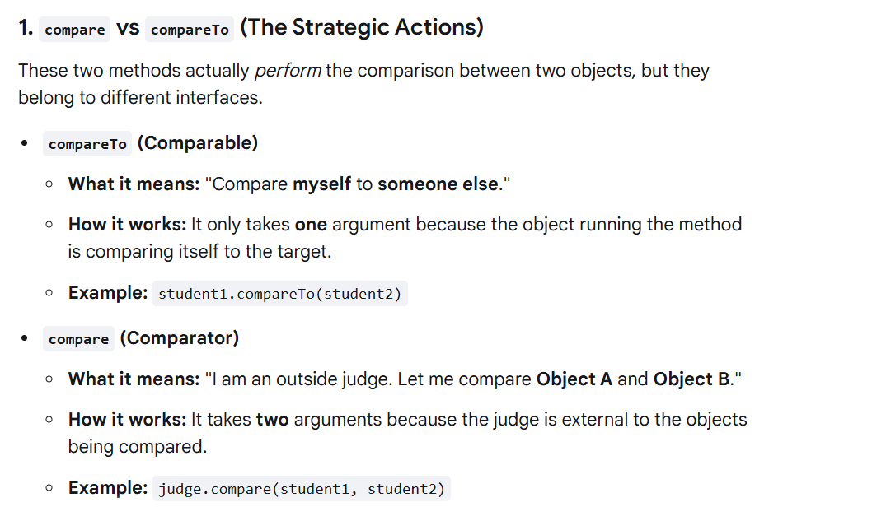
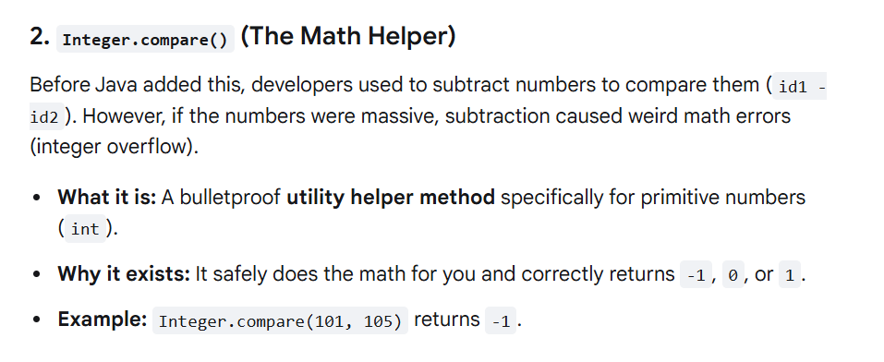
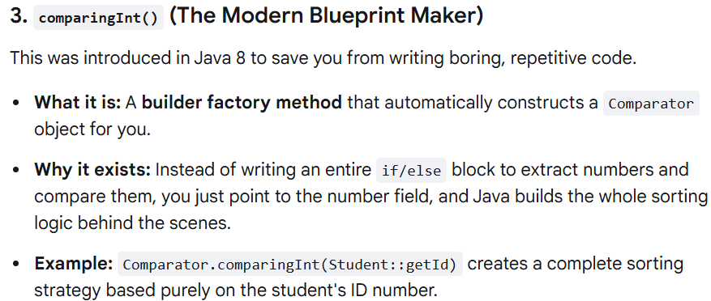
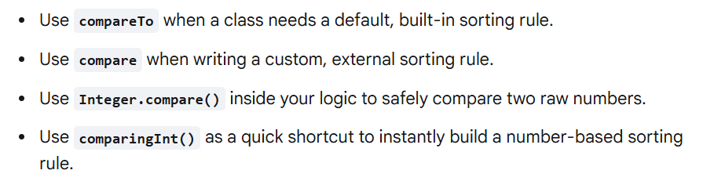

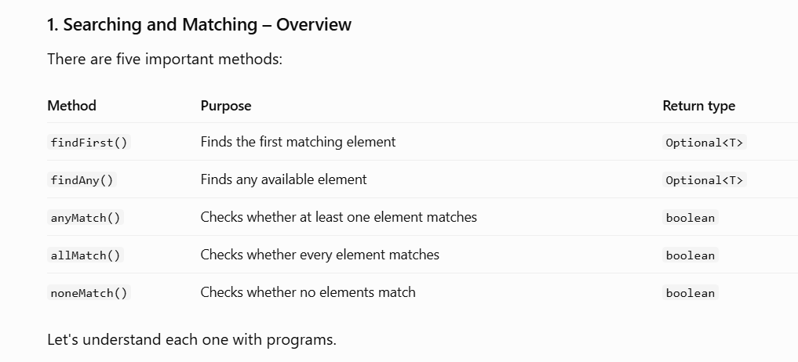

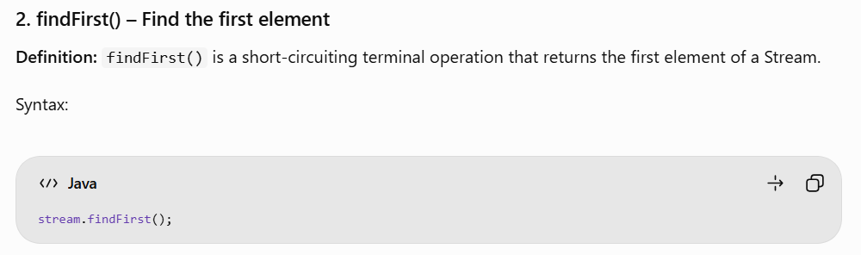

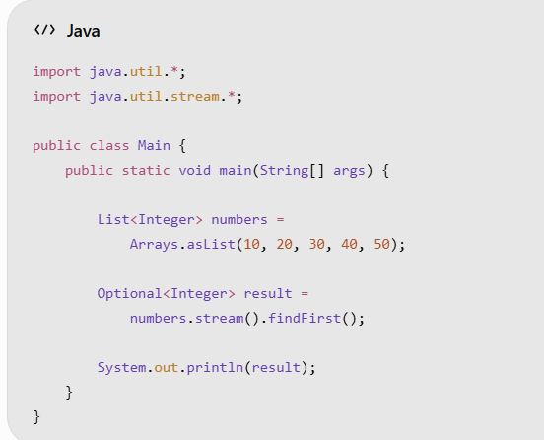
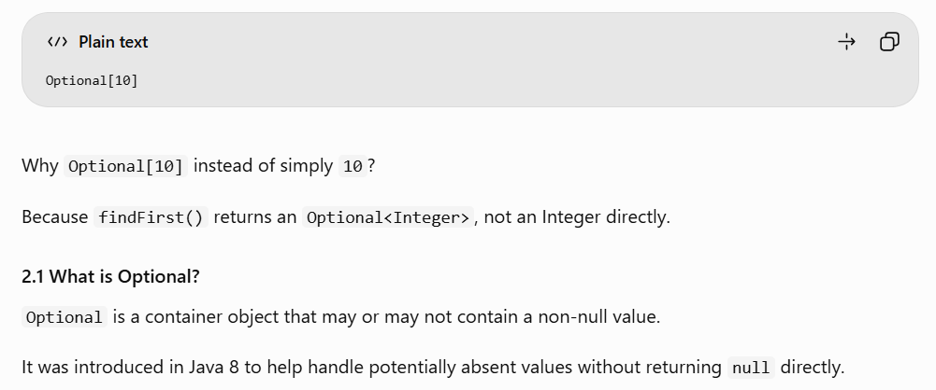
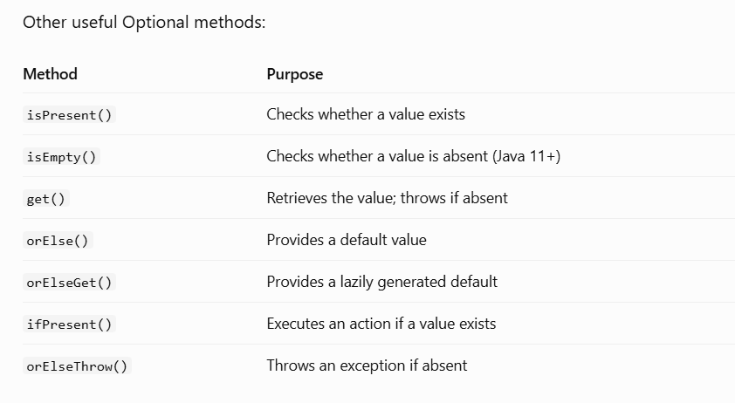

AGGREGATION OPERATIONS :
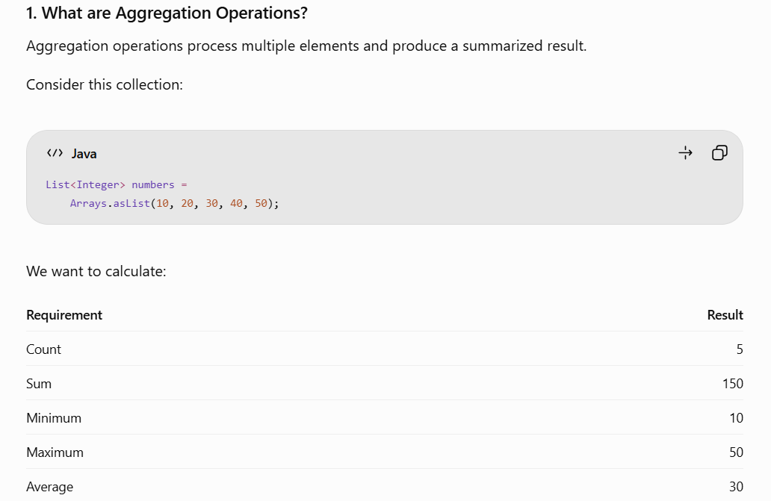

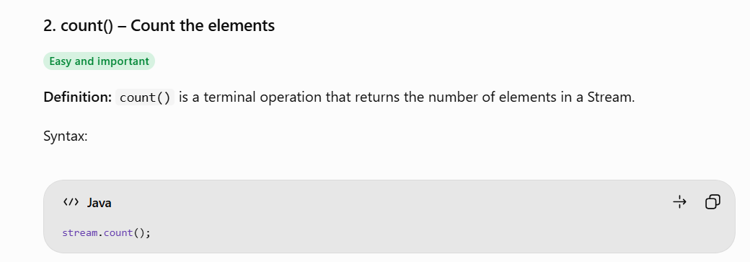
The count will return the long datatype.
long result = numbers.stream().count();
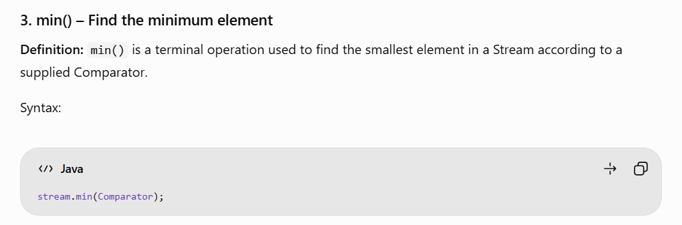

Optional<Integer> result = numbers.stream().min(Comparator.naturalOrder());
Why does it return Optional?
Because the Stream might be empty. In that case, there is no minimum value.
We can safely retrieve the result:
System.out.println(result.orElse(-1));
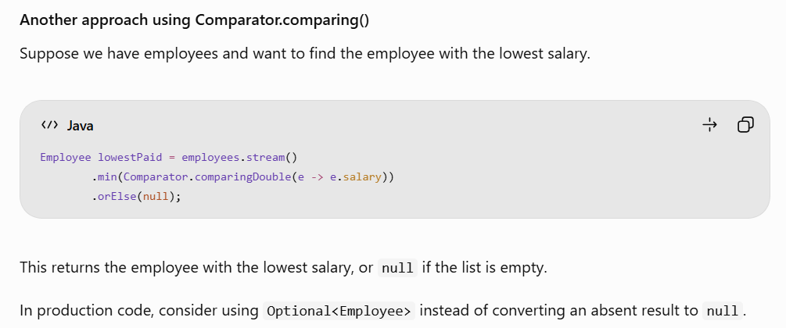
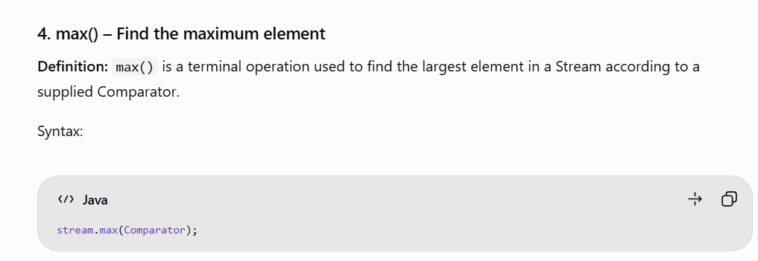

Optional<Integer> result = numbers.stream().max(Comparator.naturalOrder());
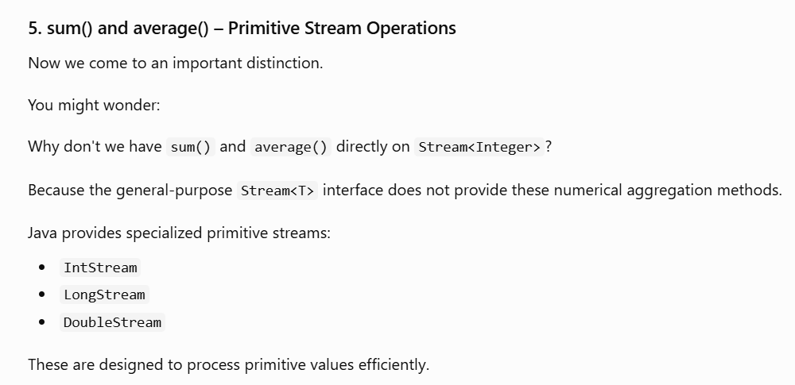

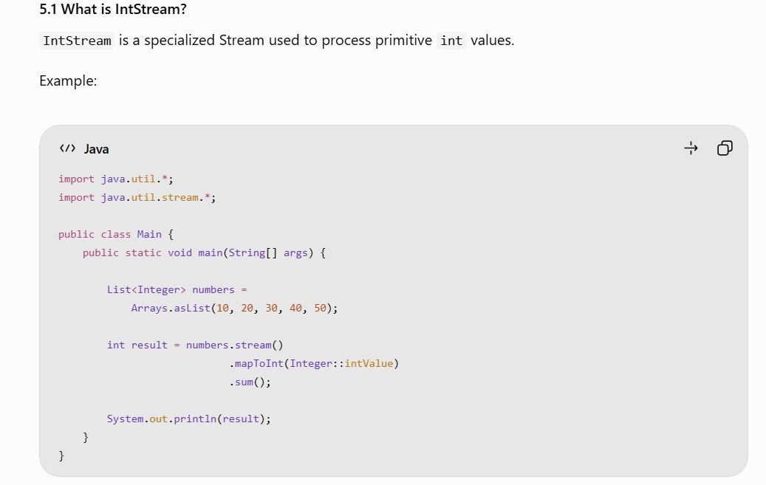
Output:
150
.mapToInt(Integer::intValue) - This converts Stream<Integer> -- > IntStream.
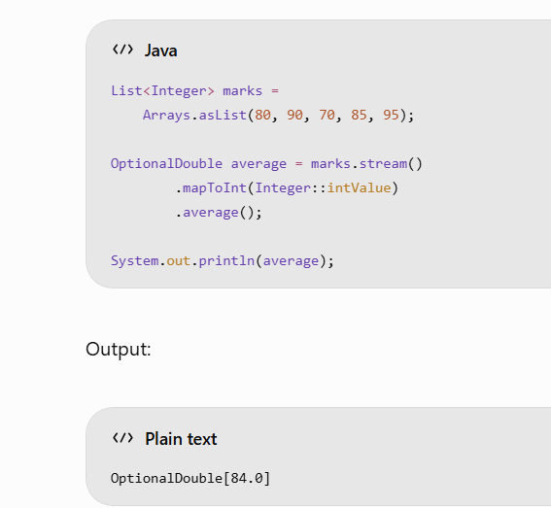
Why OptionalDouble?
Because an empty stream has no average.

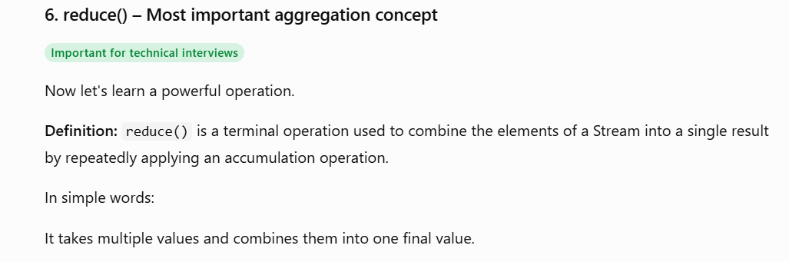
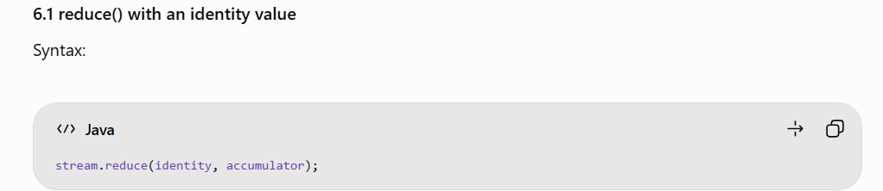
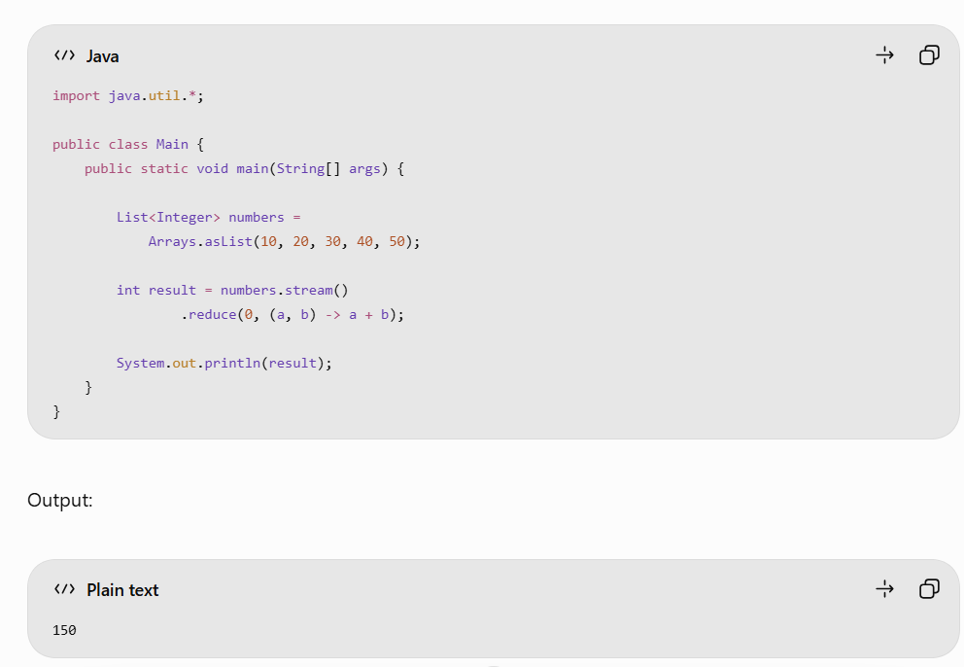
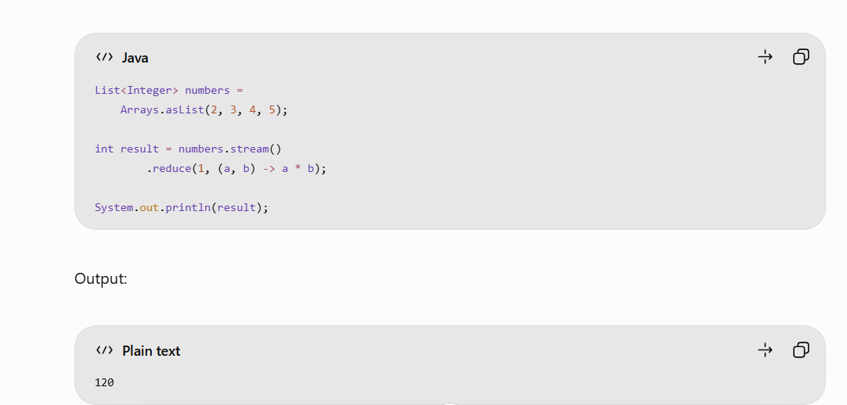

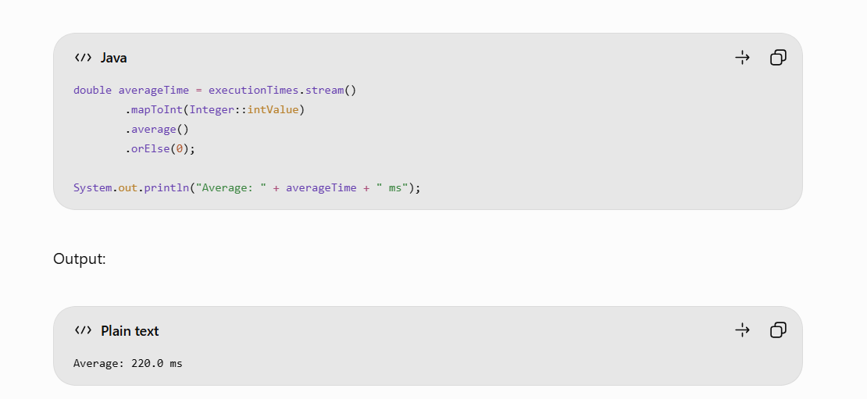

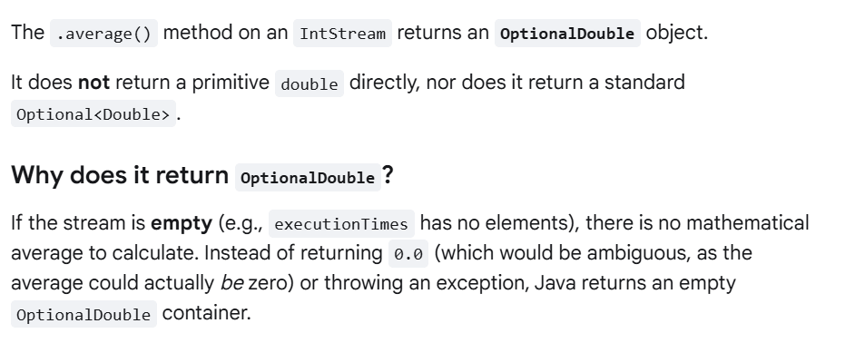
What does count() return?
A) long
What is accumulator?
A)Function that combines the current result with the next element

Collect :
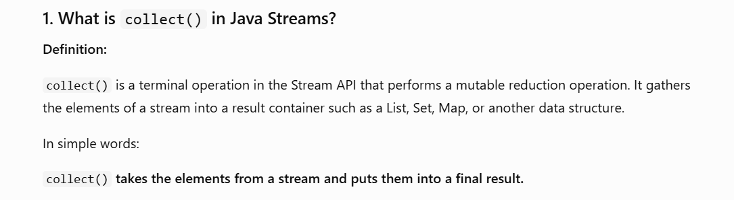
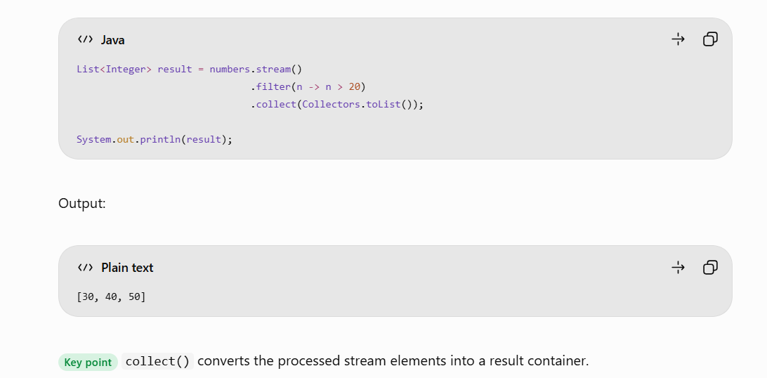
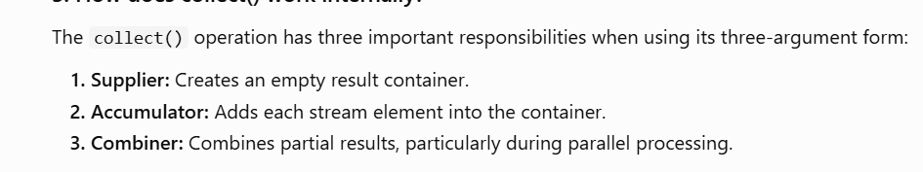
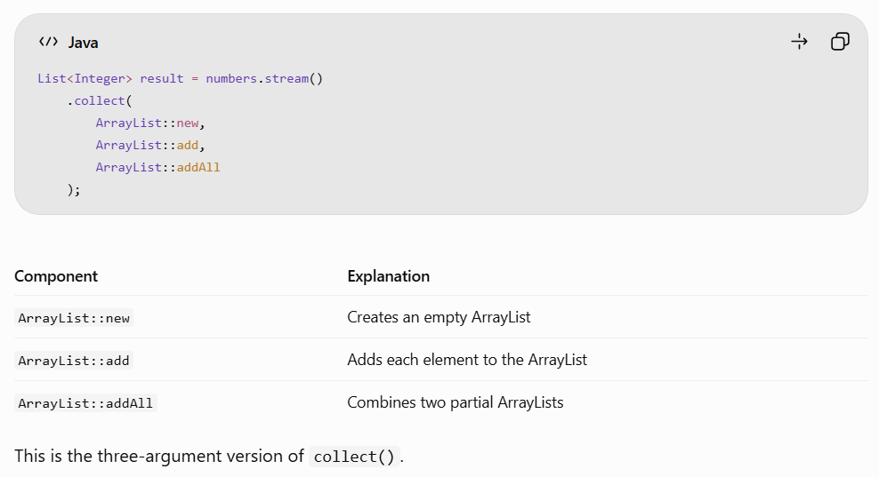
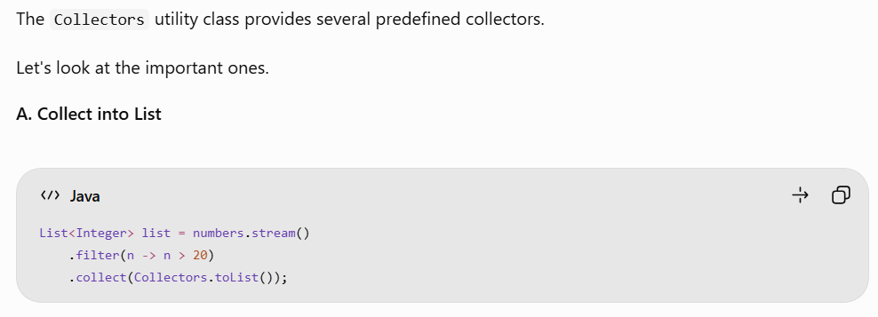
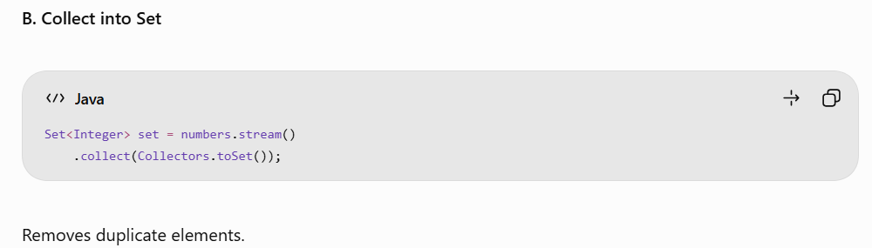
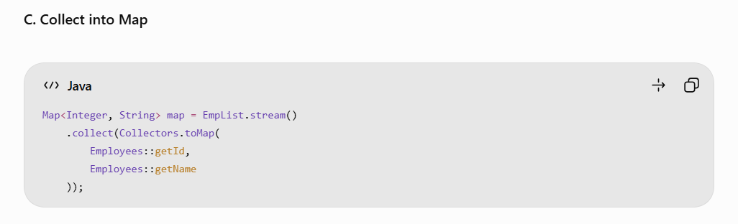
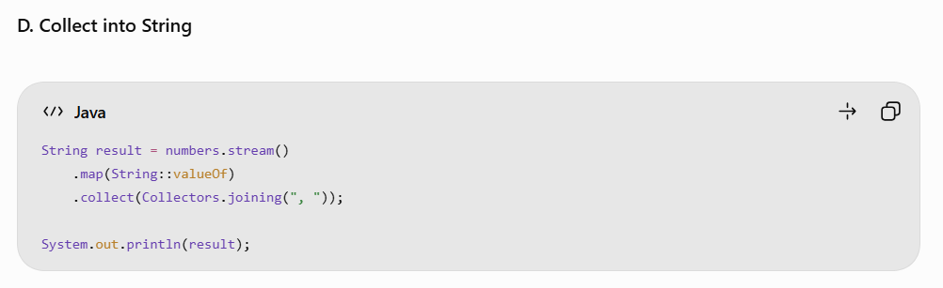
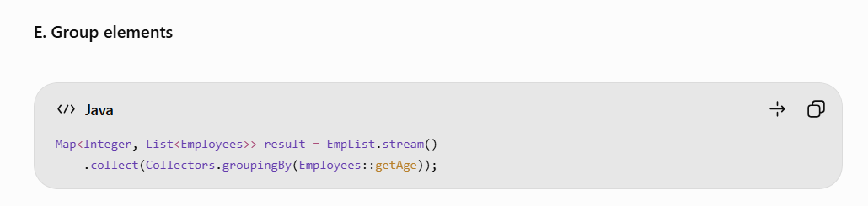
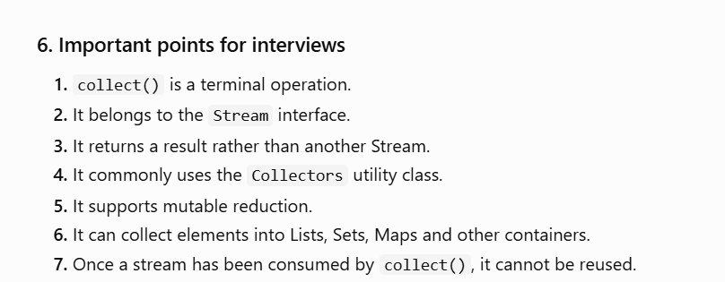
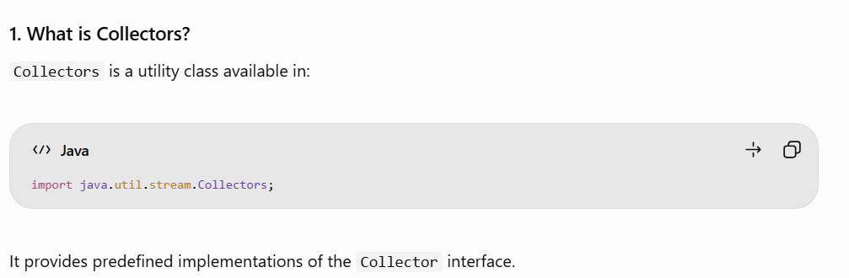
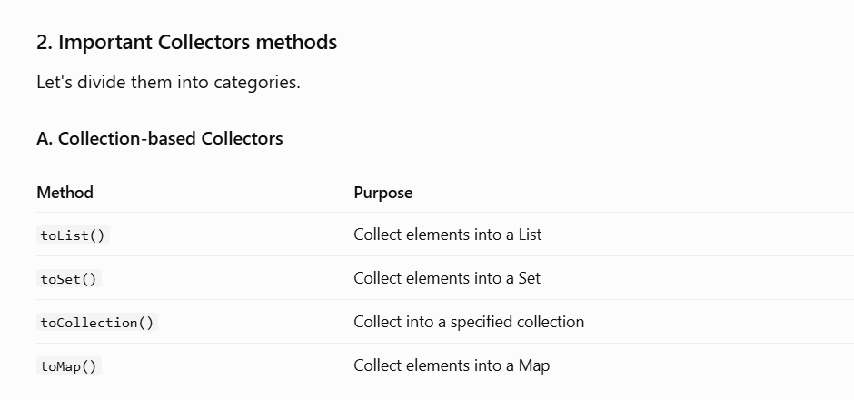
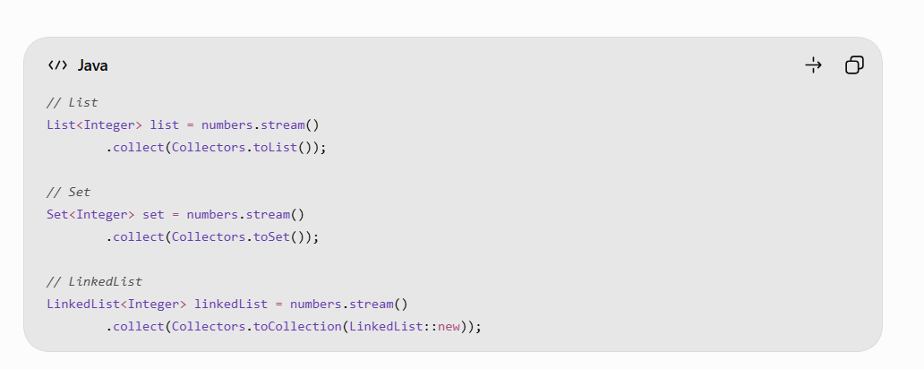
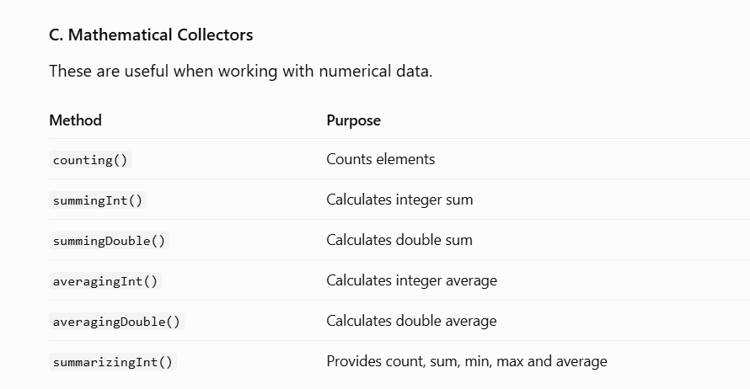
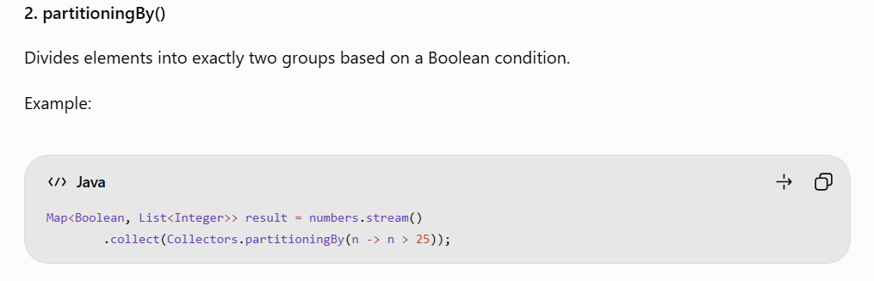
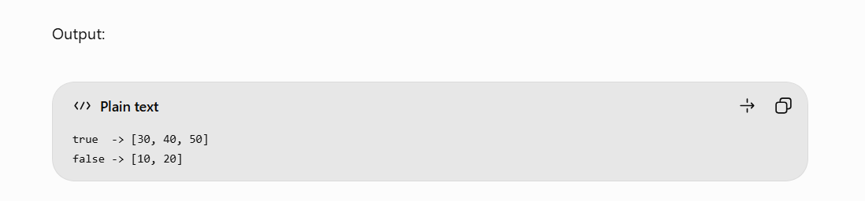

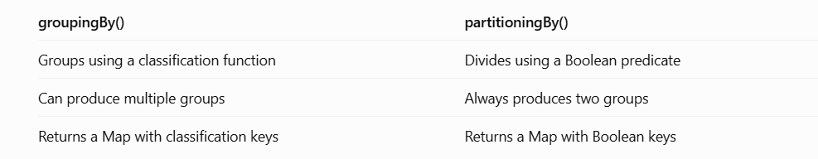

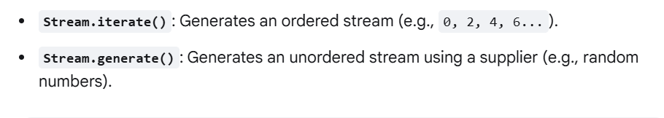
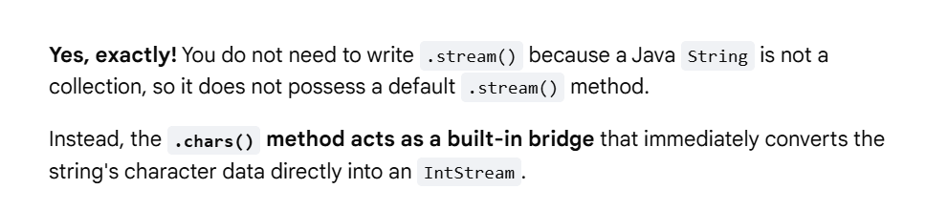
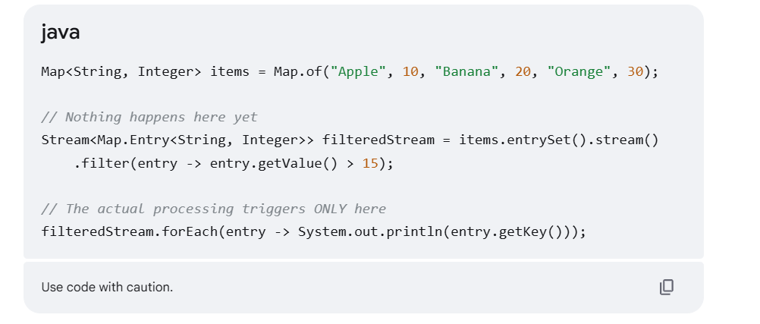

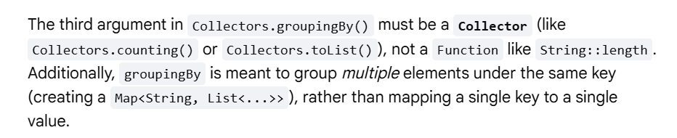
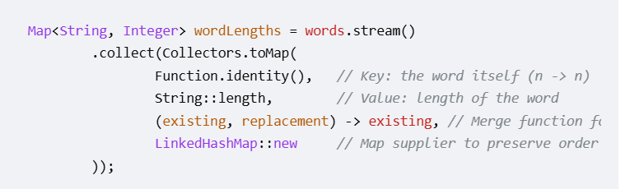

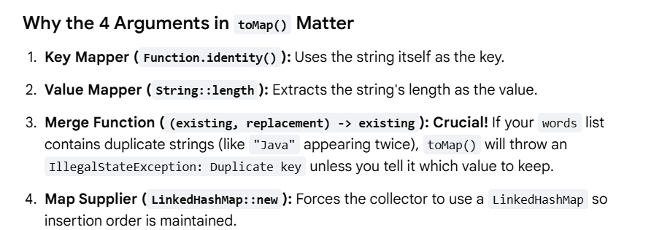
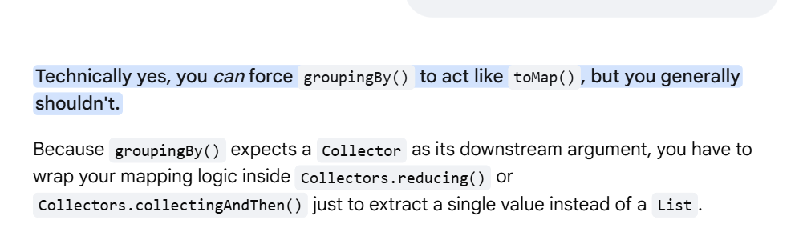

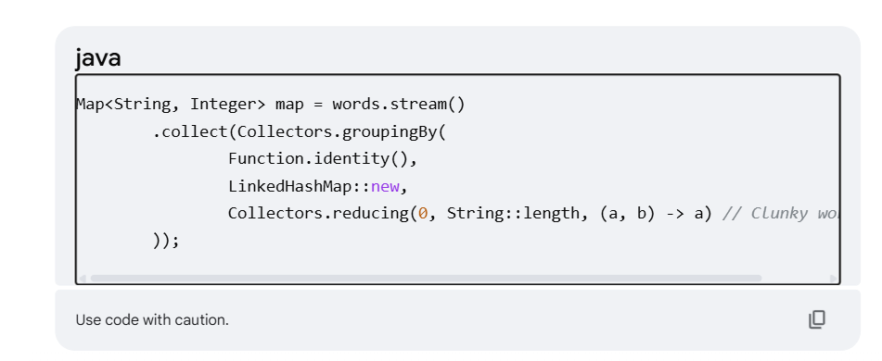
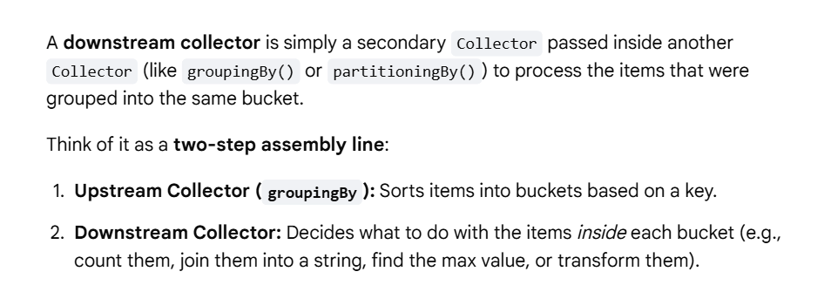
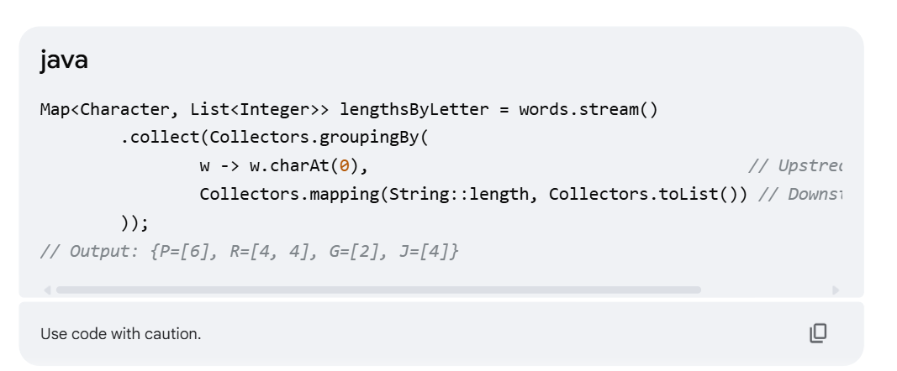
Collector.groupingBy – classffier,mapfactory ,downstream collector

