 

**Aspire Systems RFP RESPONSE to TEMENOS**

**New Omnichannel Platform for**



**Version:** 1.0

**Date:** March 15, 2021



Copyright © 1996-2021 Aspire Systems. All rights reserved. The contents on this document are not to be reproduced or duplicated in any form or kind, either in part or full, without written consent from Aspire Systems

**Contents**

Proprietary and Confidentiality Notice 4

Contact Details 4

Validity period 5

1. Requirement understanding 5

1.1 Functional Requirements 5

1.2 Non Functional Requirements 5

2. Proposed solution 6

3. scope of services 7

3.1.1 UX Design 7

3.1.2 Implementation 8

3.1.3 Testing 8

3.1.4 Support 10

4. PROJECT timeline 11

5. Design Approach 11

5.1 UX DESIGN PROCESS 11

5.1.1 Design Thinking Approach 11

5.1.2 UX Discovery Process 12

5.1.3 UX Design Process 13

5.1.4 User Research & Analysis 15

5.1.5 Interaction Design 15

5.1.6 User Interface Design 15

6. IMPLEMENTATION APPROACH- iTIM 16

6.1 Initiation 16

6.2 Discover 17

6.3 Design 20

6.4 Deliver 23

6.5 Deploy 27

6.5.1 UAT- User Acceptance Testing 27

6.5.2 Non Functional Testing 28

6.5.3 Project Handover 29

6.5.4 Go Live 30

6.6 Closure 31

6.6.1 Project Closure 32

6.6.2 Project Implementation Review 32

7. Quality Assurance 33

7.1 Project Health Index (PHI) 33

7.2 Technical Health Index 33

8. Testing Approach 35

8.1 Our Experience with Temenos Suite 35

8.2 Our Approach to Testing 35

8.3 SIT Approach- Customizable 36

8.4 UAT Approach 36

8.5 UAT Support Approach 37

8.6 Value from our regression automation methodology using validata 37

8.7 Performance & Security Testing Approach 38

8.8 Measuring Test Experience 38

8.9 Why Aspire Testing? 39

8.10 Our Testing Customers 39

9. Data Migration Approach 39

9.1 Stage 1 – Design & Analysis 40

9.2 Stage 2 – System Build 40

9.3 Stage 3 – Testing & Trails 41

9.4 Stage 4 – Benchmarking 42

10. Training plan 42

10.1 Technical Training Plan 42

10.2 Functional Training Plan 43

11. APPLICATION Support APPROACH 46

11.1 Support Services Model 46

11.2 L2 Support Flow 47

11.3 SLAs for L2 Application Support 47

11.4 SLAs for L3 Application Support 48

**Proprietary and Confidentiality Notice**

This response has been prepared in accordance with Aspire Systems’ understanding of the requirements based upon the information provided and good system design techniques. All flow charts, system design, man-day estimates, and related information provided, the actual results in operation (including among other aspects speeds, personnel requirements, and costs) may vary from those indicated in the response due to variations in software, programs, volume, environment, personnel, and other factors. The final determination that the proposed solution meets your requirements must be yours.

This document contains confidential information of Aspire. This information is supplied under a non-disclosure basis. In consideration of the receipt of this document, you agree not to reproduce or make this information available in any manner to persons outside the group directly responsible for evaluation of its contents.

This document is not a contract and does not create any representations or warranties by Aspire. All applicable representations, warranties and covenants are contained only in the appropriate agreement signed by the parties.

The information contained herein is subject to change without notice. Revisions may be issued from time to time to advice of such changes and/or additions.

**Contact Details**

Aspire welcomes the opportunity to submit this proposal and would be pleased to clarify any aspect of it or provide you with further information. Questions or requests for clarification or additional information should be addressed in the first instance to:

|  |  |
| --- | --- |
| **Company Name** | **Aspire Systems Consulting Middle East DMCC, Dubai Branch** |
| **Contact** | Faizan Mohammed |
| **Position** | Sales Manager |
| **Email** | faizan.mohammed@aspiresys.com |
| **Mobile** | +966-508088581 |
| **Location** | Aspire Systems Consulting Middle East DMCC, Dubai Branch  The Citadel Tower  Office 2201, 22nd Floor  Al Abraj Street, Business Bay  Dubai, United Arab Emirates |

**Validity period**

Validity period of the proposal is **120 days** from the day of submission.

# Requirement understanding

## Functional Requirements

The high- level functional/module requirements of BSF is:

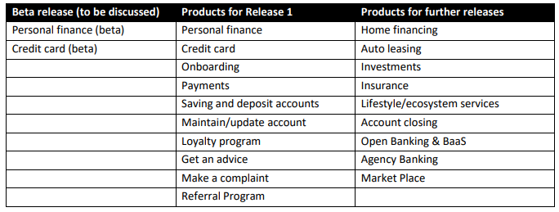

The new omni-channlel solution to integrate with:

* Labiba, Chatbot
* NCR, ATM
* Unica, campaign management
* Skwid, content management
* LinQ2, SMS gateway
* TCS BaNCS, core banking
* Cotrex, card management
* custom developed, brokerage and IPO subscription
* Splunk and AppDynamics, monitoring and logging
* Oracle data bases, reporting and analysis
* MS Dynamics, CRM
* Loyalty program (JANA)

## Non Functional Requirements

|  |  |  |
| --- | --- | --- |
|  | **Technical capabilities level** | **Technical capabilities level 2** |
| UI / UX | | * Customer frontends * Employee UI |
| Process and workflow | | * Process designer (GUI) * Workflow engine |
| Data | | * Synchronization across channels * Data architecture * Data exchange patterns * Analytical engine |
| Integration | | * Integration principles * API integration * Event based communication |
| Security | | * Identity and access management * Encryption mechanisms * Governance & procedures |
| Reliability | | * Capacity / sizing * Availability * Backup and disaster recovery |
| Operations | | * Logging and monitoring * Automatic root cause |

# Proposed solution

We are proposing Temenos Quantum solution for the omni-channel platform and Temenos Infinity solution for the functionalities of the online and mobile channel application.

The target architecture of the solution is depicted as below:

Note- All integrations will happen via IBM App Connect

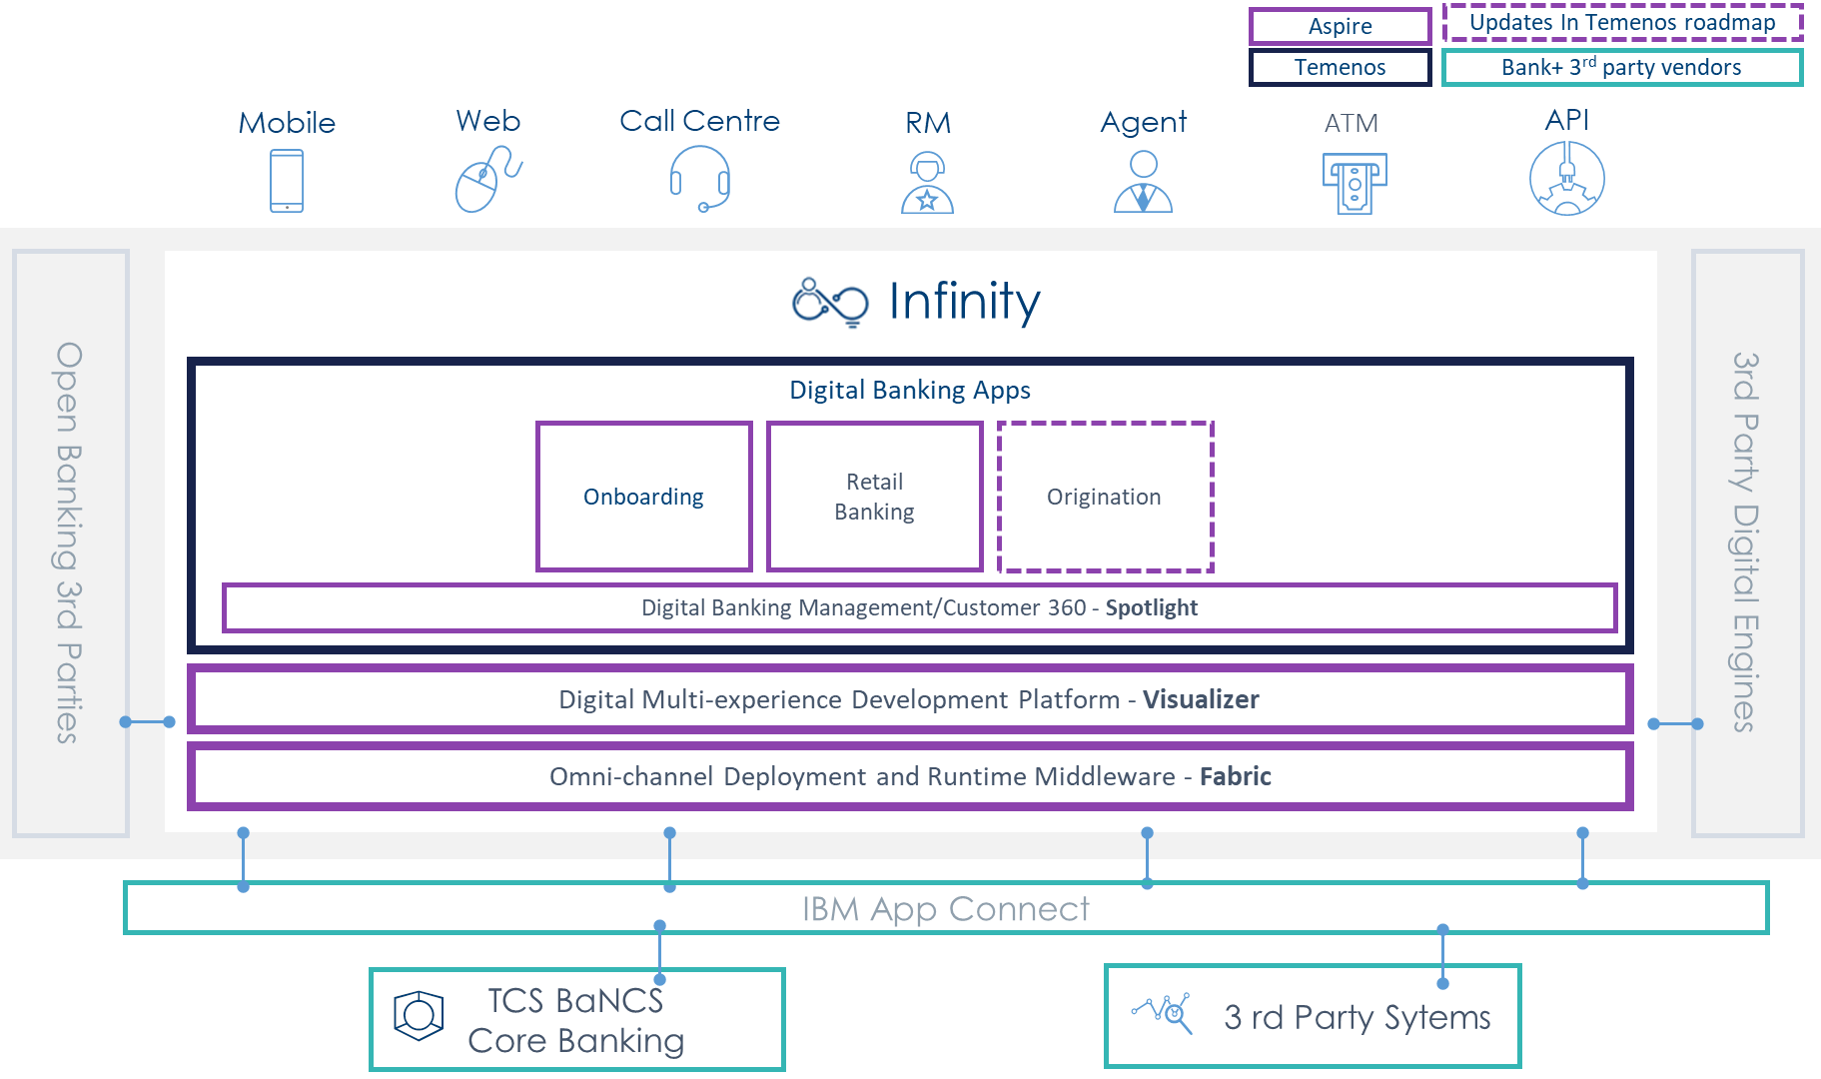

The 3rd party systems considered for integrations are:

* Labiba, Chatbot
* NCR, ATM
* Unica, campaign management
* Skwid, content management
* LinQ2, SMS gateway
* TCS BaNCS, core banking
* Cotrex, card management
* custom developed, brokerage and IPO subscription
* Splunk and AppDynamics, monitoring ad logging
* Oracle data bases, reporting and analysis
* MS Dynamics, CRM
* Loyalty program (JANA)

# scope of services

### UX Design

The design scope covers:

1. UX research activities/Field Studies such as Ethnography, Usability Gap analysis, Quantitative and Qualitative Studies that are to be performed to Identify User needs and Goals.

2. UX/UI Activities that are to be performed to arrive at the best possible solutions for the Omni Channel Experience.

3. Phases that are involved in the Design Scheduling Process which are

* User research
* Interaction Design
* Visual Design
* Usability Testing

4. Usability testing activities to be performed to continuously improve the user experience.

**Release 1:**

List of user journeys to be Re-Imagined:

* Personal Financing Journey (Sales & Servicing).
* Credit card Journey (Sales & Servicing).
* Payment Journey (All types of payments).
* On boarding Journey.

List of user journeys to be as is:

* Saving and Deposit accounts
* Accounts servicing.
* Loyalty Program.
* Contact/Advisory Solution.
* Compliant/Claim Solutions.

List of user journeys which are currently not available and are to be added:

* Referral Program

**Release 2:**

List of user journeys to be Re-Imagined and Add the functionalities if not available currently:

* Home financing sales & servicing
* Auto Leasing sales & Servicing
* Investment Account sales & Servicing
* Insurance sales & servicing
* Lifestyle/ecosystem services
* Other services(e.g., find ATM)
* Functionality to request account/product closure
* Market place
* Open banking & BaaS
* Agency Banking

**Deliverables:**

* **Interaction Design Phase**: Static, grey-coloured low fidelity wireframes in JPG or PNG format and Click through prototype
* **User Interface Design Phase**: Static and coloured high fidelity visual screens in JPG or PNG format and Click-through prototype.

### Implementation

The implementation scope covers the functionalities described in the the business requirements of BSF considering the Journey-specific, General and Product features requirements. Please refer to the coverage details in the business requirements sheet.

### Testing

**Release 1:**

|  |  |
| --- | --- |
| **Web and Mobile App** |  |
| Estimated Number of Test Cases designed (Web + Mobile) | 1485 |
| No of Test Cases executed (including regression and defect retesting) | 2937 |
| Estimated Number of Person Days | 468 |
| **What is Covered?** 1 Round of Functional Execution - 100% 1 Round of Regression - 50% of Functional (only phase 1 features) Defect Retesting - 20% of functional test cases Test Case Design Test Data Setup - with bank's help  **Device Execution Matrix** iPhone - iOS latest     100% Android - Android OS Latest   100% iPad          10% Android Tablet        10%  **Browser Execution Matrix** Browser - Chrome (Latest) 100% Browser - Edge (Latest) 10% Browser - Firefox (Latest) 10% Browser - Safari (Latest) 40% iPhone - Web Browser 5% iPAD - Web Browser 5% Android - Web Browser 5% Android Tab - Web Browser 5% |  |

**Performance Testing**

|  |  |
| --- | --- |
| **S.No** | **Web Application & Native Mobile App - Temenos Kony Infinity (Module - Scenario)** |
| 1 | Payments - Bill Payment (Any single Bill Payment) |
| 2 | Payments - Standing Order |
| 3 | Payments - Scheduled Payments |
| 4 | Payments - Credit Card Payment |
| 5 | Liability Products - Savings Account/Current Account/RD Account (Any one account) |
| 6 | Card Management - Issue of Debit Card/Credit Card (Any one card type) |
| 7 | Loyalty Program - Loyalty Program Setup |
| 8 | Personal Loan - Apply Personal Loan |

**Release 2:**

|  |  |
| --- | --- |
| **Web and Mobile App** |  |
| Estimated Number of Test Cases designed (Web + Mobile) | 1215 |
| No of Test Cases executed (including regression and defect retesting) | 2403 |
| Estimated Number of Person Days | 449 |
| **What is Covered?** 1 Round of Functional Execution - 100% 1 Round of Regression - 70% of Functional (Including Phase 1 and Current Release features) Defect Retesting - 20% of functional test cases Test Case Design Test Data Setup - with bank's help  **Device Execution Matrix** iPhone - iOS latest     100% Android - Android OS Latest   100% iPad          10% Android Tablet        10%  **Browser Execution Matrix** Browser - Chrome (Latest) 100% Browser - Edge (Latest) 10% Browser - Firefox (Latest) 10% Browser - Safari (Latest) 40% iPhone - Web Browser 5% iPAD - Web Browser 5% Android - Web Browser 5% Android Tab - Web Browser 5% |  |

**Performance Testing**

|  |  |
| --- | --- |
| **S.No** | **Web Application & Native Mobile App - Temenos Kony Infinity (Module - Scenario)** |
| 1 | Financial Services - IPO Subscription |
| 2 | Financial Services - IPO Right Issue |
| 3 | Financial Services - Brokerage Transfer |
| 4 | Financial Services - Other Transfers (Any one transfer type) |
| 5, 6 | Home Financing - Any 2 types of financing |
| 7 | Auto Leasing |
| 8 | Investments |
| 9 | Insurance - Educational Insurance/Travel Insurance (Any one insurance type) |

### Support

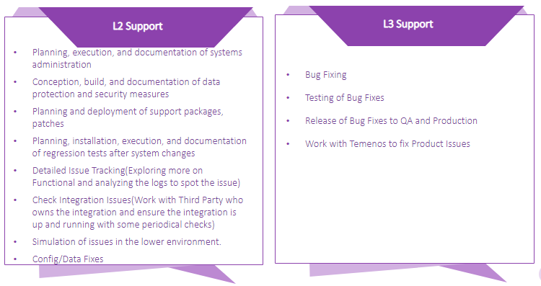

# PROJECT timeline

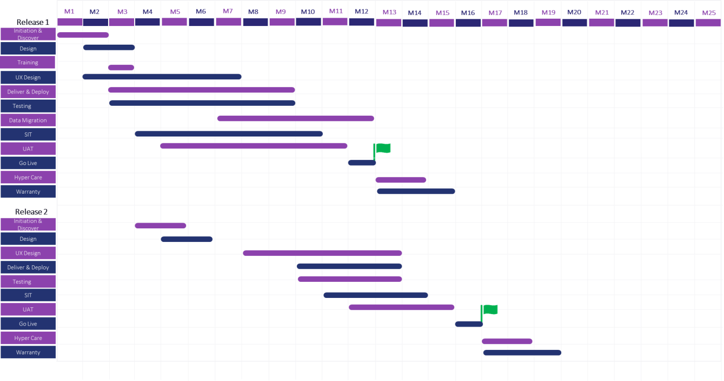

# Design Approach

## ****UX DESIGN PROCESS****

### ****Design Thinking Approach****

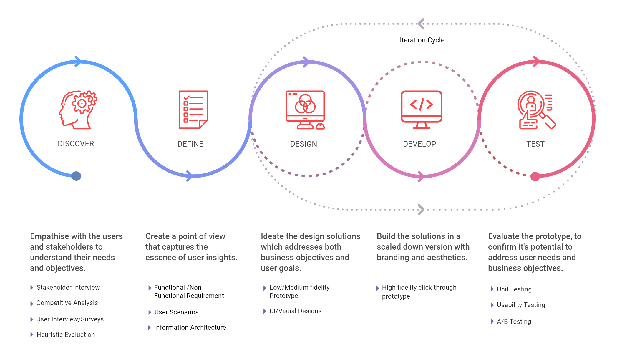

### UX Discovery Process

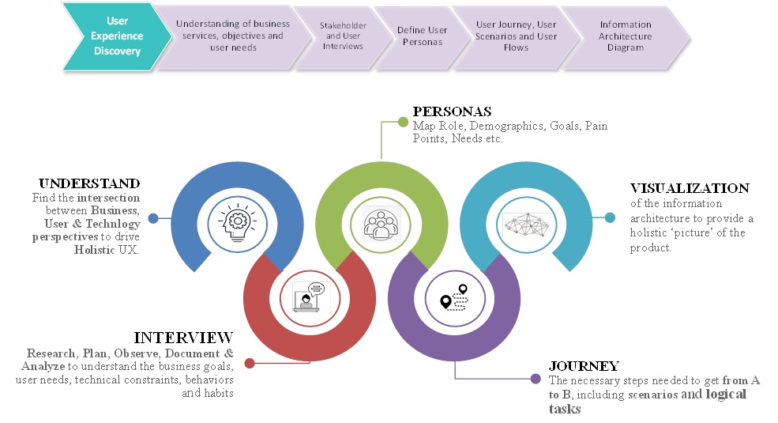

**Sample Persona**

### UX Design Process

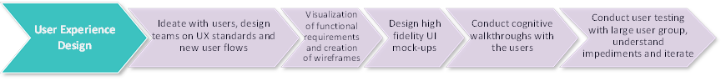

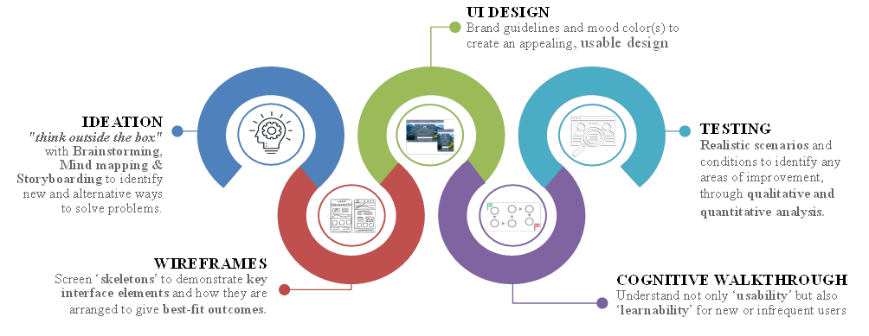

**Sample Wireframe and Visual Design**

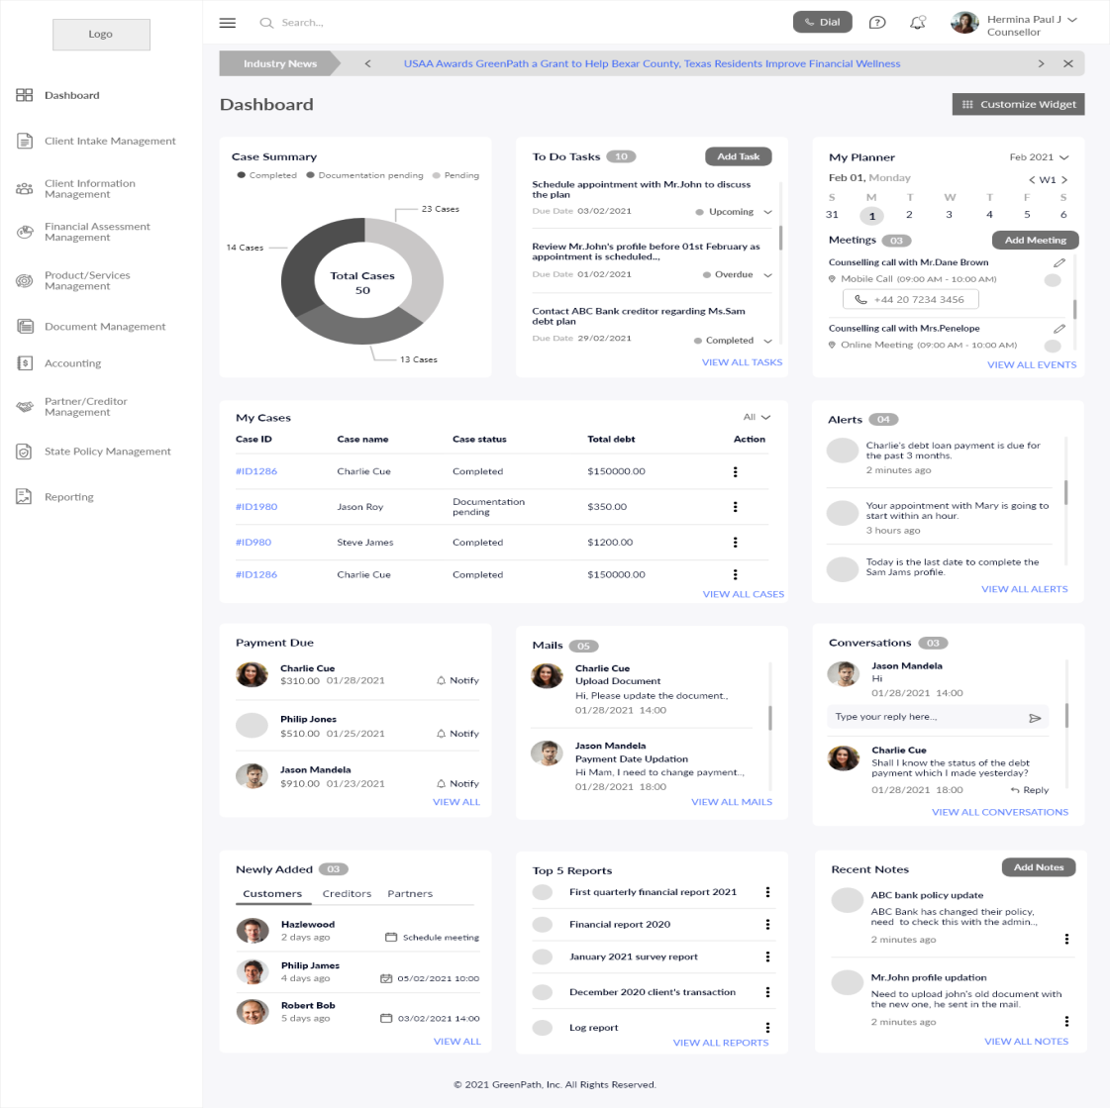

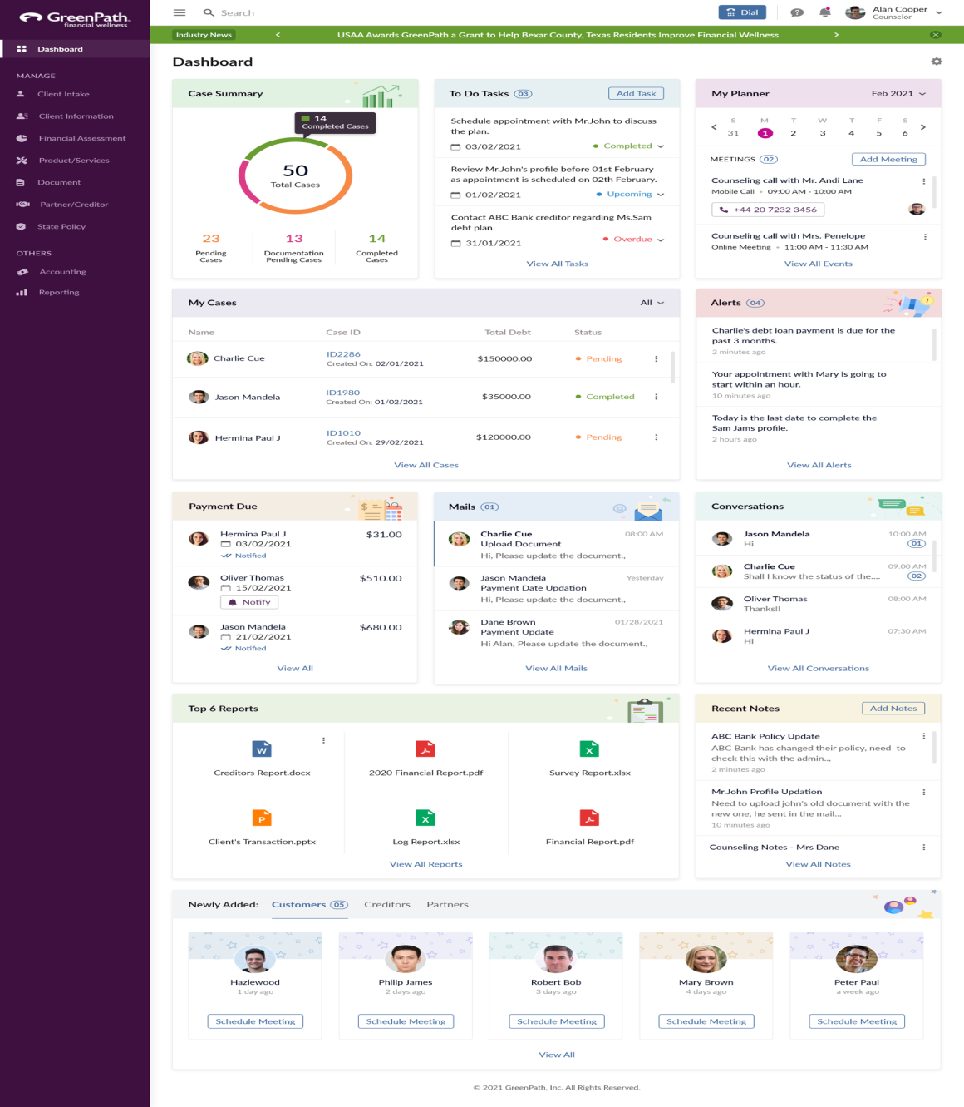

### ****User Research & Analysis****

* Stakeholder and user interview.
* Personas.
* Requirement Analysis.
* Competitor Analysis.

### ****Interaction Design****

* Wireframe Design / Information Architecture

### ****User Interface Design****

* Design intuitive and aesthetically pleasing user interface design mock-ups based on approved wireframes

# IMPLEMENTATION APPROACH- iTIM

Aspire adheres to the Temenos Implementation Methodology for Infinity (iTIM) approach for project implementation.The iTIM is designed to provide our service organization with structured delivery processes that create defined value for our Clients. The iTIM provides a roadmap that clearly communicates essential steps and ensures that each step is fulfilled. It is a process-driven approach, so that each activity in the implementation is clearly identified with a step-by-step documented procedure guide for each process step.

The entire implementation process is covered, from project initiation through to project closure.

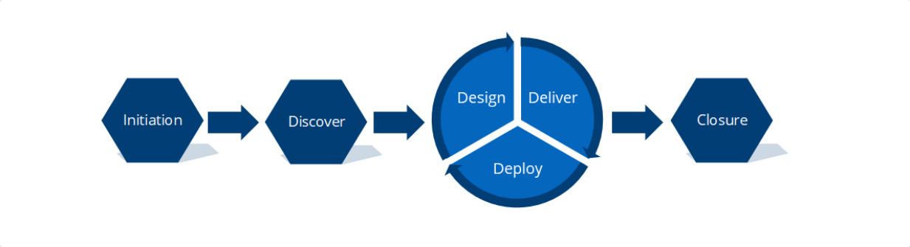

Snapshot on the Implementation Approach is as depicted below:

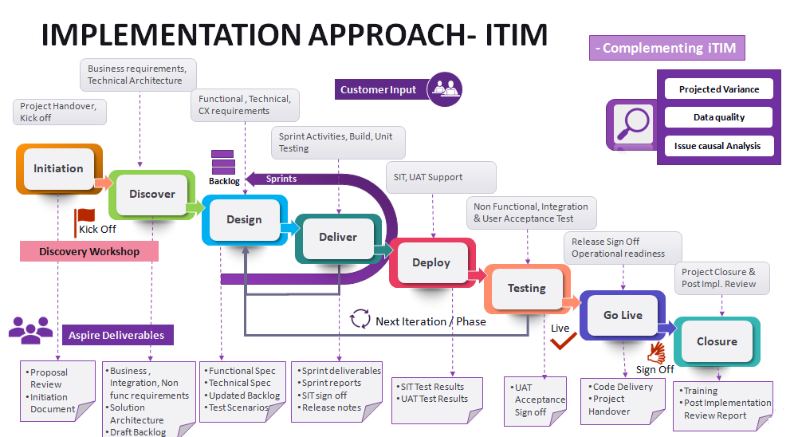

## Initiation

The exact approach used needs to be right for the prospect, therefore an agile maturity assessment is undertaken to ascertain this prior to signing the statement of work, with alignment to the bank’s own delivery methodology being considered. Infinity project deliveries can be located on Client premises or fully remote but will usually be comprised of a mix of people from onshore/nearshore and offshore resources. The [TIM](https://partnerstim.temenos.com/tim/Infinity/Initiation/index.htm) for Infinity contains elements of both traditional waterfall and agile concepts, as a very effective method of technical project delivery. The methodology applies, where possible, a level of agility using principles/methods of agile with some of the formal practices of Waterfall.

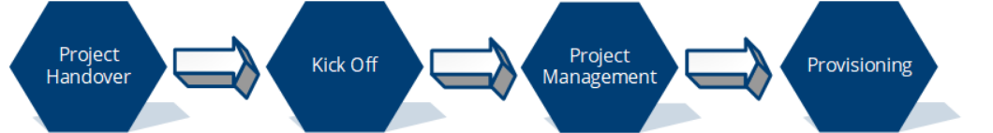

|  |  |  |  |
| --- | --- | --- | --- |
| **Project Handover** | **Kickoff** | **Project Management** | **Provisioning** |
| Prepare For Handover- Review Documentation Gathered by Sales, Pre-sales, Cloud Delivery Manager and Client Engagement Teams | Review Project Plan | Identify project stakeholders, reviewers and approvers | Initial Environment setup and preparations- on premise or cloud |
|
| Produce Project Pack | Review Communication Plan | Setup or Review Governance Process |  |
|
| Produce Agenda | Frame Risk Log |  |  |
|
| Arrange Convenient Time for Attendees, and Distribute Agenda and Project Pack | Change Management |  |  |
|
| Review the Sales to Services Handover Checklist | Prepare Project Initiation Document |  |  |
|
| Review Background Documentation |  |  |  |
|
| Conduct Handover |  |  |  |
|
| Close the Handover Process |  |  |  |
|

## Discover

The Discover Stage is the analysis phase of the project and the following artefacts are the inputs to the discover phase:

* Signed off Services [Statement of Work](https://temenosgroup.sharepoint.com/temenosteams/Engagement/Templates/20200702-%20SoW%20Infinity%20Implementation%20Agile%20V1.docm?d=w8f4633dec3dc416ab53acdea8148bead) outlining the scope, implementation approach, deliverables, dependencies, conditions, assumptions and governance for the implementation at the Client of the software solution described within.
* Project Plan - Generated by Infinity [PM](https://partnerstim.temenos.com/tim/Infinity/Discover/index.htm) during the [Initiation Stage](https://partnerstim.temenos.com/tim/Infinity/Initiation/index.htm) of the Project, describing the Temenos activities, and their sequencing.

 Depending on the size and complexity of the Client’s needs, a series of workshops over a number of days will be scheduled to enable the implementation team to gather a clear understanding of the main aspects of the project, through the Discover workshops, held with the corresponding workstreams.

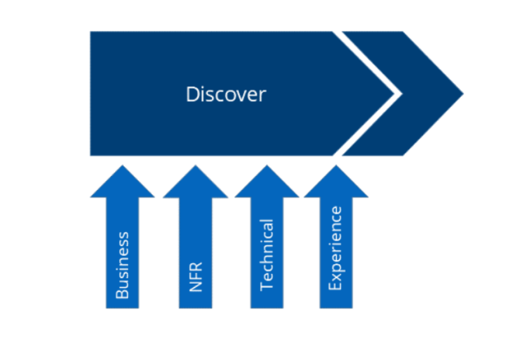

|  |  |  |
| --- | --- | --- |
| **Work streams** | **Activities** | **Outputs/ Deliverables** |
| Business Requirements | * Identify project stakeholders, reviewers, and approvers * Walkthrough the [Base Product](https://partnerstim.temenos.com/tim/Infinity/Discover/Business_Discover.htm) features and documented Base Product User Journeys * Agree on the [Base Product](https://partnerstim.temenos.com/tim/Infinity/Discover/Business_Discover.htm) features to be adopted as part of the to-be solution * Discuss the Client’s business requirements * Analyze the functional gaps between the Infinity base product and the Client’s requirements * Assisting the Client in preparing the User Stories * Identify all 3rd party integrations required * Validate/update the High-Level Scope (as described in the [SOW](https://partnerstim.temenos.com/tim/Infinity/Discover/Business_Discover.htm)) * Define the [NFR](https://partnerstim.temenos.com/tim/Infinity/Discover/Business_Discover.htm)s * User Administration requirements * Agree on the dates for the delivery of the signed-off Client business requirements for review | * Client’s business requirements, either in the form of [Business Requirements Document(s)](https://temenosgroup.sharepoint.com/:w:/r/sites/qms/_layouts/15/Doc.aspx?sourcedoc=%7BCD009DF2-772D-452B-92D7-72FAA592EA7F%7D&file=Product-%20Business%20Requirement%20Document%20-%20Template.docx&action=default&mobileredirect=true)or some other acceptable format, such as Jira - Produced by the Client and signed off by the implementation [BC](https://partnerstim.temenos.com/tim/Infinity/Discover/Business_Discover.htm) * [Non-Functional Requirements document](https://partnerstim.temenos.com/tim/Documents/Generic/Non-Functional%20Requirements%20Document%20Template_v1.0.docx) - Produced by the Client and signed off by the implementation [Solution Architect](https://partnerstim.temenos.com/tim/Infinity/Discover/Business_Discover.htm)/[TC](https://partnerstim.temenos.com/tim/Infinity/Discover/Business_Discover.htm) * [Integration Requirements Document](https://partnerstim.temenos.com/tim/Documents/Generic/Interface%20Requirement%20Definition%20Template_v1.0.docx) - Produced by the Client and signed off by the implementation [Solution Architect](https://partnerstim.temenos.com/tim/Infinity/Discover/Business_Discover.htm)/[TC](https://partnerstim.temenos.com/tim/Infinity/Discover/Business_Discover.htm) * Client’s Test Strategy Document * Draft Project Backlog |
| Technical & Architecture | * Review the Client’s current technical/ architecture landscape/ ecosystem into which the Infinity solution will be integrated, including authentication system, core banking system and other internal and 3rd party systems * Explain the standard deployment stack, as per the [SOW](https://partnerstim.temenos.com/tim/Infinity/Discover/Technical_Discover.htm) provision, pre-requisites and dependencies * Sizing requirements * Pre-requisite for the deployment of Microservices (mandatory and solution ones) * High-level Authentication requirements and the involvement of the 3rd party Authentication solution provider. * Discuss and agree on the environment management strategy * Review the Disaster Recovery (DR) plan * Providing access to the implementation team to the Client’ backend software anonymized development and/or test environments * Identify and discuss any migration requirements i.e. identifying all systems impacted by the new solution and migrating them * Discuss other requirements like Test Automation, User Accesses & Permissions, etc. * Identify potential risks | * System Architecture Document - Draft - Produced by the implementation [Solution Architect](https://partnerstim.temenos.com/tim/Infinity/Discover/Technical_Discover.htm)/[TC](https://partnerstim.temenos.com/tim/Infinity/Discover/Technical_Discover.htm) * Draft Project Backlog |
| UI/UX Experience | * Brand Standards * Style Guide * Interactive Guide (if applicable) * Branding Assets, Logos, etc. * Image Assets * Typography Assets * Links to existing T&C, Privacy Policy, Disclaimers * Any existing user flows or customer journey maps including prototypes | * UX Design Document - Produced by the implementation [CX](https://partnerstim.temenos.com/tim/Infinity/Discover/Experience_Discover.htm)/UX/[TC](https://partnerstim.temenos.com/tim/Infinity/Discover/Experience_Discover.htm) and signed off by the Client * Draft Project Backlog |
| Project Management | * Business requirement documents (BRDs) for gaps identified - signed off by the implementation BC * Non-Functional Requirements document - signed off by the implementation Solution Architect/TC * Creating and providing high level User Stories (business transformation objectives), which will constitute the Project Backlog, which will be reviewed, amended and finalized at the Design Stage. * Creation of Test Strategy and test plan. * Complete sizing questionnaire | * System Architecture Document * UX Design Document * Updated Project Backlog * Updated Project Plan |

## Design

This Stage describes how the Design of an Infinity project implementation should be conducted. It describes the scope, roles & responsibilities, activities, inputs, outputs along with entry and exit criteria. During this phase the implementation team will work to translate the Client’s requirements (from the [Discover](https://partnerstim.temenos.com/tim/Infinity/Discover/index.htm) phase) into system and technical solution options that will then lead into the development phase of the project.

The following artefacts are the inputs to the Design phase:

* Signed-off Client business requirements (either [Business Requirements Documents](https://temenosgroup.sharepoint.com/:w:/r/sites/qms/_layouts/15/Doc.aspx?sourcedoc=%7BCD009DF2-772D-452B-92D7-72FAA592EA7F%7D&file=Product-%20Business%20Requirement%20Document%20-%20Template.docx&action=default&mobileredirect=true) ([BRDs](https://partnerstim.temenos.com/tim/Infinity/Design/index.htm)) or Jira User Stories)
* Signed-off UX Design Document
* System Architecture Document
* Project Backlog

A series of workshops will be scheduled and conducted by the implementation team to derive the final implementation solution from the point of view of functional, technical, experience, non-functional requirements. This will include the project backlog, technical design, specific UX design/prototype, API mapping and system configuration.

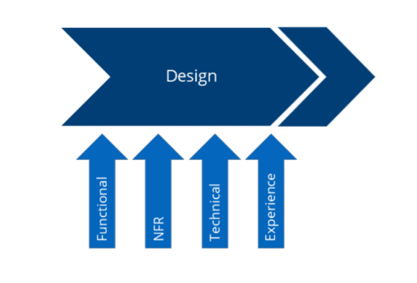

|  |  |  |
| --- | --- | --- |
| **Work streams** | **Activities** | **Outputs/Deliverables** |
| Functional | * Translate the signed-off [business requirements](https://temenosgroup.sharepoint.com/:w:/r/sites/qms/_layouts/15/Doc.aspx?sourcedoc=%7BCD009DF2-772D-452B-92D7-72FAA592EA7F%7D&file=Product-%20Business%20Requirement%20Document%20-%20Template.docx&action=default&mobileredirect=true) into Functional Requirements, documented as [Functional Specifications Documents](https://partnerstim.temenos.com/tim/Documents/Generic/Functional%20Specification%20Document%20-%20Template.docx) ([FSD](https://partnerstim.temenos.com/tim/Infinity/Design/Functional_Requirements.htm)s) and present them to the Client for review and approval (where appropriate High level solution documents can be produced first). * Update the base user stories and create new/updated user stories for the approved gaps * Map data to Infinity Business objects * Capture customer specific rules, to be configured in the solution * Any standard user stories that need to be amended as part of the Client requirements elaboration workshops will have their estimate updated. * Any new feature user stories identified as required will be estimated by the Infinity implementation team. * Identify dependencies and their potential risks to the project timeline | * [Functional Specification Document(s)](https://partnerstim.temenos.com/tim/Documents/Generic/Functional%20Specification%20Document%20-%20Template.docx) - Produced by the implementation [BC](https://partnerstim.temenos.com/tim/Infinity/Design/Functional_Requirements.htm)/[TC](https://partnerstim.temenos.com/tim/Infinity/Design/Functional_Requirements.htm) and signed off by the Client * Updated Project Backlog |
| Non Functional Requirement Workshop | * Where required, produce design documents to describe amendments needed to cover any requirements raised in the signed-off [Non-Functional Requirements](https://partnerstim.temenos.com/tim/Documents/Generic/Non-Functional%20Requirements%20Document%20Template_v1.0.docx) and present them to the Client for review and approval. * Identify dependencies and their potential risks to the project timeline | * Technical Specification Document(s) - Produced by the implementation [TC](https://partnerstim.temenos.com/tim/Infinity/Design/Non_Functional.htm) and signed off by the Client * Updated [Project Backlog](https://partnerstim.temenos.com/tim/Infinity/Design/Non_Functional.htm) |
| Technical Requirement Workshop | * Review with the Client the sizing document received from the Temenos Sizing team * Finalise review and sign off the System Architecture Document (infrastructure for Dev and Prod like environments) * Finalise the environment management agreement with the Client * Production of [Integration Design Document](https://partnerstim.temenos.com/tim/Documents/Generic/Interface%20Design%20Document_v1.0.docx) in response to Client's signed-off [Integration Requirements Document](https://partnerstim.temenos.com/tim/Documents/Generic/Interface%20Requirement%20Definition%20Template_v1.0.docx) * Authentication solution | * System Architecture Document - Produced by the implementation [Solution Architect](https://partnerstim.temenos.com/tim/Infinity/Design/Technical_Requirements.htm)/[TC](https://partnerstim.temenos.com/tim/Infinity/Design/Technical_Requirements.htm) and signed off by the Client * [Integration Design Document(s)](https://partnerstim.temenos.com/tim/Documents/Generic/Interface%20Design%20Document_v1.0.docx) - Produced by the implementation [TC](https://partnerstim.temenos.com/tim/Infinity/Design/Technical_Requirements.htm) and signed off by the Client * Updated Project Backlog |
| Customer Experience UI/UX Workshop | * Using the Real-time Design & Prototyping approach, apply the Client’s branding style guides to the base Infinity product; review it with the Client and get the sign off. * Use the InVision Infinity Retail Banking base product to produce the custom design prototype (new screen designs or update base product screen design as per the outcome of the Functional Requirements workshop); a maximum of three (3) iteration cycles can be planned to drive the review, triage, amendment the Client review, make changes and sign-off. * If required, adapt the solution to meet local language requirements (right-to-left, longer terms, etc.) | * UX/UI design prototype - Produced by the Implementation UX/UI/[TC](https://partnerstim.temenos.com/tim/Infinity/Design/Customer_Experience.htm) in collaboration with the Client * Updated Project Backlog |
| Project Management | * Once the Client’s final requirements and the related solution are clarified, estimated and signed-off, the Infinity [PM](https://partnerstim.temenos.com/tim/Infinity/Design/Project_Management.htm) will update the Project Plan, ensuring all Actions, Issues and Risks are fully documented and shared appropriately. * In addition, the [PM](https://partnerstim.temenos.com/tim/Infinity/Design/Project_Management.htm) must ensure that the resourcing plan and any additional linked commercials are completed and updated. This may mean requesting additional resources, or adjusting timelines, as the [Discover](https://partnerstim.temenos.com/tim/Infinity/Discover/index.htm) and [Design](https://partnerstim.temenos.com/tim/Infinity/Design/index.htm) stages drives additional clarity to the project. * Environment Management | * Signed-off [Functional Specifications Document(s)](https://partnerstim.temenos.com/tim/Documents/Generic/Functional%20Specification%20Document%20-%20Template.docx) * Signed-off Technical Specifications Document(s) to cover [NFRs](https://partnerstim.temenos.com/tim/Infinity/Design/Project_Management.htm) * Signed-off UX/UI design prototype * Signed-off [Integration Design Document(s)](https://partnerstim.temenos.com/tim/Documents/Generic/Interface%20Design%20Document_v1.0.docx) * [Project Backlog](https://partnerstim.temenos.com/tim/Infinity/Design/Project_Management.htm) for delivery * Updated Project Plan |

## Deliver

The objective of this stage is to undertake iterative functional development/configuration sprints to deliver the defined Client solution.

In addition, if required as part of the [NFR](https://partnerstim.temenos.com/tim/Infinity/Deliver/index.htm)s, the iterative sprints will include any technical work needed to deliver those [non-functional requirements](https://partnerstim.temenos.com/tim/Documents/Generic/Non-Functional%20Requirements%20Document%20Template_v1.0.docx), as documented in any Technical Specification Documents.

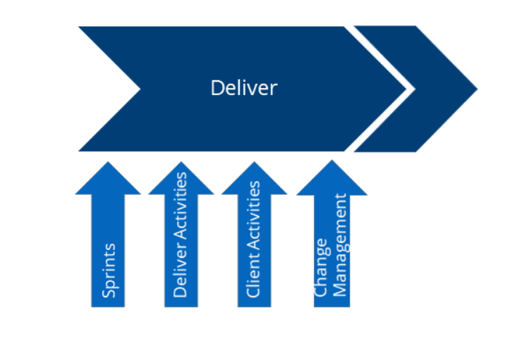

|  |  |  |
| --- | --- | --- |
| **Key Inputs** | **Activities** | **Outputs** |
| * Signed-off System Architecture Document * Signed-off UX/UI design prototype * Signed-off System Design Document * Signed-off [Functional Specification Documents](https://partnerstim.temenos.com/tim/Documents/Generic/Functional%20Specification%20Document%20-%20Template.docx) * SIgned-off Technical Specification Documents * Signed-off [Integration Design Documents](https://partnerstim.temenos.com/tim/Documents/Generic/Interface%20Design%20Document_v1.0.docx) * [Project Backlog](https://partnerstim.temenos.com/tim/Infinity/Deliver/index.htm) for Delivery * Updated Project Plan | **Delivery Activities**   * Sprint Planning * Daily Stand-Up Calls (Internal/external) * Backlog Refinement and Management * Ensuring a level of quality assurance of the Unit Testing against the specific Acceptance Criteria of each User Story delivered by the Client to the implementation team. * Sprint Demonstrations, when possible. * For each Software package released to the Client for testing, the Infinity project team will deliver a detailed demonstration of User Stories to be delivered. * Train the trainer sessions where applicable * Preparing the Deployment plan with the Client, this will be executed at [Deploy Stage](https://partnerstim.temenos.com/tim/Infinity/Deploy/index.htm). * Providing CI/CD framework and deployment run books, when applicable   **Client Activities**   * The Client shall be ready to commence System Integration Testing ([SIT](https://partnerstim.temenos.com/tim/Infinity/Deliver/Client_Activities.htm)) upon completion of Unit Testing and availability of the relevant Build that is to be tested. * Standard project resourcing for Infinity implementations allows for a certain portion (in man days) of delivery team velocity per sprint to review and remediate this initial [SIT](https://partnerstim.temenos.com/tim/Infinity/Deliver/Client_Activities.htm) feedback from the Client in parallel to the remainder of the functional delivery sprints. If this is agreed pre-project it will be included in the [SOW](https://partnerstim.temenos.com/tim/Infinity/Deliver/Client_Activities.htm), otherwise it will be an output of the review of the Client’s Test Strategy.   **Other Activities:**   * Organising and executing [SIT](https://partnerstim.temenos.com/tim/Infinity/Deliver/Client_Activities.htm) * Preparing with the implementation team, the Deployment plan, which will be executed at [Deploy Stage](https://partnerstim.temenos.com/tim/Infinity/Deploy/index.htm). * Documenting the Testing procedure and results. * Providing approval to transition to the next sprint, [SIT](https://partnerstim.temenos.com/tim/Infinity/Deliver/Client_Activities.htm) or [UAT](https://partnerstim.temenos.com/tim/Infinity/Deliver/Client_Activities.htm). * Responding to all relevant queries from the implementation team (Onsite or Offsite). | * Planned sprint deliverables/ increments * Sprint reports * [SIT](https://partnerstim.temenos.com/tim/Infinity/Deliver/Change_Management.htm) signed-off * Release notes * Relevant binaries (IPA, APK) - native apps, web archives, APIs * Deployment runbook |

The project delivery execution happens in agile methodology with below standards:

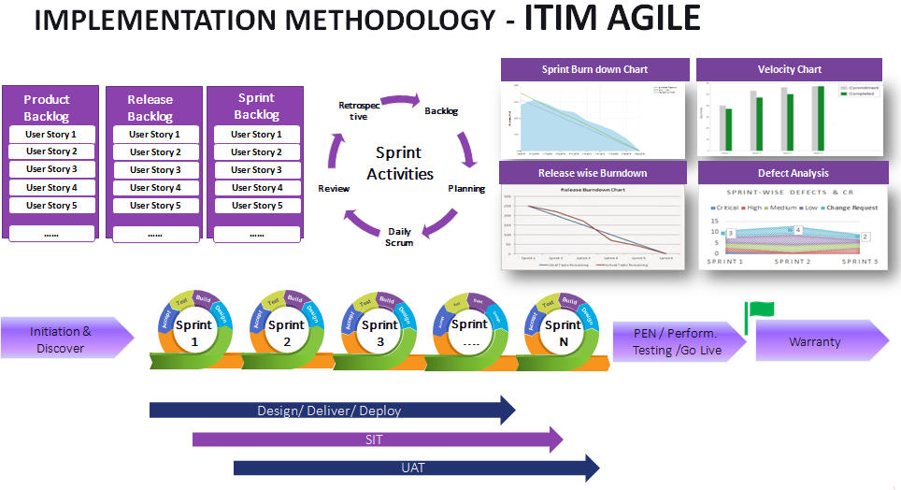

**Sprint 0**

Sprint 0 is a maximum 5 days period for the Infinity project implementation team to get clarity and assurance that all is in place to be able to deliver the final Client solution activities during this phase include:

* General Team Briefing
* Solution Design Overview (including [NFR](https://partnerstim.temenos.com/tim/Infinity/Deliver/Sprints.htm)s)
* User Story Readiness
* Environment Readiness – on premise or cloud

**Subsequent Sprints (based on output from Discover and Design phase)**

* Configuration/parameterization, for example user management, user language, configuration for Microservices, Authentication solution
* Third Party integration
* Development

## Deploy

Deployment involves the planning and execution of the system in the production environment following the Client's deployment strategy, which is developed during the course of the project.

It is critical that all components are deployed in the correct sequence and following the scripts and/or runbooks as available. The deployment itself must be planned and several [Dress Rehearsals](https://partnerstim.temenos.com/tim/Infinity/Deploy/index.htm) are performed to ensure that the deployment plan is realistic and that the timings are accurate.

The overall objective of this stage is to support the Client in taking the completed deliverables through their testing and on to production ready state, including the promotion to live.

Key Inputs to this Stage:

* Planned sprint deliverables/ increments
* Release notes
* Signed off [SIT](https://partnerstim.temenos.com/tim/Infinity/Deploy/index.htm)
* Relevant binaries (IPA, APK) - native apps
* Deployment runbook

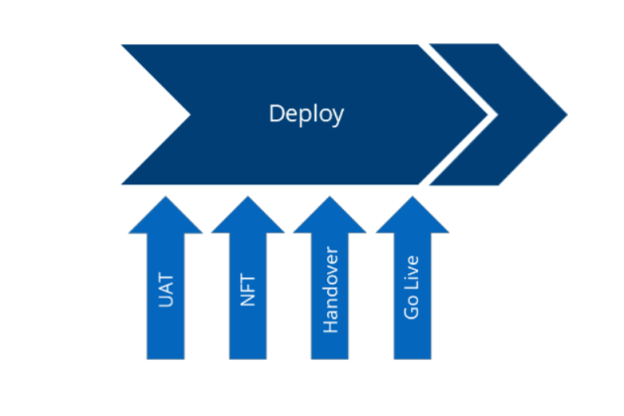

### UAT- User Acceptance Testing

|  |  |
| --- | --- |
| **Aspire Activities** | **Client Activities** |
| * Provide support for [UAT](https://partnerstim.temenos.com/tim/Infinity/Deploy/UAT.htm) * Fixing Software Issues or assisting the Client with the process for fixing Software Issues that relate solely to the Software * Consultative assistance to the Client for the relevant Testing process using the available time of relevant members of the implementation team. | * Organising and executing [UAT](https://partnerstim.temenos.com/tim/Infinity/Deploy/UAT.htm) activities and any other testing identified * For on-premise (or Client cloud) deployments * Ensuring that the Client Environment for Testing is available and stable * Client will, with support from the implementation team, perform Non-Functional Testing, including performance and penetration testing, which cannot be done by the implementation team due to lack of correct environments, etc. * We recommend that the Client engages expert assistance with penetration testing, including utilising the knowledge and experience of the contracted third-party authentication experts. * Once the exit criteria for the relevant Testing process have been met, the Client must Sign-off that the Testing process has been completed and the System Scope is ready for Deployment. * If the exit criteria have not been met, then the Client must raise Software Issues with the project implementation team. |

### Non Functional Testing

|  |  |  |
| --- | --- | --- |
| **Stream** | **Aspire Activities** | **Client Activities** |
| Non Functional Testing- for OnPrem Deployment | * Provide support for [NFT](https://partnerstim.temenos.com/tim/Infinity/Deploy/Non_Functional_Testing.htm) * Fixing Software Issues or assisting the Client with the process for fixing Software Issues that relate solely to the Software * Consultative assistance to the Client for the relevant Testing process using the available time of relevant members of the implementation team. | * Non-Functional Testing of documented [Non-Functional Requirements](https://partnerstim.temenos.com/tim/Documents/Generic/Non-Functional%20Requirements%20Document%20Template_v1.0.docx) * Penetration testing * Disaster Recovery testing * Performance / Load / Stress testing * All test results by the project need to be signed off by the Client. * Once the exit criteria for the relevant Testing process have been met, the Client must Sign-off that the Testing process has been completed and the System Scope is ready for Deployment. * If the exit criteria have not been met, then the Client must raise Software Issues with the project implementation team. |
| Non Functional Testing- for Cloud Deployment | * Non-Functional Testing of documented [Non-Functional Requirements](https://partnerstim.temenos.com/tim/Documents/Generic/Non-Functional%20Requirements%20Document%20Template_v1.0.docx) * Fixing Software Issues or assisting the Client with the process for fixing Software Issues that relate solely to the Software * All test results by the project need to be signed off by the Client. * Once the exit criteria for the relevant Testing process have been met, the Client must Sign-off that the Testing process has been completed and the System Scope is ready for Deployment. * If the exit criteria have not been met, then the Client must raise Software Issues with the project implementation team. |  |

### Project Handover

The project handover encompasses a series of procedures that ensures that the project has accomplished its objectives from a services delivery standpoint and can ultimately be considered completed.

It is essential to ensure that all project activities have been delivered, documented and signed off by the relevant parties.

From an implementation perspective, it provides a formal mechanism to handover responsibility both to the Client and the support and account management functions.

For On-Premise implementations, the [PM](https://partnerstim.temenos.com/tim/Infinity/Deploy/Project_Handover.htm) will ensure that the Project Handover Pack includes a detailed list of L3 Developments and a clear statement regarding whether or not they are responsible for maintenance of these developments.

For Temenos Cloud implementations, any L3 Developments must be maintained by Temenos and handover to Temenos Non Core Support team must take place. Please note that such handover involves KT sessions (knowledge transfer) that need to be carefully planned.

|  |  |
| --- | --- |
| **Workstream** | **Activities** |
| Prepare plan for project closure | * Conduct meetings with support managers to define handover steps and review the outstanding issues. * Create [Application Handover checklist](https://partnerstim.temenos.com/tim/Documents/Generic/Application%20handover%20checklist_Client.xls). Ensure that all L3 Developments are listed (see notes above). * Update project plan in conjunction with the Client's project manager and support managers to confirm dates and activities for project handover. * Update [Application Handover Checklist](https://partnerstim.temenos.com/tim/Documents/Generic/Application%20handover%20checklist_Client.xls). * Ensure Product Support readiness in terms of skill set/capability review to ensure that Product Support is able to support what is being handed over to them. |
| Finalize project documentation | * Contract / [SOW](https://partnerstim.temenos.com/tim/Infinity/Deploy/Project_Handover.htm) * Project Plan * [Project dashboards](http://odb.temenos.com/SitePages/DBHome.aspx) * Weekly/monthly status reports and any meeting minutes * [Application handover checklist](https://partnerstim.temenos.com/tim/Documents/Generic/Application%20handover%20checklist_Client.xls) |
| Complete Ownership Transition | * [Milestone Acceptance Certificate](https://partnerstim.temenos.com/tim/Documents/Generic/Milestone%20Acceptance%20Certificate_v1.1.docx) * [Client Application Handover checklist](https://partnerstim.temenos.com/tim/Documents/Generic/Application%20handover%20checklist_Client.xls) * Support Handover checklist |

### Go Live

|  |  |
| --- | --- |
| **Stream** | **Activities** |
| Go Live in Temenos Cloud Implementation | In the week ahead of go-live for Temenos Cloud implementations:   * Presentation of the [ORB checklist](https://partnerstim.temenos.com/tim/Infinity/Deploy/GO_Live.htm); for each deliverable, presentation of results of signoffs (Infinity [PM](https://partnerstim.temenos.com/tim/Infinity/Deploy/GO_Live.htm)) and commitments to complete outstanding actions ([ASM](https://partnerstim.temenos.com/tim/Infinity/Deploy/GO_Live.htm) of the project for Temenos primed projects and Infinity [PM](https://partnerstim.temenos.com/tim/Infinity/Deploy/GO_Live.htm) for partner primed projects) * Confirmation of the signoffs and commitments (Chair of ORB) * Actions and Decision * Ensure that the completed and reviewed Deployment Runbook is handed to the Cloud Delivery Team |
| Go Live- On Premise or Client Cloud | **Aspire activities:**   * Ensure that the completed and reviewed Deployment Runbook is handed to the Client * Providing consultative assistance to the Client for the Deployments using the available time of relevant members of the project team. * Delivering the approved System Scope and providing support during Go-live.   **Client activities:**   * Deploy System Scope * Sign off Go-live |

The key outputs of this stage include:

* Client Sign Off of [UAT](https://partnerstim.temenos.com/tim/Infinity/Deploy/GO_Live.htm) [Milestone Acceptance Certificate](https://partnerstim.temenos.com/tim/Documents/Generic/Milestone%20Acceptance%20Certificate_v1.1.docx)
* Operational readiness
* Deployment runbook executed and completed
* Final Infinity Project Code Delivered
* Client Sign Off of Go-Live [Milestone Acceptance Certificate](https://partnerstim.temenos.com/tim/Documents/Generic/Milestone%20Acceptance%20Certificate_v1.1.docx)

## Closure

Closure is the final Stage in the [TIM](https://partnerstim.temenos.com/tim/Infinity/Closure/index.htm) for Infinity and it is broken down into three broad areas involving a structured handover of the system to the Client and to the support teams, a formal closure and a post-implementation review of the entire project.

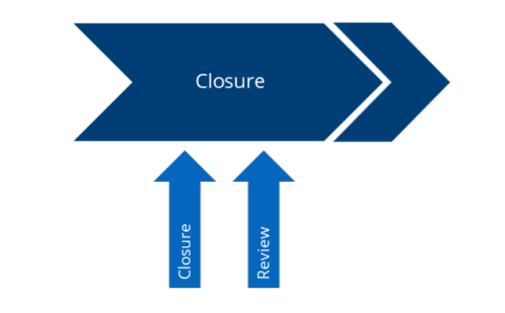

### Project Closure

The [Project Closure Report](https://partnerstim.temenos.com/tim/Documents/Generic/Project%20Closure%20template_v4.xlsx) is a checklist tool used to ensure that all outstanding activities have been completed and that the project can be formally closed. Although the process formally resides under the Project Closure stage, the [report](https://partnerstim.temenos.com/tim/Documents/Generic/Project%20Closure%20template_v4.xlsx) itself can be developed and reviewed at each stage of the project implementation life cycle.

**Prepare Project Closure Report**

* Conduct internal meetings with the implementation team members to secure feedback for the initial draft of the [Project Closure Report](https://partnerstim.temenos.com/tim/Documents/Generic/Project%20Closure%20template_v4.xlsx) and create the initial draft.
* Review the initial draft and elicit feedback from the following parties:
* Project implementation team
* Client [PM](https://partnerstim.temenos.com/tim/Infinity/Closure/Project_Closure.htm)
* Other relevant third-parties
* Complete the [Project Closure Report](https://partnerstim.temenos.com/tim/Documents/Generic/Project%20Closure%20template_v4.xlsx) and submit it to the [ASM](https://partnerstim.temenos.com/tim/Infinity/Closure/Project_Closure.htm) for a formal review.

**Review Project Closure Report**

* [ASM](https://partnerstim.temenos.com/tim/Infinity/Closure/Project_Closure.htm) and Regional Governance Team review the [Project Closure Report](https://partnerstim.temenos.com/tim/Documents/Generic/Project%20Closure%20template_v4.xlsx) for accuracy and completeness.
* Confirm acceptance of the [Project Closure Report](https://partnerstim.temenos.com/tim/Documents/Generic/Project%20Closure%20template_v4.xlsx).
* [ASM](https://partnerstim.temenos.com/tim/Infinity/Closure/Project_Closure.htm) to signoff the [Project Closure Report](https://partnerstim.temenos.com/tim/Documents/Generic/Project%20Closure%20template_v4.xlsx).

### Project Implementation Review

The [Post-Implementation Report](https://partnerstim.temenos.com/tim/Documents/Generic/PIR%20v1.1.docx) is a critical management tool that enables us to review, capture and refine the intellectual property, derived from the implementations. It ensures that software developments are documented, accessible and reusable.

From an implementation methodology perspective, it provides the opportunity to continuously improve the processes and delivery execution.

**Prepare Post-Implementation Review Report**

* Conduct internal meeting with the implementation team members to secure feedback for the initial draft of the [Post-Implementation Review Report](https://partnerstim.temenos.com/tim/Documents/Generic/PIR%20v1.1.docx) and create an initial draft.
* Review the initial draft and elicit feedback from the following parties:
* Project implementation team
* Other relevant third parties
* Complete the [Post-Implementation Review Report](https://partnerstim.temenos.com/tim/Documents/Generic/PIR%20v1.1.docx) and submit it to the [ASM](https://partnerstim.temenos.com/tim/Infinity/Closure/Post_Implementation_Review.htm) for a formal review.

**Review Post-Implementation Review Report**

Circulate the [Post-Implementation Review Report](https://partnerstim.temenos.com/tim/Documents/Generic/PIR%20v1.1.docx) to the relevant parties:

* Chief Cloud and Delivery Officer
* [RSD](https://partnerstim.temenos.com/tim/Infinity/Closure/Post_Implementation_Review.htm)
* [ASM](https://partnerstim.temenos.com/tim/Infinity/Closure/Post_Implementation_Review.htm)
* Product Manager (if applicable)
* Support Manager
* Account Manager

Arrange meeting/conference call for a formal review.

Sign off project closure review and upload the report in SharePoint.

# Quality Assurance

## Project Health Index (PHI)

Our PHI standards measure the project process compliance as per ISO 9001: 2008, ISO 27001: 2013 and CMMi level- 3 is as depicted

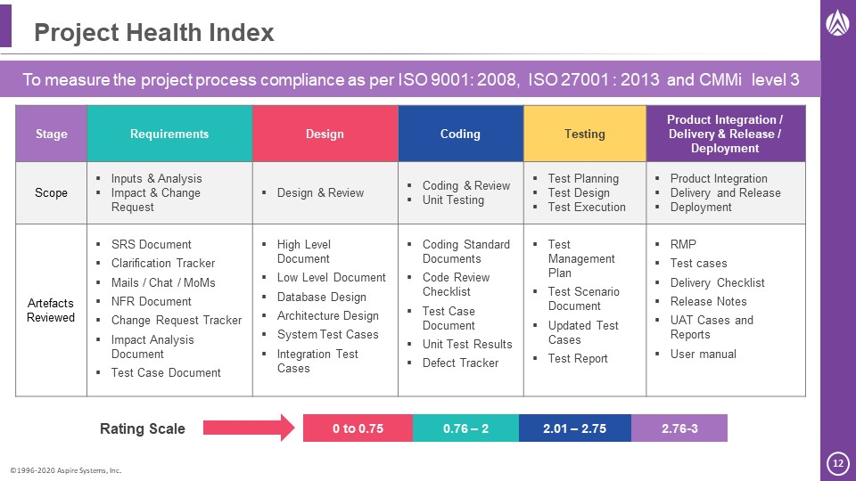

## Technical Health Index

Our THI standard principles comprise of:

* A monthly review process against the technical quality of the application on all the active projects​
* The process is defined based on the technology​
* All the members of ATG & Tech Leads from other projects are formed as the THI auditor group​
* THI guidelines & check list are defined for the auditors to conduct the audit​
* A centralized system “[thi.aspiresys.com](http://thi.aspiresys.com)” is used to schedule the THI as well as to update the Review comments​
* A score in the range of 0 to 3 with 0 as poor and 3 as good with color code GREEN – AMBER – RED will be provided against each category​
* The score & review comments is visible to the Management and will be reviewed with DM/PM​

Auditors will follow up with the respective team for the closure of the identified reviews in the consecutive audits.

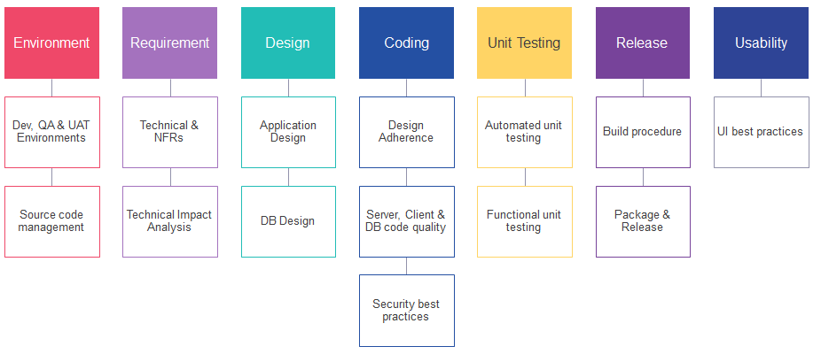

# Testing Approach

## Our Experience with Temenos Suite

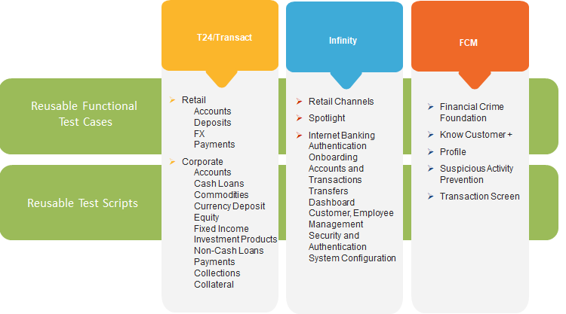

## Our Approach to Testing

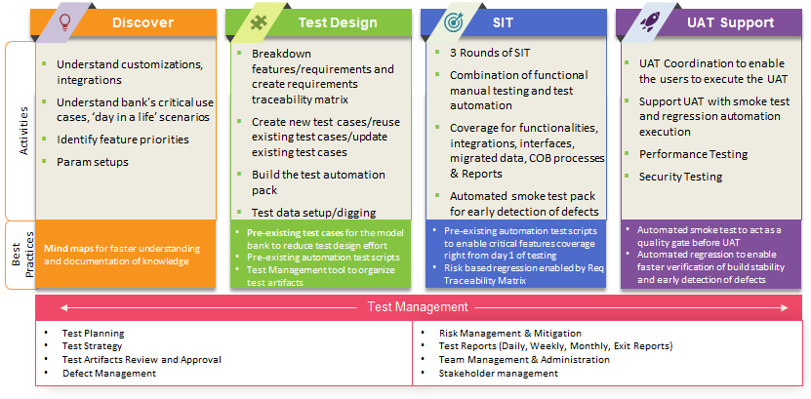

## SIT Approach- Customizable

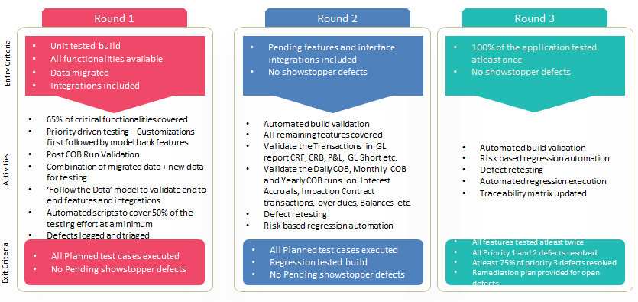

## UAT Approach

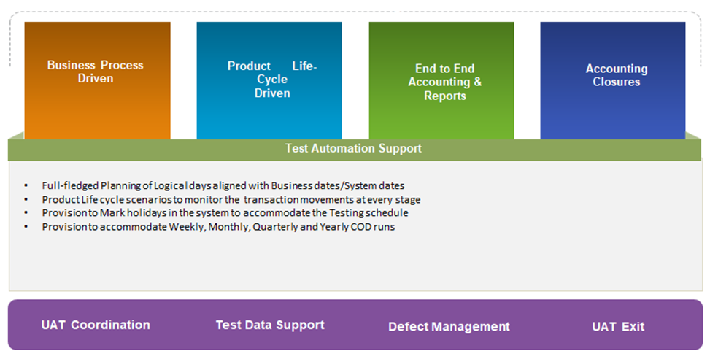

## UAT Support Approach

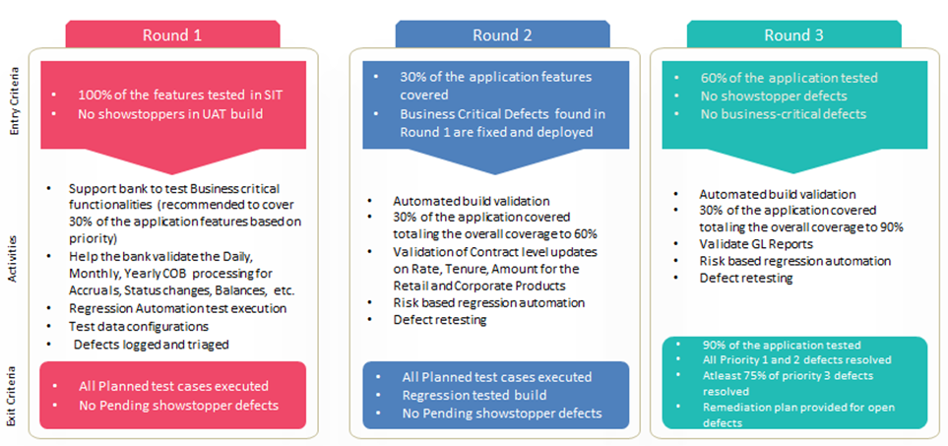

## Value from our regression automation methodology using validata

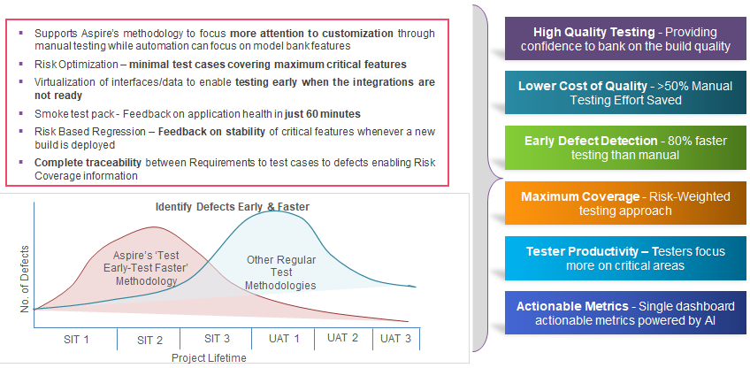

## Performance & Security Testing Approach

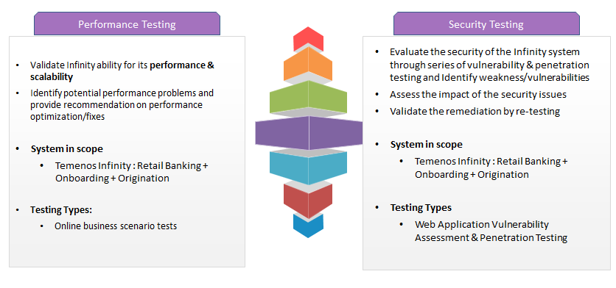

## Measuring Test Experience

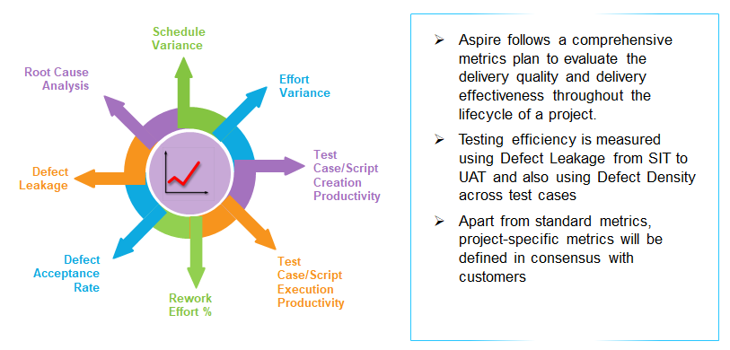

## Why Aspire Testing?

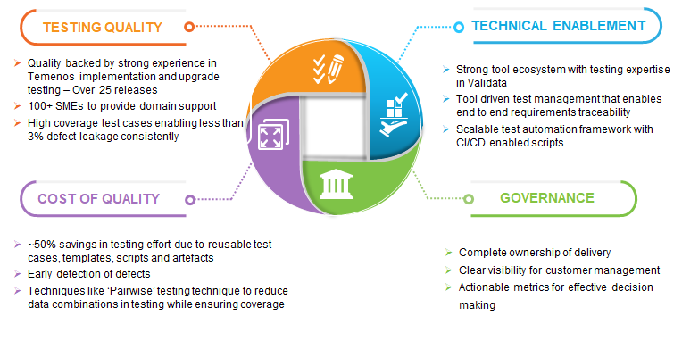

## Our Testing Customers

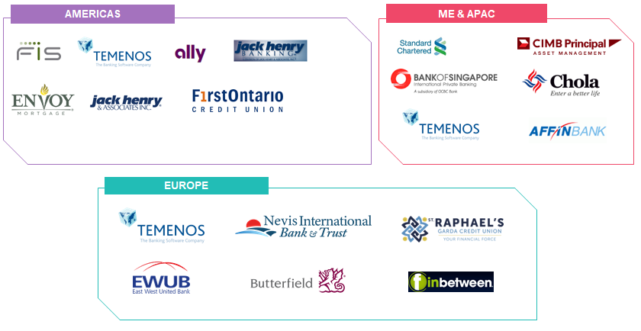

# Data Migration Approach

This document outlines the methodology to be followed for Data Migration Activity. This methodology is process driven with each stage clearly defined by below process flow diagram.

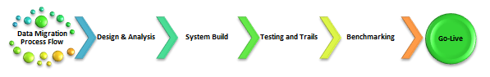

The stages above describe high-level approach for data migration and highlights the main steps to be considered and executed. Although these stages are described sequentially in practice, some may overlap or be applied concurrently. The outcome of each stage is described by a set of project management deliverable. These deliverables provide visibility to all project stakeholders. Each stages and deliverables are described in more detail in the sections that follow.

## Stage 1 – Design & Analysis

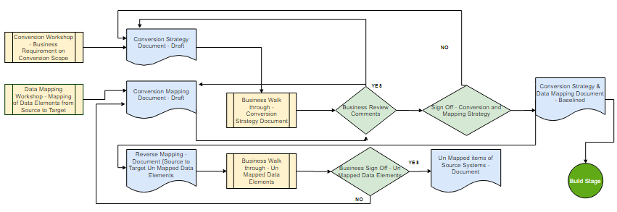

By analysing the functionality being implemented, ASPIRE will identify data that is required in Digital platform. Once both the legacy and target data analysis are complete, they will be brought together for assessment and the proposed migration inventory will be updated and approved. The dependencies, sequencing, estimated volumes and runtimes will be established for each migration.

For each migration execution, procedures will be understood and data mapping document will be completed. These design and data mapping will include extract criteria that must be applied in the source system and upload method used in target system. Partner will own the design for Transformation, migration and reconciliation approach in the target system.

Reverse mapping will be accomplished in target system during mapping phase to ensure the un-mapped data fields are identified and reported. This procedure will ensure end-to-end mapping is covered from source to the target system.

## Stage 2 – System Build

This stage includes developing the scripts for source data extraction, target data upload and data reconciliation. These scripts are built in such a way to reuse the capabilities and reduce the dependency within the build solution.

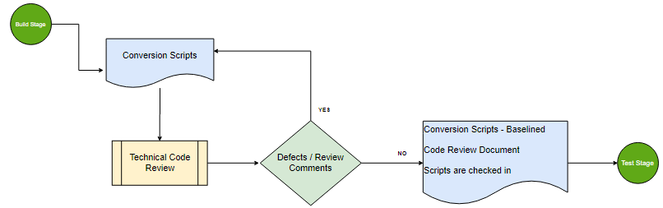

Source: The procedure logic in the extract script in the source system is built in line with data mapping sheet designed during the mapping phase. The extract program must control the scope of records by exact definition of selection criteria as defined in design document.

## Stage 3 – Testing & Trails

Data validation after a data migration is essential to make sure that the data has been transferred and converted correctly as expected from Business point of view. The below validation should be performed during implementation and cut-over to ensure the integrity of data.

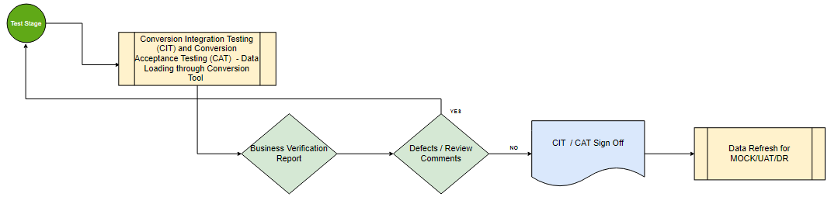

**Technical Validation (CIT):**

All the migration process will be validated during the conversion integration testing. Technical validation will be performed to ensure that the migration process (Mapping, Conversion and Upload) are implemented correctly. Below are the objectives of CIT.

* Data Mapping Integrity Check
* Validate source file formatting
* Validation of transformed data
* Baseline source extraction and target upload tools
* Recon reports baseline

**Functional and Business Validation (CAT):**

Business involvement during CAT stage is to ensure that the migrated data meets the original design and processed correctly in the target system. This involves the data sampling check at application level and detailed verification of reconciliation reports. Below are the objectives of CAT.

* Validate the migrated data at field level
* Data sampling of each module on the migrated data
* Recon report verification

## Stage 4 – Benchmarking

One of the factors for successful data migration depends on the intensity is careful execution of the mock tests/trail runs. The data migration programs should be tested as early and extensively as possible with production like test data both regarding quantity and quality. Mock / DR test will ensure technical consistency between extracted and migrated data. The following aspects will be taken care during the Mock phase.

* Sequencing and dependencies of cut over activities
* Verify run times. Identify tasks on critical path.
* Identify technical shortfalls and workarounds
* Identify issues and risks

The migration success rates must trend towards 100% by the final dress rehearsal (DR) and will be considered as complete when all processes are executed end-to-end successfully. Tasks, run-times and dependencies will be reported to the cutover team to include all the information in the cut-over planning.

# Training plan

## Technical Training Plan

|  |  |  |
| --- | --- | --- |
| **Topic** | **Sub topics** | **Day** |
| Introduction | Introduction Kony Visualizer and it is basic | 1 |
| The Kony Visualizer Default Perspective |
| Lifecycle | Application Life cycle, Properties and Form cycle | 1 |
| Basic Widgets(Layouts, Button and Text) |
| Actions | Looks and properties | 2 |
| Using the Action Editor to implement business logic |
| Skins | Skinning, forking and themes, Kony JavaScript API | 2 |
| Internalization and its API |
| Application Architecture | MVC Architecture | 2 |
| Widgets | Advance Widgets (Image widget etc.) | 3 |
| Basic Segment, Types and Row Templates |
| Components | Advance Segment(Row Header) | 3 |
| Components |
| Fabric | Kony Fabric Introduction | 4 |
| list Of Services |
| Services | Service Configuration | 4 |
| Post/Pre Processors | Pre/ Post processor | 4 |
| Integration and Invoking a service |
| Animations | Animation and its Types | 5 |
| Bread Crumbs |
| API | Kony API's | 5 |
| Best Practices | Debugging an application | 5 |
| Best practices |
| FFI | FFI overview and Implementation details | 5 |
| Build an app for Multi platforms |

## Functional Training Plan

The out of box functionalities available in the BSF’s requirement has been covered in training scope. This can be modified during analysis and planning phase.

**RETAIL BANKING**

|  |  |  |
| --- | --- | --- |
| **Feature** | **Sub Features** | **Day** |
| Authentication | Sign In | 1 |
| Can't Sign In |
| Device Registration |
| Face Authentication |
| PIN-based Login |
| Fingerprint Authentication |
| Multi Factor Authentication |
| Prelogin Actions | Locale |
| Self-Enrollment |
| New User Account Opening (Onboarding) |
| Prelogin Accounts Preview |
| Accounts and Transactions | Dashboard |
| Account Details and Transactions |
| Recent and Scheduled Transactions |
| Advanced Transaction Search |
| E-Statements |
| Print Account Transactions |
| Download Account Transactions |
| Open a New Account |
| Dispute Transactions and Stop Check Payment |
| Pay Loan Amount |
| Add External Account |
| Transfer Money | Transfer | 2 |
| Recent Transfer |
| Scheduled Transfer |
| Manage Recipients |
| Add Recipients |
| Wire Transfers |
| Overdraft Notification |
| Cardless Cash | Self Cardless Cash |
| Cash Withdrawal to Other Person |
| Cardless Cash Actions |
| My Bills | Add a Bill Payee |
| Initiate a Bill Payment |
| Manage all Bill Payees |
| Initiate ude bill payment to a bill payee |
| View the previous transaction activity of the bill payee |
| Activate/Deactivate the e-bill feature for a bill payee |
| Edit the details of a bill payee |
| Delete a bill payee |
| Scheduled Bill Payments |
| Search for a Bill Payee |
| View Bill Payment History |
| Pay a Person | Add a P2P Recipient | 3 |
| Manage P2P Recipient |
| Edit the detail of a recipient |
| Delete a recipient |
| Send Money to a recipient |
| View Activity |
| Search for a recipient |
| Send Money |
| View P2P Transfers |
| Modify or Cancel a Scheduled P2P Transfer |
| Repeat a P2P Transfer |
| Cards Management | Manage Cards | 4 |
| Lock or Unlock a Card |
| Replace a Card |
| Report the Card Lost or Stolen |
| Change a card pin |
| Stop or Cancel Card |
| Travel Notification |
| MFA Integration |
| For OTP |
| For Security Questions |
| Personal Finance Management | Account List |
| Spend Analysis |
| Budget Snapshot |
| Uncategorized Transactions |
| Profile Management | Account Settings |
| Profile Settings |
| Security Settings |
| Alert Settings |
| Messages | View a Secure Message |
| View an Alert |
| About Us | Locate Us | 5 |
| Privacy Policy |
| Terms and Conditions |
| FAQs and Help |
| Contact Details |
| Locate a Nearby ATM or Branch |
| Remote Deposit Capture (Mobile only) | Initiate an RDC |
| Recent Deposits |
| Pending Deposits |
| Wearables (Mobile only) | Apple Watch |
| Additional Features | 3D Touch (Mobile only) |
| Chatbots (Mobile only) |
| Feedback |
| App Rating and Feedback (Mobile only) |
| Enable Prelogging Account Preview (Mobile only) |
| Direct Marketing (Mobile only) |
| Detect Unsupported Browsers |

**ONBOARDING (1 – Day Plan)**

|  |  |
| --- | --- |
| **S. No.** | **Feature** |
| 1 | App Landing Page |
| 2 | Resume Application |
| 3 | External Site Integration |
| 4 | Eligibility Criteria |
| 5 | Application Details |
| 6 | Pre-Fill Details |
| 7 | Enter Manually |
| 8 | Personal Information |
| 9 | Product Selection |
| 10 | Address and Identification Details |
| 11 | Verify Phone Number |
| 12 | Identity Verification |
| 13 | Co-Applicant Details |
| 14 | Submit Application |
| 15 | Application Status |
| 16 | Enrollment |
| 17 | Audit Logs |
| 18 | Configure PII Information |
|  | Configurations |
| 19 | Spotlight |
| 20 | Journey Manager |
| 21 | Microservices |

# APPLICATION Support APPROACH

## Support Services Model

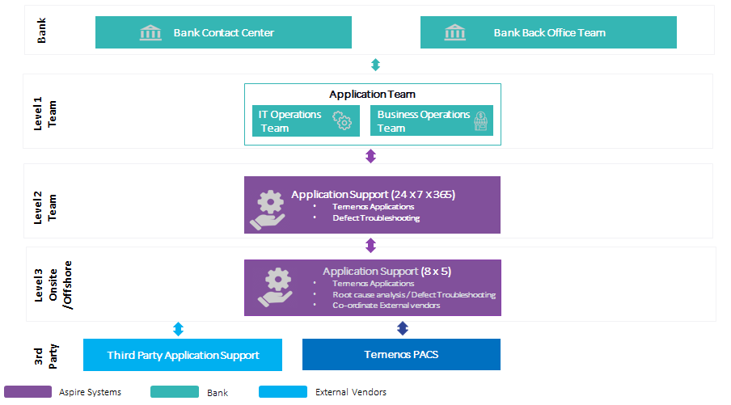

## L2 Support Flow

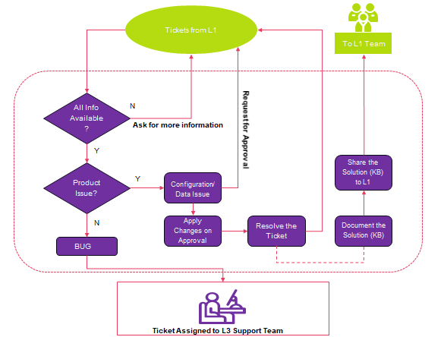

## SLAs for L2 Application Support

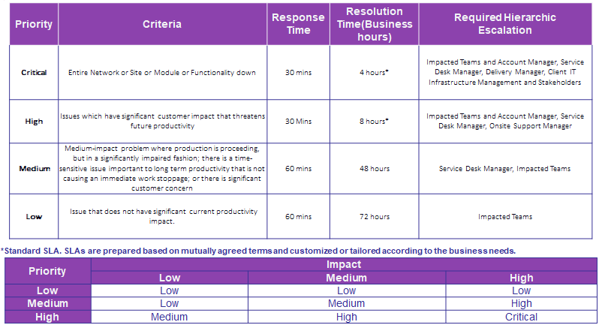

## SLAs for L3 Application Support

