User Authentication and User Authorisation

django rest framework : https://www.django-rest-framework.org/api-guide/authentication/#tokenauthentication

Method used is token authentication:

JSON Web token Authentication : (https://github.com/jazzband/djangorestframework-simplejwt)

documentation https://django-rest-framework-simplejwt.readthedocs.io/en/latest/

step 1 :

Step 2 :

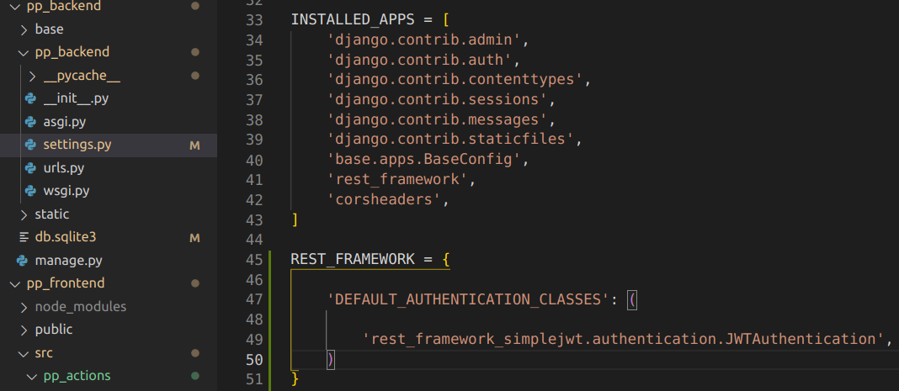
Step 3 : Use Regular token and setting lifespan of last 30days
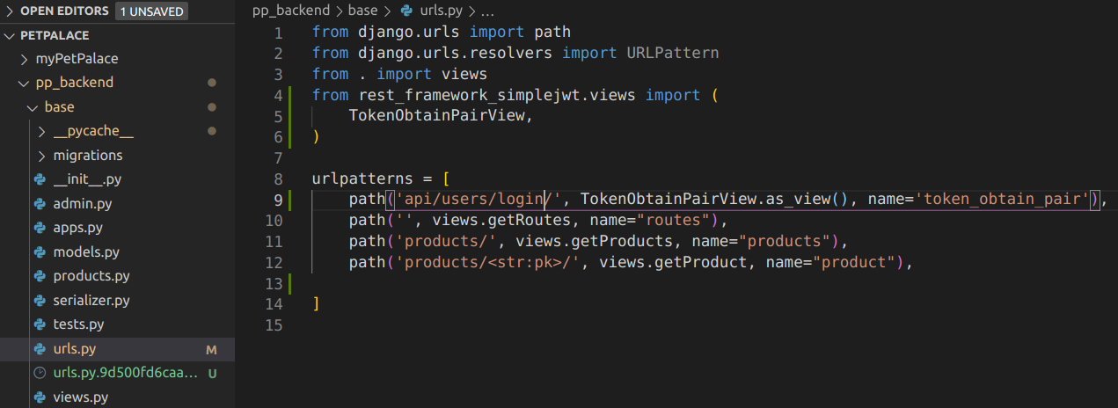

http://localhost:8000/api/users/login/
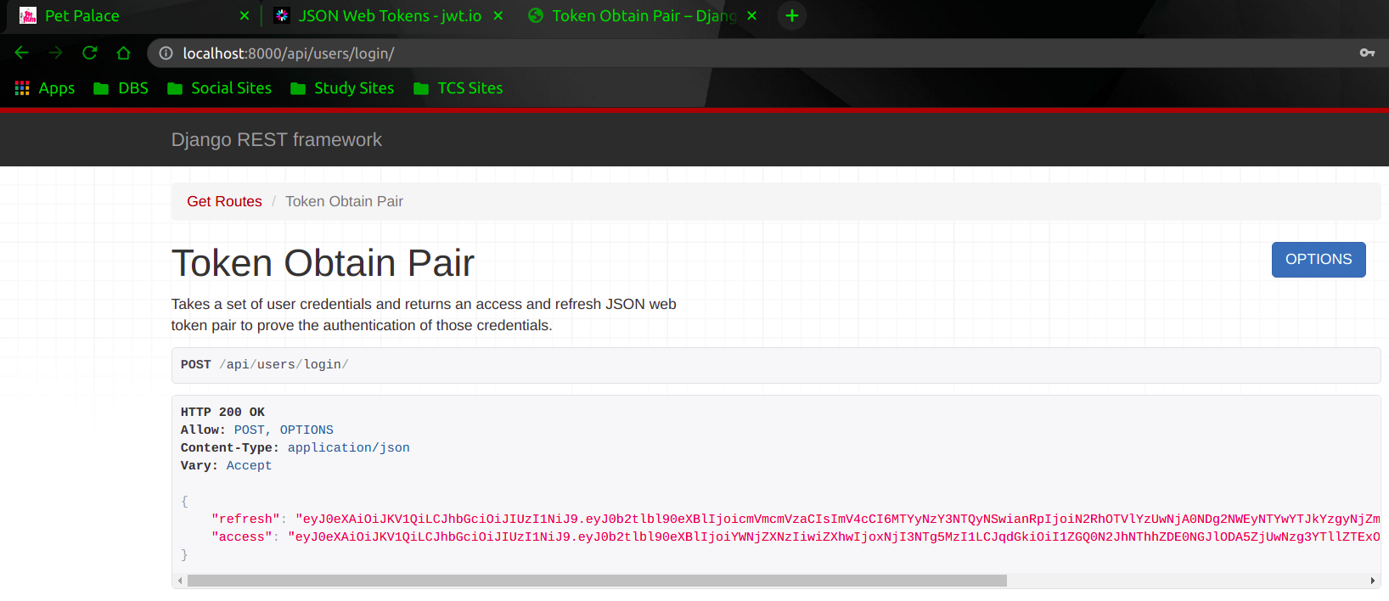

when we check this access token information on https://jwt.io/ site we get information as below

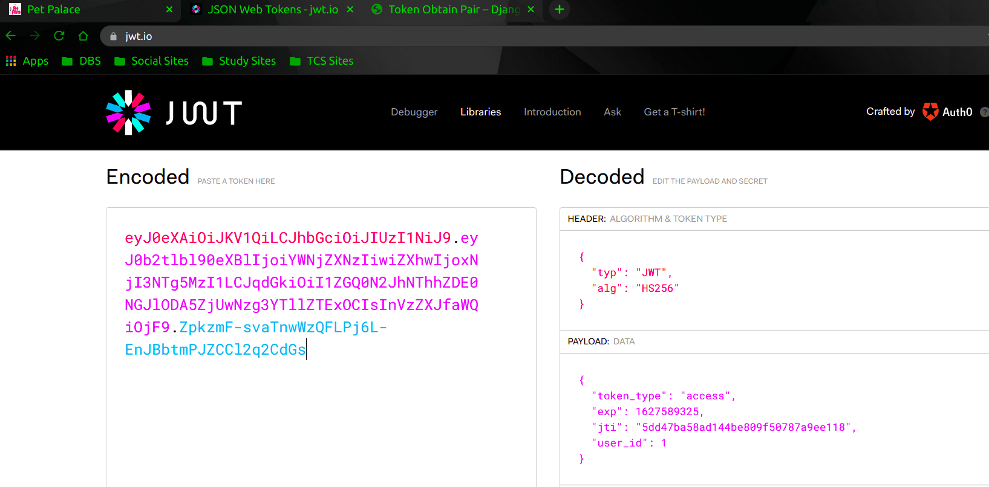

Token Customization – changing expiration time to 30days.
