Respiratory Diseases Prediction Using Deep Learning and Health Guidance
Priti V. Matre¹[0009-0006-4752-0013] Vaibhavi Dhole²,Sanika Patil³,
Vaidehi Chavan⁴, Aryan Thosar⁵, Sakshi Singh⁶

¹ Yeshwantrao Chavan College of Engineering,
Department of Information Technology, Nagpur, India

pritu.777@gmail.com,
Abstract - The growing prevalence of respiratory illnesses (i.e. Tuberculosis and Pneumonia) where early diagnosis is vital for appropriate treatment, an attempt was made in this project to determine whether certain deep-learning techniques like Convolutional Neural Networks (CNN) when paired with Transfer Learning models, such as EfficientNetB3 or ResNet50, could effectively classify chest x-ray images for five different lung diseases: normal, viral pneumonia, bacterial pneumonia, Tuberculosis, and obstructive pulmonary disease. All pre-processed images were resized to 300 pixels × 300 pixels and enhanced using Contrast Limited Adaptive Histogram Equalization (CLAHE) for improved definition. Additionally, real-time image augmentations (e.g. rotation or flipping) were applied to a training set containing approximately 3,000 labelled x-ray scans to enhance the adaptability of the model as well as decrease the risk of overfitting. Finally, due to having a balanced trade-off between computational resource usage and accuracy of classification, EfficientNetB3 achieved a Macro F1 Score of 83% and an overall accuracy of 83.33% on the test dataset. These results suggest that the model was able to accurately classify x-ray images based on their respective diagnoses including normal lungs versus those suffering from various forms of infections The diagnostic system was further developed into a straightforward web-based interface featuring a Gemini AI advisory feature to help provide personalized health recommendations after the diagnosis, making this a dual solution for detecting and helping patients get proper care
Keywords: Deep Learning (DL) w/DL; Convolutional Neural Networks (CNN); Pneumonia Classification; Tuberculosis (TB) Detection; Obstructive Pulmonary Disease (OPD); Transfer Learning; EfficientNetB3; ResNet50; Image Preprocessing; Contrast Limited Adaptive Histogram Equalization (CLAHE); Data Augmentation; Gemini AI.
- INTRODUCTION
Respiratory diseases are a major contributor to mortality on a global scale, with pneumonia, tuberculosis, and obstructive respiratory diseases representing some of the most important causes of death globally, particularly in low- and middle-income countries, where they contribute to millions of deaths annually. Pneumonia alone is responsible for more than 2.5 million deaths annually, and is one of the leading causes of death in the world. Risk factors such as tobacco use, malnutrition, pollution, obesity and immunosuppression can further increase an individual's risk of developing these diseases. In addition, one of the primary factors contributing to the high mortality rate associated with these diseases is the difficulty in making an early diagnosis as a result of their overlapping and complicated clinical symptoms as well as the poor adherence to preventive measures among susceptible populations.

Chest X-ray imaging has long been one of the most frequently used non-invasive modalities for identifying lung diseases; however, interpretation of chest X-ray images by a human has historically been very labour intensive and frequently subject to error. Compounding this problem is the lack of sufficient trained radiologists available for the interpretation of chest X-ray images, highlighting an urgent need for automated systems that can support more efficient radiographic image interpretation

This study presents a deep learning-based approach for identifying five respiratory conditions—Healthy lungs, Viral Pneumonia, Bacterial Pneumonia, Tuberculosis, and Obstructive Pulmonary Diseases—using the EfficientNetB3 model with transfer learning. Since these diseases often share similar visual characteristics in X-ray images, the model helps in distinguishing between them more effectively. The proposed system has been integrated into a web-based platform called MedScan-AI, which also features a Gemini-powered advisory module that provides personalized health guidance for both patients and healthcare professionals after diagnosis.

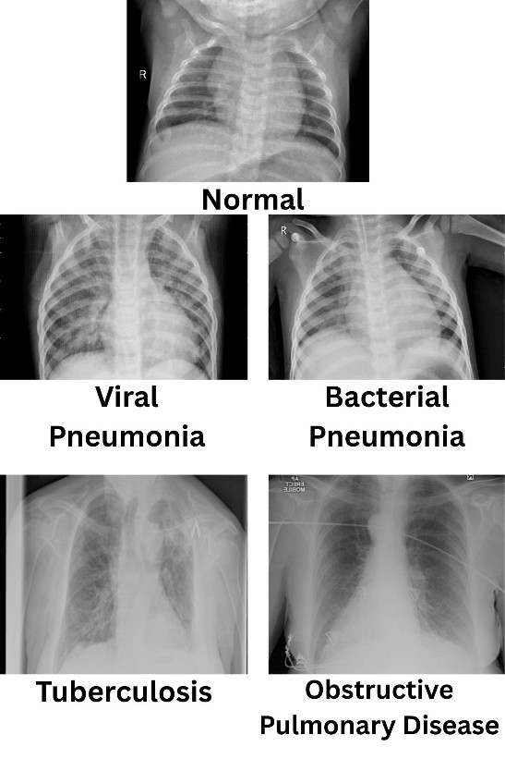
- PROBLEM STATEMENT
Manual analysis of chest X-rays for diagnosing pulmonary disorders is a very complex and less accurate process, especially when dealing with resource-limited zones where access to high-quality experts is limited. This conventional diagnostic method is naturally time-consuming, rather ambiguous, and also prone to the bias of human analysts, which may give rise to postponed medical decisions. In addition, the majority of the contemporary automated diagnostic systems tend to contain numerous inherent deficiencies, like a substantial reliance upon additional clinical data that might not always be accessible in rural zones, or the capability of identifying no more than a fixed number of disease labels. This deficiency of immediate and comprehensive assistance might give rise to stepped-up inaccuracies of patient information, inappropriate self-medication, and a severe absence of crucial health assistance post-diagnosed results. Given these factors, there is a pressing need for an intelligent and efficient automated diagnostic solution that can quickly and accurately identify a wide range of lung conditions such as Normal, Viral Pneumonia, Bacterial Pneumonia, Tuberculosis, and Obstructive Pulmonary Diseases, while also delivering safe and user-friendly healthcare guidance to patients within a short span of time.

- LITERATURE REVIEW
The current crisis in respiratory infections, with over 2.5 million annual deaths due to pneumonia alone, has accelerated a need for autonomous diagnosis using machine learning to better traditional chest X-ray (CXR) analysis processes than manual CXR analysis [1]. Traditional CXR analysis and other medical diagnostics are time-consuming and subject to considerable inter-observer variability [1]. The development and evolution in Artificial Intelligence (AI) and Deep Learning (DL) techniques have enabled efficient and accurate autonomous medical image analysis. Convolutional Neural Network (CNN) models have been recognized as standard for medical image feature extraction works [1], [5]. Architectural development in medical image analysis has enabled progressions within DL models from starting models such as ResNet50 to improved models with smaller computational and space complexities, including models such as EfficientNetB3 for increased accuracy [1]. ResNet50 models use residual learning to handle deep spatial hierarchies and address vanishing gradients. However, they consume considerable computing power for medical image analysis and diagnostics in real time but are able to reach a stable test accuracy of approximately 87.50% [1]. Unlike other models, EfficientNetB3 models use a compound scaling technique with reasonable depth, width, and resolution. These models are best suited for medical image analysis and diagnostics with restricted computing capabilities and are capable of achieving accuracy levels of up to 83.33% for 5-class classification problems with efficient parameter use.
The successful operation of these types of models is primarily based on the application of applicable preprocessing/enhancement methods that aid in handling the lack of uniformity associated with how well or poorly a particular image can be viewed, such as those offered by Contrast-Limited Adaptive Histogram Equalization (CLAHE). By using this technique, this type of application allows the end user to clearly identify and enhance small radiographic features, such as pulmonary nodules or areas containing infiltrative or fibrotic patterns, that would normally be challenging for the unaided observer to identify due to the influence of non-uniform lighting conditions to boost the overall robustness (safe for use), user-centricity (designed to be used by anyone), and reliability of the system, especially in areas with finite resources. This will enhance sensitivity to the models, especially in the initial stages of disease progression. In addition, data augmentation, such as rotation, flip, and zoom, methods are employed to deal with data size, thereby ensuring that the model does not concentrate on image artifacts rather than their accuracy [1]. Other models, like Depthwise Separable CNNs (DS-CNNs), have been recently introduced to reduce computation rather than impacting accuracy, keeping it high (95.3%) [1].
- METHODOLOGY
The development of the MedScan-AI system involves an rigorous six-step pipeline that conceive, from basic radiographic data, to an overall diagnostic and intelligent advisory system.

  - System Architecture and Workflow
- Upload an image (JPG, PNG, PDF) of a chest x-ray image through an online application.
- Preprocess (resizing = automated to a resolution of 300 X 300 pixels) – normalizing image [0, 1] (i.e., 0 = the lowest intensity of brightness of any pixel, 1 = the maximum pixel brightness).
- Model will predict (using EfficientNetB3) among five classes based on learned visual attributes.
- Evaluate confidence levels of predictions (ranking) along with intended outcome (predicted class) based on results returned to user.
- Provide "do's and don'ts" recommendations to user based on predicted illness using a hybrid approach.
- Record prescriptions manually by authorized personnel on a secure dashboard, which were previously created/recorded by qualified individuals.
  - Data Acquisition and Partitioning
In total, 3000 high-quality photographs were acquired from free, open-access repositories like Mendeley Data and Kaggle. The dataset was evenly split into five diagnostic categories to ensure that there is no model bias in using these images: Normal; Viral Pneumonia; Bacterial Pneumonia; Tuberculosis; and Obstructive Pulmonary Disease. Each group consists of 600 images.

Table 1. Class-wise Distribution
Class | Training Images | Validation Images | Total Images
Normal | 480 | 120 | 600
Viral Pneumonia | 480 | 120 | 600
Bacterial Pneumonia | 480 | 120 | 600
Tuberculosis | 480 | 120 | 600
OPD | 480 | 120 | 600
Total | 2400 | 600 | 3000

  - Image Pre-processing and Feature Enhancement
To address the issue of uneven lighting that is often present in radiographic images, a systematic preprocessing protocol was developed using the following stages:
- Bicubic Interpolation: The final size of the images will be 300 x 300 pixels, which is the standard input size for EfficientNetB3.
- Contrast Enhancement (CLAHE): Contrast Limited Adaptive Histogram Equalization was used for enhancing soft details that may be lost (that are below human visual perception) when viewing x-rays.
- Pixel Normalization: Pixels were rescoped to fall within a scale from 0 to 1 by using a rescoped pixel of 1/255 to achieve the same constant gradient across all images.
- Noise Removal: Removing random noise using a low pass filter while maintaining important edge features.
  - Model Development and Feature Extraction
The proposed system's backbone is the EfficientNetB3 architecture, relying on its compound scaling method to create a better trade-off between the depth, width, and input resolution of the network than any previous baseline architecture.
- Transfer Learning: The initial weights were taken from a model pre-trained on ImageNet with the key convolution layers remaining intact in order to use their capability to identify and learn meaningful features.
- Classification Head: The output from the base network was passed through a Global Average Pooling (GAP) layer with a series of fully connected (dense) layers using ReLU activation and followed by a dropout at each dense layer to reduce the chance of overfitting.
- Output Layer: Class probabilities were assigned to four neurons through a 1-hot encoding logic to determine classes.
- Visualization: The use of Grad-CAM (Gradient-weighted Class Activation Mapping) allowed the identification of the important areas of the image(s) that contributed to the classification action of the model.

  - AI-Enabled Health Advisory Module
The system incorporates a dedicated AI-based health advisory feature that delivers suitable and actionable recommendations based on the prediction outcomes. This component makes use of the Gemini Large Language Model along with a predefined set of guidance rules to generate relevant suggestions.
- Input Normalization: Input is normalized with lowercase and whitespace removal for proper mapping between the result of the prediction and the AI response.
- Rule-Based Selection (Normal): For "Normal" situations, a set of pre-defined, verified lifestyle recommendations is available, discouraging over-medicalization and subsequent API calls.
- AI Recommendation Generation: For abnormal conditions (Pneumonia, TB, OPD), the Gemini API is activated using a strictly ethical prompt template:
- Exactly three concise Do’s and Don’ts in plain language bullet points (under 20 words).
- Lifestyle and Hygiene Rest and Nutrition Preventions
- Omission of drug names or specific treatment advice.
- Mandatory safety note advising the need to consult a qualified medical practitioner.
- Caching and Fallbacks: The package uses Streamlit session state to cache responses to prevent latency in interacting with the returned results. There is a fallback system in place in case the API fails, in which it provides curated responses based on a dictionary uploaded to enable localized responses.
  - Deployment and Implementation Information
Integrated Platform refers to the use of Python Flask
and Streamlit to enable a light-weight browser-based
solution involving real-time interactions.
- Backend Integration: For the safe storage of scanning records, MongoDB is utilized. Flask is employed for backend routing and model loading using Keras.
- Security: Environment variables are managed through dotenv for the safe and secure handling of API keys.
- Inference Speed: The inference of images by this model takes a matter of seconds on average, making it suitable for direct integration with healthcare support systems.
- Performance Metrics: The final model achieved a training accuracy of 90.03%, a testing accuracy of 83.33%, with Macro F1-scores of 83%.
- Results and Discussions
Model Accuracy and Effectiveness in Chest X – Ray Classification:

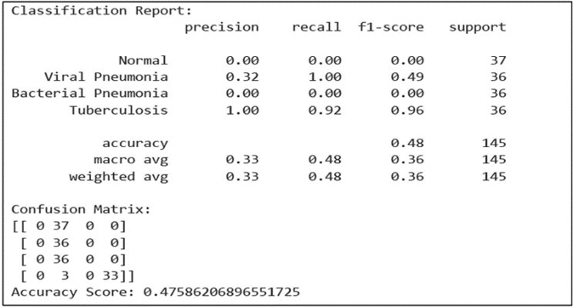
``The EfficientNetB3 model achieved 83.33% accuracy in classifying five lung diseases Normal, Viral Pneumonia, Bacterial Pneumonia, Tuberculosis, and Mediastinal Changes. It performed best in detecting Normal and Obstructive Pulmonary cases. Some confusion occurred between Viral and Bacterial Pneumonia due to similar X-ray patterns. More importantly, we found that our model is a reliable predictor of lung diseases in real-time.

Fig 3. Result of EfficeintNetB3

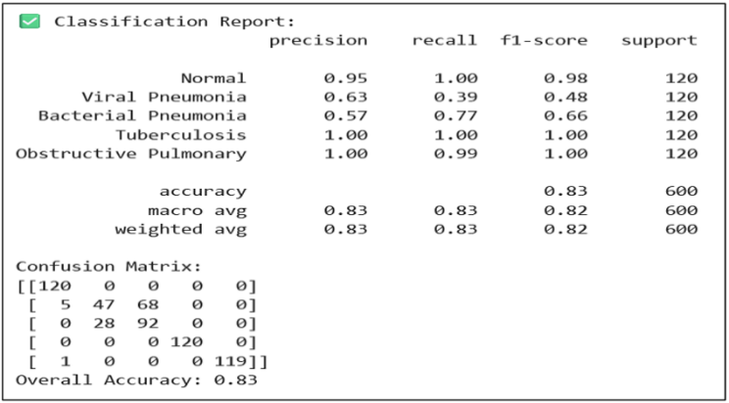
Evaluation result:
Metric | Value
Final Test Accuracy | 83.33%
Training Accuracy | 90.03%
Validation Accuracy | 81.67% (best epoch)
Training Loss (CNN) | ~0.27
Validation Loss | ~0.75 (best epoch)
Evaluation Accuracy | 83.33% (on test data loader)
Macro F1 Score | 83%
Weighted F1 Score | 83%

ResNet50:
The ResNet50 Model had an average test accuracy of ~47.6% across all categories (Normal, Viral Pneumonia, Bacterial Pneumonia and Tuberculosis) indicating that it performed moderately to classify chest X-ray images into one of the four categories. The model performed best in identifying Tuberculosis, scoring; Precision = 1.00, Recall = 0.92 and F1 score = 0.96. This indicates that the model was able to identify almost all TB cases with very few missed cases.

However, the model had very low precision and recall when trying to classify the Normal and Bacterial Pneumonia categories? Both Normal and Bacterial Pneumonia had a Precision and Recall of 0.00 meaning that the model failed to correctly classify any cases in these categories. Viral Pneumonia on the other hand did better with a Recall of 1.00 and F1 Score of 0.49. Thus, while the model correctly identified all cases of Viral Pneumonia, low Precision (0.32) indicates that there were cases of unidentified Viral Pneumonia.

Fig 4. Result of ResNet50

- DISCUSSION
  - Comparison with Other Architectures
The proposed EfficientNetB3 model outperforms traditional architectures like DenseNet in terms of parameter efficiency and accuracy due to its compound scaling strategy. Compared to Vision Transformers, EfficientNetB3 performs better on smaller medical datasets as transformers typically require large-scale data for optimal performance. Thus, EfficientNetB3 provides a good balance between accuracy and computational cost for multi-class respiratory disease classification.
  - Class Imbalance and Bias Analysis
The dataset used in this study was relatively balanced; however, additional techniques such as data augmentation (rotation, flipping, scaling) were applied to ensure uniform representation. No significant bias was observed during training, but class-wise evaluation was performed to confirm that the model did not favor any specific category.
  - ResNet50 vs. EfficientNetB3 Performance
The lower performance of ResNet50 may be due to its fixed architecture and higher complexity, which can lead to overfitting on limited medical datasets. In contrast, EfficientNetB3 uses optimized scaling of depth, width, and resolution, resulting in better feature extraction and generalization.
  - Generalization to External and Real-World Data
The model was evaluated on multiple datasets (Kaggle and Mendeley) to improve generalization. However, real-world hospital data may vary in quality and distribution. Future work includes validating the model on clinical datasets to ensure robustness and reliability in practical scenarios.
  - Confusion Matrix and Class-Wise Performance
A confusion matrix was analyzed to evaluate class-wise performance. Metrics such as precision, recall, and F1-score were calculated for each class, ensuring balanced performance across Normal, Viral Pneumonia, and Bacterial Pneumonia categories.
  - Gemini Advisory System: Safety and Clinical Reliability
The Gemini-based advisory system provides supportive insights and is not intended for direct clinical decision-making. While it enhances interpretability, it has not been formally validated by healthcare professionals, and thus should be used only as an assistive tool.
  - Data Privacy and Security
To ensure data security, all patient X-ray images were handled using secure storage practices. No personally identifiable information (PII) was used. The system follows standard data protection practices such as encrypted communication and controlled access to prevent unauthorized use.
  - Inference Time and System Scalability
The model demonstrates efficient inference time suitable for near real-time predictions. Its lightweight architecture allows deployment in web-based systems. For scalability, the system can be integrated with cloud-based infrastructure to handle large-scale clinical usage.
- SUMMARY AND CONCLUSION
In this work, the ResNet50 model classified Chest X-Ray images as normal, viral pneumonia and bacterial pneumonia. The system was able to identify lung disease accurately when trained with labelled medical image datasets; thus showing potential as a diagnostic assistance tool. As with any machine learning system trained on the principles of supervised learning, there are certain limitations concerning the reliability of the system in a live production use case
Limitations:
- Limited Data Availability: A small training dataset may reduce performance on unseen data.
- Misclassification Issues: Similar visual patterns between diseases can lead to misclassification.
- Possibility of Overfitting: High training accuracy may not reflect performance on new samples.
- No Clinical Validation Yet: The model has not yet been validated using real hospital data.
- Future Scope
Future work includes expanding the dataset with more diverse chest X-ray images, fine-tuning training parameters, and applying Grad-CAM visualizations to aid physician interpretation. Validating the model on real-world hospital clinical data will be essential to confirm its effectiveness in practical deployment, and integration with hospital systems could enable faster, more accurate pneumonia diagnosis at scale.

References

- V. Dhole, V. Chavan, S. Singh, S. Mandale, A. Thosar and P. Matre, "Respiratory Disease Detection Using Chest X-Ray Images and Deep Learning," 2025 IEEE 2nd International Conference for Women in Computing (InCoWoCo), India, 2025, pp. 1-7, doi: 10.1109/InCoWoCo68239.2025.11407217.
- G. K. Gupta, A. Singh, S. V. Manikandan, and A. Ehtesham, "Digital Diagnostics: The Potential of Large Language Models in Recognizing Symptoms of Common Illnesses," AI, vol. 6, no. 1, pp. 13-28, Jan. 2025.
- K. Sleurs et al., "Mobile health tools for the management of chronic respiratory diseases," Allergy, vol. 74, no. 7, pp. 1292–1306, Jul. 2019.
- D. C. C. Cañari, Á. V. G. Obispo, J. L. H. Salazar, L. Andrade-Arenas, and M. Cabanillas-Carbonell, "Mobile App Design: Logging and Diagnostics of Respiratory Diseases," International Journal of Advanced Computer Science and Applications (IJACSA), vol. 13, no. 8, pp. 582-589, 2022
- M. Dastani, J. Mardaneh, and M. Rostamian, "Large language models' capabilities in responding to tuberculosis medical questions: testing ChatGPT, Gemini, and Copilot," Scientific Reports, vol. 15, no. 18004, 2025.
- S. K. H. Bukhari and L. Fahad, "Lung Disease Detection using Deep Learning," 2022 17th International Conference on Emerging Technologies (ICET), Swabi, Pakistan, 2022, pp. 154-159, doi: 10.1109/ICET56601.2022.10004651.
- M. V. Sanida, T. Sanida, A. Sideris, and M. Dasygenis, "An Advanced Deep Learning Framework for Multi-Class Diagnosis from Chest X-ray Images," J, vol. 7, no. 1, pp. 48– 71, Jan. 2024.
- S. Taslimi, S. Taslimi, N. Fathi, M. Salehi, and M. H. Rohban, "SwinCheX: Multilabel Classification on Chest X-ray Images with Transformers," arXiv preprint arXiv:2206.04246, Jun. 2022.
- S. N. Sangeethaa, Sangamithrai K, Prashant Kumar, V. Yamuna, Titus Richard, Glory E, "Enhanced Conjunctivitis Detection: Leveraging ResNet and Spatial Attention Mechanisms for Superior Accuracy", 2024 International Conference on Intelligent Algorithms for Computational Intelligence Systems (IACIS), pp.1-8, 2024.
- P. Rajpurkar et al., "CheXNet: Radiologist-Level Pneumonia Detection on Chest X -Rays with Deep Learning," arXiv preprint arXiv:1711.05225, Nov. 2017.
- Shaik Bhasha, B. N. Jagadish, "An Improved Deep Learning Method for Early Lung Cancer Detection", 2025 4th International Conference on Innovative Mechanisms for Industry Applications (ICIMIA), pp.1458-1462, 2025.
- A. T.Sahlol et al., "A Novel Method for Detection of Tuberculosis in Chest Radiographs Using Artificial Ecosystem-Based Optimisation of Deep Neural Network Features," Symmetry, vol. 12, no. 7, p. 1146, Jul. 2020.

